CS 793C SEC-A
PROBLEM 2: FAMILY TREE
ROLL-1300117038

- Define parent relation: parent(suman,pradip).
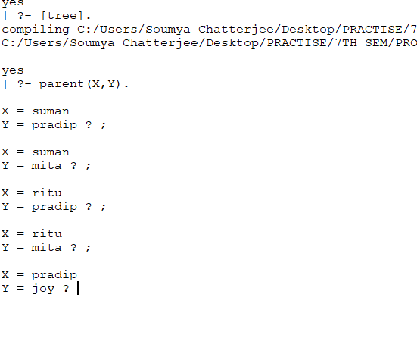
- Define grandparent and grandchild relation:
  - grandparent(X,Y):-parent(X,Z),parent(Z,Y).
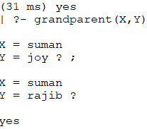

  - grandchild(X,Y):-parent(Z,X),parent(Y,Z).
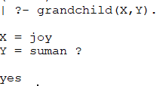
- Define brother relation: brother(X,Y):-parent(Z,Y),parent(Z,X),male(X),X\==Y.
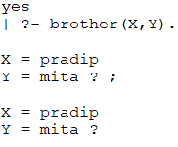
- Define Sister relation: brother(X,Y):-parent(Z,Y),parent(Z,X),female(X),X\==Y.
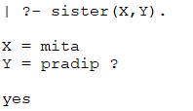

PROBLEM 3: RECURSIVE RULES
- Define predecessor relation:
predecessor(X,Y):-parent(X,Y).
predecessor(X,Y):-parent(X,Z),predecessor(Z,Y).
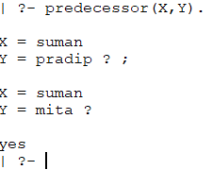
- Define successor relation:
successor(X,Y):-parent(Y,X).
successor(X,Y):-parent(Y,Z),successor(X,Z).
