**Feature Engineering ICE 1**

**Github link -** [**https://github.com/SoumyaBhandari/Feature-Engineering-fall2021**](https://github.com/SoumyaBhandari/Feature-Engineering-fall2021)

**Team Members**

* Soumya Bhandari
* Divya Geethanjali
* Amaanullah Shareef
* Syed Araib Karim
* Shabab AL Gamdi

## Code

### Creating Dataset

import urllib.request,sys,time

from bs4 import BeautifulSoup

import requests

import pandas as pd

import bs4

import requests

### Creating the function to scrap the web page.

def scrapWebPage(url, articleType): response = requests.get(url)

if response is not None: html = bs4.BeautifulSoup(response.text, 'html.parser')

#title = html.select("#firstHeading")[0].text

`paragraphs = html.select("p")`

`articleText = ""`

`for para in paragraphs:`

`articleText += para.text.strip('\n')`

`#print (para.text)`

# just grab the text up to contents as stated in question`

`#intro = '\n'.join([ para.text for para in paragraphs[0:5]])`

`#print (intro)`

`data = {'category': articleType, 'content': articleText}`

`return data`

### Webpages used for data collection

alllinks = []

alllinks.append(scrapWebPage("https://www.forbes.com/sites/bernardmarr/2020/07/17/5-ways-self-driving-cars-could-make-our-world-and-our-lives-better/?sh=17181db742a3","positive"))

alllinks.append(scrapWebPage("https://www.startupgrind.com/blog/5-reasons-you-should-embrace-self-driving-cars/","positive"))

alllinks.append(scrapWebPage("https://www.vox.com/future-perfect/2020/2/14/21063487/self-driving-cars-autonomous-vehicles-waymo-cruise-uber","negative"))

alllinks.append(scrapWebPage("https://www.iotforall.com/dangers-of-autonomous-vehicles-worldwide-adoption","negative"))

alllinks.append(scrapWebPage("https://www.theatlantic.com/technology/archive/2018/12/7-arguments-against-the-autonomous-vehicle-utopia/578638/","negative"))

alllinks.append(scrapWebPage("https://www.mosaic51.com/featured/11-benefits-of-self-driving-cars-how-will-your-life-improve/","positive"))

### Assigning category to new dataset

import csv def savingToDataframe(alllinks): rows = [] fields = ["File_Name","Content","Category","Complete_Filename"] for i in range(0, len(alllinks)): Content = alllinks[i] filename = "FileName_"+ str(i) category = "tech" Complete_Filename = filename rows.append([filename, Content,category, Complete_Filename]) df = pd.DataFrame(rows, columns=fields) print(df) return df

df = savingToDataframe(alllinks)

df.head()

df.to_csv('dataset_file.csv', index=False)

### Assigning the column name to the dataset

import pandas as pd

fields = ["File_Name","Content","Category","Complete_Filename"]

df = pd.read_csv('dataset_file.csv', names=fields,header=0)

print(df)

df.head(6)

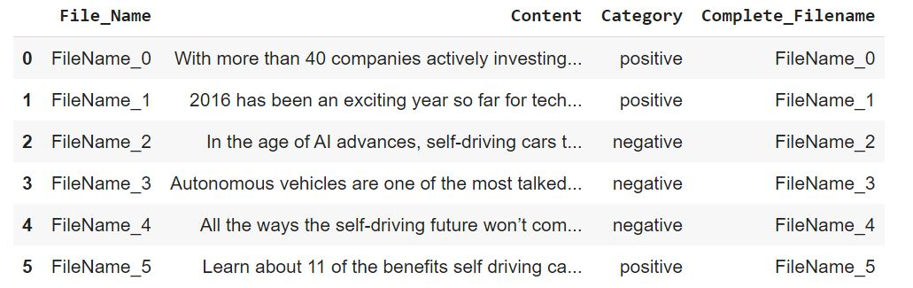

df.tail(10)

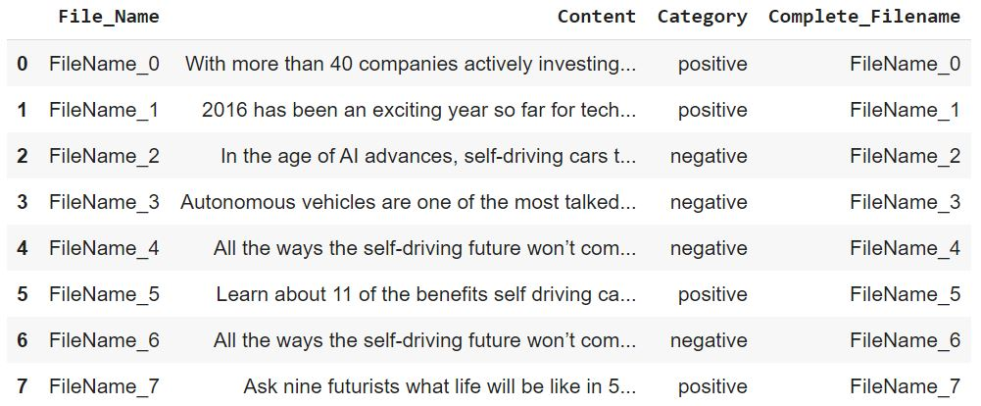

pip install vega==1.3

## EDA Analysis

import pandas as pd

import matplotlib.pyplot as plt

import pickle

import seaborn as sns

sns.set_style("whitegrid")

import altair as alt

import warnings

warnings.filterwarnings("ignore")

### Number of articles in each category

#### Bar chart

bars = alt.Chart(df).mark_bar(size=50).encode( x=alt.X("Category"), y=alt.Y("count():Q", axis=alt.Axis(title='Number of articles')), tooltip=[alt.Tooltip('count()', title='Number of articles'), 'Category'], color='Category'

)

text = bars.mark_text( align='center', baseline='bottom', ).encode( text='count()' )

(bars + text).interactive().properties( height=300, width=700, title = "Number of articles in each category", )

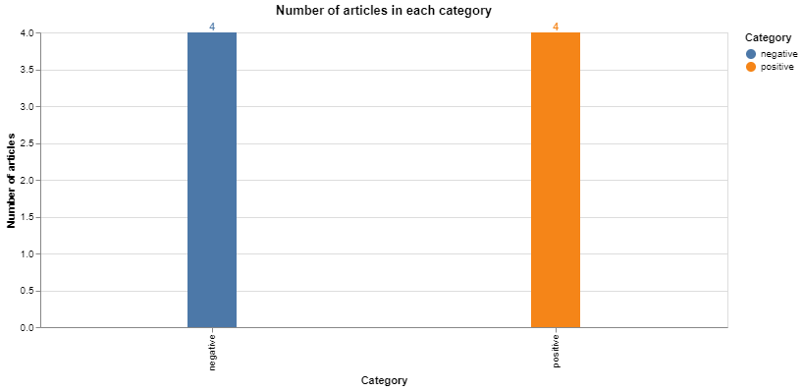

#### Percentage of articles in each category

df['id'] = 1

df2 = pd.DataFrame(df.groupby('Category').count()['id']).reset_index()

bars = alt.Chart(df2).mark_bar(size=50).encode( x=alt.X('Category'), y=alt.Y('PercentOfTotal:Q', axis=alt.Axis(format='.0%', title='% of Articles')), color='Category' ).transform_window( TotalArticles='sum(id)', frame=[None, None] ).transform_calculate( PercentOfTotal="datum.id / datum.TotalArticles" )

text = bars.mark_text( align='center', baseline='bottom', #dx=5 # Nudges text to right so it doesn't appear on top of the bar ).encode( text=alt.Text('PercentOfTotal:Q', format='.1%') )

(bars + text).interactive().properties( height=300, width=700, title = "% of articles in each category",

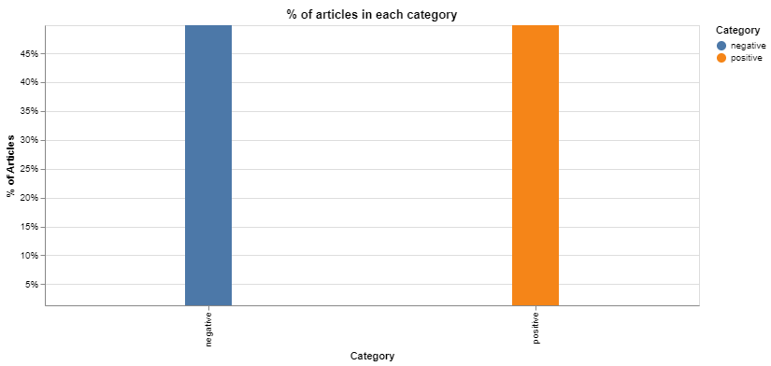

#### News length by category

#### Displot showing the new length of the article

plt.figure(figsize=(12.8,6))

sns.distplot(df['News_length']).set_title('News length distribution');

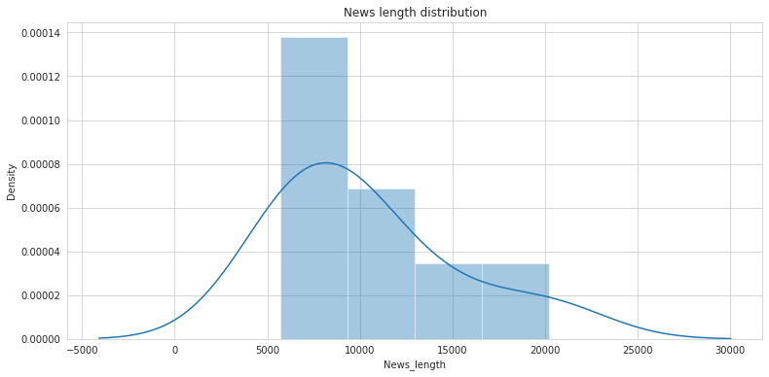

#### Calculating the statistics of the articles

df['News_length'].describe()

quantile_95 = df['News_length'].quantile(0.95)

df_95 = df[df['News_length'] < quantile_95]

plt.figure(figsize=(12.8,6))

sns.distplot(df_95['News_length']).set_title('News length distribution');

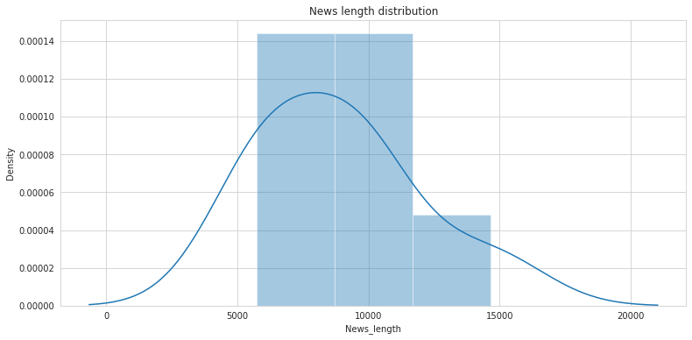

plt.figure(figsize=(12.8,6))

df_more10k = df[df['News_length'] > 10000]

len(df_more10k)

Output : 2

df_more10k['Content'].iloc[0]

Output : In the age of AI advances, self-driving cars turned out to be harder than people expected. Finding the best ways to do good. \n When it comes to self-driving cars, the future was supposed to be now. In 2020, you’ll be a “permanent backseat driver,” the Guardian predicted in 2015. “10 million self-driving cars will be on the road by 2020,” blared a Business Insider headline from 2016. Those declarations were accompanied by announcements from General Motors, Google’s Waymo, Toyota, and Honda that they’d be making self-driving cars by 2020. Elon Musk forecast that Tesla would do it by 2018 — and then, when that failed, by 2020. But the year is here — and the self-driving cars aren’t. Despite extraordinary efforts from many of the leading names in tech and in automaking, fully autonomous cars are still out of reach except in special trial programs. You can buy a car that will automatically brake for you when it anticipates a collision, or one that helps keep you in your lane, or even a....

sns.boxplot(data=df, x='Category', y='News_length', width=.5);

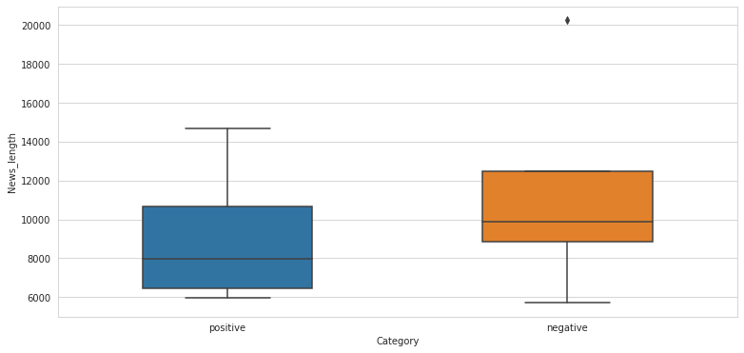

plt.figure(figsize=(12.8,6))

sns.boxplot(data=df_95, x='Category', y='News_length');

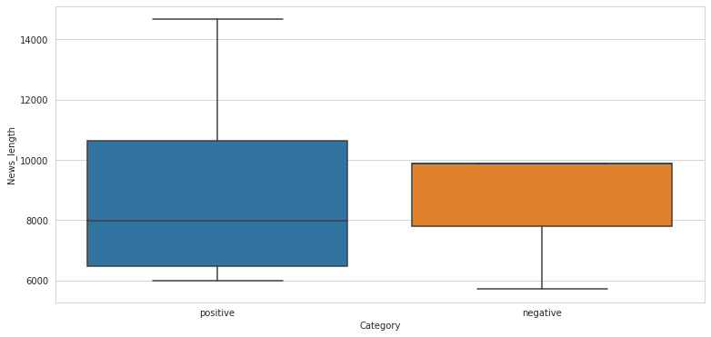

with open('News_dataset.pickle', 'wb') as output: pickle.dump(df, output)

with open('News_dataset.pickle', 'rb') as data: df = pickle.load(data)

df.head()

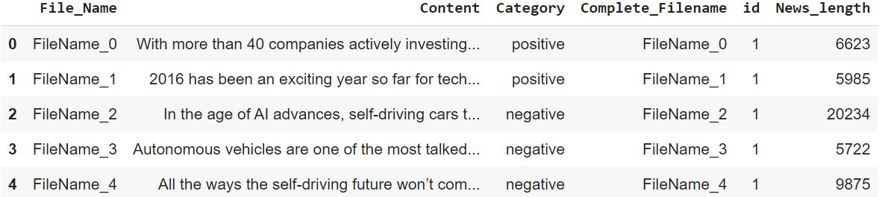

### Feature Engineering

import pickle

import pandas as pd

import re

import nltk

from nltk.corpus import stopwords

from nltk.stem import WordNetLemmatizer

from sklearn.feature_extraction.text import TfidfVectorizer

from sklearn.model_selection import train_test_split

from sklearn.feature_selection import chi2

import numpy as np

with open('News_dataset.pickle', 'rb') as data: df = pickle.load(data)

df.head()



### Visualizing news sample content

df.loc[1]['Content']

**Output**

2016 has been an exciting year so far for technologies that, until recently, have been confined to the world of science fiction dreams. Whether it’s 3D printing revolutionizing the Healthcare industry or the widespread commercial availability of VR technology, we’re continuing to witness amazing\xa0innovations that even just a few years ago seemed like distant possibilities at best.Another technological advancement causing widespread wonder is self-driving cars. We may not have arrived at a Jetsons-like future of flying automated vehicles just yet, but the self-driving car is getting closer and closer to becoming a widespread, viable method of transportation. And, while many are skeptical about the future of driverless and self-driving cars on the road, there’s actually a good deal of data and research to support the idea that self-driving cars may actually be better for our future.With that in mind, here are five reasons to embrace self-driving cars:It’s tough at first to wrap our min

#### Text and Character Cleaning

# \r and \n

df['Content_Parsed_1'] = df['Content'].str.replace("\r", " ")

df['Content_Parsed_1'] = df['Content_Parsed_1'].str.replace("\n", " ")

df['Content_Parsed_1'] = df['Content_Parsed_1'].str.replace(" ", " ")

#" when quoting the text"

df['Content_Parsed_1'] = df['Content_Parsed_1'].str.replace('"', '')

# Lowercasing the text

df['Content_Parsed_2'] = df['Content_Parsed_1'].str.lower()

#### getting rid of punctuation

punctuation_signs = list("?:!.,;")

df['Content_Parsed_3'] = df['Content_Parsed_2']

for punct_sign in punctuation_signs: df['Content_Parsed_3'] = df['Content_Parsed_3'].str.replace(punct_sign, '')

df['Content_Parsed_4'] = df['Content_Parsed_3'].str.replace("'s", "")

#### Stemming and Lemmatization

# Downloading punkt and wordnet from NLTK

nltk.download('punkt')

print("------------------------------------------------------------")

nltk.download('wordnet')

#### Saving the lemmatizer into an object

wordnet_lemmatizer = WordNetLemmatizer()

for row in range(0, nrows):

`lemmatized_list = []`

`text = df.loc[row]['Content_Parsed_4']`

`text_words = text.split(" ")`

`for word in text_words:`

`lemmatized_list.append(wordnet_lemmatizer.lemmatize(word, pos="v"))`

`lemmatized_text = " ".join(lemmatized_list)`

`lemmatized_text_list.append(lemmatized_text)`

df['Content_Parsed_5'] = lemmatized_text_list

#### Downloading the stop words list

nltk.download('stopwords')

#### Loading the stop words in english

stop_words = list(stopwords.words('english'))

stop_words[0:10]

Output ['i', 'me', 'my', 'myself', 'we', 'our', 'ours', 'ourselves', 'you', "you're"]

df['Content_Parsed_6'] = df['Content_Parsed_5']

for stop_word in stop_words:

`regex_stopword = r"\b" + stop_word + r"\b"`

`df['Content_Parsed_6'] = df['Content_Parsed_6'].str.replace(regex_stopword, '')`

#We have some dobule/triple spaces between words because of the replacements. However, it's not a problem because we'll tokenize by the spaces later.

#As an example, we'll show an original news article and its modifications throughout the process:

df.loc[2]['Content']

df.loc[2]['Content_Parsed_1']

df.loc[2]['Content_Parsed_2']

df.loc[2]['Content_Parsed_3']

df.loc[2]['Content_Parsed_4']

df.loc[2]['Content_Parsed_5']

df.loc[2]['Content_Parsed_6']

df.head(1)



# Label coding

#We'll create a dictionary with the label codification:

category_codes = { 'business': 0, 'entertainment': 1, 'politics': 2, 'sport': 3, 'tech': 4 }

# Category mapping

df['Category_Code'] = df['Category']

df = df.replace({'Category_Code':category_codes})

df.head()

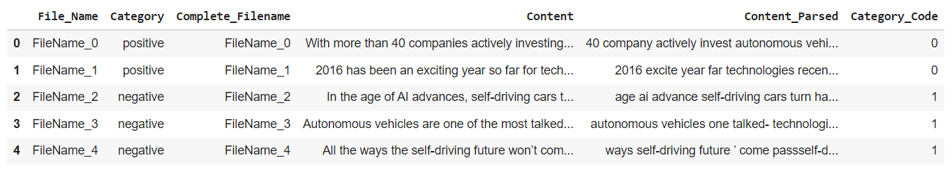

#Train - test split

X_train, X_test, y_train, y_test = train_test_split(df['Content_Parsed'], df['Category_Code'], test_size=0.15, random_state=2)

X_train.shape X_test.shape

y_test.shape

# Parameter election

ngram_range = (1,2)

max_df = 10

min_df = 1.

max_features = 300

tfidf = TfidfVectorizer(encoding='utf-8', ngram_range=ngram_range, stop_words=None, lowercase=False, max_df=max_df, min_df=min_df, max_features=max_features, norm='l2', sublinear_tf=True)

features_train = tfidf.fit_transform(X_train).toarray()

labels_train = y_train

print(features_train.shape)

features_test = tfidf.transform(X_test).toarray()

labels_test = y_test

print(features_test.shape)

from sklearn.feature_selection import chi2

import numpy as np

for Product, category_id in sorted(category_codes.items()): features_chi2 = chi2(features_train, labels_train == category_id) indices = np.argsort(features_chi2[0]) feature_names = np.array(tfidf.get_feature_names())[indices] unigrams = [v for v in feature_names if len(v.split(' ')) == 1] bigrams = [v for v in feature_names if len(v.split(' ')) == 2] print("# '{}' category:".format(Product)) print(" . Most correlated unigrams:\n. {}".format('\n. '.join(unigrams[-5:]))) print(" . Most correlated bigrams:\n. {}".format('\n. '.join(bigrams[-2:]))) print("")

bigrams

Output : ['driving cars', 'self driving', 'autonomous vehicles', 'driving car']

# X_train

with open('X_train.pickle', 'wb') as output: pickle.dump(X_train, output)

# X_test

with open('X_test.pickle', 'wb') as output: pickle.dump(X_test, output)

# y_train

with open('y_train.pickle', 'wb') as output: pickle.dump(y_train, output)

# y_test

with open('y_test.pickle', 'wb') as output: pickle.dump(y_test, output)

# df

with open('df.pickle', 'wb') as output: pickle.dump(df, output)

# features_train

with open('features_train.pickle', 'wb') as output: pickle.dump(features_train, output)

# labels_train

with open('labels_train.pickle', 'wb') as output: pickle.dump(labels_train, output)

# features_test

with open('features_test.pickle', 'wb') as output: pickle.dump(features_test, output)

# labels_test

with open('labels_test.pickle', 'wb') as output: pickle.dump(labels_test, output)

# TF-IDF object

with open('tfidf.pickle', 'wb') as output: pickle.dump(tfidf, output)

# Model Fitting

## Random Forest

#### First create the base model to tune

rfc = RandomForestClassifier(random_state=8)

#### Definition of the random search

random_search = RandomizedSearchCV(estimator=rfc, param_distributions=random_grid, n_iter=50, scoring='accuracy', cv=3, verbose=1, random_state=8)

# Fit the random search model random_search.fit(features_train, labels_train)

#### Confusion Matrix

aux_df = df[['Category', 'Category_Code']].drop_duplicates().sort_values('Category confusion_matrix(labels_test, rfc_pred) plt.figure(figsize=(12.8,6)) sns.heatmap(conf_matrix, annot=True, xticklabels=aux_df['Category'].values, yticklabels=aux_df['Category'].values, cmap="Blues") plt.ylabel('Predicted') plt.xlabel('Actual') plt.title('Confusion matrix') plt.show()

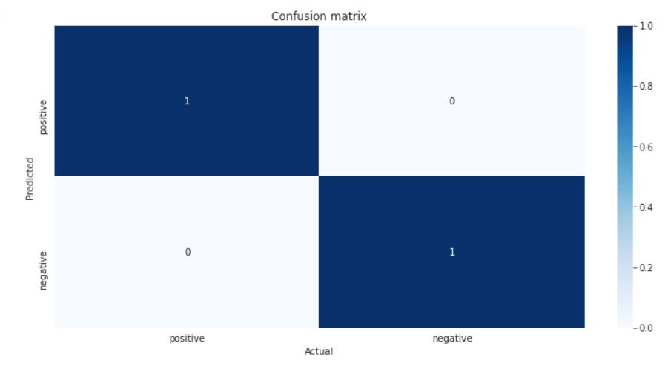

base_model = RandomForestClassifier(random_state = 8) base_model.fit(features_train, labels_train) accuracy_score(labels_test, base_model.predict(features_test)) best_rfc.fit(features_train, labels_train) accuracy_score(labels_test, best_rfc.predict(features_test))

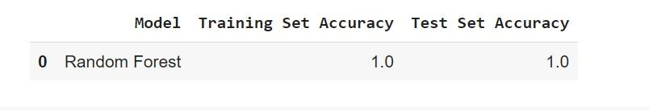

## KNN

n_neighbors = [1,2,3] param_grid = {'n_neighbors': n_neighbors}

knnc = KNeighborsClassifier() cv_sets = ShuffleSplit(n_splits = 3, test_size = .33, random_state = 8)

grid_search = GridSearchCV(estimator=knnc, param_grid=param_grid, scoring='accuracy', cv=cv_sets, verbose=1)

grid_search.fit(features_train, labels_train) print("The best hyperparameters from Grid Search are:") print(grid_search.best_params_) print("") print("The mean accuracy of a model with these hyperparameters is:") print(grid_search.best_score_)

#### Training accuracy

print("The training accuracy is: ") print(accuracy_score(labels_train, best_knnc.predict(features_train))) Output - The test accuracy is 1.00

#### Test accuracy

_Code') conf_matrix =

print("The test accuracy is: ") print(accuracy_score(labels_test, knnc_pred))

Output - The test accuracy is 1.00

#### Classification report

print("Classification report") print(classification_report(labels_test,knnc_pred))

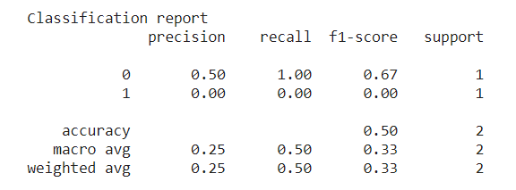

#### Confusion Matrix

aux_df = df[['Category', 'Category_Code']].drop_duplicates().sort_values('Category_Code') conf_matrix = confusion_matrix(labels_test, knnc_pred) plt.figure(figsize=(12.8,6)) sns.heatmap(conf_matrix, annot=True, xticklabels=aux_df['Category'].values, yticklabels=aux_df['Category'].values, cmap="Blues") plt.ylabel('Predicted') plt.xlabel('Actual') plt.title('Confusion matrix') plt.show()

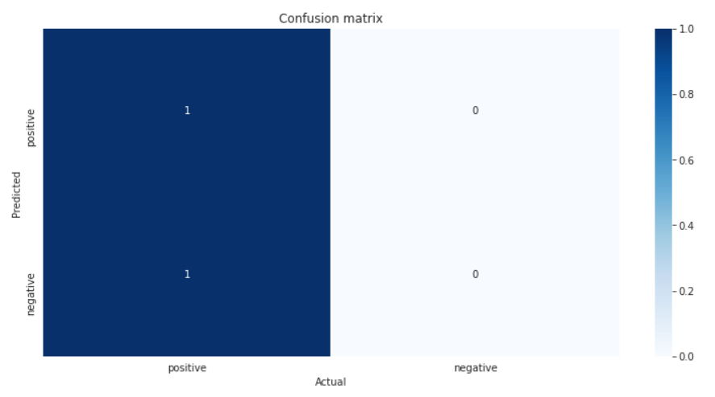

d = { 'Model': 'KNN', 'Training Set Accuracy': accuracy_score(labels_train, best_knnc.predict(features_train)), 'Test Set Accuracy': accuracy_score(labels_test, knnc_pred) }

df_models_knnc = pd.DataFrame(d, index=[0])

df_models_knnc

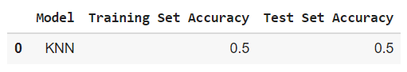

## Support Vector Machine

#Cross Validation Hyper Parameter tuning

svc_0 =svm.SVC(random_state=8)

print('Parameters currently in use:\n') pprint(svc_0.get_params())

### Best hyperparameters resulting from the Random Search

print("The best hyperparameters from Random Search are:") print(random_search.best_params_) print("") print("The mean accuracy of a model with these hyperparameters is:") print(random_search.best_score_)

Output : The best hyperparameters from Random Search are: {'probability': True, 'kernel': 'rbf', 'gamma': 100, 'degree': 3, 'C': 0.001}

The mean accuracy of a model with these hyperparameters is: 0.6666666666666666

#### Training accuracy

print("The training accuracy is: ") print(accuracy_score(labels_train, best_svc.predict(features_train)))

#### Output

The training accuracy is: 1.0

#### Test accuracy

print("The test accuracy is: ") print(accuracy_score(labels_test, svc_pred))

#### Output

The test accuracy is:

### Classification report

print("Classification report") print(classification_report(labels_test,svc_pred))

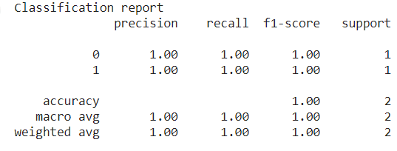

### Confusion Matrix

aux_df = df[['Category', 'Category_Code']].drop_duplicates().sort_values('Category_Code') conf_matrix = confusion_matrix(labels_test, svc_pred) plt.figure(figsize=(12.8,6)) sns.heatmap(conf_matrix, annot=True, xticklabels=aux_df['Category'].values, yticklabels=aux_df['Category'].values, cmap="Blues") plt.ylabel('Predicted') plt.xlabel('Actual') plt.title('Confusion matrix') plt.show()

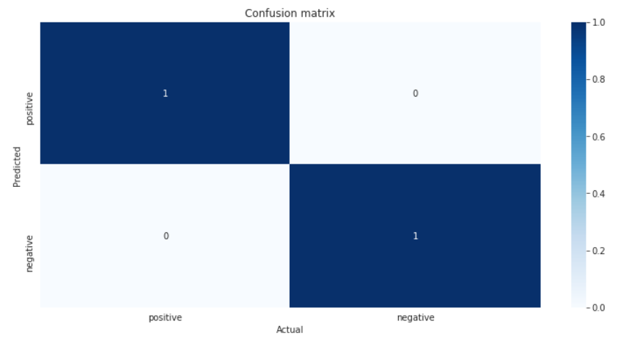

base_model = svm.SVC(random_state = 8) base_model.fit(features_train, labels_train) accuracy_score(labels_test, base_model.predict(features_test))

#### Output :

0.5

best_svc.fit(features_train, labels_train) accuracy_score(labels_test, best_svc.predict(features_test))

Output : 1.0

d = { 'Model': 'SVM', 'Training Set Accuracy': accuracy_score(labels_train, best_svc.predict(features_train)), 'Test Set Accuracy': accuracy_score(labels_test, svc_pred) }

df_models_svc = pd.DataFrame(d, index=[0])

df_models_svc

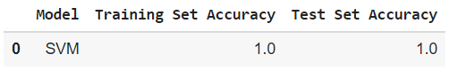

### Best Model Selection

path_pickles = ""

list_pickles = [ "df_models_knnc.pickle", "df_models_rfc.pickle", "df_models_svc.pickle" ]

df_summary = pd.DataFrame()

for pickle_ in list_pickles:

path = path_pickles + pickle

with open(path, 'rb') as data:

`df = pickle.load(data)`

df_summary = df_summary.append(df)

df_summary = df_summary.reset_index().drop('index', axis=1)

df_summary

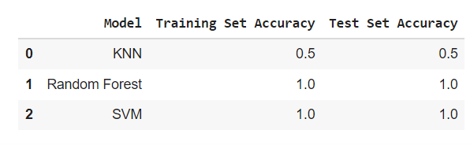

df_summary.sort_values('Test Set Accuracy', ascending=False)

