Generic Workflow Engine

**Software Requirements Specification**

**Version** <1.0.> **Status:** <draft>

**Prepared by** Kapil Dev(2017csb1085) , Aman Kumar(2017csb1067) , Kartikeya Pise(2017csb1086) , Soumya(2017csb1114) , GROUP:-9

IIT Ropar  
29 Jan , 2020

**Table of Contents**

**1.** **Introduction**

1.1 Purpose

1.2 Document Conventions

1.3 Intended Audience and Reading Suggestions

1.4 Product Scope

1.5 References

**2.** **Overall Description**

2.1 Product Perspective

2.2 Product Functions

2.3 User Classes and Characteristics

2.4 Operating Environment

2.5 Design and Implementation Constraints

2.6 User Documentation

2.7 Assumptions and Dependencies

**3.** **External Interface Requirements**

3.1 User Interfaces

3.2 Hardware Interfaces

3.3 Software Interfaces

3.4 Communications Interfaces

**4.** **System Features (Use Cases)**

5.1 Use Case <Insert the specific use case name>

5.2 …

**5.** **Other Nonfunctional Requirements**

6.1 Performance Requirements

6.2 Safety Requirements

6.3 Security Requirements

6.4 Software Quality Attributes

**6.** **Other Requirements**

**Revision History**

|  |  |  |  |  |
| --- | --- | --- | --- | --- |
| **Name** | **Date** | **Reason For Changes** | **Version** | **Date of Approval** |
|  |  |  |  |  |
|  |  |  |  |  |

# **Introduction**

## **Purpose**

*The SRS describes the software functional and non-functional requirements of generic workflow engine which will help in automating business workflow. This software will allow easy defining and adding new forms roles and various state transitions for given business workflow.*

## **Document Conventions**

*For tracking the changes mark them in the document with color (changes, additions) or cross them (~~deleting~~).*

## **Intended Audience and Reading Suggestions**

|  |  |  |
| --- | --- | --- |
| **ID** | **Stakeholder** | **Description** |
| S-1 | Signed up user | A user of the portal who has completed the sign up on the portal and the account activation and will be able to use form related to that business workflow . |
| S-2 | Development team | Forming the accurate vision of the project, detailed functional and nonfunctional requirements. |
| S-3 | Not signed up user | A user of the portal who has completed neither the sign up on the portal, nor the account activation. He owns limited rights inside the portal. |
| S-5 | Moderator | They will verify all the data given by signed up users and are part of the business workflow. |

## **Product Scope**

*The system is a web based application that will automate business workflows. It manages and monitors the state of activities in a business workflow such as processing and approval of business application form and determines which new activity to transition according to defined process. The actions may be anything from saving an application form in a document management system to send a notification to users and to control overdue of task.[1]*

## **References**

*[1] wikipedia* [*https://en.wikipedia.org/wiki/Workflow_engine*](https://en.wikipedia.org/wiki/Workflow_engine)*.*

# **Overall Description**

## **Product Perspective**

*This software is intended to be used in automating different business workflows. It is a self-contained product . If the SRS defines a component of a larger system, relate the requirements of the larger system to the functionality of this software and identify interfaces between the two.*

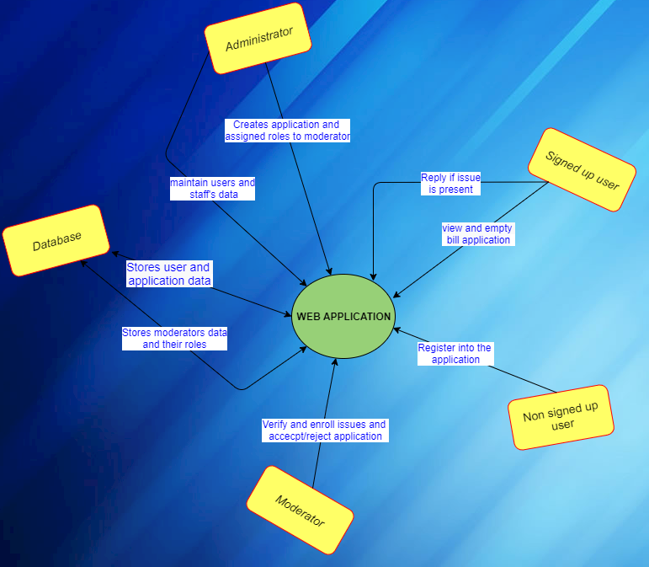

**Product Functions**

*The major function are described below for three types of users.*

*PFn-1: Admin : Generate forms related to their business needs .*

*PFn-2: Members of this business workflow having authenticating power : It will give these users the power to check and take action related to business .*

*PFn-3: End user : Allows users to fill forms related to business workflow.*

*.***User Classes and Characteristics**

*The various user classes that will use this product and its description are given below :*

|  |  |  |
| --- | --- | --- |
| **ID** | **User classes** | **Description** |
| U-1 | Administrator | A signed up user who will create and modulates roles to different members of business workflow .  He/she will also manages all the data  Related to business . |
| U-2 | Signed up user | A user of the portal who has completed the sign up on the portal and the account activation and will be able to use form related to that business workflow . |
| U-3 | Not signed up user | A user of the portal who has completed neither the sign up on the portal, nor the account activation. He owns limited rights inside the portal. |
| U-4 | Moderator | A signed up user who can take action on the form and are part of business and can also use this form. |

## **Operating Environment**

|  |  |
| --- | --- |
| *OE-1:* | *System is not dependent on geographical areas.* |
| *OE-2:* | *System shall operate in newest versions of all web browsers.* |
| *OE-3:* | *There should be no constraint on users being able to access the system at a given time.* |
| *OE-4:* | *Data generated by online forms will be stored in mongodb.* |
| *OE-5:* | *jQuery javascript library and bootstrap will be needed to create the user interface for the system.* |
| *OE-6:* | *It will be supported on PCs as well as mobiles.* |
| *OE-7:* | *It will be supported in both windows as well as linux.* |

## **Design and Implementation Constraints***:*

|  |  |
| --- | --- |
| *1.* | *Mongodb Nosql database* |
| *2.* | *Html ,css , bootstrap for frontend and django python for backend .* |
| *3.* | *HTTP and SMTP for communication protocol* |

## **User Documentation**

*It will have user manuals to help new users.*

## **Assumptions and Dependencies**

|  |  |
| --- | --- |
| *AS-1:* | *No more than 512 MB of data can be stored on mongodb freely.* |
| *AS-2:* | *Users should have a Google Account with which they can login.* |
| *AS-3:* | *All mandatory fields should be filled by users and optional field if not given , we will pass NULL .* |

# **External Interface Requirements**

## **User Interfaces**

*UI-1: Web application shall permit complete navigation and use of all the features through the combination of keyboard and mouse in PCs.*

*UI-2: Web application shall permit complete navigation and use of all the features through touch and virtual keyboard in Android.*

*UI-3: The Software will have a Navbar where a user can navigate all the features on the System.*

**Hardware Interfaces**

*No hardware interfaces have been identified.*

## **Software Interfaces**

*SI-1: Database - The system shall communicate with a database through a programmatic interface for the following options:*

*SI-1.1: To manage user’s data and the application data in the database.*

*SI-1.2: To allow the administrator to create forms and roles in the workflow.*

*SI-1.3: To manage the application status and text messages associated with it.*

*SI-2: Web browser - A web browser is required to access the application.*

*SI-3: Email - A valid email id is required to register into our system.*

**Communications Interfaces**

*CI-1: The system shall send notification to the user to inform them about issues, approval and rejection at every stage of workflow.*

*CI-2: The system shall consist of a chat functionality in case of issues.*

*CI-3: All the notification shall be sent through email using SMTP protocol.*

*CI-4: HTTP protocol is used to host our web application and for security.*

# **System Features (Use Cases)**

## **Login**

|  |  |
| --- | --- |
| **Brief Description:** | *This is used to verify the registered users.* |
| **Business Trigger:** | *Any registered user tries to login into the system.* |
| **Preconditions:** | *The system must be in healthy condition.* |

|  |  |  |  |
| --- | --- | --- | --- |
| **Basic Flow:Any user who has registered can login to the system using his user id and password.** | | | |
| **Assumptions:** None*.* | | | |
| **Line** | **System Actor Action** | | **System Response** |
|  | The user tries to login . | | The system checks in database for the user id and password and verifies it. |
|  | User enters correct credentials to login . | | System loges the user in using his credentials. |
|  | User enters wrong credentials. | | System redirect to login page and responds an error message. |
| **Post Condition:** | | At the end of the basic flow system either would be logged in or it will stay at logged out condition. | |

|  |
| --- |
| **Business Rules:** |
| 1. To make the login secure we would use gmail or email login. |

|  |
| --- |
| **Data Requirements:** |
| 1. Email or gmail of the user will be required. |

## **Generate a form**

Brief Description : This use case is to be used for applying a new form.

Business Trigger : Whenever any user tries to issue a new form to system.

Preconditions : User must be logged in to the system.

|  |  |  |  |
| --- | --- | --- | --- |
| **Basic Flow:**User is provided with a form layout that has certain entries to be filled and after that he can forward it to the next level of workflow. | | | |
| **Assumptions:** Every member of the escalating matrix in the system is also a simple user. | | | |
| **Line** | **System Actor Action** | | **System Response** |
| 1 | The user tries to generate a new application form . | | The system loads a new form and provides it to the user with appropriate entries. |
| 2 | User fills the form and submit it. | | The system accept the form and enters the details into the database and forward it to the designated member in the chain.  And user is provided with an option to cancel it.(Afx) |
| 3 | User tries to cancel the transaction. | | The transaction is canceled by the system . |

|  |  |  |  |
| --- | --- | --- | --- |
| **Post Condition:** | | At the end of the basic flow the user will have information about the status of the transaction he performed. | |

|  |  |  |  |
| --- | --- | --- | --- |
| **Alternate Flow (AFx): Having one alternate flow Afx.** | | | |
|  | | | |
| **Line** | **System Actor Action** | | **System Response** |
| 2 | User tries to save the form as a draft. | | System saves the document in database. |
|  | Then user tries to submit the form . | | The system accept the form and enters the details into the database and forward it to the designated member in the chain.  And user is provided with an option to cancel it. |
| The use case terminates . | | | |

**5.3 Reply a form**

Brief Description : This use case is to be used to reply a form by privileged members (i.e. member of workflow having some authority on that form to respond).

Business Trigger : A moderator wants to reply to the form.

Preconditions : User must be logged in to the system , he must have the power to do so.

|  |  |  |  |
| --- | --- | --- | --- |
| **Basic Flow: User select a form and reply to it by using various options provided to him and these notifications are sent to the user who applied for the form.** | | | |
| **Assumptions: Replying user(moderator) respondes under the constraints set by admin and form is sent back to applying user**. | | | |
| **Line** | **System Actor Action** | | **System Response** |
| 1 | The moderator opens the requested form and tries to reply. | | The system checks for the constraints to respond for the moderator and accordingly  gives the options to respond for that particular form. |
| 2 | Moderator sent back the form with some comments. | | The system records the comments in the database and make them visible to the user  who applied the form with the other information as well. |
| 3 | Forward it with comments. | | System records the comments in database and forward the form to designated officer.. |

|  |  |  |  |
| --- | --- | --- | --- |
| **Post Condition:** | | At the end of the basic flow the moderator would have responded to the form he got to reply. | |

**5.4 Reset the workflow by admin**

Brief Description : This use case is used to reset the information of workflow system e.g. format of the form , role of users , number of users in the workflow chain.

Business Trigger : Admin tries to reset or build a new workflow system.

Preconditions : User is logged in to the system , system is in a healthy state , users with certain role are already registered.

|  |  |  |  |
| --- | --- | --- | --- |
| **Basic Flow: Admin resets the workflow as required and configuared system is ready to use .** | | | |
| **Assumptions: GUI for admin to interact with system to reset the workflow system.** | | | |
| **Line** | **System Actor Action** | | **System Response** |
| 1 | Admin resets the form . | | System provides with the option to select number of entries the form would have and the format of the form , that particular  format of the form is loaded into the database . |
| 2 | Admin selects to reset the number of users in the workflow chain. | | System reset the workflow chain with that number of users. |
| 3 | Admin sets the roles of different users  at different level with some specific roles to each user. | | System accordingly update the database for the users at different designations in workflow system . |

|  |  |  |  |
| --- | --- | --- | --- |
| **Post Condition:** | | At the end of the basic flow the admin would be able to reset the workflow chain and system as a whole. | |

# **Other Nonfunctional Requirements**

## **Performance Requirements**

*PE-1: All User interactions with the system shall not take more than 4 seconds to execute.*

*PE-2: The software will be available for 99.9 % of the time.*

## **Safety Requirements**

*We will directly save all the data which users provide in database so that even if there is power loss of internet loss, there will not be any loss to data when user will open that form again we will show them all the information previously given.*

## **Security Requirements**

1. *Users shall be required to log in to the system for all operations.*
2. *The system shall permit only staff members who are on the list of authorized administrators to create or edit function of business workflow.*
3. *The system shall permit users who are not admin to view only their own information, not the information of other users.*
4. *After 3 wrong login attempt , we will notify users through mail about this.*

## **Software Quality Attributes**

1. *All the features and use cases available on the website for*

*signed-in and non-signed-in users can be accessed within at most 5-6 clicks.*

1. *This software will be portable as it will be supported in both mobile as well as PCs.*

# **Other Requirements**

No other requirements.

**Appendix A: Glossary**

|  |  |
| --- | --- |
| **Term** | **Description** |
| PE | Performance Requirements |
| CI | Communication Interface |
| SI | Software Interface |
| UI | User Interface |
| *AS* | Assumption |
| *OE* | Operating Environment |
| *PFn* | Product function |
| Moderator | Signed users who are a part of business workflow and have roles more than simple user. |

**Appendix B: Analysis Models**

