Name: Soumya Dixit

Prn : 23070521151

Batch : B2

Error handling

**1.**

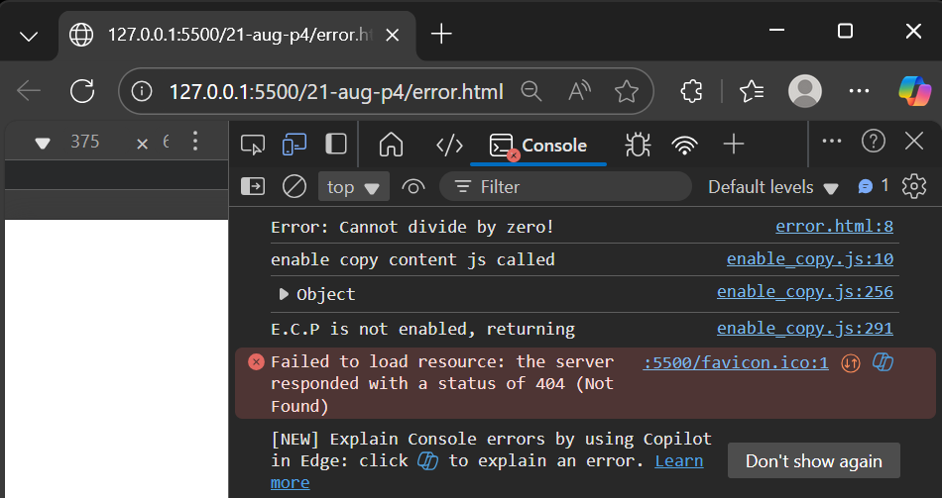

try {

let result = 10 / 0;

if (!isFinite(result)) throw new Error("Cannot divide by zero!");

console.log(result);

}

catch (err) {

console.log("Error:", err.message);

}

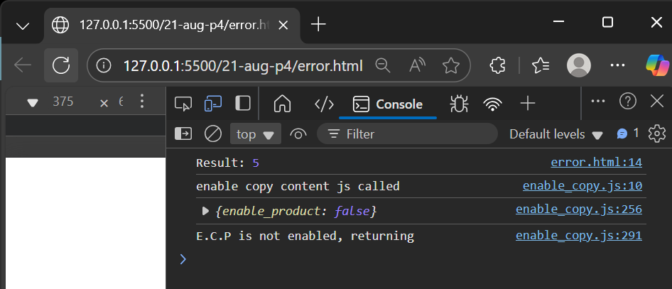

try {

let result = 10 / 2; // valid division

if (!isFinite(result)) throw new Error("Cannot divide by zero!");

console.log("Result:", result);

}

catch (err) {

console.log("Error:", err.message);

}

**2.**

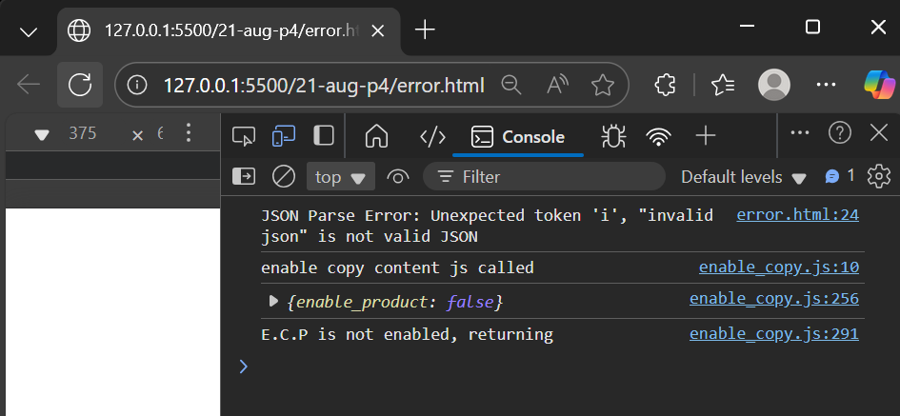

try {

let data = JSON.parse("invalid json");

}

catch (err) {

console.log("JSON Parse Error:", err.message);

}

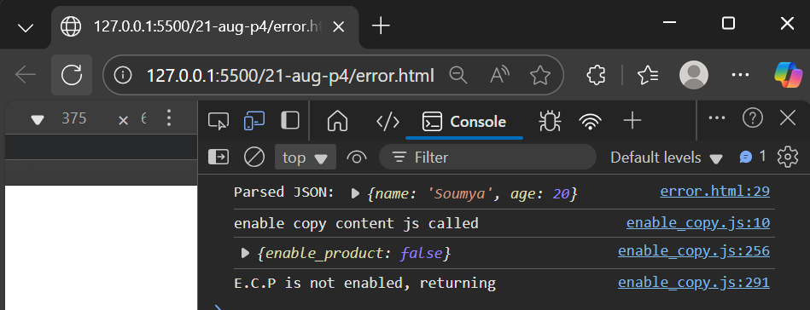

try {

let data = JSON.parse('{"name":"Soumya","age":20}');

console.log("Parsed JSON:", data);

}

catch (err) {

console.log("JSON Parse Error:", err.message);

}

**3.**

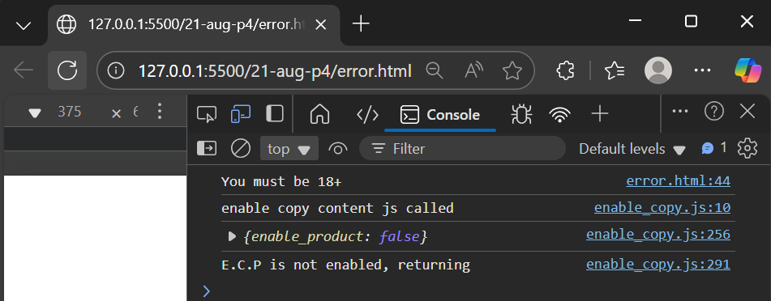

function checkAge(age) {

if (age < 18) throw new Error("You must be 18+");

return "Access granted";

}

try {

console.log(checkAge(16));

}

catch (err) {

console.log(err.message);

}

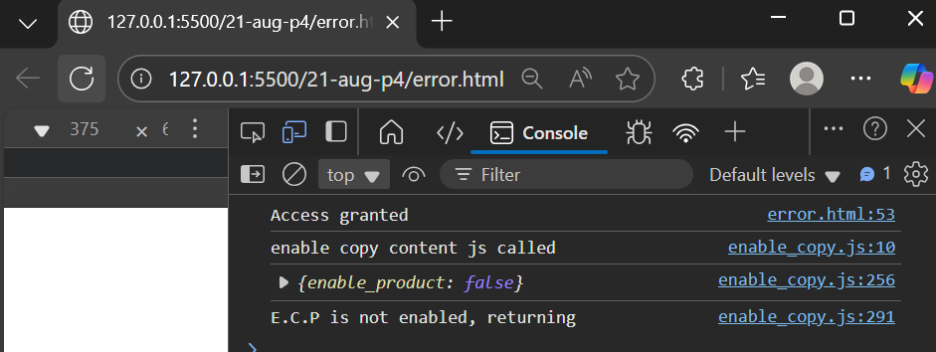

function checkAge(age) {

if (age < 18) throw new Error("You must be 18+");

return "Access granted";

}

try {

console.log(checkAge(20));

}

catch (err) {

console.log(err.message);

}

**4.**

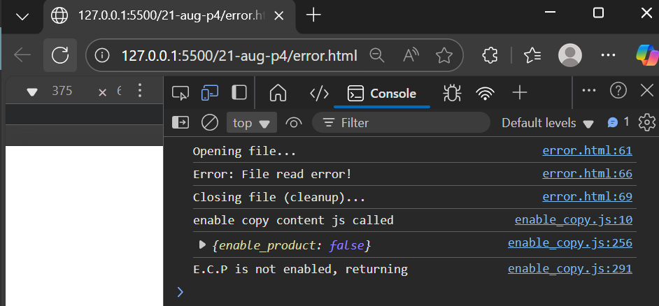

try {

let fileOpen = true;

console.log("Opening file...");

throw new Error("File read error!"); // error here

console.log("Reading file..."); // skipped

}

catch (err) {

console.log("Error:", err.message);

}

finally {

console.log("Closing file (cleanup)...");

}

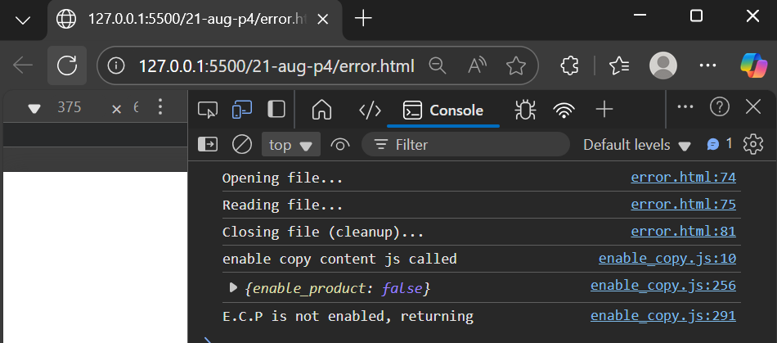

try {

let fileOpen = true;

console.log("Opening file...");

console.log("Reading file..."); // no error thrown

}

catch (err) {

console.log("Error:", err.message);

}

finally {

console.log("Closing file (cleanup)...");

}

**5.**

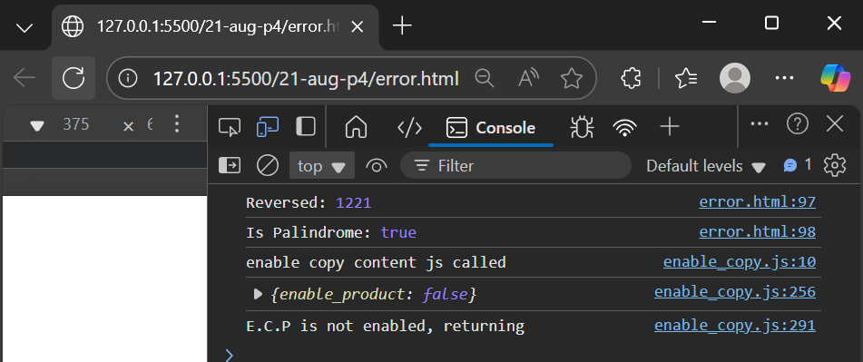

function reverseNumber(num) {

if (typeof num !== "number" || isNaN(num)) {

throw new Error("Invalid number input");

}

return parseInt(num.toString().split("").reverse().join(""));

}

function isPalindrome(num) {

return num === reverseNumber(num);

}

try {

let num = 1221; // valid number

console.log("Reversed:", reverseNumber(num));

console.log("Is Palindrome:", isPalindrome(num));

} catch (err) {

console.log("Error:", err.message);

}