Name : Soumya Dixit

PRN : 23070521151

Batch : B2  
  
  
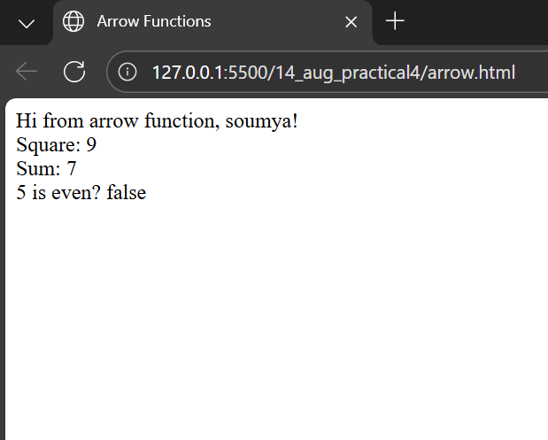

<!DOCTYPE html>

<html>

<head>

<title>Arrow Functions</title>

</head>

<body>

<script>

// Example 1

const greet = () => {

let name = prompt("Enter your name:");

document.write("Hi from arrow function, " + name + "!<br>");

};

greet();

// Example 2 – single parameter

const square = n => n \* n;

let sqNum = parseFloat(prompt("Enter number to square:"));

document.write("Square: " + square(sqNum) + "<br>");

// Example 3 – multiple parameters

const add = (a, b) => a + b;

let numA = parseFloat(prompt("Enter first number:"));

let numB = parseFloat(prompt("Enter second number:"));

document.write("Sum: " + add(numA, numB) + "<br>");

// Example 4 – multiline

const isEven = (num) => {

if (num % 2 === 0) return true;

return false;

};

let evenCheck = parseInt(prompt("Enter a number to check even/odd:"));

document.write(evenCheck + " is even? " + isEven(evenCheck) + "<br>");

</script>

</body>

</html>

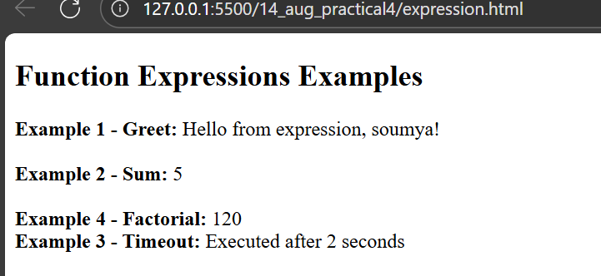

<!DOCTYPE html>

<html>

<head>

<title>Function Expressions</title>

</head>

<body>

<h2>Function Expressions Examples</h2>

<script>

// Example 1 – basic greet

const greet = function() {

let name = prompt("Enter your name:");

document.body.innerHTML += "<b>Example 1 - Greet:</b> Hello from expression, " + name + "!<br><br>";

};

greet();

// Example 2 – sum

const sum = function(a, b) {

return a + b;

};

let n1 = parseFloat(prompt("Enter first number:"));

let n2 = parseFloat(prompt("Enter second number:"));

document.body.innerHTML += "<b>Example 2 - Sum:</b> " + sum(n1, n2) + "<br><br>";

// Example 3 – anonymous inline

setTimeout(function() {

document.body.innerHTML += "<b>Example 3 - Timeout:</b> Executed after 2 seconds<br><br>";

}, 2000);

// Example 4 – named function expression

const factorial = function fact(n) {

return n <= 1 ? 1 : n \* fact(n - 1);

};

let factNum = parseInt(prompt("Enter number for factorial:"));

document.body.innerHTML += "<b>Example 4 - Factorial:</b> " + factorial(factNum) + "<br>";

</script>

</body>

</html>

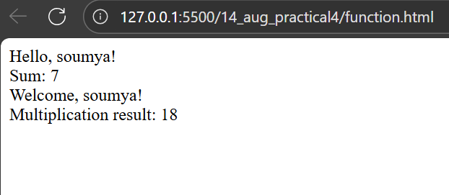

<!DOCTYPE html>

<html>

<head>

<title>Function Declarations</title>

</head>

<body>

<script>

// Example 1

function greet() {

let name = prompt("Enter your name:");

document.write("Hello, " + name + "!<br>");

}

greet();

// Example 2 – with parameters

function add(a, b) {

return a + b;

}

let num1 = parseFloat(prompt("Enter first number:"));

let num2 = parseFloat(prompt("Enter second number:"));

document.write("Sum: " + add(num1, num2) + "<br>");

// Example 3 – returning strings

function welcome(name) {

return `Welcome, ${name}!`;

}

let userName = prompt("Enter your name:");

document.write(welcome(userName) + "<br>");

// Example 4 – default parameter

function multiply(a, b = 2) {

return a \* b;

}

let mulNum = parseFloat(prompt("Enter number to multiply:"));

document.write("Multiplication result: " + multiply(mulNum) + "<br>");

</script>

</body>

</html>

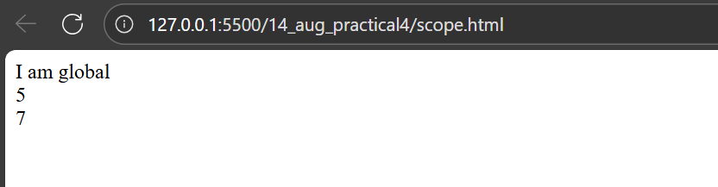

<!DOCTYPE html>

<html>

<head>

<title>Scope Example</title>

</head>

<body>

<script>

let globalVar = "I am global";

function testScope() {

let functionVar = prompt("Enter a function-scoped variable value:");

document.write(globalVar + "<br>");

document.write(functionVar + "<br>");

}

testScope();

{

let blockVar = prompt("Enter a block-scoped variable value:");

document.write(blockVar + "<br>");

}

</script>

</body>

</html>

TASKS:-

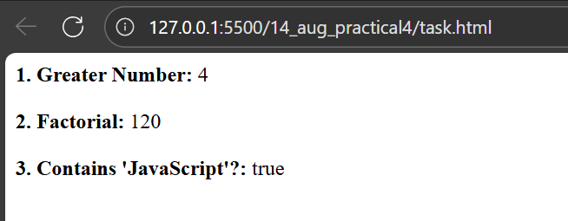

<!DOCTYPE html>

<html>

<head>

<title>Tasks</title>

</head>

<body>

<script>

// 1. Function Declaration – returns greater number

function getGreaterNumber(a, b) {

return (a > b) ? a : b;

}

let num1 = parseFloat(prompt("Enter first number:"));

let num2 = parseFloat(prompt("Enter second number:"));

document.body.innerHTML += "<b>1. Greater Number:</b> " + getGreaterNumber(num1, num2) + "<br><br>";

// 2. Function Expression – factorial of a number

const factorial = function(n) {

return (n <= 1) ? 1 : n \* factorial(n - 1);

};

let factNum = parseInt(prompt("Enter a number for factorial:"));

document.body.innerHTML += "<b>2. Factorial:</b> " + factorial(factNum) + "<br><br>";

// 3. Arrow Function – check if string contains "JavaScript"

const containsJavaScript = str => str.includes("JavaScript");

let userStr = prompt("Enter a string:");

document.body.innerHTML += "<b>3. Contains 'JavaScript'?:</b> " + containsJavaScript(userStr) + "<br><br>";

</script>

</body>

</html>