**Soumya Dixit**

**23070521151**

**B2**

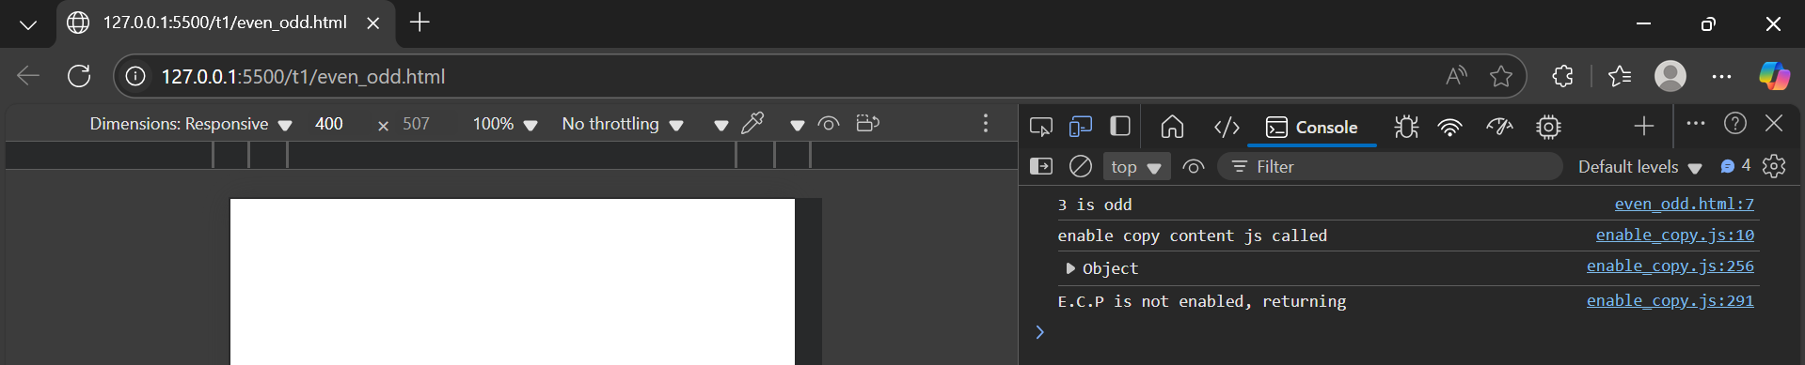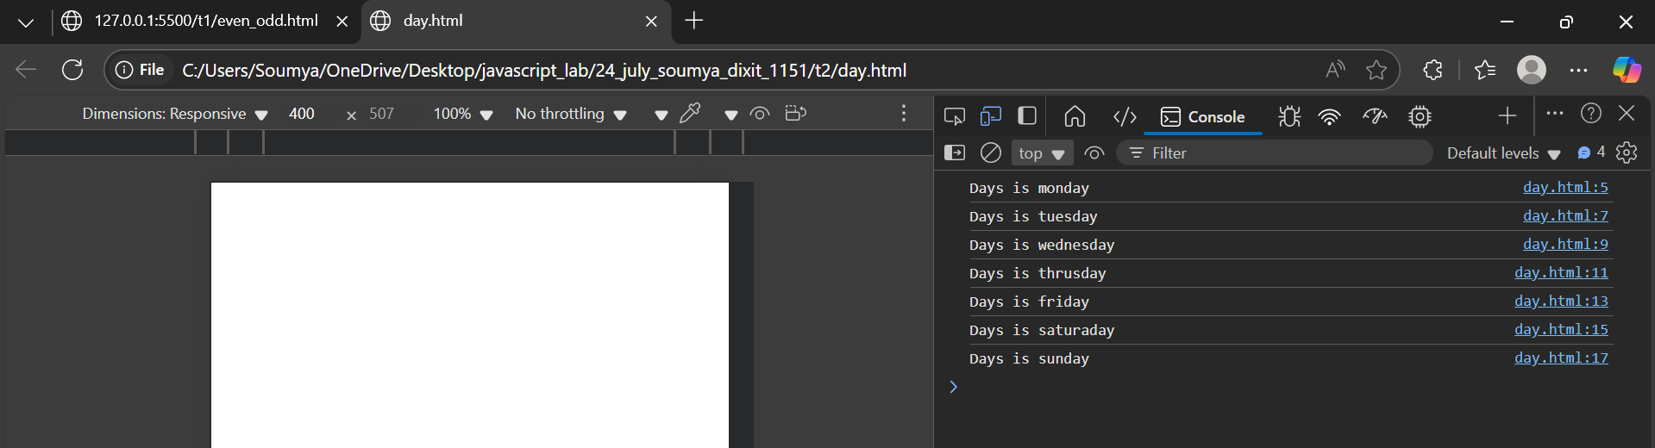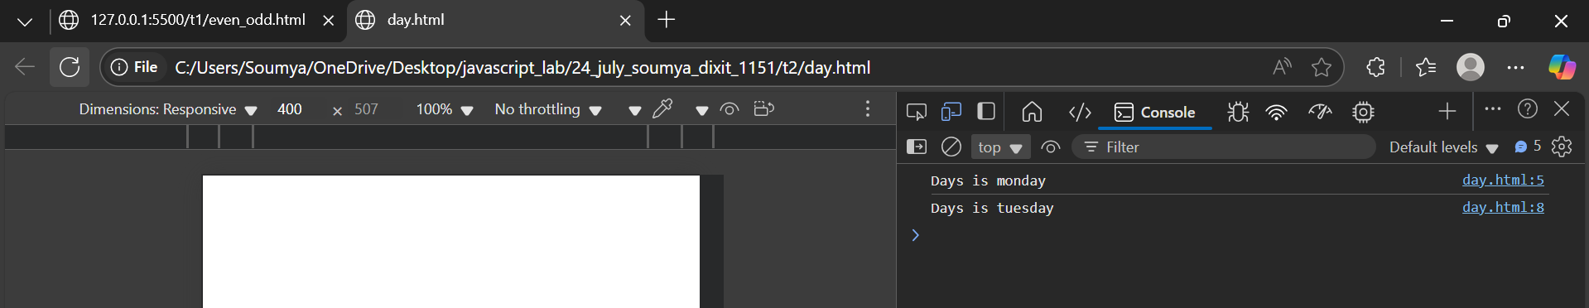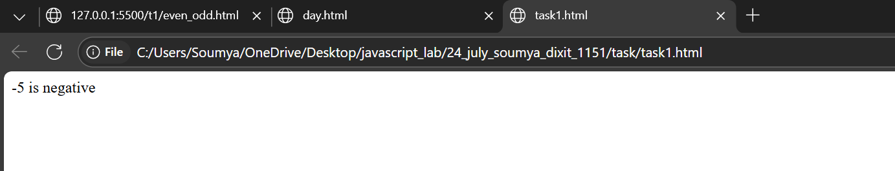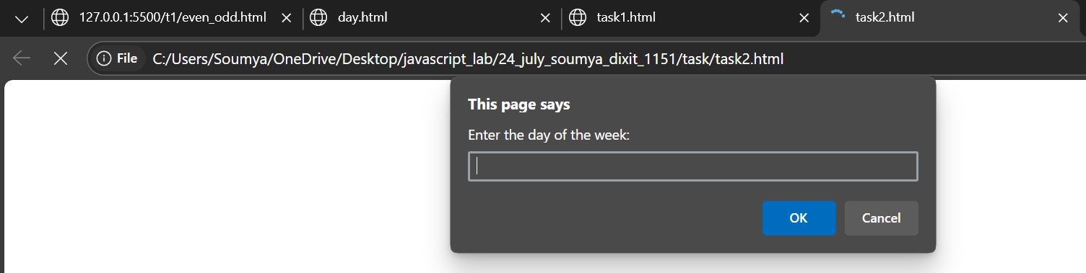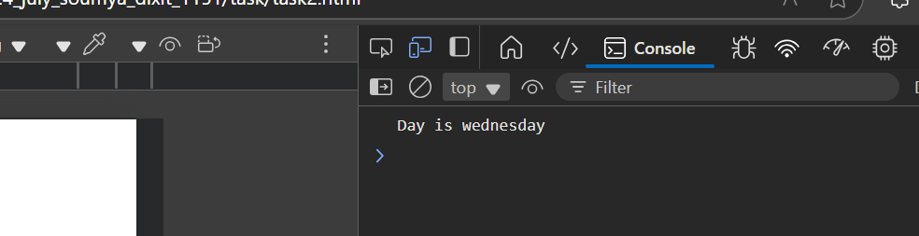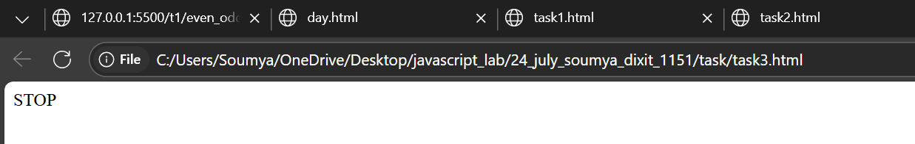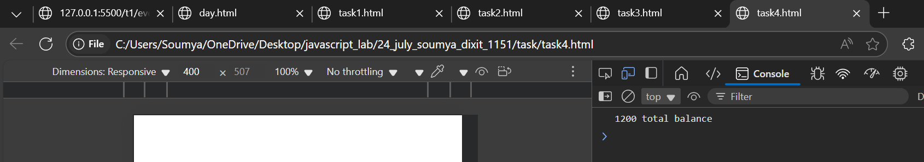

**let num = prompt("Enter a number :");**

**if (num < 0 ){**

**document.write(`${num} is negative`);**

**} else if (num == 0 ){**

**document.write(`${num} is zero`);**

**}else {**

**document.write(`${num} is positive`);**

**}**

**let day = prompt("Enter the day of the week: ");**

**switch (day) {**

**case "monday" :**

**console.log("Day is monday");**

**break;**

**case "tuesday" :**

**console.log("Day is tuesday");**

**break;**

**case "wednesday" :**

**console.log("Day is wednesday");**

**break;**

**case "thrusday" :**

**console.log("Day is thrusday");**

**break;**

**case "friday" :**

**console.log("Day is friday");**

**break;**

**case "saturaday" :**

**console.log("Day is saturaday");**

**break;**

**case "sunday" :**

**console.log("Day is sunday");**

**break;**

**let color = prompt("Enter the color of the trafic light: ");**

**switch (color){**

**case "red":**

**document.write("STOP");**

**break;**

**case "yellow":**

**document.write("WAIT");**

**break;**

**case "green":**

**document.write("GO");**

**break;**

**}**

**let transaction = prompt("Enter the type of transaction: (withdraw)/(deposit)/(check)");**

**let balance = Number(prompt("Balance :"));**

**switch(transaction.toLowerCase()){**

**case "withdraw":**

**let amount = Number(prompt("Amount to be withdraw :"));**

**if (amount > balance){**

**console.log("Low balanace");**

**}else{**

**let left = balance - amount;**

**console.log(`${left} after transaction`);**

**}**

**break;**

**case "deposit":**

**let dep = Number(prompt("Amount to be deposit :"));**

**let add = dep + balance;**

**console.log(`${add} total balance`);**

**break;**

**default:**

**console.log(`${balance} balance left`);**

**break;**

**}**