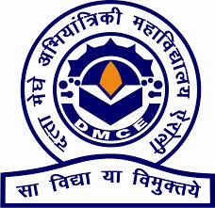

**DATTA MEGHE COLLEGE OF ENGINEERING**

Plot no 98, Cidco, Sector-3 Post Box No.15 Airoli, Navi Mumbai-400708

**CERTIFICATE**

This is to certify that

**NAMES OF STUDENTS GR No.**

1. SOUMYA SUDHAKAR GITE 2020DSIT002

2. JANHVI SANJAY GUJARE 2020DSIT016

3. BHAKTI ATAMARAM MEJARI 2020DSIT003

4. PRANJALI SALUNKE

Have submitted the Mini-project entitled “**Hotel Staff Management System**” as per the requirement of the syllabus of the **DEGREE (INFORMATION TECHNOLOGY)** course, according to the rules laid down by the DTE, during the academic year 2020-21 in view of fulfilment of the degree in Information Technology.

Date:

**Signature of Internal Examiner Signature of External Examiner**

**Signature of Head of Department Signature of Principal**

**ABSTRACT**

In our project, “Hotel Staff Management System” we have tried to show how the data/information of the staff is managed. This is just an overview of management of staff in the hotel. The project is specially developed to help hotel staff. The project Hotel Staff Management manages and maintains the records of staff in the hotel. This project has been made in a user-friendly interface, so that anyone can add, delete the entries of staff and handle all the modification easily.

**ACKNOWLEDGEMENT**

This project is spanned over a period of one year and the number of people who have helped us are outstanding. To begin with we would like to thank our project guide Prof. Dhanshree Shukla who has helped us throughout the period and has helped us through the times of needs. In spite of their busy schedules, it was very kind of them to spare some of their precious time and give us valuable suggestions which ultimately formed heart of this report. Professor was a great source of inspiration and allowed us to work in the lab for extended hours.

The Laboratory assistants needs a warm thank you who helped us all along the way. We also extend our thanks to all professors of our department for their valuable guidance. We would also like to thank our fellow students for their support and good wishes.

Finally, we thank entire Information Technology Department for excellent facilities and encouragement given during the course of project

**TABLE OF CONTENTS**

|  |  |  |
| --- | --- | --- |
| SR.NO | CONTENT | PAGE.NO |
| 1 | Project Introduction | 5 |
| 2 | Problem Definition | 6 |
| 3 | Scope of Project | 7 |
| 4 | Background Study | 8 |
| 5 | Objectives of project | 9 |
| 6 | System Design   * 1. E-R Diagram/DFD/Flowchart |  |
| 7 | Implementation (Code and Screenshots) |  |
| 8 | Conclusion & Future scope |  |
| 9 | References |  |

**INTRODUCTION**

Hotel Staff Management system is an application that enables users to create and store Hotel Staff records. The application also provides facilities of making a new entry of the staff details, editing the entries, deleting the records of the staff, searching for a particular staff details etc. This application is helpful to department of the management which maintains data of hotel staff related to a management. Java is a platform independent language. Its created applications can be used on a standalone machine as well as on distributed network. More over applications developed in java can be extended to Internet based applications.

This Hotel Staff Management system Project application stores all the staff’s information in a database. It is an application developed in Java GUI technology It contains staff information like staff id, name, salary, contact no. email -id. It is an easy-to-use application and has a user-friendly interface. It is totally built at the administrative end which means that only the admin has access rights to change or modify any records. So, this makes it safe and reliable application to use. The main aim of developing this application was to reduce the errors that occur in the manual system. One can search the details easily by just entering staff id. In earlier systems, there was not such a facility to do so. It is easy to update any staff details. All the staff records are integrated and so this makes it user-friendly and easy to use application

.

**PROJECT DEFINATION**

The definition of this project is limited to the following:

Project definition is part of the project planning that involves determining and documenting a list of Specific project goals deliverables, features, functions, tasks, deadlines and ultimately costs. In other words, it is what needs to be achieved and the work that must be done to deliver. A clear website scope allows your website design agency to finalize the cost and time frame of your website project. Scope is based on the goals of your website and needs to your users.

* Staff profile: administrator can be able to edit the staff details.
* New staff entry: administrator can able to make new entries of the staff.
* Edit the entry: administrator can edit the details of a particular staff and can also add new details to that particular staff.
* Search entry: if administrator want t search for a particular staff’s details then the administrator can also search for the same by any one of the details present in the database.
* Delete entry: the administrator can also delete the entry of a particular staff who is currently not working at the respective hotel.
* Display entry: administrator can be able to display the entries at a time of all staffs working in the hotel

**SCOPE OF THE PROJECT**

In this project, the administrator can add new staff details and manages the database of the staff details. This project works at all hotels for storing the details of the staffs and modifying the database whenever necessary. This project stores large number of details of the staff and computerize the complete management process. Project Scope is part of the project planning that involves determining and documenting a list of Specific project goals deliverables, features, functions, tasks, deadlines and ultimately costs. In other words, it is what needs to be achieved and the work that must be done to deliver. Scope is based on the goals of your application and needs to your users.

For all the software there is always a scope of future enhancement. There are few enhancements which as re pointed out in the proposed system.

They are as follows:

* Staff profile
* New staff entry
* Edit the entry
* Search entry
* Delete entry
* Display entry

**BACKGROUND STUDY**

Most of the contemporary Information systems are based on the Database technology as a collection of logically related data, and temporary DBMS as a software system allowing the users to define, create, maintain and control access to the database. The process of constructing such kind of systems is not so simple. It involves a mutual development of application program and database. The application program is actually the bridge between the users and the database, where the data is stored. Thus, the well-developed application program and database are very important for the reliability, flexibility and functionality of the system. The so defined systems differentiate to each other and their development comprises great variety of tasks to be resolved and implemented.

**OBJECTIVES**

* This project aims to simplify the task of maintaining records of the staffs of the hotel.
* To develop a well-designed database to store staff’s details
* Provides full functional reports to management of hotel
* The objective of this project is to provide a comprehensive approach towards the management of hotel staff information.
* Software is making the process of keeping database time and cost effective by making it easy to alter or update database and also keeping that safe
* This software has all necessary details about the staffs and provides all the relevant information therefore. For e.g., Searching of appropriate staff and then its details and then it is added to the database.

**PROGRAM:**

import java.io.File;

import java.io.FileInputStream;

import java.io.FileOutputStream;

import java.io.IOException;

import java.io.ObjectInputStream;

import java.io.ObjectOutputStream;

import java.io.Serializable;

import java.util.ArrayList;

import java.util.Scanner;

@SuppressWarnings("serial")

class Staff implements Serializable

{

int id;

String name;

float salary;

long contact_no;

String email_id;

public Staff(int id, String name, float salary, long contact_no, String email_id)

{

this.id = id;

this.name = name;

this.salary = salary;

this.contact_no = contact_no;

this.email_id = email_id;

}

public String toString()

{

return "\nStaff Details :" + "\nID: " + this.id + "\nName: " + this.name + "\nSalary: " +

this.salary + "\nContact No: " + this.contact_no + "\nEmail-id: " + this.email_id;

}

}

public class HotelStaffManagementProjectt

{

static void display(ArrayList<Staff> al)

{

System.out.println("\n--------------Staff List---------------\n");

System.out.println(String.format("%-10s%-15s%-10s%-20s%-10s", "ID","Name","salary","contact-no","Email-Id"));

for(Staff e : al)

{

System.out.println(String.format("%-5s%-20s%-10s%-15s%-10s",e.id,e.name,e.salary,e.contact_no,e.email_id));

}

}

@SuppressWarnings("unchecked")

public static void main(String[] args)

{

int id;

String name;

float salary;

long contact_no;

String email_id;

Scanner sc = new Scanner(System.in);

ArrayList<Staff> al = new ArrayList<Staff>();

File f = null;

FileInputStream fis = null;

ObjectInputStream ois = null;

FileOutputStream fos = null;

ObjectOutputStream oos =null;

try{

f = new File("N:/Java Work Space/Eclipse Programs/Employee Management Tool/src/EmployeeDataList1.txt");

if(f.exists())

{

fis = new FileInputStream(f);

ois = new ObjectInputStream(fis);

al = (ArrayList<Staff>)ois.readObject();

}

}

catch(Exception exp){

System.out.println(exp);

}

do

{

System.out.println("\n****HOTEL STAFF MANAGEMENT SYSTEM***\n");

System.out.println("1). Add Staff details to the DataBase\n" +

"2). Search for Staff\n" +

"3). Edit Staff details\n" +

"4). Delete Staff Details\n" +

"5). Display all Staff working in this hotel\n" +

"6). EXIT\n");

System.out.println("Enter your choice : ");

int ch = sc.nextInt();

switch(ch)

{

case 1:System.out.println("\nEnter the following details to ADD list:\n");

System.out.println("Enter ID :");

id = sc.nextInt();

System.out.println("Enter Name :");

name = sc.next();

System.out.println("Enter Salary :");

salary = sc.nextFloat();

System.out.println("Enter Contact No :");

contact_no = sc.nextLong();

System.out.println("Enter Email-ID :");

email_id = sc.next();

al.add(new Staff(id, name, salary, contact_no, email_id));

display(al);

break;

case 2: System.out.println("Enter the Staff ID to search :");

id = sc.nextInt();

int i=0;

for(Staff e: al)

{

if(id == e.id)

{

System.out.println(e+"\n");

i++;

}

}

if(i == 0)

{

System.out.println("\nStaff Details are not available, Please enter a valid ID!!");

}

break;

case 3: System.out.println("\nEnter the Staff ID to EDIT the details");

id = sc.nextInt();

int j=0;

for(Staff e: al)

{

if(id == e.id)

{

j++;

do{

int ch1 =0;

System.out.println("\nEDIT Staff Details :\n" +

"1). Staff ID\n" +

"2). Name\n" +

"3). Salary\n" +

"4). Contact No.\n" +

"5). Email-ID\n" +

"6). GO BACK\n");

System.out.println("Enter your choice : ");

ch1 = sc.nextInt();

switch(ch1)

{

case 1: System.out.println("\nEnter new Staff ID:");

e.id =sc.nextInt();

System.out.println(e+"\n");

break;

case 2: System.out.println("Enter new Staff Name:");

e.name =sc.nextLine();

System.out.println(e+"\n");

break;

case 3: System.out.println("Enter new Staff Salary:");

e.salary =sc.nextFloat();

System.out.println(e+"\n");

break;

case 4: System.out.println("Enter new Staff Contact No. :");

e.contact_no =sc.nextLong();

System.out.println(e+"\n");

break;

case 5: System.out.println("Enter new Staff Email-ID :");

e.email_id =sc.next();

System.out.println(e+"\n");

break;

case 6: j++;

break;

default : System.out.println("\nEnter a correct choice from the List :");

break;

}

}

while(j==1);

}

}

if(j == 0)

{

System.out.println("\nStaff Details are not available, Please enter a valid ID!!");

}

break;

case 4: System.out.println("\nEnter Staff ID to DELETE from the Databse :");

id = sc.nextInt();

int k=0;

try{

for(Staff e: al)

{

if(id == e.id)

{

al.remove(e);

display(al);

k++;

}

}

if(k == 0)

{

System.out.println("\nStaff Details are not available, Please enter a valid ID!!");

}

}

catch(Exception ex){

System.out.println(ex);

}

break;

case 5: try {

al = (ArrayList<Staff>)ois.readObject();

} catch (ClassNotFoundException e2) {

System.out.println(e2);

} catch (Exception e2) {

System.out.println(e2);

}

display(al);

break;

case 6: try {

fos = new FileOutputStream(f);

oos = new ObjectOutputStream(fos);

oos.writeObject(al);

} catch (IOException e1) {

e1.printStackTrace();

}

catch(Exception e2){

e2.printStackTrace();

}

finally{

try {

fis.close();

ois.close();

fos.close();

oos.close();

} catch (Exception e1) {

e1.printStackTrace();

}

}

System.out.println("\nYou have chosen EXIT !! Saving Files and closing the tool.");

sc.close();

System.exit(0);

break;

default : System.out.println("\nEnter a correct choice from the List :");

break;}}

while(true);

}

}

**OUTPUT:**

**ADD STAFF DETAILS TO THE DATABASE:**

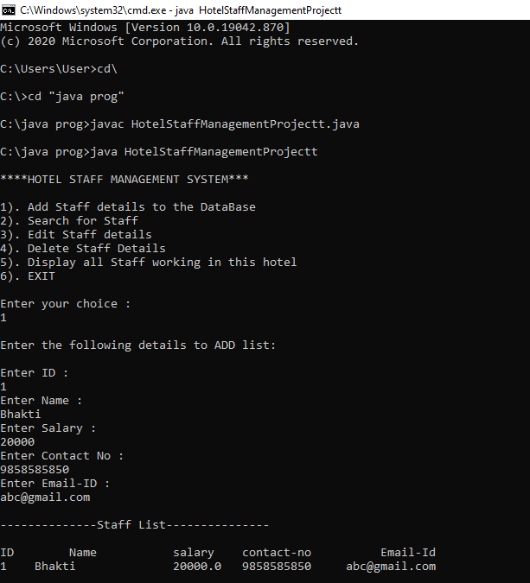

**SEARCH FOR STAFF DETAILS:**

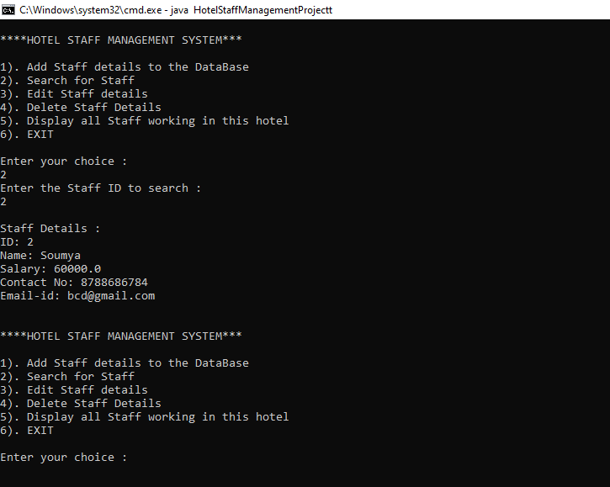

**EDIT STAFF DETAILS:**

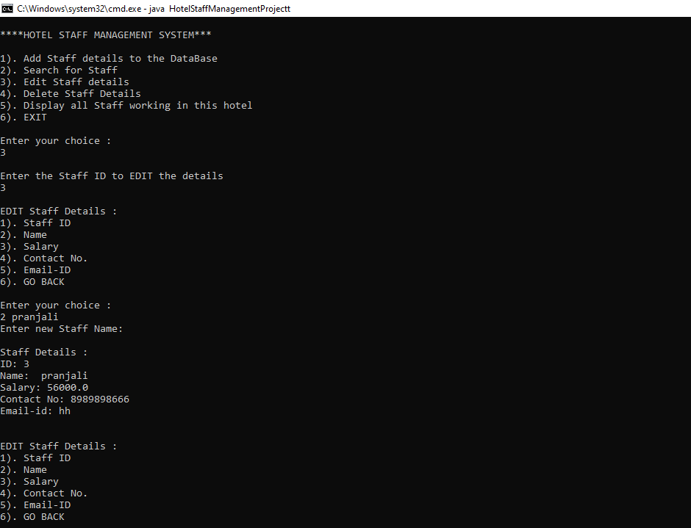

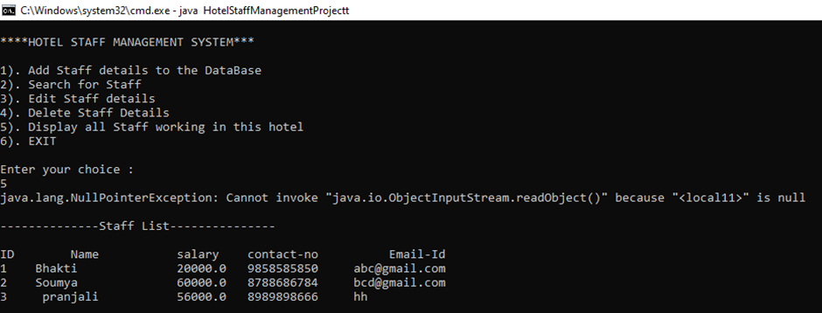

**DISPLAY ALL STAFF WORKING IN THIS HOTEL:**

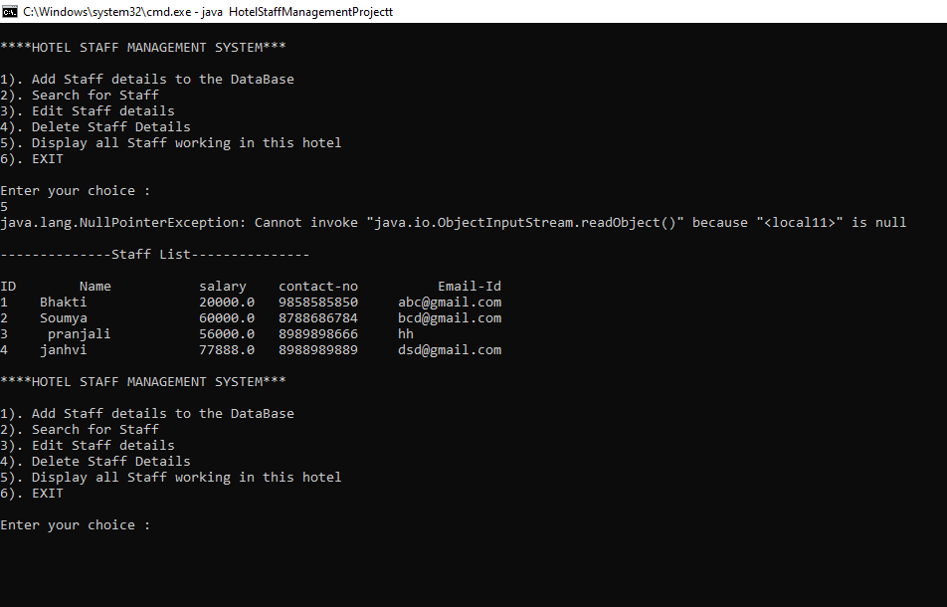

**FUTURE SCOPE**

Project Scope is part of the project planning that involves determining and documenting a list of Specific project goals deliverables, features, functions, tasks, deadlines and ultimately costs. In other words, it is what needs to be achieved and the work that must be done to deliver. Scope is based on the goals of your application and needs to your users.

Hotel Staff Management system is an application that enables users to create and store Hotel Staff records. The application also provides facilities of making a new entry of the staff details, editing the entries, deleting the records of the staff, searching for a particular staff details etc. This application is helpful to department of the management which maintains data of hotel staff related to a management. Java is a platform independent language. Its created applications can be used on a standalone machine as well as on distributed network. More over applications developed in java can be extended to Internet based applications.

**CONCLUSION**

The project titled Hotel Staff Management System is a java-based application. The aim of the project is to easy work of staff details. The project gives a good idea on developing a user-friendly application which satisfying different user. The project has been tested with live users and has provides a successful result. Hence the project has proved to work efficiently. This project is used to modify the details of the staffs working in the hotel.

**REFERENCE**

[www.tutorialspoint.com](https://www.slideshare.net/Kkushum/hotel-management-system-70024067)

[www.google.com](http://www.google.com)

[www.javatpoint.com](http://www.javatpoint.com)