**EXPERIMENT- 5**

**AIM:** To Study shell, types of shell and basic shell scripting.

THEORY:

The UNIX shell program interprets user commands, which are either directly entered by the user, or which can be read from a file called the shell script or shell program. Shell scripts are interpreted, not compiled.

## Shell types

Just like people know different languages and dialects, your UNIX system will usually offer a variety of shell types:

* **sh or Bourne Shell:** the original shell still used on UNIX systems and in UNIX related environments. This is the basic shell, a small program with few features. While this is not the standard shell, it is still available on every Linux system for compatibility with UNIX programs.
* **bash or Bourne Again shell:** the standard GNU shell, intuitive and flexible. Probably most advisable for beginning users while being at the same time a powerful tool for the advanced and professional user. On Linux, bash is the standard shell for common users. This shell is a so- called superset of the Bourne shell, a set of add-ons and plug-ins. This means that the Bourne Again shell is compatible with the Bourne shell: commands that work in sh, also work in bash. However, the reverse is not always the case. All examples and exercises in this book use bash.
* **csh or C shell:** the syntax of this shell resembles that of the C programming language.
* **tcsh or TENEX C shell:** a superset of the common C shell, enhancing userfriendliness and speed. That is why some also call it the Turbo C shell.
* Just like people know different languages and dialects, your UNIX system will usually offer a variety of shell types:
* Sometimes asked for by programmers.
* **ksh or the Korn shell: s**ometimes appreciated by people with a UNIX background. A superset of the Bourne shell; with standard configuration a nightmare for beginning users.

Bash is an sh-compatible shell that incorporates useful features from the Korn shell (ksh) and C shell (csh). It offers functional improvements over sh for both programming and interactive use; these include command line editing, unlimited size command history, job control, shell functions and aliases, indexed arrays of unlimited size, and integer arithmetic in any base from two to sixty- four. Bash can run most sh scripts without modification.

Echo ‘welcome to shell programming’ test=5

test1=$test day="Monday"

echo "welcome to day $test1 $day" testing=`date`

echo " the date is: $testing" echo "Enter two numbers" read num1 read num2

sum=$(expr "$num1" + "$num2") echo The final result is $sum

## Output:

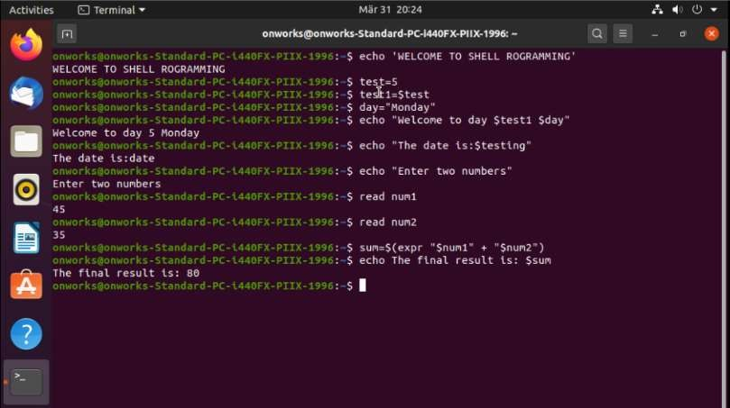

**CONCLUSION:** Thus, we have successfully studied shell, types of shell and basic shell scripting and execute it.