PARADIGM AND COMPUTER
PROGRAMMING FUNDAMENTALS

LAB JOURNAL

Name: Soumya Sudhakar Gite
Department: Information Technology
Class: I.T.-A
Roll no-60

INDEX
EXPT  NO | AIM | PAGE  NO
1 | Study of Lambda calculus using variable, beta reduction, alpha reduction, normalization and currying. | 3-5
2 | To write and execute programs to study types in prolog, syntax and prolog data objects. | 6-12
3 | To write and execute programs to study prolog operators like Arithmetic, Equality and Logical operator. | 13-21
4 | To write and execute programs to study input and output statements in prolog, input and output using characters. | 22-25
5 | To write and execute programs to study file input and output in prolog. | 26-27
6 | To write and execute programs to study loops and backtracking in Prolog. | 28-30
7 | Write and execute programs to study clauses and predicates and goals in prolog. | 31-32
8 | Write and execute programs to study Functions in Haskell | 33-40
9 | To study Functors and Monads and zippers in Haskell. | 41-42

EXPERIMENT NO-1
Aim: -
Study of Lambda calculus using variable, beta reduction, alpha reduction, normalization and currying.
Theory: -

Lambda calculus is a framework developed by Alonzo Church in 1930s to study computations with functions.
- Function creation − Church introduced the notation λx. E to denote a function in which ‘x’ is a formal argument and ‘E’ is the functional body. These functions can be of without names and single arguments.
- Function application − Church used the notation E1.E2 to denote the application of function E1 to actual argument E2. And all the functions are on single argument.

Syntax of Lambda Calculus-

Lambda calculus includes three different types of expressions, i.e.,
E: = x(variables)
| E1 E2(function application)
| λx. E (function creation)
Where λx. E is called Lambda abstraction and E is known as λ-expressions.

Evaluating Lambda Calculus-

Pure lambda calculus has no built-in functions. Let us evaluate the following expression −
(+ (* 4 6) (* 8 4))
Here, we can’t start with '+' because it only operates on numbers. There are two reducible expressions: (*4 6) and (* 8 4).
We can reduce either one first. For example −
(+ (* 4 6) (* 8 4))
(+ 24 (* 8 4))
(+ 24 32) =56

Beta Reductions:

Formally, beta reduction (also written \betaβ-reduction) is the replacement of a bound variable in a function body with a function argument. The purpose of \betaβ-reduction is to compute the result of a function-by-function application using specific rules.
- More formally, the beta reduction rule states that a function application of the form (\lambda x.t) s(λx.t) s reduces to the term t [x: = s]t [x: =s].
- The term t[x := s]t[x:=s] means that all instances of xx in tt are replaced with ss.
- The \right arrow→ syntax is used as a shorthand for beta reduction.
- We can specify beta-reduction explicitly using the notation (\lambda x.t) s \right arrow t [x: = s] (λx.t) s→t [x: =s], which means that the beta reduction of (\lambda x.t) s) (λx.t) s) is t [x: = s]t [x: =s].
- The beta reduction removes the \lambda symbol and resolves to the function’s body with the arguments substituted into the body.

Free and Bound Variables-

The abstraction operator, λ, is said to bind its variable wherever it occurs in the body of the abstraction. Variables that fall within the scope of an abstraction are said to be bound. In an expression λx.M, the part λx is often called binder, as a hint that the variable x is getting bound by appending λx to M. In the following example the single occurrence of x in the expression is bound by the second lambda: λx. y (λx. z x).

- The set of free variables of a lambda expression, M, is denoted as FV(M) and is defined by recursion on the structure of the terms, as follows:
- FV(x) = {x}, where x is a variable.
- FV(λx.M) = FV(M) \ {x}.
- FV (M N) = FV(M) ∪ FV(N)

An expression that contains no free variables is said to be closed. Closed lambda expressions are also known as combinators and are equivalent to terms is combinatory logic.

Alpha Reduction-

- α-conversion, sometimes known as α-renaming, allows bound variable names to be changed.
- For example, α-conversion of λx.x might yield λy.y. Terms that differ only by α-conversion are called α-equivalent. Frequently, in uses of lambda calculus, α-equivalent terms are considered to be equivalent.
- First, when α-converting an abstraction, the only variable occurrences that are renamed are those that are bound to the same abstraction.
- For example, an α-conversion of λx.λx.x could result in λy.λx.x, but it could not result in λy.λx.y. The latter has a different meaning from the original. This is analogous to the programming notion of variable shadowing.
- Second, α-conversion is not possible if it would result in a variable getting captured by a different abstraction. For example, if we replace x with y in λx.λy.x, we get λy.λy.y, which is not at all the same.

Normalizations-

- A lambda calculus system with the normalization property can be viewed as a programming language with the property that every program terminates.
- Although this is a very useful property, it has a drawback: a programming language with the normalization property cannot be Turing complete.
- That means that there are computable functions that cannot be defined in the simply typed lambda calculus.

Currying-

- All functions in lambda calculus are prefix and take exactly one argument.
- If we want to apply a function to more than one argument, we can use a technique called currying that treats a function applied to more than one argument to a sequence of applications of one-argument functions.
- For example, to express the sum of 1 and 2 we can write (+ 1 2) as ((+ 1) 2) where the expression (+ 1) denotes the function that adds 1 to its argument. Thus ((+ 1) 2) means the function + is applied to the argument 1 and the result is a function (+ 1) that adds 1 to its argument: (+ 1 2) = ((+ 1) 2) → 3

CONCLUSION: - Study of lambda calculus using variable, beta reduction, alpha reduction, normalization and currying was done successfully.
EXPERIMENT NO. 2
Aim: -

To write and execute programs to study types in prolog, syntax and prolog data objects.

Program Code: -

Program Code 1- Types in Prolog

1)Atoms:

Atom types in prolog- Atoms are constants that have no numerical value, all the atoms start with a lower-case letter.
atom(A).
Output:

2)Real numbers:

Real types in prolog-floating point number.
real(R).
Output-
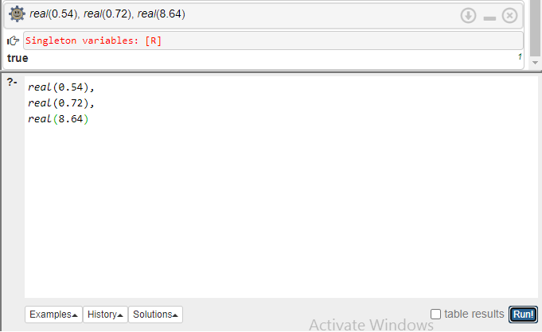

3)Integer numbers:
Integer types in prolog-integer type of number
integer(I).
Output:
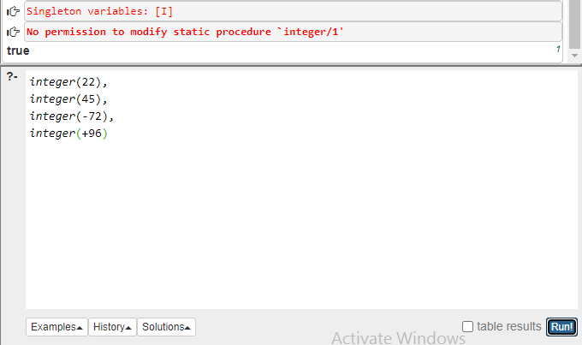

4)Variables:

Name of the variable is denoted by sequence of one or more letters-uppercase or lowercase, numerals, underscores.
var(V).
Output:

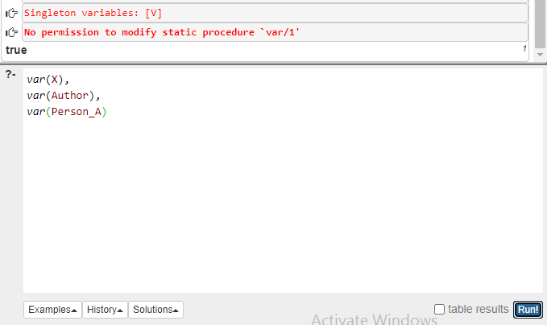

5)Compound Terms:
Compound terms -compound terms is a structured data type that begins with an atom known here as functor.
A functor is followed by a sequence of one or more arguments which are enclosed in brackets separated by commas.
T is a term with functor F, and A is an arity.
functor (T, F, A).
Output-
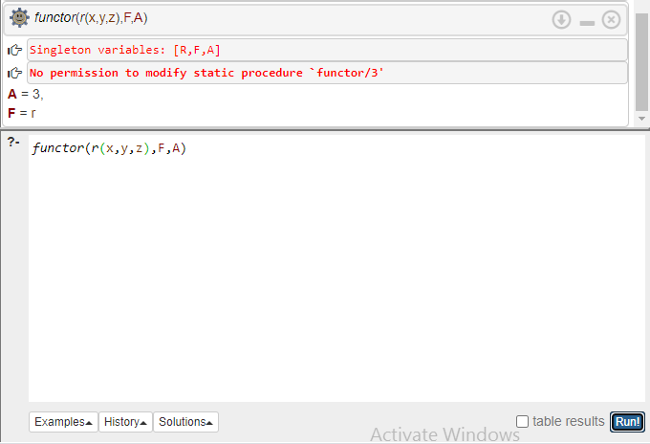
6)List:
A list is often considered to be special type of compound term lists.
T=L.
Output-
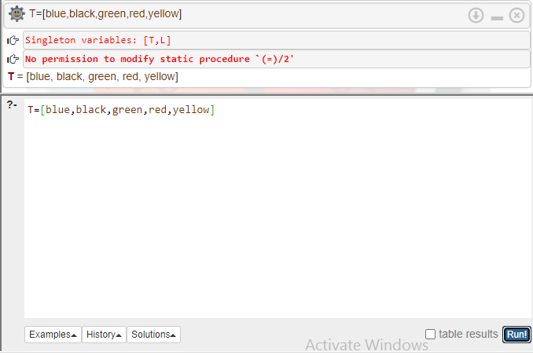

Program Code 2- Prolog Syntax

1)Facts:

A fact is like a predicate expression. It is used to provide a declarative statement about the problem.
Likes (A, B).
Output:
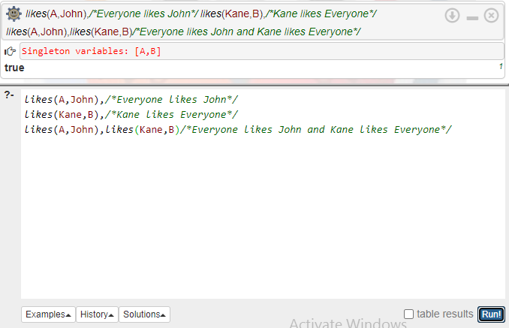
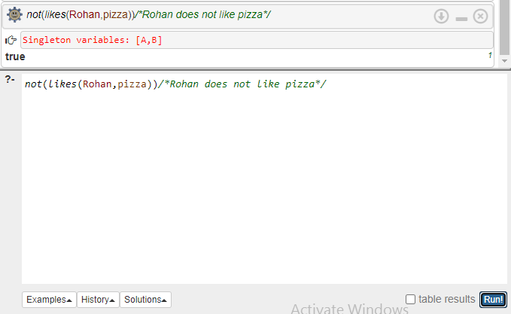

2)Queries:

In Prolog, the query is the action of asking the program about the information which is available within its database.
The above rules mean that 'large animal(A) is true if dog(A) is true, and large(A) is true.
large(rottweiler).
dog(rottweiler).
large_animal(A): - dog(A), large(A).

Output-
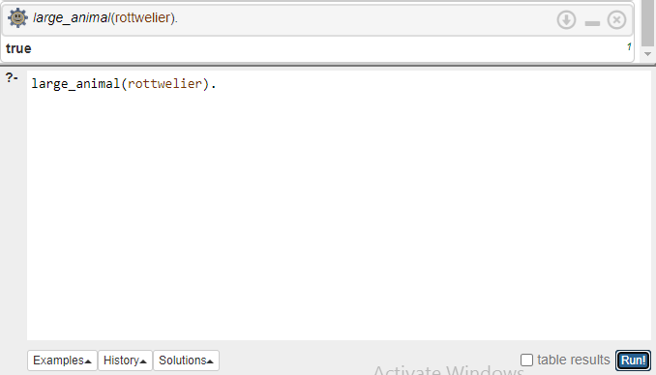

Program Code 3- Prolog data objects

1)Numbers:

- Numbers -In Prolog, all versions allow the use of integers. Any sequence of numbers from 0 to 9 is written as numbers.
- The numbers are preceded by + or - sign.
number(N).

Output-
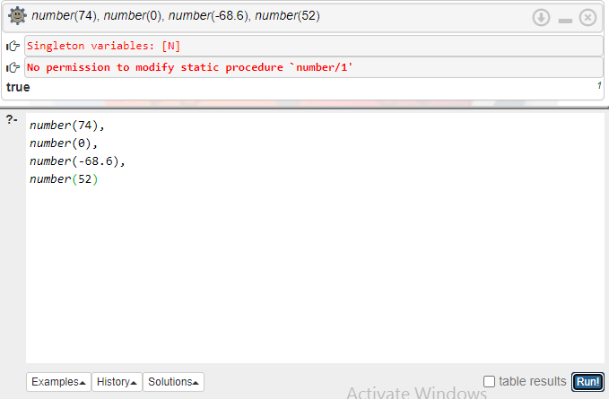
2)Atoms:

Atoms are like the constants. Here are some examples of atoms which are not valid in prolog.
atom(A).
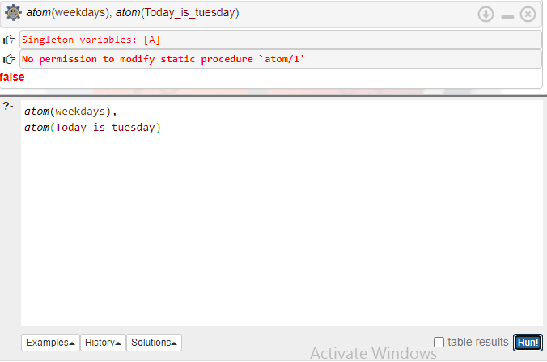

3)Variables:

Variables in prolog-The variable name can be any sequence of one or more upper case letters or lower-case letters, underscore, and numerals.
nonvar (NV)-will check if a variable is invalid.

nonvar(NV).
Output:
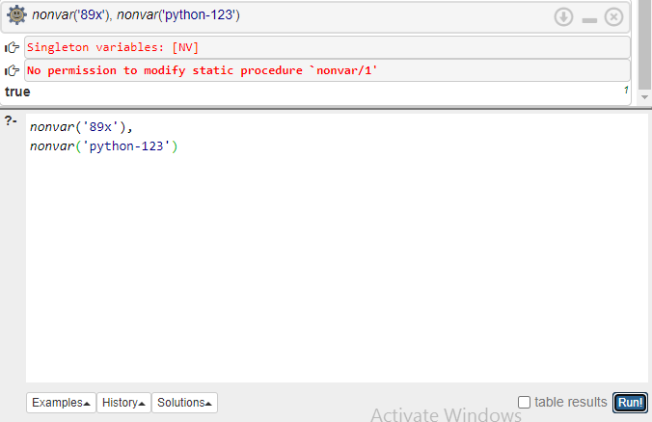

CONCLUSION: Types in Prolog, prolog syntax and prolog data objects were understood and programs on them were executed successfully.

EXPERIMENT NO-3

Aim: -

To write and execute programs to study prolog operators like Arithmetic, Equality and Logical operator.

Program Code: -

Program Code 1-Arithmetic Operators
Arithmetic functions and Arithmetic operators available in Prolog are as follows- A+B, A-B, A*B, A/B, A//B, A^B, -A, sin(A), cos(A), abs(A), sqrt(A), max (A, B).
A+B, A-B:
Output-
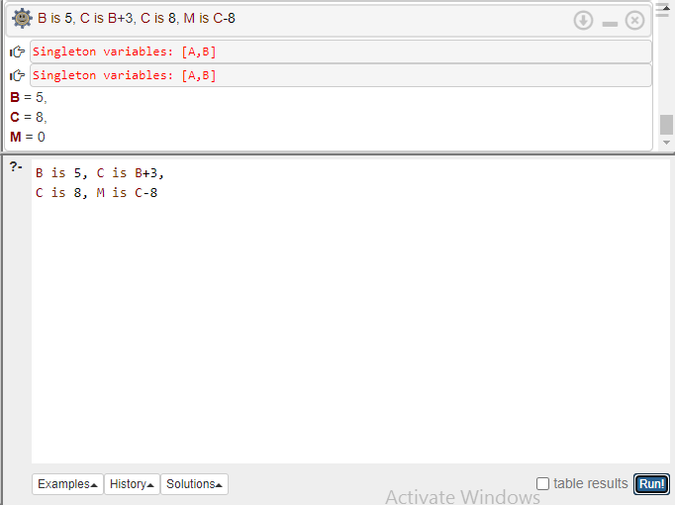

A+B, A*B, A/B:
Output:
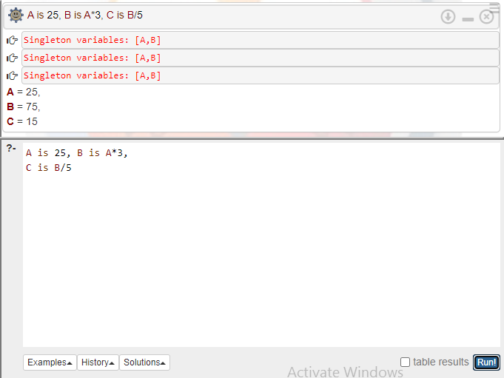

A//B, A^B, -A:
Output:
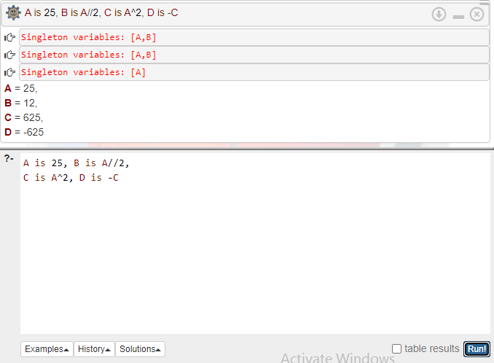

sin(A), abs(A):
Output:
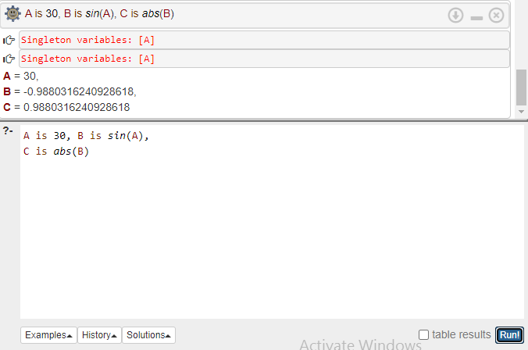

sqrt(A), max(A,B):
Output:
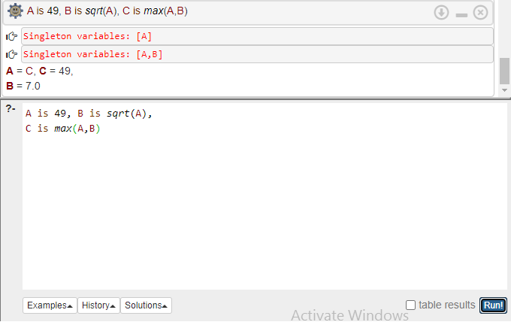

Program Code 2-Equality Operators-

1)E1 =:= E2-

The terms can be compared by other two types of relational operator. Equality Operator (=:=)
E1 =:= E2 If E1 and E2 evaluate to the same value,
The above E1 =:= E2 succeed.
Output-

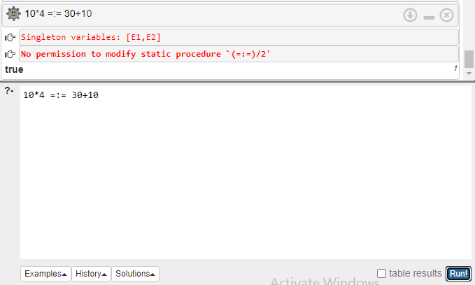

2)E1=\=E2(Inequality Operator):
Given an arithmetic expression the E1=\=E2 checks for the inequality of the two expressions, if they are not equal then the output is true.

Output-
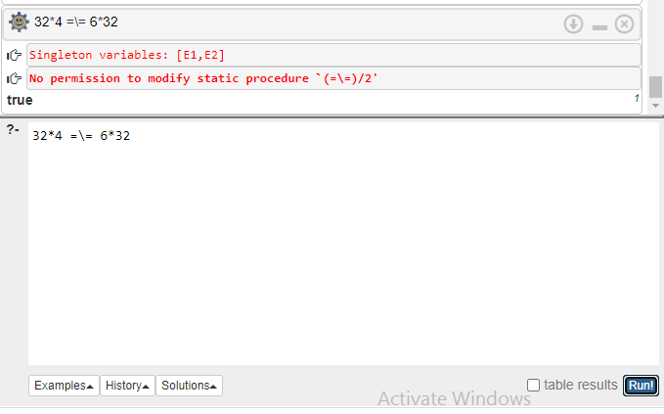
3)Terms Identical (Term1==Term2):

Terms Identical operator-In this operator in prolog the operator checks for the equality of two terms, If the terms T1 and T2 are identical then the output is true.

Output:
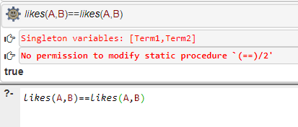
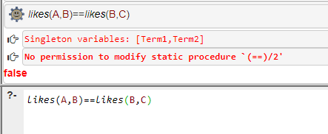
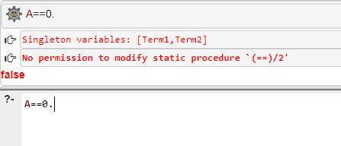

4)Terms Not Identical (Terms1\==Term2):

- Terms Not Identical operator-The above goal is used to test whether Term1 and Term2 are not identical.
- If Term1 == Term2 fails, the Term1 \== Term2 succeeds. Otherwise, the goal fails.
Output-
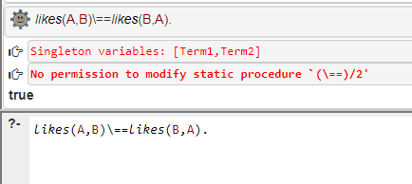
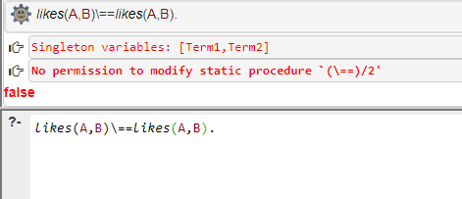
5)Terms Identical with Unification (=):

The == operator is similar to the = operator but with a major difference if Term1 and Term2 unify then Term1=Term2 succeeds.

Output:
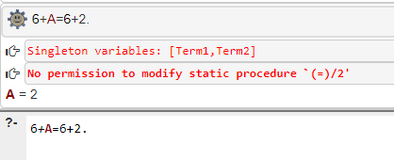
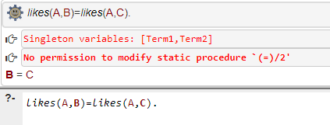
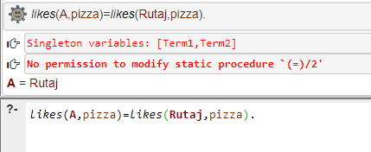

6)Non-Unification (\=):

Non-Unification-In this operator in prolog if Term1=Term2 then the above goal succeeds, it means that the two terms cannot be unified, otherwise the output is false.

Output:

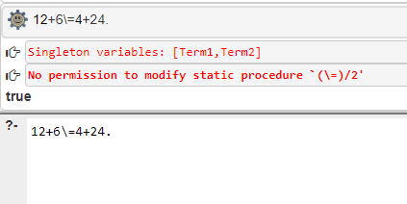
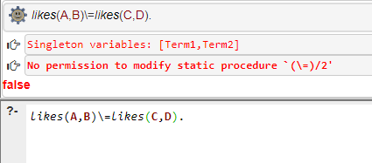

Program Code 3-Logical Operators

1)Not operator(not)-

To provide the negation, NOT prefix operator can be placed before any goal. If the original goal fails, the output will be true If the original goal is true, the output will be false.

Output-
2)Disjunction Operator (;)-

The disjunction operator is similar to the or operator It takes two arguments and returns true if any one goal's output is true
Output-
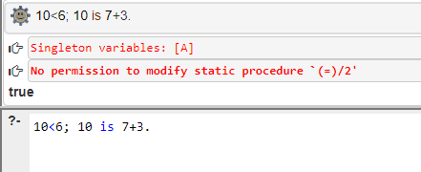
3)Conjunction Operator (,)-

The Conjunction operator in prolog is similar to the 'and' operator. It takes two arguments and the result will be true if and only if the outcomes of both the expressions are true, otherwise the result is false.

Output:

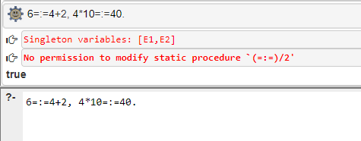

CONCLUSION: - Prolog operators like Arithmetic, Equality and logical operators were understood and programs on them were executed successfully.

EXPERIMENT NO-4

Aim: -

To write and execute programs to study input and output statements in prolog, input and output using characters.

Program Code: -

Program Code 1-Input and Output statements in prolog

1)Input statements-
To provide the input terms we will use a built-in predicate- read It takes a single argument from the keyboard and it must be a variable. when we evaluate this predicate the next term will be read by character
Read. :-
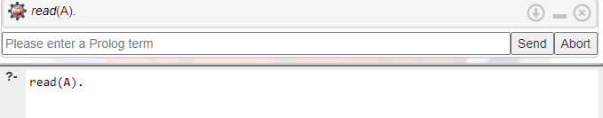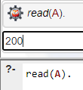

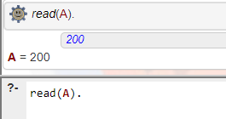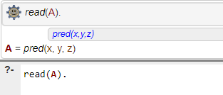

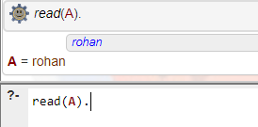
2)Output Statements-

The writeq predicate will cause the term to be written in quotes to the output stream if term is inputted in quotes.
Write. :-
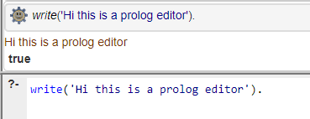

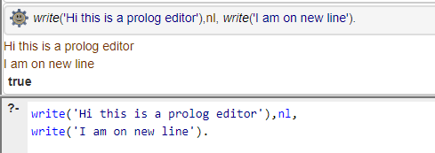

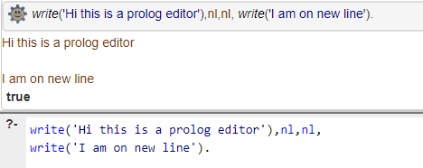

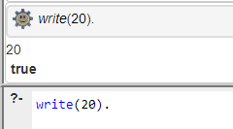

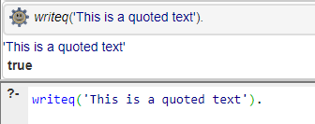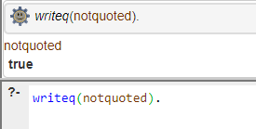

Program Code 2-Input using characters-

- We can use built in predicates get and get0 in prolog to provide input of a single character. get0 takes a single argument as a variable.
- When Prolog evaluates a get0 goal, the variable is unified with the ASCII value of the input character.

Output-

Program Code 3-Output statements for characters

This predicate takes an argument from 0 to 255 or an expression. According to the ASCII value entered the respective character will be written as output to the output stream.

Output-

CONCLUSION: - Programs on Input, Output statements in prolog were executed.

EXPERIMENT NO-5

Aim: -

To write and execute programs to study file input and output in prolog.

Program Code: -

Program Code 1-File Output-Changing the current output stream.

The tell predicate is used to change the current output stream. This predicate has a single argument as variable or atom, which represents the name of a file like tell('outfile.txt').
Output: -

Program Code 2-File Input-Changing the current input stream
The see predicate is used to change the current input stream. This predicate has a single argument as variable or atom, which represents the name of a file like see('myfile.txt').
Output: -
CONCLUSION: - File input and output operations in prolog were executed successfully.

EXPERIMENT NO-6

Aim: -

To write and execute programs to study loops and backtracking in Prolog.

Program Code: -

Program Code 1-Looping a fixed number of times
--In Prolog, there is no such facility available directly, but using recursion, we can obtain a similar effect.
--Calculates the sum of integers from N to 1.
sumOF(1, 1).
sumOF(N, M): - N>1, N1 is N-1, sumOF(N1, M1), M is M1+N.

Output-
--Displays the numbers from N to 1
loop(0).
loop(N): - N>0, write('value of N is: '), write(N), nl,
S is N-1, loop(S).
Output-

Program Code 2-Looping over a fixed condition

--To execute a set of statements repeatedly until a test condition is specified, we use recursion concept in Prolog.
loop: - write('The value is'), read(Word),
write('Input value is '), write(Word), nl,
(Word=end; loop).

Output-

Program Code 3-To implement Backtracking in Prolog
--To show a program of Backtracking with failure.
dog(retriever).
dog(boxer).
dog(rottweiler).
alldogs: - dog(A), write(A), write(' is a dog'), nl, fail.
alldogs.
Output-

--Using the cut, we can avoid unwanted backtracking. The cut is represented by! In the body of a rule, when! goal evaluates for the first time, it always succeeds.
larger(X, Y, X) :- X>Y, !.
larger(X, Y, Y).
Output-

CONCLUSION: - Programs on loops and backtracking in prolog were executed.

EXPERIMENT NO-7

Aim: -

Write and execute programs to study clauses and predicates and goals in prolog.

Program Code: -

Program Code 1 -Clauses in Prolog
In Prolog, using a dot character, a clause can be terminated. This dot character is followed by at
least one 'white space' character.
The clauses are of two types: facts and rules.
Facts:
father(Raj,Rahul).
parent(Rahul,Ram).
Rules:
grandparent(A, B) :- father(A, C), parent(C, B).
A is the grandparent of B if A is the parent of C and C is the parent of B.
Output-

Program Code 2-Predicates in Prolog

parent(kevin,simran).
go :- parent(kevin, Y), write('kevin has a daughter '), write(Y), nl.
Output-

Program Code 3-Goals in Prolog

owns(kevin,rahul).
dog(pug).
Output-

CONCLUSION: - Programs on clauses, predicates and goals in prolog were executed successfully.

EXPERIMENT NO-8

Aim: -

Write and execute programs to study Functions in Haskell.

Program Code: -

Program Code 1-Functions in Haskell

--Functions play a major role in Haskell, as it is a functional programming language.
sub :: Integer ->Integer->Integer
sub x y=x-y
main = do
putStrLn "The subtraction of the two numbers is:"
print(sub 10 5)

Output-

Program Code 2-head, tail, last, init, null, length, reverse functions

--Head function works on a List. It returns the first of the input argument which is basically a list
main = do
let x = ['a'..'z']
putStrLn "Our list is:"
print (x)
putStrLn "The first element of the list is:" print (head x)
Output-

--Tail is the function that complements the head function. It takes a list as the input and yields the entire list without the head part.
main=do
let x = ['a'..'z']
putStrLn "Our list is:"
print (x)
putStrLn "The tail of the list is:"
print (tail x)

Output-

--Last function prints the last element of the list.

main=do
let x = ['a'..'z']
putStrLn "Our list is:"
print (x)
putStrLn "The last element of the list is:"
print (last x)

Output:

--init function works opposite of tail function.
main=do
let x = ['a'..'z']
putStrLn "Our list is:"
print (x)
putStrLn "The last element of the list is:"
print (init x)
Output-
--Null function checks if a particular list is null or not.

main=do
let x = ['a'..'z']
putStrLn "Our list is:"
print (x)
putStrLn "Is our list empty?:"
print (null x)

Output-
--It works on a String input and converts the entire input into reverse order and give one output as a result.
main=do
let x = ['a'..'z']
putStrLn "Our list is:"
print (x)
putStrLn "Our reverse List:"
print (reverse x)
Output-
--length function is used to calculate the length of the list given as an argument

main=do
let x = ['a'..'z']
putStrLn "Our list is:"
print (x)
putStrLn "Length of our list:"
print (length x)
Output-

Program Code 3-take, drop, maximum, sum, elem and product functions

--Take function is used to create a sub-string from another String.

main=print(take 5 (['a'..'z']))

Output-

--drop function works opposite to that of take function.

main=print(drop 5 (['a'..'z']))

Output-

--Maximum function is used to find the element with the maximum value from the supplied list.

main=do
let var1=[1,110,670,1000]
putStrLn "The maximum element of list=" print(maximum var1)
Output-

--Sum function returns the summation of all the elements present in the supplied list.

main=do
let var1=[1,110,670,1000]
putStrLn "The sum of elements of list="
print(sum var1)

Output-
--Elem function is used to check whether the supplied list contains a specific element or not. Accordingly, it either returns a true or a false.
main = do
let x = [1,55,110,670,999,1000]
putStrLn "Our list is:"
print (x)
putStrLn "Does it contain 999?"
print (elem 999(x))
Output-

--Multiply function is used to multiply all the elements in a list and print its value.
main = do
let x = [1..5]
putStrLn "Our list is:"
print (x)
putStrLn "The multiplication of the list elements is:"
print (product x)
Output-

CONCLUSION: - Various functions in Haskell were understood and programs were executed successfully.

EXPERIMENT NO-9

Aim: -

To study Functors, Monads and Zippers in Haskell.

Program Code: -

Program Code 1-Functors in Haskell
--Functor in Haskell is a kind of functional representation of different Types which can be mapped over.
--It is a high-level concept of implementing polymorphism.

main = do
print(map (subtract 1) [2,4,8,16])
print(fmap (subtract 2) [2,4,8,16])
Output-

--A Monoid is a set of functions and operators where the output is independent of its input.

multi:: Int->Int
multi x = x * 1
add :: Int->Int
add x = x + 0
main = do
print(multi 10)
print (add 22)

Output-

Program Code 2-Monads in Haskell
--Monads are nothing but a type of Applicative Functor with some extra features.
--It is a Type class which governs three basic rules known as monadic rules.
--Left Identity Law,Right Identity Law ,Associativity.

main = do
print([1..20] >>= (\x -> if odd x then [x*2] else []))
Output-

CONCLUSION: - Functors and Monads in Haskell were understood and a program on each was executed successfully.

