**1.KANBAN METHODOLOGY:**

Kanban methodology is an agile method that aims at continuous improvement, flexibility in [task management](https://kissflow.com/project/team/guide-to-task-management/), and enhanced workflow. With this illustrative approach, the progress of the whole project can be easily understood in a glance**.**

**How does Kanban work?**

Kanban method revolves around the [kanban board](https://kissflow.com/project/agile/kanban-board-software/). It is a tool that visualizes the entire project to track the flow of their project. Through this graphical approach of Kanban boards, a new member or an external entity can understand what’s happening right now, tasks completed and future tasks.

**Kanban board indicates**

* the current tasks that are being performed
* the tasks to do in the future
* the tasks that are complete

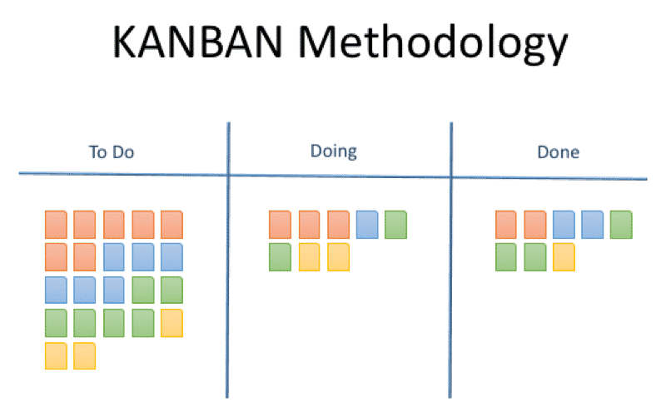

**2.LEAN METHODOLOGY**

Lean is a methodology derived from manufacturing practices, particularly the Toyota Production System (TPS), that focuses on eliminating waste and improving efficiency. The aim is to maximize value for customers with fewer resources, and it can be applied to a wide range of industries.

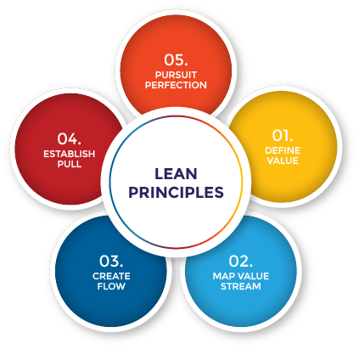

**Core Principles of Lean:**

**1. Value:**

Define value from the customer's perspective. The goal is to deliver products or services that meet customer needs while minimizing any non-value-adding activities (waste).

**2. Value Stream:**

Identify and analyse the entire value stream (the flow of materials, information, and processes) to identify waste and inefficiencies. The value stream should only contain activities that directly contribute to the value delivered to the customer.

**3. Flow:**

Create a continuous flow of work through the system. This involves reducing delays and ensuring tasks or materials move through each step of the process without interruptions. The focus is on creating a smooth and efficient process.

**4. Pull:**

Implement a pull-based system, where work is only started when there is demand for it. This prevents overproduction and ensures that resources are not wasted. This is similar to the Kanban approach, where work is pulled into the system when capacity allows.

**5. Perfection:**

Continuously improve the process by reducing waste, improving quality, and increasing efficiency. Lean advocates for a culture of continuous improvement (often referred to as Kaizen) where everyone in the organization contributes to making small, incremental improvements over time.

**6. Respect for People:**

Lean emphasizes respecting and empowering people, especially frontline workers. It encourages collaboration, problem-solving, and the idea that those closest to the work are best suited to identify issues and suggest improvements.