**WEBAPLLICATION-ONLINE LIBRARY SYSTEM**

**Screenshots**

**1.HOME PAGE**

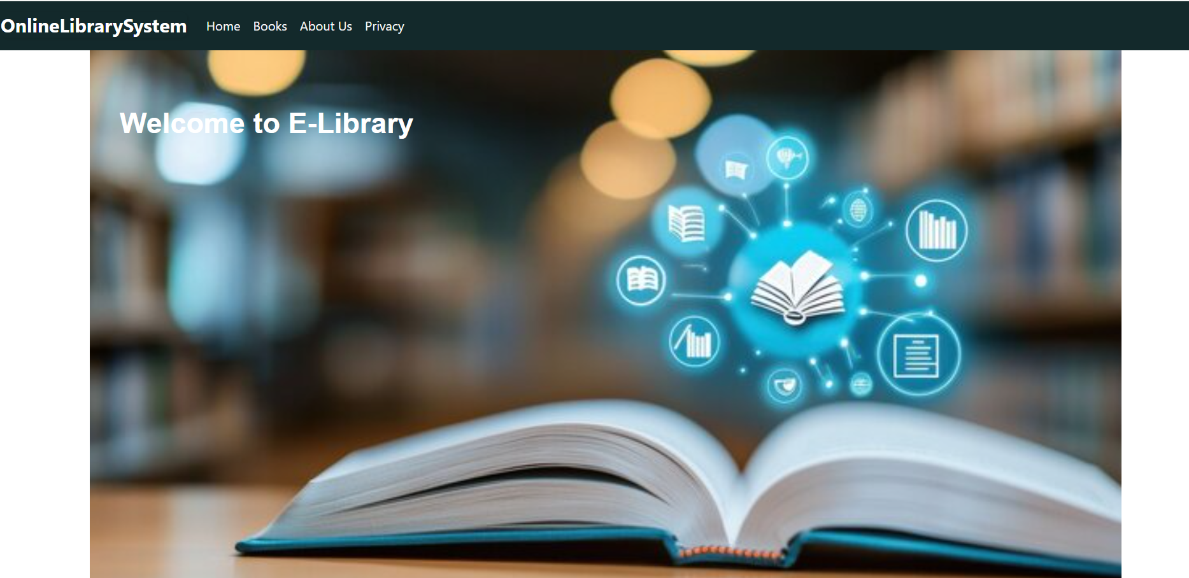

**2.BOOKS PAGE**

**3.ABOUT US PAGE**

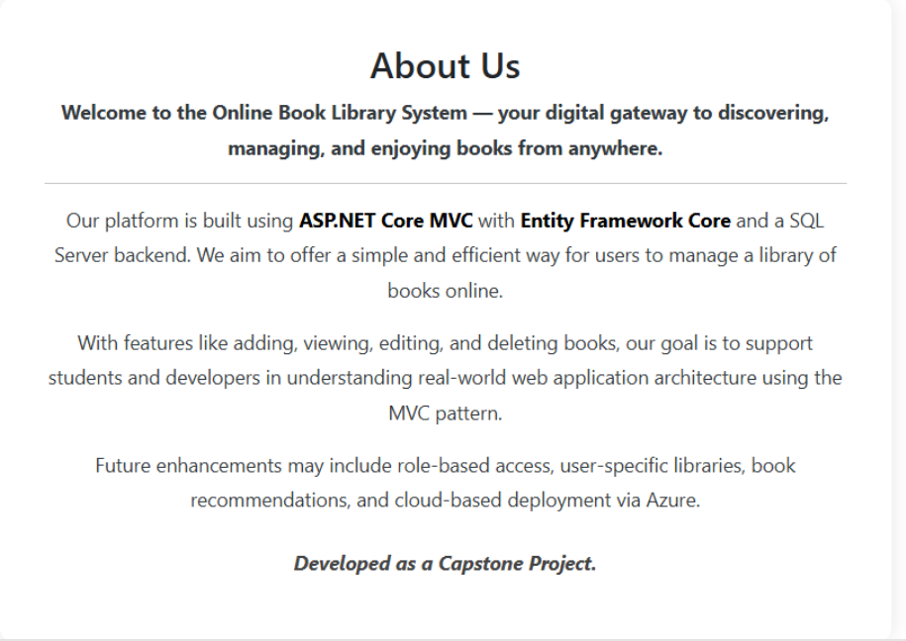

**4.PRIVACY PAGE**

