E-Library Management System
A Project Report for Industrial Training and Internship
submitted by

Ayan Purkait, Soumya Chakraborty

In the partial fulfillment of the award of the degree of

B.Tech
in the
CSE

Of

Future Institute of Engineering and Management


At

Ardent Computech Pvt. Ltd.




CERTIFICATE FROM SUPERVISOR

This is to certify that “Soumya Chakraborty, 231480110100” have completed the project titled "E-Library Management System" under my supervision during the period from “16.9.2025” to “23.12.2025” which is in partial fulfillment of requirements for the award of the B.Tech degree and submitted to the Department of “CSE” of “Future Institute of Engineering and Management”.

___________________________
Signature of the Supervisor

Date: / /

MR. Anindya Mukherjee
Name of the Project Supervisor:



BONAFIDE CERTIFICATE
Certified that this project work was carried out under my supervision
“E-Library Management System” is the bonafide work of
Name of the student: Soumya Chakraborty Signature:
Name of the student: Ayan Purkait Signature:

SIGNATURE
Name : Anindya Mukherjee
PROJECT MENTOR

SIGNATURE
Name:
EXAMINERS
Ardent Original Seal

ACKNOWLEDGEMENT

The achievement that is associated with the successful completion of any task would be incomplete without mentioning the names of those people whose endless cooperation made it possible. Their constant guidance and encouragement made all our efforts successful.

We take this opportunity to express our deep gratitude towards our project mentor, Anindya Mukherjee for giving such valuable suggestions, guidance and encouragement during the development of this project work.

Last but not the least we are grateful to all the faculty members of Ardent Computech Pvt. Ltd. for their support.

E-LIBRARY MANAGEMENT SYSTEM

CONTENTS
1 | Introduction
2 | Objective & Features
3 | Software Requirement Speicification
4 | Entity relationship diagram
5 | Data flow diagram
6 | Coding Standard Followed & Screenshots
7 | Implementation & Testing
8 | Future scope and further enhancements
9 | Conclusion
10 | References and Bibliography


INTRODUCTION:

1.1. PROJECT OVERVIEW:
E-Library Management System contains the details about essential books, journals, digital study materials used in daily student life, their availability, new reservations, database maintenance, online access, etc.

1.2. PROJECT DESCRIPTION:
E-Library Management System is a digital library platform that allows users to do free registration and provides access to books and study materials online. It also allows users to search books, reserve or issue books, manage book categories, maintain inventory, send personalized notifications, and handle fine or membership-related payments online. It saves time as users no longer need to visit a physical library, as all processes are available online. The data is automatically generated and managed by the server.
Admin is the main authority who can add, delete, or modify books, categories, user details, and library records whenever required.
The project has been planned with a distributed architecture view, along with centralized database storage. The application has been designed for efficient storage and retrieval of data.
This project also covers various features such as online user registration, updating website details by the librarian or administrator, adding, deleting, or modifying user records, book details, and digital resources. In general, this system provides a hassle-free library experience, allowing users to access educational resources from their own homes.

Objectives of the Project

The E-Library Management System is the next generation digital library platform which provides access to books, journals, and learning resources through online digital media.
The future scope includes the expansion of technologies like JAVA and STS; we can also add new technologies and many more features to improve the efficiency and performance of the software.
In recent years, the growth of digital libraries has revolutionized the way we access knowledge and information. These platforms have expanded the horizons of learning, transcending geographical boundaries and providing easy access to vast collections of educational resources.
Specialized digital libraries cater to diverse academic fields and interests, ranging from technical subjects and research papers to literature and reference materials. This diversity of resources empowers users to enhance their knowledge, explore new areas of learning, and support academic and professional growth effectively.
The main objectives of the E-Library Management System are as follows:
To provide a digital platform for accessing books, journals, and learning resources using online systems.
To make knowledge and information accessible anytime and anywhere, removing geographical barriers.
To support multiple technologies such as Java, Spring Tool Suite (STS), and future technologies.
To help users enhance knowledge and research skills through organized digital library resources.
To offer a user-friendly and interactive library environment.
To enable users to search, access, and reserve books based on their academic needs and interests.
To improve the efficiency of library operations using modern software technologies.
To create a scalable system that can be expanded with new features, resources, and technologies in the future.

Features of the Project
The E-Library Management System provides the following features:
User Registration and Login:
Allows users to create accounts and securely access the library system.
Book Management System:
Provides management of books, journals, research papers, and digital resources across various categories.
Digital Library Resources:
Learning materials such as e-books, journals, articles, and reference documents are available online.
Technology-Based System:
Supports technologies like Java, STS, and can be extended to include new technologies.
Anytime, Anywhere Access:
Users can access library resources from any location using the internet.
Category-Based Resource Access:
Offers resources related to academics, research, literature, technical subjects, and other fields.
Scalable and Future-Ready Platform:
The system is designed to easily add new books, resources, categories, and features.
Improved Library Efficiency:
Digital management ensures faster access, better record handling, and reduced manual work.

SOFTWARE REQUIREMENT SPECIFICATIONS
Software Requirements Specifications provides an overview of the entire project. It is a description of a software system to be developed, laying out functional and non-functional requirements. The software requirements specifications document enlists enough and necessary requirements that are required for the project development. To derive the requirements we need to have clear and through understanding of the project to be developed.This is prepared after the detailed communication with the project team and the customer.

The developer is responsible for:-

- Developing the system, which meets the SRS and solving all the requirements of the system.

- Demonstrating the system and installing the system at client’s location after acceptance testing is successful.

- Submitting the required user manual describing the system interfaces to work on it and also the documents of the system.
- Conducting any user training that might be needed for using the system.

- Maintain the system for a period of one year after installation.

HARDWARE REQUIREMENTS:-
- Computer that has 1.5Ghz or faster processor

- 4GB or above RAM required

- HDD 50GB(or above) or SSD space 50GB(or above)

SOFTWARE REQUIREMENTS:-

- Windows OS(10 or above)

- MySQL Server(8.0 or above)

- Spring Tool Suite(4.22.1)(Spring Boot)

- JDK 17.0.8

ENTITY RELATIONSHIP DIAGRAM
In software engineering, an entity–relationship model(ER model) is a data model for describing the data or information aspects of a
business domain or its process requirements, in an abstract way that lends itself to ultimately being implemented in a database such as a relational. The main components of ER models are entities (things) and the relationships that can exist among them.
An entity–relationship model is the result of using a systematic process to describe and define a subject area of business data. It does not define business process; only visualize business data. The data is represented as components (entities) that are linked with each other by relationships that express the dependencies and requirements between them, such as: one building may be divided into zero or more apartments, but one apartment can only be located in one building. Entities may have various properties (attributes) that characterize them. Diagrams created to represent these entities,
attributes, and relationships graphically are called entity–relationship diagrams.
An ER model is typically implemented as a database. In the case of a relational database, which stores data in tables, every row of each table represents one instance of an entity. Some data fields in these
tables point to indexes in other tables; such pointers are the physical implementation of the relationships.
The three schema approach to software engineering uses three levels of ER models that may be developed.
Conceptual data model: The conceptual ER model normally defines master reference data entities that are commonly used by the organization. Developing an enterprise-wide conceptual ER model is useful to support documenting the data architecture for an organization.A conceptual ER model may be used as the foundation for one or more logical data models . The purpose of the conceptual ER model is then to establish structural metadata commonality for

the master data entities between the set of logical ER models.

Logical data model: The logical ER model contains more detail than the conceptual ERmodel. In addition to master data entities, operational and transactional data entities are now defined. The details of each data entity are developed and the relationships between these data entities are established. The logical ER model is however developed independent of technology into which it can be implemented.

Physical data model: One or more physical ER models may be developed from each logical ER model. The physical ER model is normally developed to be instantiated as a database. Therefore, each physical ER model must contain enough detail to produce a database and each physical ER model is technology dependent since each database management system is somewhat different.
The physical model is normally instantiated in the structural metadata of a database management system as relational database objects such as database tables, database indexes such as unique key indexes, and database constraints such as a foreign key constraint or a commonality constraint. The ER model is also normally used to design modifications to the relational database objects and to maintain the structural metadata of the database.
The first stage of information system design uses these models during the requirements analysis to describe information needs or the type of information that is to be stored in a database. The data modeling technique can be used to describe any ontology (i.e. an overview and classifications of used terms and their relationships) for a certain area of interest. In the case of the design of an information system that is based on a database, the conceptual data model is, at a later stage (usually called logical design), mapped to a logical data model, such as the relational model; this in turn is mapped to a physical model during physical design. Note that sometimes, both of

these phases are referred to as "physical design". It is also used in database management system.

ENTITY RELATIONSHIP SYMBOLS:
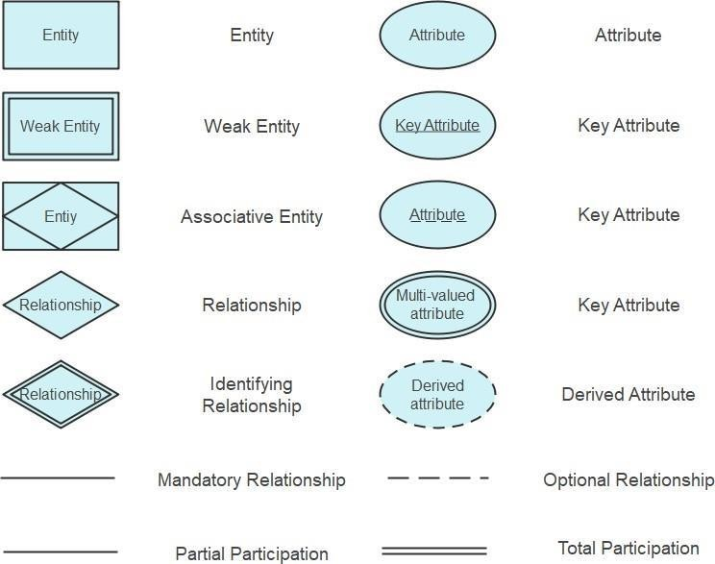

CARDINALITY:
Cardinality constraints are expressed as follows:
- A double line indicates a participation constraint, totality or subjectivity : all entities in the entity set must participate in at least one relationship in the relationship set;
- an arrow from entity set to relationship set indicates a key constraint, i.e. injectivity: each entity of the entity set can participate in at most one relationship in the relationship set;
- A thick line indicates both, i.e. bijectivity: each entity in the entity set is involved in exactly one relationship.

- An underlined name of an attribute indicates that it is a key: two different entities or relationships with this attribute always have different values for this attribute.
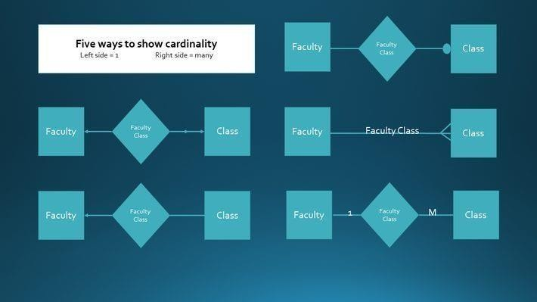

ER-DIAGRAM

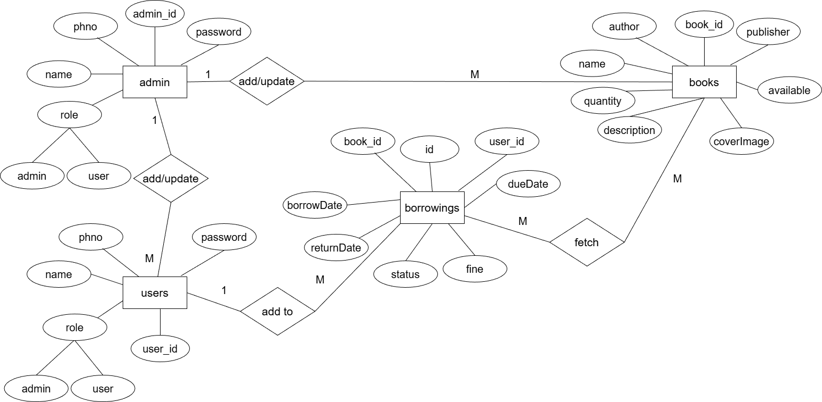

DATA FLOW DIAGRAM
A data flow diagram (DFD) is a graphical representation of the "flow" of data through an information system, modelling its process aspects. A DFD is often used as a preliminary step to create an overview of the system, which can later be elaborated.
DFDs can also be used for the visualization of data processing (structured design).
A DFD shows what kind of information will be input to and output from the system, where the data will come from and go to, and where the data will be stored. It does not show information about the timing of process or information about whether processes will operate in sequence or in parallel (which is shown on a flowchart).

This context-level DFD is next "exploded", to produce a Level 1 DFD that shows some of the detail of the system being modeled. The Level 1 DFD shows how the system is divided into sub-systems (processes), each of whi1ch deals with one or more of the data flows to or from an external agent, and which together provide all of the functionality of the system as a whole. It also identifies internal data stores that must be present in order for the system to do its job, and shows the flow of data between the various parts of the system.

Data flow diagrams are one of the three essential perspectives of the structured-systems analysis and design method SSADM. The sponsor of a project and the end users will need to be briefed and consulted throughout all stages of a system's evolution. With a data flow diagram, users are able to visualize how the system will operate, what the system will accomplish, and how the system will be implemented. The old system's dataflow diagrams can be drawn up and compared with the new system's data flow diagrams to draw comparisons to implement a more efficient system. Data flow diagrams can be used to provide the end user with a physical idea of

where the data they input ultimately has an effect upon the structure of the whole system from order to dispatch to report.
How any system is developed can be determined through a data flow diagram model.
In the course of developing a set of leveled data flow diagrams the analyst/designer is forced to address how the system may be decomposed into component sub-systems, and to identify the transaction data in the data model.

Data flow diagrams can be used in both Analysis and Design phase of the SDLC.
There are different notations to draw data flow diagrams. defining different visual representations for processes, data
stores, data flow, and external entities.

DFD NOTATION:
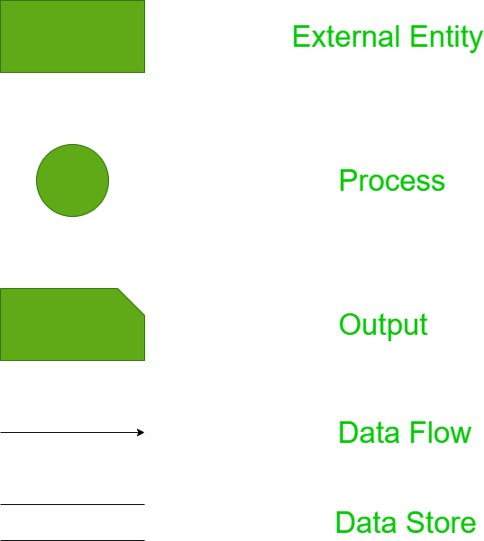

Steps to Construct Data Flow Diagram:-

Four Steps are generally used to construct a DFD.
- Process should be named and referred for easy reference. Each name should be representative of the reference.
- The destination of flow is from top to bottom and from left to right.
- When a process is distributed into lower level details they are numbered.
- The names of data stores, sources and destinations are written in capital letters.
Rules for constructing a Data Flow Diagram:-
- Arrows should not cross each other.
- Squares, Circles, Files must bear a name.
- Decomposed data flow squares and circles can have same names.
- Draw all data flow around the outside of the diagram.

LEVEL- 0 DFD DIAGRAM

LEVEL-1 DFD DIAGRAM

(ADMIN)

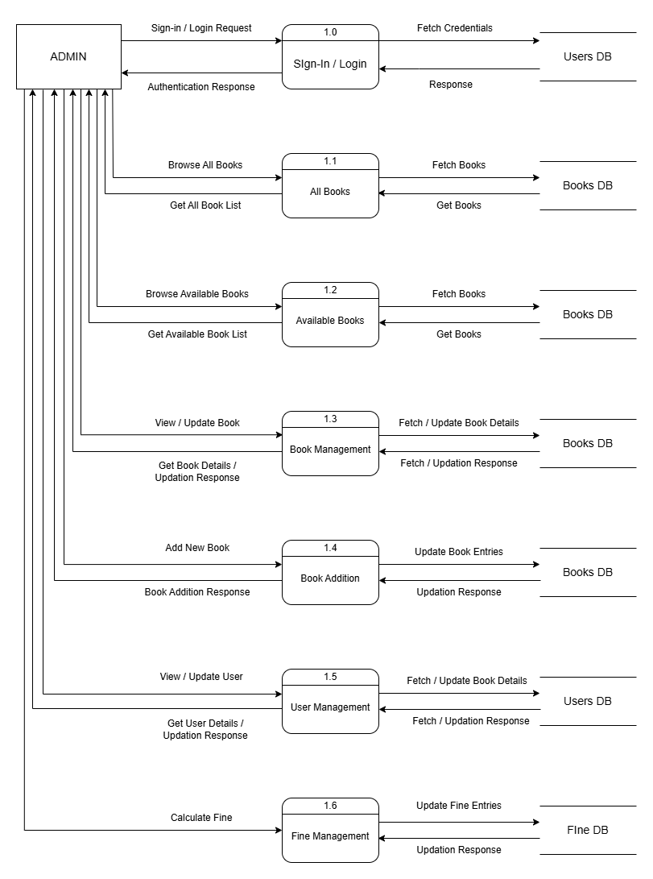

(USER)

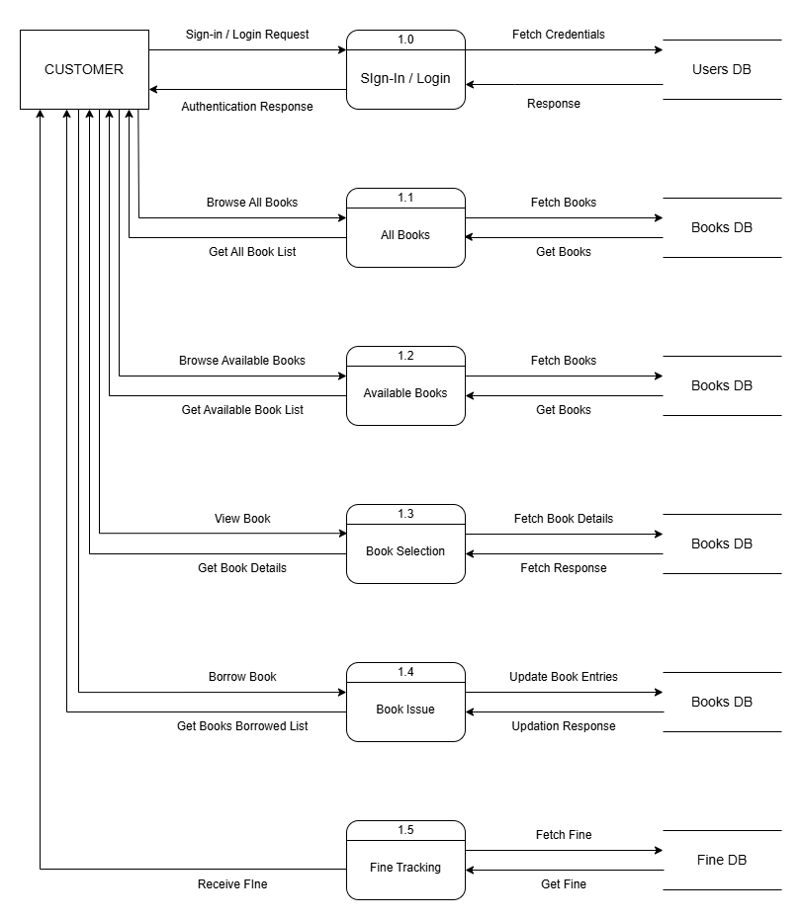
Coding Standard Followed & Screenshots

- USER REGISTRATION

BACKEND:
package com.devs.elib.controller;

import java.util.List;

import org.springframework.beans.factory.annotation.Autowired;
import org.springframework.stereotype.Controller;
import org.springframework.ui.Model;
import org.springframework.ui.ModelMap;
import org.springframework.web.bind.annotation.GetMapping;
import org.springframework.web.bind.annotation.PathVariable;
import org.springframework.web.bind.annotation.PostMapping;
import org.springframework.web.bind.annotation.RequestParam;

import com.devs.elib.model.User;
import com.devs.elib.services.UserService;

import jakarta.servlet.http.HttpServletRequest;
import jakarta.servlet.http.HttpSession;

@Controller
public class UserController {

@Autowired
private UserService userService;

@PostMapping("/regproc")
public String regProcess(@RequestParam("name") String name, @RequestParam("email") String email,
@RequestParam("phone") String phno, @RequestParam("password") String pass, ModelMap model) {
try {
userService.registerUser(name, email, phno, pass);
model.put("msg", "Successfully Registered!");
return "signup";
} catch (Exception e) {
model.put("msg", "Registration failed: " + e.getMessage());
return "signup";
}
}

@PostMapping("/logproc")
public String loginProcess(@RequestParam("email") String email, @RequestParam("password") String pass,
ModelMap model, HttpSession session) {
User user = userService.loginUser(email, pass);
if (user != null) {
String role = user.getRole();
session.setAttribute("udata", email);
session.setAttribute("userId", user.getId());
session.setAttribute("role", role);

if (role.equals("admin")) {
return "redirect:/";
} else {
return "redirect:/";
}
} else {
model.put("msg", "Wrong credentials, try again!");
return "login";
}
}

@GetMapping("/logout")
public String logout(HttpServletRequest request) {
request.getSession().invalidate();
return "redirect:/";
}

@GetMapping("/viewusers")
public String getAllUsers(HttpSession session, Model model) {
String role = (String) session.getAttribute("role");

// Check if user is logged in and is admin
if (role == null || !role.equals("admin")) {
return "redirect:/login";
}

List<User> users = userService.getAllUsers();
model.addAttribute("userdata", users);
return "user";
}

@GetMapping("/viewusers/edit/{id}")
public String showEditUserForm(@PathVariable int id, HttpSession session, Model model) {
String role = (String) session.getAttribute("role");
if (role == null || !role.equals("admin")) {
return "redirect:/login";
}

User user = userService.getUserById(id);
if (user == null) {
return "redirect:/viewusers";
}

model.addAttribute("user", user);
return "edit-user";
}

@PostMapping("/viewusers/edit/{id}")
public String editUser(@PathVariable int id,
@RequestParam("name") String name,
@RequestParam("email") String email,
@RequestParam("phone") String phone,
@RequestParam(value = "role", required = false) String role,
HttpSession session) {
String sessionRole = (String) session.getAttribute("role");
if (sessionRole == null || !sessionRole.equals("admin")) {
return "redirect:/login";
}

User updated = new User();
updated.setName(name);
updated.setEmail(email);
try {
updated.setPhno(Long.parseLong(phone));
} catch (NumberFormatException e) {
updated.setPhno(0);
}
if (role != null && !role.isEmpty()) {
updated.setRole(role);
}

userService.updateUser(id, updated);
return "redirect:/viewusers";
}

@GetMapping("/viewusers/delete/{id}")
public String deleteUser(@PathVariable int id, HttpSession session) {
String sessionRole = (String) session.getAttribute("role");
Integer sessionUserId = (Integer) session.getAttribute("userId");
if (sessionRole == null || !sessionRole.equals("admin")) {
return "redirect:/login";
}

// Prevent admin from deleting themselves
if (sessionUserId != null && sessionUserId == id) {
return "redirect:/viewusers";
}

userService.deleteUser(id);
return "redirect:/viewusers";
}
}

- ADD BOOK

BACKEND :
package com.devs.elib.controller;

import java.io.File;
import java.io.IOException;
import java.util.List;
import java.util.Optional;

import org.springframework.beans.factory.annotation.Autowired;
import org.springframework.stereotype.Controller;
import org.springframework.ui.Model;
import org.springframework.web.bind.annotation.GetMapping;
import org.springframework.web.bind.annotation.PathVariable;
import org.springframework.web.bind.annotation.PostMapping;
import org.springframework.web.bind.annotation.RequestMapping;
import org.springframework.web.bind.annotation.RequestParam;
import org.springframework.web.multipart.MultipartFile;
import org.springframework.validation.BindingResult;

import com.devs.elib.config.FileUploadProperties;
import com.devs.elib.model.Book;
import com.devs.elib.services.BookService;

import jakarta.servlet.http.HttpSession;
import jakarta.validation.Valid;

@Controller
@RequestMapping("/books")
public class BookController {

@Autowired
private BookService bookService;

@Autowired
private FileUploadProperties fileUploadProperties;

// Display all books - PUBLIC
@GetMapping("")
public String getAllBooks(Model model) {
List<Book> books = bookService.getAllBooks();
model.addAttribute("books", books);
return "books";
}

// Display book by ID - PUBLIC
@GetMapping("/{id}")
public String getBookById(@PathVariable String id, Model model) {
Optional<Book> book = bookService.getBookById(id);
if (book.isPresent()) {
model.addAttribute("book", book.get());
return "book-detail";
}
return "redirect:/books";
}

// Show add book form - ADMIN ONLY
@GetMapping("/add")
public String showAddBookForm(HttpSession session, Model model) {
String role = (String) session.getAttribute("role");

// Check if user is logged in and is admin
if (role == null || !role.equals("admin")) {
return "redirect:/login";
}

model.addAttribute("book", new Book());
return "add-book";
}

// Save new book - ADMIN ONLY
@PostMapping("/add")
public String addBook(@Valid Book book, BindingResult bindingResult,
@RequestParam("image") MultipartFile coverImage,
HttpSession session, Model model)
throws IOException {
String role = (String) session.getAttribute("role");

// Check if user is logged in and is admin
if (role == null || !role.equals("admin")) {
return "redirect:/login";
}

// Check for binding errors
if (bindingResult.hasErrors()) {
model.addAttribute("book", book);
model.addAttribute("errors", bindingResult.getAllErrors());
return "add-book";
}

Book savedBook = bookService.saveBook(book);

// Handle image upload
if (coverImage != null && !coverImage.isEmpty()) {
String fileName = handleImageUpload(savedBook.getId(), coverImage);
if (fileName != null) {
savedBook.setCoverImage(fileName);
bookService.saveBook(savedBook);
}
}

return "redirect:/books";
}

// Show edit book form - ADMIN ONLY
@GetMapping("/edit/{id}")
public String showEditBookForm(@PathVariable String id, HttpSession session, Model model) {
String role = (String) session.getAttribute("role");

// Check if user is logged in and is admin
if (role == null || !role.equals("admin")) {
return "redirect:/login";
}

Optional<Book> book = bookService.getBookById(id);
if (book.isPresent()) {
model.addAttribute("book", book.get());
return "edit-book";
}
return "redirect:/books";
}

// Update book - ADMIN ONLY
@PostMapping("/edit/{id}")
public String editBook(
@PathVariable String id,
@RequestParam String name,
@RequestParam String author,
@RequestParam String publisher,
@RequestParam int quantity,
@RequestParam(required = false) String description,
@RequestParam(required = false) MultipartFile coverImage,
HttpSession session) throws IOException {

String role = (String) session.getAttribute("role");

if (role == null || !role.equals("admin")) {
return "redirect:/login";
}

// Fetch existing book
Book existingBook = bookService.getBookById(id).orElse(null);
if (existingBook == null) {
return "redirect:/books";
}

// Update manually
existingBook.setName(name);
existingBook.setAuthor(author);
existingBook.setPublisher(publisher);
existingBook.setQuantity(quantity);
existingBook.setDescription(description);

// Handle new image
if (coverImage != null && !coverImage.isEmpty()) {
String fileName = handleImageUpload(id, coverImage);
if (fileName != null) {
existingBook.setCoverImage(fileName);
}
}

bookService.saveBook(existingBook);
return "redirect:/books";
}

// Delete book - ADMIN ONLY
@GetMapping("/delete/{id}")
public String deleteBook(@PathVariable String id, HttpSession session) {
String role = (String) session.getAttribute("role");

// Check if user is logged in and is admin
if (role == null || !role.equals("admin")) {
return "redirect:/login";
}

bookService.deleteBook(id);
return "redirect:/books";
}

// Search books - PUBLIC
@GetMapping("/search")
public String searchBooks(@RequestParam String query, Model model) {
List<Book> books = bookService.searchBooks(query);
model.addAttribute("books", books);
model.addAttribute("searchQuery", query);
return "books";
}

// Get available books only - PUBLIC
@GetMapping("/available")
public String getAvailableBooks(Model model) {
List<Book> books = bookService.getAvailableBooks();
model.addAttribute("books", books);
return "books";
}

// Handle image upload
private String handleImageUpload(String bookId, MultipartFile file) throws IOException {
if (file.isEmpty()) {
return null;
}

// Create book-specific directory
String uploadDir = fileUploadProperties.getUploadDir();
String bookUploadDir = uploadDir + File.separator + bookId;
File dir = new File(bookUploadDir);
if (!dir.exists()) {
dir.mkdirs();
}

// Generate unique filename
String originalFilename = file.getOriginalFilename();
String filename = System.currentTimeMillis() + "_" + originalFilename;

// Save file
File destinationFile = new File(bookUploadDir + File.separator + filename);
file.transferTo(destinationFile);

return filename;
}
}

- BROWSE BOOKS

FRONTEND:
<%@ taglib uri="http://java.sun.com/jsp/jstl/core" prefix="c" %>
<%@ page language="java" contentType="text/html; charset=UTF-8" pageEncoding="UTF-8"%>
<!DOCTYPE html>
<html lang="en">

<head>
<meta charset="UTF-8">
<meta name="viewport" content="width=device-width, initial-scale=1.0">
<title>E-Library - Books</title>
<link rel="stylesheet" href="${pageContext.request.contextPath}/css/dashboard.css">
<link rel="stylesheet" href="${pageContext.request.contextPath}/css/books.css">
<link rel="stylesheet" href="https://cdnjs.cloudflare.com/ajax/libs/font-awesome/6.5.0/css/all.min.css">
</head>

<body>
<header>
<div class="logo-dash-cluster">
<div class="logo">
<a href="${pageContext.request.contextPath}/">
<div class="logo-start">📚 E -</div>
<div class="logo-end"> Library</div>
</a>
</div>
<div class="dashboard">
<a href="/">
<i class="fa-solid fa-arrow-left"></i>
Go Back
</a>
</div>
</div>
</header>

<div class="books-container">
<div class="books-header">
<h2>Books Management</h2>
<div class="search-box">
<form action="${pageContext.request.contextPath}/books/search" method="GET" style="display: flex; gap: 10px; width: 100%;">
<input type="text" name="query" placeholder="Search by name or author..." value="${searchQuery}">
<button type="submit">Search</button>
</form>
</div>
<%
String role = (String) session.getAttribute("role");
if ("admin".equals(role)) {
%>
<a href="${pageContext.request.contextPath}/books/add" class="add-btn">+ Add Book</a>
<%
}
%>
</div>

<c:choose>
<c:when test="${not empty books}">
<div class="books-grid">
<c:forEach var="book" items="${books}">
<div class="book-card">
<div class="book-card-image">
<c:choose>
<c:when test="${not empty book.coverImage}">
<img src="${pageContext.request.contextPath}/images/${book.id}/${book.coverImage}" alt="${book.name}">
</c:when>
<c:otherwise>
<i class="fa-solid fa-book" style="font-size: 60px; color: #ddd;"></i>
</c:otherwise>
</c:choose>
</div>
<div class="book-card-body">
<div class="book-card-title">${book.name}</div>
<div class="book-card-author">by ${book.author}</div>
<div class="book-card-meta">
${book.publisher} | Qty: ${book.quantity}
</div>
<div>
<c:choose>
<c:when test="${book.available}">
<span class="book-card-status status-available">Available</span>
</c:when>
<c:otherwise>
<span class="book-card-status status-unavailable">Not Available</span>
</c:otherwise>
</c:choose>
</div>
<div class="book-card-actions">
<a href="${pageContext.request.contextPath}/books/${book.id}" class="btn-view">View</a>
<%
String userRole = (String) session.getAttribute("role");
if ("admin".equals(userRole)) {
%>
<a href="${pageContext.request.contextPath}/books/edit/${book.id}" class="btn-edit">Edit</a>
<a href="${pageContext.request.contextPath}/books/delete/${book.id}" class="btn-delete" onclick="return confirm('Are you sure you want to delete this book?');">Delete</a>
<%
}
%>
</div>
</div>
</div>
</c:forEach>
</div>
</c:when>
<c:otherwise>
<div class="no-books">
<i class="fa-solid fa-book"></i>
<h3>No Books Found</h3>
<p>Start by adding your first book!</p>
<%
String adminRole = (String) session.getAttribute("role");
if ("admin".equals(adminRole)) {
%>
<a href="${pageContext.request.contextPath}/books/add" class="add-btn" style="display: inline-block; margin-top: 20px;">+ Add Book</a>
<%
}
%>
</div>
</c:otherwise>
</c:choose>
</div>
</body>

</html>

IMPLEMENTATION & TESTING
A software system test plan is a document that describes the objectives, scope, approach and focus of software testing effort. The process of preparing a test plan is a usual way to think the efforts needed to validate the acceptability of a software product. The complete document will help people outside the test group understand the "WHY" and "HOW" product validation. It should be through enough to be useful but not so through that no one outside the test group will read it.

INTRODUCTION
Testing is the process of running a system with the intention of finding errors. Testing enhances the integrity of a system by detecting deviations in design and errors in the system. Testing aims at detecting error-prone areas. This helps in the prevention of errors in a system. Testing also adds value to the product by conforming to the user requirements.
The main purpose of testing is to detect errors and error-prone areas in a system. Testing must be thorough and well-planned. A partially tested system is as bad as an untested system. And the price of an untested and under-tested system is high.
The implementation is the final and important phase. It involves user-training, system testing in order to ensure successful running of the proposed system. The user tests the system and changes are made according to their needs. The testing involves the testing of the developed system using various kinds of data. While testing, errors are noted and correctness is the mode.

OBJECTIVES OF TESTING:
The objective our test plan is to find and report as many bugs as possible to improve the integrity of our program. Although exhaustive testing is not possible, we will exercise a broad range of tests to achieve our goal. Our user interface to utilize these functions is designed to be user-friendly and provide easy manipulation of the tree. The application will only be used as a demonstration tool, but we would like to ensure that it could be run from a variety of platforms with little impact on performance or usability.
Process Overview:
The following represents the overall flow of the testing process:
- Identify the requirements to be tested. All test cases shall be derived using the current Program Specification.
- Identify which particular test(s) will be used to test each module.

- Review the test data and test cases to ensure that the unit has been thoroughly verified and that the test data and test cases are adequate to verify proper operation of the unit.

- Identify the expected results for each test.
- Document the test case configuration, test data, and expected results.
- Perform the test(s).

- Document the test data, test cases, and test configuration used during the testing process. This information shall be submitted via the Unit/System Test Report (STR).
- Successful unit testing is required before the unit is eligible for

component integration/system testing.

- Unsuccessful testing requires a Bug Report Form to be generated. This document shall describe the test case, the problem encountered, its possible cause, and the sequence of events that led to the problem. It shall be used as a basis for later technical analysis.

- Test documents and reports shall be submitted. Any specifications to be reviewed, revised, or updated shall be handled immediately.

TEST CASES:
A test case is a document that describe an input, action, or event and expected response, to determine if a feature of an application is working correctly. A test case should contain particular such as test case identifier, test condition, input data.

TESTING STEPS

Unit Testing:

Unit testing focuses efforts on the smallest unit of software design. This is known as module testing. The modules are tested separately. The test is carried out during programming stage itself. In this step, each module is found to be working satisfactory as regards to the expected output from the module.

Integration Testing:

Data can be lost across an interface. One module can have an adverse effect on another, sub functions, when combined, may not be linked in desired manner in major functions. Integration testing is a systematic approach for constructing the program structure, while

at the same time conducting test to uncover errors associated within the interface. The objective is to take unit tested modules and builds program structure. All the modules are combined and tested as a whole.

Validation:

At the culmination of the integration testing, Software is completely assembled as a package. Interfacing errors have been uncovered and corrected and a final series of software test begin in validation testing. Validation testing can be defined in many ways, but a simple definition is that the validation succeeds when the software functions in a manner that is expected by the customer. After validation test has been conducted, one of the three possible conditions exists.

  - The function or performance characteristics confirm to specification and are accepted.
  - A deviation from specification is uncovered and a deficiency lists is created.
  - Proposed system under consideration has been tested by using Validation test and found to be working satisfactory.

Tested By: |  | Debopriyo Dhar
Test Type |  | Unit Testing
Test Case Number |  | 1
Test Case Name |  | User Login
Test Case Description |  | The user should enter his/ her accurate mail- id and password so that he/she can able to go for the further options. The test case will check the application for the same since a user can only login with the correct user id, password.
Item(s) to be tested
1 | Verification of the user id and password and successfully loged in.
Specifications
Input |  |  | Expected Output/Result
- Correct User id and password  - Incorrect Id or Password |  |  | - Successful login  - Email or Password error

SNAPSHOT OF USER LOGIN:

Positive:

Negative:

Tested By: |  | Ratul Mandal
Test Type |  | Unit Testing
Test Case Number |  | 2
Test Case Name |  | User Registration .
Test Case Description |  | User will enter the details in the registration form and the credentials will be checked by the validators used in the form. If the user’s credentials does match to the existing details then an error message will be shown and the email already exist.
Item(s) to be tested
1 | The entered credentials match or not. If  not the registered user gets the option to register.
Specifications
Input |  |  | Expected  Output/Result
- Registered mail-id and password  - User credintials |  |  | - Email already exists  - Account successfully created

SNAPSHOT OF Registering to a course:

Negative:

Positive:

WHITE BOX TESTING

In white box testing, the UI is bypassed. Inputs and outputs are tested directly at the code level and the results are compared against specifications. This form of testing ignores the function of the program under test and will focus only on its code and the structure of that code. Test case designers shall generate cases that not only cause each condition to take on all possible values at least once, but that cause each such condition to be executed at least once. To ensure this happens, we will be applying Branch Testing. Because the functionality of the program is relatively simple, this method will be feasible to apply.

Each function of the binary tree repository is executed independently; therefore, a program flow for each function has been derived from the code.

BLACK BOX TESTING

Black box testing typically involves running through every possible input to verify that it results in the right outputs using the software as an end-user would. We have decided to perform Equivalence Partitioningand Boundary Value Analysis testing on our application.

System Testing

The goals of system testing are to detect faults that can only be exposed by testing the entire integrated system or some major part of it. Generally, system testing is mainly concerned with areas such as performance, security, validation, load/stress, and configuration sensitivity. But in our case well focus only on function validation and performance. And in both cases we will use the black-box method of testing.

OUTPUT TESTING

After performing the validation testing, the next step is output testing of the proposed system, since no system could be useful if it does not produce the required output in a specific format. The output format on the screen is found to be correct. The format was designed in the system design time according to the user needs. For the hard copy also; the output comes as per the specified requirements by the user. Hence output testing did not result in any correction for the system.

User Acceptance Testing:
User acceptance of a system is the key factor for the success of any system. The system under consideration is tested for the user acceptance by constantly keeping in touch with the prospective system users at the time of developing and making changes whenever required.

This is done in regard to the following point:
- Input Screen Design
- Output Screen Design
- Format of reports and other outputs.

GOAL OF TESTING

"Program testing can be used to slow the presence of bug, but never to slow their absence." If the results delivered by the system are different from the excepted ones then the system is incorrect and these bugs should be fixed.

FUTURE SCOPE AND FURTHER ENHANCEMENTS

The future scope of a E-Library Management System is promising, with several key trends and opportunities emerging:

  - Continuous learning is the paradigm shift that the education sector is facing these days. Continuous learning is about how learners expand their skill set in a changing environment with new developments.

  - With online courses, learners set their own goals, at their own pace while learning and going through learning materials. This is a unique advantage that online education provides to all its learners. It helps learners navigate through their learning path and achieve their personal goals by connecting with the instructor and other learners.

  - With online courses, learners set their own goals, at their own pace while learning and going through learning materials. This is a unique advantage that online education provides to all its learners. It helps learners navigate through their learning path and achieve their personal goals by connecting with the instructor and other learners.

E-Learning has mitigated various problems associated with learning, such as time and cost problems, that previously used to restrict learners' learning paths. These reasons are enough to perpetuate E-Learning as a solution to a lot of major learning problems.
The importance of online education is something that cannot be left out in the current time period. E-Learning is not something that has originated out of thin air. Learning is a continuous process that people of all walks of life need for various purposes in their life. It should not be bound to academic classes only.

CONCLUSION

This project has been appreciated by all the users in the organization. It is easy to use, since it uses the GUI provided in the user dialog. User friendly screens are provided. The usage of software increases the efficiency, decreases the effort. It has been efficiently employed as a Site management mechanism. It has been thoroughly tested and implemented.

BIBLIOGRAPHY

    - https://www.w3schools.com
    - https://www.slideshare.com
    - https://www.scribd.com
    - https://www.tutorialspoint.com
    - https://www.geeksforgeeks.org.com
    - https://www.youtube.com
    - https://www.javatpoint.com

THANK YOU

