LAB EXPERIMENT – PART 1

Performance Analysis Using Type-1 Hypervisor
Proxmox VE
CPU Performance Analysis of an Ubuntu Virtual Machine using Sysbench

Name | Soumya
USN | 01FE24BCI121
Division | B
Roll No. | 245

Aim
To create and verify a virtual machine on the Proxmox VE Type-1 hypervisor, inspect its CPU, memory and disk configuration, monitor resource utilization, and measure CPU performance using Sysbench.

Experimental Configuration
Parameter | Configured / Observed Value
Hypervisor | Proxmox VE (Type-1)
Guest OS | Ubuntu 22.04.5 LTS
CPU allocation | 1 socket, 2 cores = 2 vCPU
CPU model | ǪEMU Virtual CPU version 2.5+
Memory allocation | 2048 MiB (2 GB)
Virtual disk | 20 GB
Network bridge | vmbr0
Virtualization vendor | KVM

Procedure
  - Access Proxmox VE: Open the Proxmox VE web interface and sign in with the assigned credentials.
  - Create the VM: Use the Create VM wizard. Configure Ubuntu as the guest OS and allocate 2 vCPU, 2 GB RAM and a 20 GB virtual disk.
  - Configure networking: Attach the VM to the vmbr0 bridge using the default/VirtIO network model.
  - Install Ubuntu: Start the VM from the Proxmox console, install Ubuntu, restart, and log in.
  - Verify the VM: Run hostnamectl, lscpu, free -h and df -h to verify the operating system, CPU, memory and disk.
  - Monitor resources: Run top to observe CPU utilization, memory utilization, processes and load average.
  - Install Sysbench: Update the package repository and install Sysbench.
  - Run CPU benchmark: Execute sysbench cpu --cpu-max-prime=20000 run and record the performance statistics.
  - Monitor from Proxmox: Use the VM Summary page to observe CPU, memory, network traffic and disk I/O.
  - Shut down: After the measurements, shut down the Ubuntu VM using sudo poweroff or the Proxmox shutdown option.

Commands Used
hostnamectl lscpu
free -h df -h top
sudo apt update
sudo apt install sysbench -y sysbench --version

sysbench cpu --cpu-max-prime=20000 run sudo poweroff

Observed Results
The supplied screenshots provide the following measurable observations from the Ubuntu VM and Proxmox VE dashboard.

Metric | Observed Result
Operating system | Ubuntu 22.04.5 LTS
Architecture | x86_64
Virtual CPUs | 2 CPUs / 2 cores
CPU model | ǪEMU Virtual CPU version 2.5+
Hypervisor / virtualization | KVM; virtualization type shown as full
Memory | Approximately 1.9 GiB total reported by free -h;  Proxmox VM configured with 2.00 GiB
Disk | 20 GB virtual disk; df -h shows a 20G root filesystem
Sysbench execution time | 10.0005 s
Sysbench total events | 15,877
Sysbench events per second | 1,587.47
Sysbench minimum latency | 0.59 ms
Sysbench average latency | 0.63 ms
Sysbench maximum latency | 1.34 ms

Resource Utilization Observations
The Proxmox VE screenshots show the VM running with 2 vCPUs and 2.00 GiB of allocated memory. The CPU graph shows short periods of increased utilization during activity, while the memory graph shows usage rising to roughly 1.8 GiB. Network traffic contains a pronounced transient spike, and the Disk I/O graph shows read/write activity during the observed period.

Result and Conclusion
Part 1 was completed on a Proxmox VE Type-1 hypervisor. The Ubuntu virtual machine was configured with 2 vCPUs, 2 GB RAM and a 20 GB virtual disk. The VM configuration was verified using standard Linux system commands, and resource utilization was monitored both inside the guest and through the Proxmox VE management interface.
For the supplied Sysbench CPU run, the VM completed the benchmark in 10.0005 seconds and processed 15,877 events at 1,587.47 events per second, with an average latency of 0.63 ms. These values form the Type-1 baseline for comparison with the Type-2 hypervisor in the next part of the experiment.

Screenshots / Experimental Evidence
All screenshots supplied for Part 1 are included below in the same evidence set. The images document VM identification, CPU/memory/disk inspection, Sysbench execution, and Proxmox VE resource monitoring.
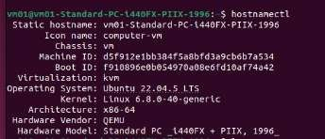
Figure 1. Ubuntu VM: hostnamectl output showing the hostname, Ubuntu operating system, kernel, architecture and virtual hardware information.
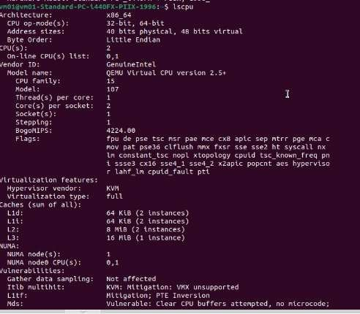
Figure 2. Ubuntu VM: lscpu output showing x86_64 architecture, 2 CPUs/cores, ǪEMU Virtual CPU model and KVM virtualization information.

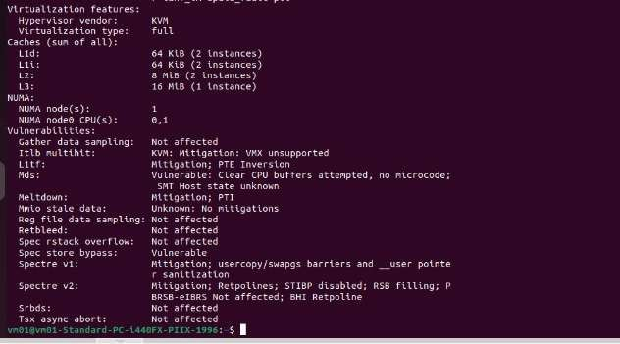
Figure 3. Ubuntu VM: extended lscpu output showing cache, NUMA and CPU vulnerability/mitigation information.

Figure 4. Ubuntu VM: free -h output showing memory and swap allocation/usage.

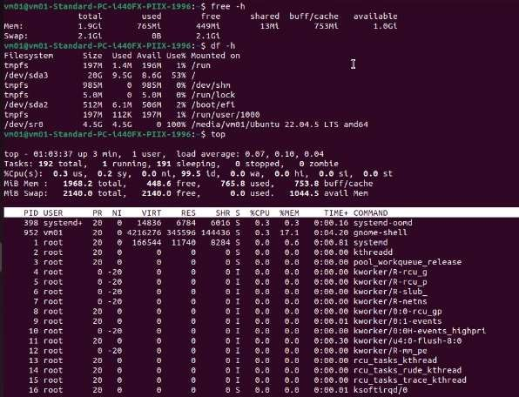

Figure 5. Ubuntu VM: combined free -h, df -h and top output showing memory, filesystem and live process/resource information.
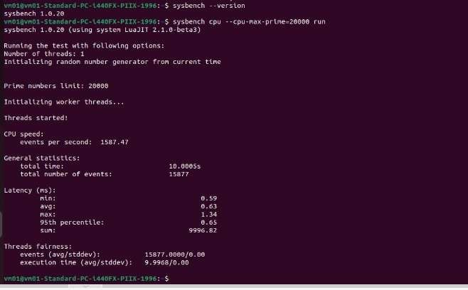
Figure 6. Ubuntu VM: Sysbench CPU benchmark output for --cpu-max-prime=20000.

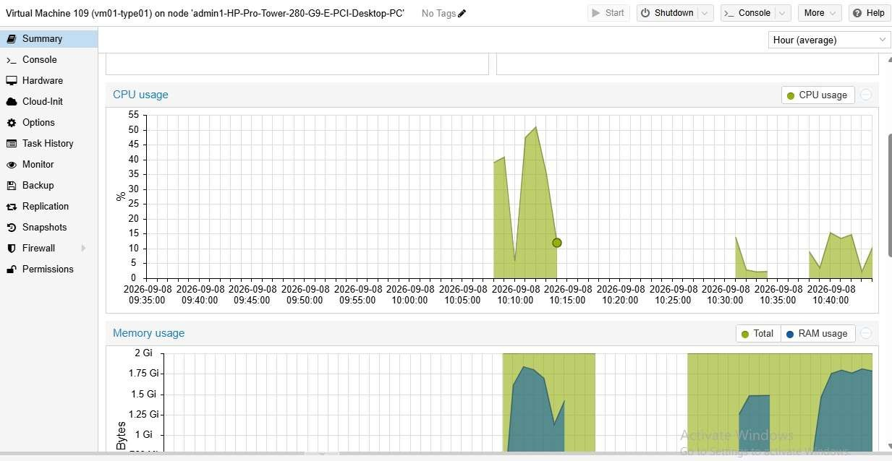

Figure 7. Proxmox VE: Summary/monitoring view showing CPU and memory usage graphs for the running VM.

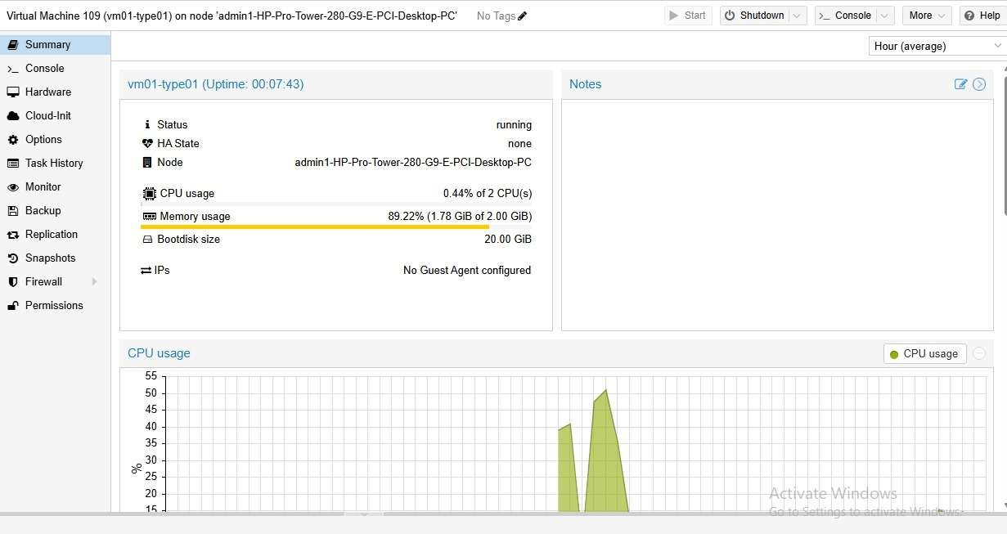

Figure 8. Proxmox VE: VM Summary showing running status, 2 CPUs, 2.00 GiB memory and 20.00 GiB boot disk.

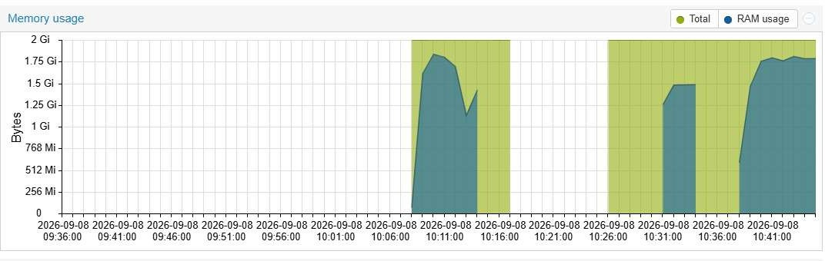

Figure G. Proxmox VE: Memory usage graph over the observed time window.

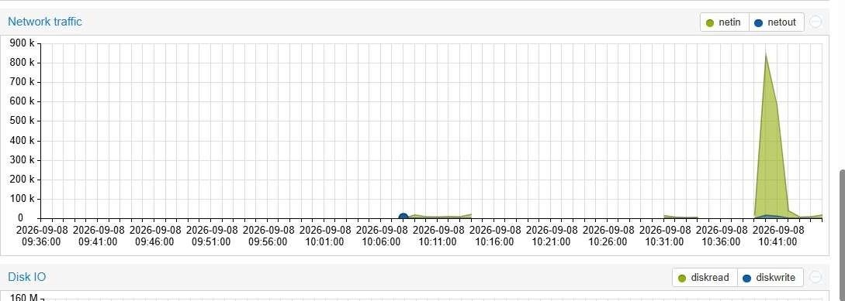

Figure 10. Proxmox VE: Network traffic graph showing the observed network activity and transient spike.

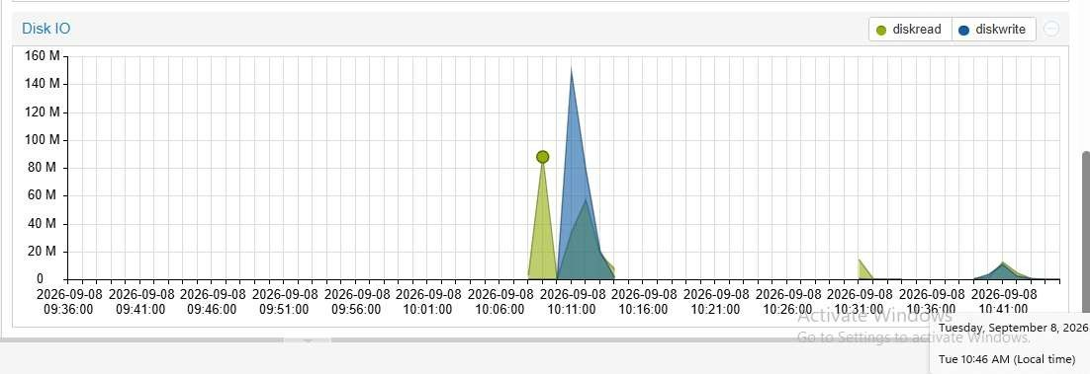

Figure 11. Proxmox VE: Disk I/O graph showing disk read/write activity during the observation period.

Final Observation Record
Type-1 Hypervisor Performance Record

Parameter | Part 1 Result
Hypervisor | Proxmox VE
Hypervisor type | Type-1
Guest OS | Ubuntu 22.04.5 LTS
CPU | 2 vCPU
Memory | 2 GB
Disk | 20 GB
Total execution time | 10.0005 s
Total events | 15,877
Events per second | 1,587.47
Average latency | 0.63 ms

