Postal Life Insurance

Department of Post

Software Requirements Specification (SRS)/ Functional Requirements Specification (FRS)
  - Aadhar

INTERNAL APPROVAL FORM

Project Name: Aadhar
Version: 1.0
Submitted on:
 | Name | Date
Approved By:
Reviewed By:
Prepared By:

VERSION CONTROL LOG
Version | Date | Prepared By | Remarks
1

Table of Contents

1. Executive Summary 4
2. Project Scope 4
3. Business Requirements 4
4. Functional Requirements Specification 5
4.1 Request Structure (IMS -> UIDAI Authentication API) 5
4.2 Response Structure (UIDAI Authentication API -> IMS) 6
4.3 Error Codes 6
5. Attachments 6

1. Executive Summary
This document outlines the requirements to enable Aadhaar-based identity verification and e-KYC during customer onboarding and servicing to comply with IRDAI and UIDAI norms, reduce fraud, and streamline KYC processes.

2. Project Scope
This Integration will:
- Aadhaar Authentication (Biometric, OTP, Demographic)
- Aadhaar e-KYC (Online and Offline XML-based)
- Secure integration with UIDAI via Authentication User Agency (AUA) and Authentication Service Agency (ASA)

3. Business Requirements

ID | Requirements
FS_AD_001 | Implement Aadhaar-based authentication and e-KYC as per UIDAI and IRDAI norms, ensuring explicit customer consent is captured and stored.
FS_AD_002 | Enable Aadhaar verification during onboarding, policy servicing, and updates; block transactions if authentication fails or consent is missing.
FS_AD_003 | Encrypt Aadhaar data (PID block, demographic details), use UIDAI-approved encryption standards, secure API calls (TLS), and store only masked Aadhaar numbers.
FS_AD_004 | Support real-time Aadhaar authentication with quicker response time, handle high-volume requests, and implement fallback mechanisms for API downtime.
FS_AD_005 | Maintain detailed logs of authentication attempts, consent records, and generate compliance reports for audits; detect anomalies and prevent identity fraud.

Flow Diagram for Aadhar Integration: 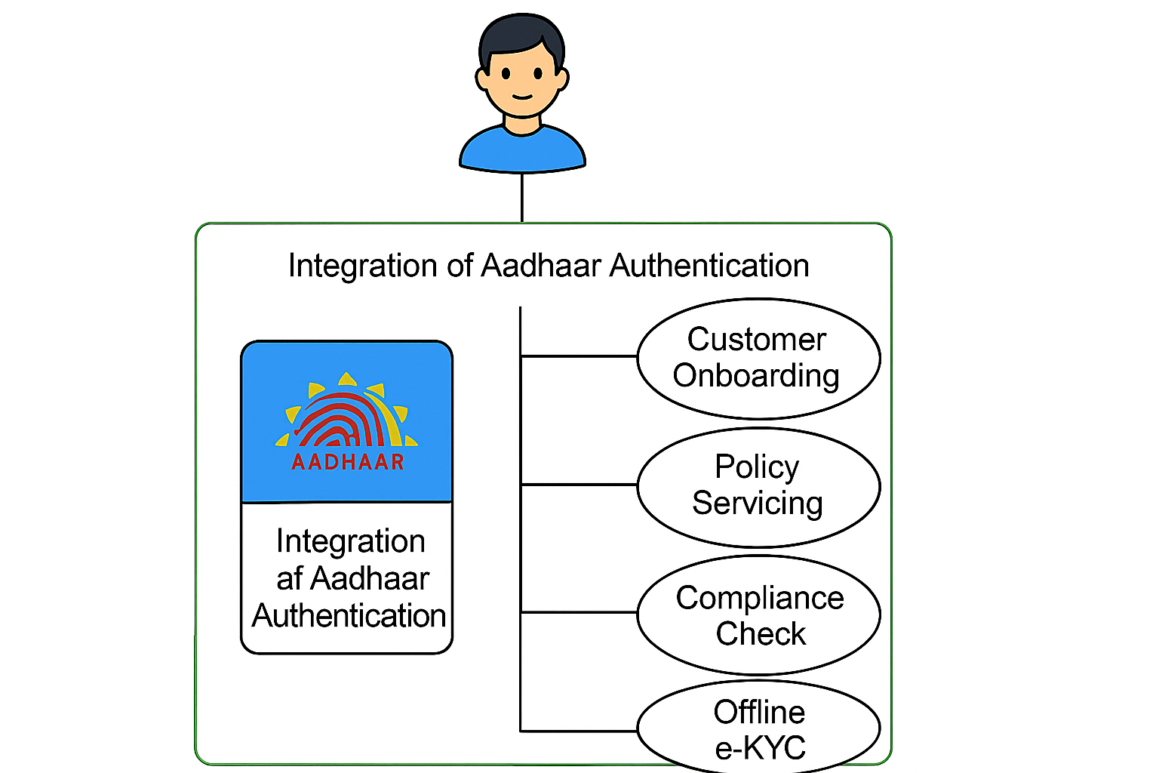

4. Functional Requirements Specification

Data Fields to be Created in IMS for Integration with Aadhar

4.1 Request Structure (IMS -> UIDAI Authentication API)
Field Name | Type | Description
uid | String | Aadhaar number (12 digits)
txn | String | Unique transaction ID (UUID)
ts | DateTime | Timestamp in ISO format
type | String | Authentication type (OTP / BIO / DEMO)
pid | Encrypted | Personal Identity Data block (encrypted)
skey | Encrypted | Session key (encrypted)
hmac | Encrypted | Hash for integrity check
meta | Object | Device info (IP, location, device ID)
consent | Boolean | Customer consent flag

4.2 Response Structure (UIDAI Authentication API -> IMS)
Field Name | Type | Description
txn | String | Same transaction ID for mapping
ret | String | Authentication result (y = success, n = failure)
code | String | Response code
err | String | Error Code, if any
info | String | Status message
ts | DateTime | Response timestamp

4.3 Error Codes
- 100: Success – Authentication successful
- 300: Invalid Aadhaar number
- 310: Aadhaar number does not exist
- 400: Invalid OTP
- 401: OTP expired
- 500: Biometric data mismatch
- 510: Biometric data quality check failed
- 600: Invalid PID block
- 700: Invalid encryption or HMAC
- 800: Invalid AUA/ASA credentials
- 810: Digital signature verification failed
- 900: Technical error at UIDAI server
- 910: Service unavailable
- 999: Unknown error

5. Attachments
The following documents can be referred.

