Postal Life Insurance

Department of Post

Software Requirements Specification (SRS)/ Functional Requirements Specification (FRS)
  - PAN/e-PAN

INTERNAL APPROVAL FORM

Project Name: PAN/e-PAN
Version: 1.0
Submitted on:
 | Name | Date
Approved By:
Reviewed By:
Prepared By:

VERSION CONTROL LOG
Version | Date | Prepared By | Remarks
1

Table of Contents

1. Executive Summary 4
2. Project Scope 4
3. Business Requirements 4
4. Functional Requirements Specification 5
4.1 Request Structure (IMS -> PAN API) 5
4.2 Response Structure (PAN API -> IMS) 5
4.3 Error Codes 6
5. Attachments 6

1. Executive Summary
This document outlines the requirements to enable real-time PAN verification during customer onboarding, policy issuance, and KYC validation in the Insurance Management System. This ensures compliance with regulatory norms and enhances fraud prevention.

2. Project Scope
This Integration will:
- Validate PAN details via NSDL/Income Tax Department APIs.
- Fetch PAN holder information securely.
- Store verified PAN data in IMS.
- Support bulk and individual PAN verification.

3. Business Requirements

ID | Requirements
FS_PAN_001 | Ensure PAN verification and e-PAN retrieval for all customers as per IRDAI and Income Tax norms.
FS_PAN_002 | Validate PAN during onboarding, policy servicing, and updates; prevent onboarding if PAN is invalid.
FS_PAN_003 | Detect duplicate PAN usage, flag suspicious entries, and maintain audit trails of all verification attempts.
FS_PAN_004 | Real-time PAN validation using NSDL/Protean or API Setu with TLS encryption, digital signatures, and secure credentials.
FS_PAN_005 | Store verified PAN details in IMS, encrypt data at rest and in transit, and enforce role-based access control.
FS_PAN_006 | Support high-volume PAN verification (bulk processing), ensure response time < 2 seconds, and handle API downtime gracefully.
FS_PAN_007 | Provide clear verification status messages, allow retries, maintain logs, and generate compliance reports for audits.

Flow Diagram for PAN/e-PAN Integration: 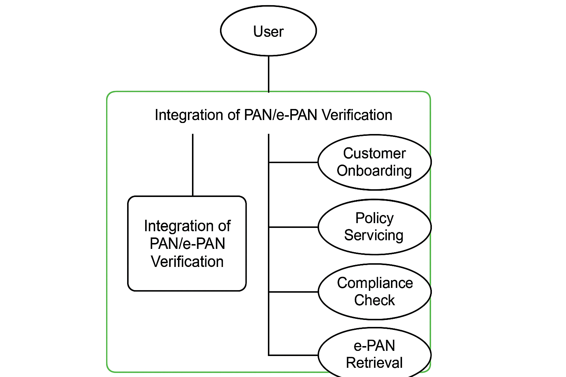

4. Functional Requirements Specification

Data Fields to be Created in IMS for Integration with PAN

4.1 Request Structure (IMS -> PAN API)
Field Name | Type | Description
requestId | String | Unique ID for the request (UUID)
pan | String | PAN number (10 characters, format: ABCDE1234F)
entityId | String | IMS identifier registered with NSDL/API Setu
timestamp | DateTime | Request timestamp in ISO format
signature | String | Digital signature for authentication
channel | String | Source of request (Web, Mobile, Bulk)

4.2 Response Structure (PAN API -> IMS)
Field Name | Type | Description
requestId | String | Same as request for mapping
pan | String | PAN number verified
name | String | Name as per PAN
status | String | Valid / Invalid / Not Found
dob | Date | Date of Birth from PAN
lastUpdated | Date | Last update in PAN database
errorCode | String | Error code if any
errorMessage | String | Error message if any
verificationTime | DateTime | Timestamp of verification

4.3 Error Codes
- 32: Invalid PAN format
- 33: PAN not found
- 15: Signature mismatch
- 27: Timestamp expired

5. Attachments
The following documents can be referred.

