Postal Life Insurance

Department of Post

Software Requirements Specification (SRS)/ Functional Requirements Specification (FRS)
  - e-KYC/c-KYC

INTERNAL APPROVAL FORM

Project Name: e-KYC/c-KYC
Version: 1.0
Submitted on:
 | Name | Date
Approved By:
Reviewed By:
Prepared By:

VERSION CONTROL LOG
Version | Date | Prepared By | Remarks
1

Table of Contents

1. Executive Summary 4
2. Project Scope 4
3. Business Requirements 4
4. Functional Requirements Specification 5
4.1 e-KYC 5
4.1.1 Request Structure for (IMS -> UIDAI e-KYC API) 5
4.1.2 Response Structure (UIDAI e-KYC API -> IMS) 5
4.1.3 Error Codes 6
4.2 c-KYC 6
4.2.1 Request Structure for (IMS -> CKYC API) 6
4.2.2 Response Structure (CKYC API -> IMS) 6
4.2.3 Error Codes 6
5. Attachments 6

1. Executive Summary
This document outlines the requirements to enable digital KYC verification using Aadhaar-based e-KYC and Central KYC Registry (CKYC) for customer onboarding, servicing, and compliance in IMS.

2. Project Scope
This Integration will:
- e-KYC: Aadhaar-based authentication for identity verification.
- CKYC: Fetch and update customer KYC records from Central KYC Registry as per IRDAI AML/CFT guidelines.

3. Business Requirements

ID | Requirements
FS_KYC_001 | Implement e-KYC (Aadhaar-based) and CKYC verification as per UIDAI, IRDAI, and PMLA guidelines, ensuring explicit customer consent is captured and stored.
FS_KYC_002 | Enable KYC verification during onboarding, policy servicing, and claims; block transactions if KYC fails or consent is missing.
FS_KYC_003 | Encrypt Aadhaar and CKYC data, use secure API communication (TLS, digital signatures), and store only masked identifiers; comply with UIDAI and CKYC security norms.
FS_KYC_004 | Support real-time KYC verification with quicker response time, handle bulk requests, and implement fallback mechanisms for API downtime.
FS_KYC_005 | Maintain logs of all KYC verification attempts, consent records, and generate compliance reports; detect duplicate or fraudulent identities and flag anomalies.

Flow Diagram for e-KYC/c-KYC Integration: 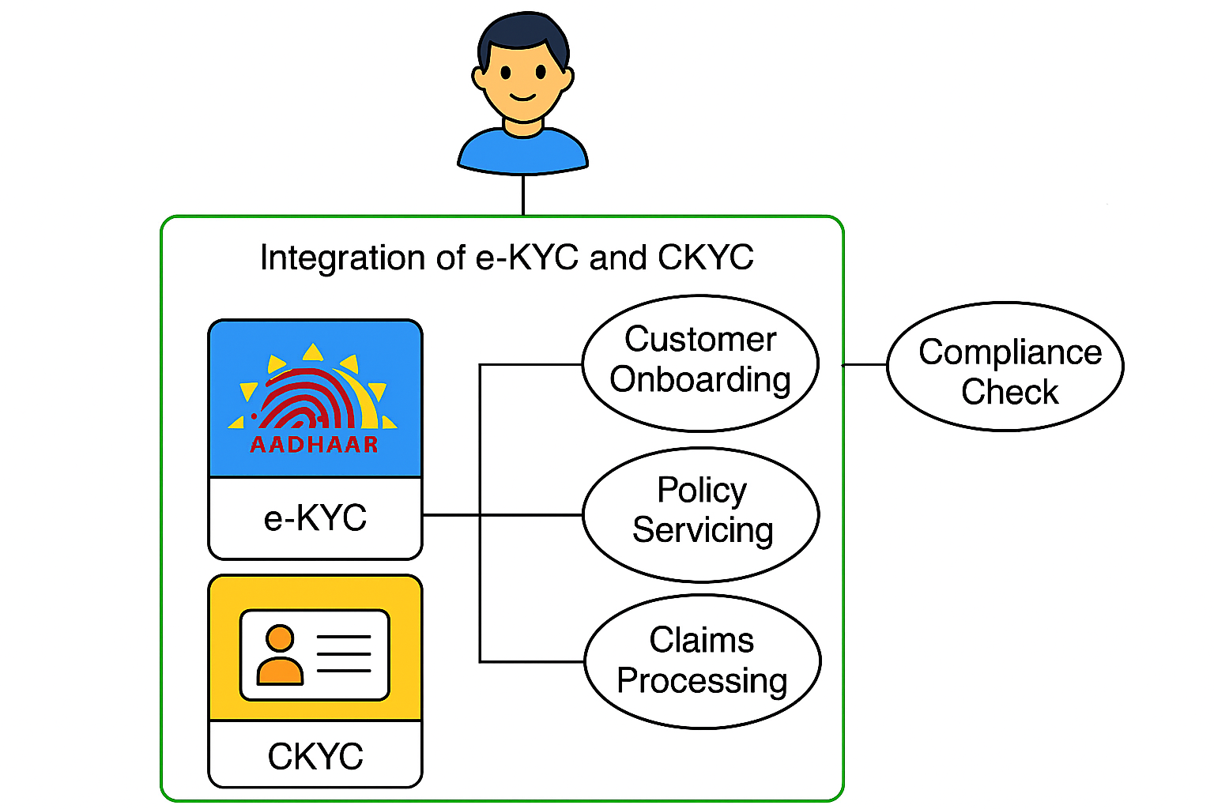

4. Functional Requirements Specification

4.1 e-KYC

4.1.1 Request Structure for (IMS -> UIDAI e-KYC API)
Field Name | Type | Description
aadhar | String | 12-digit Aadhaar number
otp | String | One-Time Password for authentication
txn | String | Unique transaction ID
consent | Boolean | Customer consent flag

4.1.2 Response Structure (UIDAI e-KYC API -> IMS)
Field Name | Type | Description
status | String | Success / Failure
name | String | Name as per Aadhaar
dob | Date | Date of Birth
gender | String | Gender
address | String | Full address
photo | Base64 | Photo from Aadhaar
mobile | String | Registered mobile number
email | String | Registered email address

4.1.3 Error Codes
- 100: Success
- 300: Invalid Aadhaar
- 400: Invalid OTP
- 500: Consent missing

4.2 c-KYC

4.2.1 Request Structure for (IMS -> CKYC API)
Field Name | Type | Description
fi_code | String | Financial Institution code
request_id | String | Unique request identifier
id_type | String | Type of ID (CKYC)
id_no | String | CKYC number (14 digits)
date_time | DateTime | Request timestamp

4.2.2 Response Structure (CKYC API -> IMS)
Field Name | Type | Description
status | String | Success / Failure
ckyc_no | String | CKYC number
name | String | Customer name
dob | Date | Date of Birth
address | String | Customer Address
Kyc_type | String | KYC type (Normal / Simplified)

4.2.3 Error Codes
- 200: Success
- 310: CKYC record not found
- 700: Invalid encryption
- 900: Technical error

5. Attachments
The following documents can be referred.

