Postal Life Insurance

Department of Post

Software Requirements Specification (SRS)/ Functional Requirements Specification (FRS)
  - Digilocker

INTERNAL APPROVAL FORM

Project Name: Digilocker
Version: 1.0
Submitted on:
 | Name | Date
Approved By:
Reviewed By:
Prepared By:

VERSION CONTROL LOG
Version | Date | Prepared By | Remarks
1

Table of Contents

1. Executive Summary 4
2. Project Scope 4
3. Business Requirements 4
4. Functional Requirements Specification 5
4.1 Use Case-1: Generate Policy Bond & Save in Digilocker 5
4.2 Use Case-2: Submit Aadhaar, PAN, and Other Required Documents for Policy Issue/Claim 6
5. Attachments 7

1. Executive Summary
This document outlines the requirements for integrating the Insurance Management System (IMS) of India Post PLI with the Digilocker to enable customers to generate and store e-Bonds digitally.

2. Project Scope
The integration will allow PLI/RPLI customers to:
- Access Digilocker via app or URL.
- Authenticate using Aadhaar-linked Digilocker account.
- Fetch policy details from IMS.
- Generate and store e-Bonds in Digilocker.
- Submit documents for policy procurement or claims through Digilocker.

3. Business Requirements

ID | Requirements
FS_DL_001 | Enable integration between IMS and Digilocker for e-Bond generation. Generate e-Bond in PDF format and store in Digilocker.
FS_DL_002 | Provide Aadhaar-based authentication for auto-fetching Name and DOB.
FS_DL_003 | Send SMS/email confirmation with e-Bond reference number after successful generation.
FS_DL_004 | Provide a “Report an Issue” button linked to PLI helpdesk for customer support.
FS_DL_005 | Enable submission of documents for policy procurement or claims through Digilocker.

4. Functional Requirements Specification
Use Case Diagram for Digilocker Integration with IMS: 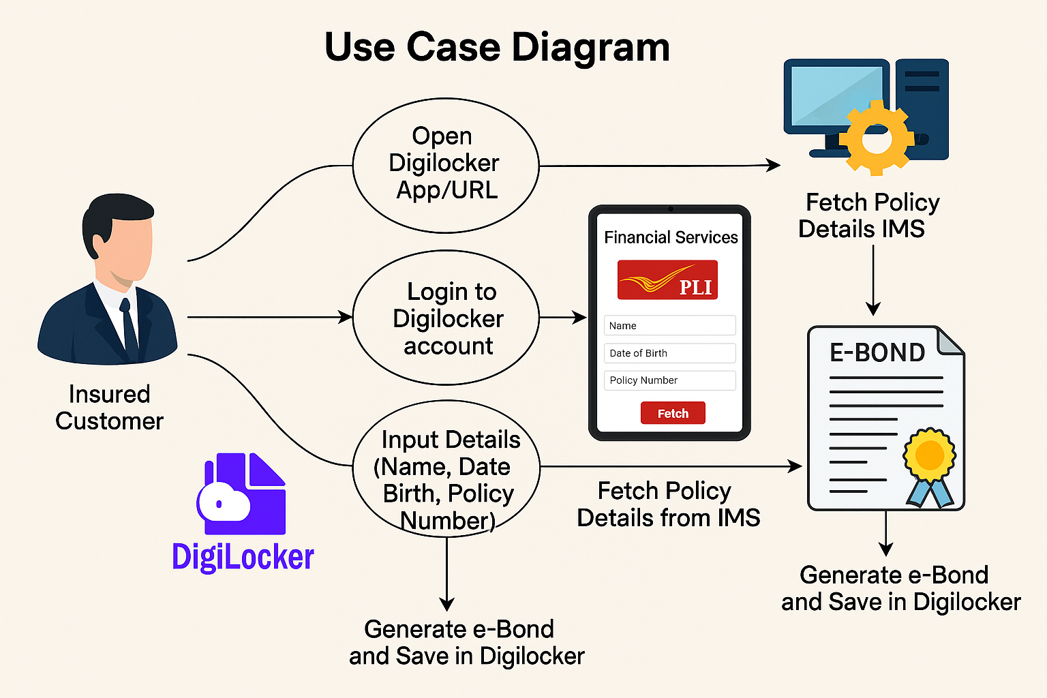

4.1 Use Case-1: Generate Policy Bond & Save in Digilocker
- Purpose: To allow an insured customer to generate an electronic policy bond (e-Bond) for their PLI/RPLI policy and securely store it in their Digilocker account.

- Main Flow:
  - Customer opens Digilocker app or URL and logs in using Aadhaar credentials.
  - Navigates to Financial Services → PLI.
  - Inputs required details (Policy Number; Name and DOB auto-fetched via Aadhaar).
  - Digilocker sends request to IMS to validate policy details.
  - IMS verifies details and returns policy information.
  - IMS generates e-Bond in PDF format and sends it to Digilocker.
  - Digilocker stores e-Bond in customer’s account.
  - Customer receives SMS/email confirmation with e-Bond reference number.
Use Case Diagram for Generate Policy Bond & Save in Digilocker Use Case: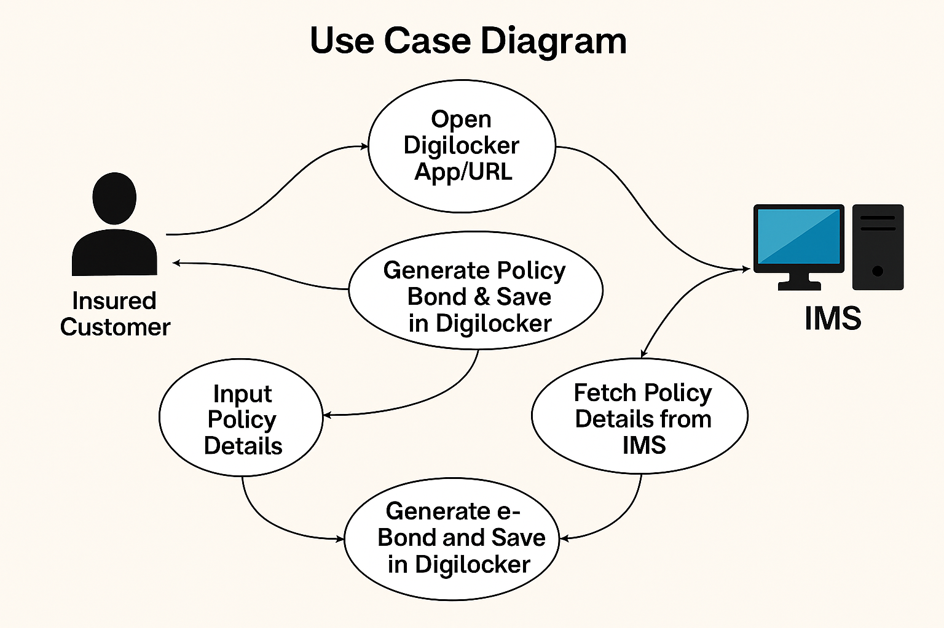

4.2 Use Case-2: Submit Aadhaar, PAN, and Other Required Documents for Policy Issue/Claim
- Purpose: To enable customers to submit KYC and other required documents (Aadhaar, PAN, income proof, claim documents) through Digilocker for policy issuance, servicing, or claim settlement.

- Main Flow:
  - Customer logs into Digilocker and navigates to Financial Services → PLI.
  - Selects option to submit documents for policy issuance or claim.
  - Chooses required documents (Aadhaar, PAN, etc.) from Digilocker repository.
  - Digilocker sends selected documents securely to IMS via API.
  - IMS receives and validates documents for completeness and authenticity.
  - IMS updates policy or claim status accordingly.
  - Customer receives confirmation of successful submission.
Use Case Diagram for Submit Aadhaar, PAN, and Other Required Documents for Policy Issue/Claim Use Case: 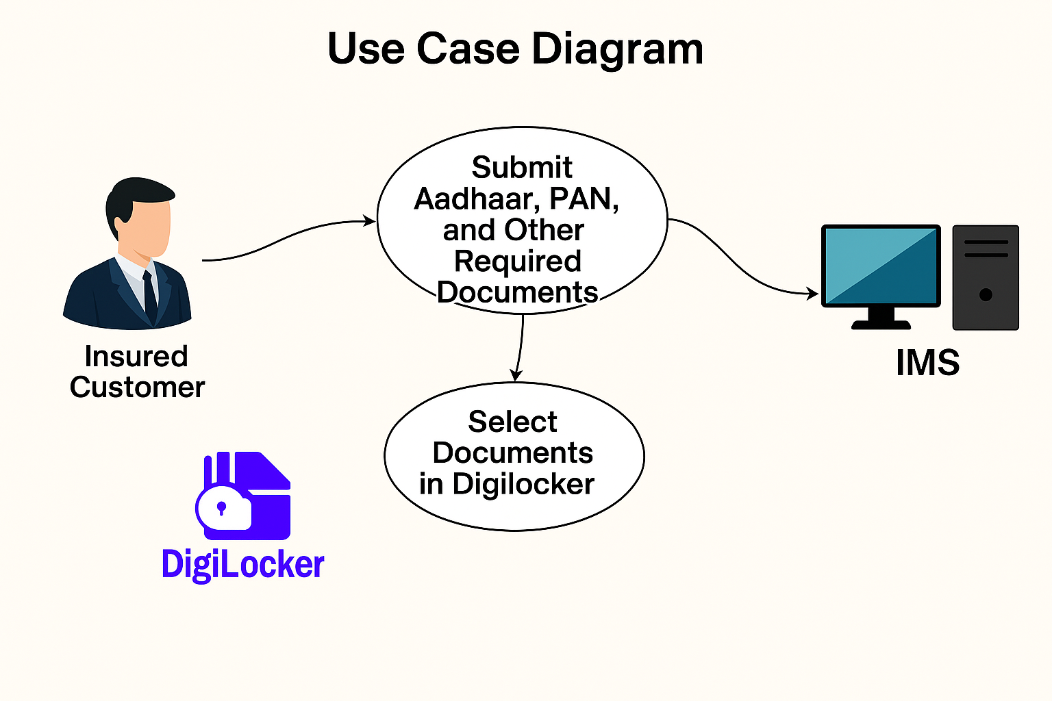

5. Attachments
The following documents can be referred.

