Postal Life Insurance

Department of Post

Software Requirements Specification (SRS)/ Functional Requirements Specification (FRS)
  - Post Office Savings Bank (POSB)

INTERNAL APPROVAL FORM

Project Name: Post Office Savings Bank (POSB)
Version: 1.0
Submitted on:
 | Name | Date
Approved By:
Reviewed By:
Prepared By:

VERSION CONTROL LOG
Version | Date | Prepared By | Remarks
1

Table of Contents

1. Executive Summary 4
2. Project Scope 4
3. Business Requirements 4
4. Functional Requirements Specification 6
4.1 Billing Method Change by In-Person Visit to Post office 6
4.2 Billing Method Change through Digital Mode 7
5. Attachments 9

1. Executive Summary
This document defines the requirements for integrating the Postal Life Insurance (PLI) Insurance Management System (IMS) with Post Office Savings Bank (POSB) to enable automated premium payments and loan repayments through Standing Instructions (SI), Mobile Banking (m-Banking), and Online Banking (e-Banking). The integration will allow customers to change their billing method from existing modes to POSB-based digital or assisted channels.

2. Project Scope
This Integration aims to:
- Facilitate billing method change and premium collection through POSB accounts.
- Support both in-person and digital modes for SI, m-Banking, and e-Banking.
- Ensure secure, real-time integration between POSB and IMS.
- Enhance customer experience with notifications, multilingual support, and document submission.

3. Business Requirements

ID | Functionality | Requirements
FS_POSB_001 | Enable Billing Method Change | The system must allow customers to change their existing billing method to:  - Standing Instruction (SI) via POSB account.  - m-Banking option.  - e-Banking option.
FS_POSB_002 | Support Multiple Channels | Customers should be able to initiate billing method change:  - In-person at Post Office (mandatory for SI).  - Digitally via Mobile Banking (m-Banking) or Online Banking (e-Banking).
FS_POSB_003 | Standing Instruction Registration | The system must support SI registration through Post Office counters. SI must be linked to the customer’s POSB account and PLI/RPLI policy.
FS_POSB_004 | Digital Payment Processing | Enable premium payment and loan repayment through:  - India Post Mobile Banking App.  - India Post e-Banking Portal.
FS_POSB_005 | Real-Time Account verification | Integrate POSB API for:  - Account number validation.  - Signature verification.  - Transaction authentication.
FS_POSB_006 | Policy Validation | IMS must validate policy details (policy number, premium amount, due date) before processing payment.
FS_POSB_007 | Transaction Confirmation | Display confirmation page with:  - Policy details.  - Premium amount.  - Taxes/rebates.  - Total payable amount.
FS_POSB_008 | Payment Outcome Notification | Notify customers of transaction status (Success/Failure) via:  - SMS.  - Email.  - WhatsApp.  - Hard copy (for SI).
FS_POSB_009 | Receipt Generation | Generate and share digital receipts for successful transactions. Provide duplicate receipt option via IMS and banking channels.
FS_POSB_010 | Refund/Reconciliation | Handle failed transactions with refund and reconciliation by Nodal office.
FS_POSB_011 | Auto-Renewal of SI | Enable SI auto-renewal post-expiry with customer consent.
FS_POSB_012 | Notifications & Alerts | Push notifications for:  - SI activation.  - Upcoming debit reminders.  - Expiry alerts.  - Premium due alerts.  - Missed payment notifications.
FS_POSB_013 | Dashboard Visibility | Display summary of active SIs in POSB m-Banking and e-Banking dashboards.
FS_POSB_014 | Document Submission | Support DigiLocker-based document upload for claims or service requests.
FS_POSB_015 | Multi-Language Support | Provide language options via Bhashini for rural customers.
FS_POSB_016 | Offline Mode | Enable offline transaction initiation with auto-sync when connectivity is restored.

4. Functional Requirements Specification
Use Case Diagram for Integration with POSB: 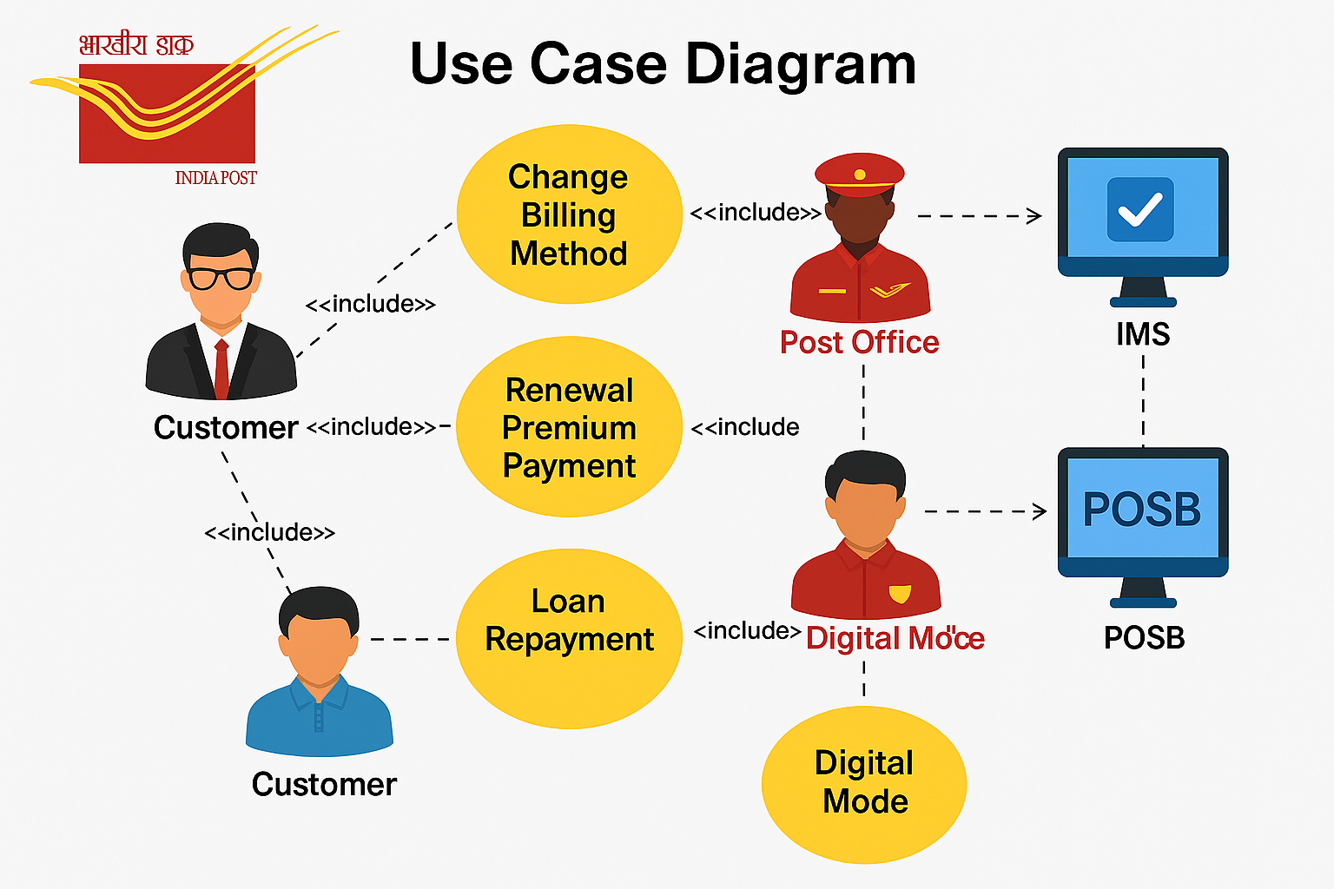

The Customer may choose either of the following options to change the existing billing method to Standing Instruction (SI), m-Banking, or e-Banking through their POSB account —
- By visiting the Post Office in person, or
- Through digital mode (without visiting the Post Office) using online or mobile banking facilities.
** Standing Instructions may be opt by visiting the Post Office in person only

4.1 Billing Method Change by In-Person Visit to Post office
- Purpose: To allow customers to change billing method for Renewal Payment or Loan Repayment on its policy through in-person visit to post office using its POSB Account.
- Flow Chart for Standing Instructions:
Customer Visits Post Office for Billing Method Change

Selects Standing Instruction (SI) via POSB Account

Submits Form and Documents

Official Registers Request in System

System Auto-populates and Verifies Account Details

POSB API Verification of Account and Signature

If Verified → Request Accepted | If Error → Rejected

System Generates Acceptance/Rejection Letter

Customer Informed via SMS / Email / WhatsApp / Hard Copy

4.2 Billing Method Change through Digital Mode

4.2.1 Billing Method Change through Mobile Banking
- Purpose: To allow customers to change billing method for Renewal Payment or Loan Repayment on its policy through M-Banking App of POSB.
- Flow Chart for M-banking App:

Customer logs in to the India Post Mobile Banking App

Customer selects “requests” tab from the m-banking dashboard

Customer chooses “Pay PLI/RPLI renewal Premium/Loan Repayment”

Customer enter details i.e. Policy Number, No. of Instalments, Debit Account No., and transaction remarks etc.{then click on submit}

Confirmation page
{System display details i.e. Policy No., Account No., Policyholder Name, Premium, Dates, Taxes (if applicable), rebate (if applicable) & final total premium amount etc.}

Verification
{Customer verifies all details and enter transaction password for confirmation}

Transaction Processing
{System validates payment through POSB integration}

Payment Outcome
{Success – Receipt Generated & shared via e-Mail, SMS, Whatsapp etc.}
{Failure- Error message & refund/reconciliation by Nodal office}

* Duplicate receipt Option:- Customer can generate duplicate receipt via m-Banking and IMS

4.2.1 Billing Method Change through e-Banking
- Purpose: To allow customers to change billing method for Renewal Payment or Loan Repayment on its policy through e-Banking.
- Flow Chart for e-Banking:
- Customer logs in to the India Post e-Banking Portal

- Customer selects “ General Services” tab from the e-banking dashboard
- {Customer then selects, “Service requests” then select “ New Service Request” option from Dropdown and clicks Ok

- Customer then clicks on “Pay PLI/RPLI renewal Premium/Loan Repayment” from available request type

- Customer enter details i.e. Policy Number, No. of Instalments, Debit Account No. etc. and transaction remarks {then click on submit}

- Confirmation page
- {System display details i.e. Policy No., Account No., Policyholder Name, Premium, Dates, Taxes (if applicable), rebate (if applicable) and final total premium amount etc.}

- Verification
- {Customer verifies all details and enter transaction password for confirmation}

- Transaction Processing
- {System validates payment through POSB integration}

- Payment Outcome
- {Success – Receipt Generated & shared via e-Mail, SMS, WhatsApp etc.}
- {Failure- Error message & refund/reconciliation by Nodal office}

- * Duplicate receipt Option: - Customer can generate duplicate receipt via m-Banking and IMS

5. Attachments
The following documents can be referred.

