Postal Life Insurance

Department of Post

Software Requirements Specification (SRS)/ Functional Requirements Specification (FRS)
  - Payroll

INTERNAL APPROVAL FORM

Project Name: Payroll
Version: 1.0
Submitted on:
 | Name | Date
Approved By:
Reviewed By:
Prepared By:

VERSION CONTROL LOG
Version | Date | Prepared By | Remarks
1

Table of Contents

1. Executive Summary 4
2. Project Scope 4
3. Business Requirements 4
4. Functional Requirements Specification 4
4.1 Dashboard Page 5
4.2 Opt-in for Pay Recovery Page 6
4.3 Request Verification Page (Postal DDO Only) 7
4.4 Success/Failure Page 7
4.5 Demand file Management Page 8
4.6 Bulk Upload Page 8
5. Attachments 8

1. Executive Summary
The Payroll Module will enable premium collection for PLI policies through salary deductions for Department of Posts (DoP) employees who opt for the Pay Recovery method. It will integrate with the Employee Self Service (ESS) Portal (APT 2.0) and the Insurance Management System (IMS) to ensure seamless data flow, verification, and transaction processing.

2. Project Scope
The scope of the module is:
- Employees submit policy details via ESS Portal/App.
- Postal DDO verifies and configures payroll changes.
- Payroll system deducts premiums based on IMS demand file.
- API-based integration between Payroll Module and IMS for real-time updates.
- Notifications to employees for success/failure cases.

3. Business Requirements

ID | Requirements
FS_PR_001 | DoP employees can opt for PLI premium payment via salary deduction by submitting policy details on the ESS Portal (APT 2.0) for Pay Recovery configuration.
FS_PR_002 | Postal DDOs should verify employee requests and configure payroll settings for premium deduction.
FS_PR_003 | IMS should generate a monthly demand file specifying premium amounts for employees who opted for Pay Recovery.
FS_PR_004 | Payroll system must deduct premiums from employee salaries during payroll run based on IMS demand file.
FS_PR_005 | Employees should receive success/failure notifications via ESS Portal, SMS, and/or email.
FS_PR_006 | The module should maintain logs of all transactions, failures, and refunds for audit purposes.

4. Functional Requirements Specification
Flow Chart for Payroll module:
IMS Generates Demand File on Defined Date Each Month
⬇
Data Available for Policy Premium Deduction from Employees’ Salaries
⬇
Payroll Run Executed → Premium Amount Deducted as per Demand File
⬇
Transaction Details Transmitted via APT 2.0 to IMS
⬇
APT 2.0 Response Received by IMS
⬇
IMS Captures and Processes Response
⬇
Success Case → Premium Details Successfully Updated in IMS
⬇
Failure Case → IMS Shares Failure Reason with APT 2.0
⬇
DDO Reviews Failure:
• If Update Not Possible → Refund Initiated via APT 2.0
• If Update Possible → Bulk Upload Method Used for Premium Updation
⬇
Notifications Triggered to Insurant (Success/Failure)
⬇
Status Updated on Employee Self-Service Portal

4.1 Dashboard Page
- Purpose: Provides a centralized view of all payroll-related actions and navigation to sub-pages.

- Fields:
  - Navigation Tiles for the Following Pages:
    - Opt-in for Pay Recovery
    - Request Verification
    - Success/Failure
    - Demand File Management
    - Bulk Upload
  - Status Indicators: Pending Verifications, Failed Recoveries

Dashboard Page Wireframe:
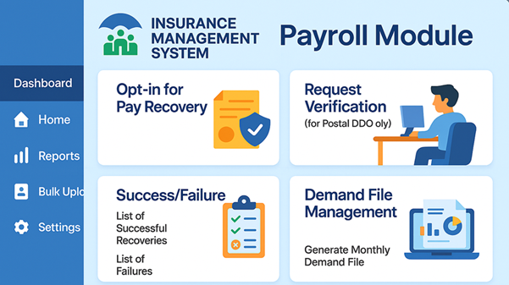

4.2 Opt-in for Pay Recovery Page
- Purpose: Allows employees to opt-in for premium recovery from salary.

- Fields:
  - Employee ID (Text, Mandatory)
  - Policy Number (Text, Mandatory)
  - Opt-in Checkbox (Boolean)
  - Effective Date (Date Picker)
  - Submit Button

4.3 Request Verification Page (Postal DDO Only)
- Purpose: Enables DDO to verify employee requests for payroll deduction.

- Fields:
  - Employee ID
  - Policy Number
  - Request Status (Dropdown: Pending/Approved/Rejected)
  - Verification Date
  - Remarks (Text Area)
  - Approve/Reject Buttons
- Rules:
  - Postal DDO should only be able to access Request Verification Page.
  - Postal DDO Should be able to approve the requests.

4.4 Success/Failure Page
- Purpose: Displays results of payroll recovery transactions.

- Fields:
  - Successful Recovery Table: All the Successful Recoveries should get displayed with only 10 display in first page and then pagination option given. This Table should contain the following details:
    - Employee ID
    - Policy Number
    - Deducted Amount
    - Transaction Date
    - Status (Success)
  - Recovery Failure Table: All the Recoveries that got failed should get displayed with only 10 display in first page and then pagination option given. This Table should contain the following details:
    - Employee ID
    - Policy Number
    - Deducted Amount
    - Failure Reason
    - Retry Button: Button: Clicking this button should ask for the following additional information and upon submit should create request for retry of recovery. The additional fields are:
      - Next Retry Date: Calendar Icon: To choose the next date on which Pay Recovery will be retried.
      - Submit: Button: To complete the Recovery Retry setup.

4.5 Demand file Management Page
- Purpose: Generates monthly demand file for payroll deduction.

- Fields:
  - Month/Year (Dropdown)
  - Generate File Button
  - Download File Link
  - Status (Generated/Processing)
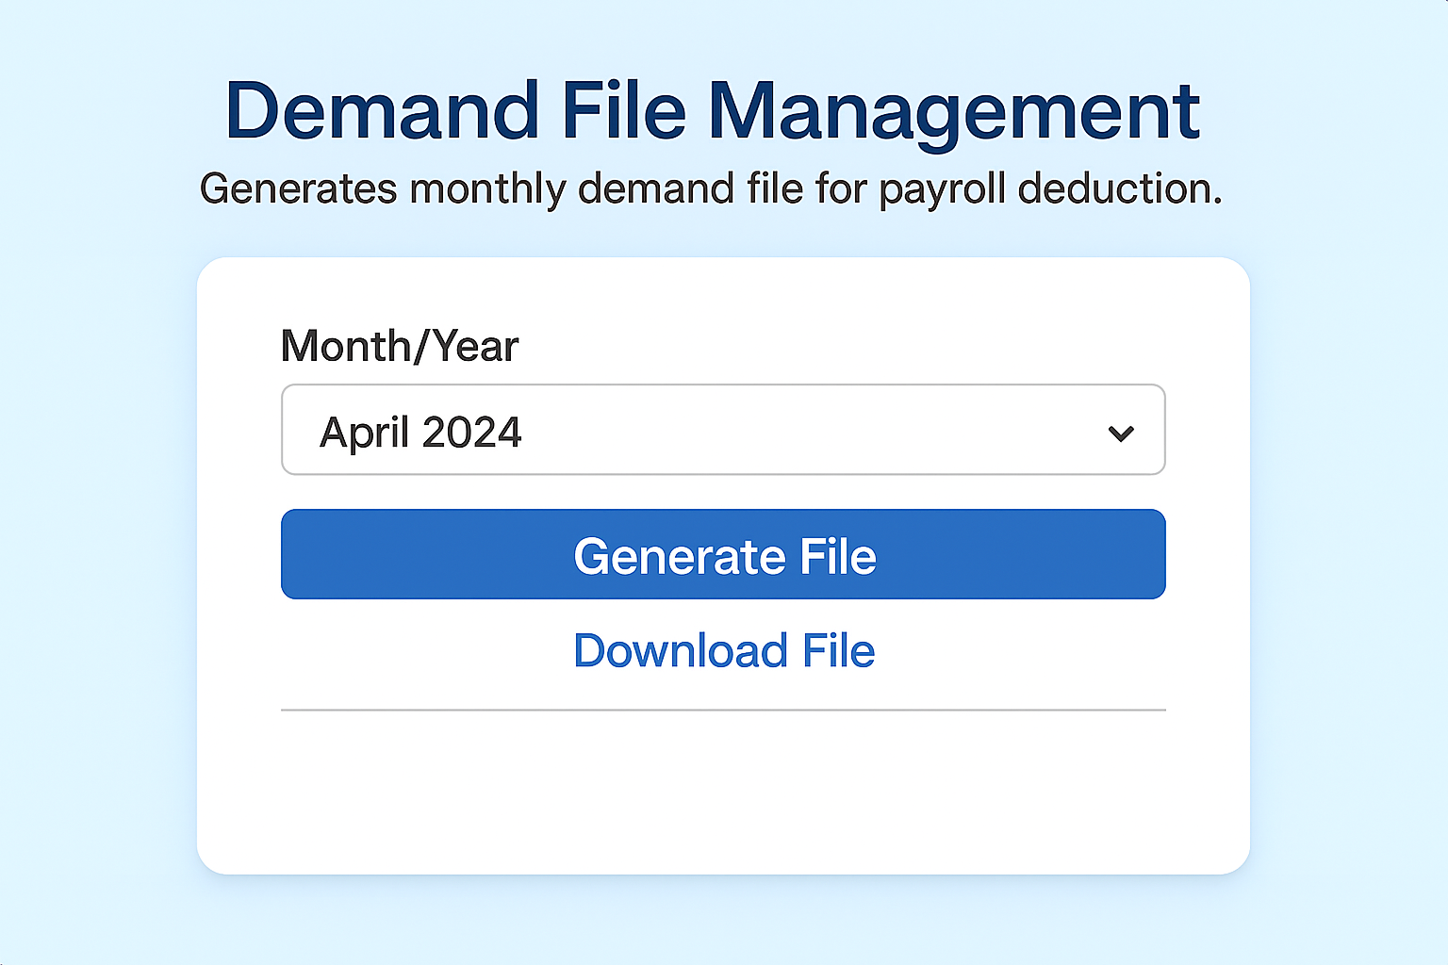

4.6 Bulk Upload Page
- Purpose: Used to Perform Bulk Upload for Pay Recovery or Meghdoot File Upload Process.
Note: Details regarding Bulk Upload is given in separate SRS document.

5. Attachments
The following documents can be referred

