Postal Life Insurance

Department of Post

Software Requirements Specification (SRS)/ Functional Requirements Specification (FRS)
  - e-NACH

INTERNAL APPROVAL FORM

Project Name: e-NACH
Version: 1.0
Submitted on:
 | Name | Date
Approved By:
Reviewed By:
Prepared By:

VERSION CONTROL LOG
Version | Date | Prepared By | Remarks
1

Table of Contents

1. Executive Summary 4
2. Project Scope 4
3. Business Requirements 4
4. Functional Requirements Specification 4
4.1 Customer Initiation Page 6
4.2 Mandate Registration Page 6
4.3 Mandate Status Page 6
4.4 Premium Deduction Dashboard 7
4.5 Notifications & Alerts Page 7
4.6 Exception Handling Page 7
4.7 Admin Dashboard 7
5. Attachments 8

1. Executive Summary
The purpose of the e-NACH module is to enable automated, secure, and paperless premium collection for PLI policies via NPCI’s e-NACH platform. This module will streamline recurring payments, reduce manual errors, and enhance customer convenience.

2. Project Scope
This module will integrate with the IMS (APT 2.0 / McCamish) and NPCI’s e-NACH platform to facilitate mandate registration, authentication, recurring premium deductions, and exception handling.

3. Business Requirements

ID | Functionality | Requirements
FS_NACH_001 | Mandate Registration | During policy purchase or renewal, customers should be able to opt for e-NACH, provide bank details, and authenticate the mandate using Net Banking, Debit Card, or Aadhaar, with the status updated in the Insurance Management System (IMS).
FS_NACH_002 | Premium Collection | Premiums should be auto-debited on the due date for active mandates, followed by confirmation updates in the policy record and generation of premium receipts.
FS_NACH_003 | Notifications | Customers must receive SMS or email notifications regarding mandate registration status and premium deduction outcomes.
FS_NACH_004 | Exception Handling | The system should detect and log failed transactions, notify customers with reasons, and allow re-initiation of mandates or payments.
FS_NACH_005 | Admin & Reporting | Admin users should have access to dashboards for mandate tracking, reconciliation reports, and audit logs to ensure compliance.

4. Functional Requirements Specification

Visual Flowchart for the e-NACH Process: 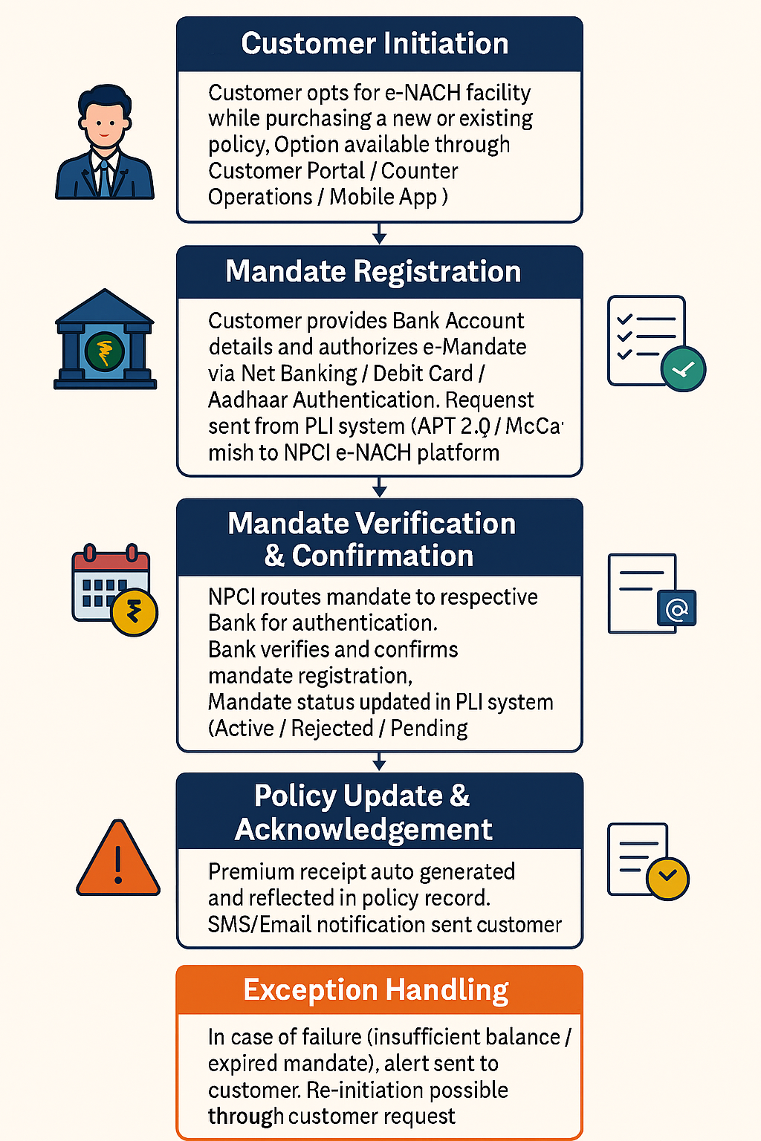

4.1 Customer Initiation Page
- Purpose: Allow customer to opt for e-NACH during policy purchase or renewal.

- Fields:
  - Policy Number (Auto-populated from IMS)
  - Customer Name (Auto-populated)
  - Mobile Number (Editable for verification)
  - Email ID (Editable for notifications)
  - Opt-in Checkbox (“I agree to register for e-NACH”)
  - Preferred Channel (Dropdown: Portal / Mobile App / Counter)
  - Submit Button (Triggers mandate registration process)

4.2 Mandate Registration Page
- Purpose: Capture bank details and initiate mandate request.

- Fields:
  - Policy Number (Read-only)
  - Customer Name (Read-only)
  - Bank Name (Dropdown with search)
  - IFSC Code (Auto-validated)
  - Account Number (Masked input for security)
  - Account Type (Radio: Savings / Current)
  - Authentication Mode (Radio: Net Banking / Debit Card / Aadhaar)
  - NPCI Consent Checkbox (Mandatory before proceeding)
  - Proceed to Authentication Button (Redirects to NPCI page)

4.3 Mandate Status Page
- Purpose: Display current status of mandate.

- Fields:
  - Policy Number
  - Mandate Reference Number (MRN)
  - Status (Active / Pending / Rejected)
  - Date of Registration
  - Bank Response Details (Reason for rejection if any)
  - Download Mandate Confirmation (PDF)

4.4 Premium Deduction Dashboard
- Purpose: Show upcoming and completed premium deductions.

- Fields:
  - Policy Number
  - Due Date
  - Premium Amount
  - Transaction Status (Success / Failed)
  - NPCI Transaction ID
  - Receipt Download Link

4.5 Notifications & Alerts Page
- Purpose: Manage SMS/Email notifications.

- Fields:
  - Policy Number
  - Customer Contact Details
  - Notification Type (Mandate Confirmation / Premium Deduction / Failure Alert)
  - Status (Sent / Pending)
  - Resend Option

4.6 Exception Handling Page
- Purpose: Handle failed transactions and re-initiation.

- Fields:
  - Policy Number
  - Failure Reason (Insufficient Balance / Expired Mandate / Bank Rejection)
  - Retry Option (Button to re-initiate)
  - Alternative Payment Option (UPI / Net Banking)
  - Customer Acknowledgement Checkbox

4.7 Admin Dashboard
- Purpose: For PLI staff to monitor and reconcile.

- Fields:
  - Total Mandates (Active / Pending / Rejected)
  - Total Premium Collections
  - Failed Transactions Count
  - Reconciliation Report Download
  - Search by Policy Number / MRN

5. Attachments
The following documents can be referred.

