IoT Wearable “Context” Engine
Agentic AI · Project Plan

1. Architecture Workflow
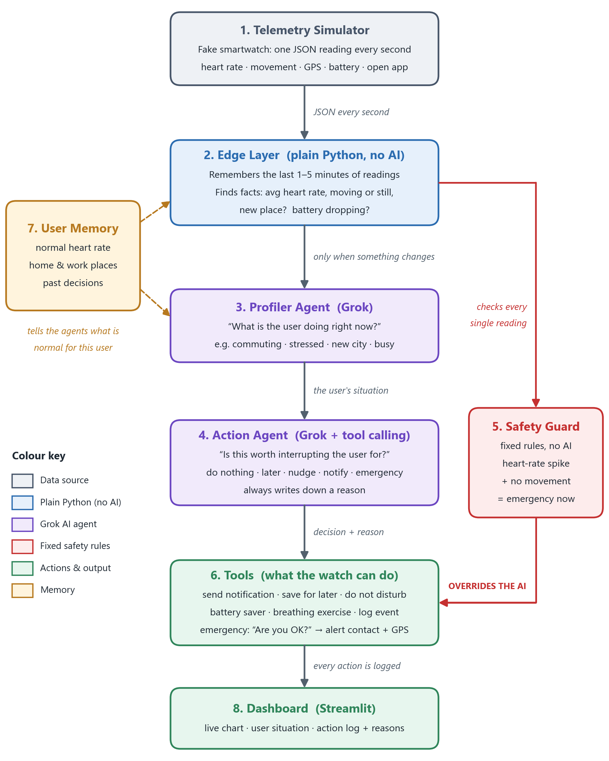
Figure 1. Architecture workflow. Data flows from top to bottom, once every second.

2. The Building Blocks
The project has 8 parts. Each one has a single, clear job.

Block 1: Telemetry Simulator (the fake smartwatch)
- Every second the simulator sends one reading in JSON format: heart rate, movement (accelerometer), steps, GPS location and speed, battery %, which app is open, and whether the screen is on.
- It plays pre-written “stories” (scenarios), like sleeping, a stressful commute, running, or a sudden heart-rate spike.
Example of one reading:
{
"time": "2026-10-25T08:15:03",
"heart_rate": 118,
"accel": {"x": 0.02, "y": 0.01, "z": 0.98},
"steps": 4210,
"gps": {"lat": 22.57, "lon": 88.36, "speed_kmh": 24},
"battery": 41,
"active_app": "maps",
"screen_on": true
}
Built with: Python (async generator)

Block 2: Edge Layer (quick thinking on the watch)
- “Edge” means work done on the device itself, not in the cloud.
- It remembers only the last 1–5 minutes of readings (a “rolling window”).
- From these it works out simple facts: average heart rate, whether heart rate is higher than normal for this user, whether the user is moving, how fast, whether this is a new place, and whether the battery is dropping.
- It wakes up the AI only when something meaningfully changes. This saves Grok tokens and keeps the system fast.
Built with: Python

Block 3: Profiler Agent (what is the user doing?)
- Takes the facts from the Edge Layer and describes the user’s current situation.
- Output example: activity = commuting, stress = high, location = unfamiliar, attention = busy, plus one sentence: “User is highly stressed and commuting.”
- Simple cases (sleeping, running) are handled by rules. Mixed or tricky cases go to Grok.
Built with: Python + Grok

Block 4: Action Agent (should I interrupt?)
- Looks at the user’s situation and asks: “Is this worth disturbing them for?”
- Chooses one of five responses: do nothing, save for later, gentle nudge, notify, or emergency.
- Always writes down the reason for its choice.
Built with: Grok with tool calling (Grok picks and runs the functions in Block 6)

Block 5: Safety Guard (the rule that can never be broken)
- A fixed rule written in code, not AI.
- If heart rate suddenly spikes while the user has not moved at all for a set time, it starts the emergency protocol straight away.
- It overrides the Action Agent. AI can make mistakes, so a life-safety alert must never depend on it.
Built with: plain Python rules

Block 6: Tools (the actions the system can take)
These are the functions the Action Agent is allowed to call:
Tool | What it does
send_notification(priority) | Shows an alert on the watch, marked low, medium or high importance.
defer_notification() | Holds a message and delivers it later, e.g. after the user wakes up.
enable_dnd() | Turns on Do Not Disturb.
battery_saver_mode() | Switches off non-essential features to save battery.
suggest_breathing() | Offers a short breathing exercise to calm the user.
start_emergency_protocol() | Shows “Are you OK?” with a 30-second countdown. If there is no answer, it alerts the emergency contact with the user’s GPS location.
log_event() | Records what happened and why.

Block 7: User Memory (what is normal for this user)
- Stores the user’s normal resting heart rate, home and work locations, and past decisions.
- Lets the system judge “high” or “unusual” for this person, not for an average person.
Built with: a simple JSON file or SQLite database

Block 8: Dashboard (the demo screen)
- A live chart of the incoming watch data.
- The user’s current situation from the Profiler Agent.
- An action log showing every decision and its reason.
Built with: Streamlit

3. Example: One Situation, Step by Step
Situation: the user is sitting on the sofa and their heart rate suddenly jumps.
- The simulator sends readings: heart rate jumps from 72 to 145, but the accelerometer shows no movement.
- The Edge Layer notices heart rate is far above this user’s normal (from User Memory) while the user is completely still.
- The Safety Guard rule matches, so it triggers the emergency protocol directly, without waiting for the AI.
- Meanwhile the Profiler Agent labels the situation: “User is sitting still with a very high heart rate.”
- The watch shows “Are you OK?” with a 30-second countdown. No reply means the emergency contact gets an alert with the GPS location.
- The Dashboard logs the event and the reason.
Compare: the same heart rate of 145 while the user is running. The Profiler says “User is exercising”, the Action Agent chooses do nothing, and the Safety Guard stays silent because the user is moving. Same number, different situation, different action. That is the whole point of a context engine.

4. Test Situations
These six stories are played by the simulator to prove the system makes the right call:
Situation | What the system should do | Why
Battery at 5% while navigating an unfamiliar city | Stay quiet, turn on battery saver, keep navigation running | The map is the most important thing right now
Heart rate 140 while sitting still | Start the emergency protocol | Could be a medical problem
Heart rate 140 while running | Do nothing | Normal during exercise
Sleeping when a low-priority message arrives | Save it for the morning | Don’t wake the user for something unimportant
Stressed and commuting | Hold notifications, suggest breathing on arrival | Avoid adding more stress
Beads-counting (meditation) app is open | Do Not Disturb, give a summary afterwards | Respect focus time

5. Technology
Need | What we use
Programming language | Python
AI model (LLM) | Grok via the xAI API.
Agent framework | LangGraph, or a simple Python loop
Checking data shapes | Pydantic
Live data stream | Python asyncio
User memory | JSON file or SQLite
Demo screen | Streamlit

