glprod

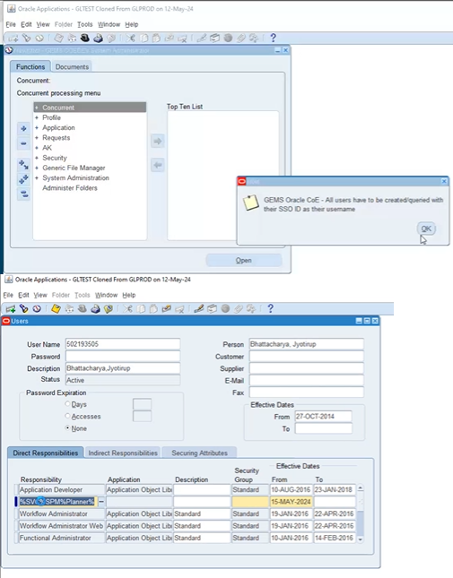

Open users tab

Give user name

Responsibility:

%SVC%SPM%Planner% : gems global svc spm

%Purchasing%World: gehc purchasing, worldwide

Paste the %queries and execute the commands.

Close users:

Open Responsibilities:

GE%: gehc purchasing, worldwide services support user

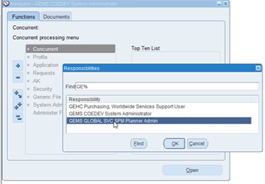

ping a **part**: 6208000-80 U00

we take a particular part number

For any part to be defined as an external supplier there are some basic steps we need to check.

in gehc purchasing:

Supply Base Vendor Inquiry +

Select **Approved Supplier List**

Organizations:

%u00 : Organization

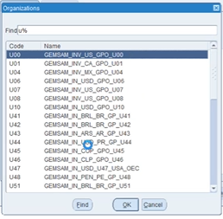

Parts:

Paste the part number in item column.

Crtl + F to execute the query.

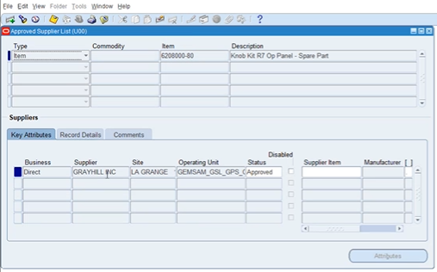

We find the **suppliers**.



Click on **attributes**:

Source Documents: Type: Blanket, Number**: Blanket Purchase Agreement Number**

Planning Constraints: Processing Lead time: time for part to come to inventory; in days

Close the window

Return to gehc purchasing, wssuser

Open responsibilities:

Select GEMS COEDEV System Administrator.

Then:

New functions list opens.

Security: User: Define

Users window opens:

Type username, Person: %Buyer%GXS%



Close

Return to gehc purchasing from responsibilities

Expand and click on purchase orders.

Type in the new window in purchase orders: Blanket purchase Agreement no. in PO. Rev

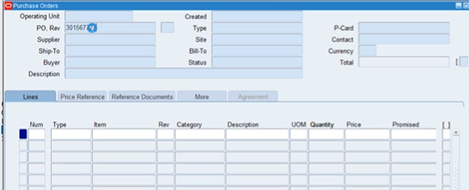

This completes bpa setup.

Sourcing rule setup:

gehc purchasing

Supply Base Vendor Inquiry: Assign Sourcing Rules

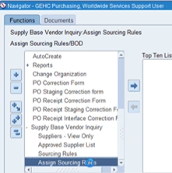

Select a organization name: u00

Assignment Set:

Query: %GPO%NEWBUY%ASSIGN%

in sourcing rule/ bill of distribution assignments

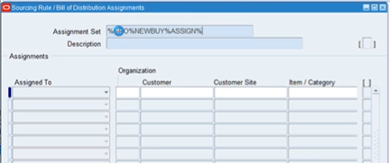

GPO newbuy assignset

This is also a prerequisite: For any part to have a sourcing record, this setup should be there.

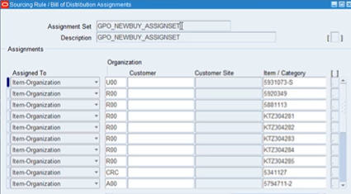

How to understand the item is there, copy the item no.

Click on Find Assignments in taskbar:

Organization: U00

Item: Paste the item no.

Click on Find.

So sourcing rule, autopopulates in the sourcing rule tab.



Copy the sourcing rule number.

Buying from external supplier.

For any external supplier to be defined, we have to have the full supplier list defined.

In the full supplier list, it should be enabled.

Clicking on attributes, shows the blanket purchase agreement number which shows the part is currently active on the bpa.

After that we ensure the part is assigned in assignment set GPO_NEWBUY_ASSIGNSET.

ASL, BPA and Sourcing Rule Setups