GE Healthcare ERP Integration

MD60 Functional Design– Oracle to SPM Data Feeds

The purpose of this document is to outline the process to extract the item master, part source, onhand details, demand history, supply, part transaction information’s and the processed recommendations records to SPM.

Revision of the GLPROD_MD60_PLN_GLPROD_DATA_TO_SPM.doc is controlled by the MyWorkshop system. Copies can be obtained via MyWorkshop.

This cover sheet controls the layout and components of the entire document.

File Revision: 26.0

Issued: When Released in MyWorkshop

Effective: When Released in MyWorkshop

Filename: GLPROD_MD60_PLN_GLPROD_DATA_TO_SPM.doc

Document ID: DOC1824937

Status: When Released in MyWorkshop

Author(s): Saurav Pawar, Functional Consultant, Global Services

Approver(s): Pavan Venkata, Director, Global Materials Planning, HC GBL SVS-Materials Parts

Neel Sen, Director - Technical Product Management, HC IT-DST-Parts & lifecycle Solutions.

Note: Before using this document, make sure it is the latest revision. Access the MyWorkshop system to verify the current revision. If you do not have access to, or are unfamiliar with, MyWorkshop system, you should consult your quality representative.

Any printout of this document is considered an uncontrolled copy.

This document is proprietary to GE Healthcare.

Revision History

|  |  |  |  |  |  |
| --- | --- | --- | --- | --- | --- |
| Revision | Date | **Author** | **Change Reference** | **Reason for Change** | **Project/Control Number** |
| 1.0 | 01-Feb-2016 | Jyotirup Bhattacharya | Initial Version | Initial Version | Daptiv Number: 10635,  Service Parts Management Project for Global Services, GLPROD 2016.3 release. |
| 2.0 | 18-May-2016 | Jyotirup Bhattacharya | Section 9.2.4,  9.2.6.4,  Sections 9.3.4, 9.4.4,  9.5.4, 9.6.4, 9.7.4, 11 | Added additional field names.  Added the business logic to derive the Average Repair Cost.  Added additional field names. | Daptiv Number: 10635,  Service Parts Management Project for Global Services, GLPROD 2016.3 release. |
| 3.0 | 24-JUL-2016 | Jyotirup Bhattacharya | Section 9.2.6.3  Section 9.3.4.66 | Removed logic for price calculation for ‘XOEC’ modality.  Added additional fields of ORG_SYS_DOCUMENT_REF | Daptiv Number: 10635,  Service Parts Management Project for Global Services, GLPROD 2016.3 release. |
| 4.0 | 23-May-2017 | Akhilesh Jha | Section 9.1.1  9.1.4  9.1.5.2  9.1.6.2, 9.1.6.3, 9.1.6.4  13.1, 13.2  9.2.5.1, 9.2.5.2  9.3.4.67  9.5.4.65, 9.5.4.36, 9.5.4.34, 9.3.4.64  9.5.4.66, 9.5.4.37,9.5.4.35,9.3.4.65  9.6.4.1.14, 9.6.4.2.16, 9.6.6.10 | Modified the logic to update error message in staging table  Removed the assumption that transaction id will be a unique field coming from SPM.  Updated the process flow to describe the process of marking unprocessed recommendations as error at the end of the day  Updated the business rules to incorporate the correct error message logging  updated the issue/risks and Response/Resolution  Updated the logic to Include those parts for which Planning item category has been assigned/updated  Updated the logic to derive the Order Type classification  Updated the logic to derive the delivered quantity  Updated the logic to derive PO Classification  Updated the logic to derive the SPM Enabled flag against the subinventory | FCCC# CHG0106272  FCCC# CHG0106625 |
| 5.0 | 22-Aug-2017 | Soumyadip Ghosh | 9.7.4.32  9.7.6.8 | FE Details to be sent as a part of Part Transactions Information Extract | FCCC# CHG0116566 |
| 6.0 | 25-Sep-2017 | Soumyadip Ghosh | 9.7.4.32  9.7.6.8 | FE Details to be sent as a part of Part Transactions Information Extract. (Revision 5.0 FCCC# CHG0116566 withdrawn as design not complying with test scenarios) | FCCC# CHG0120202 |
| 7.0 | 29-Mar-2018 | Priyanka Bali | 9.2.4.32 to 9.2.4.41  9.2.4.69 to 9.2.4.94  9.5.4.67 | Part Master data extraction logic update and additional columns.  Part Supply data extraction in additional information. | FCCC# CHG0136561 |
| 8.0 | 16-Jul-2018 | Akhilesh Jha | Section 9.2.6.12 | Changed condition of Special parameter submitted without date range for Part Master Extract | FCCC# CHG0151930 |
| 9.0 | 17-Aug-2018 | Akhilesh Jha | Section 9.2.4.23  Section 9.2.6.3  9.2.6.10  Section 9.5.4  Section 9.5.4.68  Section 9.5.6.12  Section 9.5.6.13  Section 9.5.6.14  Section 9.7.4.33  Section 9.7.6.8 | Updated Data entity for part Cost  Updated the logic to derive part cost.  Updated the logic to derive shelf life control  Updated Data entity 9.5.4.69 and from 9.5.4.74 through 9.5.4.109  Added the purpose of additional_info_4 in table GEHC_SVC_SPM_PART_SUPPLY_FEEDS  Added business rules to populate identifier to restrict POs  Updated logic to derive sales order details corresponding to an Affiliate, Internal, Defective or Repair purchase order.  Added the logic to derive PO Source  Updated Data entity to capture FE Local warehouse  Updated logic to derive FE Local warehouse | FCCC# CHG0152798 |
| 10.0 | 12-Mar-2019 | Akhilesh Jha | Section 9.5.2  Section 9.5.6.2  Section 7.3 | Updated the Program parameters for Supply extract program.  Updated the data extract logic to cover appropriate scenarios to extract data.  Expected Performance and Volume for Supply Program documented. | FCCC# GXPCHG0036216 |
| 11.0 | 29-May-2019 | Akhilesh Jha | Section 9.2.4.85  Section 9.2.4.86  Section 9.2.4.87  Section 9.2.6.10  Section 9.2.6.14  Section 9.2.6.15  Section 9.2.6.16  Section 9.3.4.68  Section 9.3.4.69  Section 9.3.6.10  Section 9.3.6.11  Section 9.4.4.1.16  Section 9.4.6.10  Section 9.6.4.1.15, 9.6.4.2.17  Section 9.6.4.2.18  Section 9.6.4.2.19  Section 9.6.4.2.20  Section 9.6.6.13  Section 9.6.6.14  Section 9.6.6.15  Section 9.6.6.16  Section 9.7.4.33  Section 9.7.4.34  Section 9.7.6.9  Section 9.7.6.10  Section 13.1, 13.2 | Updated data entity for part weight in kilograms  Updated data entity for BIN BULK flag  Updated data entity for Business Modality  Updated value set name for item modality to business mapping  Updated business rules for part weight in kilograms  Updated business rules for BIN BULK flag  Updated business rules for Business Modality  Updated the data entity to include the default warehouse  Updated the data entity to include the Customer class code  Updated logic to derive the default warehouse  Updated logic to derive the customer class code  Updated data entity for Internal Supplier Lead Time  Updated business logic for Internal Supplier Lead Time  Updated data entity for frozen cost in USD  Updated data entity for locator  Updated data entity for Customer Class code  Updated data entity for Primary PUDO location  Updated business logic for frozen cost in USD  Updated business rules for locator  Updated business rules for Customer Class code  Updated business rules for Primary PUDO location  Updated data entity for Customer class Code  Updated data entity for primary PUDO location  Updated business logic for Customer class Code  Updated business rules for primary PUDO location  Bug Fix for issue identified in Supply Extract program | FCCC# GXPCHG0039983 |
| 12.0 | 05-Jul-2019 | Akhilesh Jha | Section 3 | Documentation Reference to enter proper Requirement Id | FCCC# GXPCHG0039983 |
| 13.0 | 09-Sep-2019 | Akhilesh Jha | Section 9.3.4.65, 9.3.4.70, 9.3.4.71  Section 9.3.6.12  Section 9.3.6.13  Section 9.4.4.2.7, 9.4.4.2.8,9.4.4.2.9  Section 9.4.4.1.16  9.4.4.2.10  Section 9.4.6.10  Section 9.4.6.11  Section 9.5.4.65  Section 9.5.4.70  Section 9.5.6.15  Section 9.5.6.16  Section 9.6.4.1.19  9.6.4.2.21  Section 9.6.4.2.22  Section 9.6.6.17  Section 9.6.6.18  Section 9.7.4.32, 9.7.4.35  Section 9.7.4.36  Section 9.7.6.8, 9.7.6.11 | Updated the logic for FE_WAREHOUSE, ADDITIONAL_INFO_5 and ADDITIONAL_INFO_6 fields  Updated the logic for FE_WAREHOUSE column  Updated the logic for ADDITIONAL_INFO_5(default FE warehouse) column  Added the data entity for preprocessing, processing and post processing lead time of internal suppliers  Added the data entity for Sourcing rule name in Internal and external supplier extracts  Updated the logic of data extraction for pre-processing, processing and post processing component of internal supplier lead time  Updated the data extraction logic for sourcing rule name  Updated the data entity for FE local warehouse for RMA receipts  Updated the data entity for PO Price in USD  Updated the data extraction logic for PO Price in USD  Data extraction logic for FE local warehouse for RMA receipts  Updated data entity for subinventory disable date  Updated Data entity for FE local warehouse for service organization onhand  Updated business rules for subinventory disable date  Updated the logic to extract FE local warehouse for service organization onhand  updated data entity for FE SSO and local warehouse  updated data entity for Sales Order header warehouse  updated business rules for FE SSO and local warehouse | FCCC# GXPCHG0042415 |
| 14.0 | 24-Jan-2020 | Ankur Vikas | Section 9.4.4.3  Section 9.5.6.17  Section 9.6.5.3,4 | Data Entity for Repair Suppliers  Updated logic to derive Additional Info 7 and 8 for defective POs  Updated logic to compute Defective onhands | SPE# 201953496 |
| 15.0 | 14-Jul-2020 | Akhilesh Jha | Section 9.3.2  Section 9.3.4.72, 9.3.4.73, 9.3.4.74  Section 9.3.5.3,9.3.5.5  Section 9.3.5.4  Section 9.3.6.2, 9.3.6.4  Section 9.3.6.7  Section 9.3.6.13  Section 9.7.4.37 | Updated input section of demand extract program  Updated data entity with mapping logic for columns ADDITIONAL_INFO_7, ADDITIONAL_INFO_8, ADDITIONAL_INFO_9 to get Order type DFF Use for autorelease, delivery detail status and Cross reference auto release status respectively.  Updated Criteria to extract the order information  Updated process flow for Repair Center demand data  Updated the business rules to correct the order type criteria  Updated the business rule for data extraction  Updated business rules for Repair Center demand data  Updated data entity for transfer organization code of direct org transfer | SPE # 208600938 |
| 16.0 | 05-JAN-2020 | Hariharan Alagarraja | Section 9.3.6.14  Section 9.3.6.15  Section 9.3.6.16 | Added logic to get demand for 12 months | SPE# 214228979 |
| 17.0 | 19-Jul-2021 | Akhilesh Jha | Section 9.4.4.1.17,9.4.4.2.11,9.4.4.2.20,9.4.4.2.21 | Updated data entity for MOQ, Procurement lot size and supplier capacity for internal suppliers. | FCCC # GXPCHG0065416 |
| 18.0 | 06-Dec-2021 | Ankur Vikas | Section 9.4.6.12, 9.4.4.3.25  Section 9.6.5.4 | Included Repair Supplier extract for Swap part routings with purpose Swap  Warranty status of defective swap onhands mapped to additional_info_9 column | SPE # 222882805 |
| 19.0 | 29-May-2022 | Akhilesh Jha | Section 9.3.4.28  Section 9.3.4.48  Section 9.3.4.71  Section 9.3.6.17  Section 9.3.6.18 | Updated data entity for schedule ship date  Updated data entity for sales validation organization  Updated data entity for SR type  Updated logic for SR Type  Updated logic for Sales validation organization | SPE 226608581 |
| 20.0 | 21-Jul-2022 | Akhilesh Jha | section 9.2.4.88 through 9.2.4.114  Section 9.5.6.18 | Addition of columns additional_info_26 to additional_info_45 and derivation logic for ADDITIONAL_INFO_19(Use Onhands),ADDITIONAL_INFO_20(Block Procurement From),ADDITIONAL_INFO_21(Block Procurement To),ADDITIONAL_INFO_22(Block Repair From),ADDITIONAL_INFO_23(Block Repair To),ADDITIONAL_INFO_24(Quality Hold Date),ADDITIONAL_INFO_25(Phase In Date),ADDITIONAL_INFO_26(C2R Date),ADDITIONAL_INFO_27(R2C Date)  Updated logic for PO LINE LOCATION CREATED BY and PO LINE LOCATION LAST UPDATED BY fields | SPE 228125574 |
| 21.0 | 4-Aug-2022 | Akhilesh Jha | Section 9.2.4.89 to 9.2.4.92  Section 9.2.5.4 | Updated the field type of APC attributes from character to date  Added the new responsibility name for APC attribute update and bulk upload | SPE 228125574 |
| 22 | 9-Aug-2022 | Akhilesh Jha | Section 9.2.4.89 through 9.2.4.96  Section 9.5.4.54 | Changed the Attribute group and columns mapping  Updated length for hold name field | SPE 228125574 |
| 23 | 6-Sep-2022 | Akhilesh Jha | Section 9.2.4.32 through 9.2.4.46  Section 9.2.6.16 | Removed the logic of deriving the planning attributes from category set GE_GPO_SPM_PLN_DETAILS.  Removal of values from GE_GPO_SPM_PLN_DETAILS to derive planning attributes | SPE 228885774 |
| 24 | 19-Oct-2022 | Akhilesh Jha | Section 9.4.4.5.1 through 9.4.4.5.9  Section 9.4.5.5  Section 14 | Added data entity for Transfer routing  Added process flow for data extraction of transfer routing data  Added screenshot of defective routing form in appendix | 229583613 |
| 25 | 08-Dec-2022 | Saurav Pawar | Section 9.4.4.3.19 and  9.4.4.3.20  Section 9.4.6.13 and  9.4.6.14  Section 14 | Added data entity for Purpose and Supplier city of the repair supplier  Added Business rule for data extraction of Purpose and Supplier city  Added screenshot of defective routing and Supply base form in appendix. | SPE 230378112 |
| 26 | 14-Feb-2023 | Saurav Pawar | Section 9.5.4.3,  9.5.4.63,  9.5.4.66,  9.5.4.67 | Added data entry for RMA data set as part of Supply extract, to get all type of RMA returns with sub Inventory code and sub Inventory classification details | SPE 11617578366 |

Table of Contents

1. Introduction 12

2. Scope 12

2.1.In Scope 12

2.2.Out of Scope 12

3. Documentation References 12

4. Prerequisites 13

5. Terminology 13

6. As Is Process 14

6.1.Process Flow Diagram 14

6.2.Process Flow Narrative 14

7. To Be Process 15

7.1.Process Flow Diagram 15

7.2.Process Flow Narrative 15

7.3.Performance & Volume 16

7.4.Security (Encryption & Authorization) 17

8. Critical to Quality and or GxP 17

9. Functions 17

9.1.Function: SPM Recommendation feedback. 17

9.1.1. Approach / Description 17

9.1.2. Inputs 18

9.1.3. Outputs 18

9.1.4. Data Entity 18

9.1.5. Process Flow 20

9.1.6. Business Rules 21

9.1.7. Translations/Transformations (Interfaces Only) 22

9.1.8. Initiation 22

9.1.9. Error Handling, Reprocessing / Rollback & Error Messaging 22

9.2.Function: Part master Data 22

9.2.1. Approach / Description 22

9.2.2. Inputs 23

9.2.3. Outputs 23

9.2.4. Data Entity 23

9.2.5. Process Flow 35

9.2.6. Business Rules 35

9.2.7. Translations/Transformations (Interfaces Only) 37

9.2.8. Initiation 37

9.2.9. Error Handling, Reprocessing / Rollback & Error Messaging 37

9.3.Function: Part Demand Data 37

9.3.1. Approach / Description 37

9.3.2. Inputs 38

9.3.3. Outputs 38

9.3.4. Data Entity 38

9.3.5. Process Flow 45

9.3.6. Business Rules 46

9.3.7. Translations/Transformations (Interfaces Only) 49

9.3.8. Initiation 49

9.3.9. Error Handling, Reprocessing / Rollback & Error Messaging 49

9.4.Function: Part Source Data 50

9.4.1. Approach / Description 50

9.4.2. Inputs 50

9.4.3. Outputs 50

9.4.4. Data Entity 50

9.4.5. Process Flow 60

9.4.6. Business Rules 60

9.4.7. Translations/Transformations (Interfaces Only) 63

9.4.8. Initiation 63

9.4.9. Error Handling, Reprocessing / Rollback & Error Messaging 63

9.5.Function: Parts Supply 63

9.5.1. Approach / Description 63

9.5.2. Inputs 64

9.5.3. Outputs 64

9.5.4. Data Entity 65

9.5.5. Process Flow 91

9.5.6. Business Rules 91

9.5.7. Translations/Transformations (Interfaces Only) 96

9.5.8. Initiation 96

9.5.9. Error Handling, Reprocessing / Rollback & Error Messaging 96

9.6.Function: Extract Onhand Information 97

9.6.1. Approach / Description 97

9.6.2. Inputs 97

9.6.3. Outputs 97

9.6.4. Data Entity 97

9.6.5. Process Flow 103

9.6.6. Business Rules 104

9.6.7. Translations/Transformations (Interfaces Only) 106

9.6.8. Initiation 106

9.6.9. Error Handling, Reprocessing / Rollback & Error Messaging 106

9.7.Function: Extract Part Transactions Information 107

9.7.1. Approach / Description 107

9.7.2. Inputs 107

9.7.3. Outputs 107

9.7.4. Data Entity 107

9.7.5. Process Flow 113

9.7.6. Business Rules 113

9.7.7. Translations/Transformations (Interfaces Only) 117

9.7.8. Initiation 117

9.7.9. Error Handling, Reprocessing / Rollback & Error Messaging 117

9.8.Function: Purging of the recommendations staging table 117

9.8.1. Approach/Description 117

9.8.2. Inputs 117

9.8.3. Outputs 117

9.8.4. Data Entity 117

9.8.5. Process Flow 117

9.8.6. Business Rule 118

9.8.7. Translations/Transformations (Interfaces Only) 118

9.8.8. Initiation 118

9.8.9. Error Handling, Reprocessing / Rollback & Error Messaging 118

10. Scheduling 118

11. Dependent Programs 118

12. Additional Testing Requirements 120

13. Issues, Risks & Decisions 120

13.1.Issues/Risks Identified 120

13.2.Response / Resolution to Issues 120

14. Appendix 121

# Introduction

Service Parts Management (SPM) is the tool to be used for planning of parts across the GE Healthcare Service organizations. This will primarily replace XELUS and other small home grown tools used across the Globe.

SPM will run its forecasting engine based on the historic demand placed in Oracle considering the incoming supplies and existing item onhand across the warehouse in the globe and its network. The forecasting engine will also consider the existing part sources and item master information to make appropriate recommendations.

The below document describes the data extraction from Oracle to SPM that will serve as input to the forecasting engine for generating plan levels and recommendations.

The other processes shall be referred to in different design documents.

# Scope

## In Scope

Oracle Data will be extracted for all the SPM planning enabled warehouses. The data to be pulled essentially includes:

* + - * Part master information
* Demand information
* Supply information
* Part source information
* Part transactions information
* SPM Recommendation results

## Out of Scope

All process unrelated to the extraction of data from Oracle for SPM.

# Documentation References

|  |  |
| --- | --- |
| **Doc ID** | **Document Name** |
| Requirement ID : 105941 | Requirement Name : URS-003_Revision_104410_Revision_2 |
| Requirement ID : 104457 | Requirement Name: URS-004_Revision_104411 |
| Requirement ID : 104459 | Requirement Name: URS-007_Revision_104414 |
| DOC0098982 | GLPROD_MD60_LOG_DEFECTIVE_SHIPMENT_PROCESS |
| Requirement ID: 106053 | Extract Demand Information of sales Order lines for past 12 months |

# Prerequisites

|  |  |
| --- | --- |
| 1 | Value ‘ORACLE_TO_SPM_INTERFACE’ should be enabled in the value set ‘GEMS_GLP_INTERFACE_VALUESET’ for the interface to process recommendations. |
| 2 | GEHC_SVC_SPM_ENABLED_WAREHOUSE is a value set created to hold all organizations in scope for the SPM integration with Oracle. All organizations active in this value set should be considered for the processes. |
| 3 | The extract programs will run in DAILY or WEEKLY mode. For every run the previous runs data will be purged. However, there will be an avenue to run in SPECIAL mode with from and to dates. |

# Terminology

|  |  |
| --- | --- |
| **Term** | **Explanation** |
| SPM | Global Parts planning tool |
| Organization | Warehouses (Physical / Logical) that represent inventory entities |
| FE | Field Engineer |
| DC | Distribution Centre |
| Sub-inventory | Subdivision of an organization, representing either a physical area or a logical grouping of parts, such as BAD, GOOD Parts. |
| Locator | Physical area within a sub-inventory where you store material, such as row, bin or shelf and quantities tracked by locator |
| Parts Organization | ‘DC’, ‘WAREHOUSE’ and ‘SERVICE’ inventory organizations |
| GPRS Organization | ‘DC’ and ‘WAREHOUSE’ inventory organizations |
| Service Organization | ‘SERVICE’ inventory organizations |
| Location | Oracle Sub-inventory |
| Good quantity | Good stocks available on-hand in GPRS organizations (‘DC’ and ‘WAREHOUSE’) |
| AWS | Amazon Work Space |
| MW | Middleware |

# As Is Process

## Process Flow Diagram



## Process Flow Narrative

1. Select organization, part and on-hands from those ‘PARTS’ organizations, which does not exist in value set ‘GE_XELUS_RESTRICT_ORGS’ and those sub-inventories that do not exist in value set GE_XELUS_EXCLUDE_SUBINV.
2. Send the extracted data file to Xelus

# To Be Process

## Process Flow Diagram

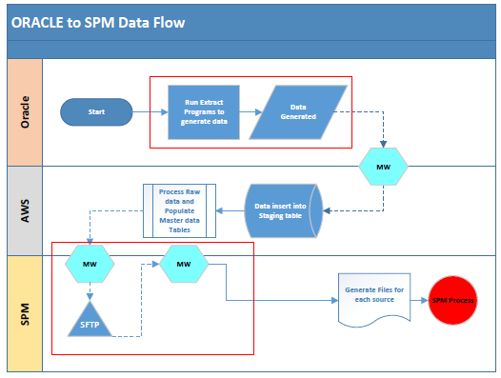

## Process Flow Narrative

The process flow narrates the process of the data transfer from Oracle to SPM. The data elements to be extracted are as follows:

* Parts Master: This is the item master information extracted from the Item master organizations defined in the ‘GEHC_SVC_SPM_ENABLED_WAREHOUSE’ warehouse, i.e the ‘GPO’ org. The screenshot for the same is provided in the Appendix. This will be a daily, weekly as well as a special extract.
* Parts Demand: This is the extract of all the sales orders whose order type is defined in the value set ‘GE_SVC_SPM_SO_DEMAND_TYPES’. The screenshot for the same is provided in the Appendix. This will be a daily incremental extract or a special extract.
* Part Supply: This is the extract of all the open supplies, i.e. Purchase Orders, Internal Requisitions that are approved. All received Return Material Authorization (RMA’s) will be referred as well. This will be extracted for organizations defined in the ‘GEHC_SVC_SPM_ENABLED_WAREHOUSE’ value set. The screenshot for the same is provided in the Appendix. This will be a daily incremental extract or a special extract.
* Part Source: This is the extract of the all the sources of a part like Suppliers (Internal or External) from who we will procure the parts. This will be a weekly extract.
* Part Transactions: All the material transactions for the transaction types defined in the value set ‘GEHC_SVC_SPM_TXN_DETAILS’ will be extracted. The screenshot for the same is provided in the Appendix. This will be a daily incremental extract or a special extract.
* Part Onhand: The onhand of the parts in the organizations defined in the ‘GEHC_SVC_SPM_ENABLED_WAREHOUSE’ value set. The screenshot for the same is provided in the Appendix. This will be a daily extract.
* SPM recommendation feedback: All the outcomes of the recommendations send by SPM will need to be fed back and done as part of this extract run daily.

Separate tables will be created for fetching the data extracts from oracle by the middleware. The data from the same shall be picked up by middleware (BOOMI) and transmitted to Amazon Web Services (AWS) and henceforth to SPM.

## Performance & Volume

| **Reference** | **Requirement** |
| --- | --- |
| Part Master | Approximate volume of 300MB ;Around 5.5 Lakh records will be fetched weekly approximately |
| Part Source | Approximate of 25 MB ; Around 1.5 Lakh records will be fetched weekly approximately |
| Part Onhand | Approximate of 25 MB ; Around 1.5 Lakh records will be fetched daily approximately |
| Part Demand Information | Approximate volume of 30MB; Around 2 Lakh records will be fetched daily approximately |
| Part Supply Information | Approximate volume of 30MB; Around 2 Lakh records will be fetched daily approximately. Around 70-80 lakh records approximately will be fetched for 3 years date range. The expected performance is as follows :   |  |  | | --- | --- | | **Date Range** | **Expected Run Duration** | | Daily | 15 min | | 1 month | 20 min | | 6 month | 1 hours 15 mins | | 1 year | 2 hours | | 3 years | ~4 hours (1 hour buffer) | |
| Part Transaction | Approximate volume of 15MB; Around 50 thousand records will be fetched daily approximately |
| SPM recommendation feedback | Approximate volume of 5MB; Around 10 thousand records will be fetched daily approximately |

| **Reference** | **Requirement** |
| --- | --- |
| 7.4.1 | None |

## Security (Encryption & Authorization)

# Critical to Quality and or GxP

The interface from SPM and Oracle is GxP.

# Functions

The following is the list of functions

| **Function Name** | **Function Description** |
| --- | --- |
| SPM Recommendation feedback | This function will update the recommendation staging table GEHC_SVC_PLN_SPM_STG with the Sales Order, Purchase Order Numbers for all records in ‘P’ status. Post updating the records will be extracted from this staging table. |
| Part master Data | Function to extract part attribute information from GPO Organization for all parts eligible for planning and feed the same to SPM. |
| Part Demand Data | Function to extract the demand information from all planning enabled GPRS Warehouses and feed the same to SPM |
| Part Source Data | Function to extract supplier’s details for each part along with supplier classification-Internal, External along with the processing lead times of each supplier. |
| Part Supply Data | Function to extract all forms of inbound data to warehouse that happens across all GPRS organizations which are planning enabled. |
| Part Onhand Data | Function to extract all onhand information across all GPRS planning enabled organizations and service organizations |
| Part Transaction Data | Function to extract the part transactions information from the material transaction for the types defined in the value set |
| Purging the recommendations staging table | The purging of the recommendations staging table to be done through a separate concurrent program. |

## Function: SPM Recommendation feedback.

### Approach / Description

This process will send feedback on the Oracle actions taken over the recommendations send by SPM.

On initiation, create an entry in the GEMS_IFACE_PROCESS_TABLE table to indicate the start time of the interface.

Firstly, all the recommendations will be updated with the relevant Sales Order (line_id) and/or Purchase Order details (line_location_id). For this extract all the records in the table GEHC_SVC_PLN_SPM_STG with for which req_line_id is populated.

* For NEWBUY recommendations, check for the Purchase Order created from the purchase requisition line id mentioned in the table. For successful PO created, update the po line location id in column PO_LINE_LOCATION_ID and update the status as ‘S’. If Purchase order is not found, update the status as ‘E’ with the PO creation failure error message in the ERROR_MESSAGE column.
* For ALLOCATION recommendations, check for the Sales Order and Purchase Order created from the internal requisition line id mentioned in the table. For successful PO and SO created, update the po line location id in column PO_LINE_LOCATION_ID, SO line id in the SO_LINE_ID column and update the status as ‘S’. If Purchase order/Sales Order is not found, update the status as ‘E’ with the processing failure error message (demand sourcing error table) in the ERROR_MESSAGE column.

Update process_flag as ‘E’ and error message as ‘Recommendation did not process by end of the day’ for all records in GEHC_SVC_PLN_SPM_STG table where creation date is today’s date and process flag is not in ‘E’ or ‘S’.

Once the records are updated, data from the recommendations table- GEHC_SVC_PLN_SPM_STG is extracted from the last extract start time of this function. This can be obtained from the GEMS_IFACE_PROCESS_TABLE data.

### Inputs

The function will have DAILY frequency as input parameter.

### Outputs

The function will update the document details (purchase order line location id and/or sales order line id) in the GEHC_SVC_PLN_SPM_STG table.

### Data Entity

The data elements for the GEHC_SVC_PLN_SPM_STG table are:

| **Column name** | **Data Type** | **Length** | **Nullable** | **Explanation** |
| --- | --- | --- | --- | --- |
| LOAD_ID | NUMBER | 25 | N | Unique Number to identify the interfaced data. This sequence will be generated by Middleware. |
| TRANSACTION_ID | NUMBER | 25 | N | Transaction id assigned against each recommendation from SPM system. |
| PLAN_RECOMMEND | VARCHAR2 | 20 | N | Type of Recommendation  REPAIR/MANUAL-REPAIR/ALLOCATION/NEWBUY/MANUAL-ALLOCATION/MANUAL-NEWBUY/MODIFICATION |
| QUANTITY | NUMBER | 25 | N | Quantity of item requested in items PRIMARY UOM |
| ITEM_NUMBER | VARCHAR2 | 40 | N | Item Number |
| SOURCE_ORGANIZATION_CODE | VARCHAR2 | 3 | Y | From Organization – used for Allocation/Repair |
| DESTINATION_ORGANIZATION_CODE | VARCHAR2 | 3 | Y | To Organization – used for New-Buy/Allocations |
| SUPPLIER_DETAILS | VARCHAR2 | 100 | Y | Supplier Number and Site Concatenated by ‘|’ |
| NEED_BY_DATE | DATE | NA | Y | Need by Date for the Purchase Order in the format ‘DD-MM-YYYY H24:MI:SS’ |
| SHIP_METHOD_TYPE | VARCHAR2 | 25 | Y | Ship Method classification (CEX/CRP) |
| DOCUMENT_ID | NUMBER | 25 | Y | LINE_LOCATION_ID – For PO, LINE_ID for SO. Will need to be send only for Modifications recommended from SPM |
| CREATED_BY_SSO | VARCHAR2 | 15 |  | SSO of the user from SPM |
| CREATION_DATE | DATE | NA | N | Creation date from SPM in the format ‘DD-MM-YYYY H24:MI:SS’ |
| LAST_UPDATED_BY | VARCHAR2 | 25 | Y | SSO of the user from SPM – populated only for Modifications |
| LAST_UPDATE_DATE | DATE | NA | Y | If modifications are sent by SPM like quantity change or Date change then this field will contain the date when SPM is suggesting the change. Else it will be same as the creation date. The field will be in the format ‘DD-MM-YYYY H24:MI:SS’ |
| PLAN_ORDER_DATE | DATE | NA | N | Date when recommendation was Planned in SPM in the format ‘DD-MM-YYYY H24:MI:SS’ |
| PROCESS_FLAG | VARCHAR2 | 5 | N | E – Error, S- Success, V – Validation Successful, N- New Record, P- In Process |
| ERROR_MESSAGE | VARCHAR2 | 3000 | Y | Error message for the Error records |
| INTERFACE_SOURCE_CODE | VARCHAR2 | 25 | N | Hard Coded : SVC-SPM |
| SUPPLIER_NUMBER | VARCHAR2 | 30 | Y | Initial half before ‘|’ in the SUPPLIER_DETAILS column |
| SUPPLIER_SITE | VARCHAR2 | 45 | Y | Later half after ‘|’ in the SUPPLIER_DETAILS column |
| AUTHORIZATION_STATUS | VARCHAR2 | 25 | Y | Hard Coded: APPROVED |
| SUBINVENTORY_CODE | VARCHAR2 | 10 | Y | SUBINVENTORY code to receive the part |
| BUYER_NAME | VARCHAR2 | 100 | Y | BUYER name to be used for Requisition |
| SHIP_TO_LOCATION | VARCHAR2 | 60 | Y | LOCATION name for the Warehouse |
| REQ_LINE_ID | NUMBER | NA | Y | Requisition Number LINE_ID – To be populated post processing |
| PO_LINE_LOCATION_ID | NUMBER | NA | Y | Purchase Order Number LINE LOCATION ID – To be populated post processing |
| SO_LINE_ID | NUMBER | NA | Y | Sales Order Number LINE_ID – To be populated post processing |
| PO_NUMBER | VARCHAR2 | 20 | Y | Purchase Order Number |
| PO_REL_NUM | NUMBER | NA | Y | Purchase Order Release Number |
| PO_LINE_NUM | NUMBER | NA | Y | Purchase Order Line Number |
| PO_SHIPMENT_NUM | NUMBER | NA | Y | Purchase Order Shipment Number |
| PO_REV_NUM | NUMBER | NA | Y | Purchase Order Revision number |
| PO_DOCUMENT_TYPE | VARCHAR2 | 25 | Y | Purchase Order Type |
| OPERATING_UNIT | VARCHAR2 | 240 | Y | Operating Unit Name |

### Process Flow

| **Reference** | **Requirement** |
| --- | --- |
| 9.1.5.1 | Update the SPM inbound table GEHC_SVC_PLN_SPM_STG with document details and the status flag. |
| 9.1.5.2 | Update process_flag as ‘E’ and error message as ‘Recommendation did not process by end of the day’ for all records in GEHC_SVC_PLN_SPM_STG table where creation date is today’s date and process flag is not in ‘E’ or ‘S’. |
| 9.1.5.3 | Extracts records from GEHC_SVC_PLN_SPM_STG based on the last extract start time. |

### Business Rules

| **Reference** | **Business Entity** | **Rule** |
| --- | --- | --- |
| 9.1.6.1 | Data Population | Add a record in the GEMS_IFACE_PROCESS_TABLE table with:  INTERFACE_NAME: GLPROD_TO_SPM_DATA_FEED  PROGRAM_NAME: DAILY_SPM_FEEDBACK  START_DATE: sysdate  STATUS_FLAG: ‘I’ |
| 9.1.6.2 | Data Extraction | All records where req_line_id is populated in table GEHC_SVC_PLN_SPM_STG should be looked for update. |
| 9.1.6.3 | Data Population | * For NEWBUY recommendations, check for the Purchase Order created from the purchase requisition line id mentioned in the table. For successful PO created, update the po line location id in column PO_LINE_LOCATION_ID and update the status as ‘S’. (The line location id in requisition lines table matches the line location id in PO line locations table). If Purchase order is not found, update the status as ‘E’ with the PO creation failure error message (from PO_INTERFACE_ERRORS table in the ERROR_MESSAGE column. * For ALLOCATION recommendations, check for the Sales Order and Purchase Order created from the internal requisition line id mentioned in the table(look in GEMS_ONT.GEMS_DS_LINES_ALL table with the requisition line id). For successful PO and SO created, update the po line location id in column PO_LINE_LOCATION_ID, SO line id in the SO_LINE_ID column and update the status as ‘S’. If Purchase order/Sales Order is not found, update the status as ‘E’ with the processing failure error message (demand sourcing error table GEMS_APPS.GEMS_GEMOMDSS_MSGS) in the ERROR_MESSAGE column. * If Purchase order/Sales Order is not found , then try to find the error message in table GEMS_APPS.GEMS_GEMOMDSS_MSGS against the requisition line id   If there are no error messages in GEMS_APPS.GEMS_GEMOMDSS_MSGS table against the requisition line then find the first error message from the table for the requisition header and populate it in Error message column of the staging table. |
| 9.1.6.4 | Data Population | Update process_flag as ‘E’ and error message as ‘Recommendation did not process by end of the day’ for all records in GEHC_SVC_PLN_SPM_STG table where creation date is today’s date and process flag is not in ‘E’ or ‘S’. |
| 9.1.6.5 | Data Extraction | The data extraction of the staging table is done based on the functions last run start time which can be fetched from the GEMS_IFACE_PROCESS_TABLE. |
| 9.1.6.6 | Data Population | For successful completion:  Update the GEMS_IFACE_PROCESS_TABLE table with the completion date and time of this execution of the function and status as ‘C’.  For failure:  Update the GEMS_IFACE_PROCESS_TABLE table with the completion date and time of this execution of the function, status as ‘E’ and the error reason in the Message field. |

### Translations/Transformations (Interfaces Only)

There will be no transformation/translation of data at oracle end.

### Initiation

This function will run always on daily frequency.

### Error Handling, Reprocessing / Rollback & Error Messaging

None

## Function: Part master Data

### Approach / Description

Extract the item master information for all parts eligible for planning from item Master Organization mentioned for the organization in the value set ‘GEHC_SVC_SPM_ENABLED_WAREHOUSE’. Whenever the function is invoked, a respective entry, highlighting the interface name, is created in custom table – GEMS_IFACE_PROCESS_TABLE to allow easy debugging in case of any issue.

Before extraction of data, the custom table where the extracts are stored for the previous run are purged completely for the corresponding interface name and are loaded with a new set of data by using the previous extract start run date/time as input for the next set of extraction or between a specific date intervals passed as input to the concurrent program.

The new set of data extracted will be appended to the previous set stored in the AWS layer making it an incremental type of extract.

### Inputs

Part Attributes information needs to be fetched for Item Master Organization mentioned for the organization in the value set ‘GEHC_SVC_SPM_ENABLED_WAREHOUSE’ for all parts and the same will be fed to the interface connected to SPM. The attributes to be extracted are mentioned in the section 9.2.4

### Outputs

At the start and end of this program, the corresponding entries must be made into the GEMS_IFACE_PROCESS_TABLE specifying the date and time for interface name: ORACLE_TO_SPM_DAILY and program name: PARTS_MASTER. The extracted records are stored into the table- GEHC_SVC_SPM_PART_MASTER_FEED

### Data Entity

The data entities of the Part Master extract and table (GEHC_SVC_SPM_PART_MASTER_FEED) columns are:

| **Reference** | **Data Entity** | **Field** | **Data Type** | **Length** | **Navigation** | **Description** |
| --- | --- | --- | --- | --- | --- | --- |
| 9.2.4.1 | Data Type | DATA TYPE | VARCHAR2 | 20 | Constant | PART_MASTER |
| 9.2.4.2 | Data Frequency | DATA FREQUENCY | VARCHAR2 | 10 | NA | DAILY/WEEKLY – as passed in the concurrent program parameter.  SPECIAL- when the extract runs for a specified date interval passed as parameter to the concurrent program |
| 9.2.4.3 | Item Master | ITEM NUMBER | VARCHAR2 | 40 | Inventory 🡪Items🡪 Organization Items🡪Item | Number from Item Master |
| 9.2.4.4 | Item Master | ITEM STATUS | VARCHAR2 | 10 | Inventory 🡪Items🡪 Organization Items🡪Main tab🡪Item status | Status of the part from Item Master |
| 9.2.4.5 | Item Master | ITEM DESCRIPTION | VARCHAR2 | 240 | Inventory 🡪Items🡪 Organization Items🡪 Description | Description of the part from Item Master |
| 9.2.4.6 | Item Master | ITEM ID | NUMBER | NA | Inventory 🡪Items🡪 Organization Items | Inventory Item Id of the part from Item Master |
| 9.2.4.7 | Item Master | MODALITY | VARCHAR2 | 240 | Inventory 🡪Items🡪 Organization Items🡪DFF🡪Modality (Attribute 3) | Modality of the part for GPO org where context is Global Parts Items |
| 9.2.4.8 | Item Master | ITEM TYPE | VARCHAR2 | 30 | Inventory 🡪Items🡪 Organization Items🡪Main tab🡪User Item type | Item type of the part from Item Master |
| 9.2.4.9 | Item Master | HAZARDOUS DETAILS | VARCHAR2 | 281 | Inventory 🡪Items🡪 Organization Items🡪Purchasing tab🡪Hazard class | Combination of Hazard Class and Description separated in pipe delimited format. |
| 9.2.4.10 | Item Master | PLANNER CODE | VARCHAR2 | 10 | Inventory 🡪Items🡪 Organization Items🡪General Planning->Planner | Planner Code of the item from Item Master |
| 9.2.4.11 | Item Master | PROD REL DATE (ATTRIBUTE4) | VARCHAR2 | 240 | Inventory🡪Items🡪Master Item🡪DFF 🡪 PROD REL DATE | Prod Rel Date (Attribute 4) |
| 9.2.4.12 | Item Master | ECCN CODE(ATTRIBUTE5) | VARCHAR2 | 240 | Inventory🡪Items🡪Master Item🡪DFF 🡪 ECCN CODE | ECCN Code (Attribute 5) |
| 9.2.4.13 | Item Master | COUNTRY OF ORIGIN(ATTRIBUTE7) | VARCHAR2 | 240 | Inventory🡪Items🡪Master Item🡪DFF 🡪 COUNTRY OF ORIGIN | Country of Origin (Attribute 7) |
| 9.2.4.14 | Item Master | SPECIAL HANDLING(ATTRIBUTE8) | VARCHAR2 | 240 | Inventory🡪Items🡪Master Item🡪DFF 🡪 SPECIAL HANDLING | Special Handling (Attribute 8) |
| 9.2.4.15 | Item Master | GEMSIT TP STATUS FLAG(ATTRIBUTE9) | VARCHAR2 | 240 | Inventory🡪Items🡪Master Item🡪DFF 🡪 GEMSIT TP STATUS FLAG | Gemsit Tp Status Flag(Attribute 9) |
| 9.2.4.16 | Item Master | RECEIVING INSPECTION CODE(ATTRIBUTE10) | VARCHAR2 | 240 | Inventory🡪Items🡪Master Item🡪DFF 🡪 RECEIVING INSPECTION CODE | Receiving Inspection Code (Attribute10) |
| 9.2.4.17 | Item Master | INVOICE UOM(ATTRIBUTE15) | VARCHAR2 | 240 | Inventory🡪Items🡪Master Item🡪DFF 🡪 INVOICE UOM | Invoice UOM (Attribute 15) |
| 9.2.4.18 | Item Master | GEMS_INSTALL_BASE_TRACKING (ATTRIBUTE14) | VARCHAR2 | 240 | Inventory🡪Items🡪Master Item🡪DFF 🡪 GEMS_INSTALL_BASE_TRACKING | Gems_Install_Base_Tracking (Attribute 14) |
| 9.2.4.19 | Item Master | ITEM ATTRIBUTE11 | VARCHAR2 | 240 | Inventory🡪Items🡪Master Item🡪DFF 🡪 ATTRIBUTE11 | Item Attribute 11 |
| 9.2.4.20 | Item Master | ITEM ATTRIBUTE12 | VARCHAR2 | 240 | Inventory🡪Items🡪Master Item🡪DFF 🡪 ATTRIBUTE12 | Item Attribute 12 |
| 9.2.4.21 | Item Master | ITEM ATTRIBUTE13 | VARCHAR2 | 240 | Inventory🡪Items🡪Master Item🡪DFF 🡪 ATTRIBUTE13 | Item Attribute 13 |
| 9.2.4.22 | Item Master | PLANNER DETAILS | VARCHAR2 | 372 | Purchasing🡪Setup🡪Personnel🡪Buyers | Planner Details comprises of a combination of Planner Name, Planner Employee Number and Planner User Name separated in pipe delimited format |
| 9.2.4.23 | Item Master | ITEM COST | NUMBER | NA | trp_cur_mmicv  from prepro.gems_tran_price_tb table | MMICV Item Cost (Derive the cost as trp_cur_mmicv  from first record after sorting all the records in descending order of trp_cur_mmicv) |
| 9.2.4.24 | Hold Sources | MANUAL BACKLOG HOLD | CHAR | 1 | Order Management🡪Order Organizer🡪Tools🡪Create Hold Sources | Manual Backlog Hold in M02.Screenshot of the same is added in Appendix |
| 9.2.4.25 | Item Category | AUTO-RELEASE EXCLUSION REASON(SEGMENT1) | VARCHAR2 | 40 | Inventory🡪Items🡪Master Item🡪Tool🡪Category🡪 GEHC_GPO_EXCLUDE_AUTOREL | Auto Release Exclusion Reason Flag |
| 9.2.4.26 | Hold Sources | JAPAN SPECIFIC HOLDS- EXPORT | CHAR | 1 | Order Management🡪Order Organizer🡪Tools🡪Create Hold Sources | Japan export only hold. Screenshot of the same is added in Appendix |
| 9.2.4.27 | Hold Sources | JAPAN SPECIFIC HOLDS- DOMESTIC | CHAR | 1 | Order Management🡪Order Organizer🡪Tools🡪Create Hold Sources | Japan domestic hold. Screenshot of the same is added in Appendix |
| 9.2.4.28 | Item Master | MEDICAL DEVICE | VARCHAR2 | 30 | Fetched from APC attributes | Refer to screenshot in appendix. Medical Device identifier for GEM org |
| 9.2.4.29 | Item Master | CONTAINS MEDICAL DEVICE | VARCHAR2 | 30 | Fetched from APC attributes | Refer to screenshot in appendix Contains Medical Device identifier for GEM org |
| 9.2.4.30 | Item Master | SHELF LIFE CODE | NUMBER | NA | Inventory 🡪Items🡪 Organization Items🡪Inventory tab🡪Lot Expiration(Shelf Life) 🡪Control | Shelf Life Code determines whether a part is shelf life controlled or not. |
| 9.2.4.31 | Item Master | GPO CATEGORY SET | VARCHAR2 | 81 | Inventory🡪Items🡪Master Item🡪Tool🡪Category🡪 GEHC GPO CAT SET | GPO Category Set: Concatenated value of segment1 and segment2. Separated in pipe delimited format  Segment2 will have values for Swap, Harvest and C2R. |
| 9.2.4.32 | Item Category | PLANNING CATEGORY  SEGMENT1 | VARCHAR2 | 30 | APC 🡪 Setup 🡪 Setup Workbench 🡪 Items 🡪Item Attributes 🡪 Part Criticality 🡪 Part Criticality | Planning Category Segment1 Flag to be derived from APC Item Attribute Setup |
| 9.2.4.33 | Item Category | PLANNING CATEGORY  SEGMENT2 | VARCHAR2 | 30 | APC 🡪 Setup 🡪 Setup Workbench 🡪 Items 🡪Item Attributes 🡪 NPI Program | Planning Category Segment2 Flag to be derived from APC Item Attribute Setup. |
| 9.2.4.34 | Item Category | PLANNING CATEGORY  SEGMENT3 | VARCHAR2 | 30 | APC 🡪 Setup 🡪 Setup Workbench 🡪 Items 🡪Item Attributes 🡪 Tech Obso | Planning Category Segment3 Flag to be derived APC Item Attribute Setup. |
| 9.2.4.35 | Item Category | PLANNING CATEGORY  SEGMENT4 | VARCHAR2 | 30 | APC 🡪 Setup 🡪 Setup Workbench 🡪 Items 🡪Item Attributes 🡪 Fin Obso | Planning Category Segment4 Flag to be derived APC Item Attribute Setup. |
| 9.2.4.36 | Item Category | PLANNING CATEGORY  SEGMENT5 | VARCHAR2 | 30 | APC 🡪 Setup 🡪 Setup Workbench 🡪 Items 🡪Item Attributes🡪 LTB | Planning Category Segment5 Flag to be derived from APC Item Attribute Setup. |
| 9.2.4.37 | Item Category | PLANNING CATEGORY  SEGMENT6 | VARCHAR2 | 30 | APC 🡪 Setup 🡪 Setup Workbench 🡪 Items 🡪Item Attributes 🡪 Early Repair | Planning Category Segment6 Flag to be derived from APC Item Attribute Setup. |
| 9.2.4.38 | Item Category | PLANNING CATEGORY  SEGMENT7 | VARCHAR2 | 30 | APC 🡪 Setup 🡪 Setup Workbench 🡪 Items 🡪Item Attributes 🡪 Harvest Active | Planning Category Segment7 Flag to be derived from APC Item Attribute Setup. |
| 9.2.4.39 | Item Category | PLANNING CATEGORY  SEGMENT8 | VARCHAR2 | 30 | APC 🡪 Setup 🡪 Setup Workbench 🡪 Items 🡪Item Attributes 🡪 No Source | Planning Category Segment8 Flag to be derived from APC Item Attribute Setup. |
| 9.2.4.40 | Item Category | PLANNING CATEGORY  SEGMENT9 | VARCHAR2 | 30 | APC 🡪 Setup 🡪 Setup Workbench 🡪 Items 🡪Item Attributes 🡪 Software | Planning Category Segment9 Flag to be derived from APC Item Attribute Setup. |
| 9.2.4.41 | Item Category | PLANNING CATEGORY  SEGMENT10 | VARCHAR2 | 30 | APC 🡪 Setup 🡪 Setup Workbench 🡪 Items 🡪Item Attributes 🡪 Milestone | Planning Category Segment10 Flag to be derived from APC Item Attribute Setup. |
| 9.2.4.42 | Item Category | PLANNING CATEGORY  SEGMENT11 | VARCHAR2 | 30 | APC 🡪 Setup 🡪 Setup Workbench 🡪 Items 🡪Item Attributes 🡪 Milestone | Planning Category Segment11 Flag to be derived from APC Item Attribute Setup. |
| 9.2.4.43 | Item Category | PLANNING CATEGORY  SEGMENT12 | VARCHAR2 | 30 | APC 🡪 Setup 🡪 Setup Workbench 🡪 Items 🡪Item Attributes 🡪 Milestone | Planning Category Segment12 Flag to be derived from APC Item Attribute Setup. |
| 9.2.4.44 | Item Category | PLANNING CATEGORY  SEGMENT13 | VARCHAR2 | 30 | APC 🡪 Setup 🡪 Setup Workbench 🡪 Items 🡪Item Attributes 🡪 Milestone | Planning Category Segment13 Flag to be derived from APC Item Attribute Setup. |
| 9.2.4.45 | Item Category | PLANNING CATEGORY  SEGMENT14 | VARCHAR2 | 30 | APC 🡪 Setup 🡪 Setup Workbench 🡪 Items 🡪Item Attributes 🡪 Milestone | Planning Category Segment14 Flag to be derived from APC Item Attribute Setup. |
| 9.2.4.46 | Item Category | PLANNING CATEGORY  SEGMENT15 | VARCHAR2 | 30 | APC 🡪 Setup 🡪 Setup Workbench 🡪 Items 🡪Item Attributes 🡪 Milestone | Planning Category Segment15 Flag to be derived from APC Item Attribute Setup. |
| 9.2.4.47 | Item Master | LAST UPDATE DATE | DATE | NA | Inventory🡪Items🡪Master Item🡪Help🡪Record History🡪Update Date | Last Updated Date of the item in format ‘DD-MM-YYYY HH24:MI:SS’ |
| 9.2.4.48 | Item Master | CREATION DATE | DATE | NA | Inventory🡪Items🡪Master Item🡪Help🡪Record History🡪Creation Date | Creation Date of the item in format ‘DD-MM-YYYY HH24:MI:SS’ |
| 9.2.4.49 | Item Master | STOCK ENABLED FLAG | VARCHAR2 | 1 | Inventory🡪Items🡪Master Item🡪Inventory Tab🡪Stockable Flag | Stockable Flag of the item. |
| 9.2.4.50 | Item Master | HARMONIZATION CODE | VARCHAR2 | 240 | Inventory🡪Items🡪Master Item🡪DFF 🡪Harmonization Code | Harmonization Code of the item (Attribute 6) |
| 9.2.4.51 | Item Master | PROPRIETARY CODE | VARCHAR2 | 240 | Inventory🡪Items🡪Master Item🡪DFF 🡪Prop Code | Proprietary Code of the item (Attribute 1) |
| 9.2.4.52 | Item Master | REPAIR LEAD TIME | NUMBER | NA | Inventory🡪Items🡪Master Item🡪MPS/MRP Planning Tab🡪Repair Lead-Time | Repair Lead Time |
| 9.2.4.53 | Item Master | VARIABLE LEAD TIME | NUMBER | NA | Inventory🡪Items🡪Master Item🡪Lead Times Tab🡪Variable | Variable Lead Time |
| 9.2.4.54 | Item Master | FIXED LEAD TIME | NUMBER | NA | Inventory🡪Items🡪Master Item🡪Lead Times Tab🡪Fixed | Fixed Lead Time |
| 9.2.4.55 | Item Master | PROCESSING LEAD TIME | NUMBER | NA | Inventory🡪Items🡪Master Item🡪Lead Times Tab🡪Processing | Processing Lead Time |
| 9.2.4.56 | Item Master | PREPROCESSING LEAD TIME | NUMBER | NA | Inventory🡪Items🡪Master Item🡪Lead Times Tab🡪Preprocessing | Preprocessing Lead Time |
| 9.2.4.57 | Item Master | POSTPROCESSING LEAD TIME | NUMBER | NA | Inventory🡪Items🡪Master Item🡪Lead Times Tab🡪Postprocessing | Postprocessing Lead Time |
| 9.2.4.58 | Item Master | TARGET INVENTORY WINDOW | NUMBER | NA | Inventory🡪Items🡪Master Item🡪MPS/MRP Planning Tab🡪Target Inventory | Target Inventory Window |
| 9.2.4.59 | Item Master | MAXIMUM INVENTORY WINDOW | NUMBER | NA | Inventory🡪Items🡪Master Item🡪MPS/MRP Planning Tab🡪Maximum Inventory | Maximum Inventory Window |
| 9.2.4.60 | Item Master | DRP PLANNED FLAG | VARCHAR2 | 3 | Inventory🡪Items🡪Master Item🡪MPS/MRP Planning Tab🡪Distribution Planned Flag | Distribution Planned Flag |
| 9.2.4.61 | Item Master | MRP PLAN METHOD | VARCHAR2 | 80 | Inventory🡪Items🡪Master Item🡪MPS/MRP Planning Tab🡪Planning Method | MRP Planning Method |
| 9.2.4.62 | Item Master | INVENTORY PLAN METHOD | VARCHAR2 | 80 | Inventory🡪Items🡪Master Item🡪General Planning Tab🡪Inventory Planning Method | Inventory Planning Method |
| 9.2.4.63 | Item Master | SOURCE POLE | VARCHAR2 | 240 | Inventory🡪Items🡪Master Item🡪DFF 🡪Source Pole | Source Pole for GPO Org where DFF Context = ‘Global Parts Items’(Attribute 2) |
| 9.2.4.64 | Item Master | UN DETAILS | VARCHAR2 | 266 | Purchasing 🡪 UN Numbers🡪UN Number and Description | Concatenated fields of UN Number and Description separated in pipe delimited format |
| 9.2.4.65 | Item Master | PRIMARY UOM | VARCHAR2 | 3 | Inventory 🡪Items🡪 Organization Items🡪Main tab🡪Unit of Measure🡪 Primary | Primary Unit of Measurement |
| 9.2.4.66 | Item Master | FORECASTABLE FLAG | NUMBER | NA | Inventory🡪Items🡪Master Item🡪MPS/MRP Planning Tab🡪Forecast Control | Forecastable Flag |
| 9.2.4.67 | Item Master | PLANNER DESCRIPTION | VARCHAR2 | 50 | Inventory🡪Planning 🡪Planners🡪Description | Planner Description |
| 9.2.4.68 | Item Master | ARC COST | NUMBER | NA | Inventory🡪Cost🡪Item Costs → Enter item Number and Cost Type as ARC🡪Find🡪Unit Cost | Average Repair Cost |
| 9.2.4.69 | Item Master | Planning_Master_Org | VARCHAR2 | 3 | Inventory 🡪Items🡪 Organization | Part Master Org |
| 9.2.4.70 | Item Master | ADDITIONAL_INFO_1 | DATE | NA | APC 🡪 Setup 🡪 Setup Workbench 🡪 Items 🡪Item Attributes 🡪 NPI_M6_DATE | NPI_M6_DATE |
| 9.2.4.71 | Item Master | ADDITIONAL_INFO_2 | DATE | NA | APC 🡪 Setup 🡪 Setup Workbench 🡪 Items 🡪Item Attributes 🡪 SWAP_SETUP_DATE | SWAP_SETUP_DATE |
| 9.2.4.72 | Item Master | ADDITIONAL_INFO_3 | DATE | NA | APC 🡪 Setup 🡪 Setup Workbench 🡪 Items 🡪Item Attributes 🡪 TECH_OBSO_DATE | TECH_OBSO_DATE |
| 9.2.4.73 | Item Master | ADDITIONAL_INFO_4 | DATE | NA | APC 🡪 Setup 🡪 Setup Workbench 🡪 Items 🡪Item Attributes 🡪 FIN_OBSO_DATE | FIN_OBSO_DATE |
| 9.2.4.74 | Item Master | ADDITIONAL_INFO_5 | DATE | NA | APC 🡪 Setup 🡪 Setup Workbench 🡪 Items 🡪Item Attributes 🡪 LTB_DATE | LTB_DATE |
| 9.2.4.75 | Item Master | ADDITIONAL_INFO_6 | DATE | NA | APC 🡪 Setup 🡪 Setup Workbench 🡪 Items 🡪Item Attributes 🡪 EOSL_DATE | EOSL_DATE |
| 9.2.4.76 | Item Master | ADDITIONAL_INFO_7 | DATE | NA | APC 🡪 Setup 🡪 Setup Workbench 🡪 Items 🡪Item Attributes 🡪 M7a_DATE | M7a_DATE |
| 9.2.4.77 | Item Master | ADDITIONAL_INFO_8 | DATE | NA | APC 🡪 Setup 🡪 Setup Workbench 🡪 Items 🡪Item Attributes 🡪 M7b_DATE | M7b_DATE |
| 9.2.4.78 | Item Master | ADDITIONAL_INFO_9 | DATE | NA | APC 🡪 Setup 🡪 Setup Workbench 🡪 Items 🡪Item Attributes 🡪 M8a_DATE | M8a_DATE |
| 9.2.4.79 | Item Master | ADDITIONAL_INFO_10 | DATE | NA | APC 🡪 Setup 🡪 Setup Workbench 🡪 Items 🡪Item Attributes 🡪 M8b_DATE | M8b_DATE |
| 9.2.4.80 | Item Master | ADDITIONAL_INFO_11 | DATE | NA | NA | NA |
| 9.2.4.81 | Item Master | ADDITIONAL_INFO_12 | DATE | NA | NA | NA |
| 9.2.4.82 | Item Master | ADDITIONAL_INFO_13 | DATE | NA | NA | NA |
| 9.2.4.83 | Item Master | ADDITIONAL_INFO_14 | DATE | NA | NA | NA |
| 9.2.4.84 | Item Master | ADDITIONAL_INFO_15 | DATE | NA | NA | NA |
| 9.2.4.85 | Item Master | ADDITIONAL_INFO_16 | VARCHAR2 | 500 | Organization Item -> Physical Attributes -> Weight -> Unit Weight | Part Weight in Kilogram |
| 9.2.4.86 | Item Master | ADDITIONAL_INFO_17 | VARCHAR2 | 500 | Parts that have category BINBULK assigned to them for category set GE_GPO_ITEM_STOCK_REGION | BIN BULK flag |
| 9.2.4.87 | Item Master | ADDITIONAL_INFO_18 | VARCHAR2 | 500 | Value Sets -> GE_GPO_SPM_BUSINESS_MODALITY | Business Modality |
| 9.2.4.88 | Item Master | ADDITIONAL_INFO_19 | VARCHAR2 | 500 | APC 🡪 Setup 🡪 Setup Workbench 🡪 Service Milestone Dates -> Use Onhands (column C_EXT_ATTR16 in table apps.ego_mtl_sy_items_ext_b) | Use Onhands |
| 9.2.4.89 | Item Master | ADDITIONAL_INFO_20 | VARCHAR2 | 500 | APC 🡪 Setup 🡪 Setup Workbench 🡪 Service Milestone Dates 1-> Block Procurement From (column D_EXT_ATTR1 in table apps.ego_mtl_sy_items_ext_b) | Block Procurement From |
| 9.2.4.90 | Item Master | ADDITIONAL_INFO_21 | VARCHAR2 | 500 | APC 🡪 Setup 🡪 Setup Workbench 🡪 Service Milestone Dates 2-> Block Procurement To (column D_EXT_ATTR2 in table apps.ego_mtl_sy_items_ext_b) | Block Procurement To |
| 9.2.4.91 | Item Master | ADDITIONAL_INFO_22 | VARCHAR2 | 500 | APC 🡪 Setup 🡪 Setup Workbench 🡪 Service Milestone Dates 1-> Block Repair From (column D_EXT_ATTR3 in table apps.ego_mtl_sy_items_ext_b) | Block Repair From |
| 9.2.4.92 | Item Master | ADDITIONAL_INFO_23 | VARCHAR2 | 500 | APC 🡪 Setup 🡪 Setup Workbench 🡪 Service Milestone Dates 1-> Block Repair To (column D_EXT_ATTR4 in table apps.ego_mtl_sy_items_ext_b) | Block Repair To |
| 9.2.4.93 | Item Master | ADDITIONAL_INFO_24 | VARCHAR2 | 500 | APC 🡪 Setup 🡪 Setup Workbench 🡪 Service Milestone Dates 1-> Quality Hold Date (column D_EXT_ATTR5 in table apps.ego_mtl_sy_items_ext_b) | Quality Hold Date |
| 9.2.4.94 | Item Master | ADDITIONAL_INFO_25 | VARCHAR2 | 500 | APC 🡪 Setup 🡪 Setup Workbench 🡪 Service Milestone Dates 1-> Phase In Date (column D_EXT_ATTR6 in table apps.ego_mtl_sy_items_ext_b) | Phase In Date |
| 9.2.4.95 | Item Master | ADDITIONAL_INFO_26 | VARCHAR2 | 500 | APC 🡪 Setup 🡪 Setup Workbench 🡪 Service Milestone Dates 1-> C2R Date (column D_EXT_ATTR7 in table apps.ego_mtl_sy_items_ext_b) | C2R Date |
| 9.2.4.96 | Item Master | ADDITIONAL_INFO_27 | VARCHAR2 | 500 | APC 🡪 Setup 🡪 Setup Workbench 🡪 Service Milestone Dates 1-> R2C Date (column D_EXT_ATTR8 in table apps.ego_mtl_sy_items_ext_b) | R2C Date |
| 9.2.4.97 | Item Master | ADDITIONAL_INFO_28 | VARCHAR2 | 500 | Master Item -> Query item number -> Category assignment -> Value in the category set ‘TECHNICAL NATURE’ | Technical nature |
| 9.2.4.98 | Item Master | ADDITIONAL_INFO_29 | VARCHAR2 | 500 | NA | NA |
| 9.2.4.99 | Item Master | ADDITIONAL_INFO_30 | VARCHAR2 | 500 | NA | NA |
| 9.2.4.100 | Item Master | ADDITIONAL_INFO_31 | VARCHAR2 | 500 | NA | NA |
| 9.2.4.101 | Item Master | ADDITIONAL_INFO_32 | VARCHAR2 | 500 | NA | NA |
| 9.2.4.102 | Item Master | ADDITIONAL_INFO_33 | VARCHAR2 | 500 | NA | NA |
| 9.2.4.103 | Item Master | ADDITIONAL_INFO_34 | VARCHAR2 | 500 | NA | NA |
| 9.2.4.104 | Item Master | ADDITIONAL_INFO_35 | VARCHAR2 | 500 | NA | NA |
| 9.2.4.105 | Item Master | ADDITIONAL_INFO_36 | VARCHAR2 | 500 | NA | NA |
| 9.2.4.106 | Item Master | ADDITIONAL_INFO_37 | VARCHAR2 | 500 | NA | NA |
| 9.2.4.107 | Item Master | ADDITIONAL_INFO_38 | VARCHAR2 | 500 | NA | NA |
| 9.2.4.108 | Item Master | ADDITIONAL_INFO_39 | VARCHAR2 | 500 | NA | NA |
| 9.2.4.109 | Item Master | ADDITIONAL_INFO_40 | VARCHAR2 | 500 | NA | NA |
| 9.2.4.110 | Item Master | ADDITIONAL_INFO_41 | VARCHAR2 | 500 | NA | NA |
| 9.2.4.111 | Item Master | ADDITIONAL_INFO_42 | VARCHAR2 | 500 | NA | NA |
| 9.2.4.112 | Item Master | ADDITIONAL_INFO_43 | VARCHAR2 | 500 | NA | NA |
| 9.2.4.113 | Item Master | ADDITIONAL_INFO_44 | VARCHAR2 | 500 | NA | NA |
| 9.2.4.114 | Item Master | ADDITIONAL_INFO_45 | VARCHAR2 | 500 | NA | NA |

### Process Flow

| **Reference** | **Requirement** |
| --- | --- |
| 9.2.5.1 | Make an entry into the GEMS_IFACE_PROCESS_TABLE with interface run time and derive the last run time of the program if program is submitted with frequency parameter ‘DAILY’, ‘WEEKLY’, ‘SPECIAL’ |
| 9.2.5.2 | Extract the part attribute information from the GPO item master org for all parts that are created or updated after the last run time derived in step 9.2.5.1. Any items in GPO org where a new category is assigned or updated from the category set GE_GPO_SPM_PLN_DETAILS after the last run time of program should also be included in extract. |
| 9.2.5.3 | The extracted data is inserted into the table – GEHC_SVC_SPM_PART_MASTER_FEEDS |
| 9.2.5.4 | A New Responsibility **GEHC APC Service Attribute Maintenance** will be created to update the Part attributes in APC manually or through bulk upload. |

### Business Rules

| **Reference** | **Business Entity** | **Rule** |
| --- | --- | --- |
| 9.2.6.1 | Data Population | Add a record in the GEMS_IFACE_PROCESS_TABLE table with:  INTERFACE_NAME: GLPROD_TO_SPM_DATA_FEED  PROGRAM_NAME: WEEKLY_SPM_PART_MASTER  START_DATE: sysdate  STATUS_FLAG: ‘I’ |
| 9.2.6.2 | Organization | Select the part attributes information from Part Master defined in the DFF of value set ‘GEHC_SVC_SPM_ENABLED_WAREHOUSE’ |
| 9.2.6.3 | Item Cost | Derive the cost as trp_cur_mmicv of first record from apps.gems_tran_price_tb table after sorting all the records in descending order of trp_cur_mmicv for the part. |
| 9.2.6.4 | Item Cost | Derive the Average Repair Cost (ARC) for all the items from U00. The screenshot of the same is added in Appendix. |
| 9.2.6.5 | Planning Item Category | Category set GE_GPO_SPM_PLN_DETAILS to be included to derive the planning item category. |
| 9.2.6.6 | Auto Release exclusion flag | Items to be excluded from Auto release belongs to the category structure- GEHC_GPO_EXCLUDE_AUTOREL. |
| 9.2.6.7 | Hold Sources | ‘GEHC Manual Backlog’ is a hold that is applied for specific items sourced from M02.This hold information needs to be captured for all such items and feed into Planning Tool. The screenshot of the same is added in Appendix. |
| 9.2.6.8 | Hold Sources | ‘GPRS Domestic Only Part Hold’ is a hold which is applied to certain parts sourced from A38 and this information must be fed to the planning tool. The screenshot of the same is added in Appendix. |
| 9.2.6.9 | Hold Sources | ‘GPRS Export Only Part Hold’ is a hold which is applied to certain parts sourced from A38 and this information must be fed to the planning tool. The screenshot of the same is added in Appendix. |
| 9.2.6.10 | Item Shelf Life | 1. Get the Item modality from item master DFF segment Modality (attribute3 of MTL_SYSTEM_ITEMS_B). 2. Find the modality derived above in value set GE_GPO_SPM_BUSINESS_MODALITY and get the organization code from DFF segment DC (attribute2 of FND_FLEX_VALUES table) against this value. 3. Derive the item shelf life for the item from the organization derived above. |
| 9.2.6.11 | Data Purging | Before loading any set of new data into the staging table – GEHC_SVC_SPM_PART_MASTER_FEEDS, purge all the records from this table. |
| 9.2.6.12 | Data Extraction | If the Program is submitted with Parameter ‘Daily’ :  The Item master extract will take all items whose last update date is greater than or equal to the last successful extract start time fetched from the table GEMS_IFACE_PROCESS_TABLE (serves as input to the date filter condition to the part master query) for DAILY run  If the Program is submitted with Parameter ‘Weekly’ :  The entire data-set of part information is extracted without consideration of any date range.  If the Program is submitted with Parameter ‘Special’ :   1. If the START DATE and END DATE parameter to the concurrent program is Null, then the part information would be extracted for the entire data-set without consideration of any date range 2. If the START DATE and END DATE parameters are not null, then the data extraction is carried out where last update date is within these date intervals.   The extracted data is stored in the table- GEHC_SVC_SPM_PART_MASTER_FEEDS |
| 9.2.6.13 | Data Population | For successful completion:  Update the GEMS_IFACE_PROCESS_TABLE table with the completion date and time of this execution of the function and status as ‘C’.  For failure:  Update the GEMS_IFACE_PROCESS_TABLE table with the completion date and time of this execution of the function, status as ‘E’ and the error reason in the Message field. |
| 9.2.6.14 | Data Extraction | Extract the part weight in ADDITIONAL_INFO_16 field of table GEHC_SVC_SPM_PART_MASTER_FEEDS, from the Unit weight column under block Weight in Physical attributes tab of organization items form for the part in ‘GPO’ organization. This weight should be in Kilogram. If Part weight is not in kilogram then use UOM conversion to convert the weight in kilogram. If part weight can’t be derived in Kilogram due to missing UOM or UOM conversion, then this filed will be left blank |
| 9.2.6.15 | Data Extraction | Extract the Bin Bulk flag in ADDITIONAL_INFO_17 field of table GEHC_SVC_SPM_PART_MASTER_FEEDS, from the category set GE_GPO_ITEM_STOCK_REGION. If the part is assigned to category set GE_GPO_ITEM_STOCK_REGION in ‘GPO’ organization and the assigned category value is ‘BINBULK’ then populate ‘BINBULK’ in this field. |
| 9.2.6.16 | Data Extraction | Extract the business corresponding to a modality in ADDITIONAL_INFO_18 field of table GEHC_SVC_SPM_PART_MASTER_FEEDS, from the value set GE_GPO_SPM_BUSINESS_MODALITY. Business is stored in the DFF segment Business corresponding the modality value.  If the business corresponding to a modality for a part is not assigned in the valueset GE_GPO_SPM_BUSINESS_MODALITY, the value will be extracted as NULL |
| 9.2.6.16 | Planning Item Category | Category set GE_GPO_SPM_PLN_DETAILS to be excluded to derive the planning item category and planning category segments to be derived from APC only. |

### Translations/Transformations (Interfaces Only)

There will be no transformation/translation of data at oracle end. The data extracted will be captured by MW and stored in the AWS DB for any further processing into SPM cloud.

### Initiation

The function will be part of a concurrent program with frequency as the parameter. The parameter ‘Frequency’ can have any one value of DAILY or WEEKLY or SPECIAL.

The concurrent program will also have an optional parameter ‘START DATE’ and ‘END DATE’ to enable the data to be fetched between a particular date interval.

### Error Handling, Reprocessing / Rollback & Error Messaging

None

## Function: Part Demand Data

### Approach / Description

Extract demand information from all organizations defined in the value set: GEHC_SVC_SPM_ENABLED_WAREHOUSE. Whenever the function is invoked, a respective entry, highlighting the interface name, Is created in custom table – GEMS_IFACE_PROCESS_TABLE to allow easy debugging in case of any issue.

Before extraction of data, the custom table where the extracts are stored for the previous run are purged completely for the corresponding interface name and are loaded with a new set of data by using the last extract start date/time as input for the next set of extraction or between a specific date intervals passed as input to the concurrent program.

The new set of data extracted will be appended to the previous set stored in the AWS layer making it an incremental type of extract.

### Inputs

All order types with below criteria will be considered for extraction on an incremental basis since the last run of the program

1. A) Order type DFF attribute 'use for autorelease' is set to Yes (attribute10 of oe_transaction_Types_all is 'Y' where context is 'Service OM') or

B) Order type in value set- GE_GPRS_SPM_SO_DEMAND with Context as 'GE_GPRS_SPM_SO_DEMAND' and DFF Segment 'Scope' as 'INCLUDE'.

1. Order header or line warehouse is in the value set 'GEHC_SVC_SPM_ENABLED_WAREHOUSE'

### Outputs

At the start and end of this program, the corresponding entries must be made into the GEMS_IFACE_PROCESS_TABLE specifying the date and time for interface name: ORACLE_TO_SPM_DAILY and program name: PARTS_DEMAND_SO. The extracted records are stored into the table- GEHC_SVC_SPM_PART_DEMAND_FEEDS

### Data Entity

The data entities of the Demand Information extract and table (GEHC_SVC_SPM_PART_DEMAND_FEEDS) columns are:

| **Reference** | **Data Entity** | **Field** | **Data Type** | **Length** | **Navigation** | **Description** |
| --- | --- | --- | --- | --- | --- | --- |
| 9.3.4.1 | Data Type | DATA TYPE | VARCHAR2 | 20 | Constant | PART_DEMAND |
| 9.3.4.2 | Data Frequency | DATA FREQUENCY | VARCHAR2 | 10 | NA | DAILY – as passed in the concurrent program parameter.  SPECIAL- when the extract runs for a specified date interval passed as parameter to the concurrent program |
| 9.3.4.3 | SALES ORDER HEADER | ORDER NUMBER | NUMBER | NA | Orders,Returns 🡪 Sales orders🡪Order Information🡪Main🡪Order number | Order Number |
| 9.3.4.4 | SALES ORDER HEADER | HEADER ID | NUMBER | NA | Fetched from order headers base table | Header ID of the Order Number |
| 9.3.4.5 | SALES ORDER LINE | LINE ID | NUMBER | NA | Fetched from order lines base table | Line ID of the Order Number |
| 9.3.4.6 | SALES ORDER | OPERATING UNIT | VARCHAR2 | 240 | Fetched from order headers base table | Operating Unit Name for the Order |
| 9.3.4.7 | CUSTOMER | CUSTOMER NUMBER | VARCHAR2 | 30 | Customers🡪Standard🡪Account Number | Customer Number in Order |
| 9.3.4.8 | CUSTOMER | CUSTOMER NAME | VARCHAR2 | 360 | Customers🡪Standard🡪 Customer | Customer Name in Order |
| 9.3.4.9 | CUSTOMER | CUSTOMER CATEGORY | VARCHAR2 | 30 | Customers🡪Standard🡪 Customer🡪Customer Account🡪 Profile🡪Customer Category | Customer Category in Order |
| 9.3.4.10 | CUSTOMER | FE SSO | NUMBER | NA | Customers🡪Standard🡪 Customer🡪Customer Account🡪 Profile🡪Duns Number | DUNS Number of FE |
| 9.3.4.11 | SALES ORDER | ORDER TYPE NAME | VARCHAR2 | 30 | Orders, Returns 🡪 Sales orders🡪Order Information🡪Main🡪Order Type | Order Type Name of Order |
| 9.3.4.12 | SALES ORDER TYPE | ORDER TYPE | VARCHAR2 | 30 | Setup 🡪 Transaction Types 🡪Define 🡪 Transaction Type Code | Order Type of Order |
| 9.3.4.13 | SALES ORDER TYPE | ORDER TYPE CATEGORY | VARCHAR2 | 30 | Order Management🡪Setup 🡪 Transaction Types 🡪Define 🡪Query Order Type 🡪 Order Category | Category of Order type |
| 9.3.4.14 | SALES ORDER LINE | ORDER_LINE STATUS | VARCHAR2 | 30 | Orders,Returns 🡪 Sales orders🡪Line Items🡪Main🡪Status | Line Status of Order |
| 9.3.4.15 | SALES ORDER HEADER | HEADER ORDER SOURCE | VARCHAR2 | 240 | Orders,Returns 🡪 Sales orders🡪Order Information🡪Others🡪Order Source | Order Source whether its DCOS/FEMC  from Order Header |
| 9.3.4.16 | SALES ORDER HEADER | HEADER ORDER STATUS | VARCHAR2 | 30 | Orders,Returns 🡪 Sales orders🡪Order Information🡪Main🡪Status | Order Status in Header |
| 9.3.4.17 | SALES ORDER LINE | LINE ORDER SOURCE | VARCHAR2 | 240 | Orders,Returns 🡪 Sales orders🡪Order Information🡪Line Items 🡪Main tab🡪Order Source | Order Source whether its DCOS/FEMC  from Order Line |
| 9.3.4.18 | SALES ORDER HEADER | RFS | VARCHAR2 | 50 | Orders,Returns 🡪 Sales orders🡪Order Information🡪Main🡪Customer PO | Customer PO number |
| 9.3.4.19 | SALES ORDER LINE | LINE NUMBER | VARCHAR2 | 81 | Orders,Returns 🡪 Sales orders🡪Line Items🡪Main🡪Line | Sales Order Line Number |
| 9.3.4.20 | SALES ORDER LINE | ORDERED ITEM | VARCHAR2 | 2000 | Orders,Returns 🡪 Sales orders🡪Line Items🡪Main🡪Ordered Item | Sales Order Ordered Item |
| 9.3.4.21 | SALES ORDER QUANTITY | ORDERED QUANITY | NUMBER | NA | Orders,Returns 🡪 Sales orders🡪Line Items🡪Main🡪Quantity | Ordered Quantity |
| 9.3.4.22 | SALES ORDER QUANTITY | SHIPPED QUANTITY | NUMBER | NA | Orders,Returns 🡪 Sales orders🡪Line Items🡪Shipping🡪Shipped Quantity | Quantity Shipped |
| 9.3.4.23 | SALES ORDER QUANTITY | RESERVED QUANTITY | NUMBER | NA | Orders,Returns 🡪 Sales orders🡪Line Items🡪Shipping🡪Quantity Reserved | Quantity Reserved |
| 9.3.4.24 | SALES ORDER LINE | UOM | VARCHAR2 | 3 | Orders,Returns 🡪 Sales orders🡪Line Items🡪Main🡪UOM | Unit of Measurement of Item |
| 9.3.4.25 | ORGANIZATION | SHIP FROM | VARCHAR2 | 3 | Orders,Returns 🡪 Sales orders🡪Line Items🡪Shipping🡪Warehouse | Ship From Organization Code |
| 9.3.4.26 | SALES ORDER LINE | REQUEST DATE | DATE | NA | Orders,Returns 🡪 Sales orders🡪Line Items🡪Shipping🡪Request Date | Order Request Date in format ‘DD-MM-YYYY HH24:MI:SS’ |
| 9.3.4.27 | SALES ORDER LINE | PROMISE DATE | DATE | NA | Orders,Returns 🡪 Sales orders🡪Line Items🡪Shipping🡪Promise Date | Order Promised Date in format ‘DD-MM-YYYY HH24:MI:SS’ |
| 9.3.4.28 | SALES ORDER LINE | SCHEDULED SHIP DATE | DATE | NA | Orders,Returns 🡪 Sales orders🡪Line Items🡪Shipping🡪Schedule Ship Date | For Shipped order line Actual Shipment Date for orders that are yet to to be shipped, Scheduled Ship Date in format ‘DD-MM-YYYY HH24:MI:SS’ |
| 9.3.4.29 | SALES ORDER HEADER | SHIPMENT PRIORITY | VARCHAR2 | 30 | Orders,Returns 🡪 Sales orders🡪Order Information🡪Others🡪Shipment Priority | Shipment Priority |
| 9.3.4.30 | APPLICATION DEVELOPER | SHIP METHOD | VARCHAR2 | 80 | Application Developer🡪Application🡪Lookups🡪Select Type as SHIP_METHOD🡪Meaning | Ship Method in Order |
| 9.3.4.31 | APPLICATION DEVELOPER | SHIP METHOD PRIORITY | VARCHAR2 | 150 | Application Developer🡪Application🡪Lookups🡪 Select Type as SHIP_METHOD🡪Common Lookups DFF🡪UPS Service Level | Ship Method Priority in Order |
| 9.3.4.32 | SALES ORDER HEADER | SHIPPING INSTRUCTIONS | VARCHAR2 | 2000 | Orders,Returns 🡪 Sales orders🡪Order Information🡪Others🡪Shipping Instructions | Shipping Instructions in Order |
| 9.3.4.33 | SALES ORDER HEADER | PACKING INSTRUCTIONS | VARCHAR2 | 2000 | Orders,Returns 🡪 Sales orders🡪Order Information🡪Others🡪Packing Instructions | Packing Instructions in Order |
| 9.3.4.34 | SALES ORDER HEADER | HEADER Autorelease Enabled Flag | VARCHAR2 | 240 | Order Management🡪 Setup🡪Transaction Types🡪Define🡪Query Order Type🡪DFF🡪Use For Autorelease | Denotes the Order which has been  Autoreleased in Sales Order Header(Attribute 10) |
| 9.3.4.35 | SALES ORDER HEADER | HEADER DCOS Enabled Flag | VARCHAR2 | 240 | Order Management🡪 Setup🡪Transaction Types🡪Define🡪Query Order Header Type🡪DFF🡪DCOS Order | Denotes the DCOS Orders which has been autoreleased in Sales Order Header(Attribute 9) |
| 9.3.4.36 | SALES ORDER LINE | LINE Autorelease Enabled Flag | VARCHAR2 | 240 | Order Management🡪 Setup🡪Transaction Types🡪Define🡪Query Order Line Type🡪DFF🡪Use For Autorelease | Denotes the Order which has been  Autoreleased in Sales Order Line(Attribute 10) |
| 9.3.4.37 | SALES ORDER LINE | LINE DCOS Enabled Flag | VARCHAR2 | 240 | Order Management🡪 Setup🡪Transaction Types🡪Define🡪Query Order Line Type🡪DFF🡪DCOS Order | Denotes the DCOS Orders which has been autoreleased in Sales Order Line(Attribute 9) |
| 9.3.4.38 | SALES ORDER HEADER | HEADER CREATION DATE | DATE | NA | Fetched from Order Record History | Order Header Creation Date in format ‘DD-MM-YYYY HH24:MI:SS’ |
| 9.3.4.39 | SALES ORDER HEADER | HEADER CREATED BY | VARCHAR2 | 100 | Fetched from Order Record History | Order Header Created By |
| 9.3.4.40 | SALES ORDER HEADER | HEADER uPDATION DATE | DATE | NA | Fetched from Order Record History | Order Header Updation Date in format ‘DD-MM-YYYY HH24:MI:SS’ |
| 9.3.4.41 | SALES ORDER HEADER | HEADER LAST UPDATED BY | VARCHAR2 | 100 | Fetched from Order Record History | Order Header Last Updated By User |
| 9.3.4.42 | SALES ORDER LINE | LINE CREATION DATE | DATE | NA | Fetched from Order Record History | Order Line Creation Date in format ‘DD-MM-YYYY HH24:MI:SS’ |
| 9.3.4.43 | SALES ORDER LINE | LINE CREATED BY | VARCHAR2 | 100 | Fetched from Order Record History | Order Line Created By |
| 9.3.4.44 | SALES ORDER LINE | LINE uPDATION DATE | DATE | NA | Fetched from Order Record History | Order Line Updation Date in format ‘DD-MM-YYYY HH24:MI:SS’ |
| 9.3.4.45 | SALES ORDER LINE | LINE LAST UPDATED BY | VARCHAR2 | 100 | Fetched from Order Record History | Order Line Last Updated By User |
| 9.3.4.46 | SALES ORDER LINE | CUSTOMER JOB | VARCHAR2 | 50 | Orders,Returns 🡪 Sales orders🡪Line Items🡪Others🡪Customer Job | Customer job associated with the order |
| 9.3.4.47 | SALES ORDER LINE | SYSTEM ID | VARCHAR2 | 50 | Orders,Returns 🡪 Sales orders🡪Line Items🡪Others🡪Customer Dock Code | System id passed from the CRM systems |
| 9.3.4.48 | SALES ORDER LINE | Customer PRODUCTION LINE | VARCHAR2 | 50 | Sales Validation Organization | Sales Validation Organization |
| 9.3.4.49 | SALES ORDER LINE | MODEL SERIAL NUMBER | VARCHAR2 | 50 | Orders,Returns 🡪 Sales orders🡪Line Items🡪Others🡪Model Serial Number | Customer Model serial number attached with the product |
| 9.3.4.50 | SALES ORDER LINE | SOURCED TYPE | VARCHAR2 | 13 | Orders,Returns 🡪 Sales orders🡪Line Items🡪Lines DFF🡪Source Type | Sourced from type, 1- Transfer from, 3- Buy from  (Attribute 13) |
| 9.3.4.51 | SALES ORDER LINE | SOURCED FROM | VARCHAR2 | 240 | Orders,Returns 🡪 Sales orders🡪Line Items🡪Lines DFF🡪GPO Line Fulfillment Source | Sourced from Organization Id(Attribute 8) |
| 9.3.4.52 | SALES ORDER LINE | LINE TYPE | VARCHAR2 | 30 | Orders,Returns 🡪 Sales orders🡪Line Items🡪Mains🡪Line Type | Line type of the order |
| 9.3.4.53 | SALES ORDER LINE | LINE TYPE CATEGORY | VARCHAR2 | 30 | Order Management🡪Setup 🡪 Transaction Types 🡪Define 🡪Query Line Type 🡪 Order Category | Line type category of the order |
| 9.3.4.54 | SALES ORDER LINE | HOLD NAME | VARCHAR2 | 240 | Orders,Returns 🡪 Sales orders🡪Line Items🡪Additional Line Information 🡪Holds Name | Hold Name |
| 9.3.4.55 | HOLD INFO | HOLD TYPE | VARCHAR2 | 30 | Setup 🡪 Orders 🡪 Holds 🡪 type | Type of Hold |
| 9.3.4.56 | HOLD INFO | HOLD DATE | DATE | NA | Orders,Returns 🡪 Sales orders🡪Line Items🡪Additional Line Information 🡪 Applied Date | Date when Hold was applied in format ‘DD-MM-YYYY HH24:MI:SS’ |
| 9.3.4.57 | CUSTOMER | LCT | VARCHAR2 | 20 | Customers🡪Standard🡪 Customer name→ Accounts -> Account Details🡪 DFF🡪 GPO FE LOCATOR | Fetch the FE Warehouse, FE Service Organization and FE Subinventory code concatenated with dash separator. Example: U00-SUS-LCT001.For Non FE Customers, this field will be blank |
| 9.3.4.58 | CUSTOMER | FE COUNTRY | VARCHAR2 | 60 | Customers🡪Standard🡪 Customer name→ Accounts -> details → sites →Bill To Address → Country | FE Country |
| 9.3.4.59 | CUSTOMER | CUSTOMER CLASS CODE | VARCHAR2 | 30 | Customers🡪Standard🡪 Customer | Customer Class Code |
| 9.3.4.60 | SALES ORDER | ATTRIBUTE1 | VARCHAR2 | 240 | Orders,Returns 🡪 Sales orders🡪HeaderDFF🡪 Invoice Notes/Order Comments | Invoice Notes/Order Comments (Attribute 1) |
| 9.3.4.61 | SALES ORDER | ATTRIBUTE12 | VARCHAR2 | 240 | Orders,Returns 🡪 Sales orders🡪HeaderDFF🡪Address Line1 | Address Line 1(Attribute 12) |
| 9.3.4.62 | SALES ORDER | ATTRIBUTE13 | VARCHAR2 | 240 | Orders,Returns 🡪 Sales orders🡪HeaderDFF🡪Address Line2 | Address Line 2(Attribute 13) |
| 9.3.4.63 | SALES ORDER | ATTRIBUTE10 | VARCHAR2 | 240 | Orders,Returns 🡪 Sales orders🡪LineDFF🡪Order Line Description/Comments | Order Line Description/Comments(Attribute 10) |
| 9.3.4.64 | SALES ORDER  LINE | PLANNING PRIORITY | NUMBER | NA | Orders,Returns 🡪 Sales orders🡪Line Items🡪Shipping Tab🡪Planning Priority | Planning Priority |
| 9.3.4.65 | SALES ORDER  HEADER | FE WAREHOUSE | VARCHAR2 | 3 | FE Warehouse from Customer Setup | FE Warehouse |
| 9.3.4.66 | SALES ORDER | ADDITIONAL_INFO_1 | VARCHAR2 | 500 | Orders,Returns --> Sales orders-->Others🡪Order Source Reference | Order Source Reference |
| 9.3.4.67 | SALES ORDER | ADDITIONAL_INFO_2 | VARCHAR2 | 500 | Check for the order type as an enabled value in value set ‘GE_GPRS_SPM_SO_DEMAND’ and take the description listed against that value. | Order Type Classification |
| 9.3.4.68 | SALES ORDER | ADDITIONAL_INFO_3 | VARCHAR2 | 500 | Default warehouse | Warehouse associated with the order type of the order |
| 9.3.4.69 | SALES ORDER | ADDITIONAL_INFO_4 | VARCHAR2 | 500 | Related Customer rank from Customer Account relationship | Primary PUDO location and DUNS Number concatenated by pipe delimiter |
| 9.3.4.70 | SALES ORDER | ADDITIONAL_INFO_5 | VARCHAR2 | 500 | Orders,Returns --> Sales orders-->Others🡪Warehouse | Default FE Warehouse |
| 9.3.4.71 | SALES ORDER | ADDITIONAL_INFO_6 | VARCHAR2 | 500 | NA | SR Type |
| 9.3.4.72 | SALES ORDER | ADDITIONAL_INFO_7 | VARCHAR2 | 500 | OM Super User -> Transaction Types -> Define -> Additional Order Type Information -> Use For Autorelease | Order type is enabled for Auto release or not |
| 9.3.4.73 | SALES ORDER | ADDITIONAL_INFO_8 | VARCHAR2 | 500 | OM Super User -> Shipping -> Transactions -> Lines/LPNs -> Line Status | Delivery detail status code |
| 9.3.4.74 | SALES ORDER | ADDITIONAL_INFO_9 | VARCHAR2 | 500 | Inventory Super User -> GEMS GPO CrossReference From -> Time details -> Auto Rel | Auto release is enabled for the warehouse and part type combination or not |
| 9.3.4.75 | SALES ORDER | ADDITIONAL_INFO_10 | VARCHAR2 | 500 | NA | NA |

### Process Flow

| **Reference** | **Requirement** |
| --- | --- |
| 9.3.5.1 | Make an entry into the GEMS_IFACE_PROCESS_TABLE with interface run time. |
| 9.3.5.2 | Purge all the records in the Parts demand staging table and reload it with new set of data. |
| 9.3.5.3 | Extract the different order information’s coming from various sources based on below criteria   1. A) Order type DFF attribute 'use for autorelease' is set to Yes (attribute10 of oe_transaction_Types_all is 'Y' where context is 'Service OM') or 2. Order type in value set- GE_GPRS_SPM_SO_DEMAND with Context as 'GE_GPRS_SPM_SO_DEMAND' and DFF Segment 'Scope' as 'INCLUDE' (attribute1). 3. Order header or line warehouse is in the value set 'GEHC_SVC_SPM_ENABLED_WAREHOUSE' 4. Orders with order type in value set- GE_GPRS_SPM_SO_DEMAND with Context as 'GE_GPRS_SPM_SO_DEMAND' and DFF Segment 'Scope' as 'EXCLUDE' (attribute1) should be excluded from the extract |
| 9.3.5.4 | Also, extract those orders that are created against an IR (link of SO to IR can be derived from GEMS_DS_LINES_ALL table) where combination of the source organization and destination organization (e.g., U00-RDC) is in the value set GE_GPO_REPAIR_CENTER_DEMAND and IR header DFF should not be in the value set ‘GEMS_GPO_ORDER_CLASSIFICATION’ with VALUE_CATEGORY and ATTRIBUTE1 set as ‘GEMS_GPO_ORDER_CLASSIFICATION ‘and ‘EXCLUDE’ respectively. |
| 9.3.5.5 | Data extraction is done starting from the last successful extract start time of this function or between the specific date intervals passed as input to the concurrent programs.  All sales order with criteria mentioned in section 9.3.5.3 should be extracted if any of below table has been updated in the timeframe mentioned above:   1. Order lines table (OE_ORDER_LINES_ALL) 2. Reservations table (MTL_RESERVATIONS) 3. Delivery details table (WSH_DELIVERY_DETAILS) |
| 9.3.5.6 | The extracted data is inserted into the table - GEHC_SVC_SPM_PART_DEMAND_FEEDS |

### Business Rules

| **Reference** | **Business Entity** | **Rule** |
| --- | --- | --- |
| 9.3.6.1 | Data Population | Add a record in the GEMS_IFACE_PROCESS_TABLE table with:  INTERFACE_NAME: GLPROD_TO_SPM_DATA_FEED  PROGRAM_NAME: DAILY_SPM_PART_DEMAND  START_DATE: sysdate  STATUS_FLAG: ‘I’ |
| 9.3.6.2 | Order types | Extract all orders Order type DFF attribute 'use for autorelease' is set to Yes (attribute10 of oe_transaction_Types_all is 'Y' where context is 'Service OM') or Order type in value set- GE_GPRS_SPM_SO_DEMAND with Context as 'GE_GPRS_SPM_SO_DEMAND' and DFF Segment 'Scope' (attribute1) as 'INCLUDE'.  Exclude all orders from the extract where order type in value set- GE_GPRS_SPM_SO_DEMAND with Context as 'GE_GPRS_SPM_SO_DEMAND' and DFF Segment 'Scope' (attribute1) as 'EXCLUDE'. |
| 9.3.6.3 | Sales Order | Select all order information as mentioned in 9.3.4 for the order types as mentioned in 9.3.6.2 |
| 9.3.6.4 | Type of Order | Type of Order will be determined based on below logic  If Order type name is like ‘%FE%SHIPMENT%’ then  ‘FE’  If Order type name is like ‘%REPAIR%SHIPMENT%’ or ‘%DEFECTIVE%’ then  ‘Defective_Orders’  Else  ‘DLR_DCOS’ |
| 9.3.6.5 | UOM | The Unit of Measurement (UOM) extracted here is the primary UOM of the item. |
| 9.3.6.6 | Data Purging | Before loading any set of new data into the staging table - GEHC_SVC_SPM_PART_DEMAND_FEEDS, purge all the records from the previous run of this table. |
| 9.3.6.7 | Data extraction | If the START DATE and END DATE the parameter to the concurrent program is Null, The Parts Demand extract will fetch all relevant records for which the last update date on order lines is greater than or equal to the last successful extract start time fetched from the table - GEMS_IFACE_PROCESS_TABLE (serves as input to the date filter condition of the extract query)  If the START DATE and END DATE parameters are not null, then the data extraction is carried out where last update date is within these date intervals.  The extracted data is stored in the table- GEHC_SVC_SPM_PART_DEMAND_FEED.  Sales order information should be extracted if any of below table has been updated in the timeframe mentioned above:   1. Order lines table (OE_ORDER_LINES_ALL) 2. Reservations table (MTL_RESERVATIONS) 3. Delivery details table (WSH_DELIVERY_DETAILS) |
| 9.3.6.8 | Data Population | For successful completion:  Update the GEMS_IFACE_PROCESS_TABLE table with the completion date and time of this execution of the function and status as ‘C’.  For failure:  Update the GEMS_IFACE_PROCESS_TABLE table with the completion date and time of this execution of the function, status as ‘E’ and the error reason in the Message field. |
| 9.3.6.9 | Data Extraction | ADDITIONAL_INFO_3 (Default warehouse) can be derived as the warehouse mentioned in the order type setup of the order |
| 9.3.6.10 | Data Extraction | ADDITIONAL_INFO_4 (Primary PUDO location) can be derived from the Customer account relationship for an FE customer (category code from hz_parties table is ‘GPO_FE_CUSTOMER’) where related customer is the PUDO Customer (customer class code in 'GPO_PUDO_WAREHOUSE','GPO_PUDO_SSL''GPO_PUDO_CUSTOMER','GPO_PUDO_TRANSIT') having the least value in field ‘Related Customer Rank’. (In case of multiple records fetched for PUDO customers with no/same rank assigned, need to choose any one value using rownum 1). For the given related PUDO customer, derive the locator assigned. Locator information for a PUDO is maintained at the attribute9 of hz_cust_accounts table. Populate this location in ADDITIONAL_INFO_4 column. FE to PUDO Customer mapping is shown in Appendix. |
| 9.3.6.11 | Data Extraction | Derive FE warehouse from FE customer setup using below logic  Using the sold_to_org_id column of order headers table derive the warehouse of the customer from hz_cust_accounts table (sold_to_org_id field of order headers table is the cust account id of the hz_cust_accounts table)  Populate the organization code derived above into FE_WAREHOUSE column of GEHC_SVC_SPM_PART_DEMAND_FEED table. |
| 9.3.6.12 | Data Extraction | Derive default FE warehouse from order header warehouse. Populate this information into ADDITIONAL_INFO_5 column of GEHC_SVC_SPM_PART_DEMAND_FEED table. |
| 9.3.6.13 | Data Extraction | Extract those orders that are created against an IR (link of SO to IR can be derived from GEMS_DS_LINES_ALL table) where combination of the source organization and destination organization (e.g., U00-RDC) is in the value set GE_GPO_REPAIR_CENTER_DEMAND and IR header DFF should not be in the value set ‘GEMS_GPO_ORDER_CLASSIFICATION’ with VALUE_CATEGORY and ATTRIBUTE1 set as ‘GEMS_GPO_ORDER_CLASSIFICATION ‘and ‘EXCLUDE’ respectively. |
| 9.3.6.14 | Data Extraction | Truncate table ge_gpo_demand_history |
| 9.3.6.15 | Data Extraction | Extract Country, Ordered Item, prime item of ordered item, Sum (ordered quantity).  Select Sales orders lines based on below criteria   1. Line category code= ‘ORDER’ 2. Shippable_flag in Order lines table = ‘Y’ 3. Sales order line status not in value set GE_GPO_DEMAND_EXCLUDED_SO_LINE_STATUS 4. Order type DFF attribute 'use for autorelease' is set to Yes (attribute10 of oe_transaction_Types_all is 'Y' where context is 'Service OM') OR Order type in value set- GE_GPRS_SPM_SO_DEMAND with Context as 'GE_GPRS_SPM_SO_DEMAND' and DFF Segment GPO Demand (attribute2) as 'Yes'. 5. Order type in value set- GE_GPRS_SPM_SO_DEMAND with Context as 'GE_GPRS_SPM_SO_DEMAND' and DFF Segment GPO Demand (attribute2) as 'Blank or No'. 6. Sales order line last updated in last 365 days 7. Line is shipped from PARTS Org and not present in value set GEMS_GPO_EXCLUDED_ORGS 8. Exclude orig_sys_document_ref LIKE 'GPOU%' OR 'GPO_GELS%' OR 'GPO_FLS%' |
| 9.3.6.16 | Data Extraction | Insert data into ge_gpo_demand_history |
| 9.3.6.17 | Data Extraction | SR Type  Case type from custom table gems_ont_ord_create_hdr_stg corresponding to the order (Staging table record can be cross referenced using the Order number and operating unit) |
| 9.3.6.18 | Data Extraction | Sales Validation Org  If a value is set for the customer system parameter ‘GE_DEFAULT_SHIPPING_VAL_ORG’ in the OE system parameters (table oe_sys_parameters_all) for the order operating unit and the order line type exists in the value set ‘GE_GPO_DEFAULT_LIN_TRX_TYPE_PV’ as an active value, then  Default shipping organization from Item master where item number is the item number on order line and organization is the value in the custom system parameter ‘GE_DEFAULT_SHIPPING_VAL_ORG’ in the OE system parameters (table oe_sys_parameters_all).  If the above condition is not met then Sales Validation organization will be the order header warehouse. |

### Translations/Transformations (Interfaces Only)

There will be no transformation/translation of data at oracle end. The data extracted will be captured by MW and stored in the AWS DB for further processing to SPM.

### Initiation

The function will be part of a concurrent program with frequency as the parameter. It will be scheduled to run daily once. The parameter ‘Frequency’ can have any one value of DAILY or SPECIAL.

The concurrent program will also have an optional parameter ‘START DATE’ and ‘END DATE’ to enable the data to be fetched between a particular date interval.

### Error Handling, Reprocessing / Rollback & Error Messaging

None

## Function: Part Source Data

### Approach / Description

Extract the suppliers – External/Internal, Repair details along with shipping network between warehouses to allow computation of lead times and make it available to the planning system. Whenever the function is invoked, a respective entry, highlighting the interface name, is created in custom table - GEMS_IFACE_PROCESS_TABLE to allow easy debugging in case of any issue.

Before extraction of data, the custom table where the extracts are stored for the previous run are purged completely for the corresponding interface name and are loaded with a new set of data, making it a flush and fill type of extraction.

### Inputs

Assignment set data - All data required are given in 9.4.4

### Outputs

At the start and end of this program, the corresponding entries must be made into the GEMS_IFACE_PROCESS_TABLE specifying the date and time for interface name: ORACLE_TO_SPM_DAILY and program name: PART_SOURCE. The extracted records are stored into the table- GEHC_SVC_SPM_PART_SOURCE_FEEDS.

### Data Entity

The data elements for the Part Source Information are listed below for External, Internal, Repair Suppliers and Shipping Networks.

1. **External Suppliers** : The data entity of the Part Source Information extract for External Suppliers are :

| **Reference** | **Data**  **Entity** | **Field** | **Data**  **Type** | **Length** | **Navigation** | **Description** |
| --- | --- | --- | --- | --- | --- | --- |
| 9.4.4.1.1 | Data Type | Data type | VARCHAR2 | 20 | Constant | PART_SOURCE |
| 9.4.4.1.2 | Data Frequency | Data Frequency | VARCHAR2 | 10 | NA | WEEKLY – as passed in the concurrent program parameter. |
| 9.4.4.1.3 | Supplier | Source Type | CHAR | 17 | Constant | Source Type is defined as EXTERNAL SUPPLIER |
| 9.4.4.1.4 | Assignment Set Lines | Organization Code | VARCHAR2 | 3 | Supply base-->Assign Sourcing Rules-->Organization | Organization Code |
| 9.4.4.1.5 | Assignment Set Lines | Item | VARCHAR2 | 40 | Supply base-->Assign Sourcing Rules-->Item/Category | Item Number. |
| 9.4.4.1.6 | Supplier | Supplier Number | VARCHAR2 | 30 | Supply base-->Suppliers--> Supplier Number | Supplier Number. |
| 9.4.4.1.7 | Supplier | Supplier Name | VARCHAR2 | 240 | Supply base-->Suppliers--> Supplier Name | Supplier Name. |
| 9.4.4.1.8 | Supplier | Supplier Site | VARCHAR2 | 45 | Supply base-->Suppliers--> Update -> Site Name | Supplier Site. |
| 9.4.4.1.9 | Supplier | Alternate supplier Site | VARCHAR2 | 320 | Supply base-->Suppliers-> Address Book -> Manage Sites -> Identification -> Alternate Site Name | Alternate Supplier Site. |
| 9.4.4.1.10 | Supplier | Supplier Country | VARCHAR2 | 75 | Supply base-->Suppliers--> Update -> Address Book -> Country | Supplier Country. |
| 9.4.4.1.11 | Approved Supplier List | Minimum Order Quantity | NUMBER | NA | Approved Supplier List--> Item-->Attributes-->Inventory-->Minimum order quantity | Minimum Order Quantity. |
| 9.4.4.1.12 | Approved Supplier List | Fixed Lot Multiple | NUMBER | NA | Approved Supplier List--> Item-->Attributes-->Inventory-->Fixed Lot Multiple | Fixed Lot Multiple. |
| 9.4.4.1.13 | Sourcing Rule | Rank | NUMBER | NA | Sourcing Rule-->Name-->Shipping Organization-->Rank | Supplier Rank. |
| 9.4.4.1.14 | Approved Supplier List | Processing Lead Time | NUMBER | NA | Approved Supplier List--> Item-->Attributes-->Planning Constraints-->Fixed Lot Multiple | Lead times defined for a supplier. |
| 9.4.4.1.15 | Approved Supplier List | Allocation Percent | NUMBER | NA | Approved Supplier List--> Item-->Attributes-->Planning Constraints-->Allocation Percent | Allocation Percent. |
| 9.4.4.1.16 | Sourcing Rules | ADDITIONAL_INFO_1 | VARCHAR2 | 500 | Sourcing Rule | Sourcing Rule Name |
| 9.4.4.1.17 | Approved Supplier List | ADDITIONAL_INFO_2 | VARCHAR2 | 500 | Approved Supplier List--> Item-->Attributes-->Planning Constraints-->Capacity Per Day (For Active records) | Supplier Capacity |
| 9.4.4.1.18 | Supplier | ADDITIONAL_INFO_3 | VARCHAR2 | 500 | NA | NA |
| 9.4.4.1.19 | Supplier | ADDITIONAL_INFO_4 | VARCHAR2 | 500 | NA | NA |
| 9.4.4.1.20 | Supplier | ADDITIONAL_INFO_5 | VARCHAR2 | 500 | NA | NA |
| 9.4.4.1.21 | Supplier | ADDITIONAL_INFO_6 | VARCHAR2 | 500 | NA | NA |
| 9.4.4.1.22 | Supplier | ADDITIONAL_INFO_7 | VARCHAR2 | 500 | NA | NA |
| 9.4.4.1.23 | Supplier | ADDITIONAL_INFO_8 | VARCHAR2 | 500 | NA | NA |
| 9.4.4.1.24 | Supplier | ADDITIONAL_INFO_9 | VARCHAR2 | 500 | NA | NA |
| 9.4.4.1.25 | Supplier | ADDITIONAL_INFO_10 | VARCHAR2 | 500 | NA | NA |

**2. Internal Suppliers:** The data entity of the Part Source Information extract for Internal Suppliers are:

| **Reference** | **Data Entity** | **Field** | **Data**  **Type** | **Length** | **Navigation** | **Description** |
| --- | --- | --- | --- | --- | --- | --- |
| 9.4.4.2.1 | Data Type | Data type | VARCHAR2 | 20 | Constant | PART_SOURCE |
| 9.4.4.2.2 | Data Frequency | Data Frequency | VARCHAR2 | 10 | NA | WEEKLY – as passed in the concurrent program parameter. |
| 9.4.4.2.3 | Supplier | Source Type | CHAR | 17 | Constant | Source Type is defined as INTERNAL SUPPLIER |
| 9.4.4.2.4 | Assignment Set Lines | Organization Code | VARCHAR2 | 3 | Supply base-->Assign Sourcing Rules-->Organization | Organization Code |
| 9.4.4.2.5 | Assignment Set Lines | Item | VARCHAR2 | 40 | Supply base-->Assign Sourcing Rules-->Item/Category | Item Number. |
| 9.4.4.2.6 | Supplier | Supplier Organization | VARCHAR2 | 3 | Supply base-->Suppliers--> Update -> Organization | Supplier Organization. |
| 9.4.4.2.7 | Sourcing Rule Assignments | Preprocessing_lead_time | Number |  | Sourcing Rule Assignments -> DFF -> Pre Processing Lead Time |  |
| 9.4.4.2.8 | Sourcing Rule Assignments | Processing_lead_time | Number |  | Sourcing Rule Assignments -> DFF -> Processing Lead Time |  |
| 9.4.4.2.9 | Sourcing Rule Assignments | PostProcessing_lead_time | Number |  | Sourcing Rule Assignments -> DFF -> Processing Lead Time |  |
| 9.4.4.2.10 | Sourcing Rules | ADDITIONAL_INFO_1 | VARCHAR2 | 500 | Sourcing Rule | Sourcing Rule Name |
| 9.4.4.2.11 | Approved Supplier List | ADDITIONAL_INFO_2 | VARCHAR2 | 500 | Approved Supplier List--> Item-->Attributes-->Planning Constraints-->Capacity Per Day (For Active records) | Supplier Capacity |
| 9.4.4.2.12 | Supplier | ADDITIONAL_INFO_3 | VARCHAR2 | 500 | NA | NA |
| 9.4.4.2.13 | Supplier | ADDITIONAL_INFO_4 | VARCHAR2 | 500 | NA | NA |
| 9.4.4.2.14 | Supplier | ADDITIONAL_INFO_5 | VARCHAR2 | 500 | NA | NA |
| 9.4.4.2.15 | Supplier | ADDITIONAL_INFO_6 | VARCHAR2 | 500 | NA | NA |
| 9.4.4.2.16 | Supplier | ADDITIONAL_INFO_7 | VARCHAR2 | 500 | NA | NA |
| 9.4.4.2.17 | Supplier | ADDITIONAL_INFO_8 | VARCHAR2 | 500 | NA | NA |
| 9.4.4.2.18 | Supplier | ADDITIONAL_INFO_9 | VARCHAR2 | 500 | NA | NA |
| 9.4.4.2.19 | Supplier | ADDITIONAL_INFO_10 | VARCHAR2 | 500 | NA | NA |
| 9.4.4.2.20 | Approved Supplier List | Minimum Order Quantity | NUMBER | NA | Approved Supplier List--> Item-->Attributes-->Inventory-->Minimum order quantity | Minimum Order Quantity. |
| 9.4.4.2.21 | Approved Supplier List | Fixed Lot Multiple | NUMBER | NA | Approved Supplier List--> Item-->Attributes-->Inventory-->Fixed Lot Multiple | Fixed Lot Multiple. |

**3. Repair Suppliers:** The data entity of the Part Source Information extract for Repair Suppliers are :

| **Reference** | **Data Entity** | **Field** | **Data Type** | **Length** | **Navigation** | **Description** |
| --- | --- | --- | --- | --- | --- | --- |
| 9.4.4.3.1 | Data Type | Data type | VARCHAR2 | 20 | Constant | PART_SOURCE |
| 9.4.4.3.2 | Data Frequency | Data Frequency | VARCHAR2 | 10 | NA | WEEKLY – as passed in the concurrent program parameter. |
| 9.4.4.3.3 | Supplier | Source Type | CHAR | 17 | Constant | Source Type is defined as REPAIR SUPPLIER |
| 9.4.4.3.4 | Defective Routing Definition | Organization Code | VARCHAR2 | 3 | GPO Routing Definition Detail Form -->Organization | Organization Code from the routing view |
| 9.4.4.3.5 | Defective Routing Definition | Item | VARCHAR2 | 40 | GPO Routing Definition Form -> Item | Item Number from the routing view |
| 9.4.4.3.6 | Supplier | Supplier Number | VARCHAR2 | 30 | Supply base-->Suppliers--> Supplier Number | Supplier Number. |
| 9.4.4.3.7 | Defective Routing Definition | Supplier Name | VARCHAR2 | 240 | GPO Routing Definition Form -> Supplier Name | Supplier Name. |
| 9.4.4.3.8 | Defective Routing Definition | Supplier Site | VARCHAR2 | 45 | GPO Routing Definition Form -> Site Name | Supplier Site. |
| 9.4.4.3.9 | Supplier | Supplier Country | VARCHAR2 | 75 | Supply base-->Suppliers--> Update -> Address Book -> Country | Supplier Country. |
| 9.4.4.3.10 | Approved Supplier List | Minimum Order Quantity | NUMBER | NA | Approved Supplier List--> Item-->Attributes-->Inventory-->Minimum order quantity | MOQ will be defined as 1. If MOQ is not defined leave it as blank |
| 9.4.4.3.11 | Sourcing Rule | Rank | NUMBER | NA | Sourcing Rule-->Name-->Shipping Organization-->Rank | Supplier Rank will be defined as 1. If Rank is not defined leave it as blank |
| 9.4.4.3.12 | Approved Supplier List | Allocation Percent | NUMBER | NA | Approved Supplier List--> Item-->Attributes-->Planning Constraints-->Allocation Percent | Allocation Percent will be defined as 100. If Allocation is not defined leave it as blank |
| 9.4.4.3.13 | Defective Routing Definition | Processing Lead Time | NUMBER | NA | Routing Definition Form | Processing Lead Time. Leave it as blank if not setup |
| 9.4.4.3.14 | Defective Routing Definition | Preprocessing Lead Time | NUMBER | NA | Routing Definition Form | Preprocessing Lead Time . Leave it as blank if not setup |
| 9.4.4.3.15 | Defective Routing Definition | Postprocessing Lead Time | NUMBER | NA | Routing Definition Form | Postprocessing Lead Time. Leave it as blank if not setup |
| 9.4.4.3.16 | Supplier | ADDITIONAL_INFO_1 | VARCHAR2 | 500 | NA | NA |
| 9.4.4.3.17 | Supplier | ADDITIONAL_INFO_2 | VARCHAR2 | 500 | NA | NA |
| 9.4.4.3.18 | Supplier | ADDITIONAL_INFO_3 | VARCHAR2 | 500 | NA | NA |
| 9.4.4.3.19 | Purpose | ADDITIONAL_INFO_4 | VARCHAR2 | 500 | GEHC Global Services, GPO Defective Routing -> Purpose | Extracting the Purpose of the Repair Routing. (Repair/SWAP/Local)  (Based on the logic in the Business Rule section 9.4.6.13, populate Purpose) |
| 9.4.4.3.20 | Supplier City | ADDITIONAL_INFO_5 | VARCHAR2 | 500 | Supply base-->Suppliers--> Update -> Address Book -> City | City from where the Supplier Belongs.  (Based on the logic in the Business Rule section 9.4.6.14, populate City) |
| 9.4.4.3.21 | Supplier | ADDITIONAL_INFO_6 | VARCHAR2 | 500 | NA | NA |
| 9.4.4.3.22 | Supplier | ADDITIONAL_INFO_7 | VARCHAR2 | 500 | NA | NA |
| 9.4.4.3.23 | Supplier | ADDITIONAL_INFO_8 | VARCHAR2 | 500 | NA | NA |
| 9.4.4.3.24 | Supplier | ADDITIONAL_INFO_9 | VARCHAR2 | 500 | NA | NA |
| 9.4.4.3.25 | Supplier | ADDITIONAL_INFO_10 | VARCHAR2 | 500 | NA | If the purpose from routing is ‘Local Repair’, populate LOCAL, else if the purpose is ‘Repair’ OR the purpose is ‘SWAP’ AND Item is repairable or the item has repairable item (based on the logic in the Business Rule section 9.4.6.12, populate GLOBAL |

**4. Shipping Network** : The data entity of the Part Source Information extract for Shipping Network are :

| **Reference** | **Data Entity** | **Field** | **Data**  **Type** | **Length** | **Navigation** | **Description** |
| --- | --- | --- | --- | --- | --- | --- |
| 9.4.4.4.1 | Data Type | Data type | VARCHAR2 | 20 | Constant | PART_SOURCE |
| 9.4.4.4.2 | Data Frequency | Data Frequency | VARCHAR2 | 10 | NA | WEEKLY – as passed in the concurrent program parameter. |
| 9.4.4.4.3 | Supplier | Source Type | CHAR | 17 | Constant | Source Type is defined as SHIPPING NETWORK |
| 9.4.4.4.4 | Shipping Network | Organization Code | VARCHAR2 | 3 | Shipping Network → To Organization | Organization Code |
| 9.4.4.4.5 | Supplier | Supplier Number | VARCHAR2 | 30 | Supply base-->Suppliers--> Supplier Number | Supplier Number. |
| 9.4.4.4.6 | Shipping Network | Supplier Name | VARCHAR2 | 240 | Shipping Network --> DFF -> Supplier Name | Supplier Name. |
| 9.4.4.4.7 | Shipping Network | Supplier Site | VARCHAR2 | 45 | Shipping Network --> DFF -> Supplier Site | Supplier Site. |
| 9.4.4.4.8 | Supplier | Alternate supplier Site | VARCHAR2 | 320 | Supply base-->Suppliers-> Address Book -> Manage Sites -> Identification -> Alternate Site Name | Alternate Supplier Site. |
| 9.4.4.4.9 | Shipping Network | Supplier Organization | VARCHAR2 | 3 | Shipping Network → From Organization | Supplier Organization. |
| 9.4.4.4.10 | Supplier | Supplier Country | VARCHAR2 | 75 | Supply base-->Suppliers--> Update -> Address Book -> Country | Supplier Country. |
| 9.4.4.4.11 | Approved Supplier List | CRP ALLOCATION LEAD TIME | NUMBER | NA | Shipping Network🡪Tools🡪Shipping Methods🡪Intransit Time (for shipping method : GPO_ALLOCATE) | Intransit time for ship method = GPO ALLOCATE |
| 9.4.4.4.12 | Approved Supplier List | CEX ALLOCATION LEAD TIME | NUMBER | NA | Shipping Network🡪Tools🡪Shipping Methods🡪Intransit Time | Intransit time for default ship method. |
| 9.4.4.4.13 | Supplier | ADDITIONAL_INFO_1 | VARCHAR2 | 500 | NA | NA |
| 9.4.4.4.14 | Supplier | ADDITIONAL_INFO_2 | VARCHAR2 | 500 | NA | NA |
| 9.4.4.4.15 | Supplier | ADDITIONAL_INFO_3 | VARCHAR2 | 500 | NA | NA |
| 9.4.4.4.16 | Supplier | ADDITIONAL_INFO_4 | VARCHAR2 | 500 | NA | NA |
| 9.4.4.4.17 | Supplier | ADDITIONAL_INFO_5 | VARCHAR2 | 500 | NA | NA |
| 9.4.4.4.18 | Supplier | ADDITIONAL_INFO_6 | VARCHAR2 | 500 | NA | NA |
| 9.4.4.4.19 | Supplier | ADDITIONAL_INFO_7 | VARCHAR2 | 500 | NA | NA |
| 9.4.4.4.20 | Supplier | ADDITIONAL_INFO_8 | VARCHAR2 | 500 | NA | NA |
| 9.4.4.4.21 | Supplier | ADDITIONAL_INFO_9 | VARCHAR2 | 500 | NA | NA |
| 9.4.4.4.22 | Supplier | ADDITIONAL_INFO_10 | VARCHAR2 | 500 | NA | NA |

**5. Transfer Routing**: A new data category of ‘TRANSFER_ROUTING’ is being added in the part source staging table (GEHC_SVC_SPM_PART_SOURCE_FEED). The data entity of the Part Source Information extract for Transfer routing are:

| **Reference** | **Data Entity** | **Field** | **Data**  **Type** | **Length** | **Navigation** | **Description** |
| --- | --- | --- | --- | --- | --- | --- |
| 9.4.4.5.1 | Data Type | Data type | VARCHAR2 | 20 | Constant | PART_SOURCE |
| 9.4.4.5.2 | Data Frequency | Data Frequency | VARCHAR2 | 10 | NA | WEEKLY – as passed in the concurrent program parameter. |
| 9.4.4.5.3 | Transfer routing | Source Type | CHAR | 17 | Constant | TRANSFER_ROUTING |
| 9.4.4.5.4 | Transfer routing | Organization Code | VARCHAR2 | 3 | GEHC Global Services, GPO Defective Routing -> From Org | Transfer From org |
| 9.4.4.5.5 | Transfer routing | ITEM | VARCHAR2 | 40 | GEHC Global Services, GPO Defective Routing -> Item | Item |
| 9.4.4.5.6 | Transfer routing | Supplier Organization | VARCHAR2 | 3 | GEHC Global Services, GPO Defective Routing -> Transfer Org | Transfer to org |
| 9.4.4.5.7 | Shipping Network | CRP ALLOCATION LEAD TIME | NUMBER | NA | Shipping Network🡪Tools🡪Shipping Methods🡪Intransit Time (for shipping method : GPO_ALLOCATE) | Intransit time for ship method = GPO ALLOCATE from shipping network between From org and transfer org |
| 9.4.4.5.8 | Shipping Network | CEX ALLOCATION LEAD TIME | NUMBER | NA | Shipping Network🡪Tools🡪Shipping Methods🡪Intransit Time | Intransit time for default ship method from shipping network between From org and transfer org |
| 9.4.4.5.9 | Transfer routing | ADDITIONAL_INFO_3 | VARCHAR2 | 500 | GEHC Global Services, GPO Defective Routing -> GPO Item Type | Item type |

### Process Flow

| **Reference** | **Requirement** |
| --- | --- |
| 9.4.5.1 | An entry is made into the GEMS_IFACE_PROCESS_TABLE with respective start times |
| 9.4.5.2 | Purge all the records in the Part Source staging table and reload it with new set of data. |
| 9.4.5.3 | All the external, internal, repair supplier details, attributes, and shipping network details are extracted as per data entity mentioned in 9.4.4 |
| 9.4.5.4 | Lead time of various suppliers like Internal, External and Repair needs to be stored and maintained in Oracle. The lead times between warehouses per ship method classification should be maintained in Oracle. |
| 9.4.5.5 | Extract transfer routing records from view GE_GPO_DEF_ROUTING_V in the format defined in the data entity section where value for column purpose is ‘TRANSFER’.  Extract only active records (Records for which effective_from_date and effective_to_date as well as lin_effective_from_date and lin_effective_to_date from view GE_GPO_DEF_ROUTING_V are in active date range). |
| 9.4.5.6 | The extracted data is inserted into the table - GEHC_SVC_SPM_PART_SOURCE_FEEDS |

### Business Rules

| **Reference** | **Business Entity** | **Rule** |
| --- | --- | --- |
| 9.4.6.1 | Data Population | Add a record in the GEMS_IFACE_PROCESS_TABLE table with:  INTERFACE_NAME: GLPROD_TO_SPM_DATA_FEED  PROGRAM_NAME: WEEKLY_SPM_PART_SOURCE  START_DATE: sysdate  STATUS_FLAG: ‘I’ |
| 9.4.6.2 | External/Internal Supplier extraction | Extract part source for both External and Internal Suppliers. The assignment set to be considered can be found from the below logic :-  The sourcing assignment set profile option to be derived from the valueset – GEMS_GLP_INTERFACE_VALUESET value- 'PART_SOURCE_NEWBUY_ASSIGNMENT_SET'  The Assignment set is then derived with the profile option identified in 9.4.6.3 at user level where user is 'GLOBALPARTS'.  The Organization in scope for fetching the supplier details are defined as 'PARTS' organization and are enabled for planning defined under the value set GEHC_SVC_SPM_ENABLED_WAREHOUSE. |
| 9.4.6.3 | Source Type | Source Type 1 denotes the Internal Supplier,  Repair Supplier details is derived from the custom table -gehc_inv_gpo_routing |
| 9.4.6.4 | Supplier Classification | Extract the supplier classification as Internal, External, Repair and Shipping Network |
| 9.4.6.5 | Lead Times | For external suppliers fetch the processing lead time from the approved supplier list attribute. Pre and Post processing times to be Null for such case.  For Repair Suppliers, the pre-processing, processing and post processing lead times are fetched from the new defective routing from the view formed on the table - GE_GPO_DEF_ROUTING and GE_GPO_DEF_ROUTING_DETAILS.  For Internal Suppliers the lead times would be Null  For Processing lead time within a shipping network, the in-transit time for the ‘GPO ALLOCATE’ shipping method will be considered. If GPO ALLOCATE shipping method is not found within the shipping network then the processing lead time would be Null. Pre and Post processing lead times to be Null. method |
| 9.4.6.6 | Shipping Network | The organizations to be considered are maintained in the valueset - GEHC_SVC_SPM_ENABLED_WAREHOUSE. |
| 9.4.6.7 | Data Purging | Before loading any set of new data into the staging table - GEHC_SVC_SPM_PART_SOURCE_FEEDS, purge all the records from the previous run from this table. |
| 9.4.6.8 | Data extraction | The extracted data is stored in the table- GEHC_SVC_SPM_PART_SOURCE_FEEDS. No date filter condition is used here. |
| 9.4.6.9 | Data Population | For successful completion:  Update the GEMS_IFACE_PROCESS_TABLE table with the completion date and time of this execution of the function and status as ‘C’.  For failure:  Update the GEMS_IFACE_PROCESS_TABLE table with the completion date and time of this execution of the function, status as ‘E’ and the error reason in the Message field. |
| 9.4.6.10 | Data Extraction | Derive preprocessing, processing and post processing lead time components of Internal supplier lead time for the item and organization combination from sourcing rule assignment DFF segment post processing lead time, processing lead time and post processing lead time respectively where context value is 'GLOBALPARTS' and populate this value in preprocessing_lead_time, processing_lead_time and postprocessing_lead_time columns of table GEHC_SVC_SPM_PART_SOURCE_FEEDS respectively.  All global parts newbuy sourcing rules are defined in assignment set 'GPO_NEWBUY_ASSIGNSET'. For no value assigned to the DFF, value to be extracted as NULL. |
| 9.4.6.11 | Data Extraction | Derive the sourcing rule name for internal and external supplier extracts from the sourcing rule assigned for item and warehouse combination in assignment set 'GPO_NEWBUY_ASSIGNSET'. Populate this value in ADDITIONAL_INFO_1 column of table GEHC_SVC_SPM_PART_SOURCE_FEED. |
| 9.4.6.12 | External Repair Supplier | All The Repair routings defined in routing tables with purpose REPAIR or LOCAL REPAIR  AND  All the Repair routings defined in routing tables with purpose SWAP with repairable Items or if the routing Item has a Repairable Item  Repairable Item can be found using below logic.  To determine the Harvest, Repair, Prime  APC Attribute GE_Refurbished = ‘Yes’, indicates part is refurbished part.  APC Attribute (Attribute Group: “Additional PC Attributes”, Attribute Name: “Refurbished_Category”), indicates part is ‘Harvest’ or ‘Repairable’.  Relation between prime and Refurbished parts is stored in Item Relationship form and sample records would exist in this form as below:-   |  |  |  |  |  | | --- | --- | --- | --- | --- | | **From** | **To** | **Relation** | **DFF** | **APC Attribute** (Refurbished Category) – Not in Relationship table | | ABC-R | ABC | Substitute | Refurbished | Repairable | | ABC-H | ABC | Substitute | Refurbished | Harvest | |
| 9.4.6.13 | Repair Supplier- Purpose | Extract the value for purpose from field Purpose from Defective routing details (<GEMS_INV.GE_GPO_DEF_ROUTING_V>) for repair suppliers |
| 9.4.6.14 | Repair Supplier- Supplier city | Extract the Supplier city Information from Supplier details where Supplier Number and Supplier name is same as in Defective routing details. |

### Translations/Transformations (Interfaces Only)

There will be no transformation/translation of data at oracle end. The data extracted will be captured by MW and stored in the AWS DB for any further processing based on any business logics.

### Initiation

The function will be part of a concurrent program with frequency as the parameter. It will be scheduled to run daily once. The parameter frequency can have only one value of WEEKLY.

### Error Handling, Reprocessing / Rollback & Error Messaging

None

## Function: Parts Supply

### Approach / Description

Extract all forms of inbound data to warehouse across all GPRS Planning enabled warehouses included in the value set- GEHC_SVC_SPM_ENABLED_WAREHOUSE. The extracts which comprise the Supply Information are:-

* + PO extracts having the PO's created for all the organization and all BLANKET PO's in the Approved Supplier list attributes.
  + Internal Requisitions created as part of the allocation process of moving parts within warehouses.
  + Return Material Authorizations (RMA’s) created for field returns and repair returns.

Whenever the function is invoked, a respective entry, highlighting the interface name, is created in custom table - GEMS_IFACE_PROCESS_TABLE to allow easy debugging in case of any issue. Data extraction is done starting from the last extracted run time of the function obtained from the table- GEMS_IFACE_PROCESS_TABLE.

Before extraction of data, the custom table where the extracts are stored for the previous run are purged completely for the corresponding interface name and are loaded with a new set of data by using the last extract start run date/time as input for the next set of extraction or a between a specific date intervals passed as input to the concurrent program.

The new set of data extracted will be appended to the previous set stored in the AWS layer making it an incremental type of extract.

### Inputs

Organizations to be considered are included in the value set- GEHC_SVC_SPM_ENABLED_WAREHOUSE.

This program will have below 5 parameters:

* + 1. Frequency:

This parameter specifies the mode in which the program should run. This parameter can have below 3 values:

* + - 1. DAILY: When the Program is submitted with Frequency as ‘DAILY’ then all other parameters except ‘Truncate table’ will be Null. In this mode system will extract the last successful run of the program with frequency as ‘DAILY’ and extract all eligible records after that date.
      2. SPECIAL: In this mode, user will specify the start date and end date within which the eligible records need to be extracted. In this mode parameter ‘No of Days’ will not have any value.
      3. DAYS: In this mode, user will specify number of days in the ‘No of Days’ parameter, for which the eligible records need to be extracted. In this mode, program will extract all eligible records created/updated in last ‘No of days’ from current date. When frequency is selected as ‘DAYS’ and ‘No of days’ is not specified then processing of program should stop and error message (‘No of Days is required for frequency ‘DAYS’) will be logged into IFACE table.
    1. Start Date: This Parameter will only be populated when running in ‘SPECIAL’ mode and specifies the start data for data extraction.
    2. End Date: This Parameter will only be populated when running in ‘SPECIAL’ mode and specifies the end data for data extraction.
    3. Truncate Table: This parameter will default to ‘Yes’ in all modes so that data from previous run can be purged.
    4. No of Days: This parameter will only be applicable when frequency is ‘DAYS’. This parameter will specify for how many days in past the transactions need to be extracted starting with the current date.

### Outputs

At the start and end of this program, the corresponding entries must be made into the GEMS_IFACE_PROCESS_TABLE specifying the date and time for interface name: ORACLE_TO_SPM_DAILY and program name: PART_SOURCE. The extracted records are stored into the table- GEHC_SVC_SPM_PART_SUPPLY_FEED.

### Data Entity

The data elements for the Part Supply Information are listed below for PO Supply, PO Part Source, Requisition and RMA Details.

**1. PO SUPPLY Details:** The data columns are derived for all the PO supplies with the PARTS enabled warehouses.

| **Reference** | **Data Entity** | **Field** | **Data Type** | **Length** | **Navigation** | **Description** |
| --- | --- | --- | --- | --- | --- | --- |
| 9.5.4.1 | Data Type | Data type | VARCHAR2 | 20 | Constant | PART_SUPPLY |
| 9.5.4.2 | Data Frequency | Data Frequency | VARCHAR2 | 10 | Constant | DAILY as passed in the concurrent program parameter.  SPECIAL- when the extract runs for a specified date interval passed as parameter to the concurrent program |
| 9.5.4.3 | Purchase Order | EXTRACT TYPE | CHAR | 17 | Constant | Extract Type will be ‘PO_SUPPLY_DETAILS’ |
| 9.5.4.4 | Purchase Order | PO NUMBER | VARCHAR2 | 20 | Purchasing🡪 Purchase Orders 🡪 PO, Rev | Purchase Order Number |
| 9.5.4.5 | Purchase Order | PO TYPE | VARCHAR2 | 25 | Purchasing 🡪 Purchase Orders 🡪 TYPE | Purchase Order Type |
| 9.5.4.6 | Purchase Order | PO HEADER ID | NUMBER | NA | Fetched from Purchase Order Record History | Purchase Order Header ID |
| 9.5.4.7 | Purchase Order | PO HEADER CLOSED CODE | VARCHAR2 | 25 | Purchase Orders-> Purchase Order Summary ->Closure Status | Purchase Order Closed Code |
| 9.5.4.8 | Purchase Order | PO HEADER AUTHORIZATION STATUS | VARCHAR2 | 25 | Purchasing 🡪 Purchase Order🡪Status | Status Of Purchase Order |
| 9.5.4.9 | Purchase Order | PO HEADER ORG ID | NUMBER | NA | Purchase Orders-> Purchase Orders ->Operating Unit | PO Operating Unit : Derive the Org Id from the Operating Unit. |
| 9.5.4.10 | Purchase Order | PO HEADER CLASSIFICATION | VARCHAR2 | 150 | Purchase Orders-> Purchase Orders ->DFF → Order Classification (Attribute 6) | Purchase Order Header Classification |
| 9.5.4.11 | Purchase Order | PO HEADER COMMENTS | VARCHAR2 | 240 | Fetched from Purchase Order Record History | Purchase Order Header Comments |
| 9.5.4.12 | Supplier | SUPPLIER NUMBER | VARCHAR2 | 30 | Supply base-->Suppliers-->Query with Supplier Name -> Supplier Number | Supplier Number. |
| 9.5.4.13 | Purchase Order | SUPPLIER NAME | VARCHAR2 | 240 | Purchasing-> Purchase Orders🡪Supplier | Supplier Name |
| 9.5.4.14 | Supplier | SUPPLIER TYPE | VARCHAR2 | 30 | Supply Base 🡪Suppliers 🡪 Query with Supplier Name -> Update -> Organization -> Type | Supplier Type |
| 9.5.4.15 | Purchase Order | SUPPLIER SITE | VARCHAR2 | 45 | Purchasing 🡪 Purchase Orders🡪 Site | Supplier Site. |
| 9.5.4.16 | Supplier | SUPPLIER COUNTRY | VARCHAR2 | 75 | Supply Base 🡪Suppliers 🡪 Query with Supplier Name -> Update -> Address Book -> Country | Supplier Country |
| 9.5.4.17 | Purchase Order | BUYER | NUMBER | NA | Purchasing 🡪 Purchase Orders🡪Buyer | Buyer |
| 9.5.4.18 | Purchase Order | PO HEADER CREATION DATE | DATE | NA | Purchasing-> Purchase Orders -> created | Purchase Order Creation Date in format 'DD-MM-YYYY HH24:MI:SS' |
| 9.5.4.19 | Purchase Order | PO HEADER CREATED BY | VARCHAR2 | 100 | Fetched from Purchase Order Record History | Purchase Order Header Created By |
| 9.5.4.20 | Purchase Order | PO HEADER LAST UPDATE DATE | DATE | NA | Fetched from Purchase Order Record History | Purchase Order Header Last Update Date in format 'DD-MM-YYYY HH24:MI:SS' |
| 9.5.4.21 | Purchase Order | PO HEADER LAST UPDATED BY | VARCHAR2 | 100 | Fetched from Purchase Order Record History | Purchase Order Header Last Updated By User |
| 9.5.4.22 | Purchase Order | PO LINE ID | NUMBER | NA | Fetched from Purchase Order Record History | Purchase Order Line ID |
| 9.5.4.23 | Purchase Order | PO LINE NUM | NUMBER | NA | Purchasing🡪 Purchase Orders ->Line NUM | Purchase Order Line Number |
| 9.5.4.24 | Purchase Order | ITEM NUMBER | VARCHAR2 | 40 | Purchasing🡪 Purchase Orders ->Line NUM -> Item | Item Number |
| 9.5.4.25 | Purchase Order | VENDOR PRODUCT NUMBER | VARCHAR2 | 25 | Purchasing -> Line NUM -> supplier Item | Vendor Product Number |
| 9.5.4.26 | Purchase Order | PO LINE CLOSED CODE | VARCHAR2 | 25 | Fetched from Purchase Order Record History | PO Line Closed Code |
| 9.5.4.27 | Purchase Order | PO LINE CANCEL FLAG | VARCHAR2 | 1 | Purchasing 🡪Purchase Orders🡪Line Items🡪Shipments🡪Cancelled | PO Line Cancel Flag |
| 9.5.4.28 | Purchase Order | PO LINE CREATION DATE | DATE | NA | Fetched from Purchase Order Record History | PO Line Creation Date in format 'DD-MM-YYYY HH24:MI:SS' |
| 9.5.4.29 | Purchase Order | PO LINE CREATED BY | VARCHAR2 | 100 | Fetched from Purchase Order Record History | Purchase Order Line Created By |
| 9.5.4.30 | Purchase Order | PO LINE LAST UPDATE DATE | DATE | NA | Fetched from Purchase Order Record History | Purchase Order Line Last Update Date in format 'DD-MM-YYYY HH24:MI:SS' |
| 9.5.4.31 | Purchase Order | PO LINE LAST UPDATED BY | VARCHAR2 | 100 | Fetched from Purchase Order Record History | Purchase Order Line Last Update By User |
| 9.5.4.32 | Purchase Order | RELEASE ID | NUMBER | NA | Fetched from Order Release Record History | Release ID |
| 9.5.4.33 | Purchase Order | RELEASE NUM | NUMBER | NA | Purchasing🡪Releases->query PO-> Release | Release Number |
| 9.5.4.34 | Purchase Order | RELEASE PO CLASSIFICTION | VARCHAR2 | 150 | Purchase Orders🡪Releases->query PO-> DFF-> Order Classification (Attribute 6) | Release PO Classification |
| 9.5.4.35 | Purchase Order | RELEASE PO BUYER | NUMBER | NA | Purchase Orders🡪Releases->query PO-> Buyer | Release PO Buyer |
| 9.5.4.36 | Purchase Order | RELEASE PO AUTHORIZATION STATUS | VARCHAR2 | 25 | Purchase Orders🡪Releases->query PO-> Status | Release PO Authorization Status |
| 9.5.4.37 | Purchase Order | RELEASE PO CLOSED CODE | VARCHAR2 | 25 | Purchasing🡪Releases->query PO-> Status | Release PO Closed Code |
| 9.5.4.38 | Purchase Order | RELEASE PO CREATION DATE | DATE | NA | Purchasing🡪Releases->query PO-> created | Release PO creation Date in format 'DD-MM-YYYY HH24:MI:SS' |
| 9.5.4.39 | Purchase Order | RELEASE PO CREATED BY | VARCHAR2 | 100 | Fetched from Order Release Record History | Release PO creation By |
| 9.5.4.40 | Purchase Order | RELEASE PO LAST UPDATE DATE | DATE | NA | Fetched from Order Release Record History | Release PO Last Update Date in format 'DD-MM-YYYY HH24:MI:SS' |
| 9.5.4.41 | Purchase Order | RELEASE PO LAST UPDATED BY | VARCHAR2 | 100 | Fetched from Order Release Record History | Release PO Last Update Dated By User |
| 9.5.4.42 | Purchase Order | PO LINE LOCATION ID | NUMBER | NA | Fetched from Order Release Record History | PO Line Location ID |
| 9.5.4.43 | Purchase Order | SHIP TO ORGANIZATION CODE | VARCHAR2 | 3 | Purchasing-> Purchase Orders -> Shipments->ORG | Ship To Organization Code |
| 9.5.4.44 | Purchase Order | SHIPMENT NUMBER | NUMBER | NA | Fetched from Order Release Record History | Shipment Number |
| 9.5.4.45 | Purchase Order | NEED BY DATE | DATE | NA | Purchasing🡪Purchase Orders🡪Lines🡪Need By | PO Need By Date in format 'DD-MM-YYYY HH24:MI:SS' |
| 9.5.4.46 | Purchase Order | PROMISED DATE | DATE | NA | Purchasing🡪Purchase Orders🡪Lines🡪Need | PO Promised Date in format 'DD-MM-YYYY HH24:MI:SS' |
| 9.5.4.47 | Purchase Order | LINKED PO SO LINE NUMBER | VARCHAR2 | 150 | Purchasing-> Purchase Orders -> Shipments-->DFF → Sales Order Line | SO line number linked with PO |
| 9.5.4.48 | Purchase Order | WAYBILL NUMBER | VARCHAR2 | 150 | Purchasing-> Purchase Orders🡪Lines🡪Shipments->DFF🡪Way Bill Number (Attribute 7) | PO Way Bill Number |
| 9.5.4.49 | Purchase Order | ITEM QUANTITY ORDERED | NUMBER | NA | Purchasing-> Purchase Orders🡪Lines🡪Shipments->Status-> Ordered | Item Quantity Ordered |
| 9.5.4.50 | Purchase Order | ITEM QUANTITY RECEIVED | NUMBER | NA | Purchasing-> Purchase Orders🡪Lines🡪Shipments->Status-> Received | Item Quantity Received |
| 9.5.4.51 | Purchase Order | ITEM QUANTITY CANCELLED | NUMBER | NA | Purchasing-> Purchase Orders🡪Lines🡪Shipments->Status-> Cancelled. | Item Quantity Cancelled |
| 9.5.4.52 | Purchase Order | PO LINE LOCATION CLOSED CODE | VARCHAR2 | 30 | Purchasing 🡪Purchase Orders🡪Line Items🡪Shipments🡪Status | PO Line Location Closed Code |
| 9.5.4.53 | Purchase Order | PO LINE LOCATION CREATION DATE | DATE | NA | Fetched from Order Release Record History | PO Line Location Creation Date in format 'DD-MM-YYYY HH24:MI:SS' |
| 9.5.4.54 | Purchase Order | PO LINE LOCATION CREATED BY | VARCHAR2 | 100 | As described in section 9.5.6.18 | PO Line Location Created By |
| 9.5.4.55 | Purchase Order | PO LINE LOCATION LAST UPDATE DATE | DATE | NA | Fetched from Order Release Record History | PO Line Location Last Updated Date in format 'DD-MM-YYYY HH24:MI:SS' |
| 9.5.4.56 | Purchase Order | PO LINE LOCATION LAST UPDATED BY | VARCHAR2 | 100 | As described in section 9.5.6.18 | PO Line Location Last Updated By User |
| 9.5.4.57 | Purchase Order | PO DESTINATION TYPE CODE | VARCHAR2 | 25 | Fetched from Order Release Record History | PO destination type code |
| 9.5.4.58 | Purchase Order | PO DESTINATION SUBINVENTORY CODE | VARCHAR2 | 10 | Purchasing-> Purchase Order🡪Shipments->distributions -> subinventory | PO Destination Subinventory Code |
| 9.5.4.59 | Purchase Order | PO DISTRIBUTION SO NUMBER | VARCHAR2 | 150 | Purchasing-> Purchase Orders -> Shipments-->distributions -> DFF → Sales Order No. | PO Distribution SO number |
| 9.5.4.60 | Purchase Order | REQUISITION DETAILS | VARCHAR2 | 29 | Requisitions🡪Requisitions Summary🡪Query Requisition number 🡪Line🡪Requesting org | Fetch the look up type code and source organization code concatenated with pipe delimiter. The PO created can be linked with the requisitions through the gems_ds_lines_all table which holds the information of PO created. |
| 9.5.4.61 | Purchase Order | FIRST RECEIPT DATE | DATE | NA | Purchasing🡪Receiving transaction summary🡪Transaction Date | First Receipt Date in format 'DD-MM-YYYY HH24:MI:SS'. Is the minimum of the transaction dates in the receiving summary for a corresponding PO line received. The transaction type will be ‘RECEIVE’ for the corresponding PO line. |
| 9.5.4.62 | Purchase Order | PO REVISION | NUMBER | NA | Purchasing-> Purchase Order🡪Rev | PO Revision Number |
| 9.5.4.63 | Purchase Order | PO HEADER APPROVAL DATE | DATE | NA | NA | PO Header Approval Date (APPROVED_DATE from Purchase Orders) |
| 9.5.4.64 | Purchase Order | PO RELEASE APPROVAL DATE | DATE | NA | NA | PO Release Approval Date (APPROVED_DATE from PO RELEASES) |
| 9.5.4.65 | Purchase Order | ADDITIONAL_INFO_1 | VARCHAR2 | 500 | Delivered quantity against the po shipment from rcv transactions | Item Quantity delivered |
| 9.5.4.66 | Purchase Order | ADDITIONAL_INFO_2 | VARCHAR2 | 500 | 1.If PO is created against an IR and Source and destination both organizations are parts (attribute7 from mtl parameters as ‘PARTS’) then ‘Allocation’  2.If PO is created against an IR and Source organization is not a parts organization (attribute7 from mtl parameters is not ‘PARTS’) and destination organizations is parts organization (attribute7 from mtl parameters as ‘PARTS’) then ‘Internal’  3.If the PO is a blanket release and created against a purchase requisition where destination organization is a parts organization (attribute7 from mtl parameters in ‘PARTS’) then ‘EXTERNAL) | PO Classification |
| 9.5.4.67 | Purchase Order | ADDITIONAL_INFO_3 | VARCHAR2 | 500 | For the Requisition Lines of the PO created  Requisition -> Lines -> Justification | The Justification column in Requisition Lines for the PO created through Requisition, needs to be fetched in this column |
| 9.5.4.68 | Purchase Order | ADDITIONAL_INFO_4 | VARCHAR2 | 500 | NA | This field will determine if this PO needs to be restricted from being sent to Planning system |
| 9.5.4.69 | Purchase Order | ADDITIONAL_INFO_5 | VARCHAR2 | 500 | PO Source | SPM or NON-SPM |
| 9.5.4.70 | Purchase Order | ADDITIONAL_INFO_6 | VARCHAR2 | 500 | Purchase order -> PO Line -> PO Price | PO Price converted in USD |
| 9.5.4.71 | Purchase Order | ADDITIONAL_INFO_7 | VARCHAR2 | 500 | NA | As explained in 9.5.6.17 |
| 9.5.4.72 | Purchase Order | ADDITIONAL_INFO_8 | VARCHAR2 | 500 | NA | As explained in 9.5.6.17 |
| 9.5.4.73 | Purchase Order | ADDITIONAL_INFO_9 | VARCHAR2 | 500 | NA | NA |
| 9.5.4.74 | Purchase Order | ADDITIONAL_INFO_10 | VARCHAR2 | 500 | NA | NA |
| 9.5.4.74 | Sales Order | ORDER_NUMBER | NUMBER |  | Order Management -> Orders, Returns -> Order Information -> Sales Order | Order Number corresponding to the Repair/Defective, Allocation or Internal Sales Orders |
| 9.5.4.75 | Sales Order | HEADER_ID | NUMBER |  |  | Order header ID |
| 9.5.4.76 | Sales Order | LINE_ID | NUMBER |  |  | Order Line ID |
| 9.5.4.77 | Sales Order | OPERATING_UNIT | VARCHAR2 | 240 | Order Management -> Orders, Returns -> Order Information -> Operating Unit | Operating Unit Name |
| 9.5.4.78 | Sales Order | CUSTOMER_NUMBER | VARCHAR2 | 30 | Order Management -> Orders, Returns -> Order Information -> Customer Number | Customer Number |
| 9.5.4.79 | Sales Order | CUSTOMER_NAME | VARCHAR2 | 360 | Order Management -> Orders, Returns -> Order Information -> | Customer Name |
| 9.5.4.80 | Sales Order | CUSTOMER_CATEGORY | VARCHAR2 | 30 | Customer -> Profile -> Customer Category | Customer Category |
| 9.5.4.81 | Sales Order | ORDER_TYPE_NAME | VARCHAR2 | 30 | Order Management -> Orders, Returns -> Order Information -> Order Type | Order Type Name |
| 9.5.4.82 | Sales Order | ORDER_TYPE | VARCHAR2 | 30 |  | Order Type ID |
| 9.5.4.83 | Sales Order | ORDER_LINE_STATUS | VARCHAR2 | 30 | Order Management -> Orders, Returns -> Line Items -> Status | Order line status |
| 9.5.4.84 | Sales Order | HEADER_ORDER_SOURCE | VARCHAR2 | 240 | Order Management -> Orders, Returns -> Order Information -> Order Source | Order Source |
| 9.5.4.85 | Sales Order | HEADER_ORDER_STATUS | VARCHAR2 | 30 | Order Management -> Orders, Returns -> Order Information -> Status | Order header status |
| 9.5.4.86 | Sales Order | LINE_ORDER_SOURCE | VARCHAR2 | 240 | Order Management -> Orders, Returns -> Line Items -> Order Source | Order Line Source |
| 9.5.4.87 | Sales Order | LINE_NUMBER | VARCHAR2 | 81 | Order Management -> Orders, Returns -> Line Items -> Line | Order Line Number |
| 9.5.4.88 | Sales Order | ORDERED_ITEM | VARCHAR2 | 2000 | Order Management -> Orders, Returns -> Line Items -> Ordered Item | Ordered item |
| 9.5.4.89 | Sales Order | ORDERED_QUANITY | NUMBER |  | Order Management -> Orders, Returns -> Line Items -> Qty | Ordered Quantity |
| 9.5.4.90 | Sales Order | SHIPPED_QUANTITY | NUMBER |  | Order Management -> Orders, Returns -> Line Items -> Qty Shipped | Shipped Quantity |
| 9.5.4.91 | Sales Order | RESERVED_QUANTITY | NUMBER |  | Order Management -> Orders, Returns -> Line Items -> Qty Reserved | Reserved Quantity |
| 9.5.4.92 | Sales Order | UOM | VARCHAR2 | 3 | Order Management -> Orders, Returns -> Line Items -> UOM | Item UOM |
| 9.5.4.93 | Sales Order | REQUEST_DATE | DATE |  | Order Management -> Orders, Returns -> Line Items -> Request Date | Order line request date |
| 9.5.4.94 | Sales Order | PROMISE_DATE | DATE |  | Order Management -> Orders, Returns -> Line Items -> Promise Date | Order line promise date |
| 9.5.4.95 | Sales Order | SCHEDULED_SHIP_DATE | DATE |  | Order Management -> Orders, Returns -> Line Items -> Scheduled Ship Date | Order line Scheduled Ship Date |
| 9.5.4.96 | Sales Order | SHIPMENT_PRIORITY | VARCHAR2 | 30 | Order Management -> Orders, Returns -> Line Items -> Shipment Priority |  |
| 9.5.4.97 | Sales Order | SHIP_METHOD | VARCHAR2 | 80 | Order Management -> Orders, Returns -> Line Items -> Shipping Method |  |
| 9.5.4.98 | Sales Order | SHIP_METHOD_PRIORITY | VARCHAR2 | 150 |  |  |
| 9.5.4.99 | Sales Order | HEADER_CREATION_DATE | DATE |  | Order Management -> Orders, Returns -> Order Information -> Date Ordered |  |
| 9.5.4.100 | Sales Order | HEADER_CREATED_BY | VARCHAR2 | 100 |  |  |
| 9.5.4.101 | Sales Order | HEADER_UPDATION_DATE | DATE |  |  |  |
| 9.5.4.102 | Sales Order | HEADER_LAST_UPDATED_BY | VARCHAR2 | 100 |  |  |
| 9.5.4.103 | Sales Order | LINE_CREATION_DATE | DATE |  | Order Management -> Orders, Returns -> Line Items -> |  |
| 9.5.4.104 | Sales Order | LINE_CREATED_BY | VARCHAR2 | 100 |  | Order line Created By |
| 9.5.4.105 | Sales Order | LINE_UPDATION_DATE | DATE |  |  | Order line updation Date |
| 9.5.4.106 | Sales Order | LINE_LAST_UPDATED_BY | VARCHAR2 | 100 |  | Order line last updated by |
| 9.5.4.107 | Sales Order | SOURCED_FROM | VARCHAR2 | 240 | Order Management -> Orders, Returns -> Line Items -> Warehouse |  |
| 9.5.4.108 | Sales Order | LINE_TYPE | VARCHAR2 | 30 | Order Management -> Orders, Returns -> Line Items -> Line Type |  |
| 9.5.4.109 | Sales Order | HOLD_NAME | VARCHAR2 | 30 | Order Management -> Orders, Returns -> Line Items -> Additional Line Information - > Holds |  |

**2.PO PART SOURCE-** The columns fetched are for the Blanket Purchase Agreements created for External Suppliers.

| **Reference** | **Data Entity** | **Field** | **Data Type** | **Length** | **Navigation** | **Description** |
| --- | --- | --- | --- | --- | --- | --- |
| 9.5.4.1 | Data Type | Data type | VARCHAR2 | 20 | Constant | PART_SUPPLY |
| 9.5.4.2 | Data Frequency | Data Frequency | VARCHAR2 | 10 | Constant | DAILY – as passed in the concurrent program parameter.  SPECIAL- when the extract runs for a specified date interval passed as parameter to the concurrent program |
| 9.5.4.3 | Purchase Order | EXTRACT TYPE | CHAR | 17 | Constant | Extract Type will be ‘PO PART SOURCE’ |
| 9.5.4.4 | Purchase Order | PO NUMBER | VARCHAR2 | 20 | Purchasing🡪 Purchase Orders-> Purchase Orders 🡪 PO,Rev | Purchase Order Number |
| 9.5.4.5 | Purchase Order | PO TYPE | VARCHAR2 | 25 | Purchasing 🡪 Purchase Orders-> Purchase Orders 🡪TYPE | Purchase Order Type |
| 9.5.4.6 | Purchase Order | PO HEADER ID | NUMBER | NA | Fetched from Purchase Order Record History | Purchase Order Header ID |
| 9.5.4.7 | Purchase Order | PO HEADER CLOSED CODE | VARCHAR2 | 25 | Purchasing🡪Purchase Orders-> Purchase Order Summary ->Closure Status | Purchase Order Closed Code |
| 9.5.4.8 | Purchase Order | PO HEADER AUTHORIZATION STATUS | VARCHAR2 | 25 | Purchasing 🡪 Purchase Orders-> Purchase Order🡪Status | Status Of Purchase Order |
| 9.5.4.9 | Purchase Order | PO HEADER ORG ID | NUMBER | NA | Purchasing🡪 Purchase Orders-> Purchase Orders ->Operating Unit | PO org id to be derived from the PO Operating Unit |
| 9.5.4.10 | Purchase Order | PO HEADER CLASSIFICATION | VARCHAR2 | 150 | Purchasing🡪 Purchase Orders-> Purchase Orders ->DFF → Order Classification | Purchase Order Header Classification |
| 9.5.4.11 | Purchase Order | PO HEADER COMMENTS | VARCHAR2 | 240 | Fetched from Purchase Order Record History | Purchase Order Header Comments |
| 9.5.4.12 | Supplier | SUPPLIER NUMBER | VARCHAR2 | 30 | Supply base-->Suppliers-->Query with Supplier Name -> Supplier Number | Supplier Number. |
| 9.5.4.13 | Supplier | SUPPLIER NAME | VARCHAR2 | 240 | Purchasing Purchase Orders-> Purchase Orders🡪Supplier | Supplier Name |
| 9.5.4.14 | Supplier | SUPPLIER TYPE | VARCHAR2 | 30 | Supply Base 🡪Suppliers 🡪 Query with Supplier Name -> Update -> Organization -> Type | Supplier Type |
| 9.5.4.15 | Supplier | SUPPLIER SITE | VARCHAR2 | 45 | Purchasing 🡪SSupply base-->Suppliers-->Query Supplier-Supplier Site | Supplier Site. |
| 9.5.4.16 | Supplier | SUPPLIER COUNTRY | VARCHAR2 | 75 | Purchasing 🡪 Supply Base 🡪Suppliers 🡪 Query with Supplier Name -> Update -> Address Book -> Country | Supplier Country |
| 9.5.4.17 | Supplier | BUYER | NUMBER | NA | Purchasing 🡪 Purchase Orders-> Purchase Orders🡪Buyer | Buyer |
| 9.5.4.18 | Purchase Order | PO HEADER CREATION DATE | DATE | NA | Fetched from Purchase Order Record History | Purchase Order Creation Date in format 'DD-MM-YYYY HH24:MI:SS' |
| 9.5.4.19 | Purchase Order | PO HEADER CREATED BY | VARCHAR2 | 100 | Fetched from Purchase Order Record History | Purchase Order Header Created By |
| 9.5.4.20 | Purchase Order | PO HEADER LAST UPDATE DATE | DATE | NA | Fetched from Purchase Order Record History | Purchase Order Header Last Update Date in format 'DD-MM-YYYY HH24:MI:SS' |
| 9.5.4.21 | Purchase Order | PO HEADER LAST UPDATED BY | VARCHAR2 | 100 | Fetched from Purchase Order Record History | Purchase Order Header Last Updated By User |
| 9.5.4.22 | Purchase Order | PO LINE ID | NUMBER | NA | Fetched from Purchase Order Record History | Purchase Order Line ID |
| 9.5.4.23 | Purchase Order | PO LINE NUM | NUMBER | NA | Purchasing🡪 Purchase Orders-> Purchase Orders -> Lines-> NUM | Purchase Order Line Number |
| 9.5.4.24 | Purchase Order | ITEM NUMBER | VARCHAR2 | 40 | Purchasing🡪 Purchase Orders-> Purchase Orders -> Lines-> Item | Item Number |
| 9.5.4.25 | Purchase Order | VENDOR PRODUCT NUMBER | VARCHAR2 | 25 | Purchasing Purchase Orders-> Purchase Orders -> Lines-> Supplier Item | Vendor Product Number |
| 9.5.4.26 | Purchase Order | PO LINE CLOSED CODE | VARCHAR2 | 25 | Purchasing 🡪Purchase Orders🡪Line Items🡪Shipments🡪Status | PO Line Closed Code |
| 9.5.4.27 | Purchase Order | PO LINE CANCEL FLAG | VARCHAR2 | 1 | Purchasing 🡪Purchase Orders🡪Line Items🡪Shipments🡪Cancelled | PO Line Cancel Flag |
| 9.5.4.28 | Purchase Order | PO LINE CREATION DATE | DATE | NA | Fetched from Order Record History | PO Line Creation Date in format 'DD-MM-YYYY HH24:MI:SS' |
| 9.5.4.29 | Purchase Order | PO LINE CREATED BY | VARCHAR2 | 100 | Fetched from Order Record History | Purchase Order Line Created By |
| 9.5.4.30 | Purchase Order | PO LINE LAST UPDATE DATE | DATE | NA | Fetched from Order Record History | Purchase Order Line Last Update Date in format 'DD-MM-YYYY HH24:MI:SS' |
| 9.5.4.31 | Purchase Order | PO LINE LAST UPDATED BY | VARCHAR2 | 100 | Fetched from Order Record History | Purchase Order Line Last Update By User |
| 9.5.4.32 | Purchase Order | SHIP TO ORGANIZATION CODE | VARCHAR2 | 3 | Purchasing-> Shipments->ORG | Ship To Organization Code |
| 9.5.4.33 | Purchase Order | PO REVISION | NUMBER | NA | Purchasing-> Purchase Order🡪Rev | PO Revision Number |
| 9.5.4.34 | Purchase Order | PO HEADER APPROVAL DATE | DATE | NA | NA | PO Header Approval Date (APPROVED_DATE from Purchase Orders ) |
| 9.5.4.35 | Purchase Order | PO RELEASE APPROVAL DATE | DATE | NA | NA | PO Release Approval Date (APPROVED_DATE from PO RELEASES) |
| 9.5.4.36 | Purchase Order | ADDITIONAL_INFO_1 | VARCHAR2 | 500 | Delivered quantity against the po shipment from rcv transactions | Delivered quantity against the po shipment from rcv transactions |
| 9.5.4.37 | Purchase Order | ADDITIONAL_INFO_2 | VARCHAR2 | 500 | 1.If PO is created against an IR and Source and destination both organizations are parts (attribute7 from mtl parameters as ‘PARTS’) then ‘Allocation’  2.If PO is created against an IR and Source organization is not a parts organization (attribute7 from mtl parameters is not ‘PARTS’) and destination organizations is parts organization (attribute7 from mtl parameters as ‘PARTS’) then ‘Internal’  3.If the PO is a blanket release and created against a purchase requisition where destination organization is a parts organization (attribute7 from mtl parameters in ‘PARTS’) then ‘EXTERNAL) | PO Classification |
| 9.5.4.38 | Purchase Order | ADDITIONAL_INFO_3 | VARCHAR2 | 500 | NA | NA |
| 9.5.4.39 | Purchase Order | ADDITIONAL_INFO_4 | VARCHAR2 | 500 | NA | NA |
| 9.5.4.40 | Purchase Order | ADDITIONAL_INFO_5 | VARCHAR2 | 500 | NA | NA |
| 9.5.4.41 | Purchase Order | ADDITIONAL_INFO_6 | VARCHAR2 | 500 | NA | NA |
| 9.5.4.42 | Purchase Order | ADDITIONAL_INFO_7 | VARCHAR2 | 500 | NA | NA |
| 9.5.4.43 | Purchase Order | ADDITIONAL_INFO_8 | VARCHAR2 | 500 | NA | NA |
| 9.5.4.44 | Purchase Order | ADDITIONAL_INFO_9 | VARCHAR2 | 500 | NA | NA |
| 9.5.4.45 | Purchase Order | ADDITIONAL_INFO_10 | VARCHAR2 | 500 | NA | NA |

**3. REQUISITION :** The columns fetched are for the Requisitions which are in APPROVED status.

| **Reference** | **Data Entity** | **Field** | **Data Type** | **Length** | **Navigation** | **Description** |
| --- | --- | --- | --- | --- | --- | --- |
| 9.5.4.1 | Data Type | Data type | VARCHAR2 | 20 | Constant | PART_SUPPLY |
| 9.5.4.2 | Data Frequency | Data Frequency | VARCHAR2 | 10 | Constant | DAILY – as passed in the concurrent program parameter.  SPECIAL- when the extract runs for a specified date interval passed as parameter to the concurrent program |
| 9.5.4.3 | REQUISITION | EXTRACT TYPE | CHAR | 17 | Constant | Extract Type will be ‘REQ SUPPLY DETAILS’ |
| 9.5.4.4 | REQUISITION | REQUISITION NUMBER | VARCHAR2 | 20 | Purchasing🡪 Requisitions->Requisitions Summary🡪 Number | Requisition Number |
| 9.5.4.5 | REQUISITION | REQUISITION TYPE | VARCHAR2 | 25 | Purchasing🡪 Requisitions->Requisitions Summary🡪 Type | Requisition TYPE |
| 9.5.4.6 | REQUISITION | REQUISITION HEADER ID | NUMBER | NA | Fetched from Order Record History | Requisition Header ID |
| 9.5.4.7 | REQUISITION | AUTHORIZATION STATUS | VARCHAR2 | 25 | Purchasing🡪 Requisitions->Requisitions Summary🡪 Approval Status | Authorization Status of the requisition |
| 9.5.4.8 | REQUISITION | REQUISITION HEADER OPERATING UINT | NUMBER | NA | Fetched from Requisition Record History | Requisition Header Operating Unit |
| 9.5.4.9 | REQUISITION | REQUISITION HEADER CLASSIFICATION | VARCHAR2 | 150 | Fetched from Order Record History | Requisition Header Classification ( Attribute6 of the requisitions DFF) |
| 9.5.4.10 | REQUISITION | REQUISITION HEADER COMMENTS | VARCHAR2 | 240 | Purchasing🡪 Requisitions->Requisitions Summary🡪 Description | Description of the Requisitions to be included as Requisition Header Comments |
| 9.5.4.11 | REQUISITION | SOURCE ORGANIZATION | VARCHAR2 | 30 | Purchasing🡪 Requisitions->Requisitions Summary🡪 Lines🡪Requesting Org | Source Organization |
| 9.5.4.12 | REQUISITION | BUYER | NUMBER | NA | Purchasing🡪 Requisitions->Requisitions Summary🡪 Lines🡪Requestor | Buyer of the requisition document |
| 9.5.4.13 | REQUISITION | REQUISITION HEADER CREATION DATE | DATE | NA | Fetched from Requisition Record History | Requisition Header Creation Date in format 'DD-MM-YYYY HH24:MI:SS' |
| 9.5.4.14 | REQUISITION | REQUISITION HEADER CREATED BY | VARCHAR2 | 100 | Fetched from Requisition Record History | Requisition Header Created By |
| 9.5.4.15 | REQUISITION | REQUISITION HEADER LAST UPDATE DATE | DATE | NA | Fetched from Requisition Record History | Requisition Header Last Update Date in format 'DD-MM-YYYY HH24:MI:SS' |
| 9.5.4.16 | REQUISITION | REQUISITION HEADER LAST UPDATED BY | VARCHAR2 | 100 | Fetched from Requisition Record History | Requisition Header Last Updated By User |
| 9.5.4.17 | REQUISITION | REQUISITION LINE ID | NUMBER | NA | Fetched from Requisition Record History | Requisition Line ID |
| 9.5.4.18 | REQUISITION | REQUISITION LINE NUM | NUMBER | NA | Purchasing🡪 Requisitions->Requisitions Summary🡪 Lines🡪Line | Requisition Line Num |
| 9.5.4.19 | REQUISITION | ITEM NUMBER | VARCHAR2 | 40 | Purchasing🡪 Requisitions->Requisitions Summary🡪 Lines🡪Item | Item Number |
| 9.5.4.20 | REQUISITION | REQUISITION LINE CLOSED CODE | VARCHAR2 | 25 | Fetched from Requisition Record History | Requisition Line status |
| 9.5.4.21 | REQUISITION | REQUISITION LINE CANCEL FLAG | VARCHAR2 | 1 | Fetched from Requisition Record History | Requisition Line Cancellation Flag |
| 9.5.4.22 | REQUISITION | REQUISITION LINE CREATION DATE | DATE | NA | Fetched from Requisition Record History | Requisition Line Creation Date in format 'DD-MM-YYYY HH24:MI:SS' |
| 9.5.4.23 | REQUISITION | REQUISITION LINE CREATED BY | VARCHAR2 | 100 | Fetched from Requisition Record History | Requisition Line Created By |
| 9.5.4.24 | REQUISITION | REQUISITION LINE LAST UPDATE DATE | DATE | NA | Fetched from Requisition Record History | Requisition Line Last Update Date in format 'DD-MM-YYYY HH24:MI:SS' |
| 9.5.4.25 | REQUISITION | REQUISITION LINE LAST UPDATED BY | VARCHAR2 | 100 | Fetched from Requisition Record History | Requisition Line Last Updated By User |
| 9.5.4.26 | REQUISITION | SHIP TO ORGANIZATION | VARCHAR2 | 3 | Purchasing🡪 Requisitions->Requisitions Summary🡪 Lines🡪Location | Organization Code to be derived from the location |
| 9.5.4.27 | REQUISITION | SHIPMENT NUMBER | NUMBER | NA | Fetched from Order Record History | Reference Number from the Requisitions Line table |
| 9.5.4.28 | REQUISITION | NEED BY DATE | DATE | NA | Purchasing🡪 Requisitions->Requisitions Summary🡪 Lines🡪Need-By | NEED BY DATE in format 'DD-MM-YYYY HH24:MI:SS' |
| 9.5.4.29 | REQUISITION | QUANTITY ORDERED | NUMBER | NA | Purchasing🡪 Requisitions->Requisitions Summary🡪 Lines🡪Quantity | Quantity Ordered |
| 9.5.4.30 | REQUISITION | REQUISITION APPROVAL DATE | DATE | NA | NA | Approved Date in Requisition Headers. |
| 9.5.4.31 | REQUISITION | REQUISITION LINE DESTINATION TYPE CODE | VARCHAR2 | 25 | Fetched from Requisition Record History | Requisitions Line Destination type code fetched from the requisitions line table which gets populated during the requisition creation. |
| 9.5.4.32 | REQUISITION | REQUISITION LINE DESTINATION SUBINVENTORY | VARCHAR2 | 10 | Fetched from Requisition Record History | Requisitions Line Subinventory fetched from the requisitions line table which gets populated during the requisition creation. |
| 9.5.4.33 | REQUISITION | ADDITIONAL_INFO_1 | VARCHAR2 | 500 | NA | NA |
| 9.5.4.34 | REQUISITION | ADDITIONAL_INFO_2 | VARCHAR2 | 500 | NA | Item Quantity delivered |
| 9.5.4.35 | REQUISITION | ADDITIONAL_INFO_3 | VARCHAR2 | 500 | NA | PO Classification |
| 9.5.4.36 | REQUISITION | ADDITIONAL_INFO_4 | VARCHAR2 | 500 | NA | NA |
| 9.5.4.37 | REQUISITION | ADDITIONAL_INFO_5 | VARCHAR2 | 500 | NA | NA |
| 9.5.4.38 | REQUISITION | ADDITIONAL_INFO_6 | VARCHAR2 | 500 | NA | NA |
| 9.5.4.39 | REQUISITION | ADDITIONAL_INFO_7 | VARCHAR2 | 500 | NA | NA |
| 9.5.4.40 | REQUISITION | ADDITIONAL_INFO_8 | VARCHAR2 | 500 | NA | NA |
| 9.5.4.41 | REQUISITION | ADDITIONAL_INFO_9 | VARCHAR2 | 500 | NA | NA |
| 9.5.4.42 | REQUISITION | ADDITIONAL_INFO_10 | VARCHAR2 | 500 | NA | NA |

**4.RMA Receipts :** This columns are fetched for all FE RMA field returns.

| **Reference** | **Data Entity** | **Field** | **Data Type** | **Length** | **Navigation** | **Description** |
| --- | --- | --- | --- | --- | --- | --- |
| 9.5.4.1 | Data Type | Data type | VARCHAR2 | 20 | Constant | PART_SUPPLY |
| 9.5.4.2 | Data Frequency | Data Frequency | VARCHAR2 | 10 | NA | DAILY – as passed in the concurrent program parameter.  SPECIAL- when the extract runs for a specified date interval passed as parameter to the concurrent program |
| 9.5.4.3 | RMA | item_quantity_received | NUMBER | NA | RMA -> Received Quantity | Number of quantity received for RMA |
| 9.5.4.4 | SALES ORDER HEADER | ORDER NUMBER | NUMBER | NA | Orders,Returns --> Sales orders-->Order Information-->Main-->Order number | Order Number |
| 9.5.4.5 | SALES ORDER HEADER | HEADER ID | NUMBER | NA | NA | Header ID of the Order Number |
| 9.5.4.6 | SALES ORDER LINE | LINE ID | NUMBER | NA | NA | Line ID of the Order Number |
| 9.5.4.7 | SALES ORDER | OPERATING UNIT | VARCHAR2 | 240 | NA | Operating Unit Name for the Order |
| 9.5.4.8 | CUSTOMER | CUSTOMER NUMBER | VARCHAR2 | 30 | Customers-->Standard-->Account Number | Customer Number in Order |
| 9.5.4.9 | CUSTOMER | CUSTOMER NAME | VARCHAR2 | 360 | Customers-->Standard--> Customer | Customer Name in Order |
| 9.5.4.10 | CUSTOMER | CUSTOMER CATEGORY | VARCHAR2 | 30 | Customers-->Standard--> Customer-->Customer Account--> Profile-->Customer Category | Customer Category in Order |
| 9.5.4.11 | CUSTOMER | FE SSO | NUMBER | NA | Customers-->Standard--> Customer-->Customer Account--> Profile-->Duns Number | DUNS Number of FE |
| 9.5.4.12 | SALES ORDER | ORDER TYPE NAME | VARCHAR2 | 30 | Orders,Returns --> Sales orders-->Order Information-->Main-->Order Type | Order Type Name of Order |
| 9.5.4.13 | SALES ORDER TYPE | ORDER TYPE | VARCHAR2 | 30 | Orders,Returns --> Sales orders-->Order Information-->Main-->Order Type | Order Type of Order |
| 9.5.4.14 | SALES ORDER TYPE | ORDER TYPE CATEGORY | VARCHAR2 | 30 | Orders,Returns --> Sales orders-->Order Information-->Main-->Order Type | Category of Order type |
| 9.5.4.15 | SALES ORDER LINE | ORDER_LINE STATUS | VARCHAR2 | 30 | Orders,Returns --> Sales orders-->Line Items-->Main-->Status | Line Status of Order |
| 9.5.4.16 | SALES ORDER HEADER | HEADER ORDER SOURCE | VARCHAR2 | 240 | Orders,Returns --> Sales orders-->Order Information-->Others-->Order Source | Order Source whether its DCOS/FEMC  from Order Header |
| 9.5.4.17 | SALES ORDER HEADER | HEADER ORDER STATUS | VARCHAR2 | 30 | Orders,Returns --> Sales orders-->Order Information-->Main-->Status | Order Status in Header |
| 9.5.4.18 | SALES ORDER LINE | LINE ORDER SOURCE | VARCHAR2 | 240 | Orders,Returns --> Sales orders-->Order Information-->Line Items 🡪Main tab🡪Order Source | Order Source whether its DCOS/FEMC  from Order Line |
| 9.5.4.19 | SALES ORDER HEADER | RFS | VARCHAR2 | 50 | Orders,Returns --> Sales orders-->Order Information-->Main-->Customer PO | Customer PO number |
| 9.5.4.20 | SALES ORDER LINE | LINE NUMBER | VARCHAR2 | 81 | Orders,Returns --> Sales orders-->Line Items-->Main-->Line | Sales Order Line Number |
| 9.5.4.21 | SALES ORDER LINE | ORDERED ITEM | VARCHAR2 | 2000 | Orders,Returns --> Sales orders-->Line Items-->Main-->Ordered Item | Sales Order Ordered Item |
| 9.5.4.22 | SALES ORDER QUANTITY | ORDERED QUANITY | NUMBER | NA | Orders,Returns --> Sales orders-->Line Items-->Main-->Quantity | Quantity of Items Ordered – cancelled quantity |
| 9.5.4.23 | SALES ORDER QUANTITY | SHIPPED QUANTITY | NUMBER | NA | Orders,Returns --> Sales orders-->Line Items-->Shipping-->Shipped Quantity | Quantity shipped |
| 9.5.4.24 | SALES ORDER QUANTITY | RESERVED QUANTITY | NUMBER | NA | Orders,Returns --> Sales orders-->Line Items-->Shipping-->Quantity | Quantity reserved |
| 9.5.4.25 | SALES ORDER LINE | UOM | VARCHAR2 | 3 | Orders,Returns --> Sales orders-->Line Items-->Main-->UOM | Unit of Measurement of Item |
| 9.5.4.26 | ORGANIZATION | RECEIVED INTO WAREHOUSE | VARCHAR2 | 3 | Orders,Returns --> Sales orders-->Line Items-->Shipping-->Warehouse | Received into Warehouse which is the Ship From Organization Code |
| 9.5.4.27 | SALES ORDER LINE | REQUEST DATE | DATE | NA | Orders,Returns --> Sales orders-->Line Items-->Shipping-->Request Date | Order Request Date in format 'DD-MM-YYYY HH24:MI:SS' |
| 9.5.4.28 | SALES ORDER LINE | PROMISE DATE | DATE | NA | Orders,Returns --> Sales orders-->Line Items-->Shipping-->Promise Date | Order Promised Date in format 'DD-MM-YYYY HH24:MI:SS' |
| 9.5.4.29 | SALES ORDER LINE | SCHEDULED SHIP DATE | DATE | NA | Orders,Returns --> Sales orders-->Line Items-->Shipping-->Schedule Ship Date | Scheduled Ship Date in format 'DD-MM-YYYY HH24:MI:SS' |
| 9.5.4.30 | SALES ORDER HEADER | SHIPMENT PRIORITY | VARCHAR2 | 30 | Orders,Returns --> Sales orders-->Order Information-->Others-->Shipment Priority | Shipment Priority |
| 9.5.4.31 | APPLICATION DEVELOPER | SHIP METHOD | VARCHAR2 | 80 | Application Developer-->Application-->Lookups🡪Select Type as SHIP_METHOD🡪Meaning | Ship Method in Order |
| 9.5.4.32 | APPLICATION DEVELOPER | SHIP METHOD PRIORITY | VARCHAR2 | 150 | Application Developer-->Application-->Lookups🡪 Select Type as SHIP_METHOD🡪Common Lookups DFF🡪UPS Service Level | Ship Method Priority in Order |
| 9.5.4.33 | SALES ORDER HEADER | SHIPPING INSTRUCTIONS | VARCHAR2 | 2000 | Orders,Returns --> Sales orders-->Order Information-->Others-->Shipping Instructions | Shipping Instructions in Order |
| 9.5.4.34 | SALES ORDER HEADER | PACKING INSTRUCTIONS | VARCHAR2 | 2000 | Orders,Returns --> Sales orders-->Order Information-->Others-->Packing Instructions | Packing Instructions in Order |
| 9.5.4.35 | SALES ORDER HEADER | HEADER Autorelease Enabled Flag | VARCHAR2 | 240 | Order Management--> Setup-->Transaction Types🡪Define🡪Query Order Type🡪DFF🡪Use For Autorelease (Attribute 10) | Denotes the Order which has been  Autoreleased in Sales Order Header |
| 9.5.4.36 | SALES ORDER HEADER | HEADER DCOS Enabled Flag | VARCHAR2 | 240 | Order Management--> Setup-->Transaction Types🡪Define🡪Query Order Header Type🡪DFF🡪DCOS Order(Attribute 9) | Denotes the DCOS Orders which has been autoreleased in Sales Order Header |
| 9.5.4.37 | SALES ORDER LINE | LINE Autorelease Enabled Flag | VARCHAR2 | 240 | Order Management--> Setup-->Transaction Types🡪Define🡪Query Order Line Type🡪DFF🡪Use For Autorelease(Attribute 10) | Denotes the Order which has been  Autoreleased in Sales Order Line |
| 9.5.4.38 | SALES ORDER LINE | LINE DCOS Enabled Flag | VARCHAR2 | 240 | Order Management--> Setup-->Transaction Types🡪Define🡪Query Order Line Type🡪DFF🡪DCOS Order(Attribute 9) | Denotes the DCOS Orders which has been autoreleased in Sales Order Line |
| 9.5.4.39 | SALES ORDER HEADER | HEADER CREATION DATE | DATE | NA | Fetched from Order Record History | Order Header Creation Date in format 'DD-MM-YYYY HH24:MI:SS' |
| 9.5.4.40 | SALES ORDER HEADER | HEADER CREATED BY | VARCHAR2 | 100 | Fetched from Order Record History | Order Header Created By |
| 9.5.4.41 | SALES ORDER HEADER | HEADER uPDATION DATE | DATE | NA | Fetched from Order Record History | Order Header Updation Date in format 'DD-MM-YYYY HH24:MI:SS' |
| 9.5.4.42 | SALES ORDER HEADER | HEADER LAST UPDATED BY | VARCHAR2 | 100 | Fetched from Order Record History | Order Header Last Updated By User |
| 9.5.4.43 | SALES ORDER LINE | LINE CREATION DATE | DATE | NA | Fetched from Order Record History | Order Line Creation Date in format 'DD-MM-YYYY HH24:MI:SS' |
| 9.5.4.44 | SALES ORDER LINE | LINE CREATED BY | VARCHAR2 | 100 | Fetched from Order Record History | Order Line Created By |
| 9.5.4.45 | SALES ORDER LINE | LINE uPDATION DATE | DATE | NA | Fetched from Order Record History | Order Line Updation Date in format 'DD-MM-YYYY HH24:MI:SS' |
| 9.5.4.46 | SALES ORDER LINE | LINE LAST UPDATED BY | VARCHAR2 | 100 | Fetched from Order Record History | Order Line Last Updated By User |
| 9.5.4.47 | SALES ORDER LINE | CUSTOMER JOB | VARCHAR2 | 50 | Orders,Returns --> Sales orders-->Line Items-->Others-->Customer Job | Customer job associated with the order |
| 9.5.4.48 | SALES ORDER LINE | SYSTEM ID | VARCHAR2 | 50 | Orders,Returns --> Sales orders-->Line Items-->Others-->Customer Dock Code | System id passed from the CRM systems |
| 9.5.4.49 | SALES ORDER LINE | Customer PRODUCTION LINE | VARCHAR2 | 50 | Orders,Returns --> Sales orders-->Line Items-->Others-->Customer Production Line | Customer production Line |
| 9.5.4.50 | SALES ORDER LINE | MODEL SERIAL NUMBER | VARCHAR2 | 50 | Orders,Returns --> Sales orders-->Line Items-->Others-->Model Serial Number | Customer Model serial number attached with the product |
| 9.5.4.51 | SALES ORDER LINE | SOURCED TYPE | VARCHAR2 | 13 | Orders,Returns --> Sales orders-->Line Items-->Lines DFF | Sourced from type, 1- Transfer from, 3- Buy from |
| 9.5.4.52 | SALES ORDER LINE | SOURCED FROM | VARCHAR2 | 240 | Orders,Returns --> Sales orders-->Line Items-->Lines DFF | Sourced from Organization Id |
| 9.5.4.53 | SALES ORDER LINE | LINE TYPE | VARCHAR2 | 30 | Orders,Returns --> Sales orders-->Line Items-->Mains-->Line Type | Line type of the order |
| 9.5.4.54 | SALES ORDER LINE | LINE TYPE CATEGORY | VARCHAR2 | 30 | Orders,Returns --> Sales orders-->Line Items-->Mains-->Line Type | Line type category of the order |
| 9.5.4.55 | SALES ORDER LINE | HOLD NAME | VARCHAR2 | 240 | Orders,Returns --> Sales orders-->Line Items-->Additional Line Information | Hold Name |
| 9.5.4.56 | CUSTOMER | FE COUNTRY | VARCHAR2 | 60 | Customers-->Standard--> Customer | FE Country |
| 9.5.4.57 | CUSTOMER | CUSTOMER CLASS CODE | VARCHAR2 | 30 | Customers-->Standard--> Customer | Customer Class Code |
| 9.5.4.58 | SALES ORDER | ATTRIBUTE1 | VARCHAR2 | 240 | Orders,Returns --> Sales orders-->HeaderDFF🡪 Invoice Notes/Order Comments | Invoice Notes/Order Comments |
| 9.5.4.59 | SALES ORDER | ATTRIBUTE12 | VARCHAR2 | 240 | Orders,Returns --> Sales orders-->HeaderDFF🡪Address Line1 | Address Line 1 |
| 9.5.4.60 | SALES ORDER | ATTRIBUTE13 | VARCHAR2 | 240 | Orders,Returns --> Sales orders-->HeaderDFF🡪Address Line2 | Address Line 2 |
| 9.5.4.61 | SALES ORDER | ATTRIBUTE10 | VARCHAR2 | 240 | Orders,Returns --> Sales orders-->LineDFF🡪Order Line Description/Comments | Order Line Description/Comments |
| 9.5.4.62 | RECEIVING SHIPMENT HEADERS | RECEIVED ATTRIBUTE CATEGORY | VARCHAR2 | 30 | Fetched from Receiving Shipment Headers Table (Attribute_Category) | Received Attribute Category |
| 9.5.4.63 | RECEIVING SHIPMENT HEADERS | RETURN TYPE | VARCHAR2 | 150 | Fetched from Receiving Headers Table DFF number (Attribute 1) | Return Type(Green/Red/ or anyother) |
| 9.5.4.64 | RECEIVING SHIPMENT HEADERS | RETURN CODE | VARCHAR2 | 150 | Fetched from Receiving Headers Table DFF(Attribute 2) | Return Code(Surplus/Debrief/DOA,etc) |
| 9.5.4.65 | RECEIVING TRANSACTIONS | RECEIPT DATE | VARCHAR2 | 30 | Purchase Order🡪Receiving🡪Receiving Transactions Summary | Receipt Date in format 'DD-MM-YYYY HH24:MI:SS' |
| 9.5.4.66 | RMA RECEIPTS | ADDITIONAL_INFO_1 | VARCHAR2 | 500 | Purchase Order🡪Receiving🡪Received Sub-Inventory Code | Received Sub-Inventory Code |
| 9.5.4.67 | RMA RECEIPTS | ADDITIONAL_INFO_2 | VARCHAR2 | 500 | Inventory-->Setup-->Organization-->Subinventories-->Query subinventory-->DFF-->GPO inv Type (Attribute6) | Sub-inventory classification- GOOD, DEFECTIVE or REPAIR |
| 9.5.4.68 | RMA RECEIPTS | ADDITIONAL_INFO_3 | VARCHAR2 | 500 | NA | NA |
| 9.5.4.69 | RMA RECEIPTS | ADDITIONAL_INFO_4 | VARCHAR2 | 500 | NA | NA |
| 9.5.4.70 | RMA RECEIPTS | ADDITIONAL_INFO_5 | VARCHAR2 | 500 | NA | NA |
| 9.5.4.71 | RMA RECEIPTS | ADDITIONAL_INFO_6 | VARCHAR2 | 500 | NA | NA |
| 9.5.4.72 | RMA RECEIPTS | ADDITIONAL_INFO_7 | VARCHAR2 | 500 | Customers-->Standard--> Customer-->Customer Account--> Order Management -> Warehouse | FE Local warehouse |
| 9.5.4.73 | RMA RECEIPTS | ADDITIONAL_INFO_8 | VARCHAR2 | 500 | NA | NA |
| 9.5.4.74 | RMA RECEIPTS | ADDITIONAL_INFO_9 | VARCHAR2 | 500 | NA | NA |
|  | RMA RECEIPTS | ADDITIONAL_INFO_10 | VARCHAR2 | 500 | NA | NA |

### Process Flow

| **Reference** | **Requirement** |
| --- | --- |
| 9.5.5.1 | Pick the start date and time of previous run from the GEMS_IFACE_PROCESS_TABLE table where Data Type: PARTS_SUPPLY_PO_IR_RMA and consider that as input to the date filter condition of the query against the respective last update dates. |
| 9.5.5.2 | Purge all the records in the Part Supply staging table and reload it with new set of data. |
| 9.5.5.3 | Data extraction is done starting from the last successful extract start time of this function or between the specific date intervals passed as input to the concurrent programs. |
| 9.5.5.4 | Extract all the POs created, IRs in Approved status, BPA created and the RMA receipt details. |
| 9.5.5.5 | The extracted data is inserted into the table - GEHC_SVC_SPM_PART_SUPPLY_FEEDS |

### Business Rules

| **Reference** | **Business Entity** | **Rule** |
| --- | --- | --- |
| 9.5.6.1 | Data Population | Add a record in the GEMS_IFACE_PROCESS_TABLE table with:  INTERFACE_NAME: GLPROD_TO_SPM_DATA_FEED  PROGRAM_NAME: DAILY_SPM_PARTS_SUPPLY  START_DATE: sysdate  STATUS_FLAG: ‘I’ |
| 9.5.6.2 | PO Extraction | Fetch all the PO created for parts orgs defined within valueset- GEHC_SVC_SPM_ENABLED_WAREHOUSE. The fields to be extracted are mentioned in the Data entity for ‘PO Supply’.  The date range for extract is calculated by the below logic :  For Frequency ‘DAILY’ – Data extracted since the last run of program  Or  For Frequency ‘SPECIAL’ – Data extracted within the start and last date specified in the Start date and End date parameters  Or  For frequency ‘DAYS’ – Data extracted within previous number of days specified in ‘No of Days’ parameter.  Below is the logic of extraction as per the date range parameters :  **’SPECIAL’ with No. of ‘DAYS’ or ‘DAILY’**  All POs that satisfy the below logic will be picked within the extract:  Extract all POs & its corresponding information which have been approved or updated in the date range provided by the program parameters  or  If there is any receiving transaction happened against the PO within the date range provided by the program parameters  **‘SPECIAL’ with Data Range**  Extract all POs & its corresponding information which have been approved or updated in the date range provided by the program parameters. |
| 9.5.6.3 | Requisitions | Fetch all the IRs which are in APPROVED status for all the parts orgs defined within valueset- GEHC_SVC_SPM_ENABLED_WAREHOUSE, as mentioned in data entity for ‘Requisitions’. |
| 9.5.6.4 | BPA Extraction | Fetch all the Blanket Purchase Agreements created for all suppliers within the approved supplier list. Logic to derive the assignment set is as below:-  The sourcing assignment set profile option to be derived from the valueset – GEMS_GLP_INTERFACE_VALUESET value- 'PART_SOURCE_NEWBUY_ASSIGNMENT_SET'. The Assignment set is then derived with the profile option identified at user level where user is 'GLOBALPARTS'. |
| 9.5.6.5 | RMA | Select all RMAs that has been returned by FEs and received in the Warehouse. |
| 9.5.6.6 | RMA | Select all Repair Returns received in Warehouse, order type category is 'RETURN’ |
| 9.5.6.7 | UOM | The Unit of Measurement (UOM) extracted here is the primary UOM of the item. |
| 9.5.6.8 | Data Purging | Before loading any set of new data into the staging table - GEHC_SVC_SPM_PART_SUPPLY_FEEDS, purge all the records from the previous run from this table. |
| 9.5.6.9 | Data Extraction | If the START DATE and END DATE the parameter to the concurrent program is Null, The Part Supply extract is carried out starting from the last successful extract start time fetched from the table - GEMS_IFACE_PROCESS_TABLE (serves as input to the date filter condition of the extract query.)  If the START DATE and END DATE parameters are not null, then the data extraction is carried out where last update date is within these date intervals.  The extracted data is stored in the table- GEHC_SVC_SPM_PART_SUPPLY_FEED |
| 9.5.6.10 | Data Population | For successful completion:  Update the GEMS_IFACE_PROCESS_TABLE table with the completion date and time of this execution of the function and status as ‘C’.  For failure:  Update the GEMS_IFACE_PROCESS_TABLE table with the completion date and time of this execution of the function, status as ‘E’ and the error reason in the Message field. |
| 9.5.6.11 | Data Extraction | All data extracted will be incremental since the previous start time for this function in the GEMS_IFACE_PROCESS_TABLE. For PO it should be compared to the last update date in line locations.For RMA’s it should be the last update date in the order linesFor IR’s it should be the last update date on the requisition lines. |
| 9.5.6.12 | Data Extraction | For Parts affiliate POs (Parts affiliate PO can be identified as POs for which a record exists in gems_ds_lines_all table where po_line_location_id is line_location_id of the PO shipment. Organization classification of both source and destination organization of the requisition for req_line_id derived from gems_ds_lines_all above should be'PARTS' (attribute7 of MTL_PARAMETERS table))  If Attribute 6 of po_line_locations_all table is not null and stores line id of a sales order then   1. If order source of the sales order stored in attribute6 of po_line_locations all is not 'Affiliate' or 2. Order source of the sales order stored in attribute6 of po_line_locations all is 'Affiliate' and this value is same as the line id of the affiliate order created against the current Purchase order. (Sales order created against the current PO can be derived from gems_ds_lines_all table where po_line_location id is line_location_id of the PO shipment)   If above conditions are met the Update additional_info_4 of GEHC_SVC_SPM_PART_SUPPLY_FEEDS table as 'N'.    If above condition is not met then update additional_info_4 of GEHC_SVC_SPM_PART_SUPPLY_FEEDS table as 'Y'. |
| 9.5.6.13 | Data Extraction | For Affiliate, Internal, Defective and Repair POs extract the corresponding SO information (Described in in Data entity section 9.5.4.74 through 9.5.4.109).  These POs can be identified using below logic  **Part Affiliate PO**  Parts affiliate PO can be identified as POs where ship to organization on PO shipment is 'PARTS' (attribute7 of MTL_PARAMETERS table) and for which a record exists in gems_ds_lines_all table where po_line_location_id is line_location_id of the PO shipment.  **Part Internal PO**  Parts internal PO can be identified as POs where ship to organization on PO shipment is 'PARTS' (attribute7 of MTL_PARAMETERS table) and Sales order line DFF of PO shipment (attribute6 of po_line_locations table) is not null and contains line id of a sales order for which order source is not ‘Affiliate’).  **Part Defective/Repair PO**  Parts Defective and repair PO can be identified as POs where ship to organization on PO shipment is 'PARTS' (attribute7 of MTL_PARAMETERS table) and a record corresponding to that PO exists in table GEMS_PO.GEMS_PO_DEFECTIVE_SHPMNT_STG (SEGMENT1 and ORG_ID from PO_HEADERS_ALL table is PO_DOCUMENT_NUM and PO_ORG_ID from table GEMS_PO.GEMS_PO_DEFECTIVE_SHPMNT_STG respectively). |
| 9.5.6.14 | Data Extraction | Extract the Source of PO in ADDITIONAL_INFO_5 column as per the below logic:  Below mentioned POs will be classified as SPM   * + 1. All BPA releases created through an approved purchase requisitions where the interface source code of requisition is ‘SVC-SPM.     2. All Allocation POs created through approved internal requisitions where the interface source code of requisition is ‘SVC-SPM. Requisition to allocation PO mapping can be found from GEMS_DS_LINES_ALL table where column PO_LINE_LOCATION_ID and REQ_LINE_ID are line_location id of allocation PO and requisition_line_id of requisition respectively.     3. All repair POs that have been recommended through SPM. SPM repair PO can be identified as PO for which PO Classification DFF at PO header (attribute6 of PO_HEADERS_ALL) is ‘REPAIR’ and a corresponding record exists in table GEMS_PO.GEMS_PO_DEFECTIVE_SHPMNT_STG (SEGMENT1 and ORG_ID from PO_HEADERS_ALL table is PO_DOCUMENT_NUM and PO_ORG_ID from table GEMS_PO.GEMS_PO_DEFECTIVE_SHPMNT_STG respectively and column PLN_TRANSACTION_ID is not null). |
| 9.5.6.15 | Data extraction | For extract type ‘PO_SUPPLY_DETAILS’ get the PO price from PO lines and convert it into USD using the Monthly conversion rates and populate this value in ADDITIONAL_INFO_6 column of the table GEHC_SVC_SPM_PART_SUPPLY_FEED. |
| 9.5.6.16 | Data extraction | For extract type ‘RMA_RECEIPTS’, get the FE local warehouse using below logic.  Using the customer number from the CUSTOMER_NUMBER field of table GEHC_SVC_SPM_PART_SUPPLY_FEED derive the warehouse from HZ_CUST_ACCOUNTS table.  Populate this warehouse in ADDITIONAL_INFO7 column of GEHC_SVC_SPM_PART_SUPPLY_FEED table |
| 9.5.6.17 | Data extraction | Repair POs can be identified as PO for which PO Classification DFF at PO header (attribute6 of PO_HEADERS_ALL) is ‘REPAIR’  Check ‘Transfer’ routing of PO receipt org as the ‘Org’ in the routing detail and the PO Item based on Item Number/Item Type and Item Category/Item Type combination as explained in document DOC0098982, section – 9.2.5.8   1. If exists, compute the in-transit time from the warehouse lead time table. 2. With ‘To Org’ obtained from above Transfer routing, verify if there exists any other Transfer routing with other org (repair collection center) with ‘To Org’ as the ‘Org’ of the routing detail.    * If found, compute the in-transit time from the warehouse lead time table. Add the in-transit time obtained from 1 to it.   ADDITIONAL_INFO_7 = Final ‘To Org’  ADDITIONAL_INFO_8 = Total in-transit time   * + If not found,   ADDITIONAL_INFO_7 = ‘To Org’ obtained in 1  ADDITIONAL_INFO_8 = In-transit time obtained in 1  If ‘Transfer’ Routing doesn’t exists, meaning Item will be received at the repair collection center:-  ADDITIONAL_INFO_7 = Receipt Org  ADDITIONAL_INFO_8= 0 |
| 9.5.6.18 | Data extraction | value for PO LINE LOCATION CREATED BY and PO LINE LOCATION LAST UPDATED BY fields will be derived using below logic:  **SPM Generated PO**  For External Newbuy (Releases created through Purchase requisition), Internal Newbuy and Allocation PO (PO created through demand sourcing) where interface source for of requisition is 'SVC-SPM'  PO LINE LOCATION CREATED BY can be derived from the REFERENCE_NUM field in requisition line table where SSO will be mentioned after the text 'SSO:' and before the delimeter '|'. (For SPM created PO requisition line contains the text SSO:<SSO number>|ID:<Transaction id of SPM>)  Using this SSO username can be derived and both SSO and user name will be populated in Created by field.  If no SSO is found, then populate the created by field as 'SPM'.  **Non SPM generated PO**  For External Newbuy (Releases created through Purchase requisition), Internal Newbuy and Allocation PO (PO created through demand sourcing) where interface source for of requisition is other than 'SVC-SPM'  PO LINE LOCATION CREATED BY can be derived from the created by field from requisition lines. derive the SSO and username of the person who created the requisition line and update it in PO LINE LOCATION CREATED BY. |

### Translations/Transformations (Interfaces Only)

There will be no transformation/translation of data at oracle end. The data extracted will be captured by MW and stored in the AWS DB for any further processing top SPM cloud.

### Initiation

The function will be part of a concurrent program with frequency as the parameter. The parameter frequency can have any one value of DAILY or SPECIAL.

The concurrent will program will also have an optional parameter ‘START DATE’ and ‘END DATE’ to enable the data to be fetched between a particular date interval.

### Error Handling, Reprocessing / Rollback & Error Messaging

Any error during program execution will be logged into GEMS_IFACE_PROCESS_TABLE table.

## Function: Extract Onhand Information

### Approach / Description

Take a snapshot of total onhands of parts present in all sub inventories along with the reserved quantity onhands. This extract also included the onhands for FE and PUDO FE’s from the service orgs.

Whenever the function is invoked, a respective entry, highlighting the interface name, Is created in custom table - GEMS_IFACE_PROCESS_TABLE to allow easy debugging incase of any issue.

Before extraction of data, the custom table where the extracts are stored for the previous run are purged completely for the corresponding interface name and are loaded with a new set of data, making it a flush and fill type of extraction.

### Inputs

Organization to be considered is included in the value set- GEHC_SVC_SPM_ENABLED_WAREHOUSE need to be considered. Data elements to be considered are highlighted in the section 9.5.4

### Outputs

At the start and end of this program, the corresponding entries must be made into the GEMS_IFACE_PROCESS_TABLE specifying the date and time for interface name: ORACLE_TO_SPM_DAILY and program name: PART_ONHAND. The extracted records are stored into the table- GEHC_SVC_SPM_PART_ONHAND_FEED.

### Data Entity

The data elements for the Onhand Information for Warehouse Onhand and Service Organization Onhand.

**1. For Warehouse Onhand :** The data entity of the Onhand Information for Warehouse Onhand are :

| **Reference** | **Data**  **Entity** | **Field** | **Data**  **Type** | **Length** | **Navigation** | **Description** |
| --- | --- | --- | --- | --- | --- | --- |
| 9.6.4.1.1 | Data Type | Data type | VARCHAR2 | 20 | Constant | PART_ONHAND |
| 9.6.4.1.2 | Data Frequency | Data Frequency | VARCHAR2 | 10 | NA | DAILY – as passed in the concurrent program parameter. |
| 9.6.4.1.3 | On-hand Quantity | EXTRACT TYPE | VARCHAR2 | 10 | NA | Constant : WH-ONHAND |
| 9.6.4.1.4 | On-hand Quantity | ITEM NUMBER | VARCHAR2 | 40 | Inventory🡪onhand, availability🡪select item number | Item Number |
| 9.6.4.1.5 | On-hand Quantity | ORGANIZATION CODE | VARCHAR2 | 3 | Inventory🡪onhand, availability🡪select inventory code | Inventory Organization Code  For Defective onhands Organization Code is calculated as mentioned in section As mentioned section 9.6.5.4 |
| 9.6.4.1.6 | On-hand Quantity | SUBINVENTORY CODE | VARCHAR2 | 10 | Inventory🡪onhand, availability🡪select inventory code🡪 Query Material🡪subinventory | Sub-Inventory Code |
| 9.6.4.1.7 | On-hand Quantity | ASSET FLAG | NUMBER |  | Inventory-->Setup-->Organization-->Subinventories-->Query subinventory-->Asset subinventory | Asset Subinventory flag- attribute of a subinventory |
| 9.6.4.1.8 | On-hand Quantity | SUBINVENTORY CLASSIFICATION | VARCHAR2 | 150 | Inventory-->Setup-->Organization-->Subinventories-->Query subinventory-->DFF-->GPO inv Type (Attribute6) | Sub-inventory classification- GOOD, DEFECTIVE or REPAIR |
| 9.6.4.1.9 | On-hand Quantity | SUBINVENTORY STATUS | VARCHAR2 | 80 | Inventory-->Setup-->Organization-->Subinventories-->Query subinventory-->Status | Available – Reserved Quantity |
| 9.6.4.1.10 | On-hand Quantity | SUBINVENTORY DESCRIPTION | VARCHAR2 | 50 | Inventory-->Setup-->Organization-->Subinventories-->Query subinventory-->Description | Description of the Subinventory |
| 9.6.4.1.11 | On-hand Quantity | QUANTITY TRACKED | NUMBER | NA | Inventory-->Setup-->Organization-->Subinventories-->Query subinventory-->Quantity Tracked | Quantity tracked flag flag- attribute of a subinventory |
| 9.6.4.1.12 | On-hand Quantity | TOTAL ONHAND QUANTITY | NUMBER | NA | Inventory-->Onhand,Availability-->on-hand quantity-->select inv org-->Item-->Find-->total quantity | Sum of ohand quantity in a subinventory |
| 9.6.4.1.13 | On-hand Quantity | RESERVED ONHAND QUANTITY | NUMBER | NA | Inventory-->Onhand,Availability-->on-hand quantity-->select inv org-->Item-->Find-->total reserved quantity | Sum of reserved quantity in a subinventory |
| 9.6.4.1.14 | On-hand Quantity | ADDITIONAL_INFO_1 | VARCHAR2 | 500 | Check the organization code and subinventory code concatenated with ‘-‘ as an enabled value in value set ‘GEHC_SVC_SPM_SUBINV_TYPES’ and derive the information from the description column against this value. | SPM Enabled Subinv |
| 9.6.4.1.15 | On-hand Quantity | ADDITIONAL_INFO_2 | VARCHAR2 | 500 | Frozen cost of the item in the organization converted into USD | Frozen Cost |
| 9.6.4.1.16 | On-hand Quantity | ADDITIONAL_INFO_3 | VARCHAR2 | 500 | NA | NA |
| 9.6.4.1.17 | On-hand Quantity | ADDITIONAL_INFO_4 | VARCHAR2 | 500 | NA | NA |
| 9.6.4.1.18 | On-hand Quantity | ADDITIONAL_INFO_5 | VARCHAR2 | 500 | NA | NA |
| 9.6.4.1.19 | On-hand Quantity | ADDITIONAL_INFO_6 | VARCHAR2 | 500 | Subinventories -> Disable Date | Disable Date |
| 9.6.4.1.20 | On-hand Quantity | ADDITIONAL_INFO_7 | VARCHAR2 | 500 | NA | NA |
| 9.6.4.1.21 | On-hand Quantity | ADDITIONAL_INFO_8 | VARCHAR2 | 500 | NA | As mentioned section 9.6.5.4 |
| 9.6.4.1.22 | On-hand Quantity | ADDITIONAL_INFO_9 | VARCHAR2 | 500 | NA | As mentioned section 9.6.5.4 |
| 9.6.4.1.23 | On-hand Quantity | ADDITIONAL_INFO_10 | VARCHAR2 | 500 | NA | NA |

**2.For Service Org Onhand :** The data entity of the Onhand Information for Service Organization Onhand are :

| **Reference** | **Data**  **Entity** | **Field** | **Data**  **Type** | **Length** | **Navigation** | **Description** |
| --- | --- | --- | --- | --- | --- | --- |
| 9.6.4.2.1 | Data Type | Data type | VARCHAR2 | 20 | Constant | PART_ONHAND |
| 9.6.4.2.2 | Data Frequency | Data Frequency | VARCHAR2 | 10 | NA | DAILY – as passed in the concurrent program parameter. |
| 9.6.4.2.3 | On-hand Quantity | EXTRACT TYPE | VARCHAR2 | 10 | NA | Constant : SVC-ONHAND |
| 9.6.4.2.4 | On-hand Quantity | ITEM NUMBER | VARCHAR2 | 40 | Inventory🡪onhand, availability🡪select Part Number | Item Number |
| 9.6.4.2.5 | On-hand Quantity | ORGANIZATION CODE | VARCHAR2 | 3 | Inventory🡪onhand, availability🡪select inventory code | Inventory Organization Code |
| 9.6.4.2.6 | On-hand Quantity | SUBINVENTORY CODE | VARCHAR2 | 10 | Inventory🡪onhand, availability🡪select inventory code🡪 Query Material🡪subinentory | Sub-Inventory Code |
| 9.6.4.2.7 | On-hand Quantity | ASSET FLAG | NUMBER | NA | Inventory-->Setup-->Organization-->Subinventories-->Query subinventory-->Asset subinventory | Asset Subinventory flag- attribute of a subinventory |
| 9.6.4.2.8 | On-hand Quantity | SUBINVENTORY CLASSIFICATION | VARCHAR2 | 150 | Inventory-->Setup-->Organization-->Subinventories-->Query subinventory-->DFF-->GPO inv Type(Attribute6) | Sub-inventory classification- GOOD, DEFECTIVE or REPAIR |
| 9.6.4.2.9 | On-hand Quantity | SUBINVENTORY STATUS | VARCHAR2 | 80 | Inventory-->Setup-->Organization-->Subinventories-->Query subinventory-->Status | Subinventory Status |
| 9.6.4.2.10 | On-hand Quantity | SUBINVENTORY DESCRIPTION | VARCHAR2 | 50 | Inventory-->Setup-->Organization-->Subinventories-->Query subinventory-->Description | Description of the Subinventory |
| 9.6.4.2.11 | On-hand Quantity | QUANTITY TRACKED | NUMBER | NA | Inventory-->Setup-->Organization-->Subinventories-->Query subinventory-->Quantity Tracked | Quantity tracked flag flag- attribute of a subinventory |
| 9.6.4.2.12 | On-hand Quantity | TOTAL ONHAND QUANTITY | NUMBER | NA | Inventory-->Onhand,Availability-->on-hand quantity-->select inv org-->Item-->Find-->total quantity | Sum of ohand quantity in a subinventory within a specific locator and lot number |
| 9.6.4.2.13 | On-hand Quantity | CONSIGNMENT NUMBER | VARCHAR2 | 80 | Inventory-->Onhand,Availability-->on-hand quantity-->select service inv org-->Choose Item,subinventory, locator -->Lot Number | Order Number for which FE Consignment is created. |
| 9.6.4.2.14 | On-hand Quantity | DATE RECEIVED | DATE | NA | Inventory-->Material Transactions-->Find by Item/Lot Number-->Transaction Date | Receipt Date in format 'DD-MM-YYYY HH24:MI:SS' |
| 9.6.4.2.15 | On-hand Quantity | FE DETAILS | VARCHAR2 | 800 | Customers🡪Find Customer🡪Profile 🡪DUNS Number | Concatenated segments of FE SSO, FE Country and FE Name separated in a pipe delimited format. |
| 9.6.4.2.16 | On-hand Quantity | ADDITIONAL_INFO_1 | VARCHAR2 | 500 | Check the organization code and subinventory code concatenated with ‘-‘ as an enabled value in value set ‘GEHC_SVC_SPM_SUBINV_TYPES’ and derive the information from the description column against this value. The condition for deriving the value is as mentioned in Section 9.6.6.10 | SPM Enabled Subinv |
| 9.6.4.2.17 | On-hand Quantity | ADDITIONAL_INFO_2 | VARCHAR2 | 500 | Frozen cost of the item in the organization converted into USD | Frozen Cost |
| 9.6.4.2.18 | On-hand Quantity | ADDITIONAL_INFO_3 | VARCHAR2 | 500 | Locator | Transaction Location |
| 9.6.4.2.19 | On-hand Quantity | ADDITIONAL_INFO_4 | VARCHAR2 | 500 | Customer class code | Customer Class code |
| 9.6.4.2.20 | On-hand Quantity | ADDITIONAL_INFO_5 | VARCHAR2 | 500 | Primary PUDO Location | Primary PUDO Location concatenated with DUNS NUMBER by ‘|’ delimiter. |
| 9.6.4.2.21 | On-hand Quantity | ADDITIONAL_INFO_6 | VARCHAR2 | 500 | Subinventories -> Disable Date | Disable Date |
| 9.6.4.2.22 | On-hand Quantity | ADDITIONAL_INFO_7 | VARCHAR2 | 500 | Customers🡪Find Customer -> Order Management -> Warehouse | FE Local Warehouse |
| 9.6.4.2.23 | On-hand Quantity | ADDITIONAL_INFO_8 | VARCHAR2 | 500 | NA | NA |
| 9.6.4.2.24 | On-hand Quantity | ADDITIONAL_INFO_9 | VARCHAR2 | 500 | NA | NA |
| 9.6.4.2.25 | On-hand Quantity | ADDITIONAL_INFO_10 | VARCHAR2 | 500 | NA | NA |

### Process Flow

| **Reference** | **Requirement** |
| --- | --- |
|  | An entry is made into in the GEMS_IFACE_PROCESS_TABLE with respective extract start times |
|  | Purge all the records in the Part Onhand staging table and reload it with new set of data. |
|  | Extract all the available and reserved items onhand for all the organizations defined under the valueset- GEHC_SVC_SPM_ENABLED_WAREHOUSE from all subinventories except the defective subinventories. Onhand from defective subinventories will be extracted as per step below |
|  | **Total Defective Onhand**  Compute the onhand from the defective subinventories (ATTRIBUTE6=DEFECTIVE) (e.g. WHBxxxBAD) of DC and WAREHOUSE of PARTS organizations.  For each of the Item- Org combination determine if there exists a ‘Transfer’ routing based on Item Number/Item Type and Item Category/Item Type combination as explained in document DOC0098982, section – 9.2.5.8   1. If exists, compute the in-transit time from the warehouse lead time table. 2. With ‘To Org’ obtained from above Transfer routing, verify if there exists any other Transfer routing with any different Pole repair collection center with ‘To Org’ as the ‘Org’ of the routing detail.    * If found, compute the in-transit time from the warehouse lead time table. Add the in-transit time obtained from 1 to it.   ORGANIZATION_CODE= Final ‘To Org’  DATE_RECEIVED = Sysdate + total in-transit time  ADDITIONAL_INFO_8= Initial child org  TOTAL_QUANTITY=quantity in the onhand org-reserved quantity   * + If not found,   ORGANIZATION_CODE= ‘To Org’ obtained in 1  DATE_RECEIVED = Sysdate + in-transit time obtained in 1  ADDITIONAL_INFO_8= Onhand org  TOTAL_QUANTITY=quantity in the onhand org-reserved quantity  If ‘Transfer’ Routing doesn’t exists, meaning Item is at the repair collection center:-  ORGANIZATION_CODE= Actual onhand org  DATE_RECEIVED = NULL  ADDITIONAL_INFO_6= NULL  TOTAL_QUANTITY=quantity in the onhand org (including reserved quantity)  RESERVED_QUANTITY=reserved qty in that org  If Item has item category set- GEHC GPO CAT SET from GPO org has category value as GPO.SwAP, then item is considered as Swap item  If it’s a swap item, check its warranty status for the onhand lpn in the Swap receiving table (GE_GPO_SWAP_RECEIVING) and pass the value in additional_info_9 |
|  | Extract all the FE/PUDO FE’s onhand from the service inventory |
|  | The extracted data is inserted into the table - GEHC_SVC_SPM_PART_ONHAND_FEEDS |

### Business Rules

| **Reference** | **Business Entity** | **Rule** |
| --- | --- | --- |
| 9.6.6.1 | Data Population | Add a record in the GEMS_IFACE_PROCESS_TABLE table with:  INTERFACE_NAME: GLPROD_TO_SPM_DATA_FEED  PROGRAM_NAME: DAILY_SPM_PART_ONHAND  START_DATE: sysdate  STATUS_FLAG: ‘I’ |
| 9.6.6.2 | Organization | Inventory Organizations to be considered are defined under the value set GEHC_SVC_SPM_ENABLED_WAREHOUSE |
| 9.6.6.3 | Subinventory | Select sum of primary onhand quantities of a part from all the subinventories within an org. |
| 9.6.6.4 | Subinventory | Select the sum of reserved quantities of the parts whose onhand quantity was computed in 9.6.6.3 within a subinventory. |
| 9.6.6.5 | Onhand | Exclude Onhands from all Organizations for shelf life controlled parts which has expired. i.e the lot expiration date is greater than the system date. |
| 9.6.6.6 | Onhand | The service onhand is fetched for a specific locator and a specific consignment created within that locator. The locator is tied with a FE. |
| 9.6.6.7 | FE DETAILS | Derive the Fe details from the locator id, where the consignment is created. This Locator is linked to the FE customer setup where the locator is added at the account level DFF of the customer setup(attribute9). |
| 9.6.6.8 | Data Purging | Before loading any set of new data into the staging table - GEHC_SVC_SPM_PART_ONHAND_FEEDS, purge all the records from the previous run from this table. |
| 9.6.6.9 | Data Extraction | The extract will take a union of all the warehouse extract mentioned in 9.6.4.1 and the service onhands extract mentioned in 9.6.4.2 |
| 9.6.6.10 | Data Extraction | SPM Enabled Subinv will be derived from the value set ‘GEHC_SVC_SPM_SUBINV_TYPES’ (mentioned in the Appendix section) in GLPROD which will store Organization, Subinv and a flag to tell the system whether onhand from this subinv should be considered for SPM or not. If the value (<Organization_code>-<Subinventory>) is not enabled, then the value for SPM Enabled Subinv field will be ‘N’. If the value (<Organization_code>-<Subinventory>) is enabled, then the value for SPM Enabled Subinv field will be taken as the information mentioned in the description field (‘Y’/’N’). If the value (<Organization_code>-<Subinventory>) is not present in the value set then the SPM Enabled Subinv will be sent as ‘N’. |
| 9.6.6.11 | Data extraction | The extracted data is stored in the table- GEHC_SVC_SPM_PART_ONHAND_FEEDS. No date filter condition is used here. |
| 9.6.6.12 | Data Population | For successful completion:  Update the GEMS_IFACE_PROCESS_TABLE table with the completion date and time of this execution of the function and status as ‘C’.  For failure:  Update the GEMS_IFACE_PROCESS_TABLE table with the completion date and time of this execution of the function, status as ‘E’ and the error reason in the Message field. |
| 9.6.6.13 | Data extraction | Extract Frozen cost in USD in ADDITIONAL_INFO_2 column of table GEHC_SVC_SPM_PART_ONHAND_FEEDS.  This cost in the corresponding currency of the organization can be derived from costing tables for the given item and organization combination and cost type ‘Frozen’.  This value will then be converted into currency USD from the currency of the organization using the currency conversion factor. |
| 9.6.6.14 | Data extraction | For records belonging to Service orgs (attribute7 and attribute11 of mtl_parameters as ‘PARTS’ and ‘SERVICE respectively) extract the locator name and populate it in ADDITIONAL_INFO_3 column of table GEHC_SVC_SPM_PART_ONHAND_FEEDS |
| 9.6.6.15 | Data extraction | For the locator derived in above step, derive the customer class code from hz_cust_accounts. Each locator in Service orgs are associated with an FE or PUDO customer. This locator to Customer (FE/PUDO) mapping is derived as below.  Attribute9 of hz_cust_accounts is populated with the FE/PUDO customer’s locator.  Extract the customer class code and populate it in ADDITIONAL_INFO_4 column of table GEHC_SVC_SPM_PART_ONHAND_FEEDS |
| 9.6.6.16 | Data extraction | ADDITIONAL_INFO_5 (Primary PUDO location) can be derived from the Customer account relationship for an FE customer (category code from hz_parties table is ‘GPO_FE_CUSTOMER’) where related customer is the PUDO Customer (customer class code in 'GPO_PUDO_WAREHOUSE','GPO_PUDO_SSL''GPO_PUDO_CUSTOMER','GPO_PUDO_TRANSIT') having the least value in field ‘Related Customer Rank’(In case of multiple records fetched for PUDO customers with no/same rank assigned, need to choose any one value using rownum 1) For the given related PUDO customer, derive the locator assigned.. Locator information for a PUDO is maintained at the attribute9 of hz_cust_accounts table. Populate this location in ADDITIONAL_INFO_5 column. FE to PUDO Customer mapping is shown in Appendix. |
| 9.6.6.17 | Data Extraction | Derive the disable date from subinventory where onhand is present and populate it in the ADDITIONAL_INFO_6 column of the table GEHC_SVC_SPM_PART_ONHAND_FEED. |
| 9.6.6.18 | Data extraction | For the locator derived in step 9.6.6.14, derive the warehouse from hz_cust_accounts. Each locator in Service orgs is associated with an FE or PUDO customer. This locator to Customer (FE/PUDO) mapping is derived as below.  Attribute9 of hz_cust_accounts is populated with the FE/PUDO customer’s locator.  Extract the customer class code and populate it in ADDITIONAL_INFO_7 column of table GEHC_SVC_SPM_PART_ONHAND_FEED |

### Translations/Transformations (Interfaces Only)

There will be no transformation/translation of data at oracle end. The data extracted will be captured by MW and stored in the AWS DB for any further processing based on any business logics.

### Initiation

The function will be part of a concurrent program with frequency as the parameter. The parameter frequency can have only one value of DAILY.

### Error Handling, Reprocessing / Rollback & Error Messaging

None

## Function: Extract Part Transactions Information

### Approach / Description

Organizations to be considered are included in the valueset- GEHC_SVC_SPM_WH_DETAILS need to be considered. The transaction types to be considered within a warehouse is defined in valueset- GEHC_SVC_SPM_TXN_DETAILS.

Whenever the function is invoked, a respective entry, highlighting the interface name, Is created in custom table - GEMS_IFACE_PROCESS_TABLE to allow easy debugging incase of any issue. Data extraction is done starting from the last extracted start time of the function obtained from the table- GEMS_IFACE_PROCESS_TABLE.

Before extraction of data, the custom table where the extracts are stored for the previous run are purged completely for the corresponding interface name and are loaded with a new set of data by using the last extract start run date/time as input for the next set of extraction or a between a specific date intervals passed as input to the concurrent program.

The new set of data extracted will be appended to the previous set stored in the AWS layer making it an incremental type of extract.

### Inputs

Organizations to be considered are included in the valueset- GEHC_SVC_SPM_WH_DETAILS need to be considered. The transaction types to be considered within a warehouse is defined in valueset- GEHC_SVC_SPM_TXN_DETAILS

### Outputs

At the start and end of this program, the corresponding entries must be made into the GEMS_IFACE_PROCESS_TABLE specifying the date and time for interface name: ORACLE_TO_SPM_DAILY and program name: PART_TXN. The extracted records are stored into the table GEHC_SVC_SPM_PART_TXN_FEED.

### Data Entity

The data entity of the Part Transactions Information are :

| **Reference** | **Data Entity** | **Field** | **Data**  **Type** | **Length** | **Navigation** | **Description** |
| --- | --- | --- | --- | --- | --- | --- |
| 9.7.4.1 | Data Type | Data type | VARCHAR2 | 20 | Constant | PART_TRANSACTIONS |
| 9.7.4.2 | Data Frequency | Data Frequency | VARCHAR2 | 10 | Constant | DAILY – as passed in the concurrent program parameter.  SPECIAL- when the extract runs for a specified date interval passed as parameter to the concurrent program |
| 9.7.4.3 | Material Transactions | EXTRACT TYPE | CHAR | 21 | NA | Constant : MATERIAL_TRANSACTIONS |
| 9.7.4.4 | Material Transactions | TRANSCATION TYPE NAME | VARCHAR2 | 80 | Inventory-->Material Transactions-->Find by Item/Transaction Date Range-->Transaction Type Tab 🡪 Transaction Type | Transaction Type Name |
| 9.7.4.5 | Material Transactions | TRANSACTION SOURCE NAME | VARCHAR2 | 80 | Inventory-->Material Transactions--> Find by Item/Transaction Date Range-->Transaction Type Tab 🡪 Source | Transaction Source Name |
| 9.7.4.6 | Material Transactions | TRANSACTION REFERENCE | VARCHAR2 | 240 | Inventory-->Material Transactions--> Find by Item/Transaction Date Range 🡪Reason, Reference Tab🡪Reference | Transaction Reference |
| 9.7.4.7 | Material Transactions | TRANSACTION CODE | VARCHAR2 | 81 | Inventory-->Setup-->Account Aliases-->Alias | Fetch Concatenated Segment1 and Segment2 separated by a dot. |
| 9.7.4.8 | Material Transactions | ORGANIZATION CODE | VARCHAR2 | 3 | Inventory-->Material Transactions-->Find by Item/Transaction Date Range --> Organization | Organization Code derived from the Organization Name |
| 9.7.4.9 | Material Transactions | ITEM NUMBER | VARCHAR2 | 40 | Inventory-->Material Transactions--> Find by Item/Transaction Date Range --> Item | Part Number |
| 9.7.4.10 | Material Transactions | SUBINVENTORY CODE | VARCHAR2 | 10 | Inventory-->Material Transactions--> Find by Item/Transaction Date Range --> Subinventory | Name of the Subinventory |
| 9.7.4.11 | Material Transactions | INVENTORY LOCATOR | VARCHAR2 | 204 | Inventory-->Material Transactions--> Find by Item/Transaction Date Range --> Locator | Locator Information. |
| 9.7.4.12 | Material Transactions | PRIMARY QUANTITY | NUMBER | NA | Inventory-->Material Transactions--> Find by Item/Transaction Date Range --> Transaction Quantity | Quantity of the item |
| 9.7.4.13 | Material Transactions | TRANSACTION DATE | DATE | NA | Inventory-->Material Transactions--> Find by Item/Transaction Date Range --> Transaction Date | Date of the Transaction in format 'DD-MM-YYYY HH24:MI:SS' |
| 9.7.4.14 | Material Transactions | ATTRIBUTE CATEGORY | |  |  | | --- | --- | | VARCHAR2 | 30 | | 30 | Inventory-->Material Transactions--> Find by Item/Transaction Date Range --> | Determines the Attribute Category |
| 9.7.4.15 | Material Transactions | ATTRIBUTE1 | VARCHAR2 | 150 | Inventory-->Material Transactions-->Find by Item/Lot Number-->Material transaction DFF | Material Transaction Attribute Identifiers |
| 9.7.4.16 | Material Transactions | ATTRIBUTE2 | VARCHAR2 | 150 | Inventory-->Material Transactions-->Find by Item/Lot Number-->Material transaction DFF | Material Transaction Attribute Identifiers |
| 9.7.4.17 | Material Transactions | ATTRIBUTE3 | VARCHAR2 | 150 | Inventory-->Material Transactions-->Find by Item/Lot Number-->Material transaction DFF | Material Transaction Attribute Identifiers |
| 9.7.4.18 | Material Transactions | ATTRIBUTE4 | VARCHAR2 | 150 | Inventory-->Material Transactions-->Find by Item/Lot Number-->Material transaction DFF | Material Transaction Attribute Identifiers |
| 9.7.4.19 | Material Transactions | ATTRIBUTE5 | VARCHAR2 | 150 | Inventory-->Material Transactions-->Find by Item/Lot Number-->Material transaction DFF | Material Transaction Attribute Identifiers |
| 9.7.4.20 | Material Transactions | ATTRIBUTE6 | VARCHAR2 | 150 | Inventory-->Material Transactions-->Find by Item/Lot Number-->Material transaction DFF | Material Transaction Attribute Identifiers |
| 9.7.4.21 | Material Transactions | ATTRIBUTE7 | VARCHAR2 | 150 | Inventory-->Material Transactions-->Find by Item/Lot Number-->Material transaction DFF | Material Transaction Attribute Identifiers |
| 9.7.4.22 | Material Transactions | ATTRIBUTE8 | VARCHAR2 | 150 | Inventory-->Material Transactions-->Find by Item/Lot Number-->Material transaction DFF | Material Transaction Attribute Identifiers |
| 9.7.4.23 | Material Transactions | ATTRIBUTE9 | VARCHAR2 | 150 | Inventory-->Material Transactions-->Find by Item/Lot Number-->Material transaction DFF | Material Transaction Attribute Identifiers |
| 9.7.4.24 | Material Transactions | ATTRIBUTE10 | VARCHAR2 | 150 | Inventory-->Material Transactions-->Find by Item/Lot Number-->Material transaction DFF | Material Transaction Attribute Identifiers |
| 9.7.4.25 | Material Transactions | ATTRIBUTE11 | VARCHAR2 | 150 | Inventory-->Material Transactions-->Find by Item/Lot Number-->Material transaction DFF | Material Transaction Attribute Identifiers |
| 9.7.4.26 | Material Transactions | ATTRIBUTE12 | VARCHAR2 | 150 | Inventory-->Material Transactions-->Find by Item/Lot Number-->Material transaction DFF | Material Transaction Attribute Identifiers |
| 9.7.4.27 | Material Transactions | ATTRIBUTE13 | VARCHAR2 | 150 | Inventory-->Material Transactions-->Find by Item/Lot Number-->Material transaction DFF | Material Transaction Attribute Identifiers |
| 9.7.4.28 | Material Transactions | ATTRIBUTE14 | VARCHAR2 | 150 | Inventory-->Material Transactions-->Find by Item/Lot Number-->Material transaction DFF | Material Transaction Attribute Identifiers |
| 9.7.4.29 | Material Transactions | ATTRIBUTE15 | VARCHAR2 | 150 | Inventory-->Material Transactions-->Find by Item/Lot Number-->Material transaction DFF | Material Transaction Attribute Identifiers |
| 9.7.4.30 | Material Transactions | SOURCE LINE ID | NUMBER | NA | NA | Source Line Id from Material Transactions |
| 9.7.4.31 | Material Transactions | TRANSACTION_ID | NUMBER | NA | Inventory-->Material Transactions-->Find by Item/Lot Number-->Transaction ID | Transaction Id from Material Transactions |
| 9.7.4.32 | Material Transactions | ADDITIONAL_INFO_1 | VARCHAR2 | 500 | **DUNS Number** Customer🡪Standard🡪 Customer🡪 Customer   Account🡪 Profile🡪Duns Number | DUNS Number of FE |
| 9.7.4.33 | Material Transactions | ADDITIONAL_INFO_2 | VARCHAR2 | 500 | Customers > Standard -> Account -> classification | Customer Class code |
| 9.7.4.34 | Material Transactions | ADDITIONAL_INFO_3 | VARCHAR2 | 500 | Primary PUDO Location | Primary PUDO Location concatenated with DUNS number by ‘|’ delimiter |
| 9.7.4.35 | Material Transactions | ADDITIONAL_INFO_4 | VARCHAR2 | 500 | **FE Local Warehouse**  Customer🡪Standard🡪 Customer🡪 Customer   Account🡪 Order Management 🡪Warehouse | FE’s local warehouse for all transactions i.e.  FE local warehouse for all service org transactions as well as FE Demand orders, RMAs and GPO RMA Receipts |
| 9.7.4.36 | Material Transactions | ADDITIONAL_INFO_5 | VARCHAR2 | 500 | Sales Order Header Warehouse. | Order Header Warehouse  Fetch the warehouse of the order header where Source Line Id from Material Transactions matches with line id of order headers. |
| 9.7.4.37 | Material Transactions | ADDITIONAL_INFO_6 | VARCHAR2 | 500 | Transfer organization code | Transfer organization code |
| 9.7.4.38 | Material Transactions | ADDITIONAL_INFO_7 | VARCHAR2 | 500 | NA | NA |
| 9.7.4.39 | Material Transactions | ADDITIONAL_INFO_8 | VARCHAR2 | 500 | NA | NA |
| 9.7.4.40 | Material Transactions | ADDITIONAL_INFO_9 | VARCHAR2 | 500 | NA | NA |
| 9.7.4.41 | Material Transactions | ADDITIONAL_INFO_10 | VARCHAR2 | 500 | NA | NA |

### Process Flow

| **Reference** | **Requirement** |
| --- | --- |
| 9.7.5.1 | Make an entry into the GEMS_IFACE_PROCESS_TABLE with start time of this function |
| 9.7.5.2 | Purge all the records in the Part Transaction staging table and reload it with new set of data. |
| 9.7.5.3 | Data extraction is done starting from the last successful extract start time of this function or between the specific date intervals passed as input to the concurrent programs. |
| 9.7.5.4 | Extract all the material transactions data for all warehouses included in the value set : GEHC_SVC_SPM_TXN_DETAILS. |
| 9.7.5.5 | The extracted data is inserted into the table - GEHC_SVC_SPM_PART_TXN_FEEDS |

### Business Rules

|  |  |  |
| --- | --- | --- |
| **Reference** | **Business Entity** | **Rule** |
| 9.7.6.1 | Data Population | Add a record in the GEMS_IFACE_PROCESS_TABLE table with:  INTERFACE_NAME: GLPROD_TO_SPM_DATA_FEED  PROGRAM_NAME: DAILY_SPM_PART_TRANSACTIONS  START_DATE: sysdate  STATUS_FLAG: ‘I’ |
| 9.7.6.2 | Warehouse Details | List of all Warehouses which needs to be considered for Part Transactions Extract are listed in the value set : GEHC_SVC_SPM_WH_DETAILS |
| 9.7.6.3 | Transaction Types | Valueset- GEHC_SVC_SPM_TXN_DETAILS holds all the material transaction types to be used within a warehouse. The warehouse to be considered are defined in the above section 9.7.6.2  Screenshot attached showing the dependency of the two valuesets. |
| 9.7.6.4 | Transaction Code | If transaction type name is ‘’Account Alias Receipt’’, fetch the values of segment1 and segment2 as mentioned in 9.7.4.7 , else populate the value of the field as NA. |
| 9.7.6.5 | Data Purging | Before loading any set of new data into the staging table - GEHC_SVC_SPM_PART_TXN_FEEDS, purge all the records from the previous run. |
| 9.7.6.6 | Data extraction | If the START DATE and END DATE the parameter to the concurrent program is Null, The part transaction extract is carried out starting from the successful last extract start time fetched from the table - GEMS_IFACE_PROCESS_TABLE (serves as input to the date filter condition of the extract query.  If the START DATE and END DATE parameters are not null, then the data extraction is carried out where last update date is within these date intervals.  The extracted data is stored in the table- GEHC_SVC_SPM_PART_TXN_FEEDS |
| 9.7.6.7 | Data Population | For successful completion:  Update the GEMS_IFACE_PROCESS_TABLE table with the completion date and time of this execution of the function and status as ‘C’.  For failure:  Update the GEMS_IFACE_PROCESS_TABLE table with the completion date and time of this execution of the function, status as ‘E’ and the error reason in the Message field. |
| 9.7.6.8 | Field Engineer SSO Details | The FE SSO needs to be sent as a part of the Transaction extract so that the transactions for the respective field engineers is traceable in the down-chain systems, which will be helpful for further planning related algorithms.  All transactions performed in a Parts service organization (Parts service organizations can be identified from table mtl_parameters where attribute 7 is 'PARTS' and attribute11 is 'SERVICE') will be against an FE. Each FE has 1 good locator (Known as LCT or SAV) and 2 defective locators (DUE and RET) assigned to them. (Details of sub-inventory classification as GOOD/DEFECTIVE is mentioned in appendix)  All customers having customer category (in hz_parties table) as 'GPO_FE_CUSTOMER' are FE customers and their is maintained in the DUNS_NUMBER_C field (in hz_parties table).FE's good locator is maintained in attribute9 of hz_cust_accounts table.  For every transaction performed in a service organization, FE SSO corresponding to the locator where transaction is performed need to be derived using below logic: -  1. If transaction is performed in FE's good locator (first segment of the locator is 'LCT' or 'SAV') then derive the FE SSO based on this locator (FE customer to location association is explained above)  2. If transaction is performed in FE' defective locator (first segment of the locator is 'DUE' or 'RET') then derive FE good locator by replacing the first segment of the defective locator to 'LCT' or 'SAV' and then derive the FE SSO based on the derived good locator  For rest scenarios FE SSO fetched will be blank |
| 9.7.6.9 | Customer Class Code | All transactions performed in a Parts service organization (Parts service organizations can be identified from table mtl_parameters where attribute 7 is 'PARTS' and attribute11 is 'SERVICE') will be against either an FE or PUDO Customer.  Each FE/PUDO has 1 good locator (Known as LCT or SAV) and 2 defective locators (DUE and RET) assigned to them. (Details of sub-inventory classification as GOOD/DEFECTIVE is mentioned in appendix).  All transactions for an FE/PUDO are performed in these 3 locators.  If transaction is performed in FE' defective locator (first segment of the locator is 'DUE' or 'RET') then derive FE good locator by replacing the first segment of the defective locator to 'LCT' or 'SAV' and then derive the FE SSO based on the derived good locator.  For transaction performed in a Parts service organization derive the customer class code using the FE locator derived above. FE/PUDO good locator is maintained in attribute9 of hz_cust_accounts table. Populate this value in ADDITIONAL_INFO_2 field of GEHC_SVC_SPM_PART_TXN_FEED table |
| 9.7.6.10 | Primary PUDO Location | ADDITIONAL_INFO_3 (Primary PUDO location) can be derived from the Customer account relationship for an FE customer (category code from hz_parties table is ‘GPO_FE_CUSTOMER’) where related customer is the PUDO Customer (customer class code in 'GPO_PUDO_WAREHOUSE','GPO_PUDO_SSL''GPO_PUDO_CUSTOMER','GPO_PUDO_TRANSIT') having the least value in field ‘Related Customer Rank’(In case of multiple records fetched for PUDO customers with no/same rank assigned, need to choose any one value using rownum 1) . For the given related PUDO customer, derive the locator assigned. Locator information for a PUDO is maintained at the attribute9 of hz_cust_accounts table. Populate this location in ADDITIONAL_INFO_3 column.  FE Customer association to a locator can be derived using the below logic:  FE good locator is maintained in attribute9 of hz_cust_accounts table.  FE to PUDO Customer mapping is shown in Appendix. |
| 9.7.6.11 | FE Local Warehouse | Derive the FE local warehouse using below logic  For RMA Receipt  Get the RMA line number using the trx_source_line_id field of the transaction (RMA line id is the trx_source_line_id of transaction). Using the RMA line sold_to_org_id derive the warehouse from hz_cust_accounts table(sold_to_org_id of oe_order_lines_all table is the cust_account_id of the hz_cust_accounts table)  For Demand orders and GPO RMA Receipt  Get the order line number using the source_line_id field of the transaction (order line id is the source_line_id of transaction). Using the order line sold_to_org_id derive the warehouse from hz_cust_accounts table(sold_to_org_id of oe_order_lines_all table is the cust_account_id of the hz_cust_accounts table)  For Service org transactions  All transactions performed in a Parts service organization (Parts service organizations can be identified from table mtl_parameters where attribute 7 is 'PARTS' and attribute11 is 'SERVICE') will be against an FE. Each FE has 1 good locator (Known as LCT or SAV) and 2 defective locators (DUE and RET) assigned to them. (Details of sub-inventory classification as GOOD/DEFECTIVE is mentioned in appendix)  All customers having customer category (in hz_parties table) as 'GPO_FE_CUSTOMER' are FE customers and their Local warehouse is maintained in the warehouse field on the order management tab of the Customer account page (warehouse id in hz_cust_accounts table) respectively  Populate the organization code derived using above logic into the additional_info_4 column of GEMS_INV. GEHC_SVC_SPM_PART_TXN_FEED table. |

### Translations/Transformations (Interfaces Only)

There will be no transformation/translation of data at oracle end. The data extracted will be captured by MW and stored in the AWS DB for any further processing based on any business logics.

### Initiation

The function will be part of a concurrent program with frequency as the parameter. The parameter frequency can have any one value of DAILY or SPECIAL.

The concurrent will program will also have an optional parameter ‘START DATE’ and ‘END DATE’ to enable the data to be fetched between a particular date interval.

### Error Handling, Reprocessing / Rollback & Error Messaging

None

## Function: Purging of the recommendations staging table

### Approach/Description

The recommendations staging table records which are not in the status ‘N’ or ‘V’ i.e purge the records which are successful or errored out which are older than seven days from the system date.

### Inputs

NA

### Outputs

The data records from the staging table having process flag not as ‘N’ or ‘V’ will be purged which are older than seven days from the system date.

### Data Entity

NA

### Process Flow

| **Reference** | **Requirement** |
| --- | --- |
| 9.8.5.1 | The purging function is invoked through a scheduled concurrent program |
| 9.8.5.2 | The data staging table with status not in ‘N’ or ’V’ are purged |

### Business Rule

|  |  |  |
| --- | --- | --- |
| **Reference** | **Business Entity** | **Rule** |
| 9.8.6.1 | Data Purging | The records which marked not equal to the process flag ‘N’ or ‘V’ is purged which are older than seven days from the system date from the staging table - GEHC_SVC_PLN_SPM_STG |

### Translations/Transformations (Interfaces Only)

NA

### Initiation

The purging function invoked through a concurrent program scheduled to run once a day.

### Error Handling, Reprocessing / Rollback & Error Messaging

None

# Scheduling

Recommendation staging table extract, Demand, Onhand and Supply extraction, Part transaction jobs to run daily which will be an incremental load.

Part Master, Part Source data extraction jobs would run on a weekly basis.

So the program invoking the functions will run scheduled on 2 modes – DAILY and WEEKLY.

# Dependent Programs

No other programs will be dependent on this. However, the functions mentioned in Section 9 will themselves be part of a concurrent program as mentioned below:

|  |  |  |  |  |  |
| --- | --- | --- | --- | --- | --- |
| Concurrent Programs | | | | | |
| Seq | Name | Parameter | Data Type | Mandatory | Calculations/Values |
| 1 | GEHC SVC PLN SPM FEEDBACK | FREQUENCY | VARCHAR | N | FREQUENCY can take values as DAILY |
| 2 | GEHC SVC PLN PART MASTER FEED | FREQUENCY | VARCHAR | N | FREQUENCY can take values as DAILY or WEEKLY or SPECIAL. TRUNCATE TABLE can have parameter as Yes or No. Default will be Yes. If passed as Yes, the table will be truncated. If No, data will be added to the table. |
| TRUNCATE TABLE | VARCHAR | N |
| SATRT DATE | DATE | N |
| END DATE | DATE | N |
| 3 | GEHC SVC PLN PART DEMAND FEED | FREQUENCY | VARCHAR | N | FREQUENCY can take values as DAILY or SPECIAL. TRUNCATE TABLE can have parameter as Yes or No. Default will be Yes. If passed as Yes, the table will be truncated. If No, data will be added to the table. |
| TRUNCATE TABLE | VARCHAR | N |
| SATRT DATE | DATE | N |
| END DATE | DATE | N |
| 4 | GEHC SVC PLN PART SOURCE FEED | FREQUENCY | VARCHAR | N | FREQUENCY can take values as WEEKLY. TRUNCATE TABLE can have parameter as Yes or No. Default will be Yes. If passed as Yes, the table will be truncated. If No, data will be added to the table |
| TRUNCATE TABLE | VARCHAR | N |
| 5 | GEHC SVC PLN PART SUPPLY FEED | FREQUENCY | VARCHAR | N | FREQUENCY can take values as DAILY or SPECIAL. TRUNCATE TABLE can have parameter as Yes or No. Default will be Yes. If passed as Yes, the table will be truncated. If No, data will be added to the table |
| TRUNCATE TABLE | VARCHAR | N |
| START DATE | DATE | N |
| END DATE | DATE | N |
| 6 | GEHC SVC PLN PART ONHAND FEED | FREQUENCY | VARCHAR | N | FREQUENCY can take values as DAILY. TRUNCATE TABLE can have parameter as Yes or No. Default will be Yes. If passed as Yes, the table will be truncated. If No, data will be added to the table |
| TRUNCATE TABLE | VARCHAR | N |
| 7 | GEHC SVC PLN PART TRANSACTION FEED | FREQUENCY | VARCHAR | N | FREQUENCY can take values as DAILY or SPECIAL. TRUNCATE TABLE can have parameter as Yes or No. Default will be Yes. If passed as Yes, the table will be truncated. If No, data will be added to the table |
| TRUNCATE TABLE | VARCHAR | N |
| START DATE | DATE | N |
| END DATE | DATE | N |
| 8 | GEHC SVC STAGING TABLE PURGE | None | NA | NA | None |

# Additional Testing Requirements

# Issues, Risks & Decisions

## Issues/Risks Identified

|  |  |
| --- | --- |
| Issue ID# | Description |
| 001 | On failure of the concurrent programs, for incremental type of data extracts, need to have the correct filter condition for extracting the data on the subsequent runs. |
| 002 | Using Materialized Views for the data extracts. |
| 003 | Typecasting of date out of GLPROD will not be done like making the character fields upper case |
| 004 | Error in staging table is not getting populated correctly. |
| 005 | PO classification for certain POs is not happening correctly in Supply Extract because currently the GPO excluded orgs are being considered as Parts Orgs. |
| 006 | SO details corresponding to certain POs are not getting populated correctly in Supply Extract |

## Response / Resolution to Issues

|  |  |
| --- | --- |
| Issue ID# | Response / Resolution |
| 001 | If the concurrent program fails, corresponding error message will be stored in the iface table and the fresh extract which runs will pick up from the successful extract start time of the previous run. |
| 002 | Comparison was done between materialized views vs staging table approach and based on the performance it was decided that staging table approach would be more feasible approach. |
| 003 | Intention is to keep the data extract as near to the source system. |
| 004 | Changes described in revision 4 of this document provides the solution of correct error message logging into the staging table |
| 005 | Logic has been modified to not consider GPO excluded orgs as parts org. |
| 006 | Logic has been modified to populate the correct SO details corresponding to the POs |

# Appendix

Valueset GEHC_SVC_SPM_ENABLED_WAREHOUSE is created as shown:

Also the snapshot from DFF is depicted over here.

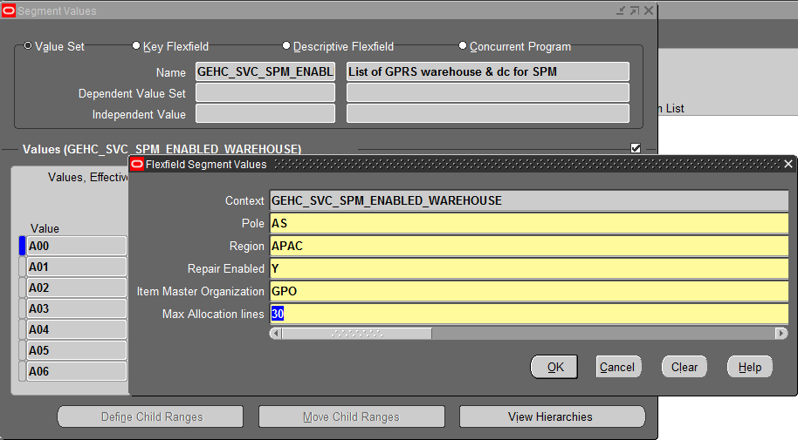

Valueset GE_GPRS_SPM_SO_DEMAND is created as shown :

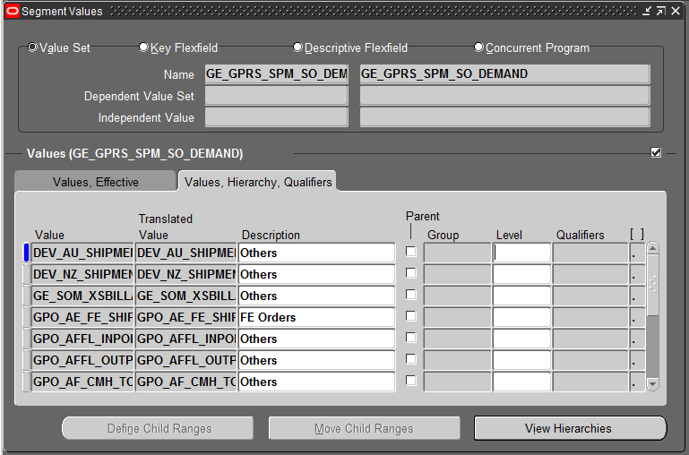

Valueset GEHC_SVC_SPM_TXN_DETAILS is created as shown :

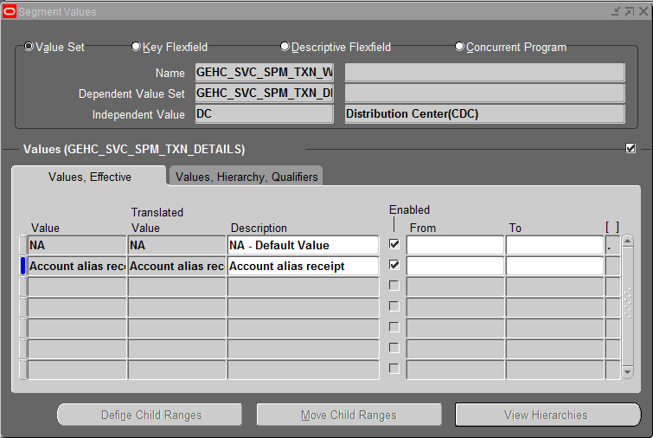

Global Parts Interface Value Set.

Value Set Name: GEMS_GLP_INTERFACE_VALUESET

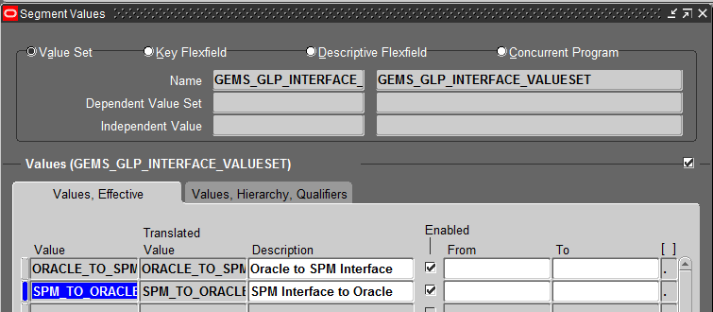

Valueset GE_GPO_SPM_PLN_DETAILS is created as shown :

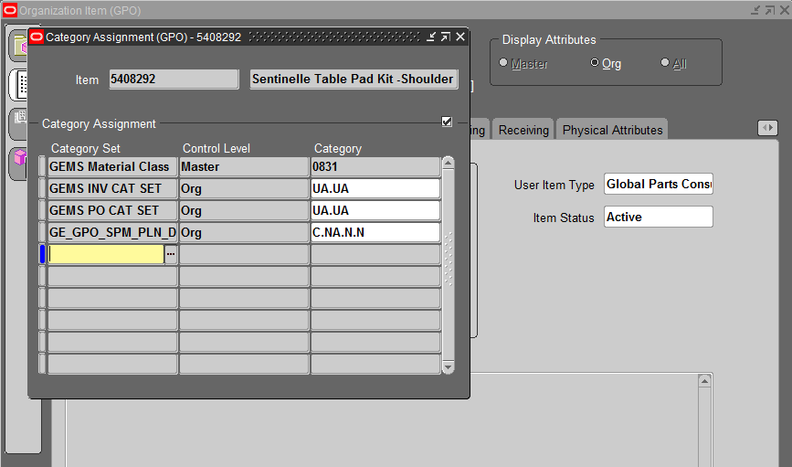

Valueset : GEHC_SVC_SPM_WH_DETAILS is created as shown :

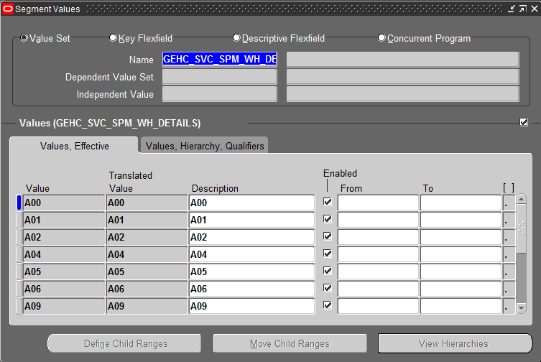

Valueset : GEHC_SVC_SPM_WH_DETAILS is created as shown :

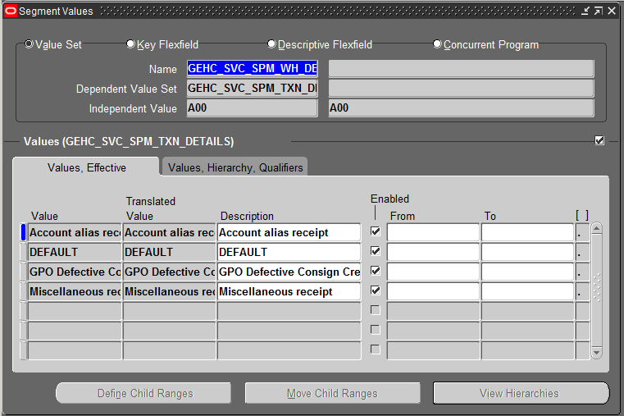

Valueset : GEHC_SVC_SPM_SUBINV_TYPES is created as shown :

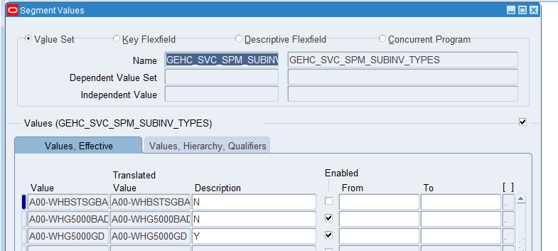

APC Attributes- Medical Device

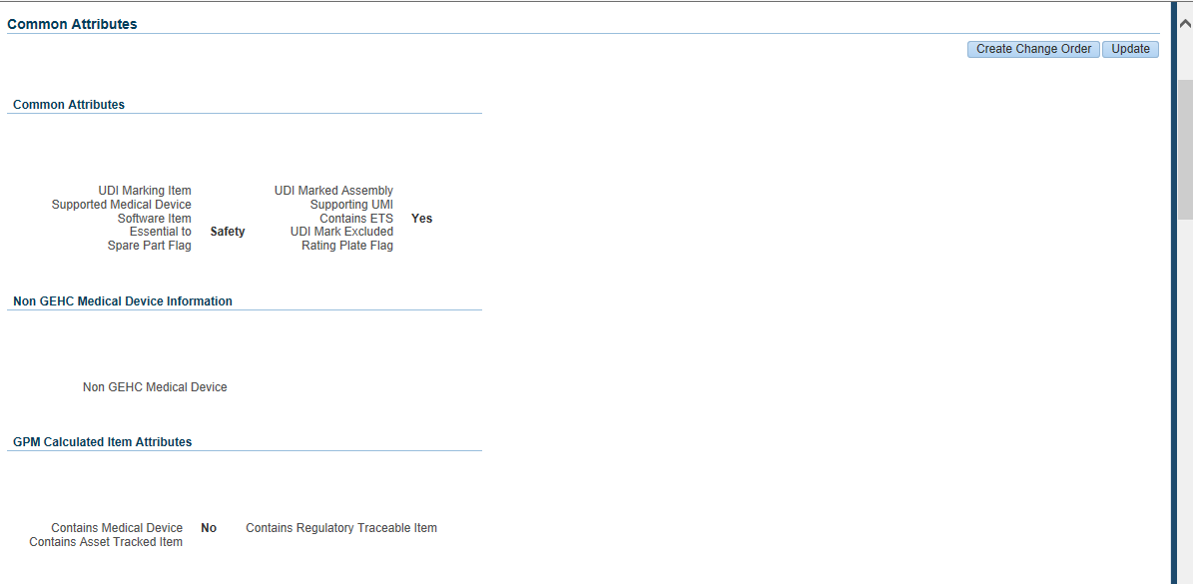

APC Attribute- Contains Medical Device

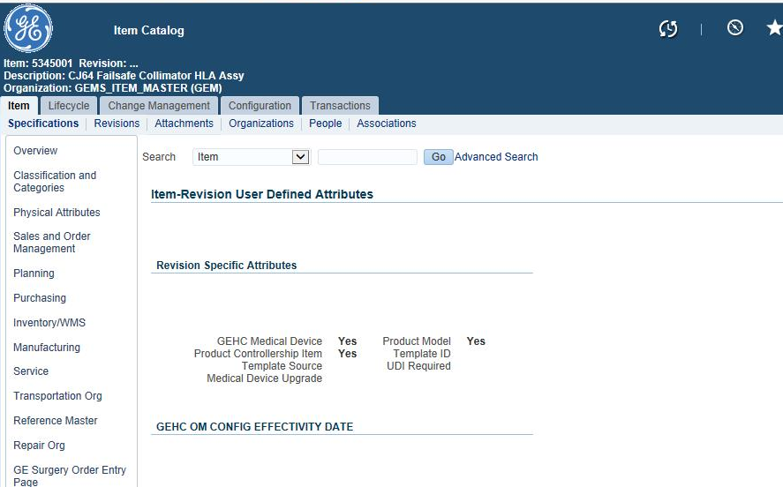

Manual Backlog Hold in M02 :

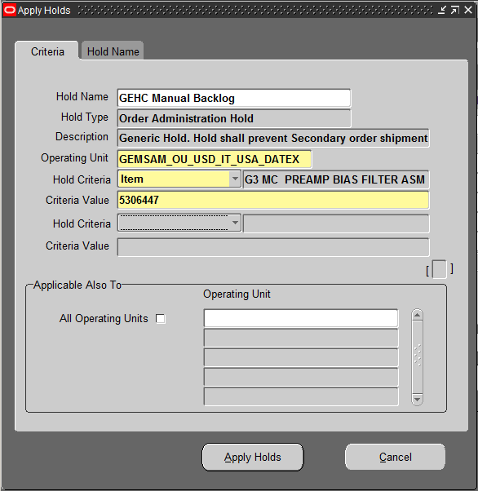

GPRS Export Only Part Hold in Japan :

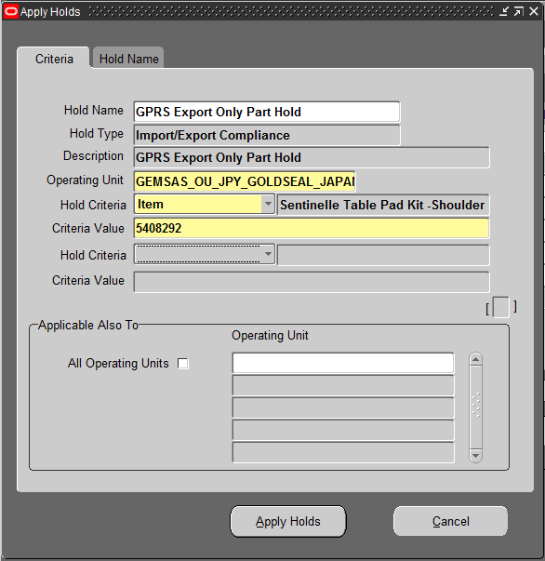

GPRS Domestic Only Part Hold in Japan :

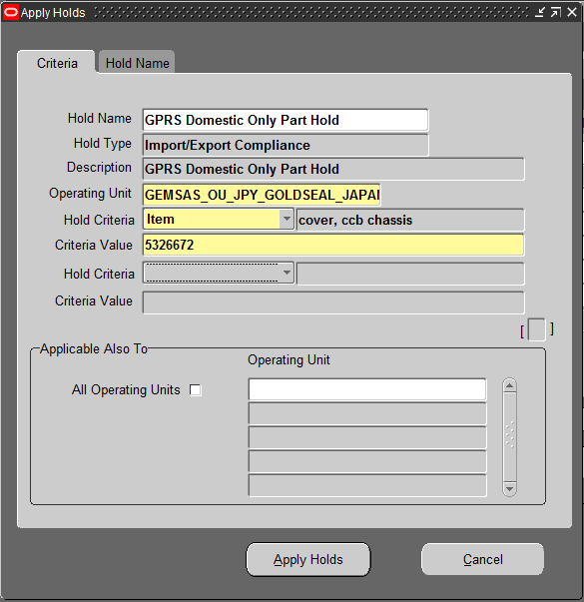

ARC Item Cost from U00 :

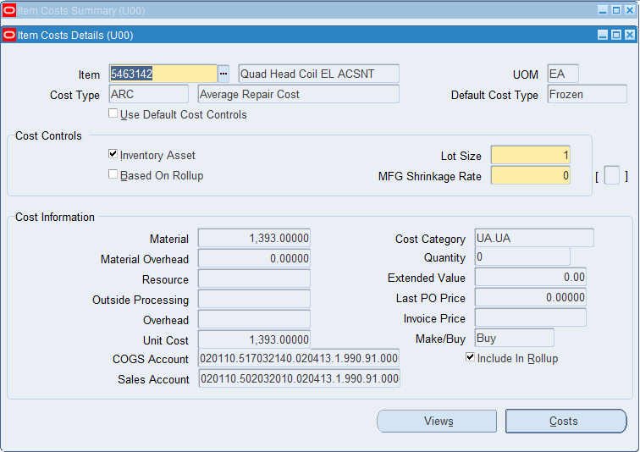

GPO Sub-inventory Type

GOOD

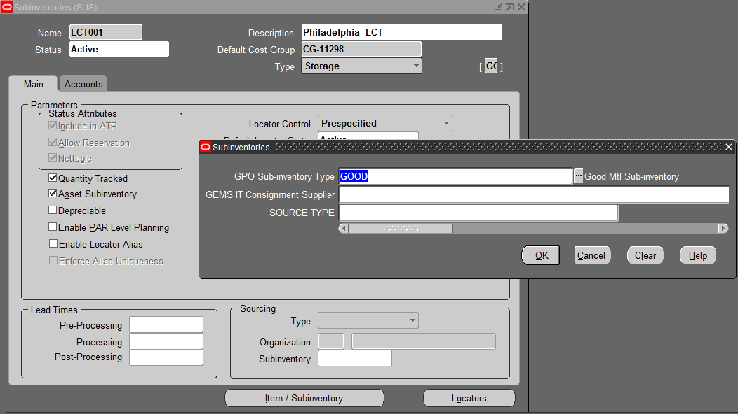

DEFECTIVE

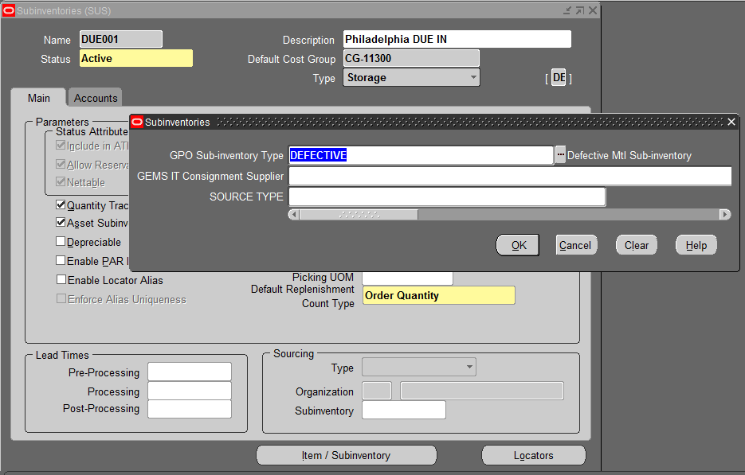

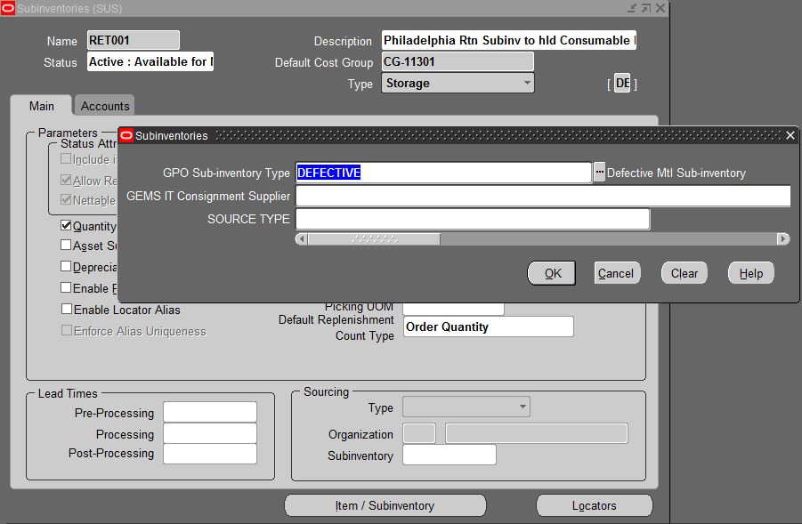

FE Customer to PUDO Customer Mapping

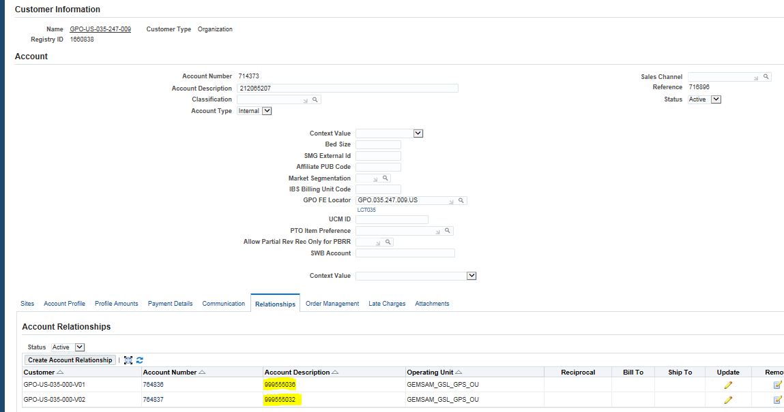

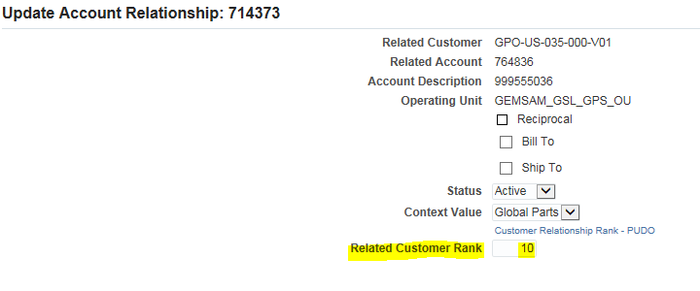

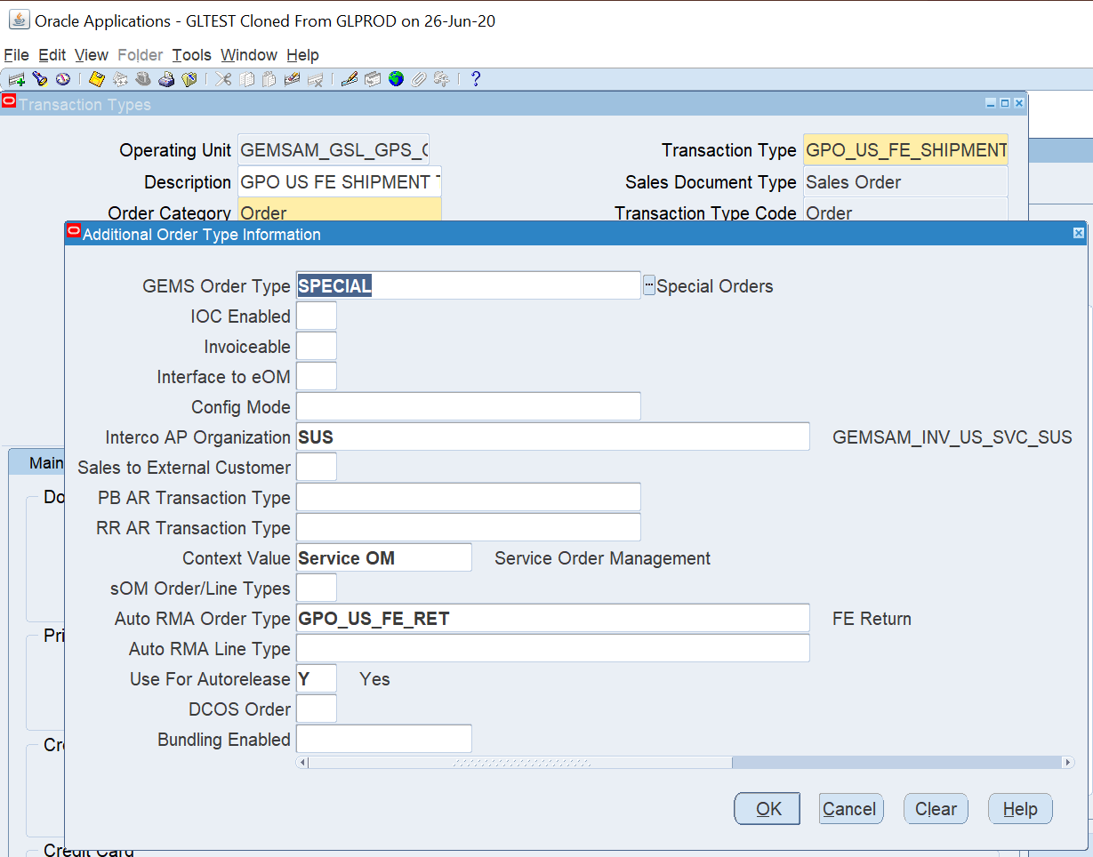

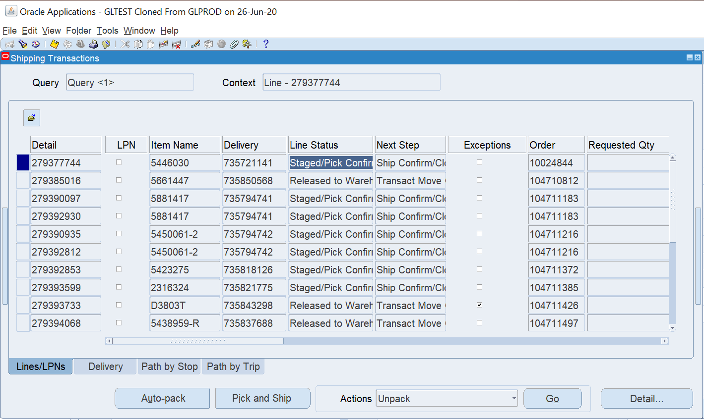

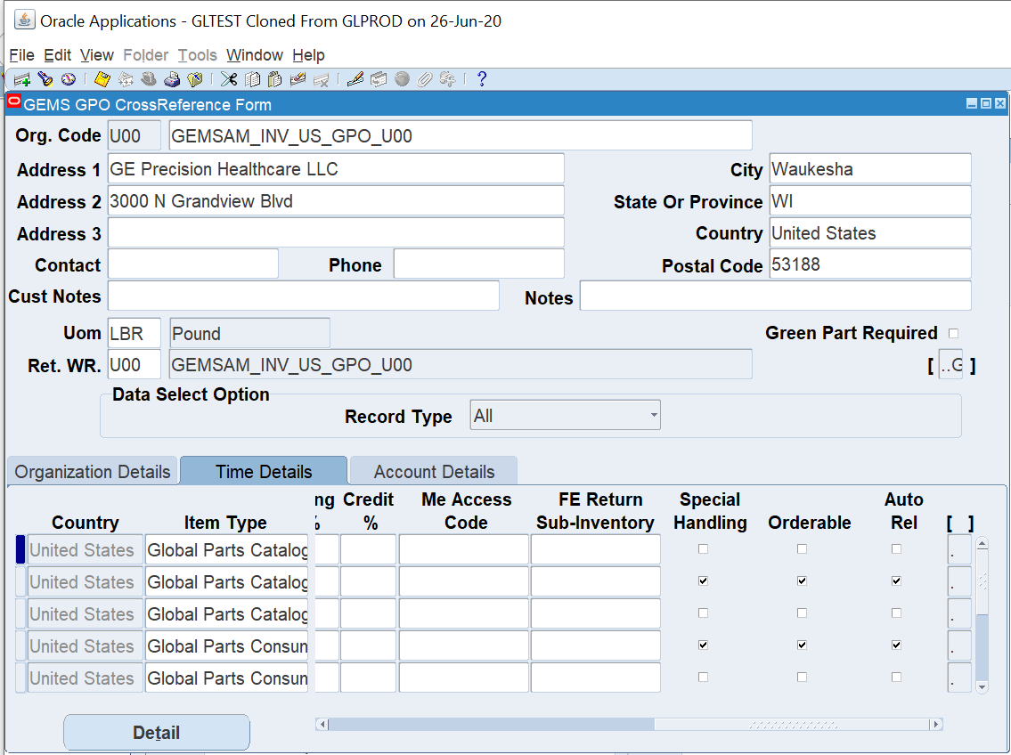

**Defective routing Form**

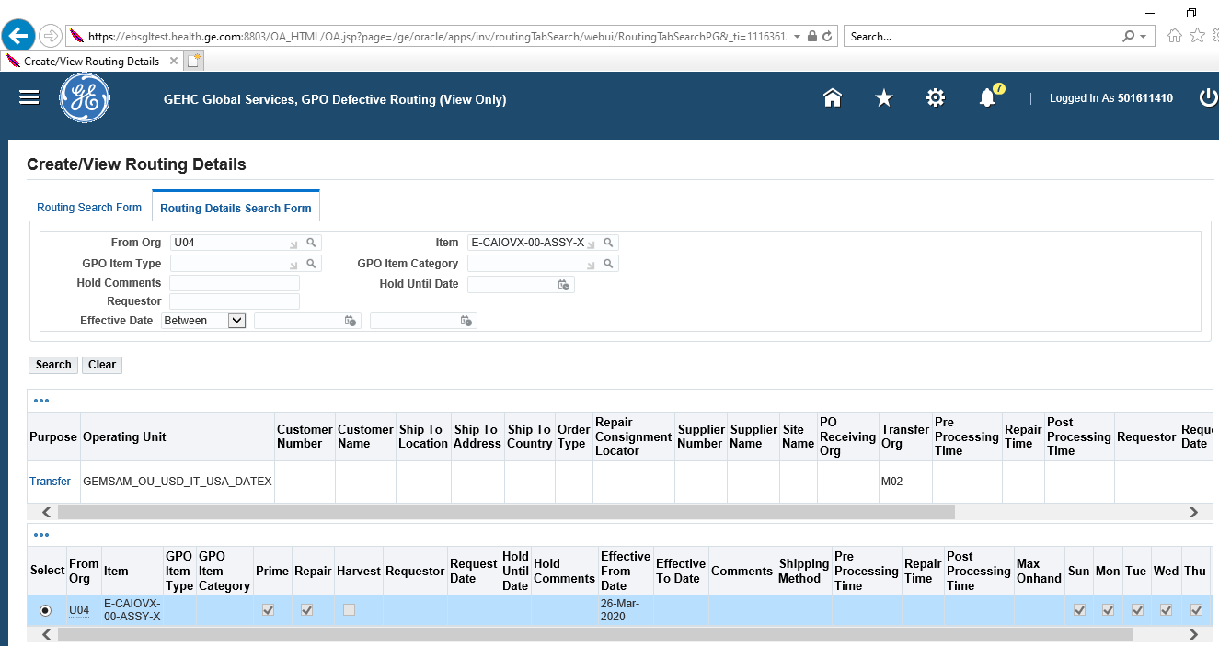

**Navigation for Purpose: GEHC Global Services, GPO Defective Routing (View Only) --> View Routing Details-->Routing Details search form--> Give the part number**

**Navigation for Supplier city:**

**GEMSAS_PO_CN_GETD_MANAGER > SUPPLY BASE VENDOR INQUIRY > SUPPLIERS (VIEW ONLY) > GIVE SUPPLIER NUMBER > ADDRESS BOOK > CLICK ON UPDATE BUTTON OF SUPPLIER NAME**

