DMERS Database Design
Use cases, relational schema, entities and integrity
This section describes the database currently implemented for the Disaster Management and Emergency Response System (DMERS). It explains how the database supports operational workflows, identifies its entities and relationships, and records the constraints and deployment modes present in the project.

1. Database purpose and operating model
DMERS stores accounts, incident reports, geographic locations, response resources, mission assignments, simulations and audit activity. PostgreSQL 16 is the shared database in the Docker deployment. When DATABASE_URL is not configured, the backend uses SQLite as a local offline store. The application accesses both engines through the same persistence layer.
Use case | Database activity | Outcome
Register or sign in | Create or look up a user by unique email; persist the password hash and role. | User identity and authorization role are available to the application.
Report an emergency | Create or select a location, then insert an incident linked to that location and optionally its reporting user. | Incident has a unique reference, severity, workflow status and timestamps.
Dispatch response | Create a mission linked to an incident and, where assigned, a rescue team and hospital. Record the assigning user and mission status. | Response assignment can be tracked through dispatch and completion.
Plan and simulate | Save a named scenario with its initiating user when available. | Scenario records can be retrieved for planning.
Review accountability | Record the actor, action, subject, details and timestamp for audit events. | Operational actions can be reviewed over time.
Check database readiness | Run a simple database query through the backend health check. | Health response reports the engine and whether a connection succeeded.

2. DBMS components
Component | Implementation in the project
Primary shared DBMS | PostgreSQL 16; Docker Compose service named postgres.
Local/offline DBMS | SQLite file database used if DATABASE_URL is empty.
Backend access | Flask persistence module selects PostgreSQL or SQLite and provides a common connection interface.
Schema setup | Idempotent PostgreSQL migration at backend/migrations/001_initial_postgresql.sql; matching SQLite schema and compatibility upgrades in backend/app/database.py.
Connection configuration | DATABASE_URL is supplied through the root .env for the Docker backend; credentials are not embedded in the report.

3 RELATIONAL SCHEMA AND ENTITY CATALOG
Core identity, geography and incident entities. PK = primary key, FK = foreign key, UQ = unique.
Entity | Key columns | Use in the system
roles | id BIGSERIAL PK; name TEXT UQ NOT NULL | Controlled list of authorization roles.
users | id BIGSERIAL PK; name TEXT; email TEXT UQ; password TEXT; role TEXT FK → roles.name; created_at TIMESTAMPTZ | Account identity and role. The password value is stored as a password hash by the backend.
locations | id BIGSERIAL PK; label TEXT; latitude NUMERIC; longitude NUMERIC; address TEXT; created_at TIMESTAMPTZ | Reusable address and coordinate record for incidents and hospitals.
incidents | id BIGSERIAL PK; reference TEXT UQ; disaster_type TEXT; severity TEXT; status TEXT; description TEXT; location_id BIGINT FK NOT NULL; reported_by BIGINT FK nullable; created_at, updated_at TIMESTAMPTZ | Emergency report with geographic context, reporting user when known, priority and workflow state.
rescue_teams | id BIGSERIAL PK; name TEXT UQ; capability TEXT; availability TEXT; created_at TIMESTAMPTZ | Response team directory with capability and deployment availability.

Operational states and domain rules
Entity | Implemented values or constraints
users.role | admin, official, responder, volunteer or citizen; default is responder.
incidents.severity | low, moderate, high or critical.
incidents.status | reported, verified, dispatched, resolved or closed; default is reported.
locations coordinates | Latitude must be within -90 to 90 and longitude within -180 to 180 when provided.
team availability | available, deployed or unavailable; default is available.

Incident location is required. The person reporting an incident is optional, allowing records to be captured when the reporter is not yet identified.

4 RELATIONAL SCHEMA AND ENTITY CATALOG
Resource coordination, simulations and audit entities.
Entity | Key columns | Use in the system
hospitals | id BIGSERIAL PK; name TEXT UQ; location_id BIGINT FK nullable; total_beds INTEGER; available_beds INTEGER; status TEXT; updated_at TIMESTAMPTZ | Hospital capacity and operational status; can reference a location.
missions | id BIGSERIAL PK; incident_id BIGINT FK nullable; report_id TEXT nullable; team_name TEXT nullable; team_id BIGINT FK nullable; hospital_id BIGINT FK nullable; status TEXT; assigned_by BIGINT FK nullable; created_at, updated_at TIMESTAMPTZ | Dispatch record connecting an incident/report to response resources and the assigning user.
simulations | id BIGSERIAL PK; name TEXT; scenario TEXT; created_at TIMESTAMPTZ; user_id BIGINT FK nullable | Saved planning scenario, optionally associated with its user.
audit_entries | id BIGSERIAL PK; actor_id BIGINT FK nullable; action TEXT; subject TEXT; details TEXT; created_at TIMESTAMPTZ | Time-stamped record of a user or system action and its subject.

Implemented mission and capacity rules
Entity | Integrity rule
missions.status | assigned, acknowledged, en_route, on_scene, in_progress, at_hospital, completed, escalated or aborted.
missions active dispatch | Partial unique indexes prevent more than one active mission for the same non-null incident or report. Completed and aborted missions are excluded.
hospitals bed counts | total_beds cannot be negative; available_beds must be between zero and total_beds.
hospitals.status | accepting, limited or divert; default is accepting.
audit_entries | action and subject are required; details defaults to an empty string.

Entity relationship summary
Parent entity | Child entity | Relationship and participation
roles | users | One role may be used by many users; each user has one role.
users | incidents | One user may report many incidents; an incident may have no linked reporter.
locations | incidents | One location may have many incidents; each incident requires one location.
locations | hospitals | One location may be referenced by multiple hospitals; hospital location is optional.
incidents / rescue_teams / hospitals / users | missions | Each may be referenced by many missions; mission links are optional in the schema.
users | simulations / audit_entries | A user may have many records; user/actor link is optional.

5 ENTITY RELATIONSHIP DIAGRAM
Arrows point from parent entities toward dependent records. The labels inside each entity distinguish primary and foreign keys.
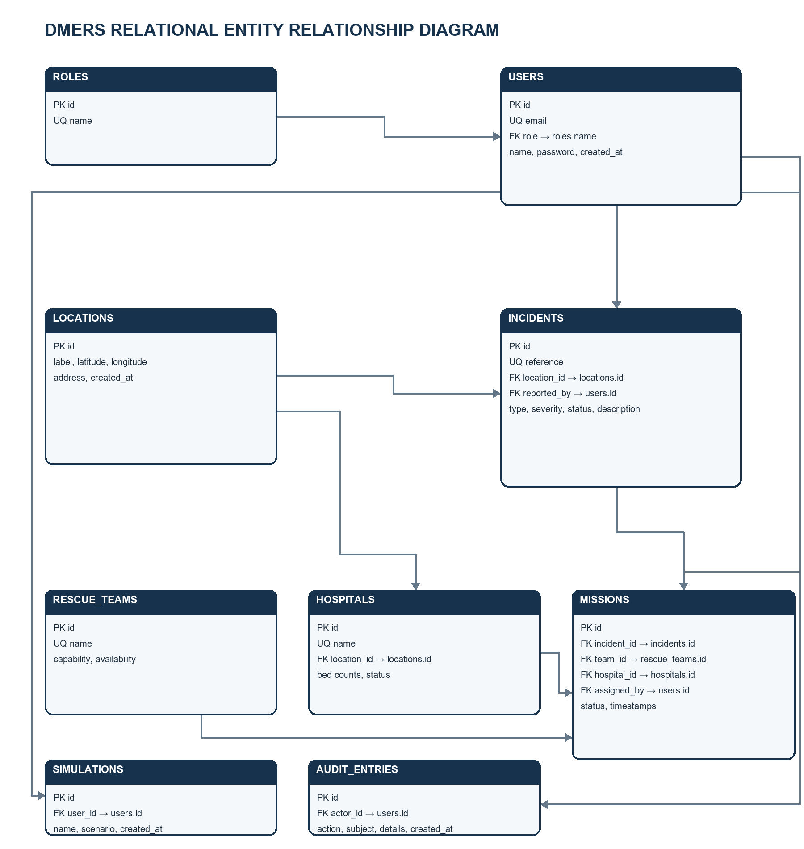
Optional foreign keys are shown where a record can exist without an associated user, hospital, team or incident link. incidents.location_id is mandatory; the remaining operational references shown in missions are nullable.

6 INTEGRITY, ACCESS AND DEPLOYMENT
How the database protects records and supports application operation.

6.1 Referential integrity and validation
Rule | Database implementation | Use case benefit
Identity | Primary keys on all entities; unique email, role name, incident reference, team name and hospital name. | Avoids duplicate identifiers and supports reliable lookup.
Relationships | Foreign keys connect users to roles; incidents and hospitals to locations; missions to incidents, teams, hospitals and users; simulations and audit entries to users. | Prevents references to parent records that do not exist.
Allowed states | CHECK constraints restrict severity, incident status, team availability, hospital status and mission status. | Keeps workflow values consistent for filtering and dispatch.
Capacity and coordinates | CHECK constraints validate bed counts and geographic ranges. | Prevents invalid coordinates and impossible hospital capacity values.
Active dispatch | Partial unique indexes allow at most one active mission per incident and per report; completed or aborted missions do not count as active. | Reduces duplicate live assignments while preserving prior completed missions.

6.2 Query support
Indexes support common operational views: filtering incidents by status and severity, sorting or selecting recent incidents by creation time, finding missions by status or incident, and reviewing audit entries in time order. The migration also creates a unique partial index for active mission control.

6.3 Transactions and persistence
The backend uses database transactions around related data changes so an incident and its supporting location and audit activity are handled consistently. PostgreSQL data is persisted in the Docker Compose postgres_data volume. SQLite remains a separate local database file for offline mode; it is not an automatic replication or synchronization mechanism for PostgreSQL.

6.4 Deployment and health check
Item | Current configuration
Docker database service | postgres using PostgreSQL 16 Alpine; internal port 5432.
Host access | 127.0.0.1:5433 forwards to the PostgreSQL container port 5432.
Backend connection | The backend container connects to host postgres on port 5432 using DATABASE_URL.
Readiness | Compose health check runs pg_isready against database dmers; backend health endpoint also checks an actual database connection.
Health URLs | http://127.0.0.1:5175/health and http://127.0.0.1:5175/api/health through the frontend proxy.

