CREATE TABLE customers (

customer_id INT PRIMARY KEY,

first_name VARCHAR(20),

last_name VARCHAR(30)

);

INSERT INTO customers VALUES (201, 'John', 'Doe');

INSERT INTO customers VALUES (202, 'Jane', 'Smith');

INSERT INTO customers VALUES (203, 'Alice', 'Johnson');

INSERT INTO customers VALUES (204, 'Bob', 'Brown');

CREATE TABLE new_order (

order_id INT PRIMARY KEY,

total_amount INT,

customer_id INT REFERENCES customers(customer_id)

);

INSERT INTO new_order VALUES (501, 15000, 201);

INSERT INTO new_order VALUES (502, 20000, 202);

INSERT INTO new_order VALUES (503, 25000, 203);

INSERT INTO new_order VALUES (504, 30000, 201);

SELECT

customers.first_name,

customers.last_name,

new_order.total_amount

FROM

customers

INNER JOIN

new_order

ON

customers.customer_id = new_order.customer_id;

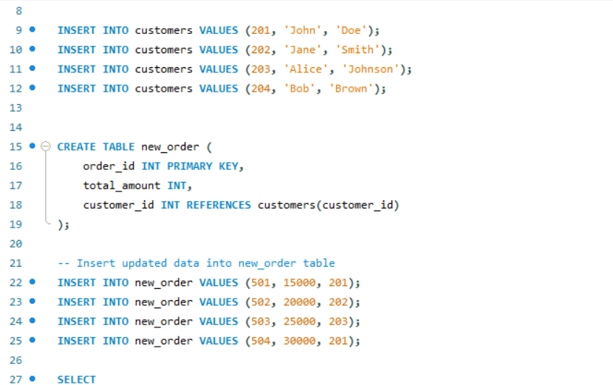

CREATE TABLE department (

department_id INT PRIMARY KEY,

department_name VARCHAR(30)

);

INSERT INTO department VALUES (101, 'HR');

INSERT INTO department VALUES (102, 'Finance');

INSERT INTO department VALUES (103, 'IT');

INSERT INTO department VALUES (104, 'Marketing');

INSERT INTO department VALUES (105, 'Operations');

CREATE TABLE employees (

employee_id INT PRIMARY KEY,

first_name VARCHAR(20),

last_name VARCHAR(30),

department_id INT REFERENCES department(department_id)

);

INSERT INTO employees VALUES (2001, 'Alice', 'Brown', 101);

INSERT INTO employees VALUES (2002, 'Bob', 'Smith', 102);

INSERT INTO employees VALUES (2003, 'Charlie', 'Johnson', 102);

INSERT INTO employees VALUES (2004, 'David', 'Williams', 103);

INSERT INTO employees VALUES (2005, 'Eve', 'Davis', 104);

INSERT INTO employees VALUES (2006, 'Frank', 'Taylor', NULL);

--

SELECT

department.department_name,

employees.first_name,

employees.last_name

FROM

department

LEFT JOIN

employees

ON

department.department_id = employees.department_id;