# ***AUTOMATED BABY CRADLE: A STEP TOWARDS INNOVATION***

**SOUMYADEEP GHOSH**  
*Guru Nanak Institute of Technology*Kolkata, India  
ronighosh242002@gmail.com

**MANTSIZ ZINATH***Guru Nanak Institute of Technology*Kolkata, India  
[ronyjps@gmail.com](mailto:ronyjps@gmail.com)

**DEBASISH SAHA**  
*Guru Nanak Institute of Technology*Kolkata, India  
[debasishsaha2910@gmail.com](mailto:debasishsaha2910@gmail.com)

**SOMA BORAL**

*Guru Nanak Institute of Technology*

Kolkata, India [Somaboral85@gmail.com](mailto:Somaboral85@gmail.com)

**ANISHA ROY***Guru Nanak Institute of Technology*Kolkata, India  
anisharoy520@gmail.com

**SUKHENDU AGUAN***Guru Nanak Institute of Technology*Kolkata, India  
sukhenduaguan@gmail.com

Abstract: “PARENTS” the word is small, but the responsibilities are very big. The basis of our project is Women's Empowerment; the current number of working mothers has greatly increased subsequently. For working parents, it is hardly possible to spend twenty-four hours with their infants. They need something unique that will help them to be connected with their babies most of the time. We all have heard the word “baby cradle”. Generally, it is used to make a baby sleep. Whenever a baby is crying his/her guardian comes to soothe the cradle. But in the case of working parents, it is not possible. In our project, we are going to propose a smart baby cradle using IoT to help both parents and babies. It will help the parents to monitor their babies even if they are far from the user mobile application API. The system design consists of a baby cradle which will mechanically swing employing motor once the baby cries. Parents can also monitor their babies’ condition through an external camera and switch on the curdle-song located on the baby cradle bed. It is going to be an innovative with piezoelectric sensor for auto rechargeable system for the battery & smart cradle with implementing video enhancement technology, where parents can see their babies and babies can be entertained by playing pre-recorded animated videos.

*Keywords: Baby monitoring, smart cradle, IoT, Video enhancement.*

1. **Introduction**

Nowadays many modern families are not able to spend much time with their infants. However, babies need more love, care and most of all monitoring 24 hours a day. As working parents gradually increases day by day so they cannot able to spend, much time with their infants which create a huge gap between them. To meet this gap we came up with a solution of Smart baby cradle which helps them to interact with their infants, monitor them at anytime from anywhere.

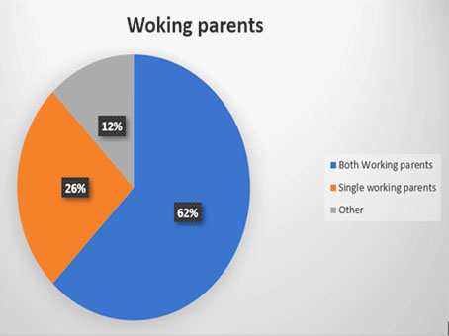

*Fig 1: percentage of working parents*

Recently smart technologies are taking over the world. Baby care services is a field that could also implement these smart technologies by means of embedded systems [1]. These systems combine hardware and software correctly, they are used by parents to monitor and take care of their infants. Several researches is going on in this area. In our paper we are proposing a smart baby cradle, an automatic swing cradle powered by a DC motor which is designed to swing when the baby is crying [2].

This system will consider all the minute details of the baby. The design includes Internet of

things (IoT) (modules like ESP32Cam, FTDI, Temperature sensing), Swing Automation, Cry detecting mechanism, Video surveillance and Android mobile application. The baby monitoring system consists a video camera and microphone without coverage limitations. If the baby cries the system will immediately notify the parents and start swinging [3]. Generally, babies cry because they are hungry, tired, unwell or need their diaper changed. To detect each and every movement of the baby, the sensors/modules will be attached to the cradle. The temperature sensing module will detect the wetness of the bed, a camera will be on top of the cradle for live video footage and a cry detection circuit which will trigger the swinging mechanism [4] [5].

The android mobile application will have UI controls including the swinging mechanism, control for switching on the camera & controls for playing the cradle song.

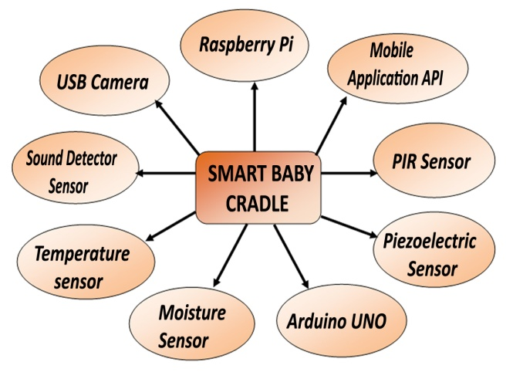

*Fig 2: Sample diagram of available system*

1. Working Principle

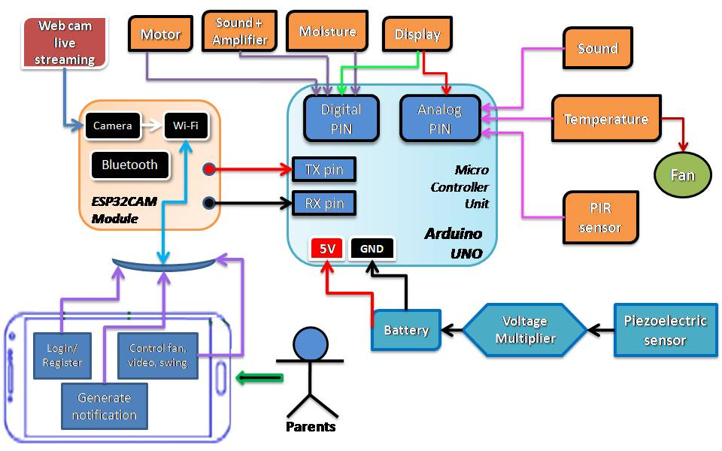

*Fig 3: Block diagram of proposed project*

* The above diagram depicts the whole operating of the sensible cradle system. When the child is made to sleep on the cradle with various sensors like sound detecting sensor, temperature sensor, wetness detector, PIR sensor, ESP32CAM module and piezoelectric sensor are enforced to monitor the various actions of the child.
* Baby Cradle swings automatically when baby cries; for this it has a cry analysis system that detects the baby cry voice and consequently the cradle swings until the baby stops crying.
* The cradle has the alarm system that indicates two conditions once the pad is wet, that is a crucial parameter to stay the baby in healthful condition, second once baby doesn't stop crying in a stipulated time, that intimated that baby wants attention.
* The cradle conjointly has the specifications of sleuthing the temperature, wetness round the baby and informs the sensed value through SMS or phone calls.
* We have also implemented the video enchantment options for parents to examine their babies what they are doing. Also parents can monitor and manage the cradle even if they are far from their babies using mobile applications.
* To build it innovative we have used piezoelectric sensor for automatic rechargeable system of the battery that implements the green energy conservation.

1. **Components required**

The proposed system is designed and implemented based on several new technology modules that are both efficient and low cost. The modules and sensor used in the implemented system are:

1. Arduino UNO

2. NTC Thermistor Temperature Sensor Module

3. Sound Sensor

4. PIR Sensor

5. Moisture Sensor

6. Bread Board

7. Mobile Phone

8. DC Motor

9. ESP32 CAM Module

10. TFT LCD Touch Screen Display Shield

11. Piezoelectric sensor

12. Fan

13. Alarm

14. 12V Battery

15. LM7805 IC 5V Voltage Regulator IC

16. MAX30100 Pulse Oximeter Heart Rate Sensor Module

17. GSM Module

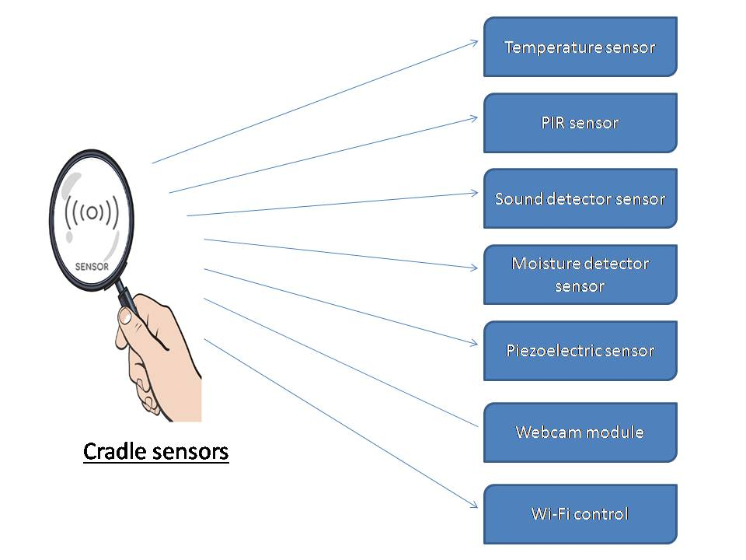

*Fig 4 : Sensor and module used in this project*

1. **Features and functions of sensors and modules**

4.1 **Cradle Swinging Principle:** The Cradle Swing will be triggered as soon as the Sound sensor crosses the threshold level. The normal DC Motor helps in swinging the Cradle.

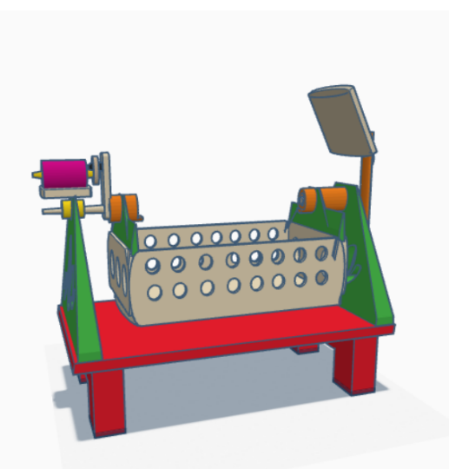

*Fig 5: Cradle Design*

Algorithm for cradle swinging:

Step-1: Start the System.

Step-2: Check if the baby is crying or not.

Step-3: If yes, it triggers DC Motor which leads to swinging of the Cradle.

Step-4: It also sends the alert message for the same.

Step-5: Parents can also turn On / Off the Cradle Swing using the Android Application.

4.2 **Moisture Detector Sensor:** This Sensor helps to check whether the baby’s diaper is wet or dry. If it is detected wet, it will inform to the parent (& nanny) via an Alert Message. This helps to keep the baby in a healthy and hygienic Environment.

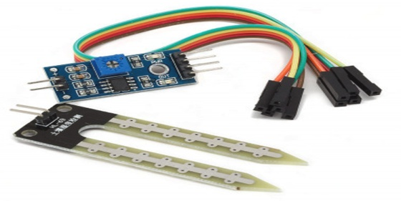 *Fig 6: Moisture Sensor*

Algorithm for checking diaper wetness:

Step-1: Start the system.

Step-2: Keep checking if the baby’s Diaper is Wet or Dry.

Step-3: If yes, notify the same to the parent (&nanny) via message.

Step-4: It also send message to parents (&nanny) that the baby’s diaper is wet.

4.3 **Temperature Detector Sensor:** This Sensor helps to detect the continuous temperature change inside the cradle. It sends a message regarding the temperature change to parents.

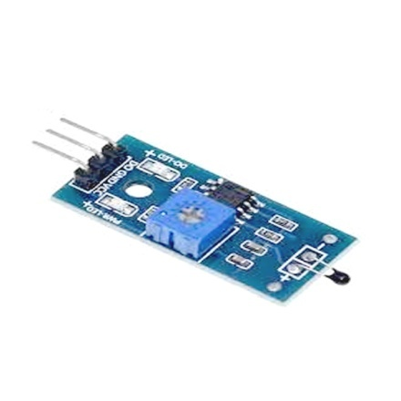

*Fig 7: NTC Thermistor Temperature sensor*

Algorithm for Temperature checking:

Step-1: Start the System.

Step-2: Keep checking the Temperature of Baby’s surrounding.

Step-3: If yes, then check whether it changes with given range of temperature.

Step-4: If yes, then turn ON the fan

Step-5: It also sends temperature value to parents (&nanny) as a message alert.

Step-6: Parents can also turn On / Off the fan using the Android Application

4.4 **PIR (Motion Detection) Sensor:** This sensor helps in motion detection in this system. It checks whether the baby is sleeping or not. If there is any unusual activity detected, it sends an alert message to the parent.

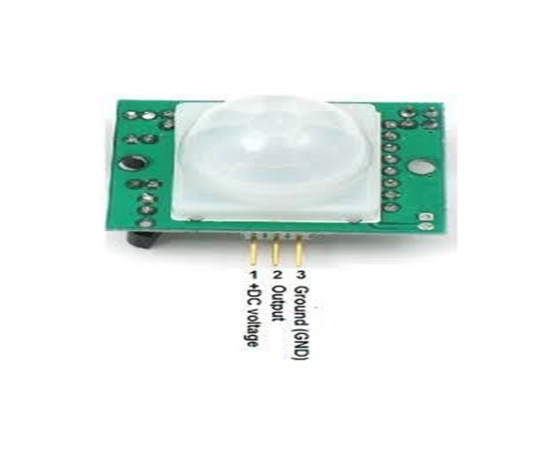

*Fig 8: PIR sensor*

Algorithm for Motion detection:

Step-1: Start the System.

Step-2: Check if there is any movement in the Cradle.

Step-3: If motion is detected, then check if the movement occurred continuously or frequently.

Step-4: If motion detected continuously then message to parents (&nanny) that baby is not comfortable.

Step-5: Else motion detected frequently then message to parents (&nanny) that baby is sleeping.

4.5 **Sound Detector Sensor:** This sensor helps to detect the crying sound of the baby. It detects whether the baby is crying for hungry or for others reasons comparing with threshold level. It will send notification to parents or nanny if the baby cries for more than stipulated time given by parents.

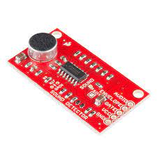

*Fig 9: Sound Detector Sensor*

Algorithm for crying detection:

Step-1: Start the System.

Step-2: Check if there is any sound detected in the Cradle.

Step-3: If sound is detected, then check if the sound frequency is high or low compared to threshold frequency.

Step-4: If high then swing the cradle at gentle speed and play lullaby song and start playing animated video on display.

Step-5: Else frequency is low then message to parents (&nanny) that baby feels hungry or need attention and play animated video on display.

Step-6: It also send message to parents if the baby is crying.

**4.6 Piezoelectric Sensor:** This sensor is used to recharge the battery. It will charge the battery with the help of voltage step up module. This will helps in energy conservation.

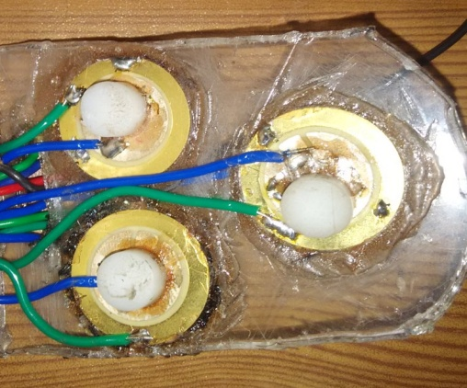

*Fig 10: Piezoelectric sensor connection*

Algorithm for piezoelectric sensor:

Step-1: Start the System.

Step-2: Check if the battery needs to charge or not.

Step-3: If it needs, then charge the battery by piezoelectric sensor.

4.7 **ESP32 CAM Module:** This module is used to monitor the baby through live video communication. This module is also used for sending message to parents and nanny. This module comes with Wi-Fi system, Bluetooth system and 2MP camera.

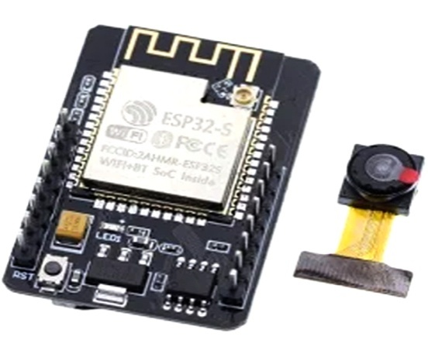

*Fig 11: ESP32CAM Module*

**4.8 MAX30100 Pulse and Oximeter Heart Rate Sensor Module:** Itis an integrated pulse oximeter and heart-rate monitor sensor solution. It’s an optical sensor that derives its readings from emitting two wavelengths of light from two LEDs – a red and an infrared one – then measuring the absorbance of pulsing blood through a photodetector. 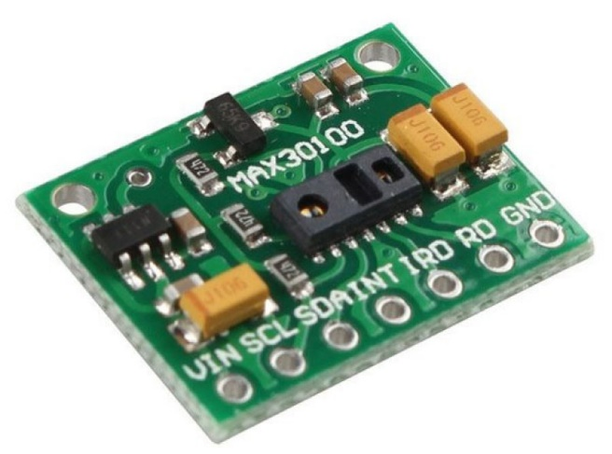

*Fig 12: Max30100 pulse and oximeter sensor*

Algorithm for piezoelectric sensor:

Step-1: Start the System.

Step-2: Check baby pulse and oximeter level.

Step-3: Then measured reading to parents through SMS alert system.

**4.9 GSM Module:** The GSM module is a circuit which is used to setup communication between mobile phones and microcontroller. It is used to send SMS, MMS and voice messages through mobile network. GPRS extension in GSM allows high data transmission. GSM uses time division multiple access approach for transmission.

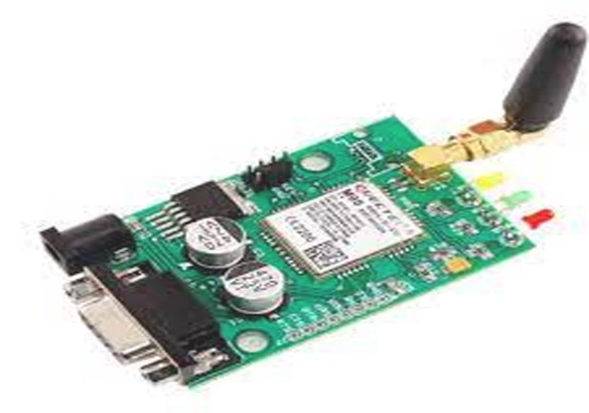

*Fig 13: GSM module*

1. **Flowchart of some sensors used in this project:**

5.1 Flowchart of Sound detector sensor:

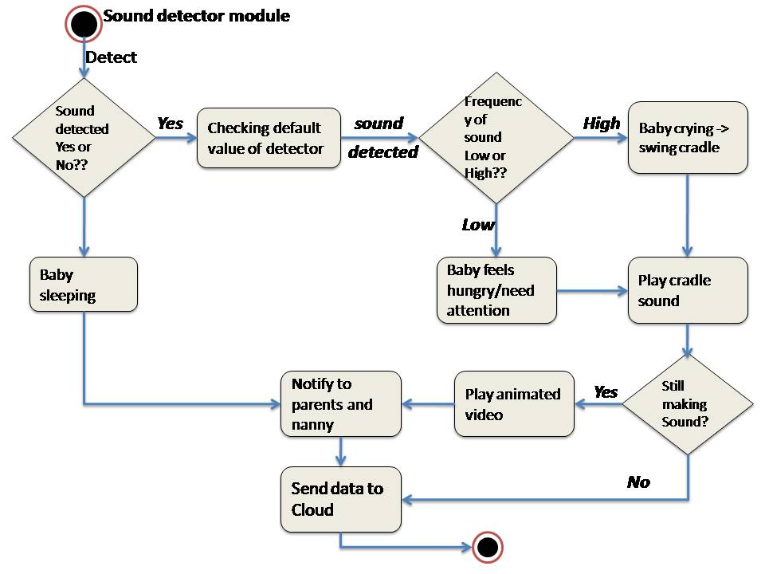

5.2 Flowchart of Wetness detector:

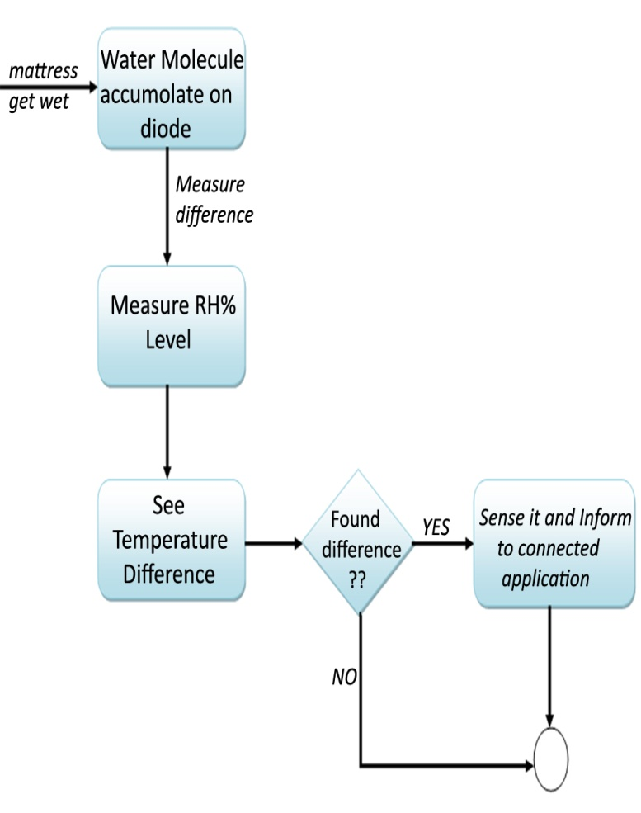

5.3 Flowchart of ESP32CAM module:

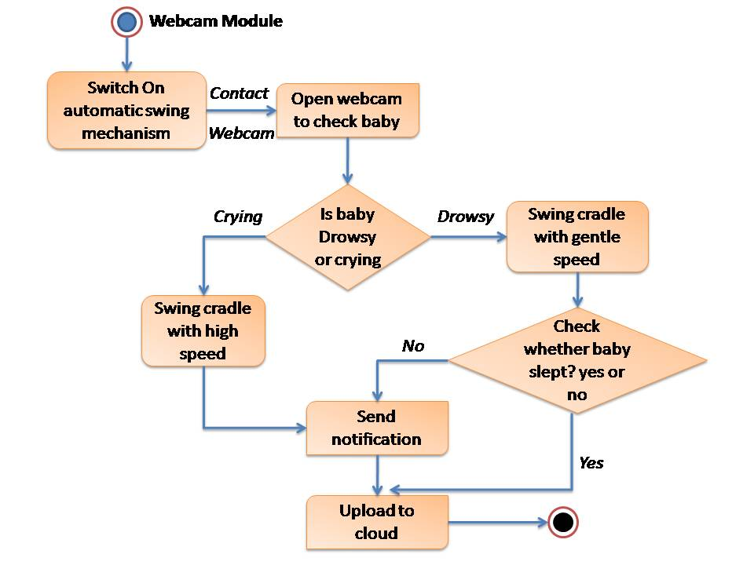

1. **Future Scope**

In this situation where a big number of medical staff (doctors, nurses) is tested positive covid 19, and such viruses. It can also be used in maternity ward and child hospital and nursing home. To take care of number of babies as it is difficult for limited number of hospital nurse to take care of the babies, in such scenario the smart baby cradle can be used to help.In future we can add more features like rotating toy with music, automatic voicemail to soothe a crying baby. Like babies, old persons also need care and love. We were planning if we can implement this technology for them too, if possible, with this system they can listen to their favorite person’s voicemails whenever they are feeling low or bore. They can also listen to music when they are tired.

1. **Conclusion**

A smart cradle with a baby monitoring system over IoT has been designed and fabricated to monitor a baby’s vital parameters, such as crying condition, humidity, and ambient temperature. A smart baby crib has been designed and implemented based on several new technologies. The system helps parents during the day while they are busy and during the night while they are sleeping by swinging a cradle and playing cradle song.

1. Acknowledgement

I would like to thank all the faculty members of Electronics and Communication Engineering, Guru Nanak Institute of Technology for their continuous support and encouragement.

All the teams members without whom it would have been impossible to make this presentation a full prove success.

Last but not the least I would also like to thank our honorable Principal Sir, *Dr. Santanu Kr. Sen* for providing us this golden opportunity to show case our knowledge in this domain

IX. Reference

1. “SMART CRADLE SYSTEM” by Samuel Neeradi, Nikhil Thomas, Abhishek Kumar Singh, Meena Ugale; Volume: 08 Issue: 05, May 2021

2. “Development of IoT Based Smart Baby Cradle” by Prof. A.B.Tupkar, Prajwal. Chahare, Shubham. Rade, Rushikesh. Wakade, Snehal. Bahirseth; Vol. 7, Issue 1, January 2020

3. <https://www.evelta.com/esp32-cam-camera-module-based-on-esp32/>

4. “Design and Implementation of a Smart Baby Crib “by H I Shahadi, D H Muhsen, H T Haider, and A H Taherinia, DOI:[10.1088/1757-899X/671/1/012050](http://dx.doi.org/10.1088/1757-899X/671/1/012050)

5. <https://www.geeksforgeeks.org/project-idea-baby-monitoring-smart-cradle/>