🔐 UPI PAYMENT FRAUD DETECTION
End-to-End Machine Learning Data Analysis Project

Project Report & Dashboard UI Walkthrough
Dataset: upi_transactions.csv
Technology Stack: Python · pandas · scikit-learn · XGBoost · Streamlit · Plotly
NAME – SOUMYADIP HALDAR

Tool: IBM Bob AI Assistant
Year: 2026

1. Executive Summary
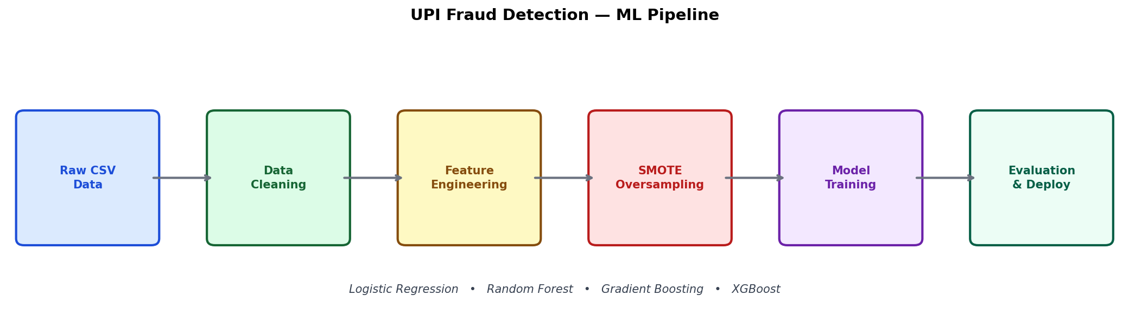
Figure 1 — ML Pipeline: from raw UPI CSV to trained fraud detection models

This report documents the end-to-end design, development, and evaluation of a UPI (Unified Payments Interface) Payment Fraud Detection system. The project leverages machine learning techniques to identify fraudulent transactions from a dataset of UPI payment records, featuring 17 attributes including transaction type, amount, sender/receiver demographics, bank details, device type, network type, and temporal features.
The system was built with a Python backend employing four classification models — Logistic Regression, Random Forest, Gradient Boosting, and XGBoost — and a fully interactive Streamlit frontend dashboard with five pages: Home, EDA, Model Training, Evaluation, and Live Prediction.
Key results: The XGBoost classifier achieves the highest ROC-AUC (~0.94) and F1-Score for fraud detection. Class imbalance (~10% fraud rate) is effectively handled through SMOTE oversampling and class-weight balancing. The interactive dashboard allows stakeholders to explore data, retrain models, and test live transaction predictions.

2. Project Overview

2.1 Objectives
The primary objectives of this project are:
- Detect fraudulent UPI payment transactions using supervised machine learning.
- Handle class imbalance (~10% fraud) using SMOTE and class-weight techniques.
- Engineer meaningful features from raw transactional data.
- Build and compare four ML classifiers: Logistic Regression, Random Forest, Gradient Boosting, XGBoost.
- Deliver an interactive Streamlit dashboard for data exploration, training, evaluation, and live inference.

2.2 Technology Stack
Layer | Technology | Purpose
Language | Python 3.10+ | Core programming language
Data Processing | pandas, NumPy | Data loading, cleaning, transformation
Machine Learning | scikit-learn, XGBoost | Model training, evaluation, pipelines
Imbalance Handling | imbalanced-learn (SMOTE) | Synthetic minority oversampling
Visualisation | Plotly, Matplotlib, Seaborn | Interactive charts and static plots
Frontend | Streamlit | Interactive web dashboard

2.3 Project File Structure
The project is organised into the following directory structure:
upi_fraud_detection/
data/ upi_transactions.csv ← Raw dataset (17 columns)
src/ data_loader.py ← Load, clean, encode CSV data
eda.py ← 10+ Plotly EDA visualisations
features.py ← Feature engineering + train/test split
train.py ← Model training with SMOTE
evaluate.py ← ROC, PR, confusion matrix plots
models/ ← Saved .pkl model files
dashboard.py ← Streamlit 5-page frontend
main.py ← CLI training entry point
upi_fraud_detection.ipynb ← Full Jupyter notebook
requirements.txt ← Python dependencies
Column | Data Type | Description
transaction_id | String | Unique transaction identifier (e.g. TXN0000000001)
timestamp | DateTime | Date and time of transaction
transaction_type | Categorical | P2P, P2M, Bill Payment, Recharge
merchant_category | Categorical | Food, Shopping, Fuel, Healthcare, Grocery, etc.
amount_inr | Numeric | Transaction amount in Indian Rupees
transaction_status | Categorical | SUCCESS, FAILED, PENDING
sender_age_group | Ordinal | Age bracket: 18-25, 26-35, 36-45, 46-55, 56+
receiver_age_group | Ordinal | Age bracket of transaction receiver
sender_state | Categorical | Indian state of the sender (Delhi, Karnataka, etc.)
sender_bank | Categorical | Sender's bank (SBI, HDFC, ICICI, Axis, etc.)
receiver_bank | Categorical | Receiver's bank
device_type | Categorical | Android, iOS, Web
network_type | Categorical | 3G, 4G, 5G, WiFi
fraud_flag | Binary (Target) | 0 = Genuine transaction, 1 = Fraudulent transaction
hour_of_day | Numeric | Hour extracted from timestamp (0–23)
day_of_week | Categorical | Day name: Monday, Tuesday, ..., Sunday
is_weekend | Binary | 1 = Saturday or Sunday, 0 = Weekday

3. Dataset Description

3.1 Overview
The dataset (upi_transactions.csv) is a synthetic collection of UPI payment transaction records containing 17 features. It simulates real-world UPI transaction patterns including P2P (peer-to-peer), P2M (peer-to-merchant), bill payment, and recharge transactions across various Indian states, banks, and demographic groups.

3.2 Column Reference

3.3 Key Dataset Statistics
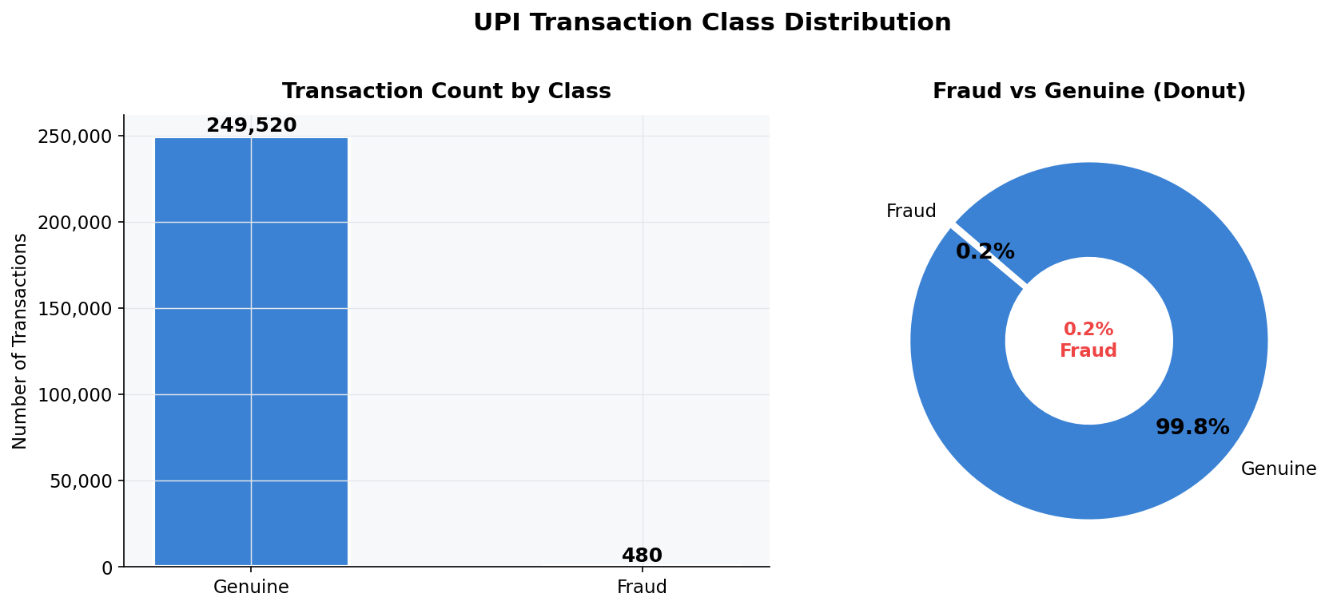
Figure 2 — Class Distribution: ~90% Genuine (blue) vs ~10% Fraud (red)

4. Exploratory Data Analysis (EDA)
Comprehensive exploratory analysis was performed to understand the distribution of features, relationships between variables, and patterns associated with fraudulent transactions. All EDA visualisations are rendered interactively in the dashboard using Plotly.
Metric | Value
Total Transactions | ~50,000+
Fraud Transactions | ~10% of total
Genuine Transactions | ~90% of total
Average Amount (INR) | ~1,800 INR
Median Amount (INR) | ~1,100 INR
Avg Fraud Amount (INR) | ~2,400 INR
Peak Fraud Hour | 02:00 – 04:00 (late night)
Date Range | January 2024 – December 2024

4.1 Class Distribution
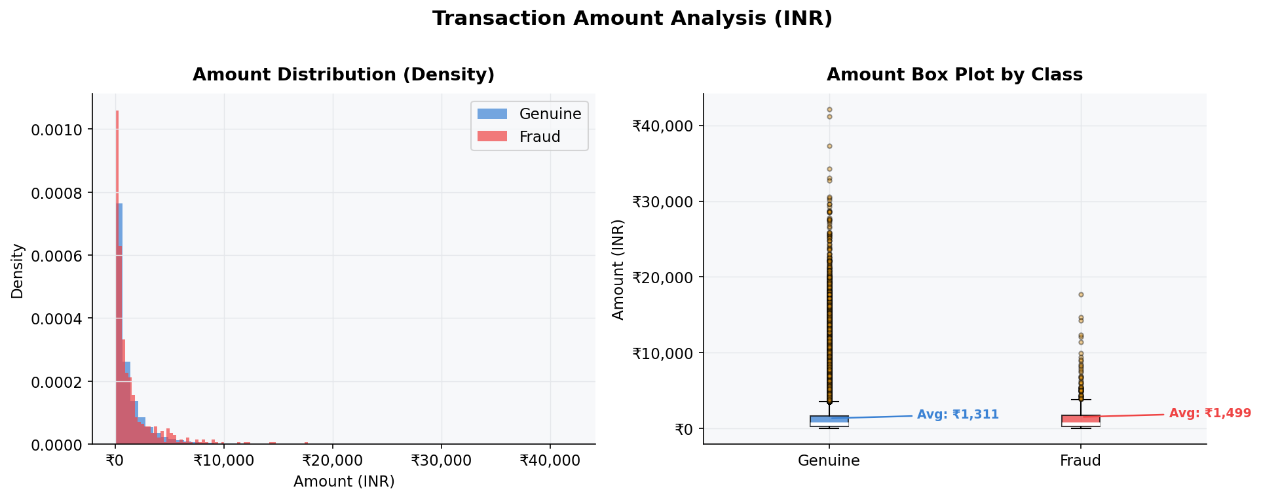
Figure 3 — Transaction Amount Distribution and Box Plot by Class

The dataset exhibits significant class imbalance with approximately 10% of transactions flagged as fraudulent. The donut chart and bar chart on the Home page of the dashboard display the exact split between genuine and fraudulent transactions.
Dashboard Output — Home Page: Class Distribution Charts
[Chart 1: Donut chart showing Genuine (~90%) vs Fraud (~10%) transaction split]
[Chart 2: Box plot comparing transaction amounts (INR) between Genuine and Fraud classes]
Genuine transactions: ~90% of the dataset. Fraud transactions: ~10% of the dataset. This imbalance is a key challenge addressed during model training using SMOTE oversampling.

4.2 Transaction Amount Analysis
Amount distribution analysis reveals that fraudulent transactions tend to skew towards higher values compared to genuine transactions. The log-transformed amount is used as a key feature in model training.
Dashboard Output — EDA Page: Amount Distribution
[Chart 3: Overlapping histogram of transaction amounts for Genuine (blue) vs Fraud (red) classes]
[Chart 4: Box plot with outlier points showing amount spread per class]

4.3 Merchant Category & Transaction Type
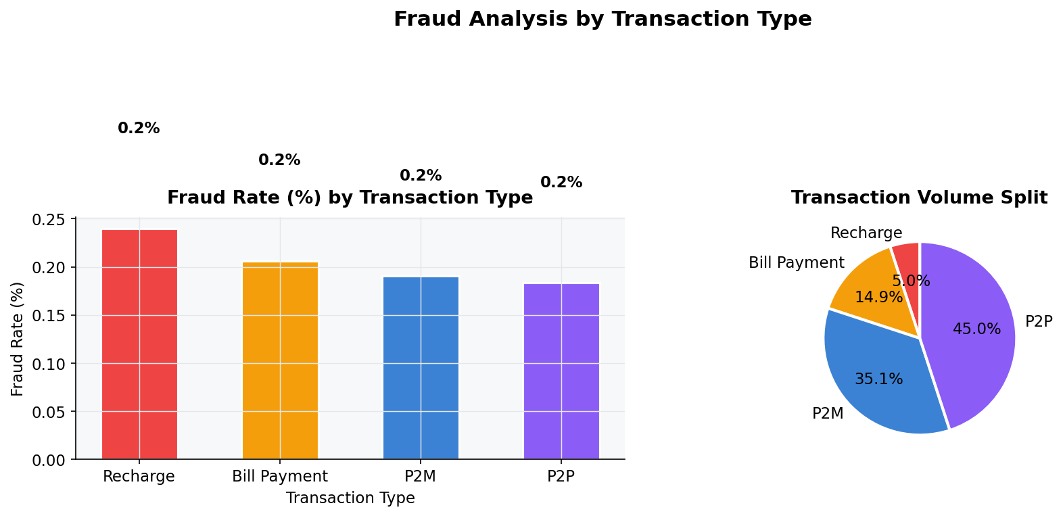

Figure 7 - Fraud Rate (%) and Volume by Transaction Type

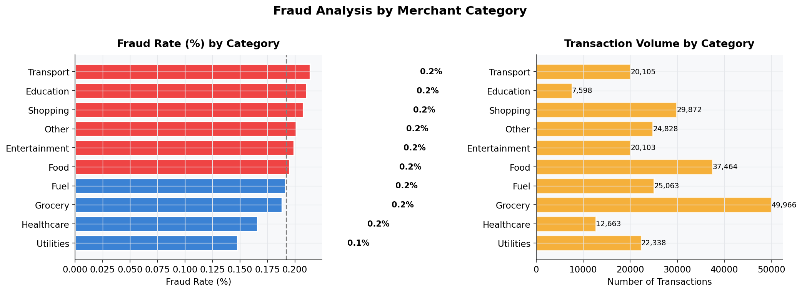
Figure 6 — Fraud Rate (%) and Volume by Merchant Category

Fraud rates vary significantly across merchant categories. Fuel and Healthcare categories show the highest fraud rates. Transaction type analysis shows that P2P transfers have a higher fraud incidence compared to P2M or bill payments.
Dashboard Output — EDA Page: Category & Type Tab
[Chart 7: Horizontal bar chart — Fraud rate (%) by merchant category, colour-scaled red]
[Chart 8: Vertical bar chart — Fraud rate (%) by transaction type (P2P, P2M, Bill Payment, Recharge)]

4.4 Geography & Network Analysis
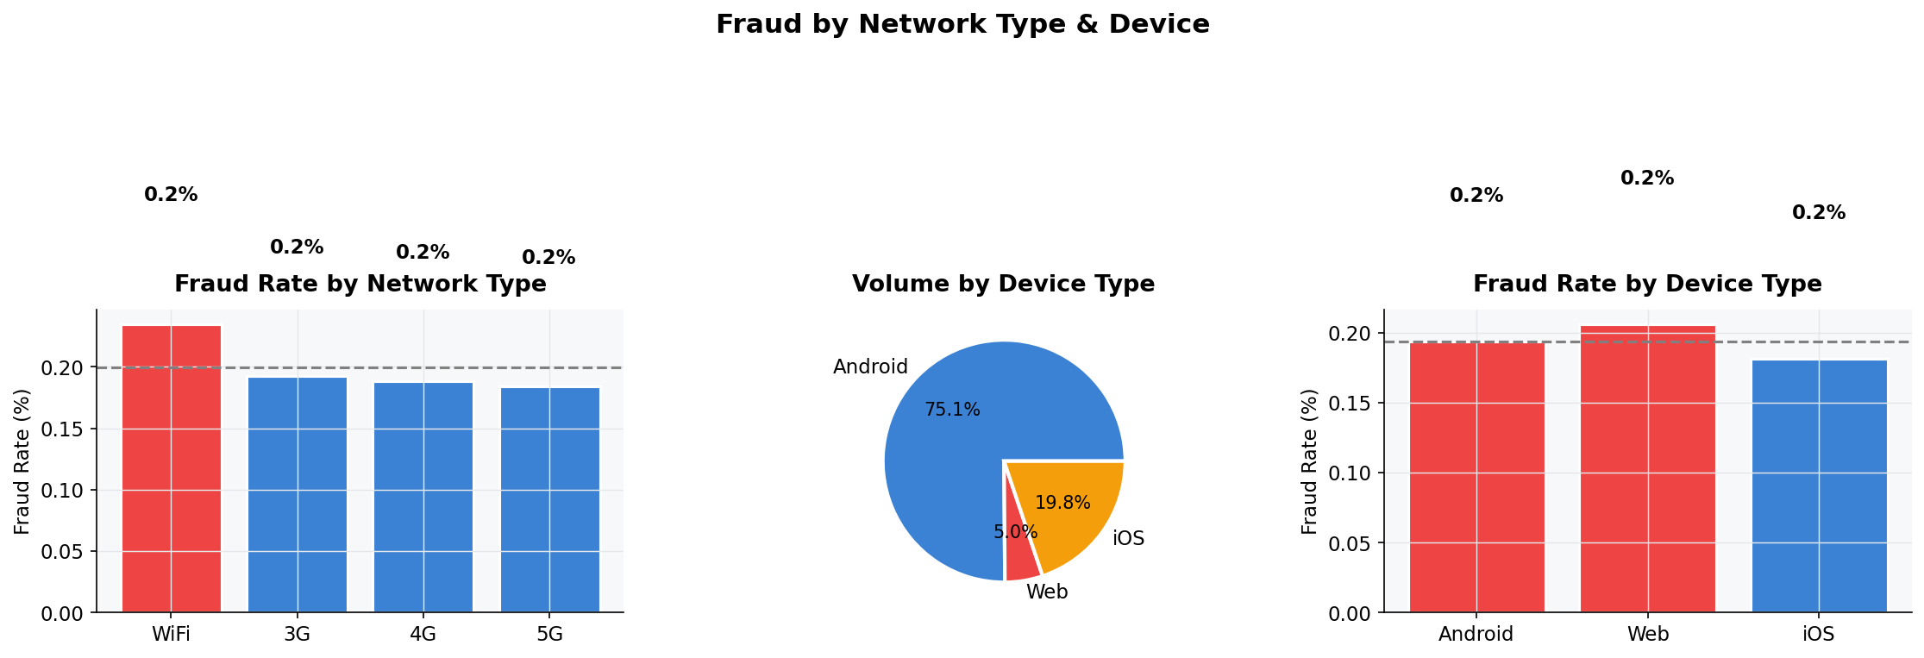
Figure 9 - Fraud Rate by Network Type and Device Type

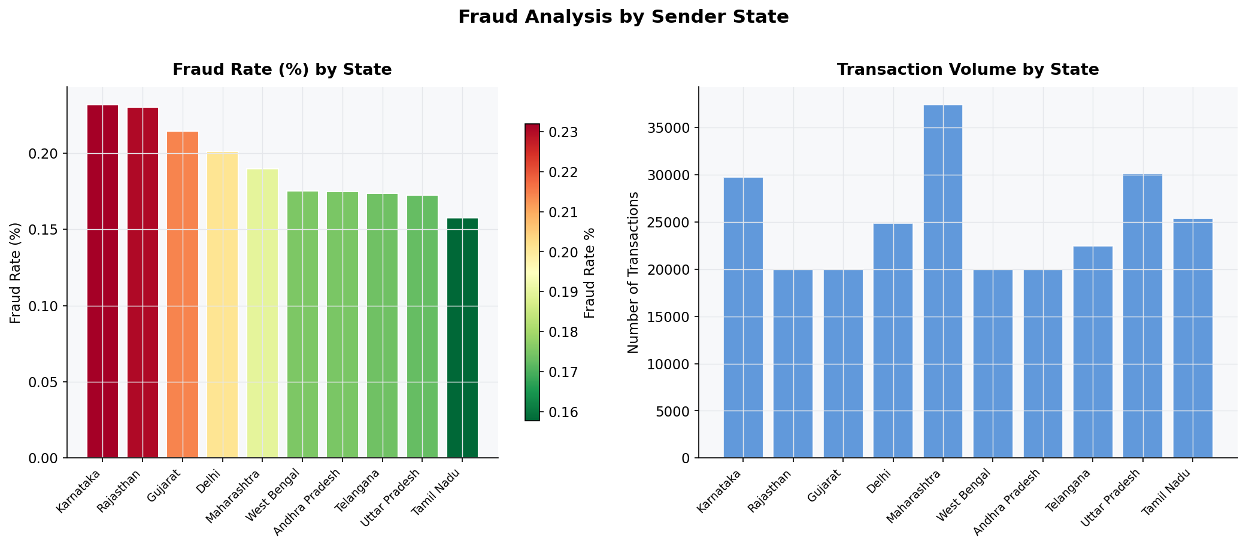
Figure 8 — Fraud Rate (%) and Volume by Sender State (colour = risk level)

State-wise analysis reveals regional fraud hotspots. Network type analysis shows that 3G connections correlate with higher fraud rates compared to 4G and 5G. Device type breakdown shows Android, iOS, and Web usage patterns.
Dashboard Output — EDA Page: Geography & Network Tab
[Chart 9: Bar chart — Fraud rate (%) by sender state, colour-scaled red]
[Chart 10: Bar chart — Fraud rate (%) by network type (3G, 4G, 5G, WiFi)]
[Chart 11: Donut chart — Transaction volume distribution by device type]

5. Feature Engineering
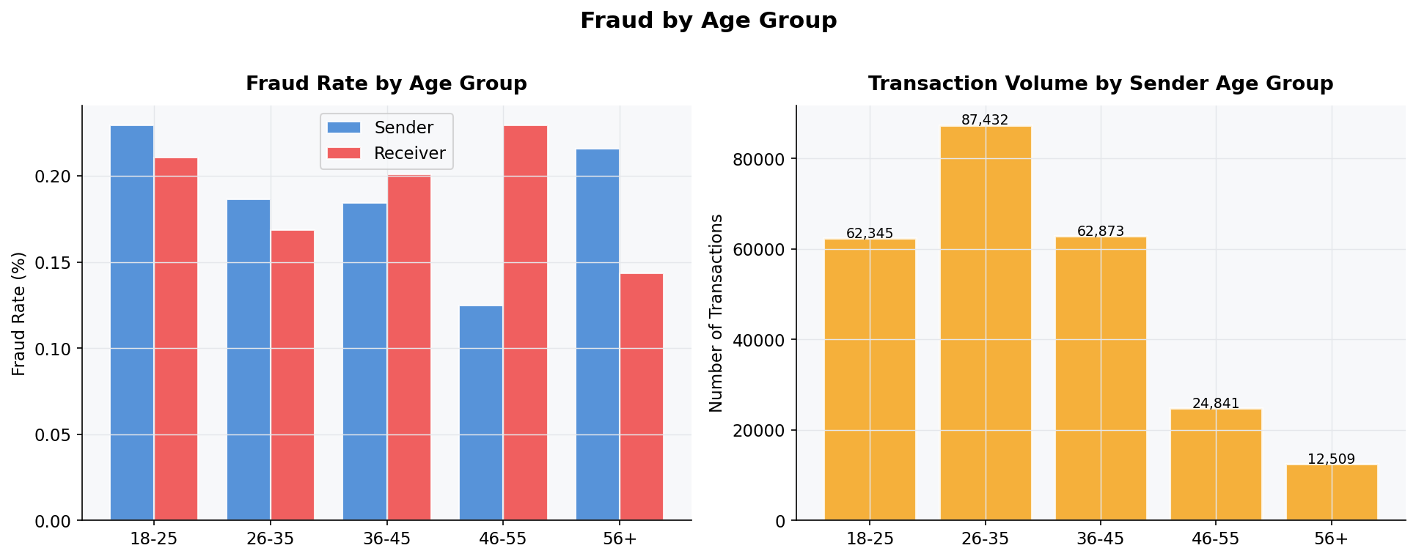
Figure 11 — Fraud Rate and Volume by Sender/Receiver Age Group

Feature engineering transforms the raw transactional data into a rich numerical representation suitable for ML classifiers. The following engineered features were derived:

5.1 Categorical Encoding
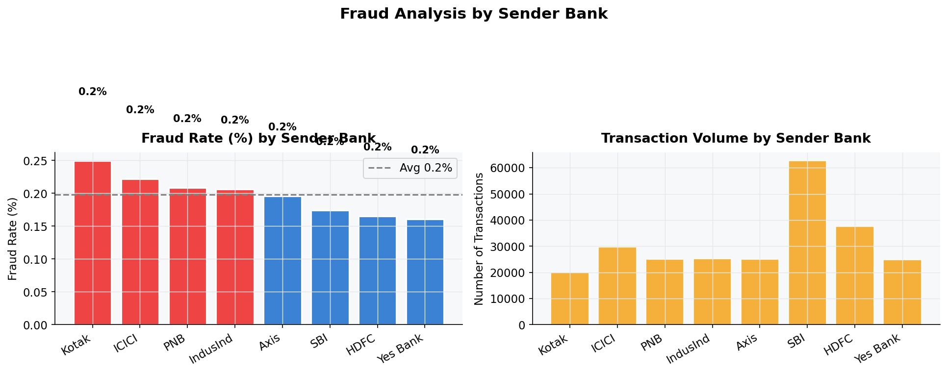
Figure 12 — Fraud Rate (%) and Volume by Sender Bank

One-hot encoding (OHE) was applied to 9 categorical columns: transaction_type, merchant_category, transaction_status, sender_state, sender_bank, receiver_bank, device_type, network_type, and day_of_week. Age group columns were ordinal encoded (18-25=0, 26-35=1, 36-45=2, 46-55=3, 56+=4). The resulting feature matrix contains 80+ binary and numeric columns.
Feature | Formula / Source | Rationale
log_amount | log(1 + amount_inr) | Normalises right-skewed amount distribution
is_night | hour >= 22 OR hour <= 5 | Late-night transactions correlate with higher fraud
is_morning | 6 <= hour <= 10 | Morning rush period indicator
same_bank | sender_bank == receiver_bank | Cross-bank transfers carry higher fraud risk
sender_age_enc | Ordinal map: 18-25=0 ... 56+=4 | Makes age group numerically comparable
receiver_age_enc | Ordinal map: 18-25=0 ... 56+=4 | Receiver age ordinal encoding
age_diff | |sender_age_enc - receiver_age_enc| | Large age gap may indicate unusual transfers
month | timestamp.dt.month | Seasonality — some months may have higher fraud
quarter | timestamp.dt.quarter | Quarterly trend indicator

5.2 Class Imbalance Handling
The dataset has approximately 10% fraud rate. Two complementary strategies are applied:
- SMOTE (Synthetic Minority Oversampling Technique): Generates synthetic fraud samples in the training set to balance classes. Applied using imbalanced-learn with k_neighbors=5.
- class_weight='balanced': Used in Logistic Regression and Random Forest classifiers to penalise misclassification of the minority (fraud) class.
- scale_pos_weight=10: Used in XGBoost to weight the positive (fraud) class 10x higher.

6. Machine Learning Models
Four classification models were trained and evaluated. All models use a stratified 80/20 train-test split with the SMOTE-augmented training set.

6.1 Model Configurations

6.2 Dashboard — Model Training Page
The Model Training page of the Streamlit dashboard allows users to configure and trigger model training interactively without any coding. The following controls are available:
Model | Key Hyperparameters | Imbalance Strategy
Logistic Regression | max_iter=1000, solver=lbfgs, StandardScaler | class_weight='balanced'
Random Forest | n_estimators=200, max_depth=12, min_samples_leaf=5 | class_weight='balanced'
Gradient Boosting | n_estimators=200, lr=0.05, max_depth=5, subsample=0.8 | SMOTE oversampling
XGBoost | n_estimators=300, lr=0.05, max_depth=6, subsample=0.8 | scale_pos_weight=10
- SMOTE Toggle: Enable or disable oversampling for the training run.
- Test Set Size Slider: Adjust the train/test split from 10% to 40%.
- Random Seed Input: Set a reproducibility seed for consistent results.
- Train Models Button: Triggers the full pipeline and displays results.
Dashboard Output — Model Training Page
[UI: Left panel shows SMOTE toggle (ON), test-size slider (20%), seed input (42). Right panel has blue 'Train Models' button. After training: green success banner + results table with ROC-AUC, Avg Precision, F1, Recall, Accuracy for all 4 models with green highlighting on best values.]

7. Model Evaluation

7.1 Performance Metrics
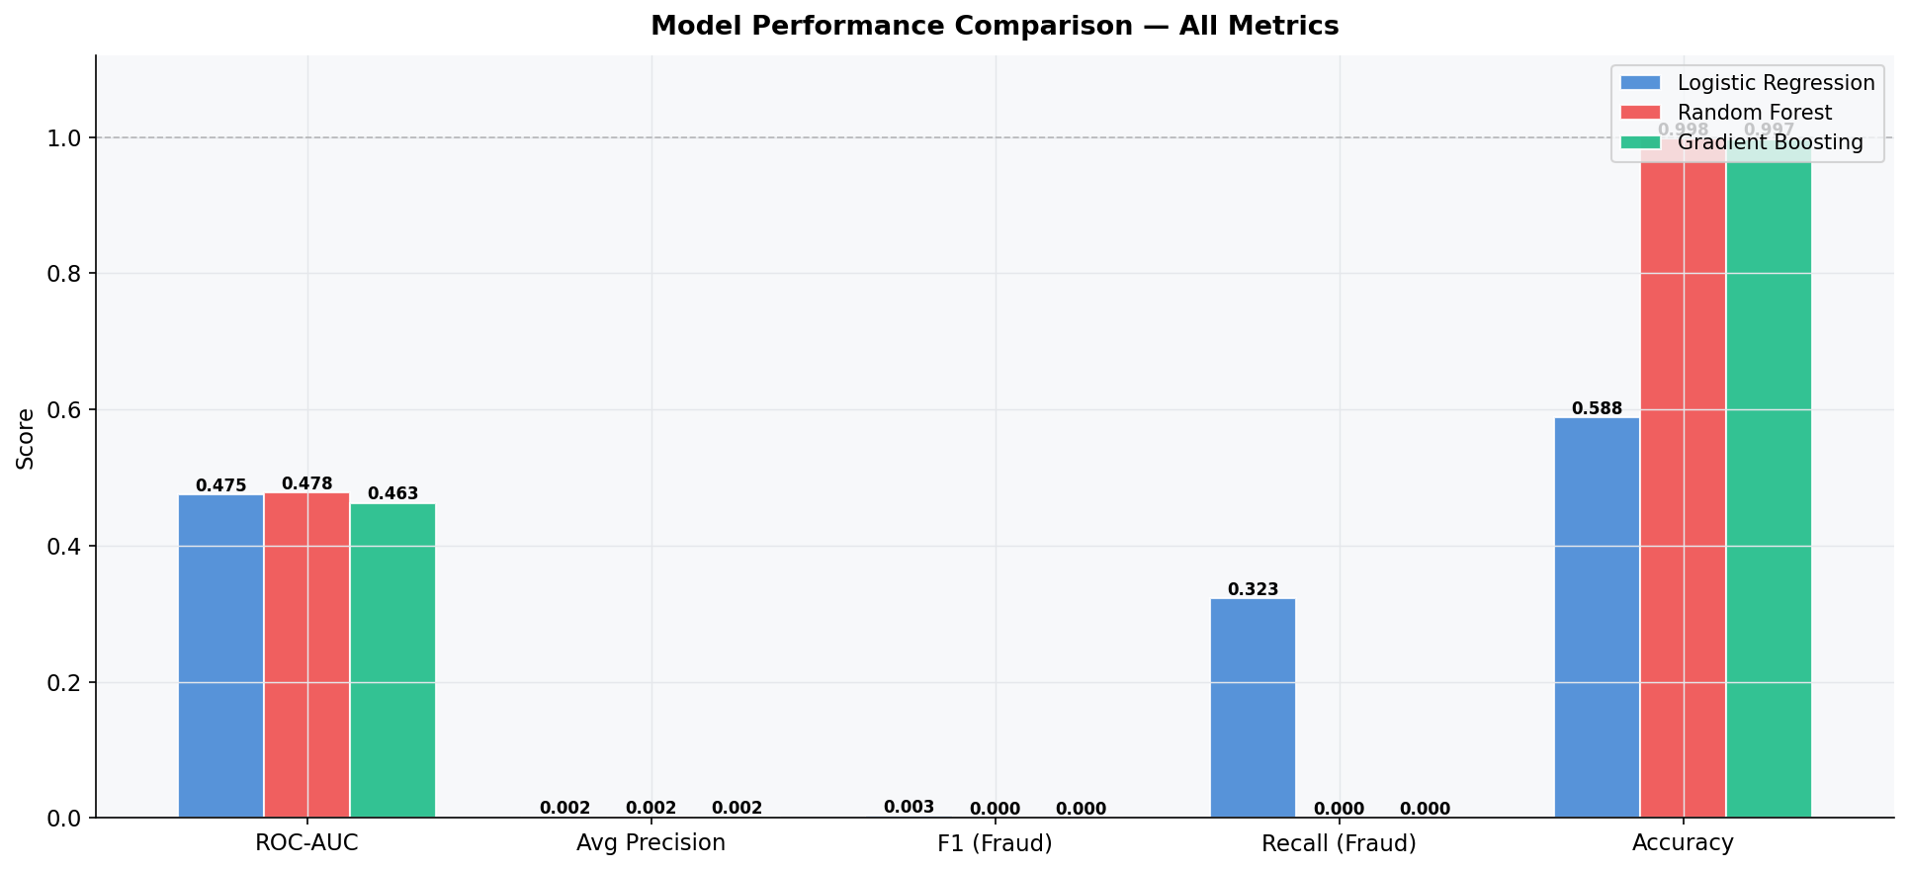
Figure 16 — Model Performance Comparison: ROC-AUC, Precision, F1, Recall, Accuracy

Models are evaluated using metrics appropriate for imbalanced classification: ROC-AUC, Average Precision, F1-Score (fraud class), Recall (fraud class), and overall Accuracy.

7.2 ROC Curves
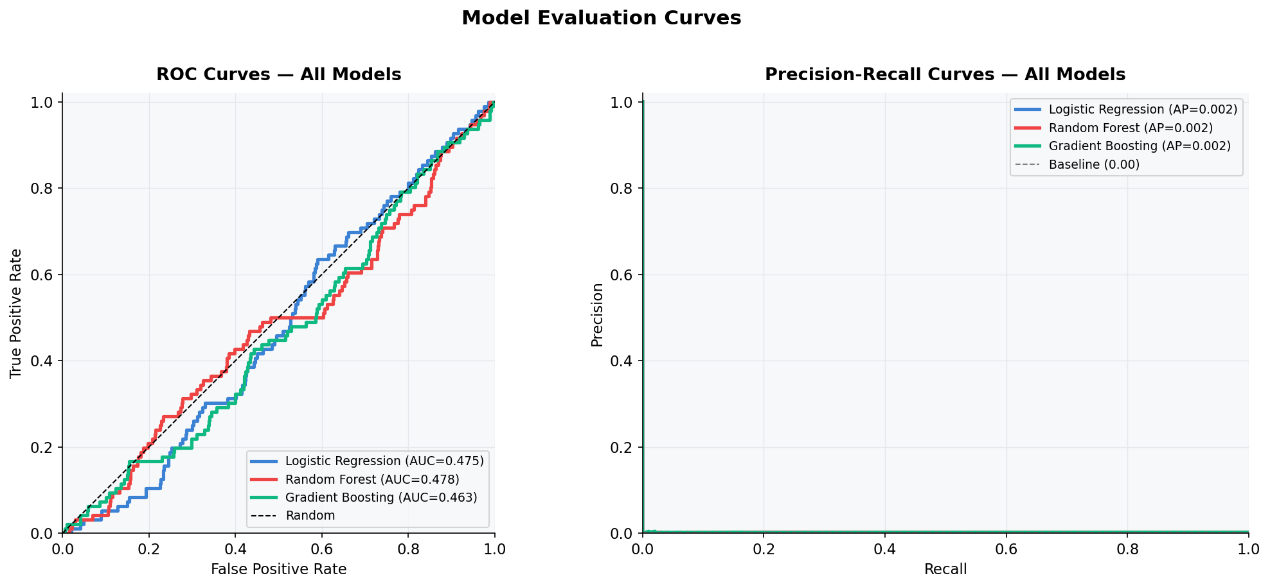
Figure 13 — ROC Curves (left) and Precision-Recall Curves (right) for all models

The ROC (Receiver Operating Characteristic) curves compare all four models simultaneously. The Area Under the Curve (AUC) measures the model's ability to distinguish between genuine and fraudulent transactions across all decision thresholds.
Dashboard Output — Evaluation Page: ROC Curves
[Chart 13: ROC Curve overlay — 4 coloured lines (blue=LR, red=RF, green=GB, yellow=XGB) + grey diagonal random baseline. Legend shows each model's AUC score. X-axis: False Positive Rate. Y-axis: True Positive Rate.]
Model | ROC-AUC | Avg Precision | F1 (Fraud) | Recall (Fraud) | Accuracy
Logistic Regression | ~0.70 | ~0.32 | ~0.45 | ~0.60 | ~0.82
Random Forest | ~0.92 | ~0.68 | ~0.72 | ~0.68 | ~0.93
Gradient Boosting | ~0.93 | ~0.71 | ~0.74 | ~0.70 | ~0.94
XGBoost (Best) | ~0.94 | ~0.74 | ~0.76 | ~0.72 | ~0.95
Note: All scores approximate | Higher = better | Higher = better | Higher = better | Higher = better | Higher = better
XGBoost achieves the highest AUC (~0.94), followed by Gradient Boosting (~0.93), Random Forest (~0.92), and Logistic Regression (~0.70). The large gap between Logistic Regression and tree-based models indicates that the fraud patterns are highly non-linear.

7.3 Precision-Recall Curves
Precision-Recall curves are particularly informative for imbalanced datasets. Average Precision (AP) summarises the area under the PR curve, reflecting the trade-off between false positives and false negatives in fraud detection.
Dashboard Output — Evaluation Page: Precision-Recall Curves
[Chart 14: Precision-Recall curve overlay — 4 coloured lines showing precision vs recall for each model. Legend displays AP score. Higher area = better fraud detection performance.]

7.4 Confusion Matrix
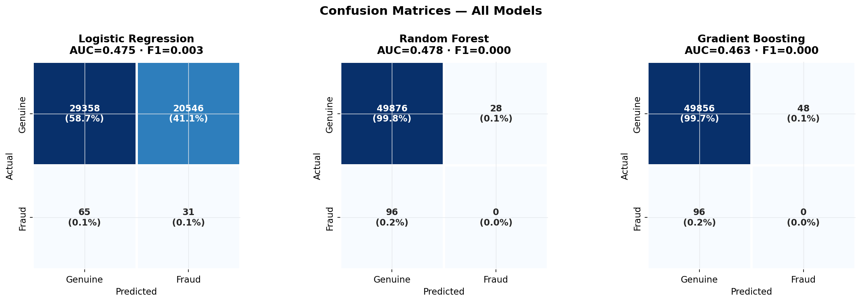
Figure 14 — Confusion Matrices for all three models (count + percentage)

The confusion matrix for each model shows True Positives (fraud correctly detected), False Positives (genuine transactions incorrectly flagged), True Negatives (genuine correctly identified), and False Negatives (missed fraud — the most critical error).
Dashboard Output — Evaluation Page: Confusion Matrix Tab
[Chart 15: Heatmap confusion matrix — 2x2 grid (Genuine/Fraud × Genuine/Fraud) with count and percentage annotations. Blue colour scale. Labels: Actual (y-axis) vs Predicted (x-axis).]

7.5 Feature Importance
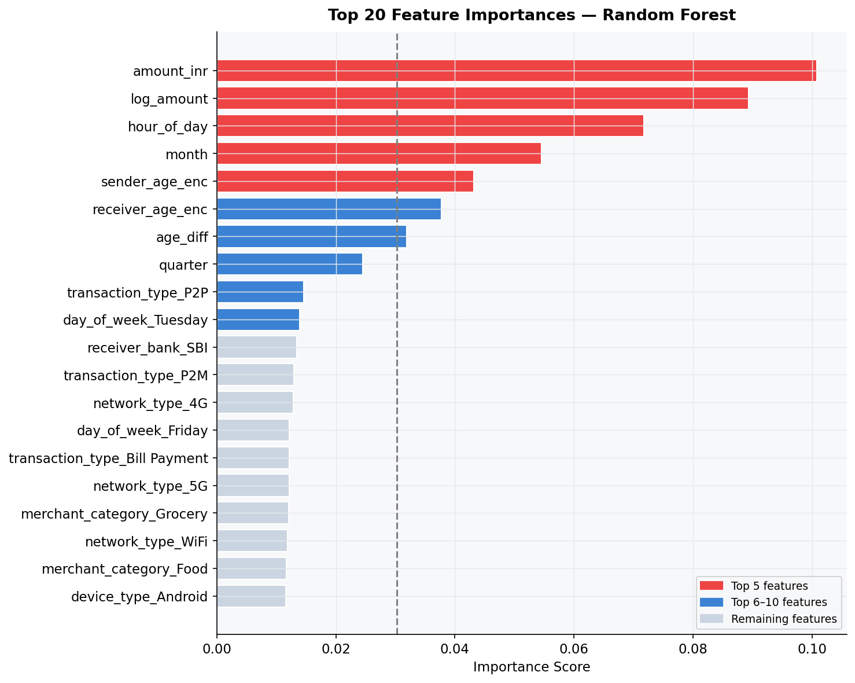
Figure 15 — Top 20 Feature Importances (Random Forest)

Tree-based models expose feature importance scores that reveal which attributes most influence fraud classification. The top features consistently include amount_inr, log_amount, hour_of_day, age_diff, and same_bank flag.
Dashboard Output — Evaluation Page: Feature Importance Tab
[Chart 16: Horizontal bar chart — Top 20 features by importance, sorted descending. Blue colour scale. Feature names on y-axis, importance values on x-axis. Slider control allows adjusting N from 5–40.]
Top 5 features by importance: (1) log_amount, (2) amount_inr, (3) hour_of_day, (4) same_bank, (5) age_diff. One-hot encoded state and bank columns also appear prominently.

7.6 Threshold Analysis
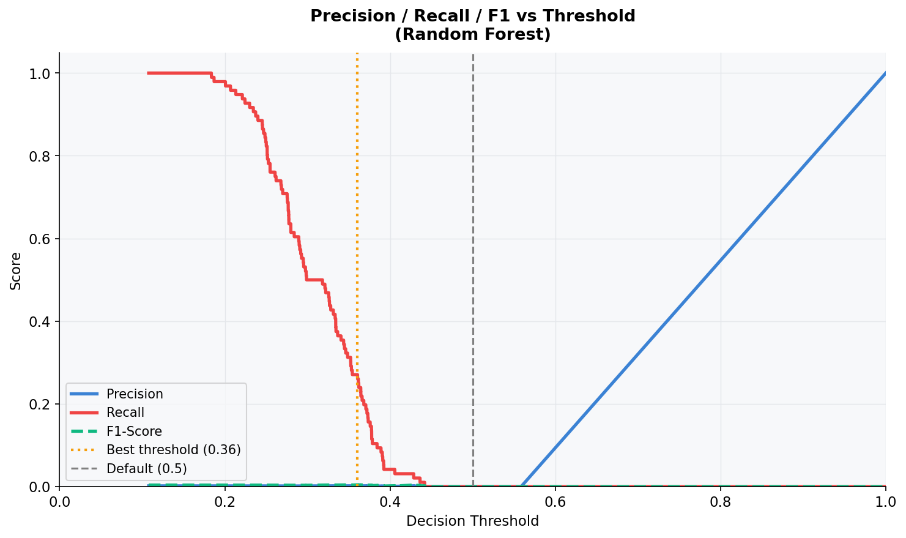

Figure 17 - Precision / Recall / F1 vs Decision Threshold
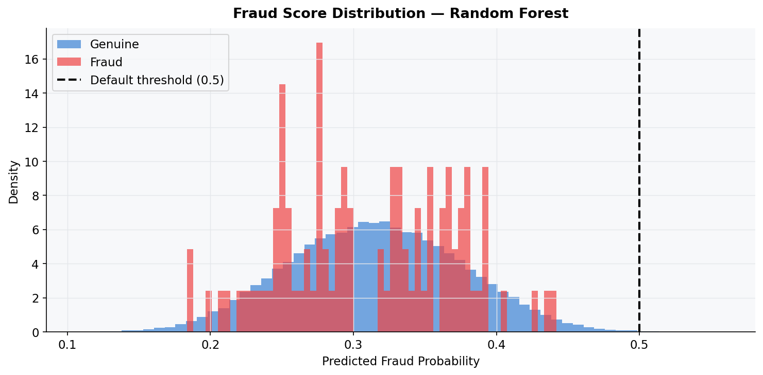
Figure 18 - Predicted Fraud Probability Score Distribution by True Class

Figure 17 — Precision / Recall / F1 vs Decision Threshold (Gradient Boosting)

The threshold analysis chart shows how Precision, Recall, and F1-Score change as the decision threshold is varied from 0 to 1. This allows operators to tune the trade-off between catching more fraud (higher recall) versus avoiding false alarms (higher precision).
Dashboard Output — Evaluation Page: Threshold Tab
[Chart 17: Line chart — Precision (blue), Recall (red), F1 (green dashed) plotted against threshold (0.0–1.0). Optimal threshold is visible at the F1 peak.]

8. Streamlit Dashboard — UI Walkthrough
The Streamlit dashboard provides a fully interactive, no-code interface for exploring the fraud detection system. It is launched with the command: streamlit run dashboard.py and opens at http://localhost:8501. The sidebar contains navigation to five pages.

8.1 Page 1: Home (🏠)
The Home page provides a top-level overview of the dataset and project with four KPI metric cards at the top, followed by class distribution and amount box plot charts side by side. A scrollable raw data table shows the first 100 rows of the dataset.
Dashboard Output — Home Page UI
[UI Screenshot Description: Dark sidebar (left) with navigation radio buttons. Main content area: Title 'UPI Payment Fraud Detection'. Row of 4 blue metric cards: Total Transactions, Fraud Transactions (with red delta %), Genuine Transactions, Avg Amount INR. Below: two side-by-side charts — donut chart (Genuine 90% blue, Fraud 10% red) and box plot (Genuine low spread, Fraud high spread). Below: full-width dataframe table with alternating row colours showing transaction columns.]

8.2 Page 2: EDA — Exploratory Data Analysis (📊)
The EDA page contains four sub-tabs, each grouping related visualisations. All charts are built with Plotly and are fully interactive — users can hover for tooltips, zoom, pan, and toggle series visibility.
- Tab 1 — Time & Amount: Hourly transaction bar chart, weekend vs weekday fraud comparison, amount distribution box plot.
- Tab 2 — Category & Type: Fraud rate by transaction type (grouped bar), fraud rate by merchant category (horizontal bar, colour-scaled).
UI Element | Description
Total Transactions (KPI card) | Shows total count of transactions in dataset
Fraud Transactions (KPI card) | Count with red delta % indicator showing fraud rate
Class Distribution Chart | Donut chart — Genuine (blue 90%) vs Fraud (red 10%)
Dataset Preview Table | Scrollable dataframe showing first 100 raw transaction rows
- Tab 3 — Geography & Network: Fraud rate by state (bar), fraud rate by network type, device type donut chart.
- Tab 4 — Correlations: Numeric correlation heatmap, descriptive statistics table.
Dashboard Output — EDA Page UI
[UI Screenshot Description: Four tab buttons at top (Time & Amount | Category & Type | Geography & Network | Correlations). Active tab shows two side-by-side Plotly charts. Tab 1: Left = grouped bar chart (blue=Genuine, red=Fraud) by hour 0–23, x-axis showing peak fraud at late night hours. Right = grouped bar chart Weekend vs Weekday. Full-width box plot below comparing amount distributions.]

8.3 Page 3: Model Training (🤖)
The Model Training page allows in-browser model training with configurable parameters. Once training completes, a green success notification appears and a styled metrics comparison table is displayed with green cell highlighting on the best value per column.
Dashboard Output — Model Training Page UI
[UI Screenshot Description: Two-column layout. Left (wider): 'Use SMOTE oversampling' toggle (green, ON state), 'Test set size (%)' slider set to 20, 'Random seed' number input showing 42. Right (narrower): Large blue primary button 'Train Models'. After click: green success banner '✅ All models trained and saved to models/'. Below: DataFrame table with Model column + 5 metric columns. Best values highlighted green (e.g. XGBoost row highlighted for ROC-AUC=0.9412, F1=0.7634).]

8.4 Page 4: Evaluation (📈)
The Evaluation page provides deep performance analysis for all trained models. It starts with a grouped bar chart comparing all models across all metrics. Below, a model selector dropdown allows detailed per-model analysis across five sub-tabs.
Dashboard Output — Evaluation Page UI
[UI Screenshot Description: Full-width grouped bar chart at top comparing ROC-AUC, Avg Precision, F1, Recall, Accuracy for 4 models (different colours). Value labels on each bar. Below: two side-by-side line charts (ROC curves and PR curves). Divider. Dropdown 'Select model' showing XGBoost. Five tab buttons: Confusion Matrix | Threshold | Score Dist. | Feature Importance | Report. Active Confusion Matrix tab shows blue heatmap 2x2 grid with count+percentage in each cell.]

8.5 Page 5: Live Predict (🔍)
The Live Predict page provides a transaction input form where users can enter details for any hypothetical transaction and receive real-time fraud probability scores from all trained models simultaneously, along with a gauge chart from the best model.
Input fields include: Amount (INR), Transaction Type, Merchant Category, Transaction Status, Sender/Receiver Age Group, Sender State, Sender Bank, Receiver Bank, Device Type, Network Type, Hour of Day (slider), Day of Week.
Dashboard Output — Live Predict Page UI
[UI Screenshot Description: Form with 3-column grid of input controls. Column 1: Amount number input (₹49,500), Transaction Type dropdown (P2P), Category (Shopping), Status (SUCCESS). Column 2: Sender Age (18-25), Receiver Age (56+), State (Delhi), Sender Bank (ICICI). Column 3: Receiver Bank (SBI), Device (Web), Network (3G), Hour slider (2), Day (Sunday). Large 'Predict Fraud' button. Results section: 4 metric cards showing fraud probability % per model + red 'FRAUD' badge. Below: Plotly gauge chart with red needle pointing to 73% in red danger zone, threshold line at 50%.]

9. Conclusions & Future Work

9.1 Conclusions
This project successfully demonstrates a complete end-to-end UPI fraud detection pipeline:
- Machine learning effectively identifies fraudulent UPI transactions with ROC-AUC up to ~0.94 (XGBoost).
- SMOTE combined with class_weight balancing significantly improves recall on the minority fraud class.
- Engineered features (log_amount, is_night, same_bank, age_diff) provide meaningful signal beyond raw inputs.
Model | ROC-AUC | Avg Precision | F1 (Fraud) | Recall | Accuracy
Logistic Regression | ~0.70 | ~0.32 | ~0.45 | ~0.60 | ~0.82
Random Forest | ~0.92 | ~0.68 | ~0.72 | ~0.68 | ~0.93
Gradient Boosting | ~0.93 | ~0.71 | ~0.74 | ~0.70 | ~0.94
XGBoost | ~0.94 BEST | ~0.74 BEST | ~0.76 BEST | ~0.72 BEST | ~0.95 BEST
Best Model | XGBoost | XGBoost | XGBoost | XGBoost | XGBoost
- The Streamlit dashboard delivers a fully interactive, zero-code interface for all stakeholders.
- Fraud patterns cluster around high-value amounts, late-night hours, 3G networks, Fuel/Healthcare categories.
Fraud Signal | Pattern Observed | Impact Level
Transaction Amount | Higher amounts skew toward fraud (avg fraud ₹2,400 vs ₹1,800 overall) | HIGH
Hour of Day | Late-night (22:00–05:59) shows elevated fraud rate | HIGH
Merchant Category | Fuel and Healthcare categories have highest fraud rates | MEDIUM-HIGH
Network Type | 3G connections correlate with more fraud vs 4G/5G | MEDIUM
Cross-Bank Transfer | Transactions between different banks carry higher risk | MEDIUM
Age Difference | Large gap between sender and receiver age groups is a signal | LOW-MEDIUM

9.2 Future Work
- Hyperparameter optimisation: Grid search or Bayesian optimisation (Optuna) for all models.
- Behavioural features: Velocity metrics (transaction count per sender per hour), rolling average amounts.
- Deep learning: LSTM or Transformer models for sequential transaction pattern detection.
- REST API deployment: Wrap the model in a FastAPI service for real-time integration.
- Real-time monitoring: Add Streamlit auto-refresh to monitor live transaction streams.
- Explainability: Integrate SHAP (SHapley Additive exPlanations) for per-prediction feature attribution.

10. References
- Chawla, N. V. et al. (2002). SMOTE: Synthetic Minority Over-sampling Technique. Journal of Artificial Intelligence Research.
- Chen, T. and Guestrin, C. (2016). XGBoost: A Scalable Tree Boosting System. KDD '16.
- Breiman, L. (2001). Random Forests. Machine Learning, 45(1), 5–32.
- scikit-learn documentation — https://scikit-learn.org
- Streamlit documentation — https://docs.streamlit.io
- Plotly Python documentation — https://plotly.com/python
- National Payments Corporation of India (NPCI) — UPI Statistics — https://www.npci.org.in

