**ASSIGNMENT-12**

**Problem Statement: Deploy and run the project in AWS without using port.**

**Step 1:** Login to the console and click on **EC2**.

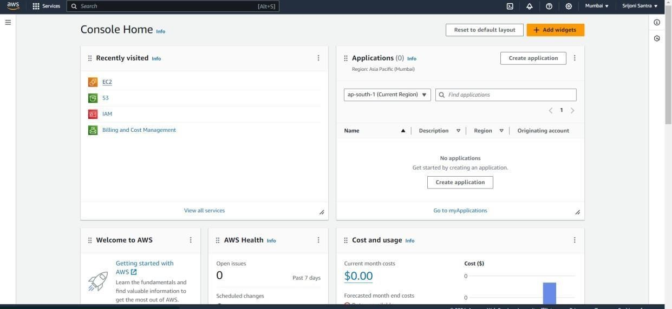

**Step 2:** Then click on Security Groups.

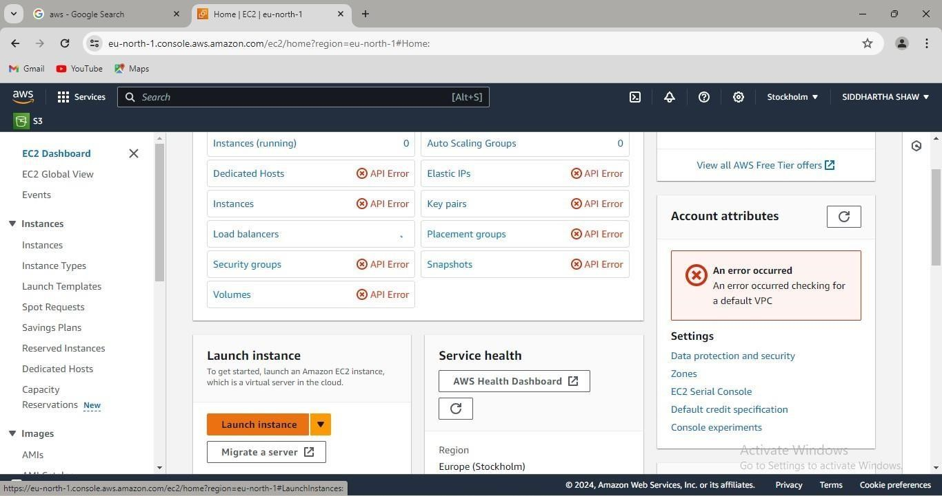

**Step 3**: Then go to the “Create Security group”

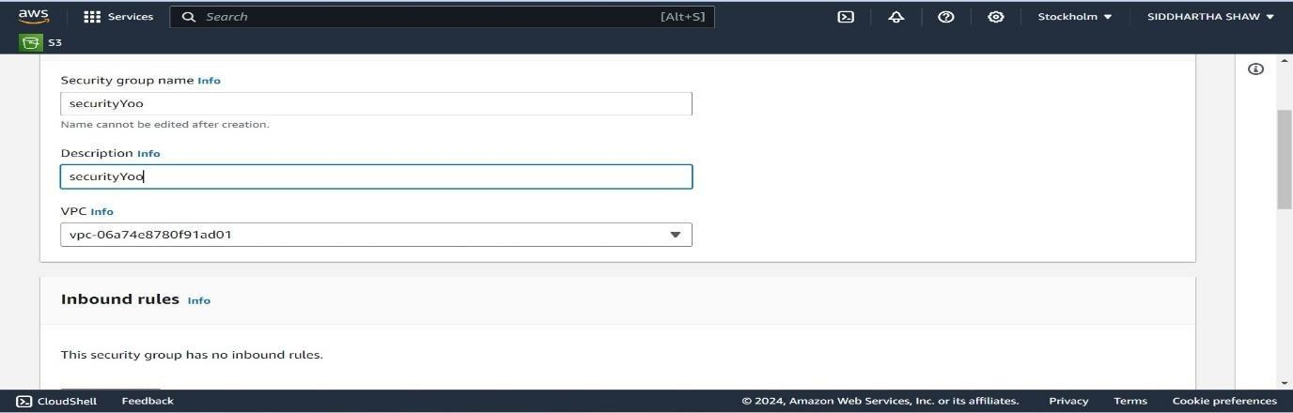

**Step 4:** Write security group name, add inbound rules and click on “Create security group”.

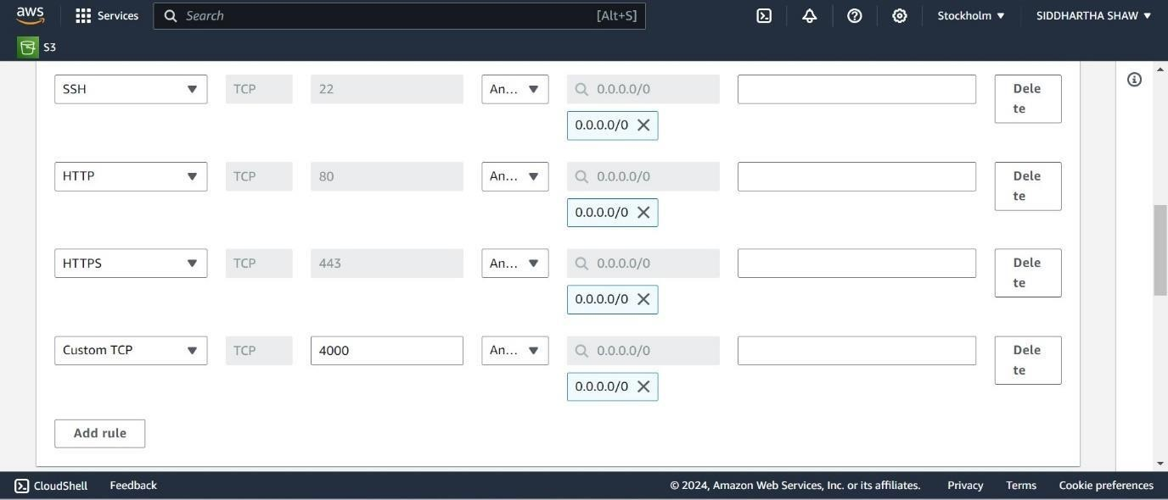

**Step 5**: after that security group is created successfully.

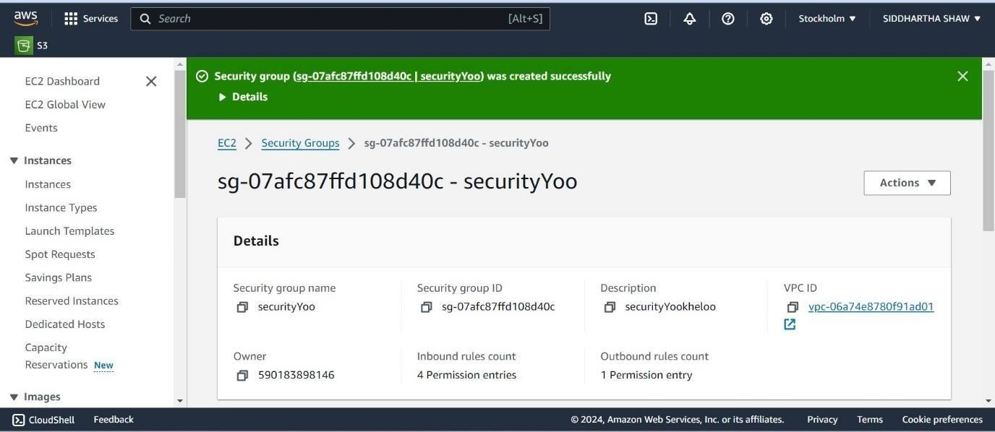

**Step 6**: Now check the security group activity whether its shows all port number or not.

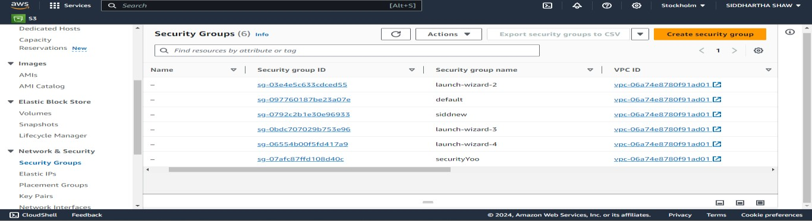

**Step 7**: The security group is created. Now go to the EC2 and click on “Launch Instances”.

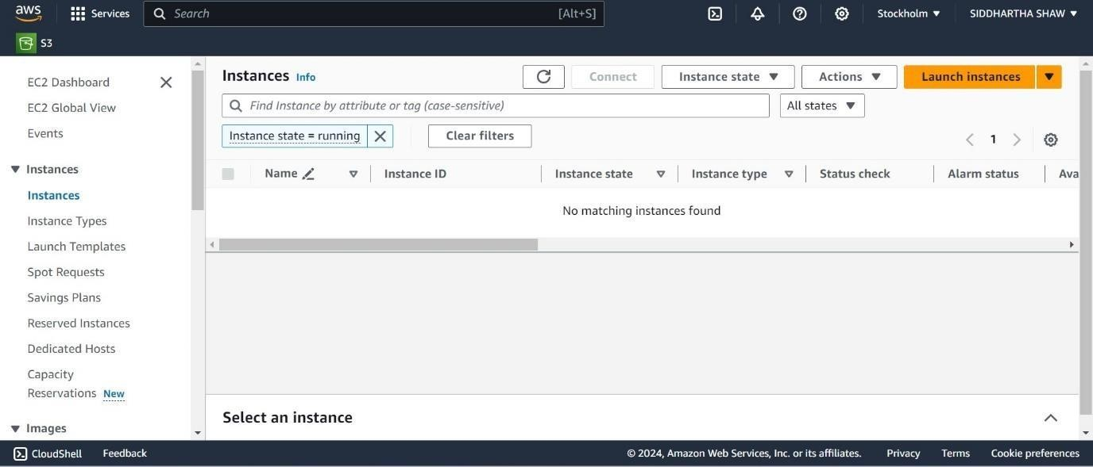

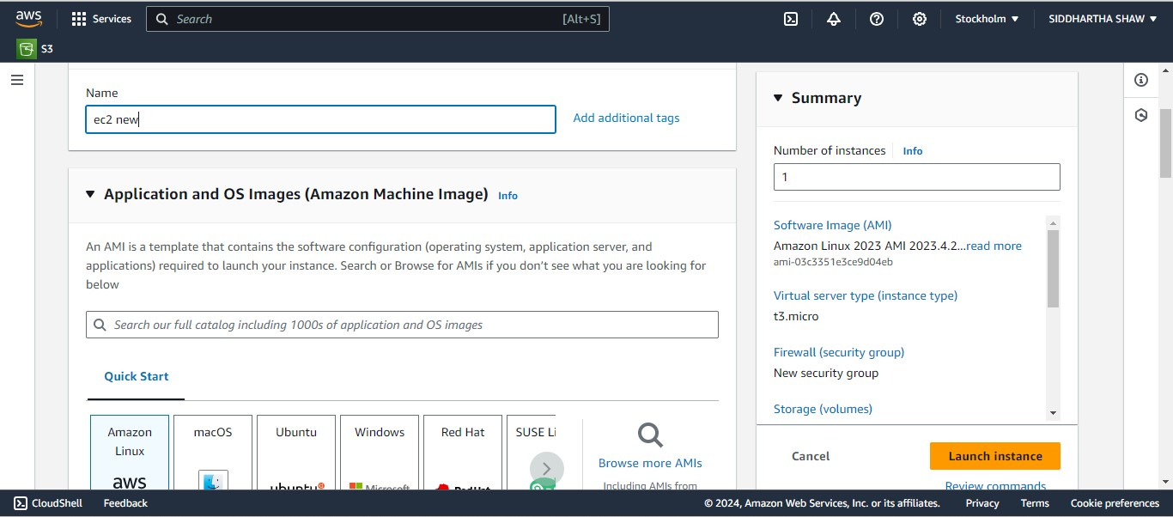

**Step 8:** search the existing key pair whether its already created.

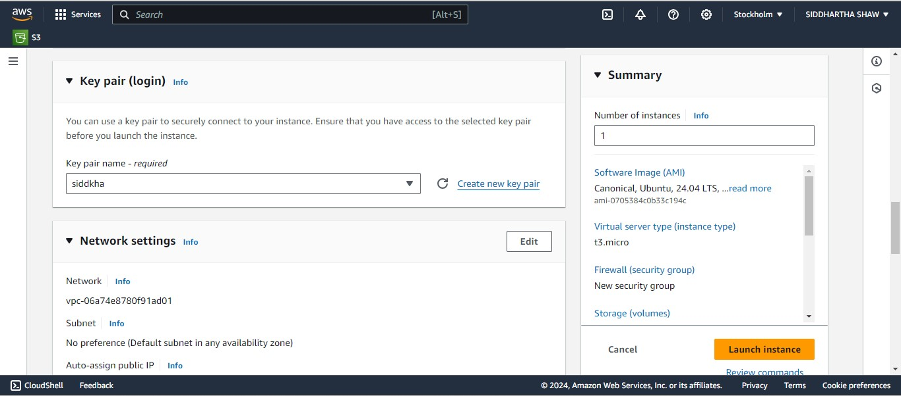

**Step 9:** select the SSH, HTTPS,HTTP and move it.

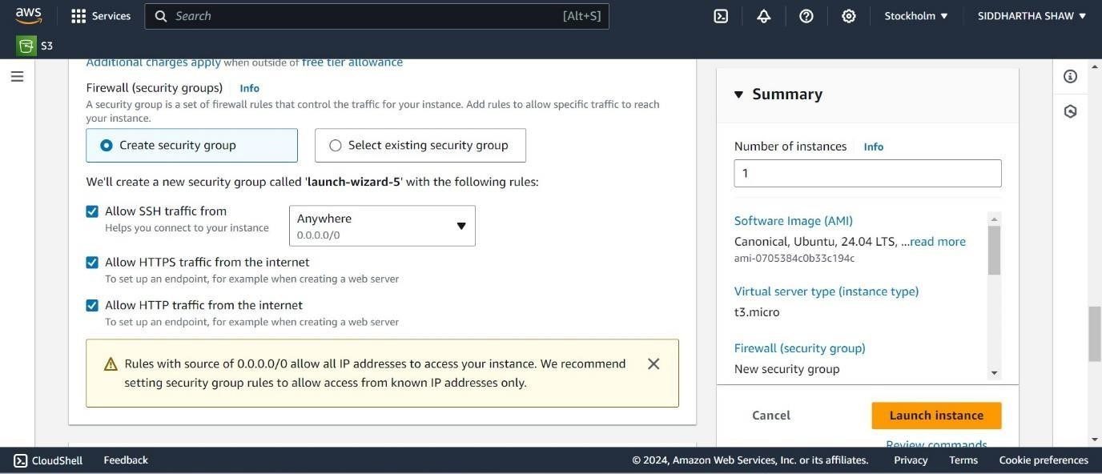

**Step 10: a**fter that the instance lunch successfully.

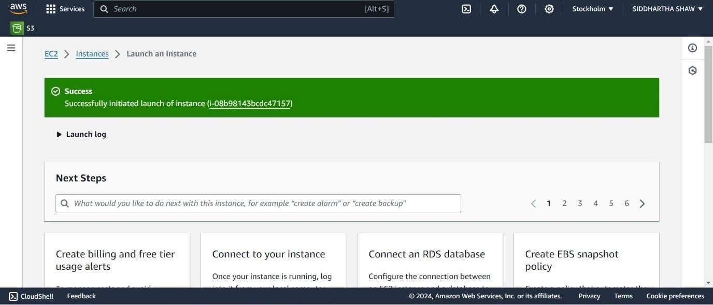

**Step 11:** Go back to the Instance, copy the “Public IPv4 address”.

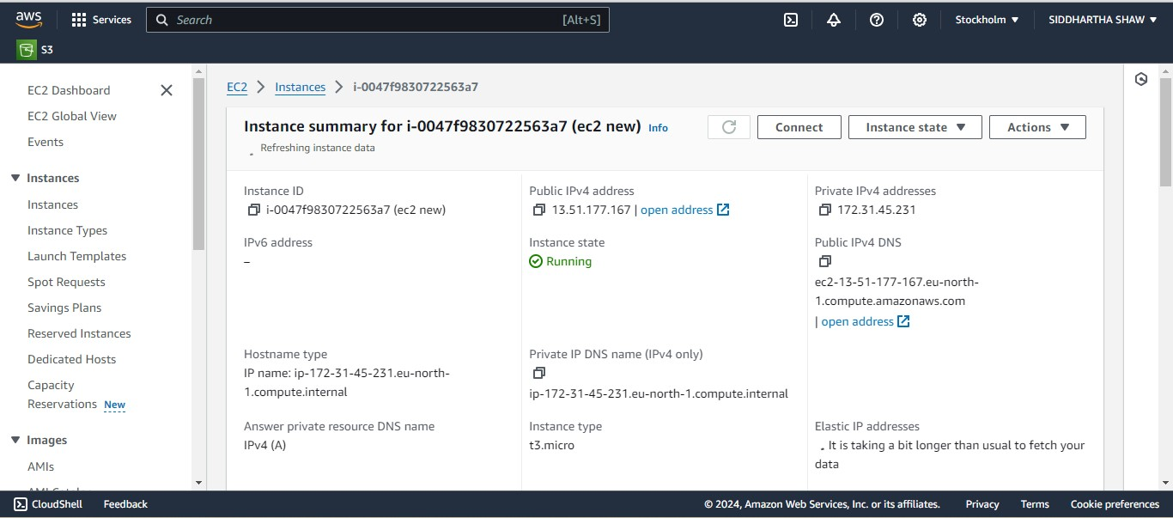

**Step 12:** In “Bitvise SSH Client”, paste the “Public IPv4 address” in “Host” and under “Authentication tab” give the username as Ubuntu. Then click on “Client Key Manager”.

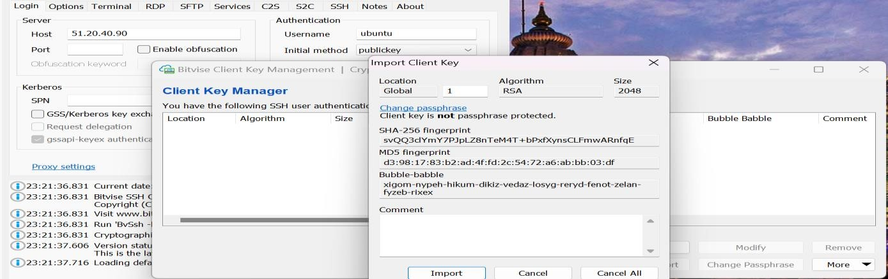

**Step 13:**  after that “bitwise ssh client” creation process done.

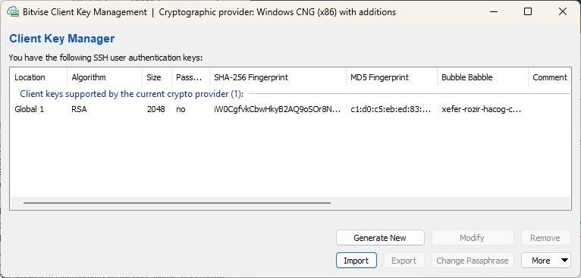

**Step 14: steps** of further processes which is done in **command pannle** in “bitwise ssh client”.

1. Remove any previously selected key if any, then click on “Import” & select the key which instance was created.
2. **In “Bitvise SSH Client”,** click on “Log in”.
3. After successful “Log in” open a “New Terminal Console”.
4. In the console, type the following commands in sequential order.

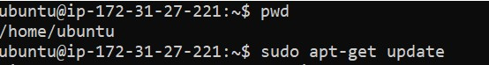

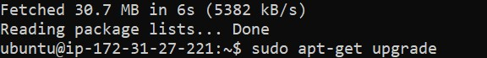

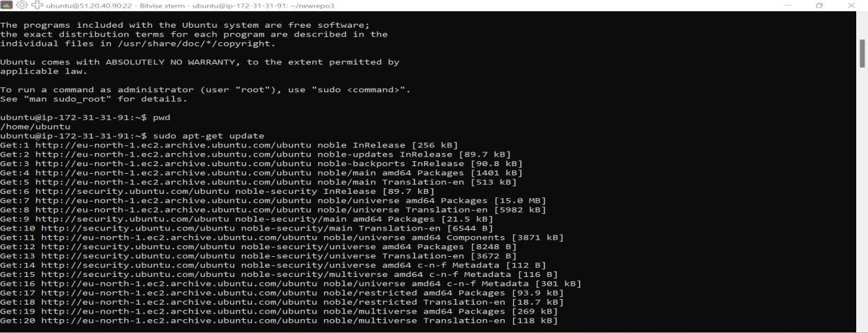

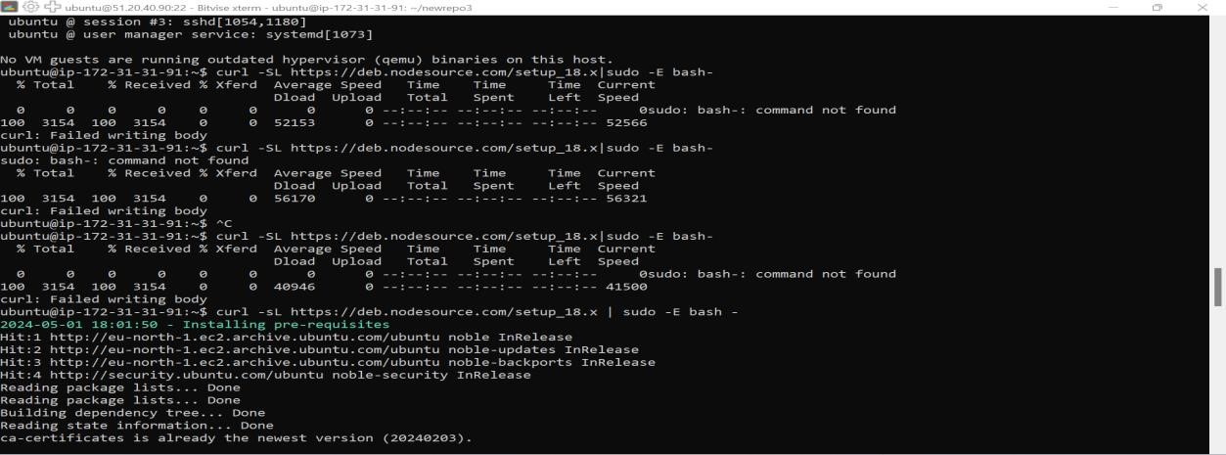

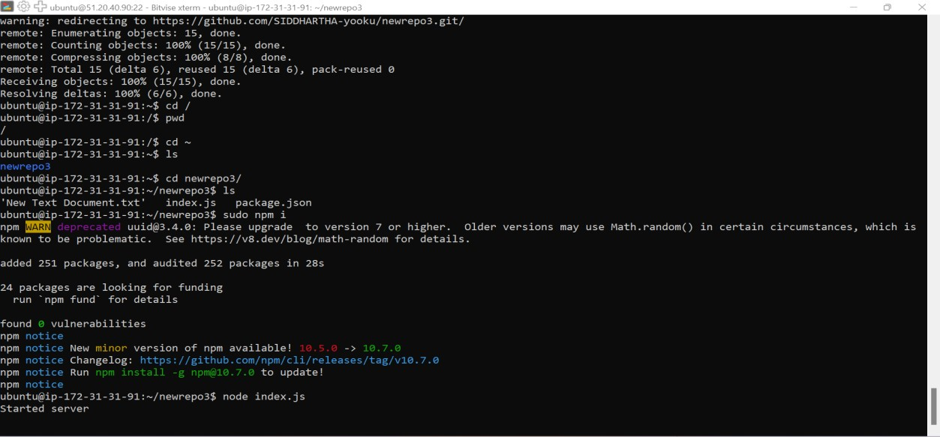

**Step 15:**  after that we start the server and show that whether its running or not.



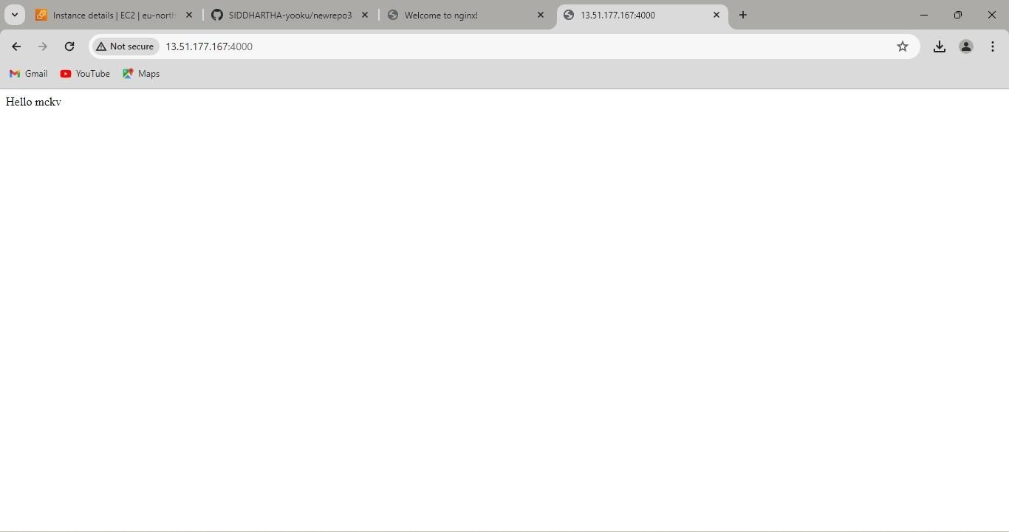

**Step 16:** Now we open another command pannle and go to the further process.

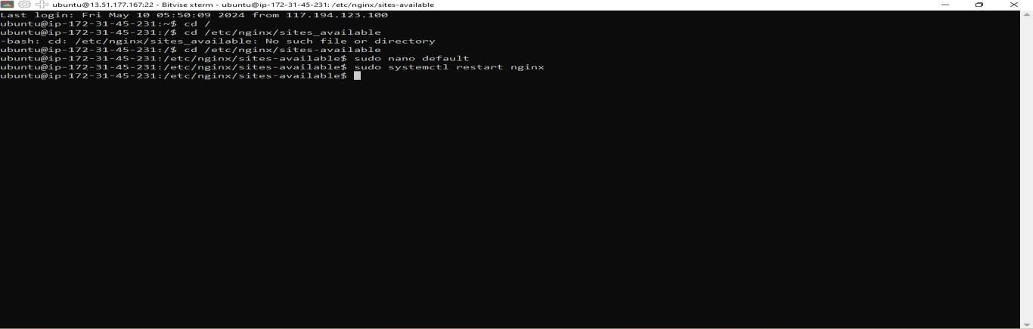

**Step 17:** Now type the commands and then go to the further steps-- In this step edit the **“location”** part only with - location / { proxy_pass [http://localhost:4000;](http://localhost:4000/) proxy_http_version 1.1; proxy_set_header Upgrade $http_upgrade; proxy_set_header Connection 'upgrade'; proxy_set_header Host $host; proxy_cache_bypass $http_upgrade; }

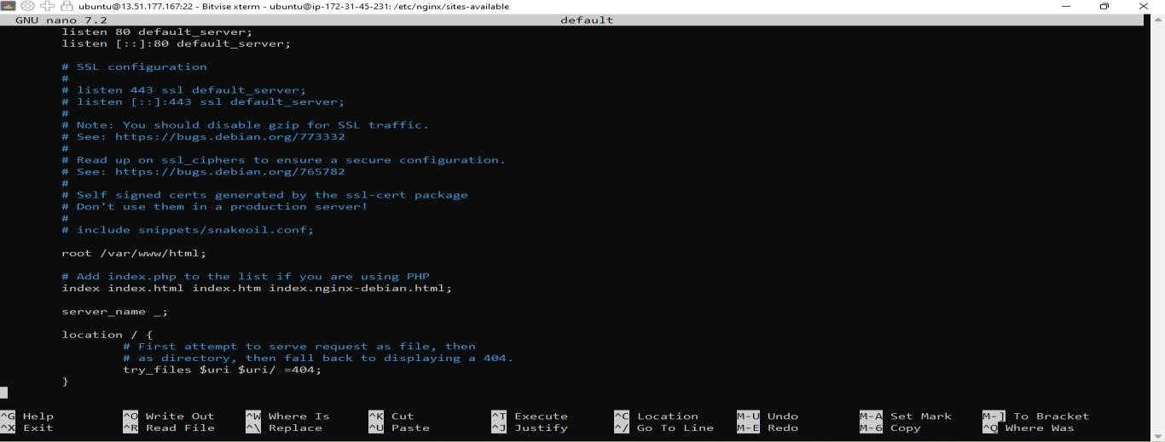

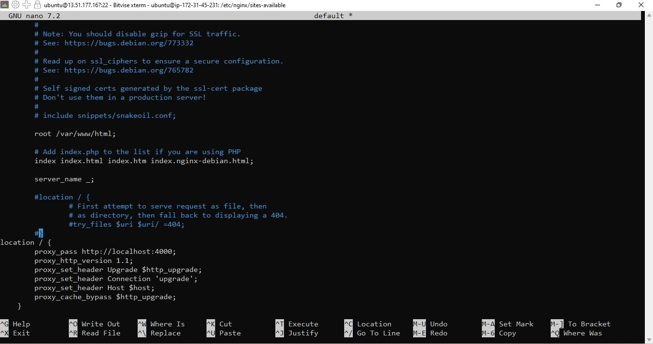

**Step 18:** Now we saw that after one more time copy the **ipv4 address** of instance its running without using port(4000).

