Assignment: 3

**Problem Statement**: Create a IAM User and give access to S3.

**Solution:**

**IAM:** An AWS Identity and Access Management (IAM) user is an entity that you create in AWS. The IAM user represents the human user or workload who uses the IAM user to interact with AWS. A user in AWS consists of a name and credentials.

**Steps and Procedures:**

**Step 1:** Goto the dashboard and search for IAM in the search box. Click on IAM.

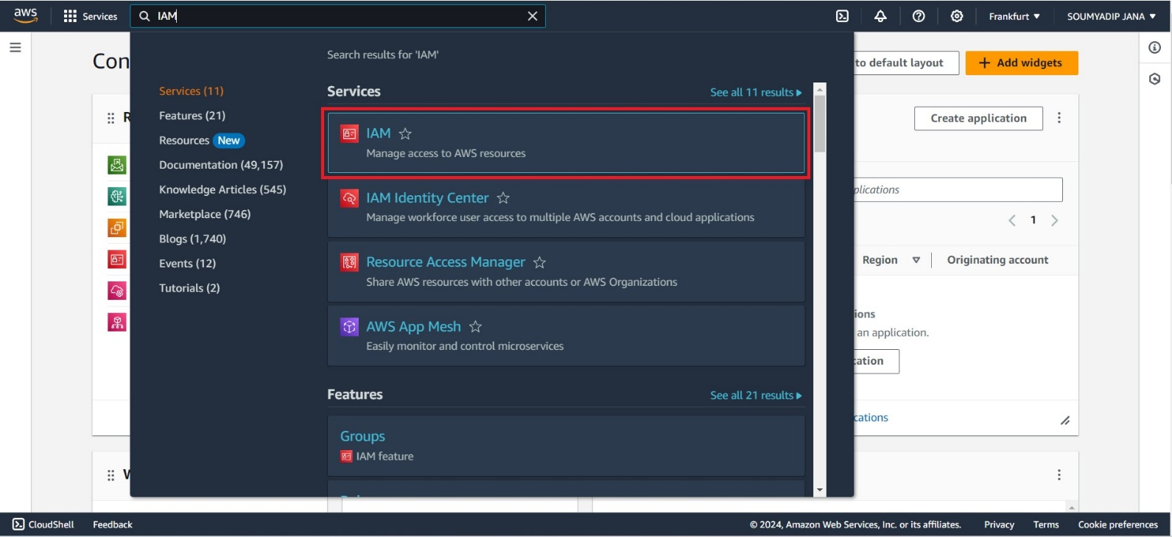

**Step 2:** In the left panel of IAM dashboard select Users

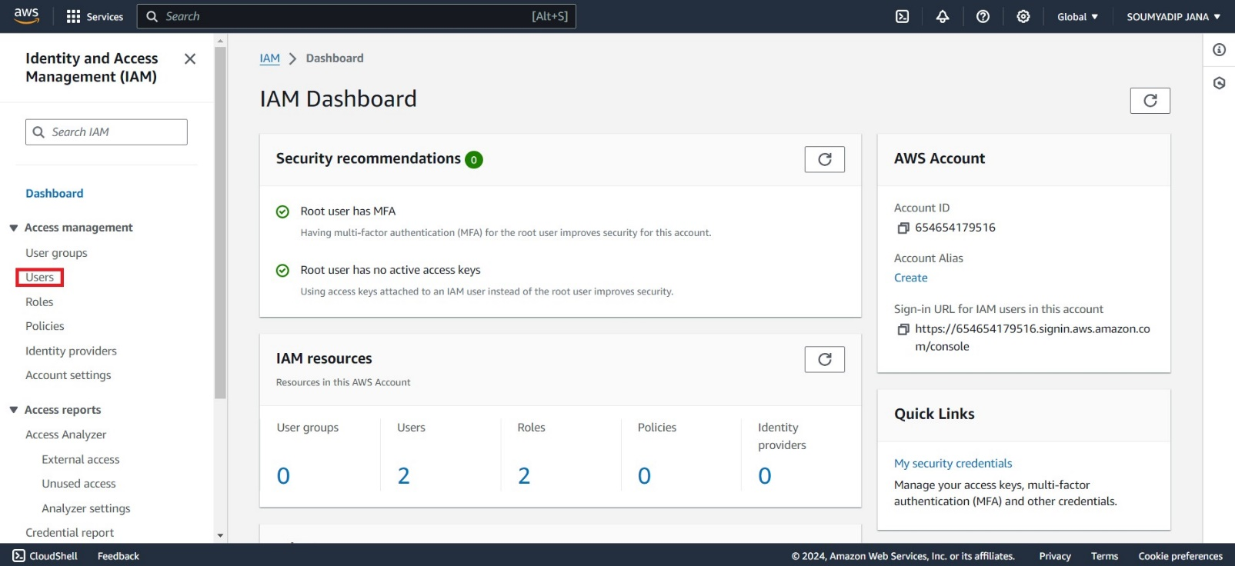

**Step 3:** Click on Create user and then give a username and give user the access of AWS management console. Then select I want to create IAM user.

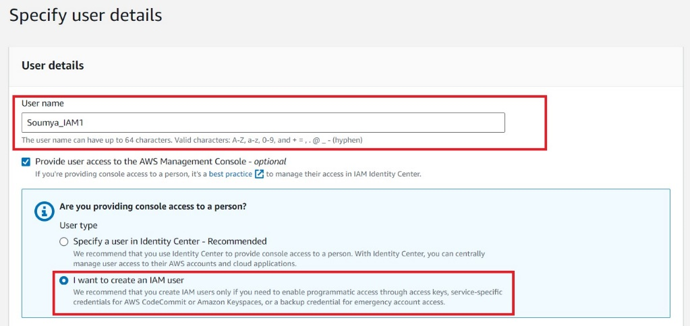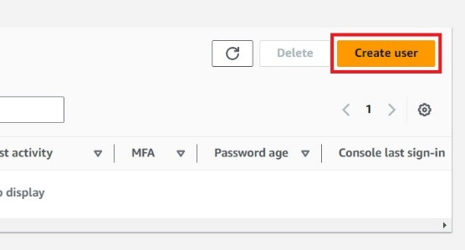

**Step 4:** Setup a password. You can also specify that the user must change the password at the time of login. Then click on next.

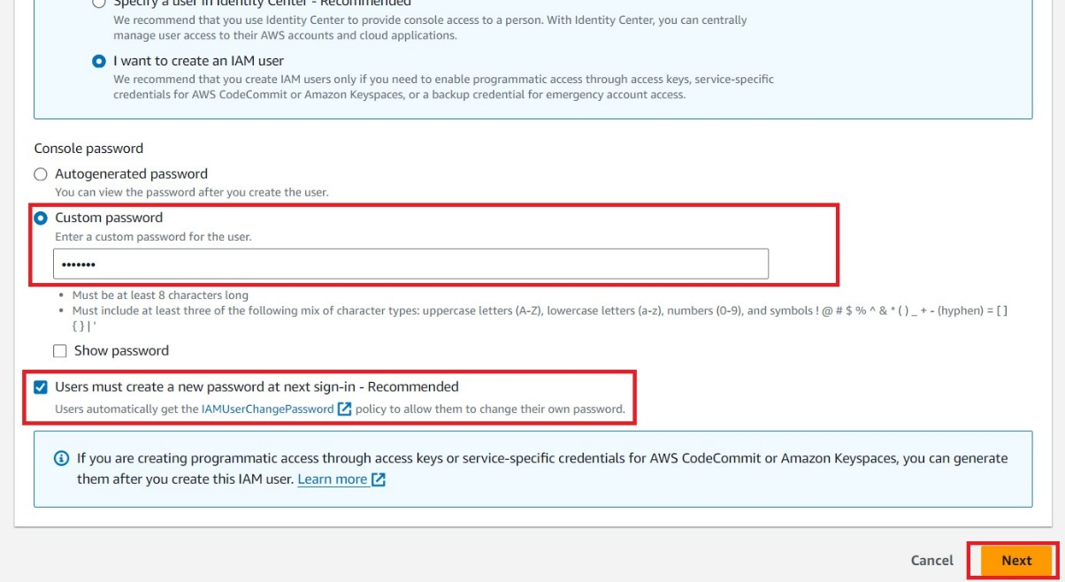

**Step 5:** It is recommended that you include the user in a group. Adding users in a group helps to manage the different permissions and access levels. Select Add user to group and click on Create group.

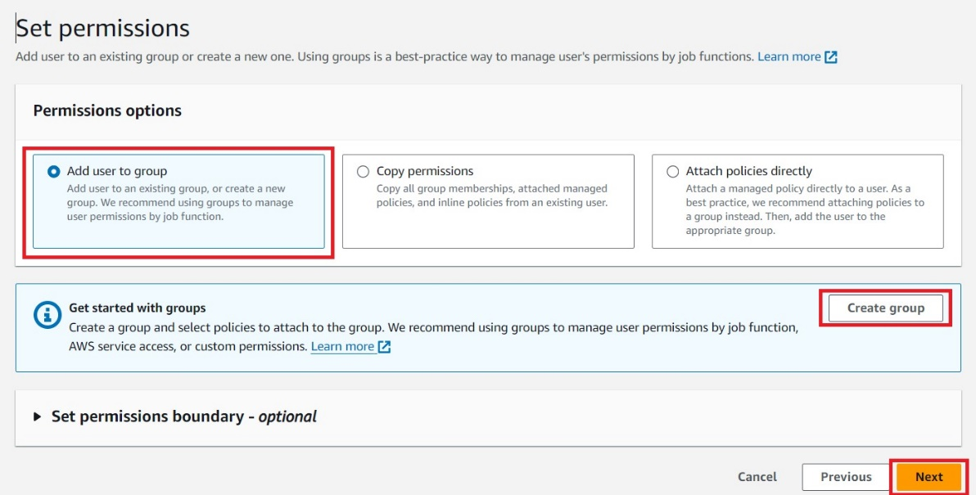

**Step 6:** Give a group name and give full access of S3 and click on create user group.

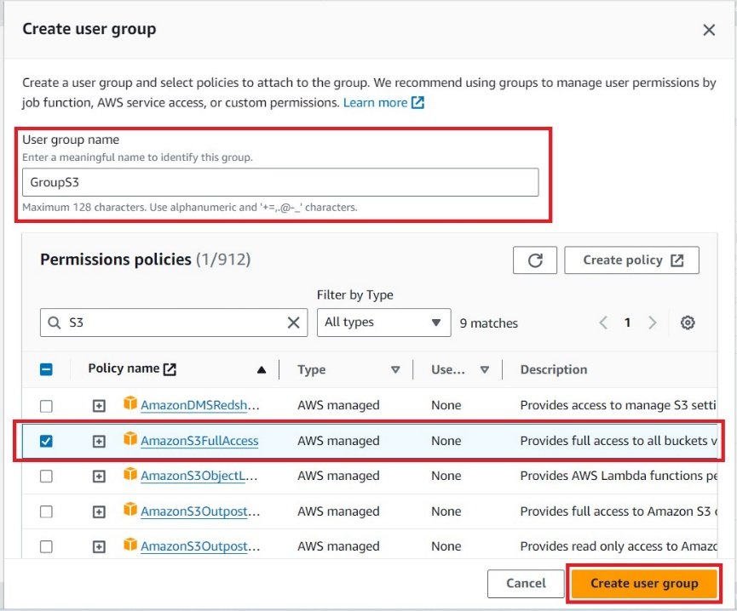

**Step 7:** Select the group and click on next and then Create User.

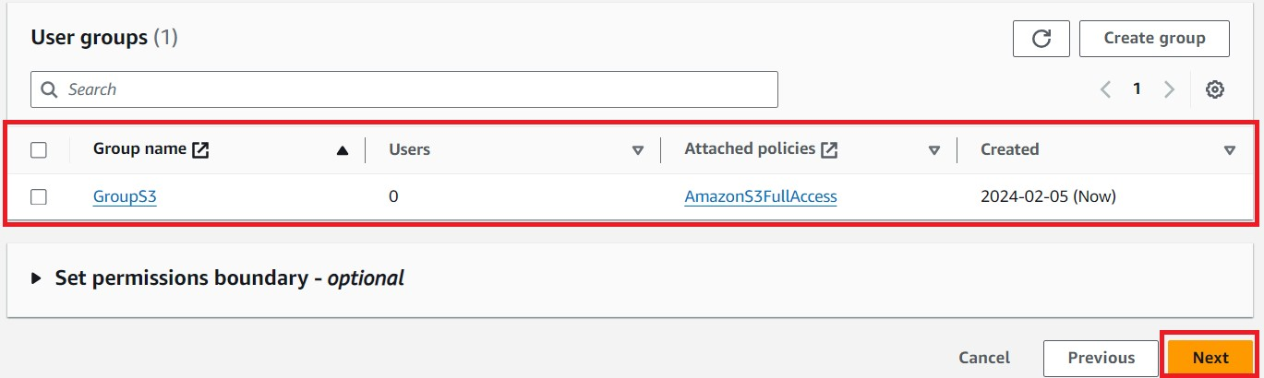

**Step 8:** After creating user you will get the user credentials in a csv file. These credentials will be required at the time of login.

