**Assignment: 6**

**Problem statement:**

Upload a static website on S3.

**Steps to upload a static website on S3->**

1. Sign up for an AWS account, search for ‘S3’ then click on it.

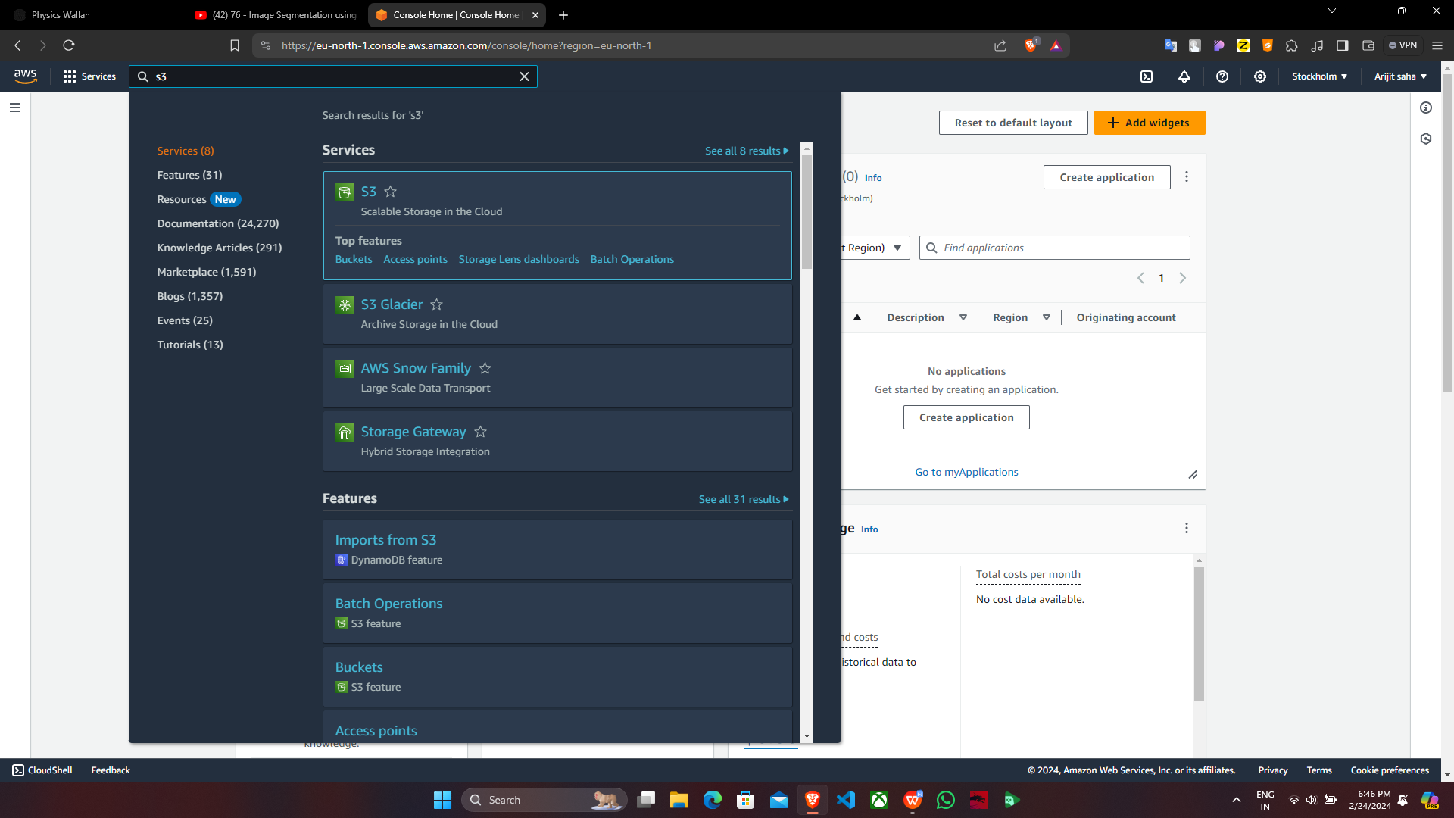

2. Click on ‘Create bucket’.

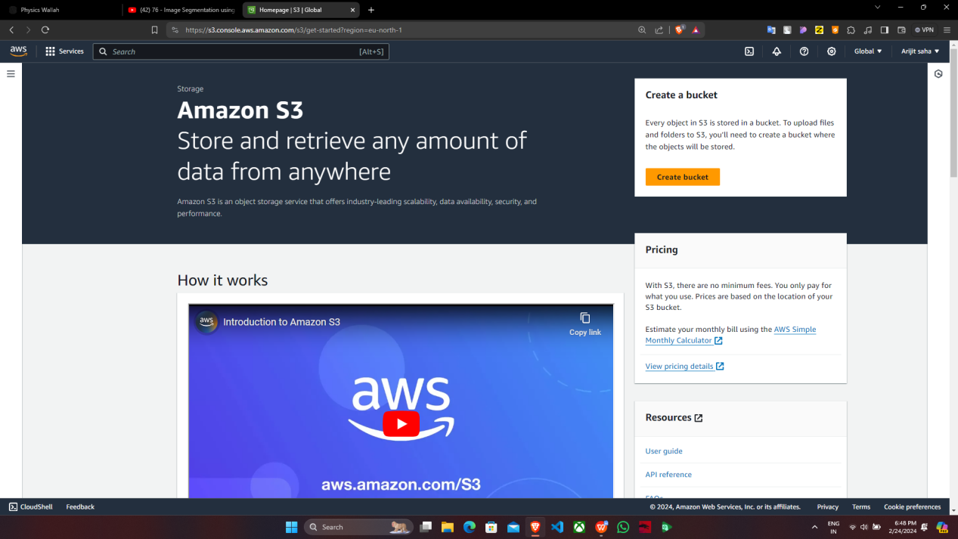

3. Fill up the required details->’Aws Region’, ’Bucket name’, click on ‘ACLs enabled’, uncheck ‘Block all public access…’, tick off ‘I acknowledge…’ and then click on ‘Create bucket’.

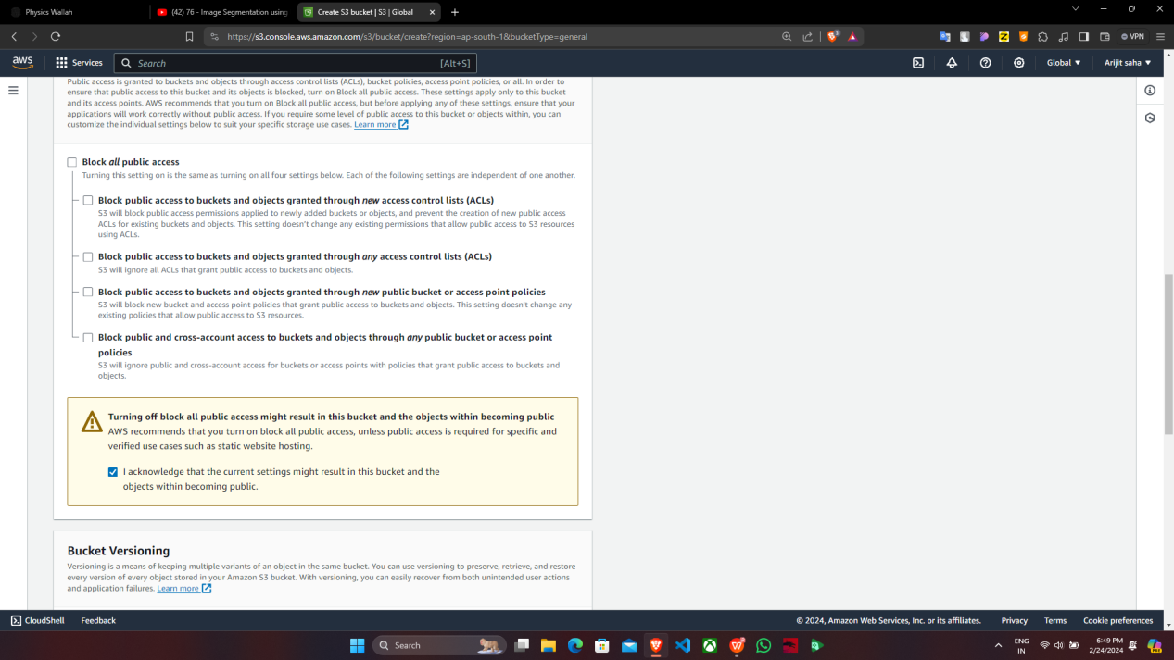

4. ‘mainak-static-website’ bucket is created successfully, click on the bucket name ‘mainak-static-website’.

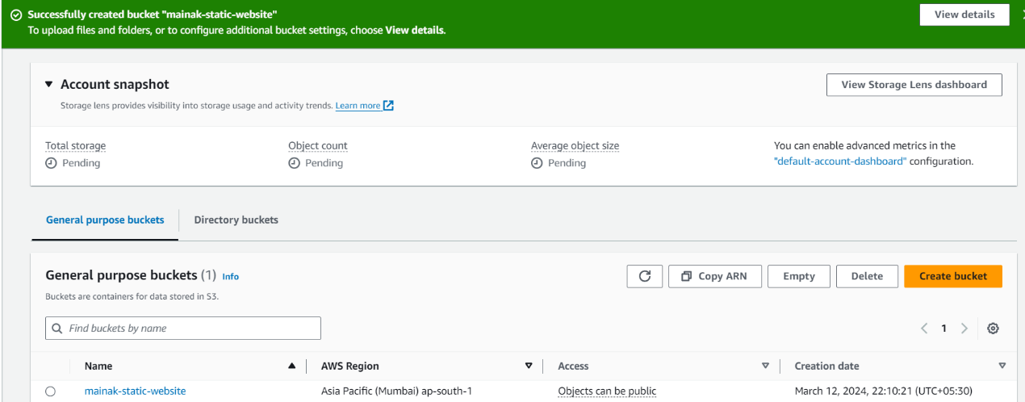

5. Under ‘mainak-static-website’, click on ‘Upload’ then choose the html files and upload it.

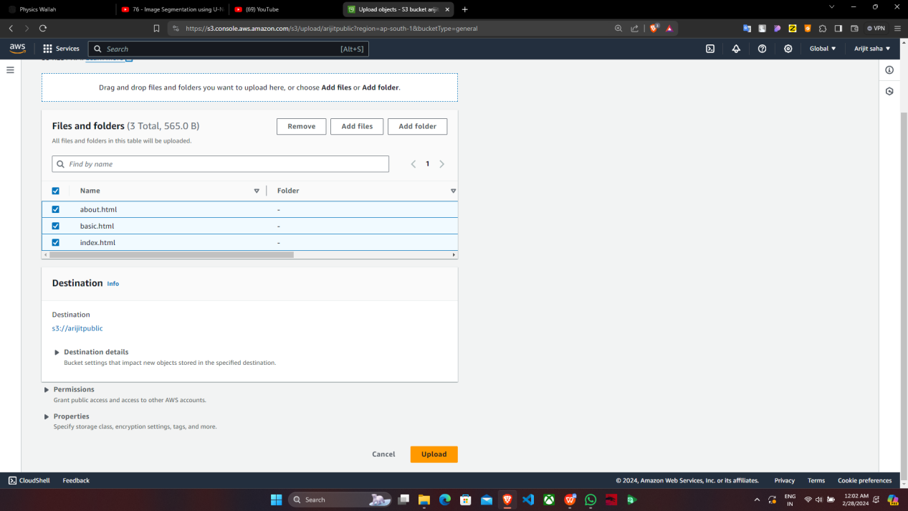

6. Click on ‘Add files’ and add the three html files namely ‘index.html’, ‘about.html’ and ‘basic.html’ then tick off the ‘Name’ of the files.

1. After ticking off ‘Name’ of the files go to ‘Permissions’ and click on it.

8. Under ‘Permissions’, click on ‘Grant public-read access’ then tick off the checkbox ‘I understand…’ and then click on ‘Upload’. In this method we directly give the public access to all the selected files altogether.

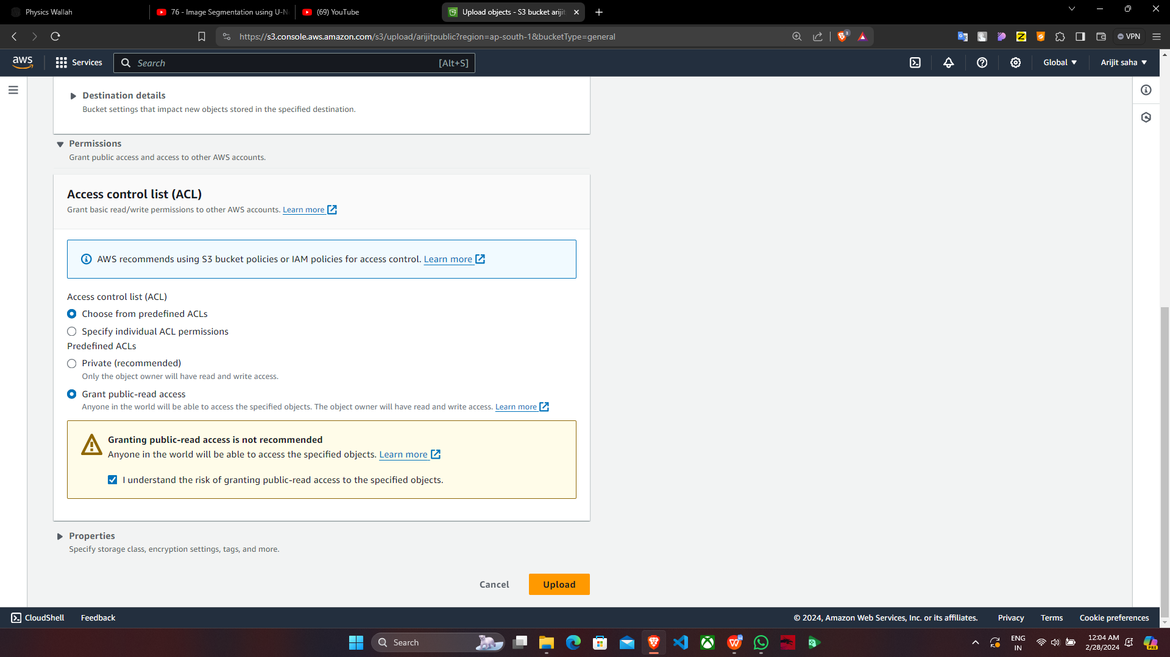

9.All the three files are successfully uploaded.

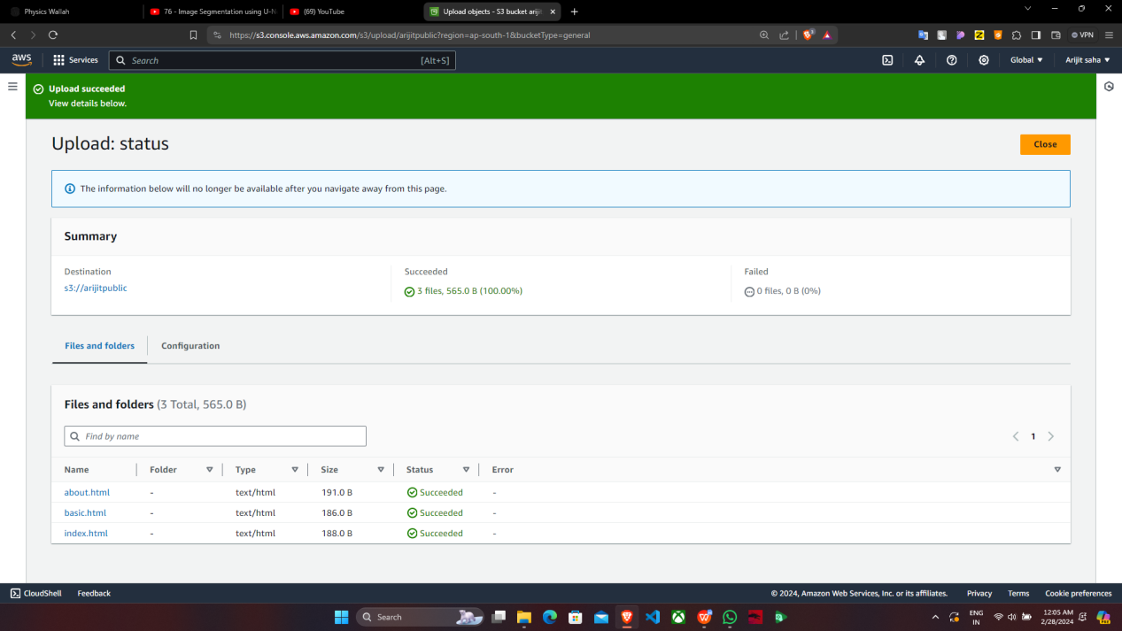

10. Under ‘mainak-static-website’, select the ‘Name’ of the files and go to ‘Properties’.

1. Under ‘Properties’, go to ‘Static website hosting’ and click on ‘Edit’.

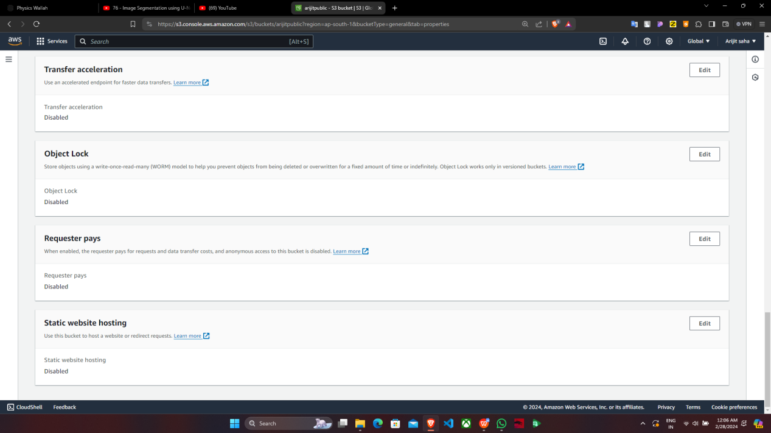

12. Under ‘Static website hosting’, click on ‘Enable’, then fill in the name of index document and click on ‘Save changes’.

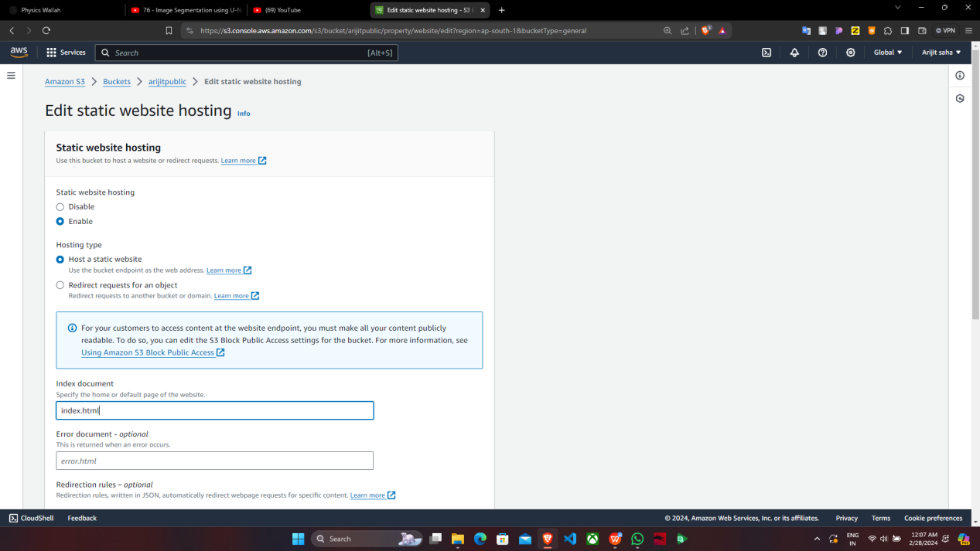

13. The ‘Static website hosting’ is successfully edited. Now under ‘Static website hosting’, copy the ‘Bucket website endpoint’.

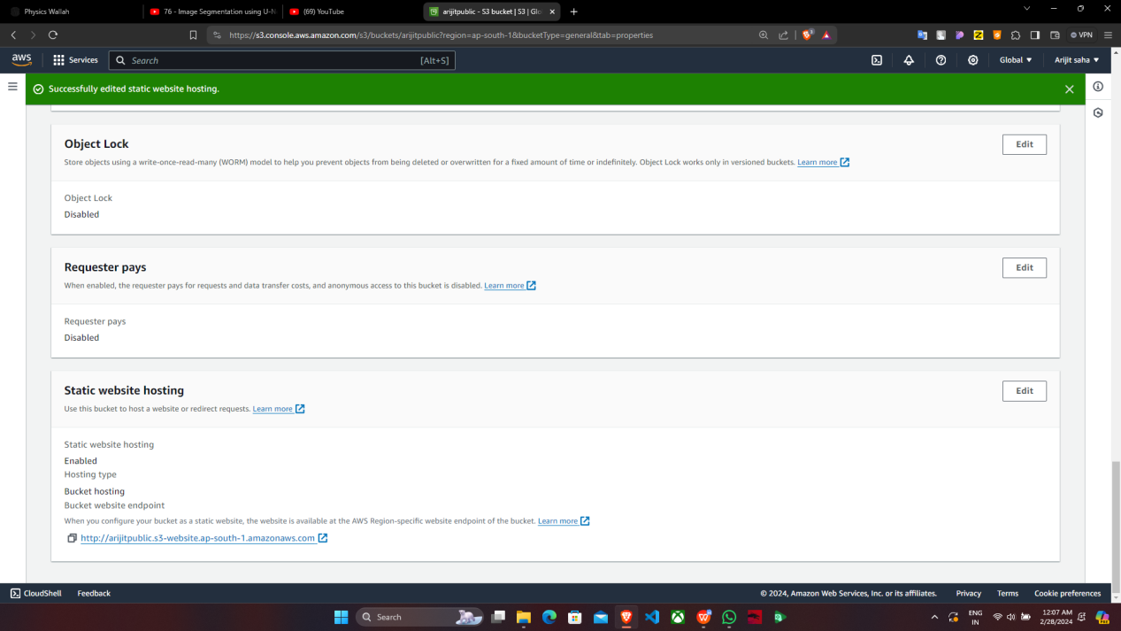

1. Open a new browser in incognito mode and paste the ‘Bucket website endpoint’

