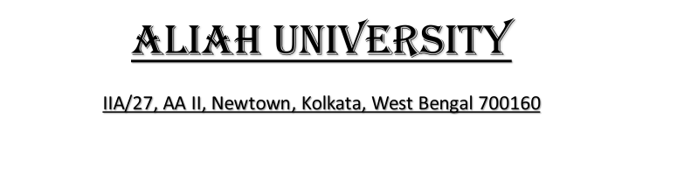



*Department of Computer Science & Engineering*

*Name: -SOUMYADIP BARIK*

*Roll no: - CSE224015*

*Year: -3rd  Semester: -5th*

*Registration no: -220682 OF 2022-2023*

*Subject Name: -OPERATING SYSTEM LAB*

*Subject Code: -CSEUGPC14*

*Teacher’s Name:* ***- ZEENAT REHANA***

Date:- Teacher’s Signature