ALIAH UNIVERSITY

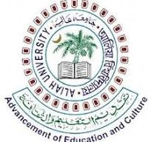

NAME : SOUMYADIP BARIK

ROLL : CSE224015

COURSE : BTECH

SECTION : CSE

SUBJECT NAME :***FORMAL LANGUAGE & AUTOMATA THEORY***

SUBJECT CODE : CSEUGPC13

YEAR : 3RD(5TH SEMESTER)

SESSION : 2024-25