**Batch: 2021 – 2025 Session: 2024 - 2025**

**SIKSHA O’ ANUSANDHAN UNIVERSITY**

**(DEEMED TO BE UNIVERSITY)**



**Assignment No: 1**

**Topic: Report on history of AI (from 1900 – 2024)**

NAME**:** SOUMYADIP MAJUMDER

REGD.NO**.:** 2141013055

BRANCH**:** COMPUTER SCIENCE AND ENGINEERING

SECTION**:** K (11)

SUBJECT**:** Introduction to Machine Learning

SEMESTER: 7TH

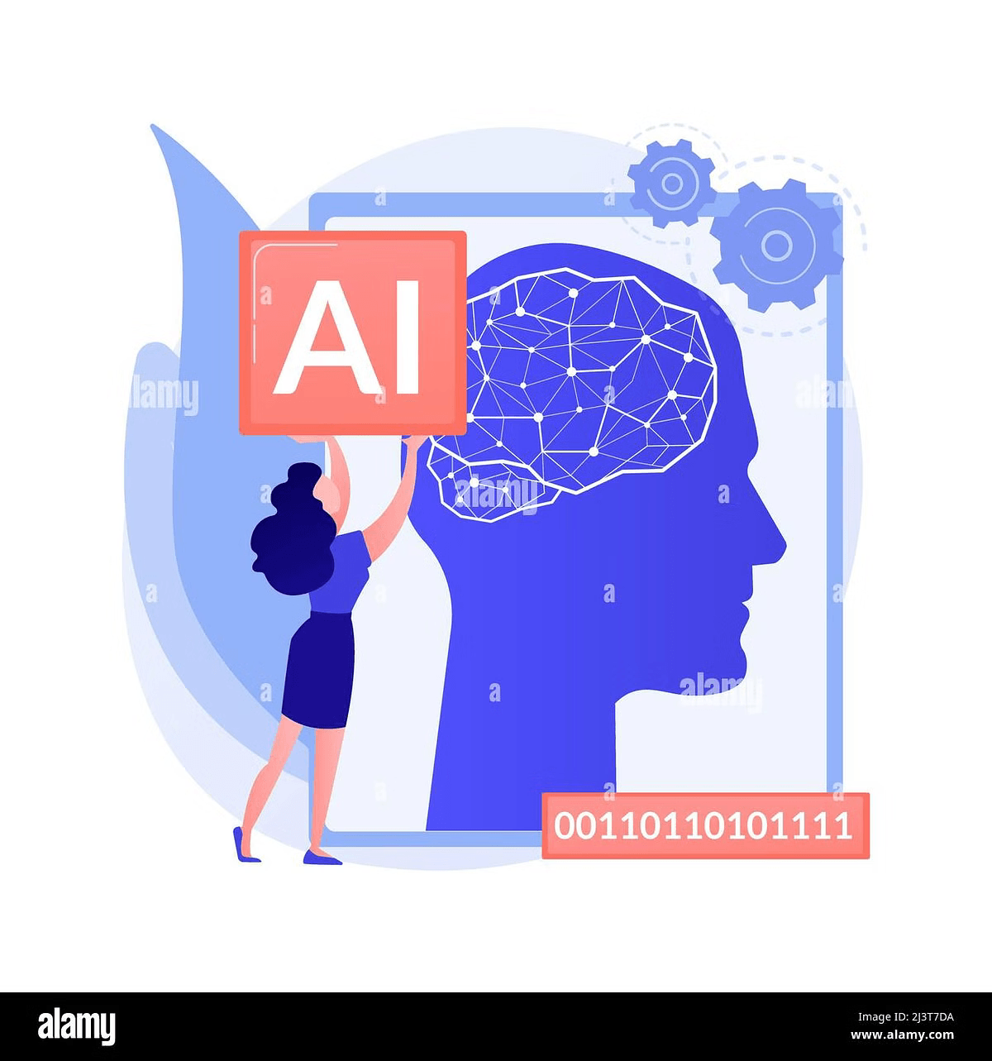Introduction to Machine

Learning

Machine learning is a branch of artificial intelligence (AI) that focuses on the development of computer systems to identify patterns, make predictions, and improve performance over time without explicit programming.

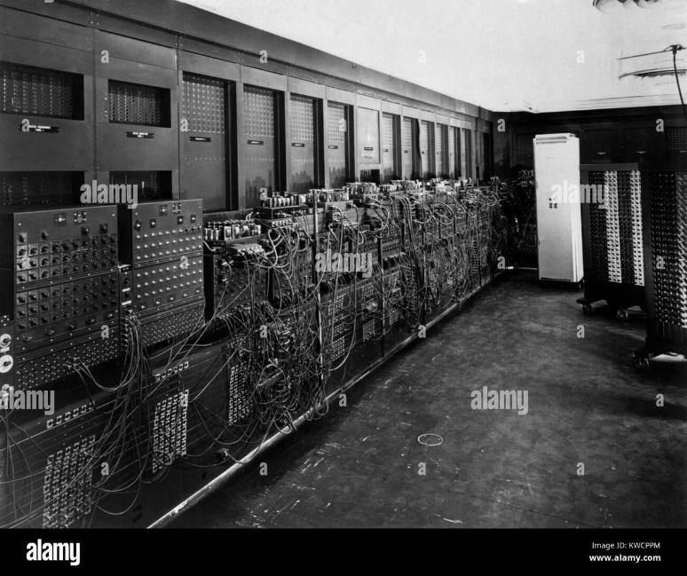History of AI:

1900 – 1950

**1900 – 1940**

Early concepts of AI emerged, but

The field was limited by the lack

of computing power and data.

**1950:** Alan Turing proposes “learning machine”.

**1952:** Arthur Samuel developed first machine learning program that could

play Checkers.

**1957:** Frank Rosenblatt designed the **first neural** **network program**

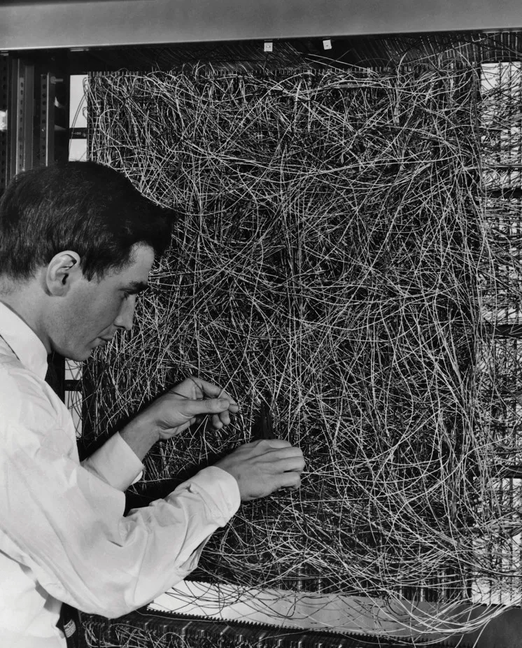 Simulating human brain.

Picture on the right side:  
 Computer Scientist Frank Rosenblatt was developing the first neural network.

**1967:** Nearest neighbor algorithm created –

start of basic pattern recognition.

**1979:** Stanford University students developed **first self – driving cart** that

can navigate and avoid obstacles in a room.

**1980:** Introduction of Backpropagation → The backpropagation algorithm

was rediscovered, leading to advancements in neural networks.



The first self-driving car using backpropagation algorithm (an Indian developer), by *Mercedes-Benz*

**1980:** AI Winter → Reduced funding and interest in AI due to unmet

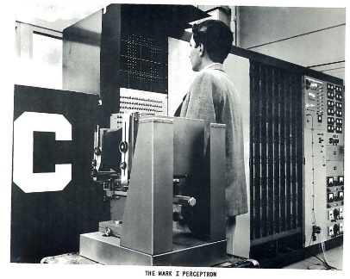 Expectations and limitations of existing technologies.

*The first AI winter in history of AI →*

**1982: Recurrent neural network** was developed.

**1989: - Reinforcement Learning** conceptualized.

**Beginning of commercialization** of Machine Learning.

**1995: Random Forest** and **Support Vector machine** algorithms developed.

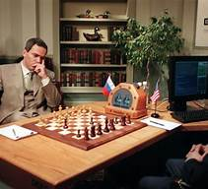

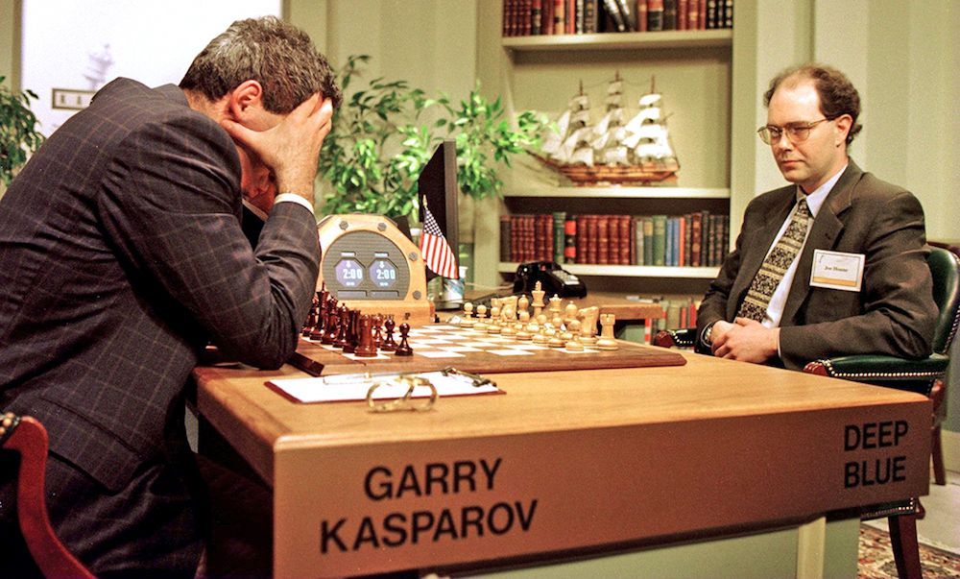**1997: IBM’s Deep Blue** beats the world chess champion Gary Kasparov.

**2000:** Rise of Machine Learning → Growth Hinton and others popularized

deep learning leading to breakthroughs in image and speech

recognition.

**2006:** Deep Learning Renaissance → Geoffrey Hinton and others

popularized deep learning, leading to breakthroughs in image and

speech recognition.

**2011:** IBM Watson wins on Jeopardy! → IBM’s Watson beats human

champions on the quiz show “Jeopardy!” using NLP and knowledge

retrieval.

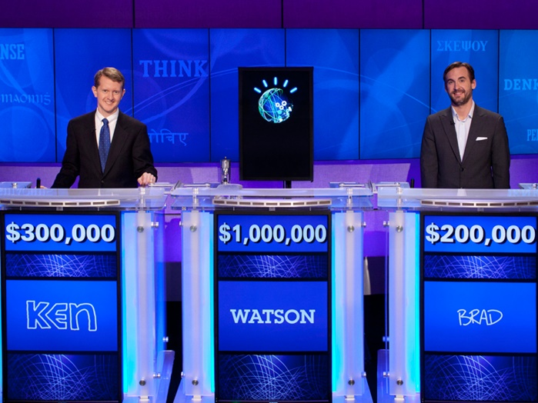*IBM Watson challenge in “Jeopardy!” 2011.*

**

**2012:** Alex Net wins ImageNet competition → A deep Convolutional

Neural Network (CNN) showed significant improvement in image

recognition tasks.

**2014:** Google’s DeepMind develops AlphaGo → AlphaGo became the first

AI to defeat a professional human player in the game of Go, a complex

board game.

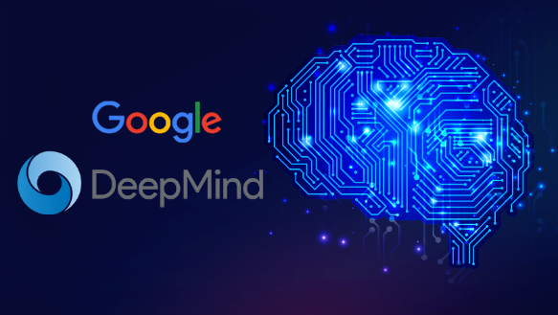

**2016:** AlphaGo defeats Lee Sedol → AlphaGo defeated world champion

Lee Sedol, demonstrating the power of deep learning and

reinforcement learning.

**2018:** Bert by Google → Introduction of Bidirectional Encoder

Representations from Transformers (BERT) for NLP tasks.

**2020:** OpenAI’s GPT-3 → Release of a large language model with 175

billion parameters, showcasing significant advances in NLP.

**2022:** AlphaFold predicts protein structures → DeepMind’s AlphaFold

achieved breakthroughs in predicting protein folding, aiding

biological research.

**2023:** OpenAI’s GPT-4 → DeepMind’s AlphaFold achieved breakthroughs

in predicting protein folding, aiding biological research.

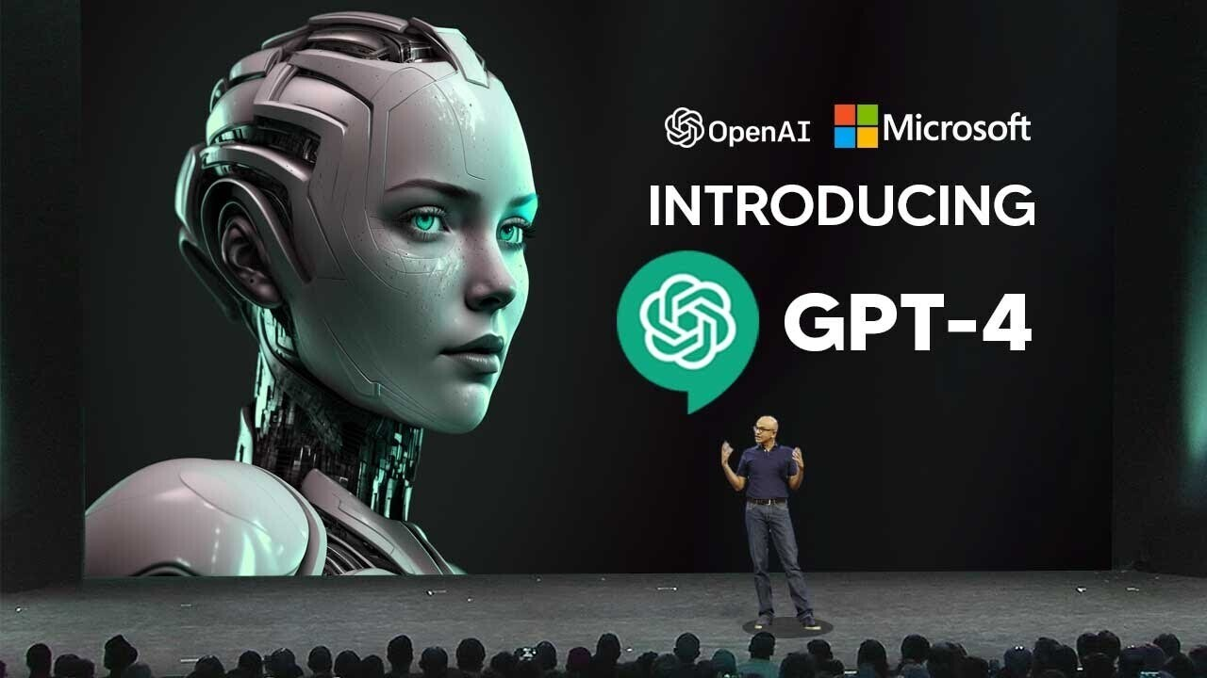

Conclusion:

AI has come a long way in just a few decades. Its impact on society, technology, and our daily lives continues to evolve rapidly. As we move forward, ethical considerations and responsible AI development will be critical.