GIT:1.

1)git config --global user.name "soumyaditya"

git config --global user.email "soumyadityas85@gmail.com"

OUTPUT:

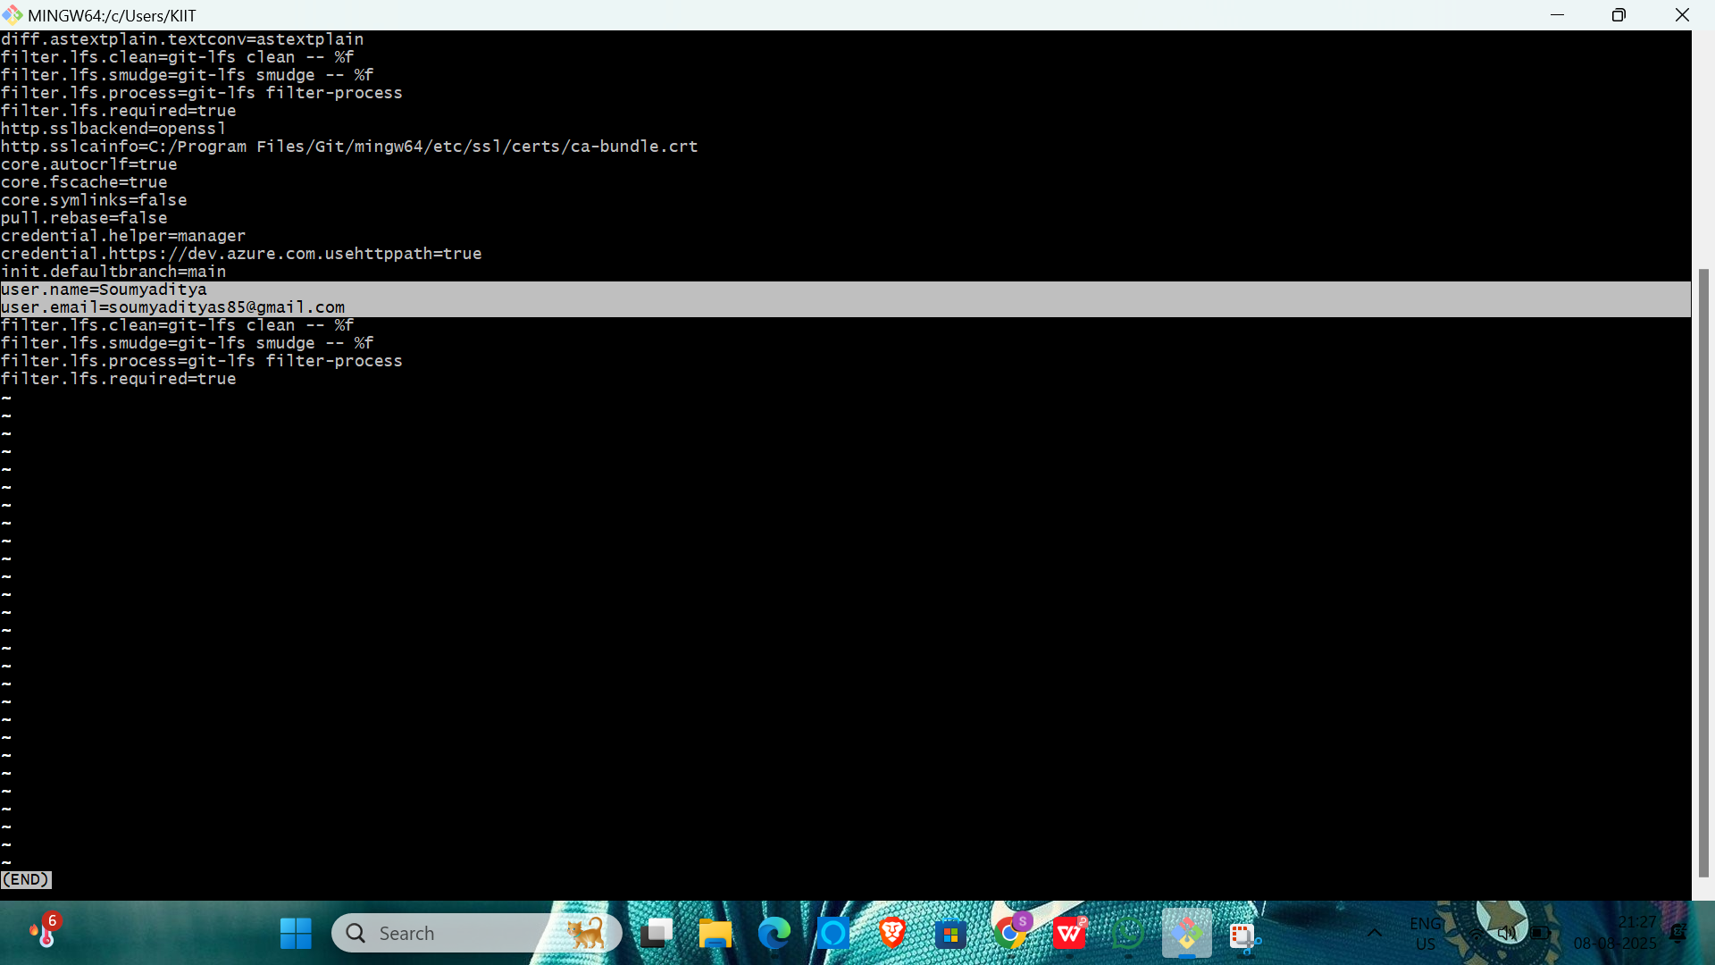

mkdir GitDemo

cd GitDemo

git init

echo "Welcome to Git!" > welcome.txt

git status

git add welcome.txt

git commit

Added welcome.txt file

OUTPUT:

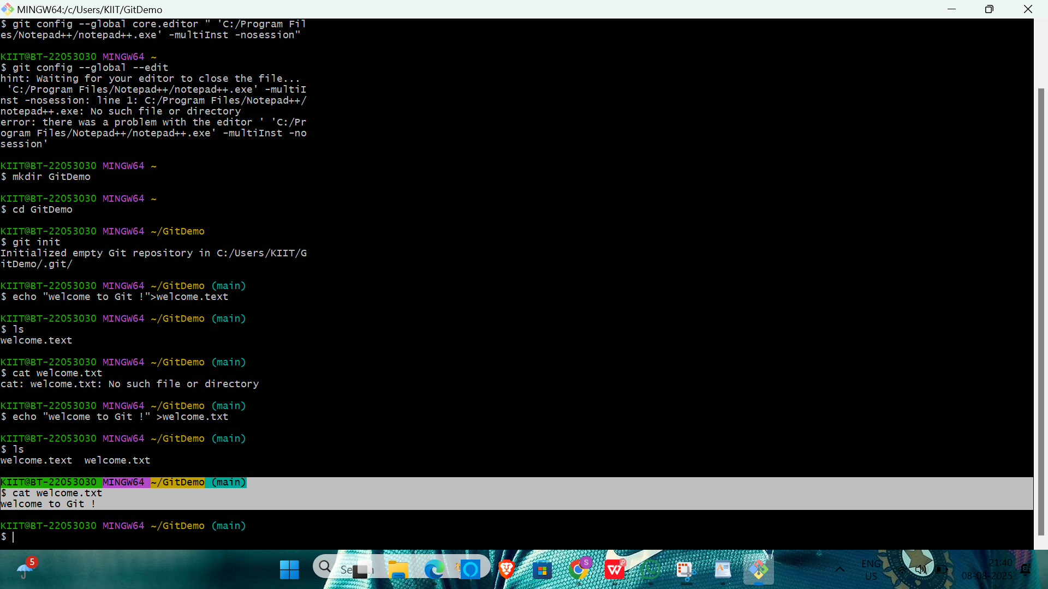

2.

mkdir GitDemo

cd GitDemo

git init

touch debug.log

mkdir log

echo "log file inside folder" > log/app.log

nano .gitignore*.log

log/

git status

OUTPUT:

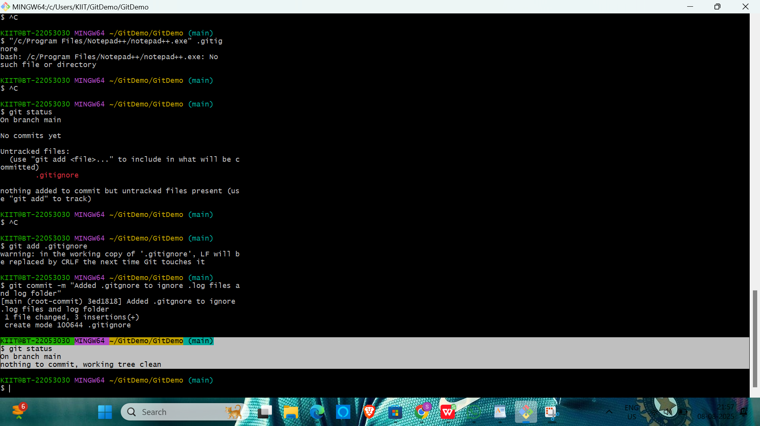

3)

git init

echo "# Initial Commit" > readme.md

git add readme.md

git commit -m "Initial commit"

git branch GitNewBranch

git branch

git checkout GitNewBranch

echo "This is a file in GitNewBranch" > branchfile.txt

git add branchfile.txt

git commit -m "Added branchfile.txt in GitNewBranch"

git status

git checkout main

git diff main..GitNewBranch

git mergetool

git config --global merge.tool p4merge

git config --global mergetool.p4merge.path "C:/Program Files/Perforce/p4merge.exe"

git status

OUTPUT:

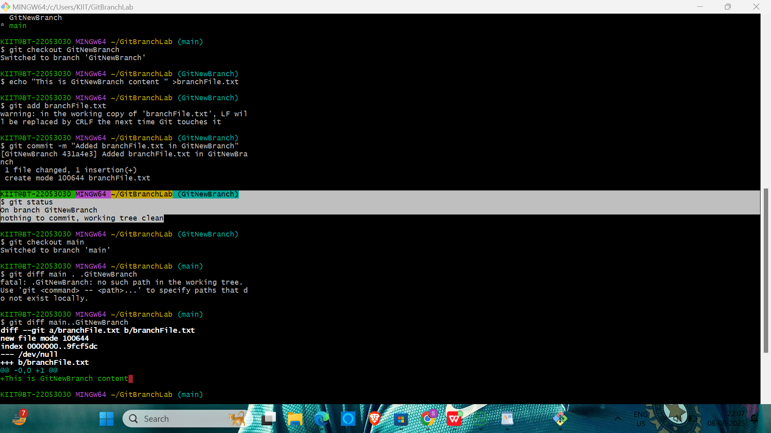

4).mkdir GitBranchLab

cd GitBranchLab

git init

echo "# Git Conflict Lab" > README.md

git add README.md

git commit -m "Initial commit"

git checkout -b GitWork

echo "<hello>This is branch content</hello>" > hello.xml

git add hello.xml

echo "<hello>This is branch content</hello>" > hello.xml

git add hello.xml

git commit -m "Added hello.xml in GitWork branch"

echo "<hello>This is updated branch content</hello>" > hello.xml

git add hello.xml

git commit -m "Updated hello.xml in GitWork branch"

git add hello.xml

git commit -m "Updated hello.xml in GitWork branch"

git checkout master

echo "<hello>This is master content</hello>" > hello.xml

git add hello.xml

git commit -m "Added hello.xml in master with different content"

git log --oneline --graph --decorate --all

echo "*.orig" >> .gitignore

git add .gitignore

git commit -m "Ignore merge backup files"

OUTPUT:

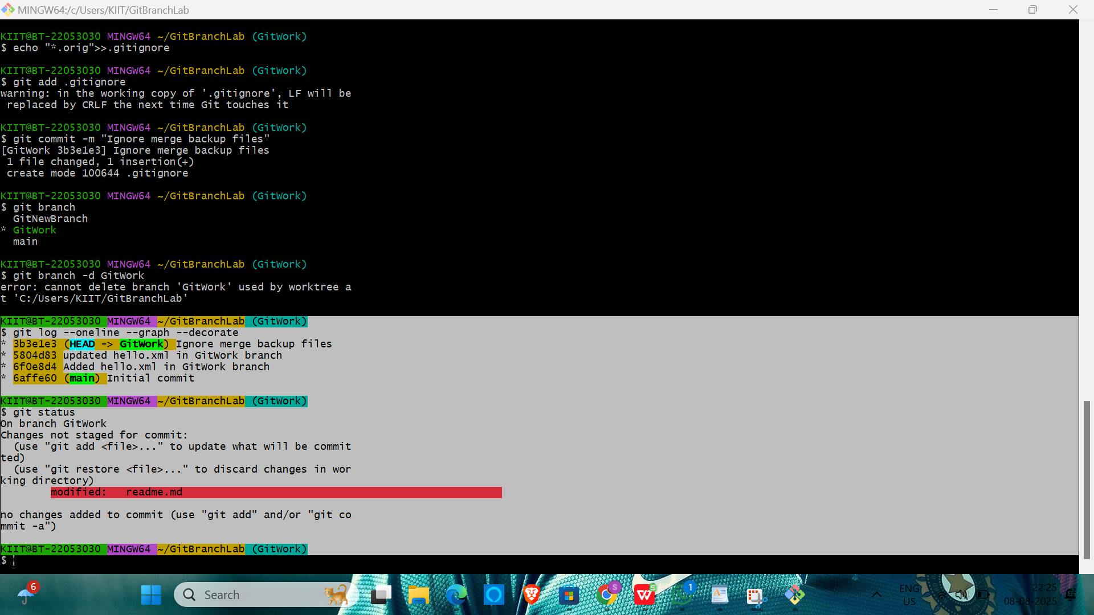

5).

KIIT@BT-22053030 MINGW64 ~ (main)

$ git branch

* main

KIIT@BT-22053030 MINGW64 ~ (main)

$ git status

On branch main

nothing to commit, working tree clean

KIIT@BT-22053030 MINGW64 ~ (main)

$ git pull origin main

Already up to date.

KIIT@BT-22053030 MINGW64 ~ (main)

$ git pull origin main

Updating a1b2c3d..e4f5g6h

Fast-forward

hello.txt | 1 +

1 file changed, 1 insertion(+)

KIIT@BT-22053030 MINGW64 ~ (main)

$ git checkout Git-T03-HOL_002

Switched to branch 'Git-T03-HOL_002'

KIIT@BT-22053030 MINGW64 ~ (Git-T03-HOL_002)

$ git status

On branch Git-T03-HOL_002

Changes not staged for commit:

(use "git add <file>..." to update what will be committed)

modified: hello.txt

no changes added to commit (use "git add" and/or "git commit -a")

KIIT@BT-22053030 MINGW64 ~ (Git-T03-HOL_002)

$ git push origin Git-T03-HOL_002

Enumerating objects: 5, done.

Counting objects: 100% (5/5), done.

Delta compression using up to 4 threads

Compressing objects: 100% (3/3), done.

Writing objects: 100% (3/3), 354 bytes | 354.00 KiB/s, done.

To <https://gitlab.com/your-repo/GitDemo.git>

3d2e1f4..1a2b3c4 Git-T03-HOL_002 -> Git-T03-HOL_002

KIIT@BT-22053030 MINGW64 ~ (Git-T03-HOL_002)

$ git log origin/Git-T03-HOL_002 --oneline

1a2b3c4 Updated hello.txt content

3d2e1f4 Previous commit message

...