React :9

APP.js

import React from 'react';

import ListofPlayers from './ListofPlayers';

import IndianPlayers from './IndianPlayers';

function App() {

const flag = true; // Change to false to show IndianPlayers

return (

<div>

<h1>🏏 Cricket App</h1>

{flag ? <ListofPlayers /> : <IndianPlayers />}

</div>

);

}

export default App;

import React from 'react';

//IndianPlayer.js

const IndianPlayers = () => {

const team = ['Virat', 'Rohit', 'Rahul', 'Shami', 'Bumrah', 'Pant'];

const oddPlayers = team.filter((_, index) => index % 2 === 0);

const evenPlayers = team.filter((_, index) => index % 2 !== 0);

const T20players = ['Surya', 'Gill', 'Hardik'];

const RanjiTrophyPlayers = ['Prithvi', 'Sarfaraz', 'Rahane'];

const allPlayers = [...T20players, ...RanjiTrophyPlayers];

return (

<div>

<h2>Odd Index Players</h2>

<ul>

{oddPlayers.map((player, index) => (

<li key={index}>{player}</li>

))}

</ul>

<h2>Even Index Players</h2>

<ul>

{evenPlayers.map((player, index) => (

<li key={index}>{player}</li>

))}

</ul>

<h2>Merged T20 and Ranji Trophy Players</h2>

<ul>

{allPlayers.map((player, index) => (

<li key={index}>{player}</li>

))}

</ul>

</div>

);

};

export default IndianPlayers;

//ListofPlayer.js

import React from 'react';

const ListofPlayers = () => {

const players = [

{ name: 'Virat Kohli', score: 85 },

{ name: 'Rohit Sharma', score: 95 },

{ name: 'KL Rahul', score: 68 },

{ name: 'Shubman Gill', score: 74 },

{ name: 'Hardik Pandya', score: 65 },

{ name: 'Ravindra Jadeja', score: 55 },

{ name: 'Rishabh Pant', score: 82 },

{ name: 'Jasprit Bumrah', score: 70 },

{ name: 'Bhuvneshwar Kumar', score: 60 },

{ name: 'Shami Ahmed', score: 50 },

{ name: 'Surya Kumar Yadav', score: 92 }

];

const below70 = players.filter(player => player.score < 70);

return (

<div>

<h2>All Players</h2>

<ul>

{players.map((player, index) => (

<li key={index}>{player.name} - {player.score}</li>

))}

</ul>

<h2>Players with Score Below 70</h2>

<ul>

{below70.map((player, index) => (

<li key={index}>{player.name} - {player.score}</li>

))}

</ul>

</div>

);

};

export default ListofPlayers;

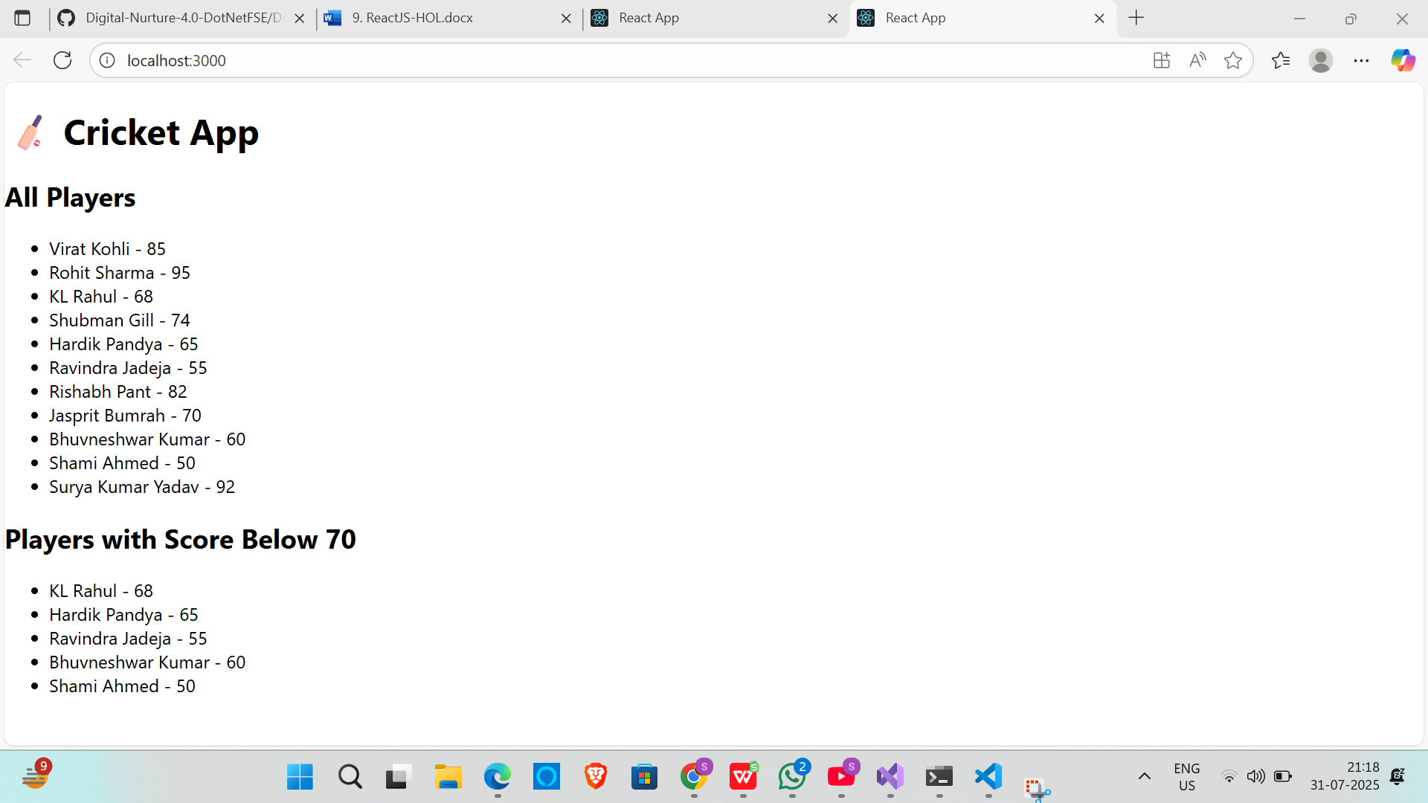

REACT 10

//APP.js

import React from 'react';

import './App.css';

function App() {

const office = {

name: "TechPark Workspace",

rent: "$1200/month",

address: "Sector 5, Salt Lake, Kolkata",

image: "<https://images.unsplash.com/photo-1600585154340-be6161a56a0c?auto=format&fit=crop&w=800&q=60>"

};

const officeList = [

{

id: 1,

name: "Cowork Hub",

rent: "$1000/month",

address: "MG Road, Bengaluru",

image: "<https://images.unsplash.com/photo-1600585153520-80b995f06ab1?auto=format&fit=crop&w=800&q=60>"

},

{

id: 2,

name: "Urban Offices",

rent: "$1400/month",

address: "Connaught Place, Delhi",

image: "<https://images.unsplash.com/photo-1580742311664-1975a5c0c75c?auto=format&fit=crop&w=800&q=60>"

},

{

id: 3,

name: "Workspace360",

rent: "$900/month",

address: "Baner, Pune",

image: "<https://images.unsplash.com/photo-1524758631624-e2822e304c36?auto=format&fit=crop&w=800&q=60>"

}

];

return (

<div className="app">

<h1 className="heading">🏢 Office Space Rental App</h1>

{/* Single office */}

<div className="office">

<img src={office.image} alt="Office" />

<h2>{office.name}</h2>

<p><strong>Rent:</strong> {office.rent}</p>

<p><strong>Address:</strong> {office.address}</p>

</div>

<hr />

{/* Office List */}

<h2>Available Offices:</h2>

<div className="office-list">

{officeList.map((off) => (

<div key={off.id} className="office">

<img src={off.image} alt={off.name} />

<h3>{off.name}</h3>

<p><strong>Rent:</strong> {off.rent}</p>

<p><strong>Address:</strong> {off.address}</p>

</div>

))}

</div>

</div>

);

}

export default App;

//APP.css

.app {

text-align: center;

font-family: Arial, sans-serif;

padding: 20px;

background-color: #f8f8f8;

}

.heading {

color: #2c3e50;

margin-bottom: 30px;

}

.office {

border: 1px solid #ccc;

border-radius: 10px;

background-color: #ffffff;

margin: 20px auto;

padding: 15px;

width: 300px;

box-shadow: 0 0 10px rgba(0, 0, 0, 0.1);

}

.office img {

width: 100%;

border-radius: 5px;

object-fit: cover;

height: 150px;

}

.office-list {

display: flex;

justify-content: center;

flex-wrap: wrap;

gap: 20px;

}

OUTPUT:

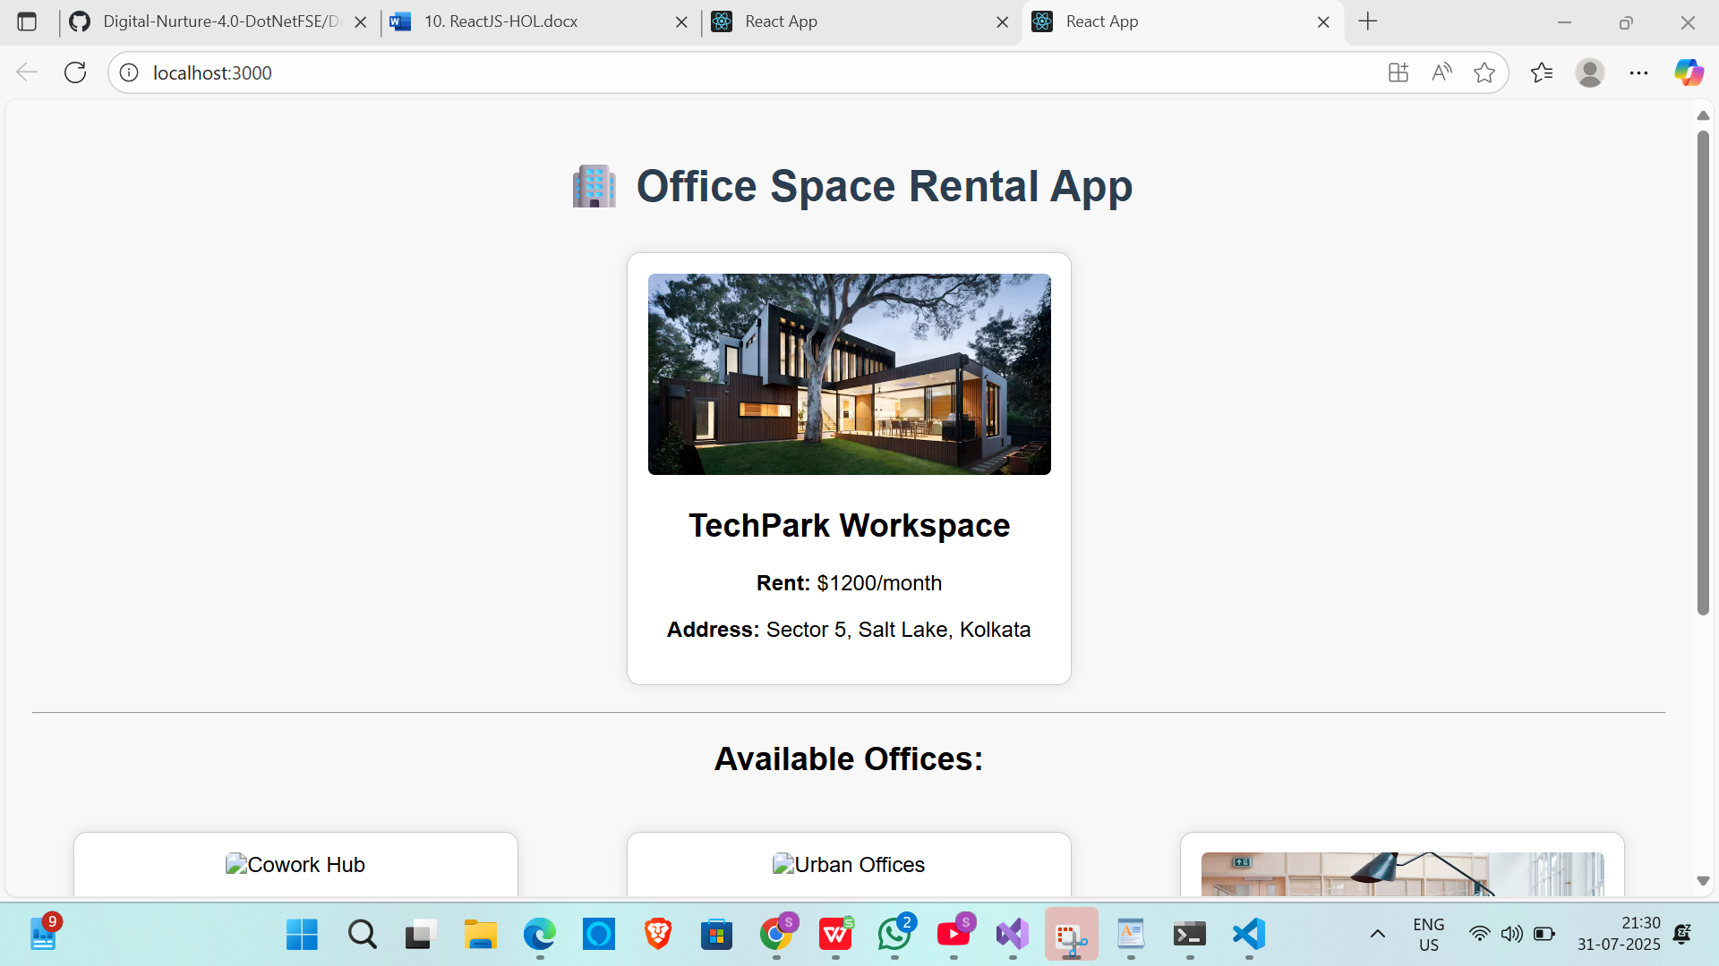

REACT 11

//App.js

import React, { useState } from 'react';

import './App.css';

import CurrencyConvertor from './CurrencyConvertor';

function App() {

const [counter, setCounter] = useState(0);

const increment = () => {

setCounter(prev => prev + 1);

sayHello();

};

const decrement = () => {

setCounter(prev => prev - 1);

};

const sayHello = () => {

console.log("Hello! This is a static message.");

alert("Hello! This is a static message.");

};

const sayWelcome = (msg) => {

alert(msg);

};

const handleSyntheticEvent = (e) => {

alert("I was clicked");

};

return (

<div className="App">

<h1>🎯 Event Examples App</h1>

<h2>Counter: {counter}</h2>

<button onClick={increment}>Increment</button>

<button onClick={decrement}>Decrement</button>

<hr />

<button onClick={() => sayWelcome("Welcome!")}>Say Welcome</button>

<hr />

<button onClick={handleSyntheticEvent}>OnPress</button>

<hr />

<CurrencyConvertor />

</div>

);

}

export default App;

//APP.css

.App {

text-align: center;

font-family: Arial, sans-serif;

padding: 30px;

}

button {

margin: 10px;

padding: 10px 20px;

cursor: pointer;

background-color: #4caf50;

color: white;

border: none;

border-radius: 5px;

}

button:hover {

background-color: #45a049;

}

input {

padding: 10px;

margin: 10px;

width: 200px;

}

.currency {

background-color: #f2f2f2;

padding: 20px;

border-radius: 10px;

display: inline-block;

}

//CurrencyConvertor.js

import React, { useState } from 'react';

function CurrencyConvertor() {

const [inr, setInr] = useState('');

const [euro, setEuro] = useState('');

const handleSubmit = () => {

if (!inr || isNaN(inr)) {

alert("Please enter a valid amount in INR");

return;

}

const euroValue = parseFloat(inr) * 0.011; // Assume 1 INR = 0.011 EUR

setEuro(euroValue.toFixed(2));

};

return (

<div className="currency">

<h2>💱 Currency Convertor (INR ➡️ EUR)</h2>

<input

type="text"

placeholder="Enter amount in INR"

value={inr}

onChange={(e) => setInr(e.target.value)}

/>

<button onClick={handleSubmit}>Convert</button>

{euro && (

<p>

{inr} INR = <strong>{euro} EUR</strong>

</p>

)}

</div>

);

}

export default CurrencyConvertor;

OUTPUT:

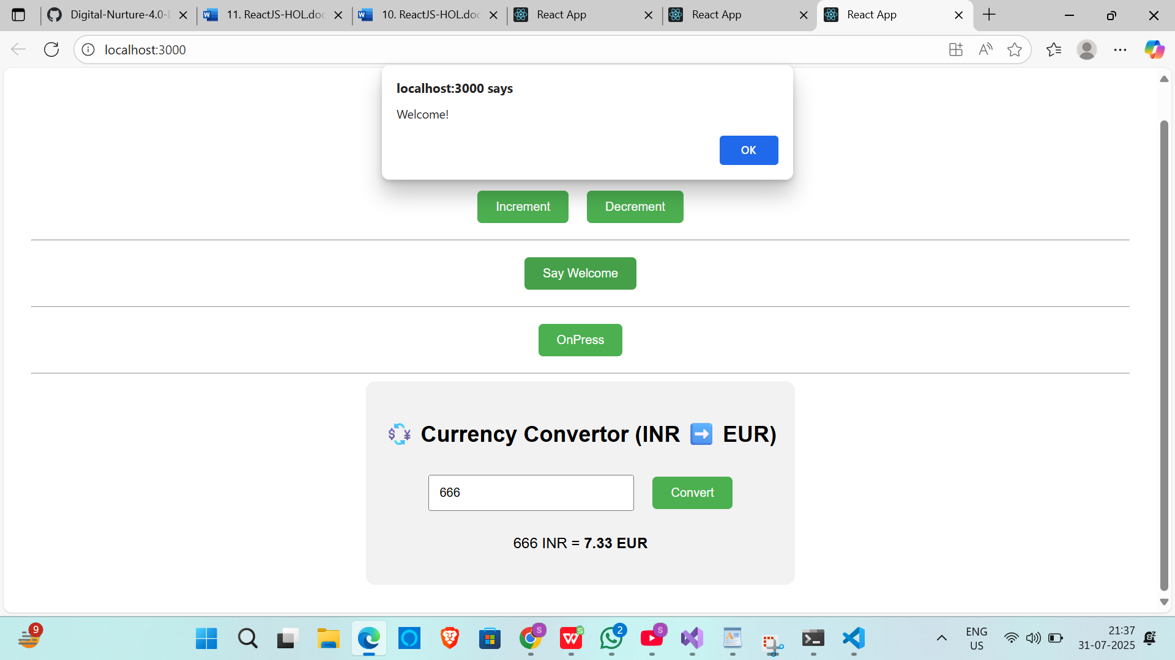

REACT 12

//APP.js

import React from 'react';

import './App.css';

function App() {

const flights = [

{

id: 1,

airline: "IndiGo",

from: "Kolkata",

to: "Delhi",

departure: "08:30 AM",

price: "₹4500"

},

{

id: 2,

airline: "Air India",

from: "Mumbai",

to: "Chennai",

departure: "11:45 AM",

price: "₹6200"

},

{

id: 3,

airline: "SpiceJet",

from: "Bangalore",

to: "Hyderabad",

departure: "02:00 PM",

price: "₹3200"

}

];

return (

<div className="App">

<h1>✈️ Ticket Booking App</h1>

<h2>Available Flights for Guests</h2>

<div className="flight-list">

{flights.map((flight) => (

<div key={flight.id} className="flight-card">

<h3>{flight.airline}</h3>

<p><strong>From:</strong> {flight.from}</p>

<p><strong>To:</strong> {flight.to}</p>

<p><strong>Departure:</strong> {flight.departure}</p>

<p><strong>Price:</strong> {flight.price}</p>

</div>

))}

</div>

</div>

);

}

export default App;

//APP.css

.App {

text-align: center;

font-family: Arial, sans-serif;

padding: 30px;

background-color: #f0f8ff;

}

.flight-list {

display: flex;

flex-wrap: wrap;

justify-content: center;

gap: 20px;

}

.flight-card {

background-color: #ffffff;

border: 1px solid #ddd;

border-radius: 10px;

padding: 20px;

width: 250px;

box-shadow: 0 4px 8px rgba(0, 0, 0, 0.1);

}

.flight-card h3 {

margin-top: 0;

color: #0074d9;

}

OUTPUT:

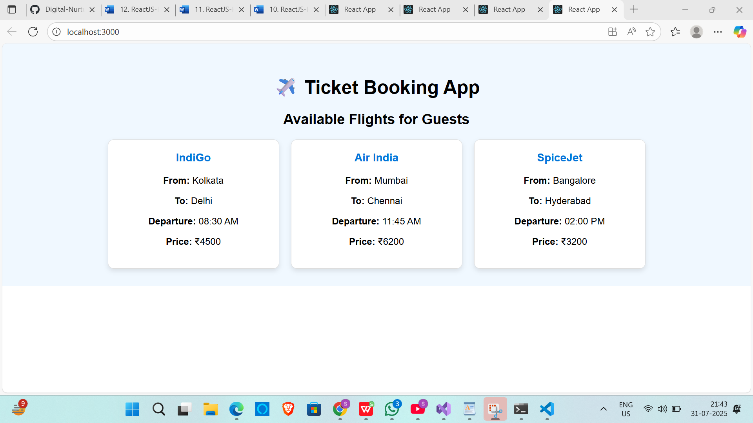

REACT 13

//APP.js

import React, { useState } from 'react';

import './App.css';

import BookDetails from './components/BookDetails';

import BlogDetails from './components/BlogDetails';

import CourseDetails from './components/CourseDetails';

function App() {

const [selected, setSelected] = useState("none");

const renderComponent = () => {

switch (selected) {

case "book":

return <BookDetails show={true} />;

case "blog":

return <BlogDetails show={true} />;

case "course":

return <CourseDetails show={true} />;

default:

return <p>Please select a component to display.</p>;

}

};

return (

<div className="App">

<h1>📚 Blogger App</h1>

<div className="buttons">

<button onClick={() => setSelected("book")}>Show Book</button>

<button onClick={() => setSelected("blog")}>Show Blog</button>

<button onClick={() => setSelected("course")}>Show Course</button>

<button onClick={() => setSelected("none")}>Clear</button>

</div>

<hr />

{renderComponent()}

</div>

);

}

export default App;

//APP.css

.App {

text-align: center;

font-family: Arial, sans-serif;

padding: 30px;

}

button {

margin: 5px;

padding: 10px 20px;

font-size: 16px;

cursor: pointer;

}

//BlogDetails.js

import React from 'react';

function BlogDetails({ show }) {

return show ? (

<div>

<h2>📝 Blog Details</h2>

<p>Title: React Best Practices</p>

<p>Writer: Sophie Alpert</p>

</div>

) : null;

}

export default BlogDetails;

//BookDetails.js

import React from 'react';

function BookDetails({ show }) {

if (!show) {

return null;

}

return (

<div>

<h2>📚 Book Details</h2>

<p>Title: Learn React</p>

<p>Author: Dan Abramov</p>

</div>

);

}

export default BookDetails;

//CourseDetails.js

import React from 'react';

function CourseDetails({ show }) {

return (

<>

{show && (

<div>

<h2>🎓 Course Details</h2>

<p>Course: Full Stack Development</p>

<p>Instructor: Kent C. Dodds</p>

</div>

)}

</>

);

}

export default CourseDetails;

OUTPUT:

