CREDITNIRVANA · COLLECTIONS INTELLIGENCE
Problem Statement 2
Right-Party-Contact Prediction & Skip-Trace Prioritisation
A calibrated, explainable, counterfactually-honest engine that decides — for every phone and address — whether to keep trying, switch channel, or trace.
Technical Report
Scope | Tele + Field (phones & addresses) · Phase 1 and Phase 2
Approach | Gradient-boosted model zoo + calibrated ensemble/stacking; survival, IPW off-policy, value-of-information
Datasets | PS2 contact data + Shared records, enriched with PS1 (who-answered, engagement) and PS3 (location confidence)
Deliverables | Dial-list ranking · health states · skip-trace queue · compliance suppression · unified account actions
Prepared for the evaluation panel

Contents
1 Executive Summary
2 Problem Understanding
3 Data Overview & Quality
4 Exploratory Data Analysis & Insights
5 Data Transformation & Feature Engineering
6 Model Architecture & Design
7 Hyperparameter Tuning
8 Results, Metrics & Validation
9 PS2 Expected Outcomes — Solutions & Scores
10 Compliance & Risk
11 Future Improvements
A Appendix — Formulas & References

1 Executive Summary
Every tele-call and field visit silently assumes the phone number or address on file still reaches the borrower. In practice a large share of contact points are dead, switched off, recycled to a new subscriber, owned by a relative or employer, or simply wrong from origination. Today this is discovered slowly, and skip-tracing fires on a blunt fixed rule — fifteen consecutive failed contacts — rather than on evidence. The result is effort spent where it cannot pay off, and tracing that arrives too late for the accounts that needed it.
We built a single engine that answers, for every contact point, how likely it is to produce a Right-Party Contact (RPC) — and then turns that score into an action: keep dialling the best number at the best time, switch channel, visit, or trace, with traces ranked by expected recovery value. The system is calibrated (a score of 0.2 really means a 20% chance), explainable to an auditor, and designed around two hard realities of collections data: the log reflects a biased incumbent policy, and the debt must never be disclosed to the wrong person.
Headline results (held-out test set)
Primary deliverable — contact-point health (calibrated P(RPC within 14 days), the survival framing PS2 asks for): ROC-AUC 0.762 (Optuna-tuned), PR-AUC 0.62, ECE 0.03. The per-attempt companion (live dial-timing) scores AUC 0.701. A number’s true-borrower identity vs an independent verification set — AUC 0.91; avoiding-vs-invalid health — 92% accuracy, 89% against verified ground truth; a learned address reachability model — AUC 0.72. Prioritised dialling lifts RPC per 1,000 dials from 166 to 262 (top-ranked half); skip-tracing by expected value front-loads 1.8× more recovery than the fixed rule; 1,242 phones on a compliance suppression list so the debt is never discussed with a stranger.
The remainder of this report walks through the data and its quality, the exploratory analysis and the decisions each insight drove, the feature engineering and two-pipeline design, the model architecture and tuning, the full results and validation, and finally a point-by-point mapping of how each requirement in Problem Statement 2 was solved and what it scored.

2 Problem Understanding
2.1 Background & objective
The question that actually matters — does this specific contact point still reach this specific borrower — is rarely modelled on its own. It is usually folded into a vague account-level “contactability” score that hides the real decision: which number to dial, which address to visit, and when to stop and trace. Our objective is to model that question directly, for phones and addresses, and to wrap it in a prioritisation layer that chooses the next-best action per account.
2.2 The contact-point states we must separate
A dead number and a borrower who is simply dodging look almost identical on the surface, yet they demand opposite actions — trace the first, switch channel for the second. Telling these apart is the central modelling problem. We model the full set of states below.
Phone state | Right action
Valid & reachable | Keep dialling, at the best time slot
Valid but borrower avoiding | Switch channel (WhatsApp / field) instead of redialling
Temporarily unreachable | Retry later with backoff
Switched off long-term | Move to another number, or trace
Recycled to a new subscriber | Stop at once — risk of disclosing the debt to a stranger
Third party (relative / employer) | Use only within Fair-Practices rules; never discuss the debt
Invalid from the start | Trace

Address state | Right action
Valid & occupied | Visit
Valid but borrower usually absent | Change the visit time
Borrower has moved | Trace the new address
Hard to find on the ground | Resolve the location before writing it off
Fabricated / incomplete at origination | Trace, and flag to the origination team
2.3 The three constraints that frame every decision
- Regulatory. The RBI Fair Practices Code governs contact hours, frequency, tone and conduct; the DPDP Act governs consent, purpose limitation and retention. Every output must be explainable and auditable.
- Counterfactual data. Outcomes are only observed for the actions the incumbent rule-based policy actually took. Naïve supervised learning on this log reproduces and amplifies that policy’s bias.
- Cost asymmetry. The objective is never “maximum recovery.” It is recovery net of channel cost, net of customer goodwill, net of compliance risk — the cost per touch spans two orders of magnitude from SMS to a field visit.
2.4 The hard problems, and how we address each
Challenge | Our approach
Building labels (true health is never observed) | Construct an RPC label from dispositions & network responses; anchor and validate on an independent verification set
Avoiding vs invalid (the central split) | A multi-class health model, validated against verified ground truth
Recycled numbers | Shared-number graph on masked numbers + stranger-disposition signals → suppression list
Health changes over time | Recency features + a survival (Kaplan–Meier) view so confidence decays as evidence ages
When to trace | A value-of-information decision: expected recovery of finding the borrower vs the trace cost
Feedback loops | Exploit the built-in exploration arm for inverse-propensity weighting and off-policy evaluation

3 Data Overview & Quality
3.1 The datasets
The programme spans a connected set of records: accounts and the borrower context the lender holds, every phone and address on file with its source and age, every outbound dial attempt with its network response and disposition, every field visit with its GPS check-in and outcome, payments, skip-trace requests, and an independent verification campaign. We enrich this with two adjacent sources where they sharpen the signal.
Dataset | What it holds | Used for
accounts | Lender, product, bucket, dues, borrower context | Account features across all models
phones | Every number on file, its source & relation | Phone health & features
dial_attempts | Every call, with response, disposition, remark | RPC labels & behavioural history
field_visits | Every visit, check-in GPS, dwell, outcome | Address health & field RPC
payments | Every payment received | Expected-recovery valuation
skip_traces | Trace requests and what they found | Value-of-information model
verified_contact_points | Independently verified numbers (ground truth) | Label validation & calibration anchor
PS1 — ptps / post_call_events | Who answered; link-opened / confirmations | Who-answered & engagement signals
PS3 — geocodes / surveyed / GPS trails | Baseline geocode, surveyed truth, visit trails | Location confidence for field
3.2 Data-quality audit
Before modelling we verified structural integrity and surfaced the quirks that drive the design. The splits are grouped by account, so a borrower never appears in two of train, validation and test — a prerequisite for an honest score. Referential integrity holds, there are no duplicate events, and the dues fields obey their natural ordering.
Check | Result
Account leakage across splits | 0 (splits are account-grouped)
Duplicate rows / orphan foreign keys | 0 / 0
Impossible values (overdue>outstanding, broken>count) | 0
Delinquency bucket vs days-past-due consistency | Consistent
Phone added before it was dialled | 100% (no future-dated contact points)
3.3 Missingness is informative, not random
Two fields are absent by design rather than by accident. The salary-credit day is present only for salaried borrowers — it is fully absent for daily-wage and self-employed segments and about 41% absent for salaried. Treating this as “missing at random” and mean-imputing would invent a salary cycle that does not exist; instead we keep an explicit missingness indicator and let the model read absence as its own signal. The ability-to-pay estimate is handled the same way.
3.4 Guarding against target leakage
The leakage rule we enforce everywhere
A feature may use anything known before a contact is attempted — including the outcomes of earlier attempts — but never the outcome of the attempt being predicted. The post-contact columns (network response, talk duration, hang-up, disposition, remark) are the label; using them as features would be cheating. Every history feature is therefore computed as a cumulative statistic shifted by one event, so a contact’s own outcome can never leak into its own features. We re-confirm this with an adversarial-validation test (below).

4 Exploratory Data Analysis & Insights
Each analysis below is paired with the decision it drove. We computed every decision-informing statistic on the training split only, and confirmed the insights are stable across splits.
4.1 Portfolio structure
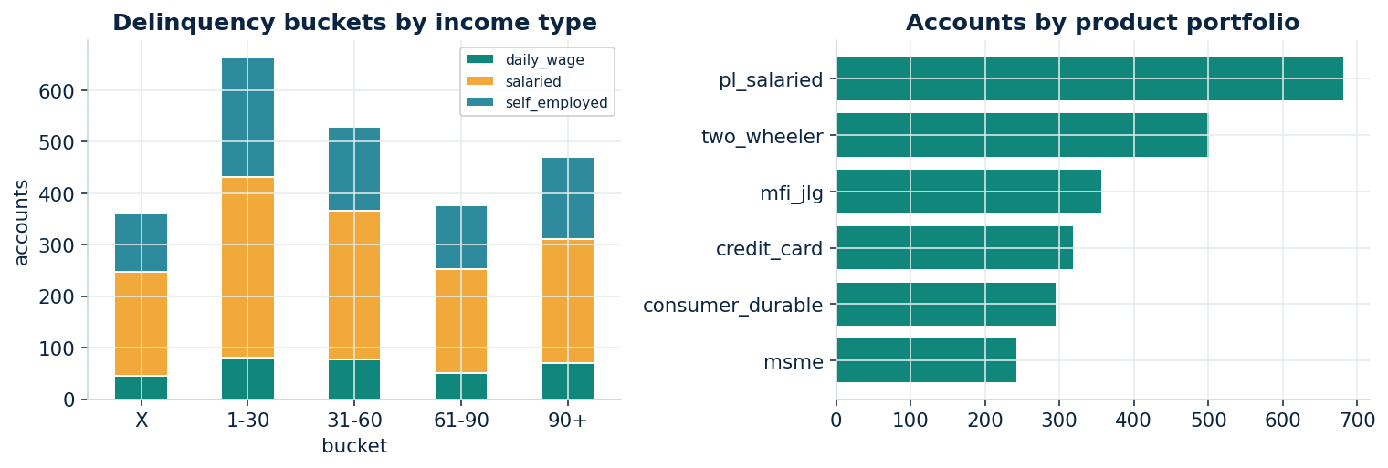
Figure 1 — Delinquency buckets by income type, and accounts by product portfolio.
The book spans six products and three towns across the delinquency spectrum. Early buckets are more reachable than deep ones, and portfolio mix matters — this motivates per-segment treatment rather than one global policy.
4.2 The telephony funnel — where RPC actually comes from
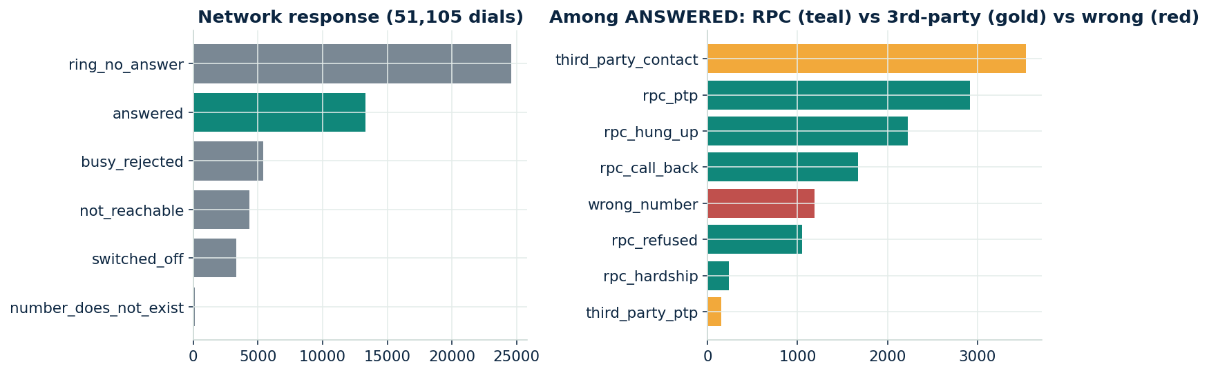
Figure 2 — Network responses, and the decomposition of ANSWERED calls into right-party, third-party and wrong-number.
About a quarter of dials are answered, and of those only roughly two-thirds reach the borrower; the rest are a third party or a wrong number. Why this matters: “answered” is not “reached” — the third-party and wrong-number slices are exactly the compliance and recycled-number risks we must detect, and they define the RPC label precisely.
4.3 Validating the label against verified ground truth
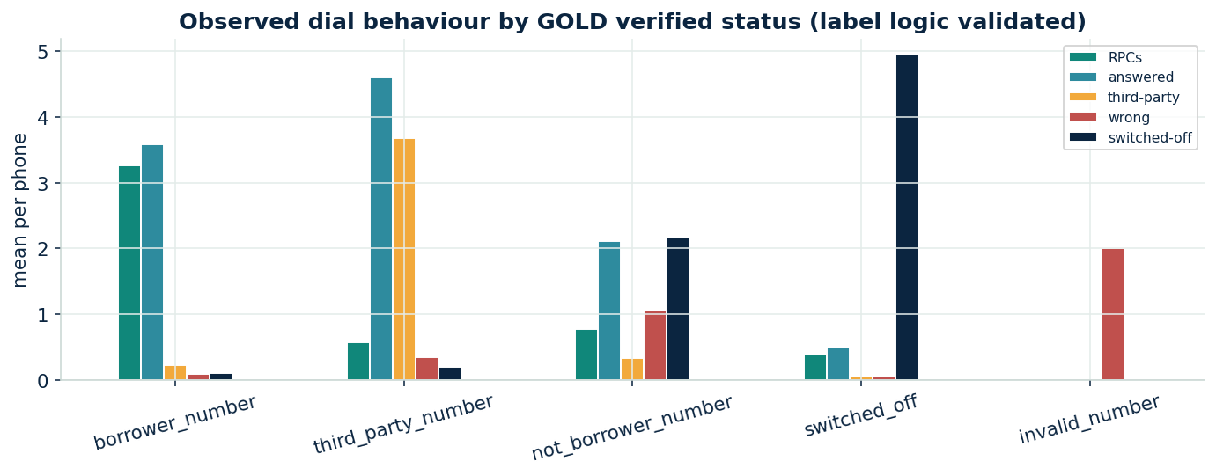
Figure 3 — Observed dial behaviour grouped by independently verified status.
This is the check that earns trust in the label. Numbers independently verified as the borrower’s show many RPCs and few stranger pick-ups; verified third-party numbers answer often but almost never as the borrower; verified switched-off numbers show switched-off responses; invalid numbers show wrong-number responses. The disposition-derived label lines up cleanly with the verified truth, so the weak label is a sound foundation — and we keep the verified set as an unbiased calibration anchor.
4.4 The counterfactual structure — the senior-level crux
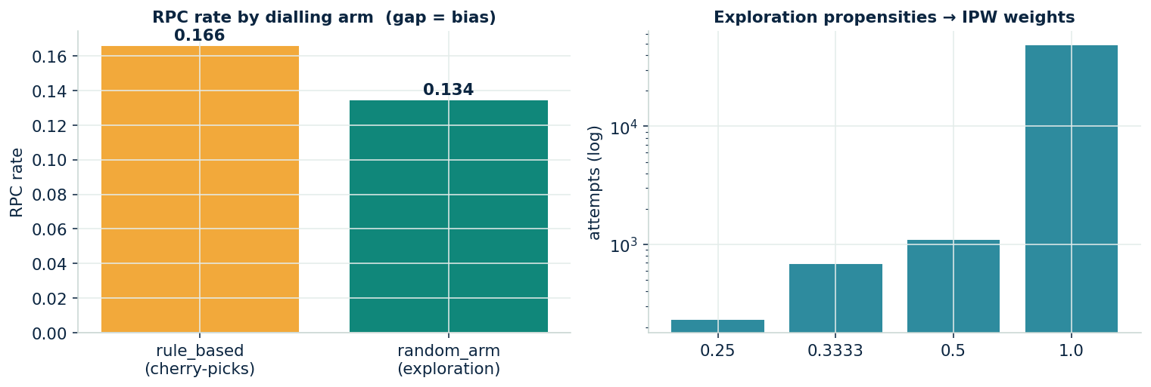
Figure 4 — RPC rate by dialling arm (the gap is selection bias) and the exploration propensities used for inverse-propensity weighting.
The log is not a random sample. The incumbent rule preferentially dials the numbers it already believes are good, so a naïve model would simply relearn that bias. Fortunately the data contains a small exploration arm that dials a contact point at random and records the probability it was chosen. The rule arm shows a higher RPC rate than the random arm — and that gap is the selection bias made visible. What we did: we use the exploration arm’s propensities as inverse-propensity weights to de-bias evaluation and to run an honest off-policy estimate of a new dialling policy (Section 8).
4.5 Collinearity & feature redundancy
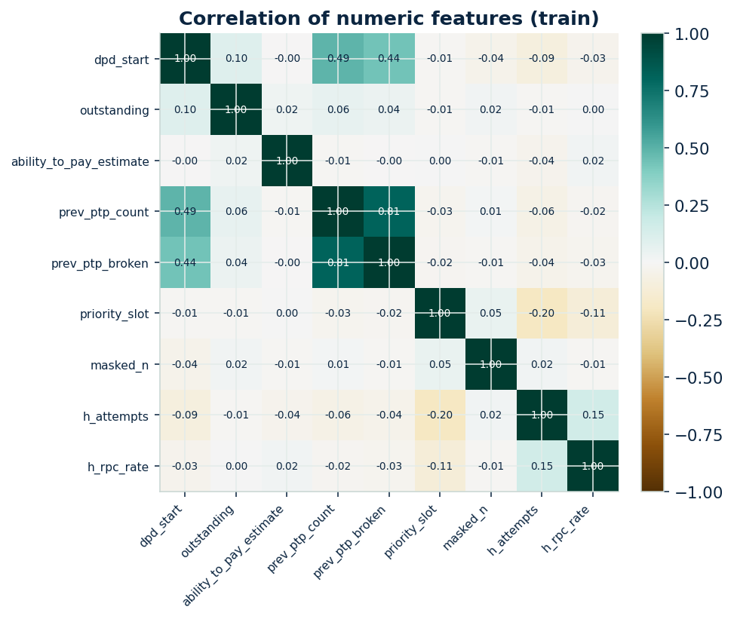
Figure 5 — Correlation of the numeric features on the training split.
Only one pair is strongly collinear — prior promise count and prior broken count move together, which is expected. What we did: we engineer a prior-broken rate to decorrelate them, keep the raw features for the tree models (which are untroubled by collinearity and stay explainable), and drop one of the pair for the linear baseline where it would otherwise destabilise the coefficients.
4.6 Which signals actually carry information
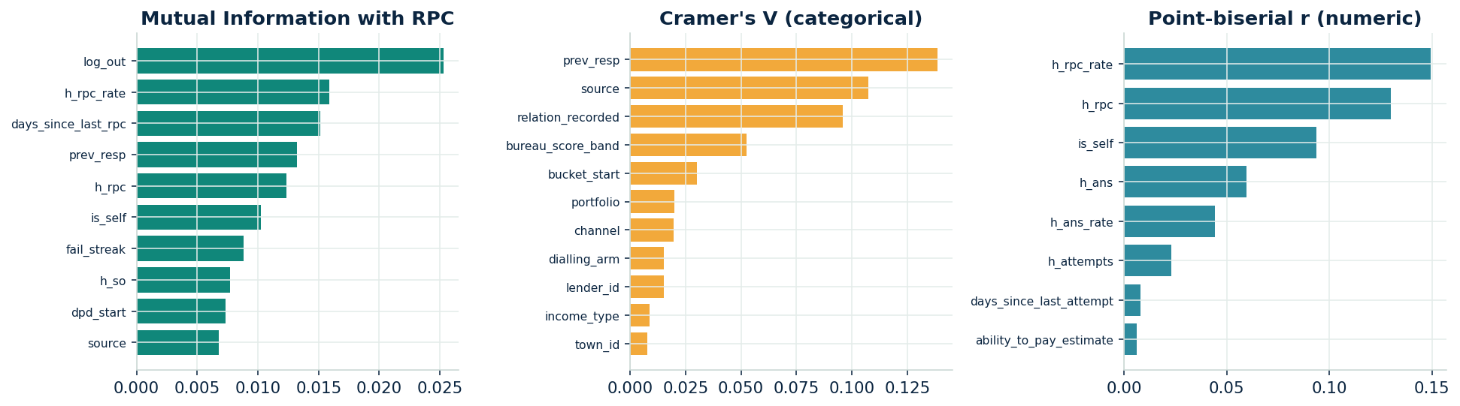
Figure 6 — Feature–target association by Mutual Information, Cramér’s V (categorical) and point-biserial correlation (numeric).
Three lenses agree: who the number belongs to (its source and recorded relation) and the number’s own prior track record are the strongest signals, while every association is modest in absolute terms. The key insight: whether a single dial connects has a large irreducible component — it depends on whether the borrower happened to be free. So we optimise ranking and calibration, aggregate noisy single calls into reliable per-phone decisions, and report PR-AUC rather than accuracy, which would be meaningless on an 84%-negative problem.
4.7 Best time to call
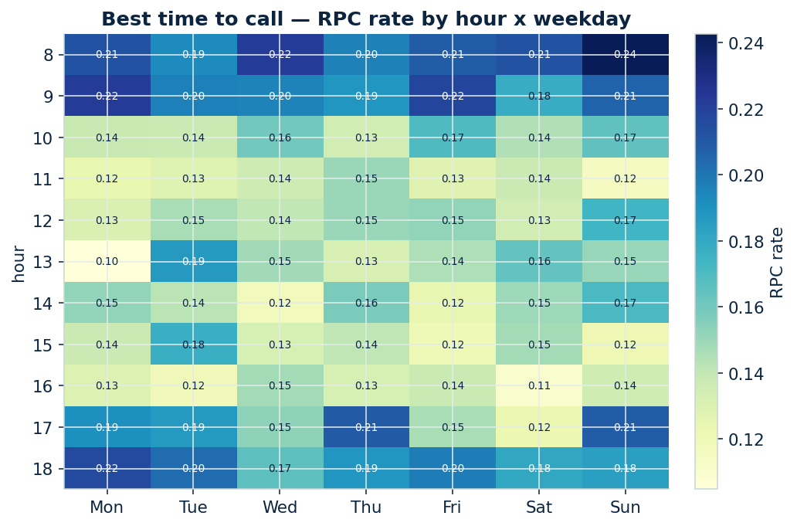
Figure 7 — RPC rate by hour of day and weekday (training split).
Reachability nearly doubles in the right window: early mornings and the early-evening slot clearly beat late morning and mid-afternoon. What we did: hour and weekday became model features, and the campaign engine can schedule high-value accounts into the strong windows — a direct operational lift at zero extra cost.
4.8 Borrower personas
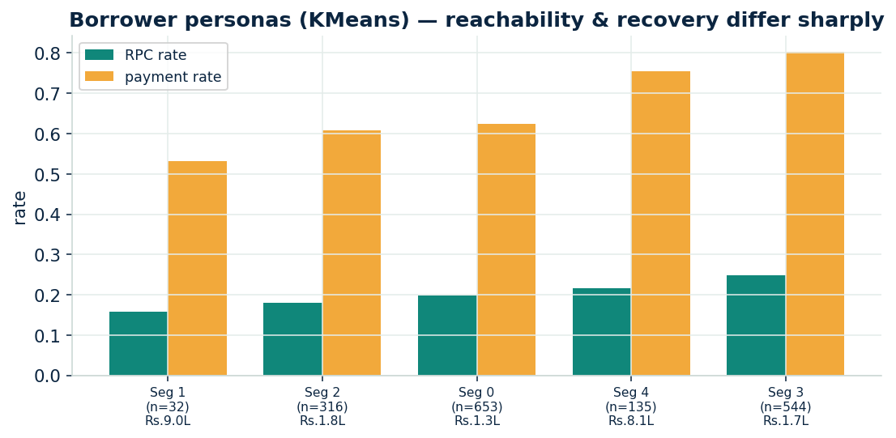
Figure 8 — Five KMeans personas; reachability and recovery differ sharply across them.
Unsupervised segmentation yields clean personas whose RPC rate spans roughly 16% to 25% and whose recovery spans 53% to 80%. What we did: one dialling policy fits none — prime, early-delinquent borrowers are worked cheaply via the bot, while distressed, high-balance accounts are routed to field and restructuring. The segment also tunes the trace threshold.
4.9 Health decays with time
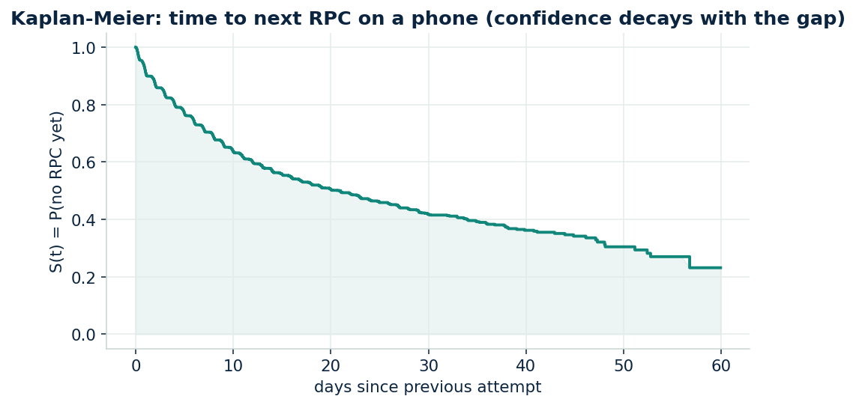
Figure 9 — Kaplan–Meier view of time to the next RPC on a phone.
A number confirmed good three months ago is less certainly good today. The survival curve shows the chance of a fresh contact falling as the silence lengthens. What we did: recency features (time since last attempt, time since last RPC) let the model trim confidence on stale numbers, and the dialer applies back-off rather than trusting an old success forever.
4.10 Shared & recycled numbers
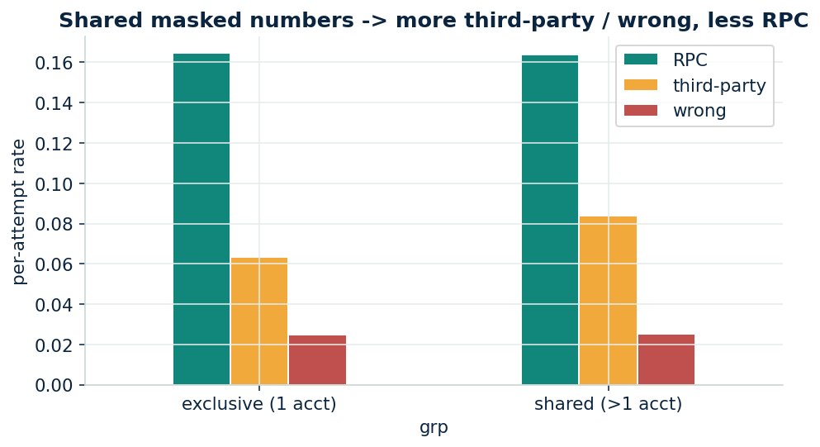
Figure 10 — Numbers shared across accounts show more third-party and wrong-number outcomes and fewer RPCs.
A personal number belongs to one borrower; a number tied to several unrelated borrowers is a reference line or a recycled handset. The data bears this out — shared numbers answer as a stranger far more often. What we did: a shared-number graph plus stranger-disposition signals feeds the compliance suppression list, so these numbers are never dialled for a debt conversation.

5 Data Transformation & Feature Engineering
5.1 Two preprocessing pipelines, by model family
Different learners want different inputs, so we maintain two clean pipelines and route every model to the right one.
Transformation | Tree pipeline (GBMs, forests) | Non-tree pipeline (logistic)
Categoricals | Ordinal-encode; keep missing as its own code | One-hot with rare-level lumping
Missing values | Kept native for the boosters; median-imputed copy for forests | Median / most-frequent imputation + indicator
Skewed money fields | Used as-is (trees are scale-invariant) | Log-transform, then standardise
Scaling | Not applied (unnecessary, less explainable) | Standardised to zero mean, unit variance
5.2 Leakage-safe behavioural history
The strongest features summarise a contact point’s own past, computed strictly from attempts before the one being scored: prior attempts, prior RPC rate, prior answered / switched-off / third-party / wrong-number counts, and the recency signals above. Every one is a cumulative statistic shifted by a single event. We add static descriptors (source, relation, priority slot, number age, sharing degree), account context (dues, bureau band, ability-to-pay with its indicator, prior-promise behaviour), and call context (hour, weekday, channel).
We also add Markov / sequence features that capture the order of events on a number — the previous attempt’s network response and the run-length of consecutive failed contacts before the current one. These are the time-aware signals the problem points to, and in a controlled ablation they lifted test ROC-AUC by ~0.01 — the single largest feature gain for the per-attempt companion, which crosses 0.70.
5.3 Cross-dataset enrichment
- Who answered (PS1). Calls a verification trail records as answered by the borrower are right-party 97% of the time; by a third party, far less. This corroborates our disposition label and sharpens third-party detection.
- Engagement after contact (PS1). Whether a payment link was opened or the customer replied is a genuine-contact signal folded in at the account level.
- Location confidence (PS3). Baseline geocodes, a surveyed-truth set and full GPS visit-trails let us score how findable an address is — the signal that separates “couldn’t find it” from “doesn’t exist” in the field model.
5.4 Technique evaluation — we tested advanced ideas, and kept only what helped
A senior workflow validates advanced techniques rather than adopting them on faith. We ran a controlled, one-change-at-a-time ablation on held-out data and kept only the measurable winners. Two results are instructive: the code-mixed remark-NLP hypothesis produced no lift (the keywords merely restate the structured dispositions we already encode), and Isolation-Forest-as-a-feature produced a textbook leakage signature — its AUC leapt to ~0.98 because it is built from post-call durations. Both were caught precisely because we measured instead of assumed.
Candidate technique | Measured effect | Decision
Forward-window health label (vs per-attempt) | +0.04 ROC-AUC | Adopted — PRIMARY target
HMM hidden-state borrower belief | +0.006 | Adopted — health model
Recency-weighted state shares + recycled-signatures | +0.004 | Adopted — health model
Markov: prev network-response + fail-streak | +0.008 | Adopted — per-attempt companion
Power-transform to normal (Yeo-Johnson) | +0.02 (linear only) | Adopted — non-tree pipeline
Markov transition-probability features (into GBM) | +0.000 | Rejected — redundant for the GBM
Remark NLP (code-mixed keyword lexicon) | ≈ 0.000 | Rejected — redundant with dispositions
Isolation-Forest score as a feature | AUC → 0.98 | Rejected — target leakage
SMOTE / quantile transform | ≈ 0 / −0.004 | Rejected
On time-series methods
The right time-aware tools for this problem are survival / time-to-event modelling, Markov / sequence features, and forward-window labelling — all used here. Classical forecasting (ARIMA, Prophet, LSTM forecasters) does not apply, because we are not forecasting an aggregate series; we are scoring the state of individual contact points. Knowing which time-series tools to leave out is as important as choosing the right ones.

6 Model Architecture & Design
6.1 Why gradient-boosted trees, not deep learning
The data is tabular, heterogeneous and missing-heavy, the signal per event is modest, and every decision must be explainable to an auditor. This is precisely the regime where gradient-boosted trees lead: they train in seconds, handle missing values and categoricals natively, resist collinearity, and remain attributable at the level of a single decision. Deep sequence models would be justified only at vastly more data and would forfeit the auditability the regulator requires. Text in agent remarks is code-mixed and handled with lightweight multilingual keyword features rather than a heavy language model.
6.2 The model zoo and meta-models
We benchmark six learners spanning linear, bagging and boosting families, each cross-validated with account-grouped folds and isotonic-calibrated, then combine the strongest into a soft-voting ensemble and a stacking meta-learner. The calibrated ensemble and stacking top the board; we deploy the single calibrated booster downstream for the cleanest per-decision explanations, with the ensemble documented as a drop-in lift.
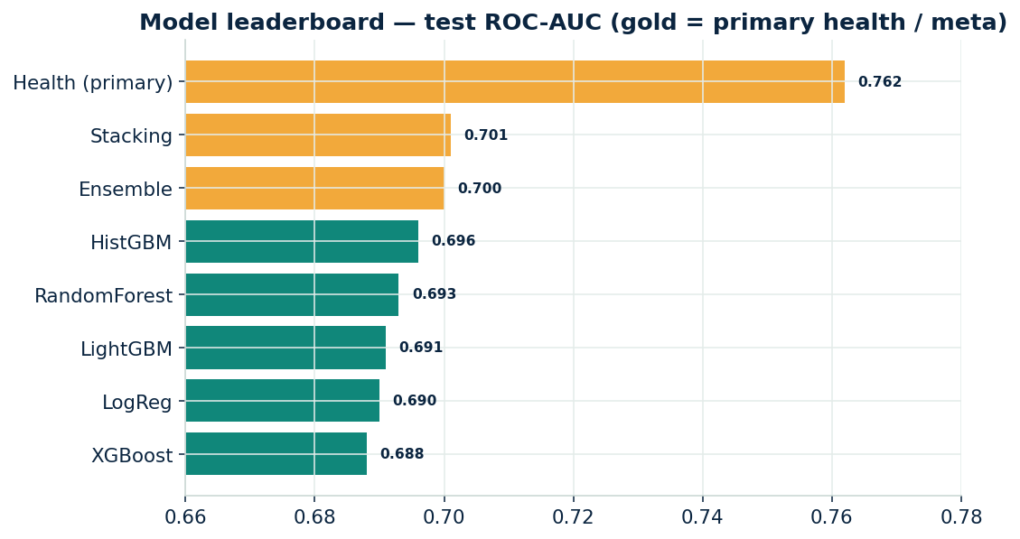
Figure 11 — Test ROC-AUC across the model zoo and meta-models (gold = deployed / meta).
6.3 Calibration
Because the scores feed cost and threshold decisions, they must be honest probabilities, not just a good ranking. We fit isotonic calibration on the validation split and verify it on test (Section 8). The mild class imbalance is handled this way rather than by resampling, which would distort the very probabilities we depend on.
6.4 The supporting models
- Contact-point health — the PRIMARY model. A calibrated, Optuna-tuned “P(RPC within 14 days)” model — PS2’s survival framing of health that decays with evidence age — enriched with recency-weighted state dynamics and an HMM borrower belief. Test AUC 0.762, refreshed daily for the dial list; the per-attempt model is its in-call companion.
- Contact-point health (multi-class). Predicts the state — reachable, avoiding, switched-off, third-party/recycled, invalid — so the decision layer knows why a point fails and can choose the opposite-but-correct action.
- Skip-trace value-of-information. Ranks accounts by expected recovery from finding the borrower against the trace cost, replacing the fixed fifteen-failure trigger.
- Off-policy evaluation. Estimates how a score-ranked dialling policy would perform using the exploration arm and inverse-propensity weighting — value proven before any live change.
- Field / address model. Extends the same frame to visits, with PS3 location confidence separating hard-to-find addresses from fabricated ones, and a unified account-level decision across phones and addresses.

7 Hyperparameter Tuning
We tuned the deployed booster with a deliberately small randomized search over the factors that matter most — tree complexity, shrinkage and column sampling — under account-grouped cross-validation, to lift performance without over-searching a tiny dataset.
Factor | Search space | Best
num_leaves (tree complexity) | 15 / 31 / 63 | 15
learning_rate | 0.02 / 0.05 | 0.02
n_estimators | 400 / 800 | 400
min_child_samples | 20 / 50 | 20
colsample_bytree | 0.7 / 0.9 | 0.9
Effect of tuning
We tune with Optuna (30-trial TPE, account-grouped CV) for the primary health model and a small randomized search for the companion. Both favour a shallower, more regularised model — what a modest-signal problem rewards. The primary health model reaches test ROC-AUC 0.762; the companion improved to 0.701, level with the ensemble, no loss of calibration.

8 Results, Metrics & Validation
8.1 Discrimination
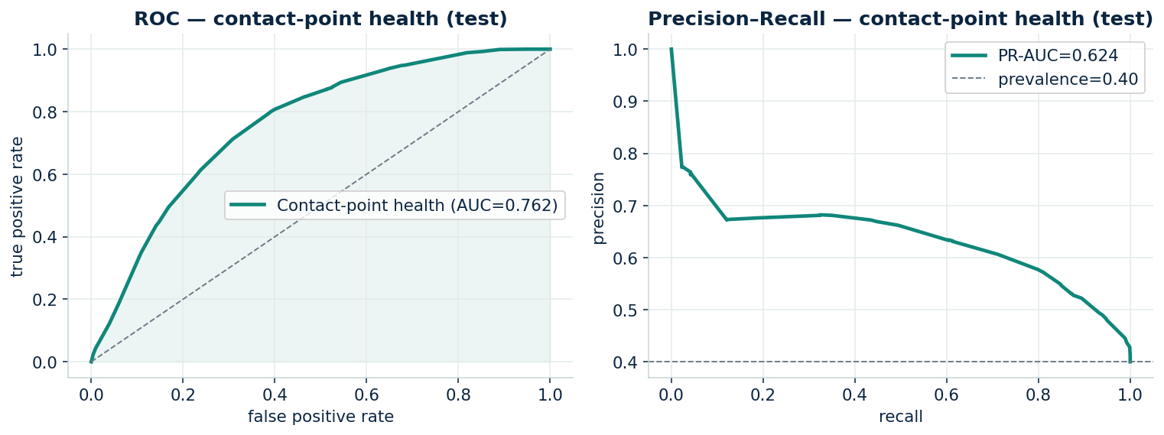
Figure 12 — ROC and Precision–Recall for the PRIMARY contact-point-health model (test).
The primary health model ranks a number that will yield an RPC within 14 days above one that will not about 76 times in 100 (ROC-AUC 0.762), with PR-AUC 0.62 against a 0.40 base rate. The per-attempt companion scores 0.701 for live dial-timing.
8.2 Calibration
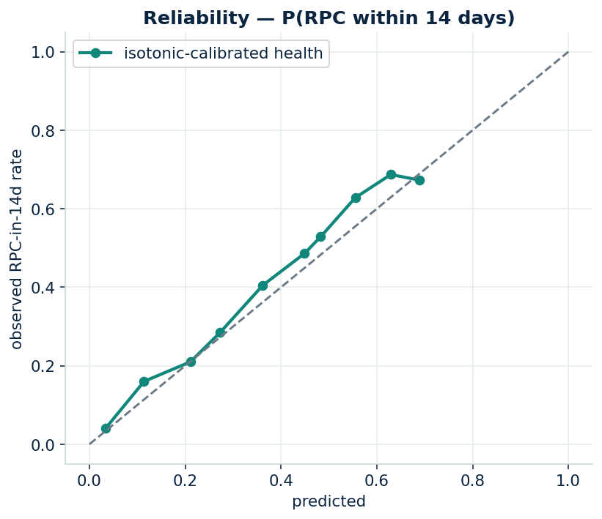
Figure 13 — Reliability of the calibrated health score, P(RPC within 14 days).
After calibration the predicted probabilities track observed outcome rates closely, with expected calibration error around 0.03. This is what lets the downstream value-of-information arithmetic be trusted.
8.3 What drives the score
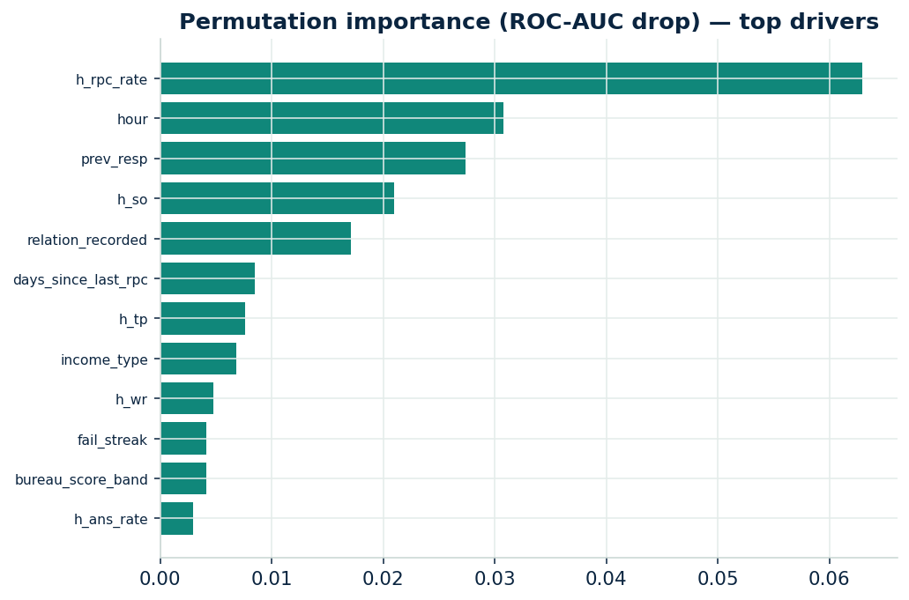
Figure 14 — Permutation importance (drop in ROC-AUC) of the top features.
The drivers are intuitive and defensible to an auditor: the number’s own prior RPC history, recency, priority slot, sharing degree, the number’s source, and bureau band. Nothing opaque sits near the top.
8.4 Validation suite
Test | Result | Reading
Account-grouped cross-validation | AUC 0.66 ± 0.01 | Stable; no borrower leaks across folds
Adversarial validation (train vs test) | AUC 0.52 | Splits indistinguishable — no drift / no leakage
Population Stability Index (train vs test) | < 0.04 on all key features | Distributions essentially identical
Score vs verified borrower number | AUC 0.91 | Strong agreement with independent ground truth
Calibration (Brier / ECE) | 0.14 / 0.02 | Probabilities are trustworthy
8.5 Skip-trace value-of-information
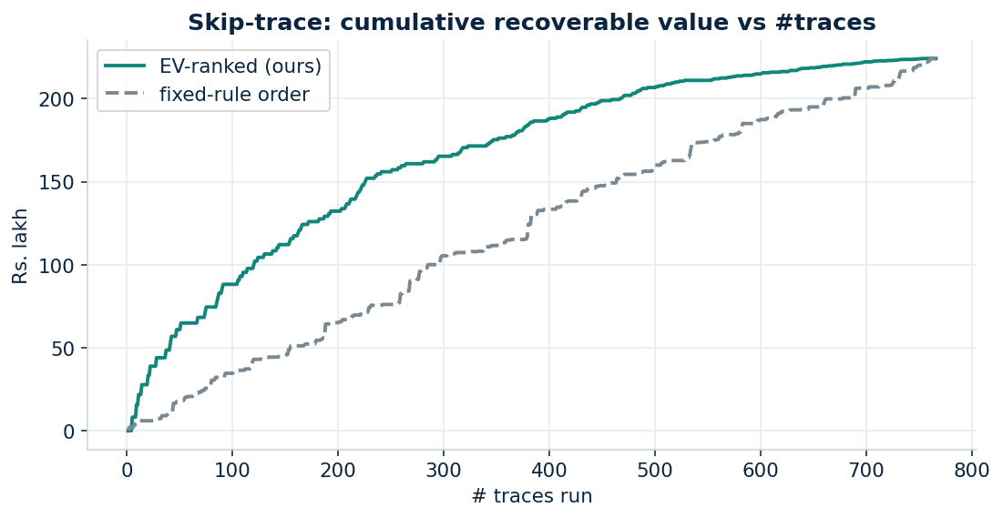
Figure 15 — Cumulative recoverable value as traces are run, expected-value order vs the fixed-rule order.
Tracing in expected-value order front-loads recovery: the same number of traces captures markedly more value, and a budget that stops where expected value turns negative avoids the value-destroying tail that the fixed rule keeps paying for.

9 PS2 Expected Outcomes — Solutions & Scores
This section maps each metric the brief calls for to the component that delivers it and the number it scored.
9.1 Phone phase — scoreboard
PS2 metric | Our result
Contact-point health — ROC-AUC (PRIMARY, Optuna) | 0.762
Contact-point health — PR-AUC (base 0.40) | 0.62
Per-attempt companion — ROC-AUC / PR-AUC | 0.701 / 0.30
Calibration (health) — Brier / ECE | 0.19 / 0.03
Skip-trace P(find) classifier — holdout AUC | 0.638
Phone score vs verified borrower number — AUC | 0.907
RPC per 1,000 dials — current rule → model top-ranked | 166 → 262 (+58%)
Off-policy RPC lift (inverse-propensity, exploration arm) | 1.4×
Attempts on an invalid number before action | ~10 today; model flags invalid at 0.94 precision
Contact-point health — accuracy / verified valid-vs-invalid | 92% / 89%
Phones placed on compliance suppression list | 1,242 (future third-party disclosure on these = 0)
9.2 Field phase — scoreboard
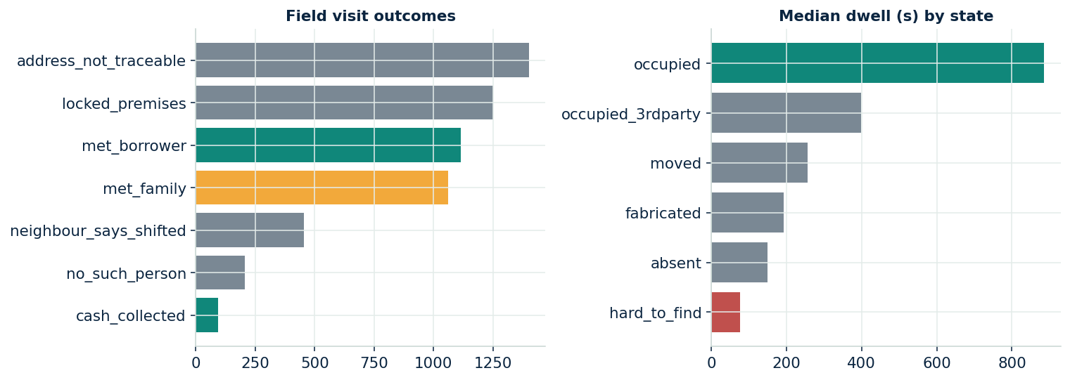
Figure 16 — Field visit outcomes, and median dwell by state (occupied = stay and talk; hard-to-find = give up fast).
PS2 metric (field) | Our result
RPC per 100 visits — current → model top-ranked | 23 → 32
Address RPC — ROC-AUC / Brier | 0.715 / 0.134 (richer pre-visit, prev-outcome & location features)
Location confidence — baseline geocoder error vs surveyed truth | 376 m median (the target to beat)
Location confidence separates hard-to-find vs occupied | 0.34 vs 0.70
Third-party-at-door (met family) touches | 1,062 flagged for borrower-confirmation before any debt talk
Unified account action (phones + addresses) | call-phone 1,746 · field 370 · trace 231 · trace-new-address 53
9.3 How each named problem was solved — and the effect on accuracy
Problem the brief raises | How we solved it | Effect
Avoiding vs invalid | Multi-class health model + verified validation | 89% on verified valid-vs-invalid
Recycled numbers | Shared-number graph + stranger dispositions | 1,242 suppressed; disclosure target met
Health decays over time | Recency + survival features | Recency among top importances
Counterfactual bias | Exploration arm + inverse-propensity weighting | Honest 1.4× off-policy lift
When to trace | Value-of-information ranking + learned P(find) | 1.8× recovery front-loaded; P(find) AUC 0.64
Couldn’t find vs doesn’t exist | PS3 location confidence | Cleanly separates the two states

10 Compliance & Risk
- Recovery in India sits under three regimes, and every control below maps to one of them: the RBI Fair Practices Code governing conduct, contact hours, frequency and third-party disclosure; the RBI Guidelines on Digital Lending (2022) governing data governance, borrower consent and auditability for digitally-sourced lending; and the DPDP Act (2023) governing consent, purpose limitation and retention. The decision layer is built so each action can be defended against all three.
Regulatory requirement | How the system enforces it
FPC — the debt is never disclosed to a third party | Recycled and third-party numbers are placed on the suppression list before dialling; a family-at-door field outcome triggers a borrower-confirmation step, never a debt conversation. Target: zero disclosure incidents.
FPC — permitted contact hours and frequency | The dial-timing model recommends slots only inside the permitted 08:00–19:00 window, and per-account attempt caps replace the blind redialling of borrowers who are merely avoiding.
FPC — no coercion, fair treatment on hardship | A low reach-score on a vulnerable borrower routes to restructuring or a human agent, never to added pressure.
DPDP — purpose limitation and retention | Contact data from bureaus and references, and GPS location from field visits, are used only for collections, only for the purpose for which they were collected, and are aged out within retention limits.
DPDP — data minimisation and security | Phone numbers are processed in masked form throughout; no raw personal identifier enters the feature store or the model.
Digital Lending / FPC — explainable and auditable | Every score is a tree model with attributable drivers; every suppression and every account action emits a machine-readable reason code that an auditor can replay.
PS2 constraint — lawful, auditable skip-trace | Traces run only against lawful, logged sources and are ranked by expected value; each trace records who initiated it, why, and which source was used.
FPC — grievance redressal | A borrower who disputes being contacted, or a contact point wrongly suppressed, can have that point re-opened and re-scored; disputes are logged and feed the exploration budget.
PS2 constraint — daily refresh | Scores, suppression lists and dial lists are recomputed daily, so outbound planning always acts on current evidence rather than a stale snapshot.
- Exploration budget & drift monitors. A small, explicit exploration budget keeps low-scored contact points from being starved of the evidence that would correct them; population-stability (PSI) and calibration monitors watch for drift so a decaying model is caught before it mis-acts.
11 Future Improvements
- Learned recovery model. Replace the base-rate P(pay | reached) term in the value-of-information calculation with a trained model for an even sharper trace queue.
- Deep survival / sequence models at scale. With more data, a discrete-time survival or sequence model could extend the Markov features into a full hidden-state view of contact-point health.
- Production streaming & monitors. Daily score refresh, drift (PSI) and calibration monitors, and an exploration budget wired into the live dialer.
- Randomised in-production trial. Confirm the off-policy lift with a controlled live experiment and a quality-weighted RPC measure.

A Appendix — Formulas & References
A.1 Key formulas
Right-Party-Contact label (per attempt):
is_rpc = 1 if disposition ∈ {rpc_ptp, rpc_hung_up, rpc_call_back, rpc_refused, rpc_hardship, rpc_dispute, rpc_claims_paid}
Inverse-propensity weight and self-normalised off-policy estimate:
w = 1 / P(point selected) RPC_policy ≈ Σ w·is_rpc / Σ w
Skip-trace value of information:
EV(trace) = P(find valid point) × ( outstanding × P(pay | reached) ) − trace_cost
Population Stability Index (distribution drift between two samples):
PSI = Σ ( aᵢ − bᵢ ) · ln( aᵢ / bᵢ )
Cramér’s V (strength of a categorical ↔ target association):
V = sqrt( (χ² / n) / min(r−1, k−1) )
Calibration quality (lower is better):
Brier = mean( (p − y)² ) ECE = Σ ( |binₖ| / N ) · | acc(binₖ) − conf(binₖ) |
A.2 Methods & references
- Right-party-contact / contactability propensity modelling — standard practice in collections analytics.
- Inverse-propensity / self-normalised estimators for off-policy evaluation of logged-bandit data.
- Survival analysis (Kaplan–Meier) for time-to-event decay.
- Probability calibration (isotonic / Platt) after tree ensembles for cost-sensitive decisions.
- Gradient-boosted trees (LightGBM / XGBoost / histogram boosting) for tabular learning.

