Snowflake Student Performance Database

1. Creating the Student Database
Created the STUDENT_DB database and checked that Snowflake had registered it successfully. The result confirms that STUDENT_DB exists and is available for the exercise.
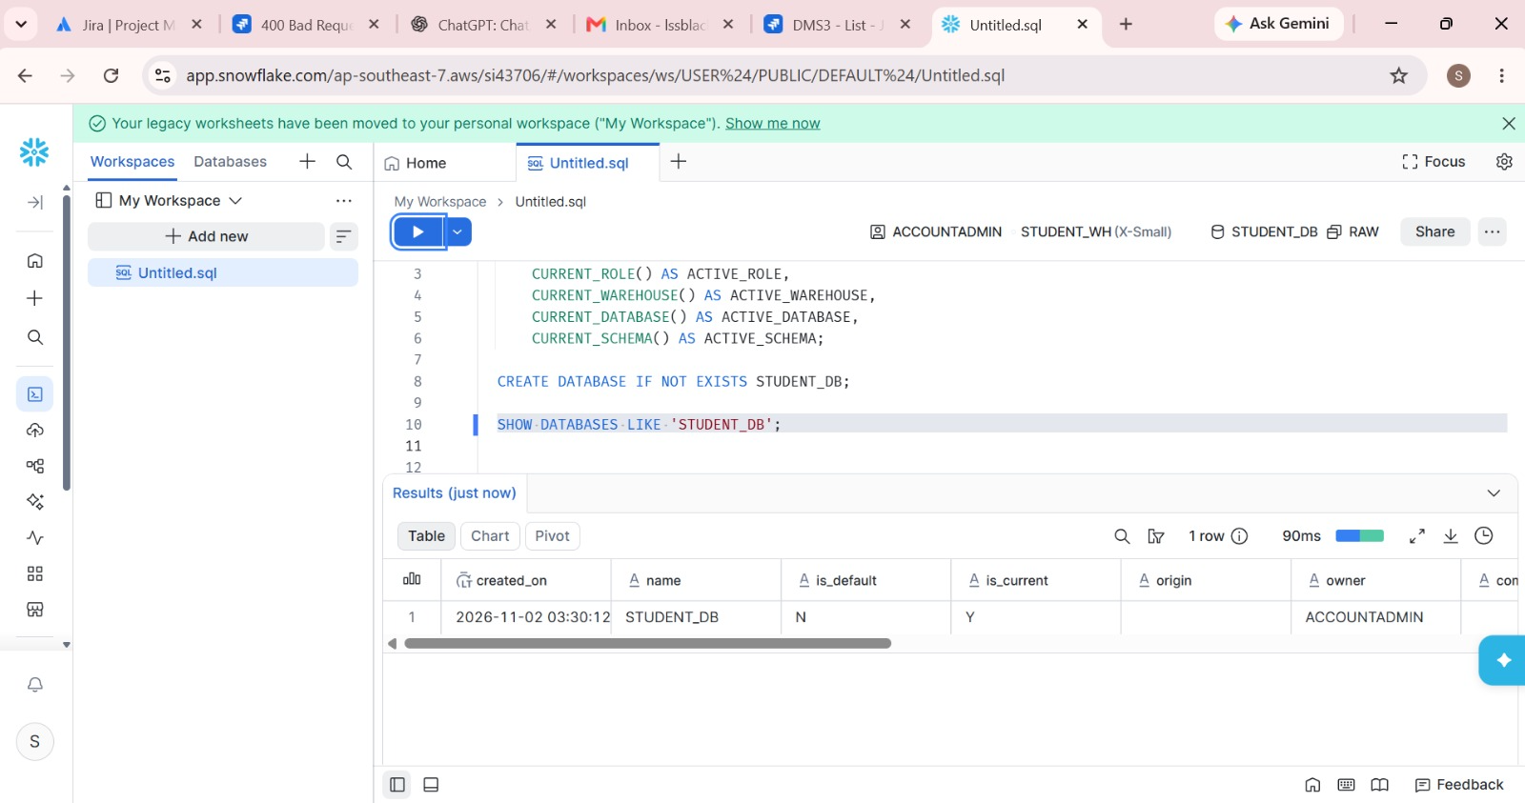

2. Creating and Checking the Virtual Warehouse
Set up the STUDENT_WH virtual warehouse and selected it for the session. The SHOW WAREHOUSES result confirms the warehouse is present. It is shown as suspended, which is normal when the warehouse is not actively running a query.
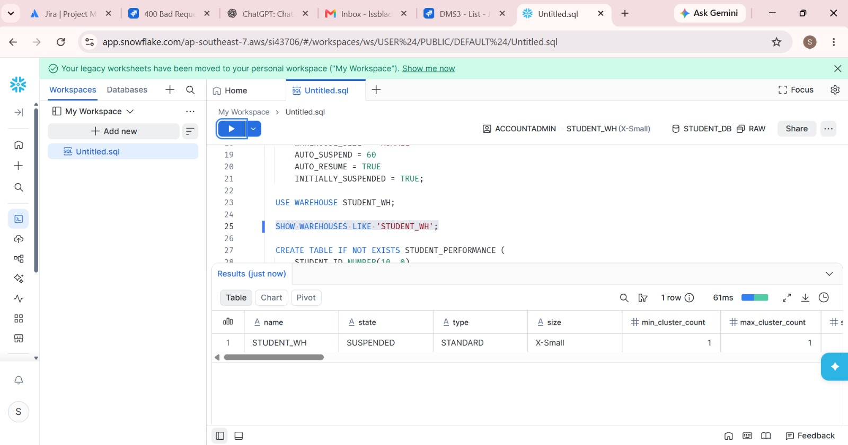

3. Creating the Student Performance Table
Created the STUDENT_PERFORMANCE table in the RAW schema with columns for student ID, name, department, subject, marks and city. The table description was then checked to verify the column definitions.
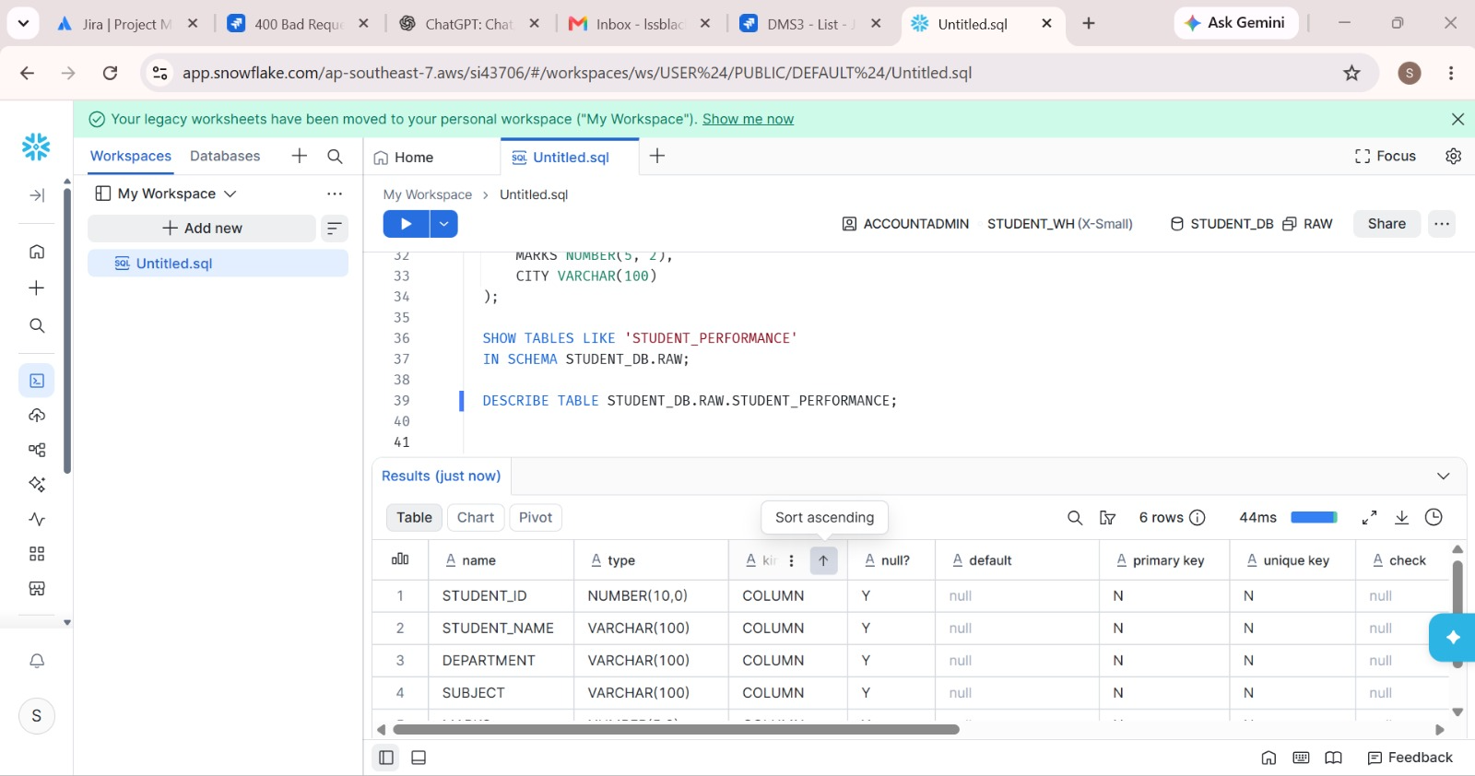

4. Defining the CSV File Format
Prepared the CSV file format settings, including the header row and handling of enclosed text and empty fields. These settings help Snowflake interpret the uploaded student data correctly.
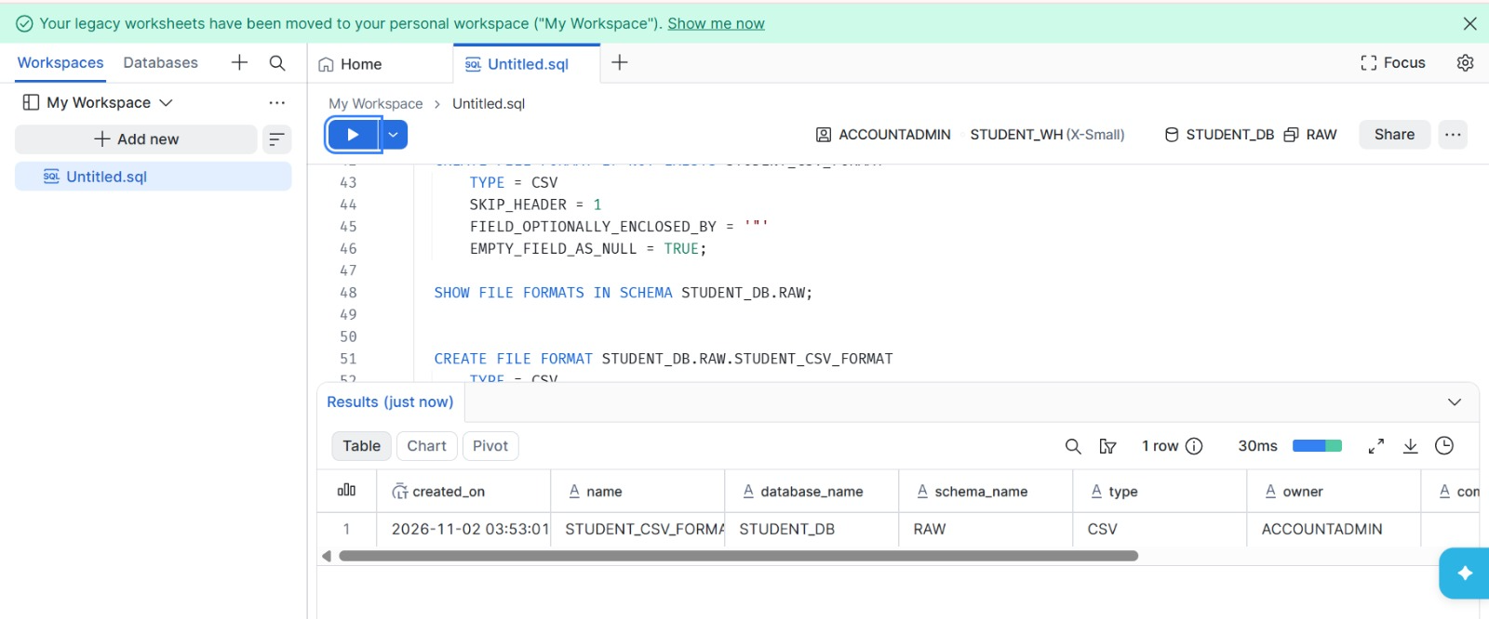

5. Creating the Student CSV File Format
Created the named file format STUDENT_CSV_FORMAT in the RAW schema. The result confirms that Snowflake recognises it as a CSV file format and that it is ready to be used by the stage.
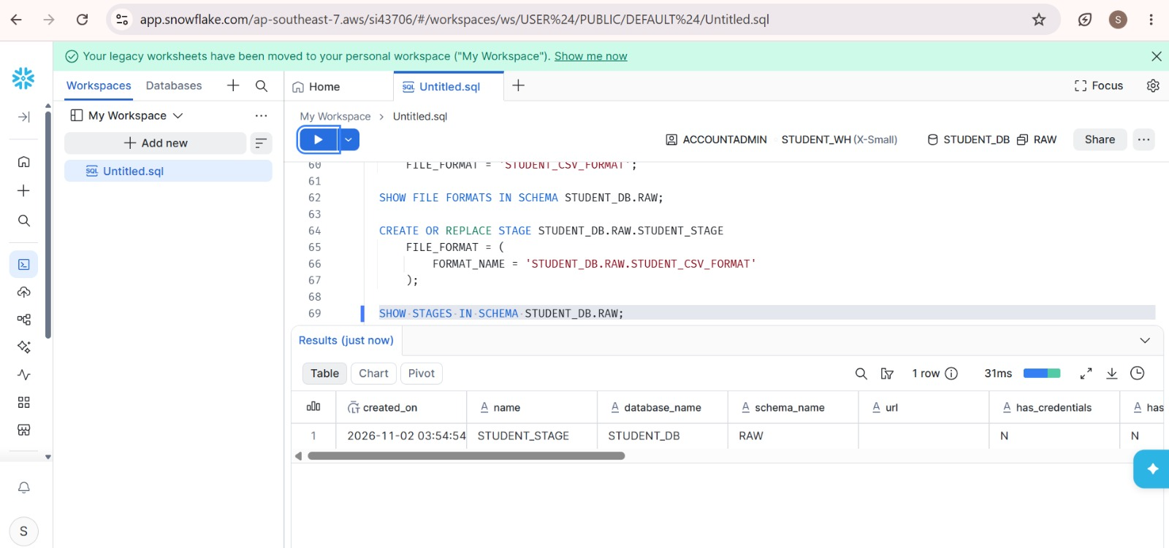

6. Creating the Internal Stage
Created the internal stage STUDENT_STAGE and linked it to STUDENT_CSV_FORMAT. The stage provides a place in Snowflake to store the CSV file before loading it into the table.
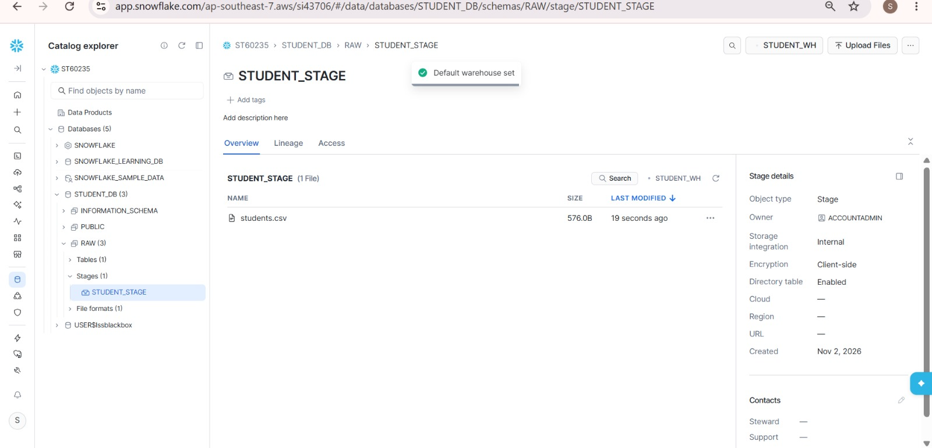

7. Uploading students.csv to the Stage
Opened the STUDENT_STAGE page in Catalog Explorer and uploaded students.csv. The file appears in the stage listing, confirming that it is available for loading.
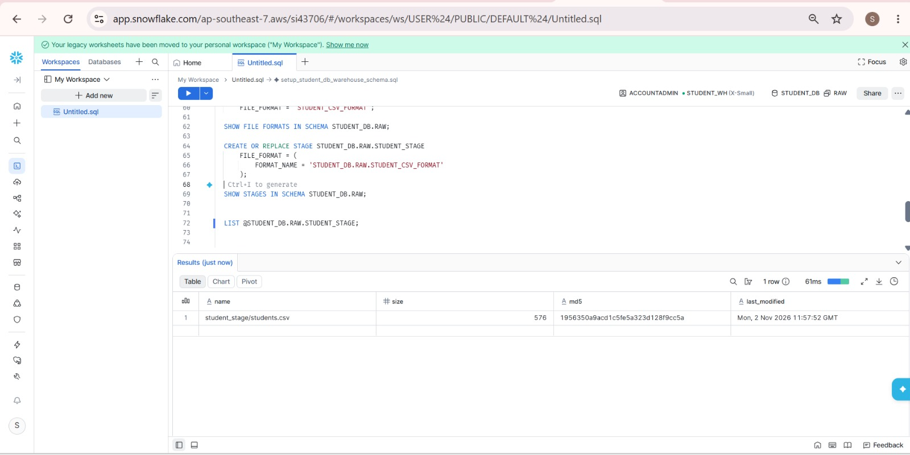

8. Verifying the Uploaded File
Used LIST on the stage to check its contents. Snowflake returned student_stage/students.csv, along with its file size and metadata, confirming that the file was uploaded successfully.
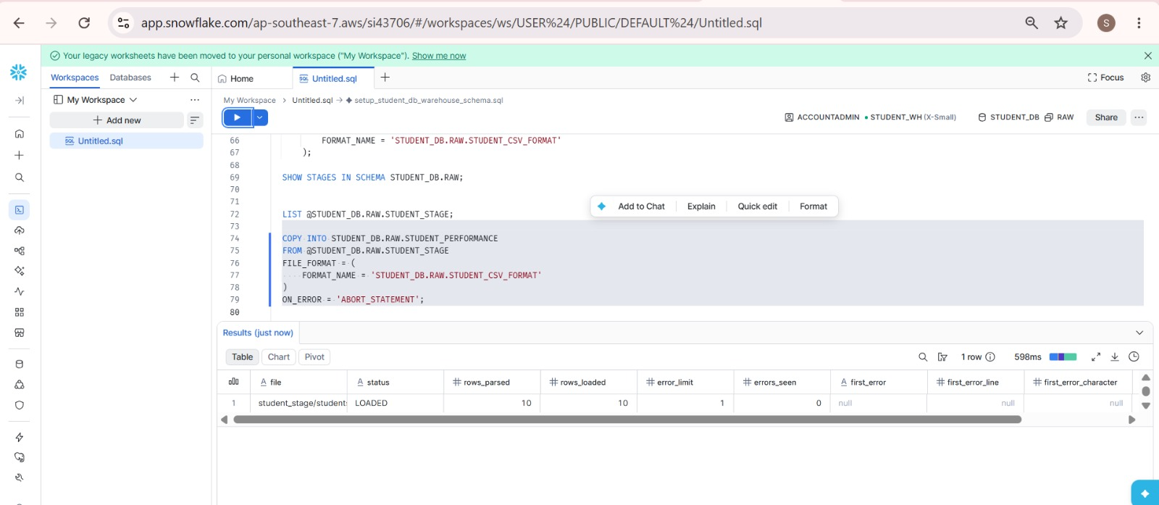

9. Loading the CSV Data into the Table
Ran COPY INTO to load the staged CSV file into STUDENT_PERFORMANCE. The load result shows 10 rows parsed and 10 rows loaded, with no errors reported.
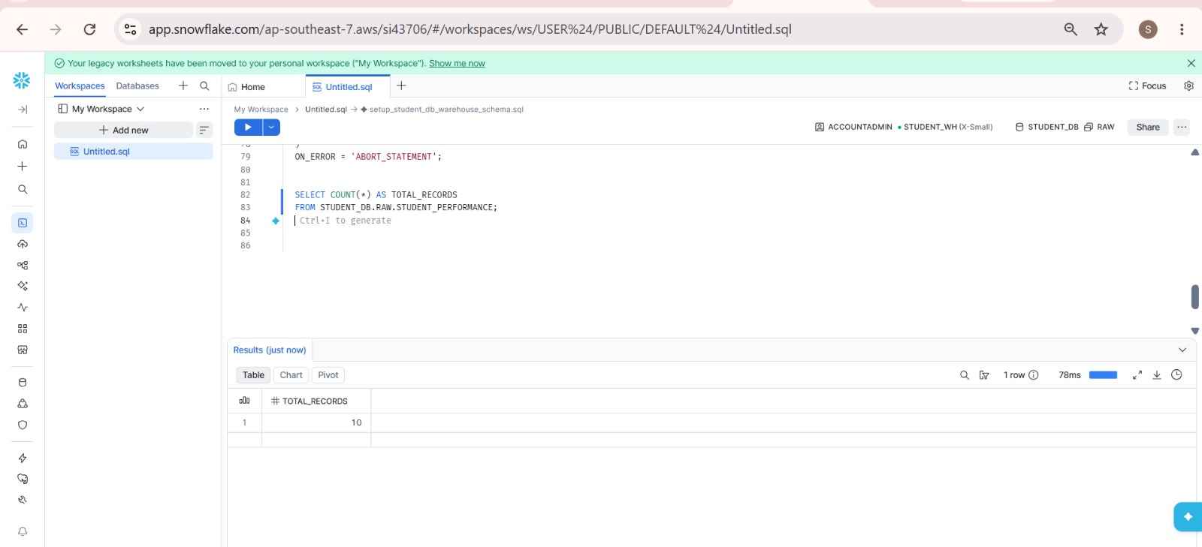

10. Checking the Total Number of Records
Ran COUNT(*) against STUDENT_PERFORMANCE to verify the load. The query returned 10, confirming that all 10 student records were inserted.
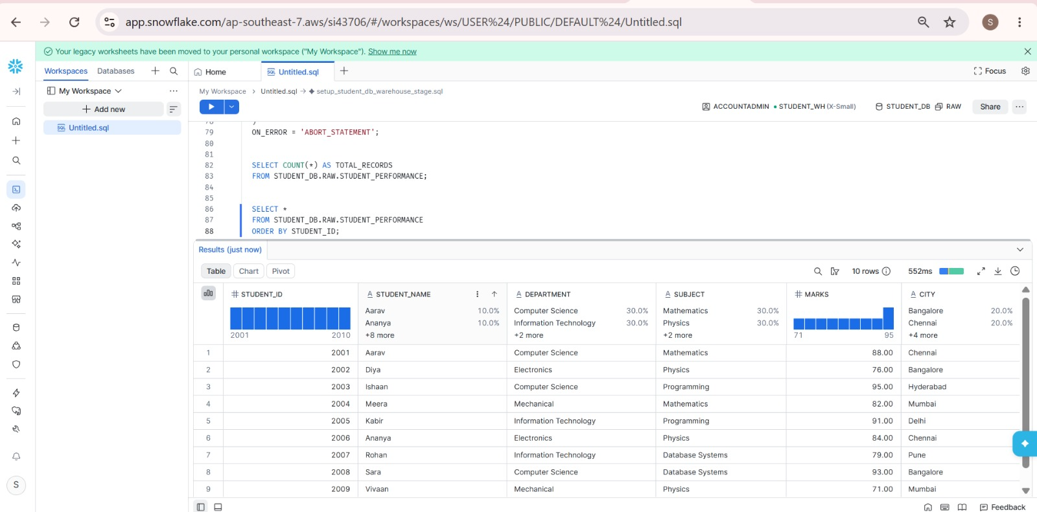

11. Viewing the Loaded Student Records
Selected all rows from STUDENT_PERFORMANCE and sorted them by STUDENT_ID. The result displays the student records and their corresponding department, subject, marks and city.
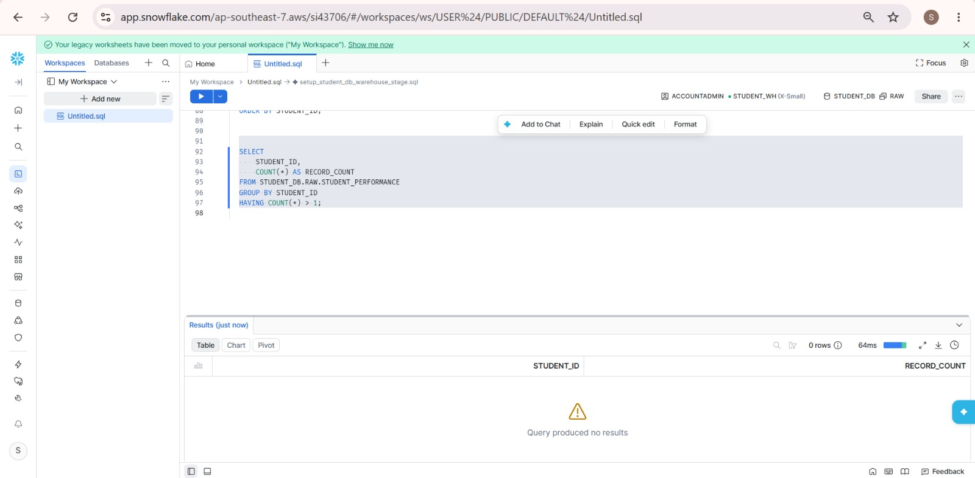

12. Checking for Duplicate Student IDs
Grouped the records by STUDENT_ID and filtered for IDs appearing more than once. The query returned no rows, indicating that no duplicate student IDs were found.
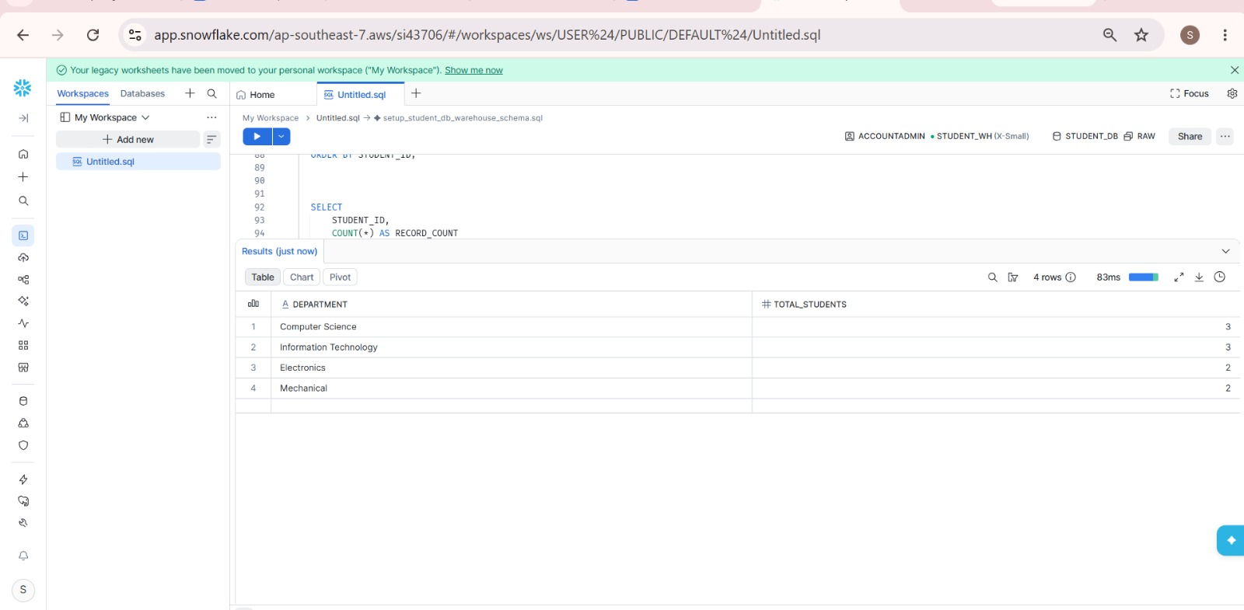

13. Counting Students by Department
Grouped the student records by department and counted the students in each group. The result shows the distribution across Computer Science, Information Technology, Electronics and Mechanical.
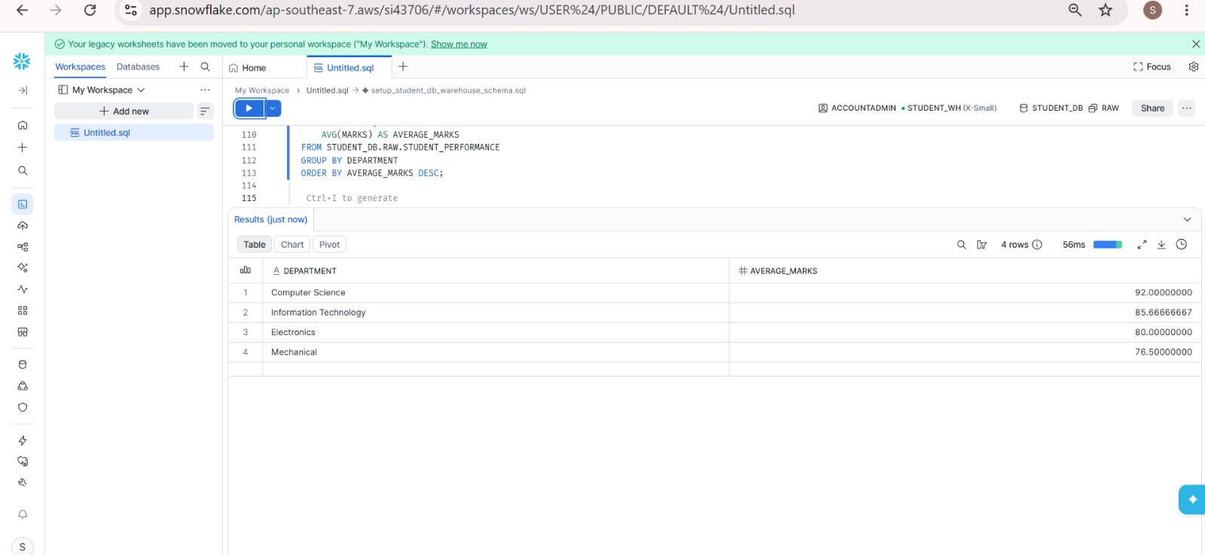

14. Calculating Average Marks by Department and Subject
Calculated average marks for each department and then for each subject. These results make it easier to compare academic performance across the different groups.
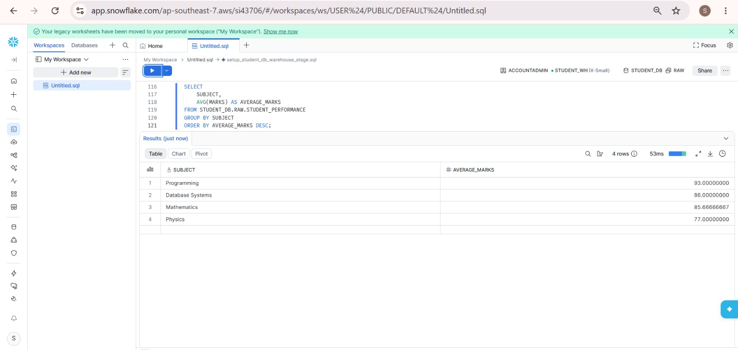

15. Finding Students Scoring Above 85
Filtered the table to show students with marks greater than 85 and sorted the results from highest to lowest. This highlights the students who scored above the selected threshold.


