AWS VPC Setup

1. VPC and Subnet Configuration

Screenshot 1
Created the private subnet and confirmed that both public and private subnets are available.
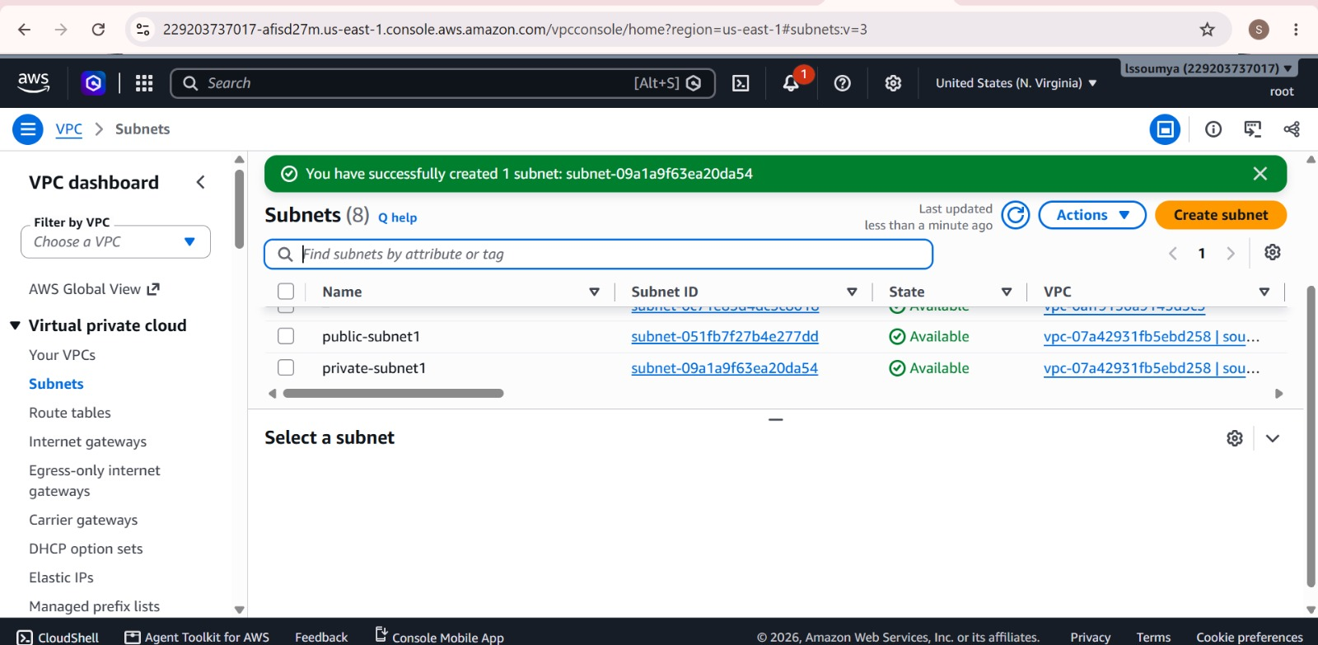

Screenshot 2
Verified the VPC created for the network setup.
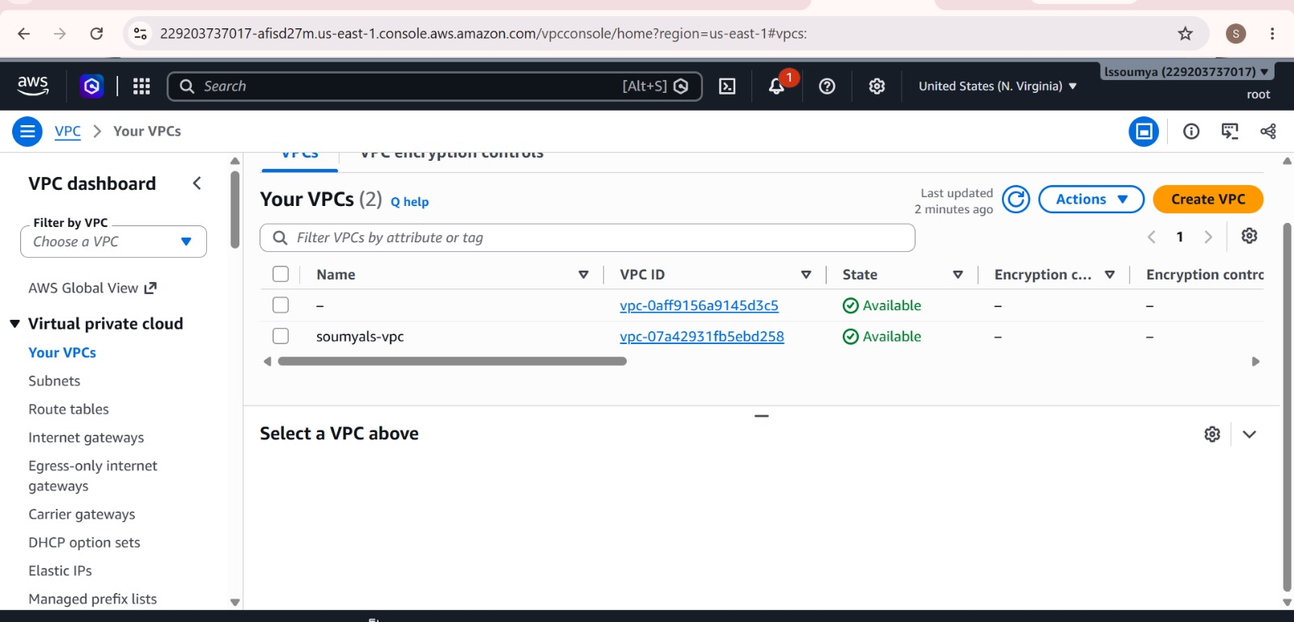

2. Internet Gateway Configuration

Screenshot 3
Created the internet gateway and selected the VPC for attachment.
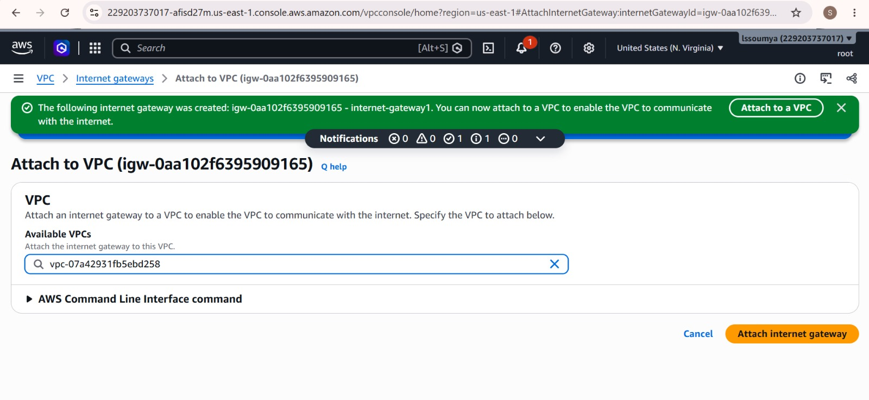

Screenshot 4
Confirmed that the internet gateway was successfully attached to the VPC.
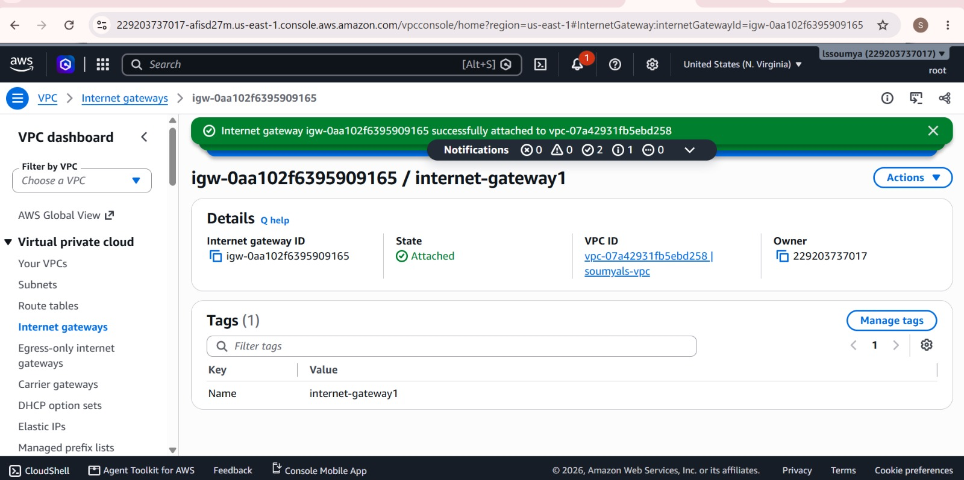

3. Route Table Configuration

Screenshot 5
Configured the public route table for the VPC.
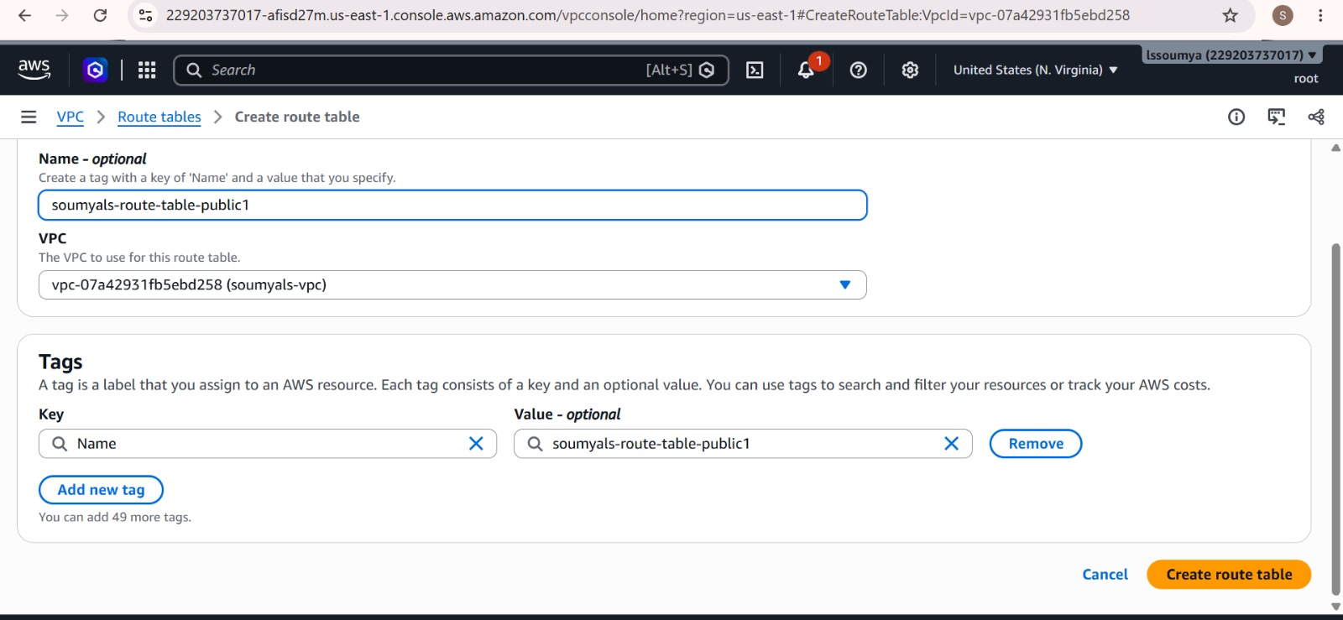

Screenshot 6
Created the private route table.
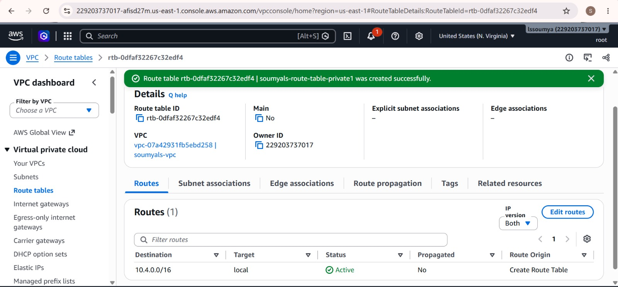

Screenshot 7
Associated the public subnet with the public route table.
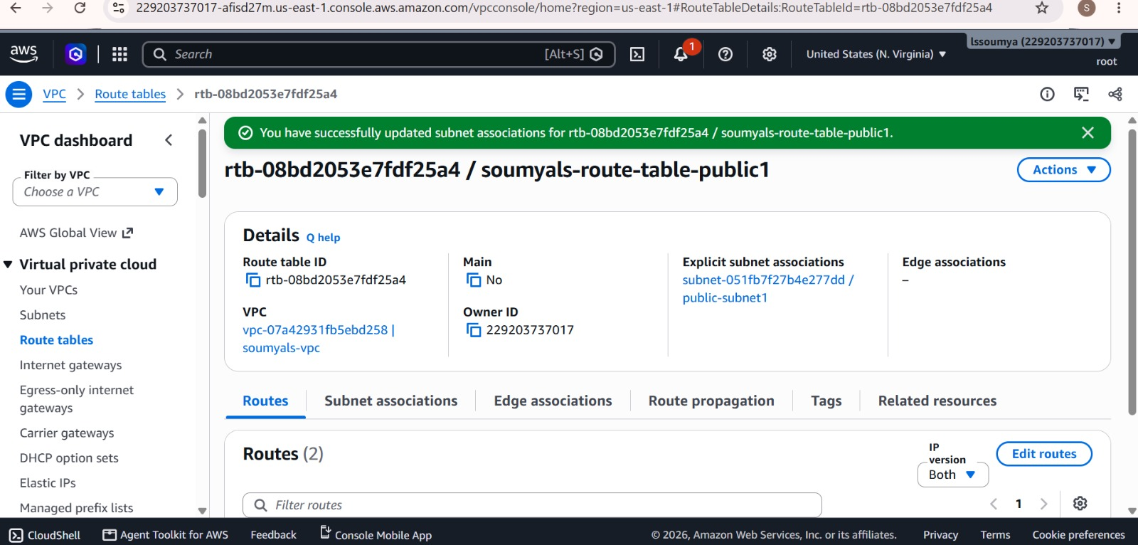

Screenshot 10
Selected the private subnet for association with its route table.
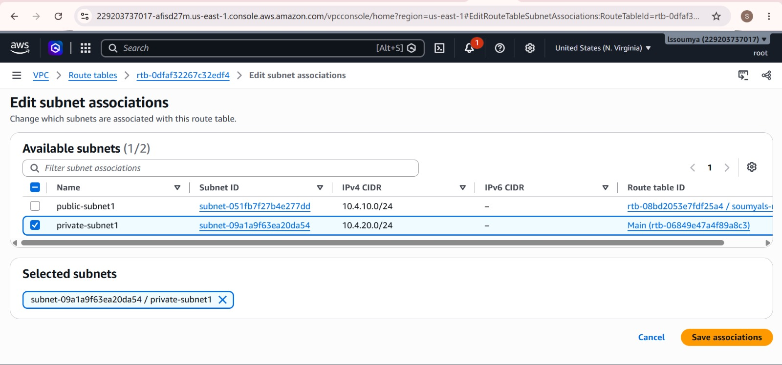

4. NAT Gateway Configuration

Screenshot 8
Allocated an Elastic IP and configured a public NAT gateway in the public subnet.
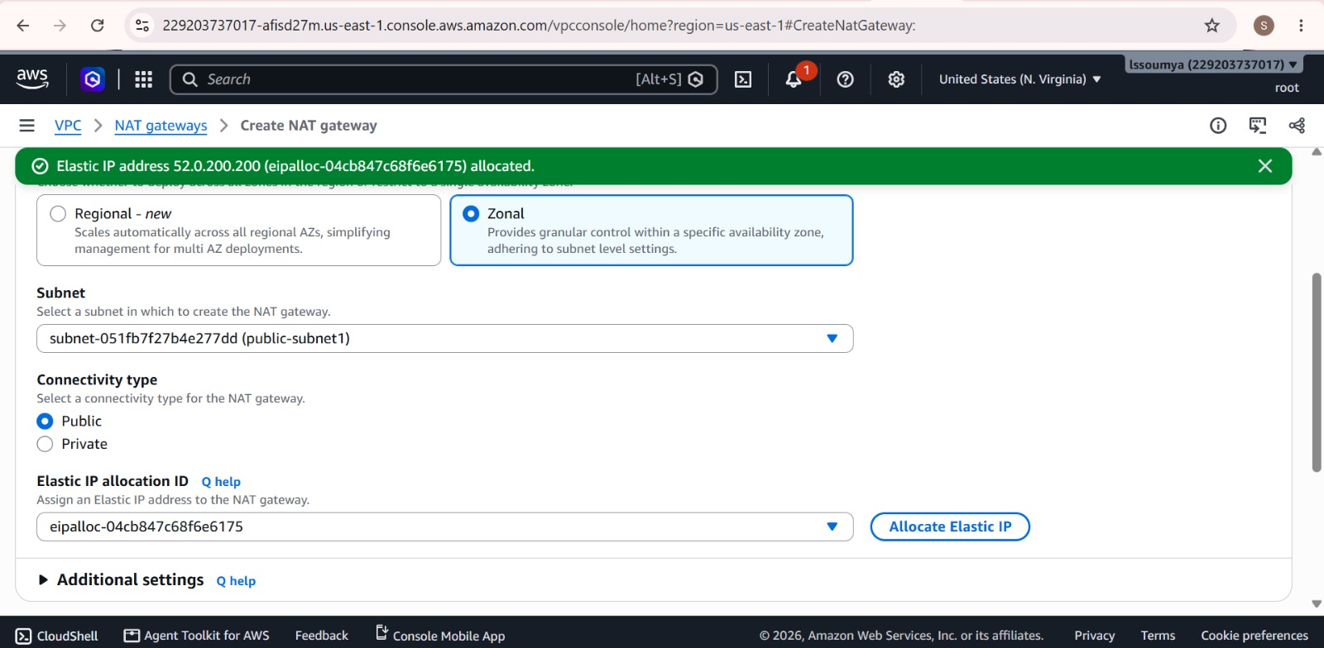

Screenshot 9
Verified that the NAT gateway was created and was in the pending state.
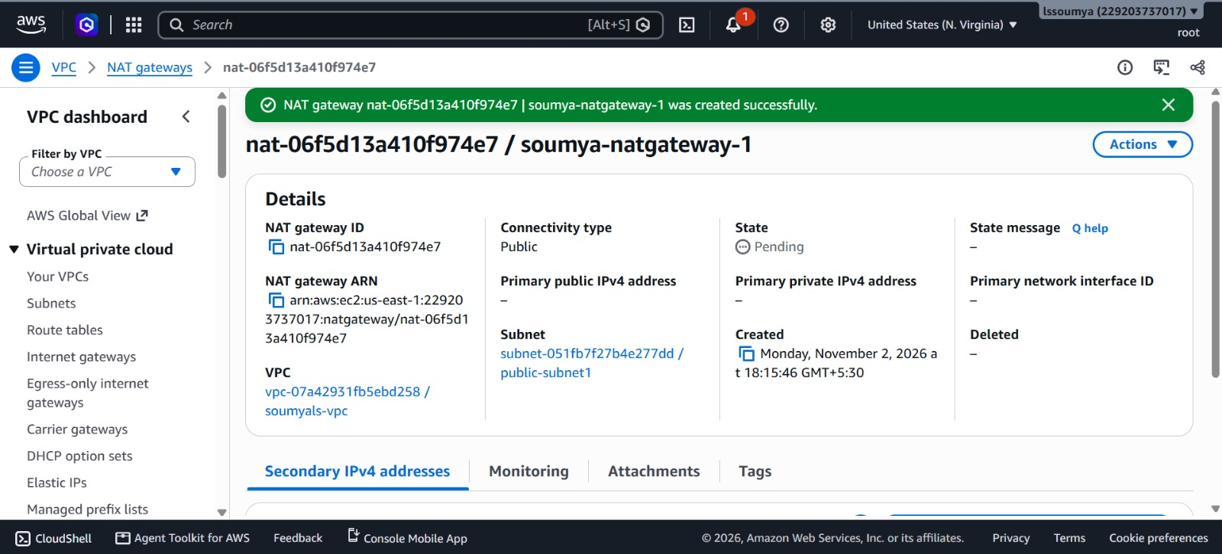

5. Security Group Configuration

Screenshot 11
Created the public security group with SSH access restricted to the current IP and HTTP/HTTPS access enabled.
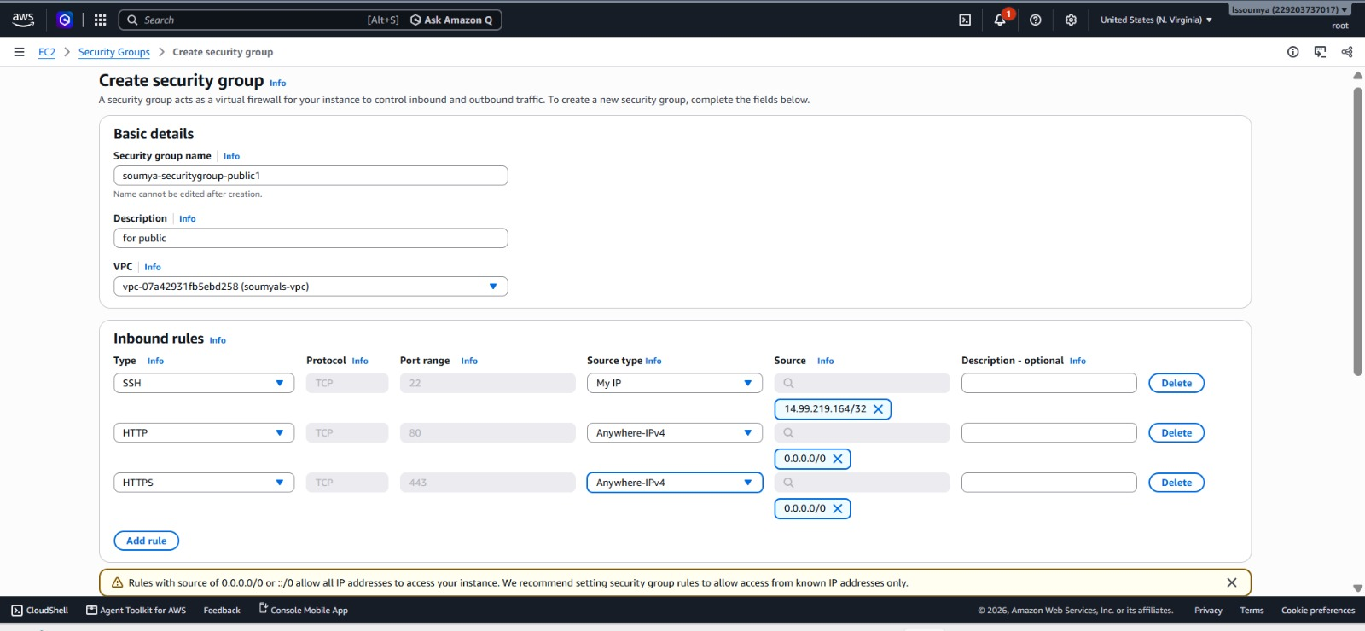

Screenshot 12
Verified the public security group's inbound rules.
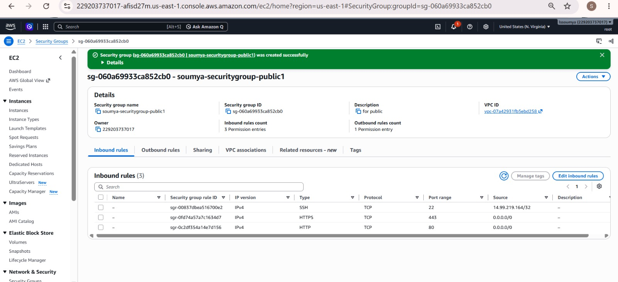

Screenshot 13
Configured the private security group to allow traffic from the public security group.
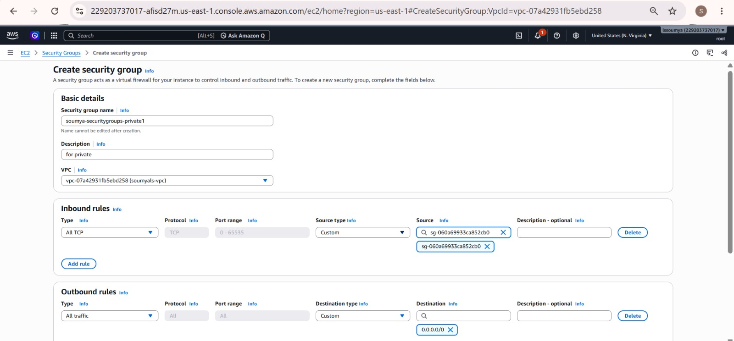

6. EC2 Instance Verification

Screenshot 14
Viewed the EC2 instances launched for the VPC setup.
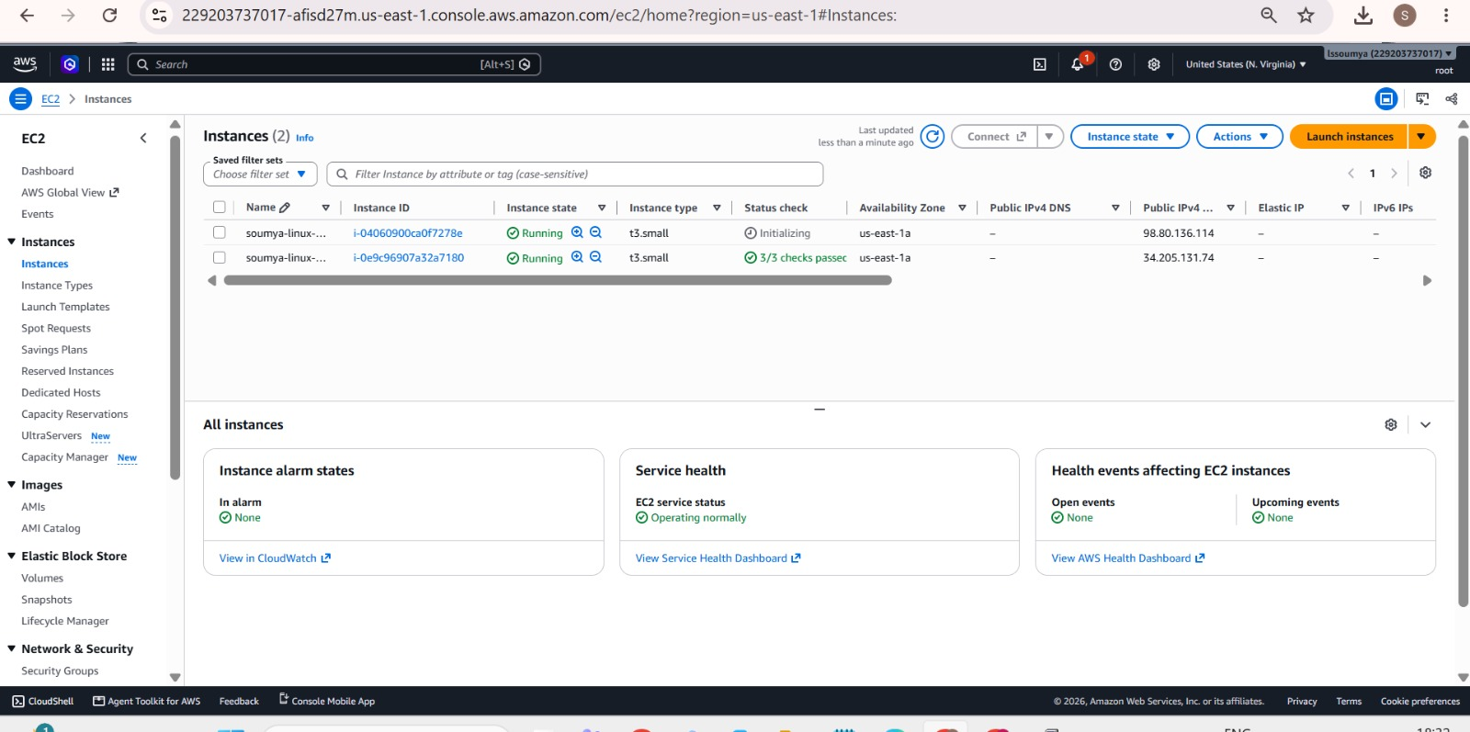

7. EC2 Connectivity and Web Server Configuration

Screenshot 15
Connected to the private EC2 instance through the public EC2 instance and verified internet connectivity using ping.
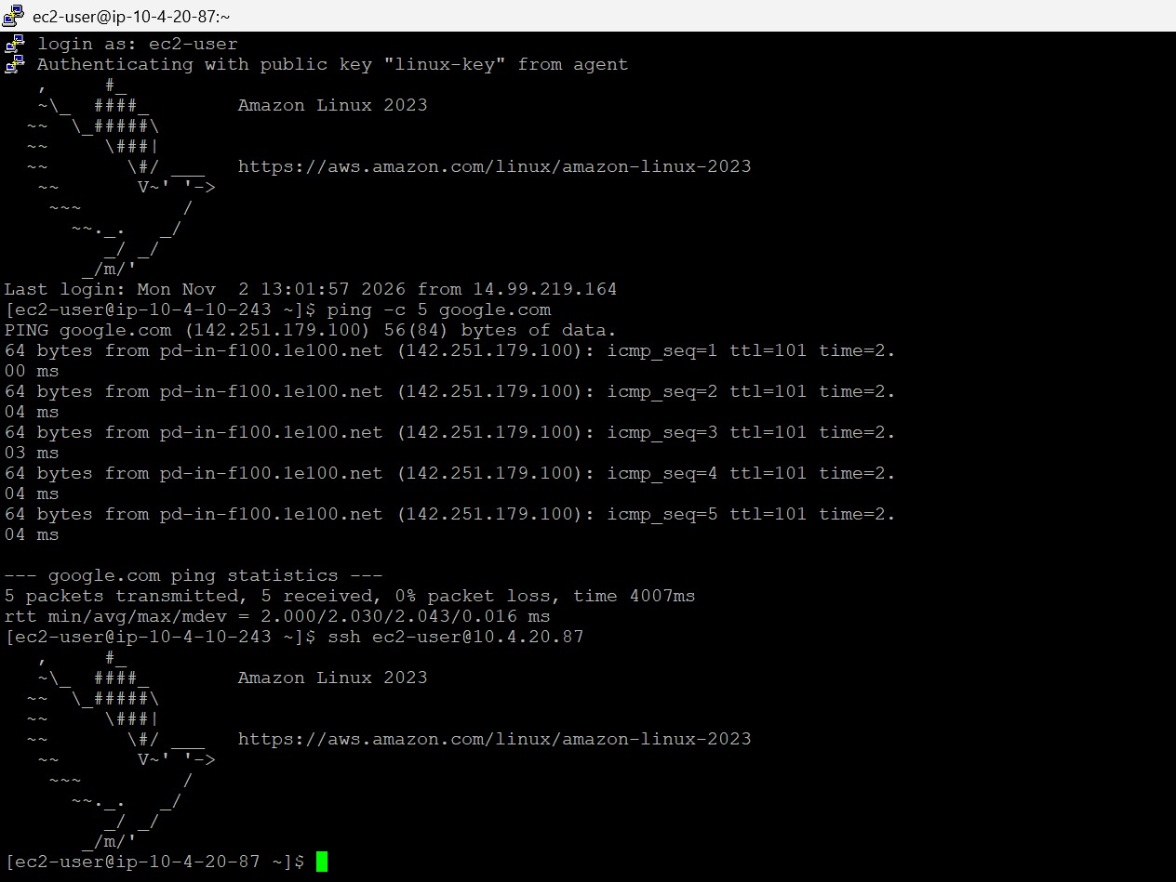

Screenshot 16
Installed and configured the Apache HTTP server, enabled the httpd service, and restarted it.
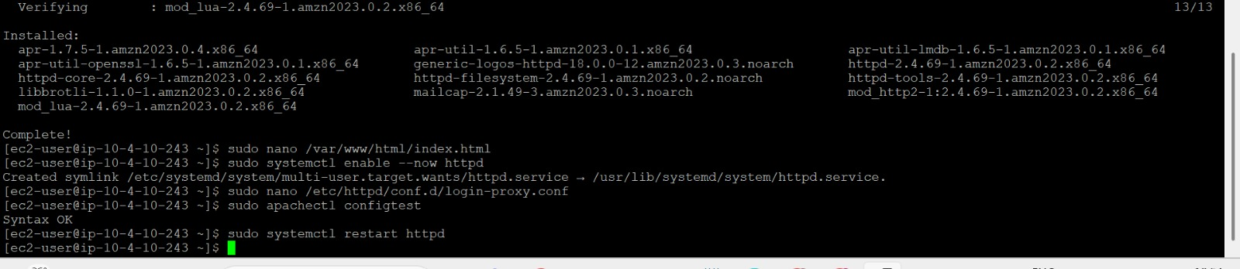

Screenshot 17
Created the homepage HTML file with a heading and a link to the login page.
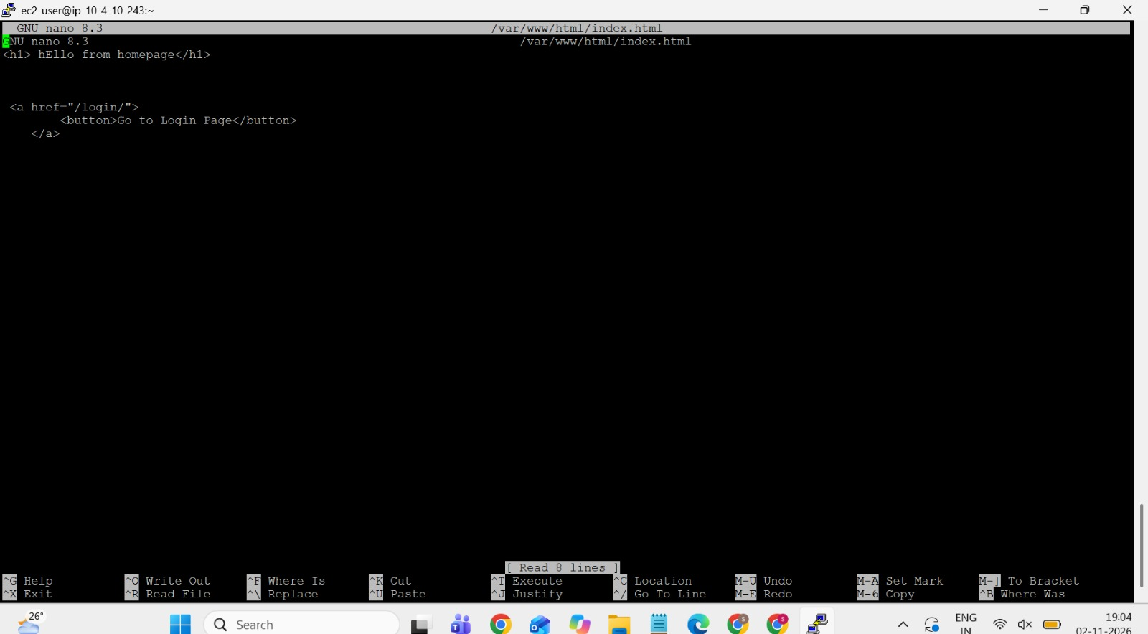

Screenshot 18
Configured Apache reverse-proxy rules to forward requests for /login/ to the private EC2 instance.
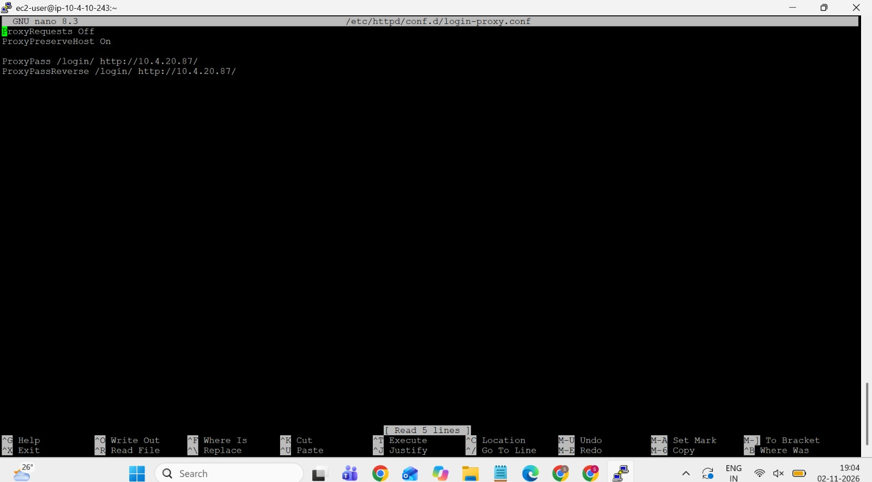

Screenshot 19
Verified that the homepage is accessible through the public EC2 instance's public IP address.
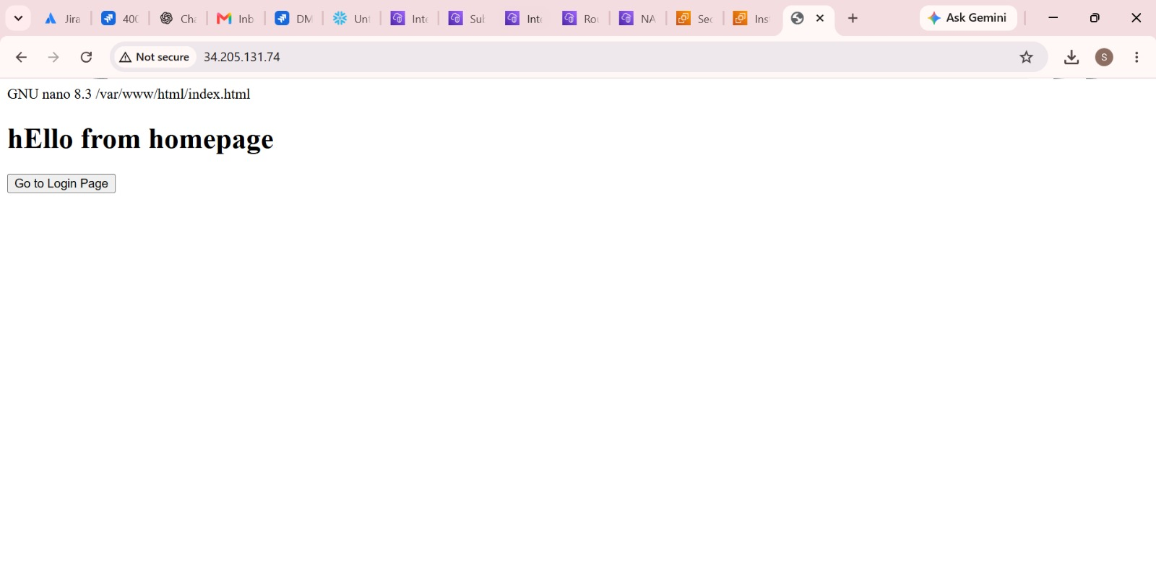

Screenshot 20
Verified that the /login/ path successfully displays the page served by the private EC2 instance.
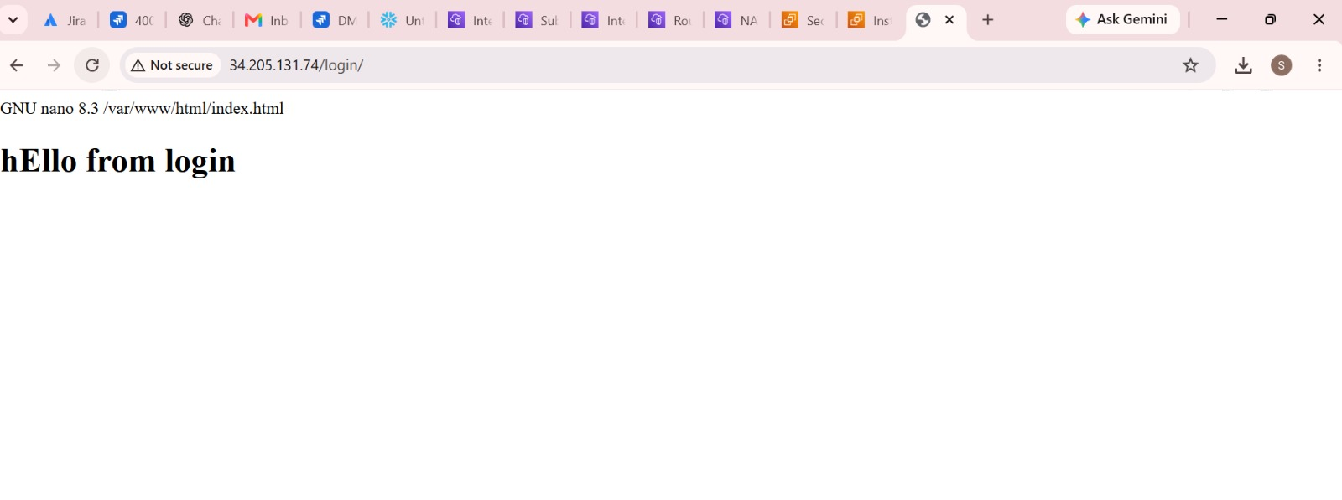

8. AWS Resource Cleanup

Screenshot 21
Selected the NAT gateway for deletion as part of the VPC cleanup process.
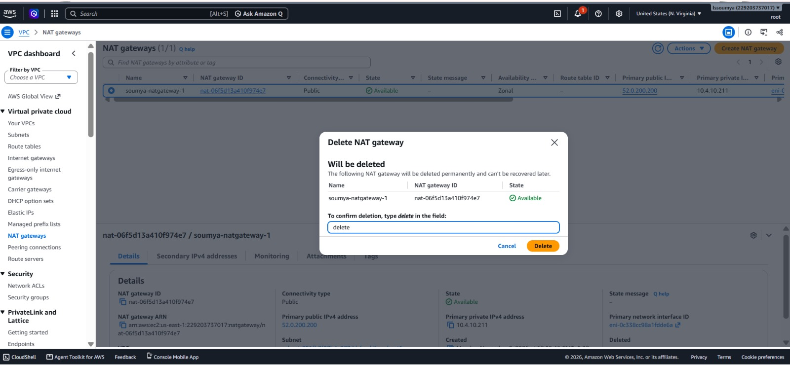

Screenshot 22
Reviewed the VPC deletion confirmation, including the associated resources that would also be deleted.
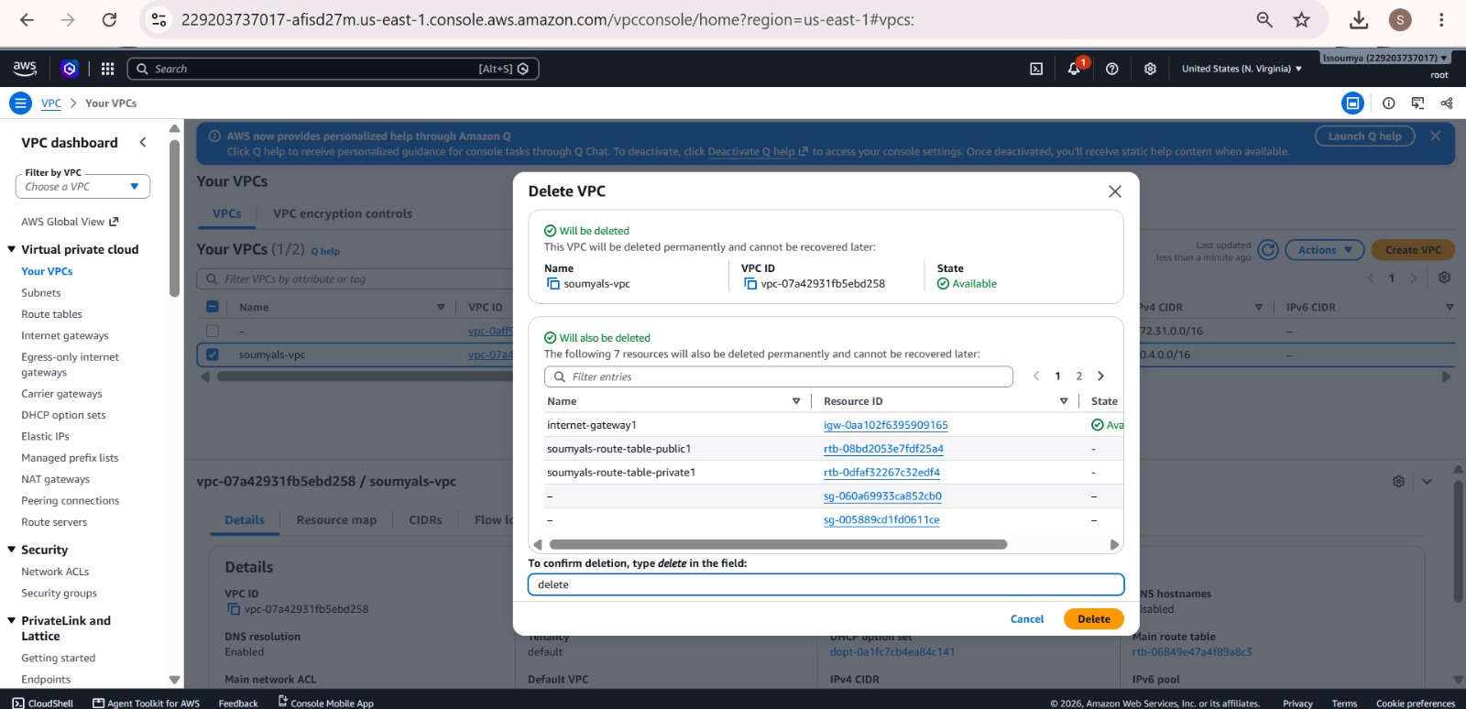

Screenshot 23
Selected the allocated Elastic IP address for release after removing the NAT gateway.


