Day 13 Task 2

Create the DataFrame
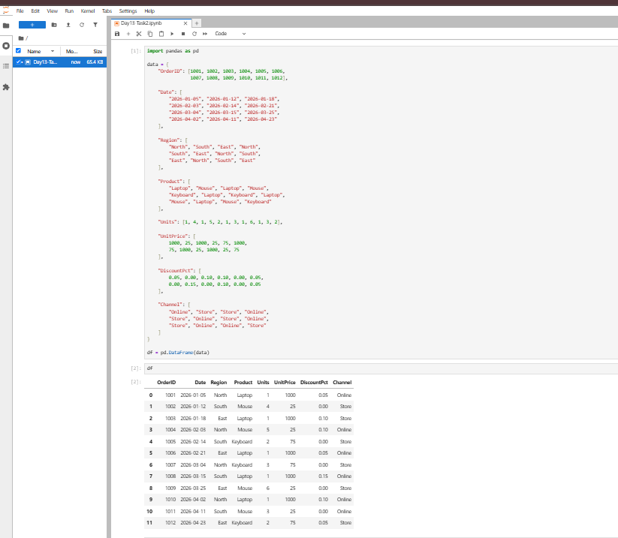

Check Unique Orders and Row Count
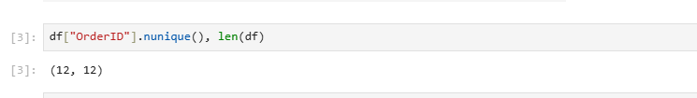

Import Libraries and Convert Dates
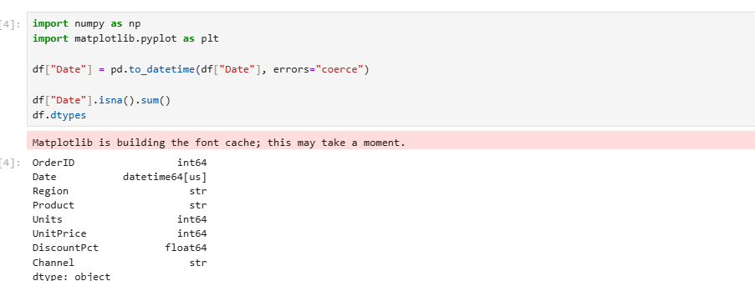

Create the Revenue Column
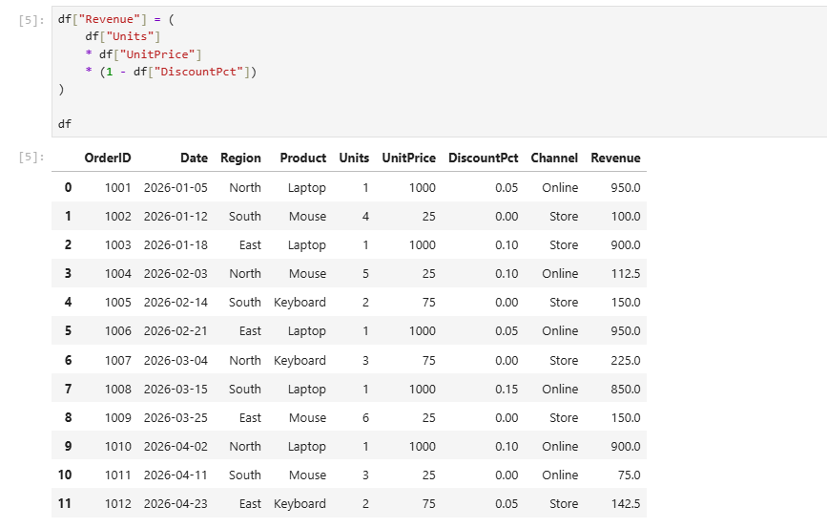

Find the Five Highest-Revenue Orders
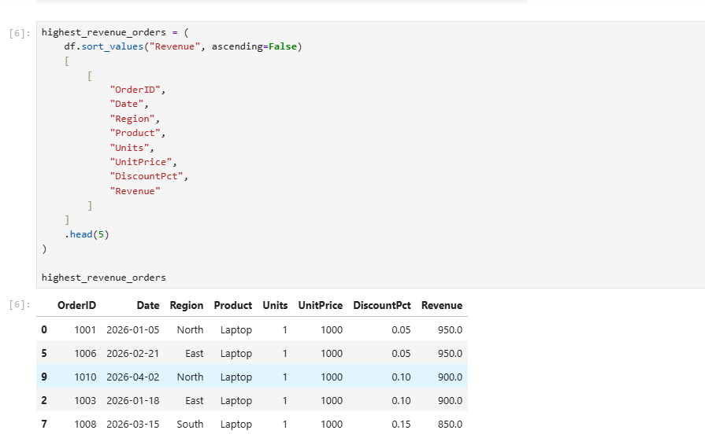

Create a Region Summary
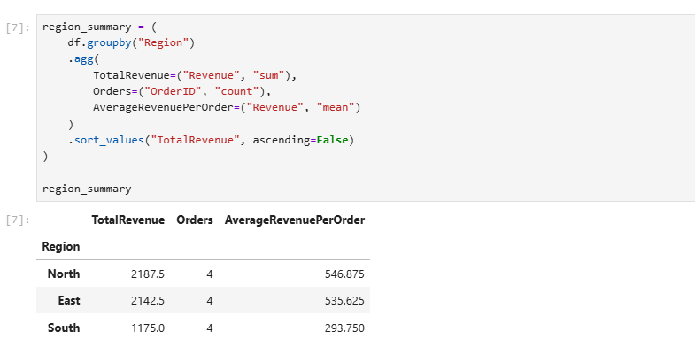

Create a Product Summary
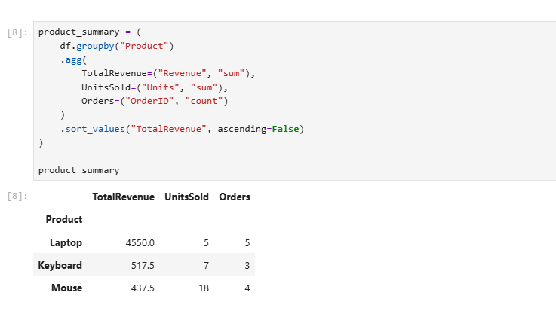

Create a Monthly Summary
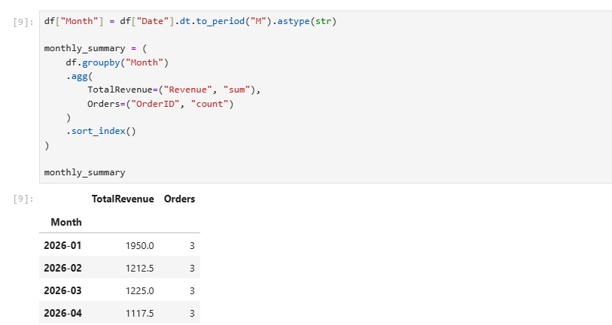

Plot Total Revenue by Region
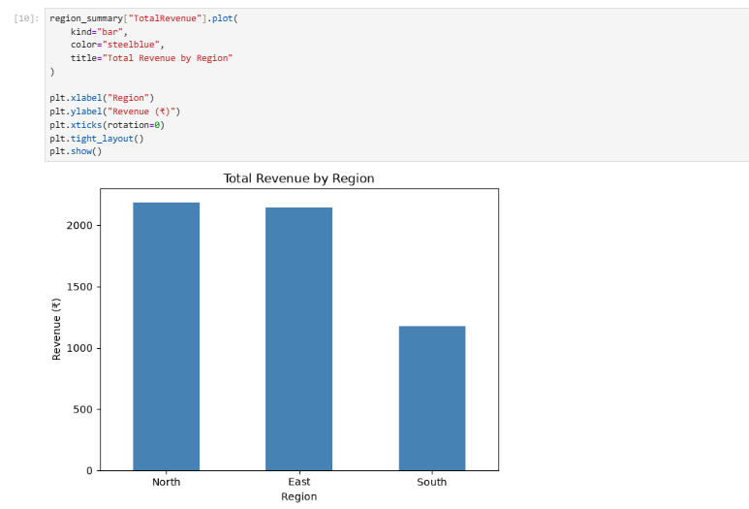

Plot Total Revenue by Product


