Linux File System Explorer
/etc
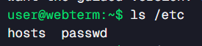
/home
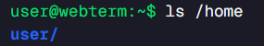
/var
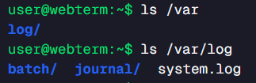
/tmp
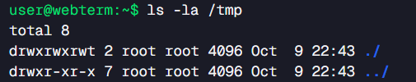
/usr
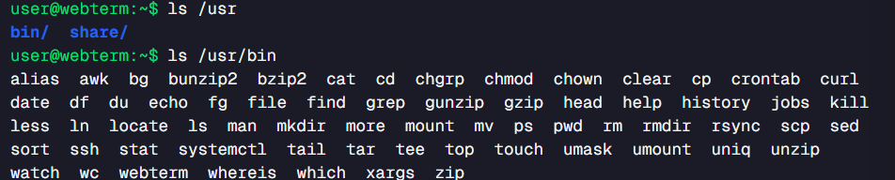

Linux Commands Investigation
Pwd
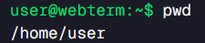
ls and ls -la
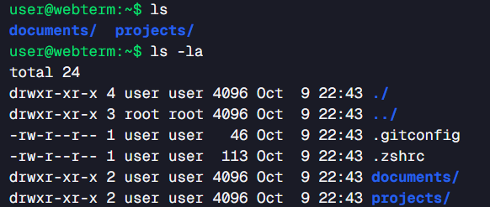
cd
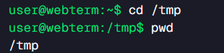
Mkdir
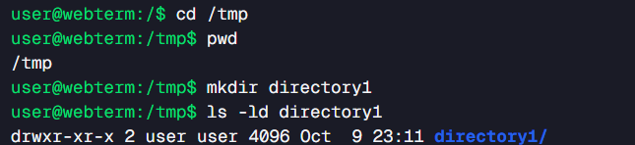

rm
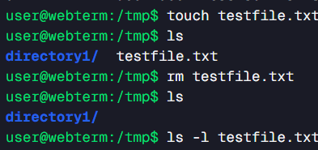

Linux Permissions
ls -l
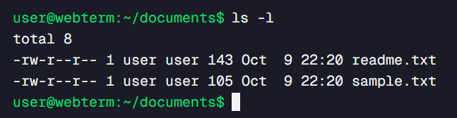
ls -l readme.txt
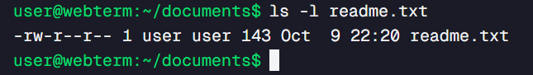
chmod 644
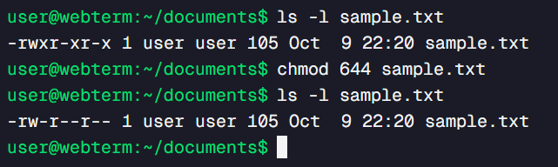
chmod 755
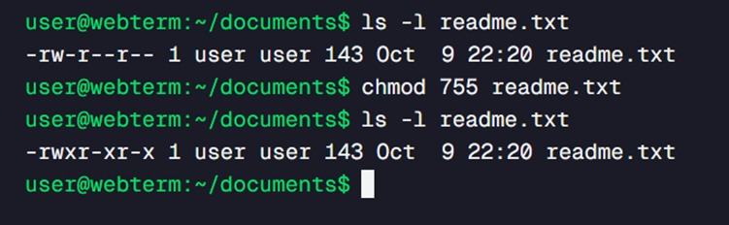

chmod 777
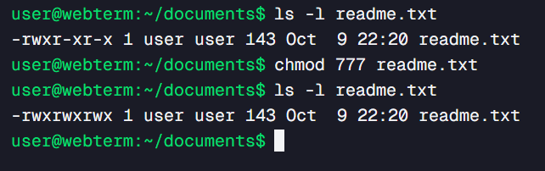

Linux Processes
- What Is a Linux Process?
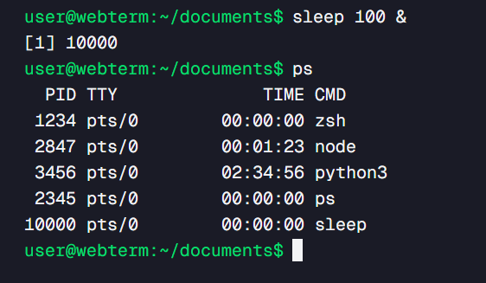
- What Does ps Show?
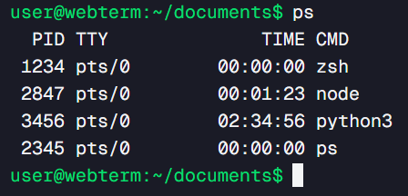
- What Does ps aux Show?
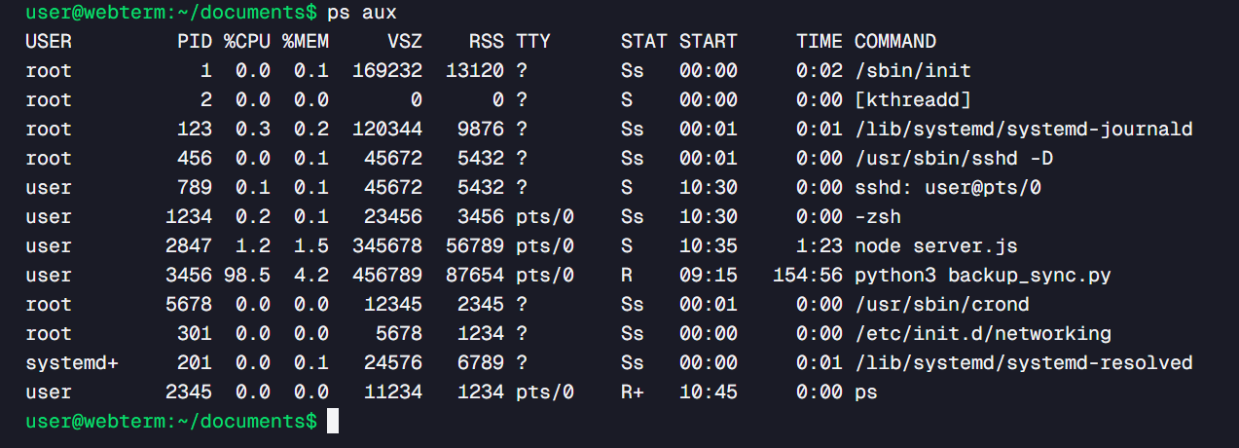
- What Does top Do?
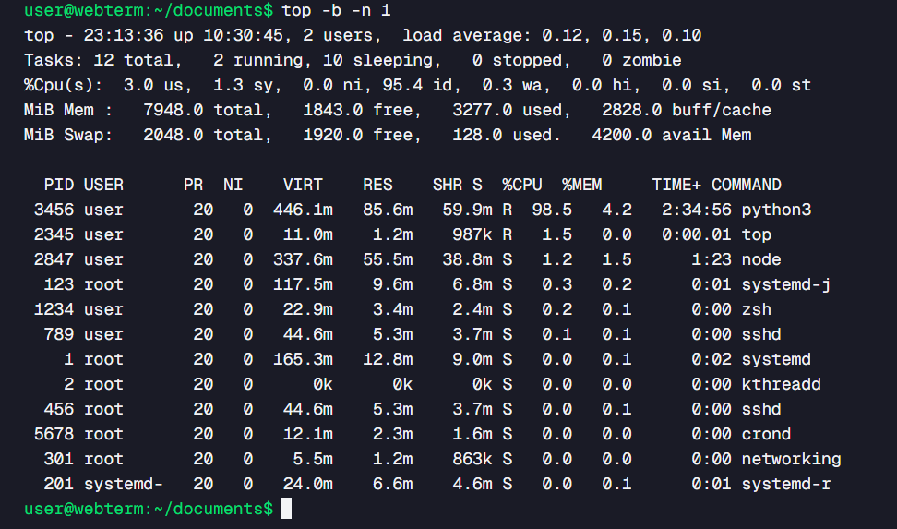
- Why Would a Developer Investigate Processes?
