**Name: Soumya Vinod Mudalgi**

**Roll No:05 Experiment No: 10**

**Title: Implement java programs based on interfaces.**

**Code:**

interface Animal

{

public void bark();

}

interface Animal1

{

public void roaring();

}

class dog implements Animal,Animal1

{

public void bark(){

System.out.println("Dog is barking");

}

public void roaring(){ System.out.println("lion is roaring");

}

public static void main(String []args)

{

dog d1=new dog(); d1.bark();

d1.roaring();

}

}

**Output:**

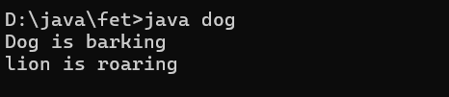

**Code:**

interface print1{ void print();

}

class A implements print1

{

public void print()

{

System.out.println("Hello");

}

public static void main(String args[]){ A obj = new A();

obj.print();

}

}

**Output:**

