**Name**- Soumya Vinod Mudalgi

**Roll no- 24**

**Div-**B **Batch-**B2

**Experiment no-**01

**Experiment name-**Implement java programs based on I/O,operators and command line arguments.

**Java command line argument-**

The java command-line argument is an argument i.e. passed at the time of running the java program.

The arguments passed from the console can be received in the java program and it can be used as an input.

# **Java I/O : Input-output in Java**

brings various Streams with its I/O package that helps the user to perform all the input-output operations. These streams support all the types of objects, data-types, characters, files etc to fully execute the I/O operations.

[](https://media.geeksforgeeks.org/wp-content/uploads/20191126125125/Java-Input-Output-Stream.jpg)

1. **Implement a Java program to display a message on the console.**

Input-

class Stud

{

public static void main(String args[])

{

System.out.println("Vaishnavi Patil");

}

}

Output-



### 2. example of command-line argument in java

Input-

class CommandLine

{

public static void main(String args[])

{

System.out.println("Your first argument is: "+args[0]);

}

}

Output-

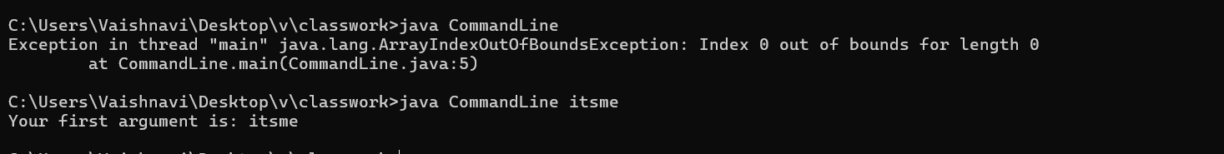

**3.Implement a program to demonstrate operators in Java.**

Input-

import java.util.Scanner;

class Stud2

{

public static void main(String args[])

{

int a,b;

Scanner aa=new Scanner(System.in);

a=aa.nextInt();

b=aa.nextInt();

add(a,b);

multiply(a,b);

substract(a,b);

division(a,b);

}

static void add(int a,int b)

{

int sum;

sum=a+b;

System.out.println("addition is-" +sum);

}

static void multiply(int a,int b)

{

int mul;

mul=a*b;

System.out.println("multiplication is-" +mul);

}

static void substract(int a,int b)

{

int sub;

sub=a-b;

System.out.println("substraction is-" +sub);

}

static void division(int a,int b)

{

int div;

div=a-b;

System.out.println("division is-" +div);

}

}

Output-

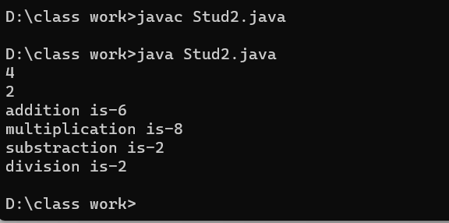

**4.Implement a program to demonstrate type casting in Java.**

Input-

class Stud3

{

public static void main(String[] args)

{

int x = 7;

long y = x;

float z = y;

System.out.println("Before conversion, int value "+x);

System.out.println("After conversion, long value "+y);

System.out.println("After conversion, float value "+z);

}

}

Output-

