**Name-Soumya Vinod Mudalgi**

**Roll no-24**

**Div-B**

**Experiment no-14**

**Experiment name-Design a graphical user interface using different UI components in swing package use event handling.**

## **What is Swing in Java?**

**Swing in Java** is a Graphical User Interface (GUI) toolkit that includes the GUI components. Swing provides a rich set of widgets and packages to make sophisticated GUI components for Java applications. Swing is a part of Java Foundation Classes(JFC), which is an API for Java GUI programing that provide GUI.

The Java Swing library is built on top of the Java Abstract Widget Toolkit (**AWT**), an older, platform dependent GUI toolkit. You can use the Java simple GUI programming components like button, textbox, etc., from the library and do not have to create the components from scratch.

1. simple swing program where we are creating one button and adding it on the JFrame object inside the main() method.

Input-

import javax.swing.*;

class FirstSwingExample

{

public static void main(String[] args)

{

JFrame f=new JFrame();

JButton b=new JButton("click");

b.setBounds(130,100,100, 40);

f.add(b);

f.setSize(400,500);

f.setLayout(null);

f.setVisible(true);

}

}

Output

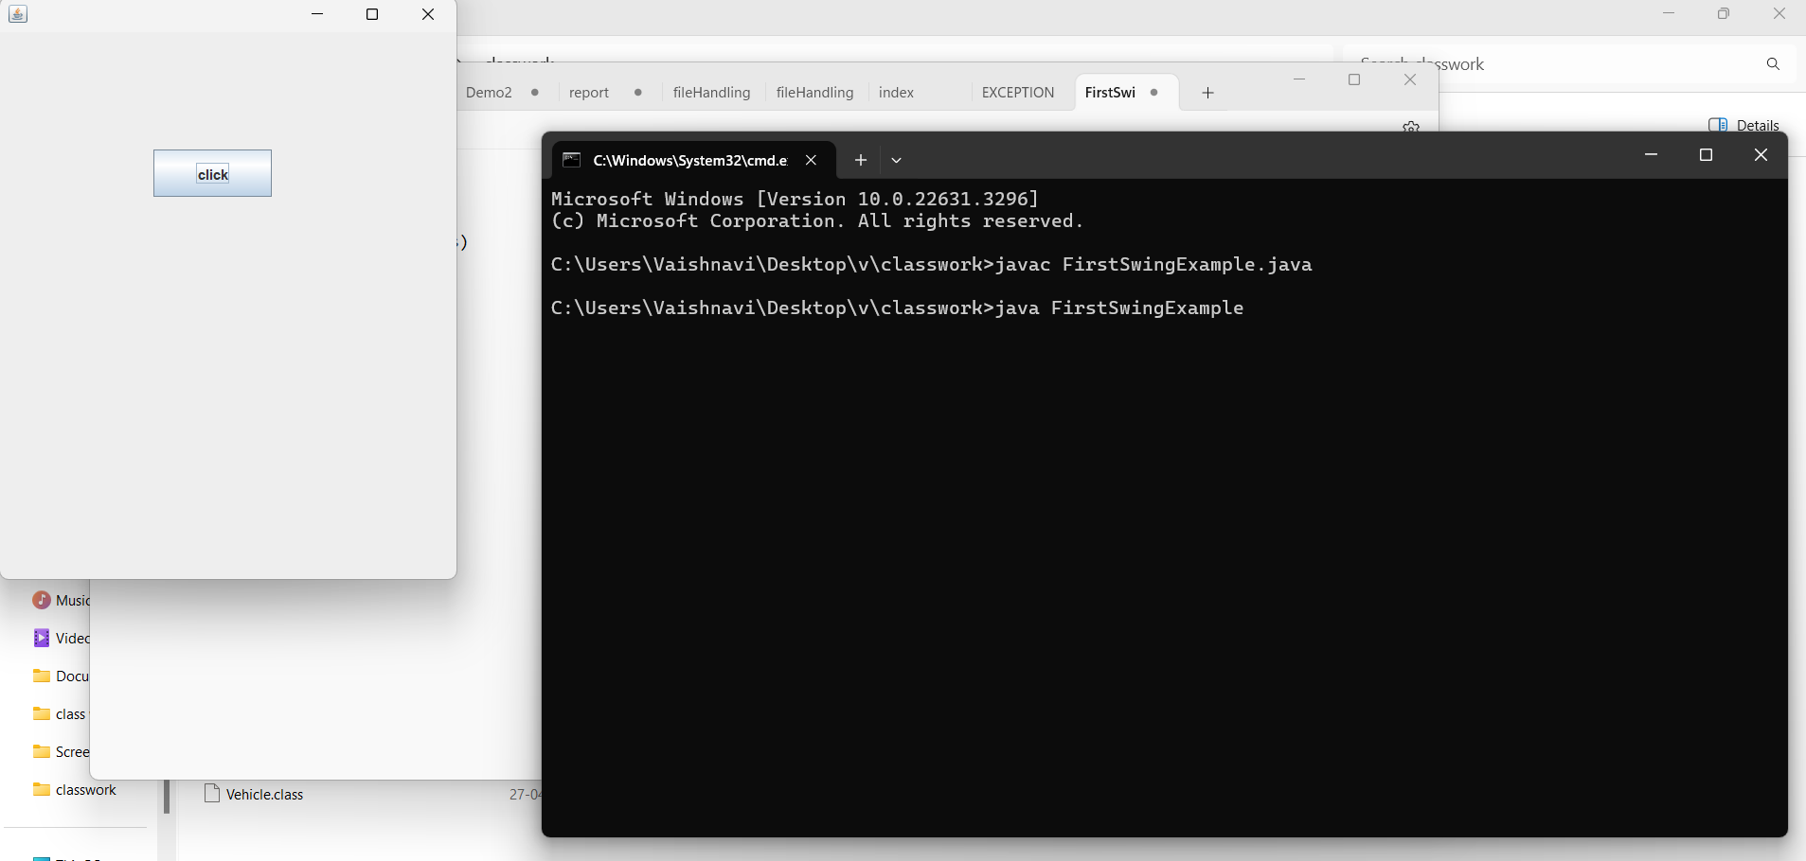

#### 2.Write a program to create three buttons with caption OK, SUBMIT, CANCEL.

Input-

import java.awt.*;

class button {

button()

{

Frame f = new Frame();

Button b1 = new Button("OK");

b1.setBounds(100, 50, 50, 50);

f.add(b1);

Button b2 = new Button("SUBMIT");

b2.setBounds(100, 101, 50, 50);

f.add(b2);

Button b3 = new Button("CANCEL");

b3.setBounds(100, 150, 80, 50);

f.add(b3);

f.setSize(500, 500);

f.setLayout(null);

f.setVisible(true);

}

public static void main(String a[])

{

new button();

}

}

Output-

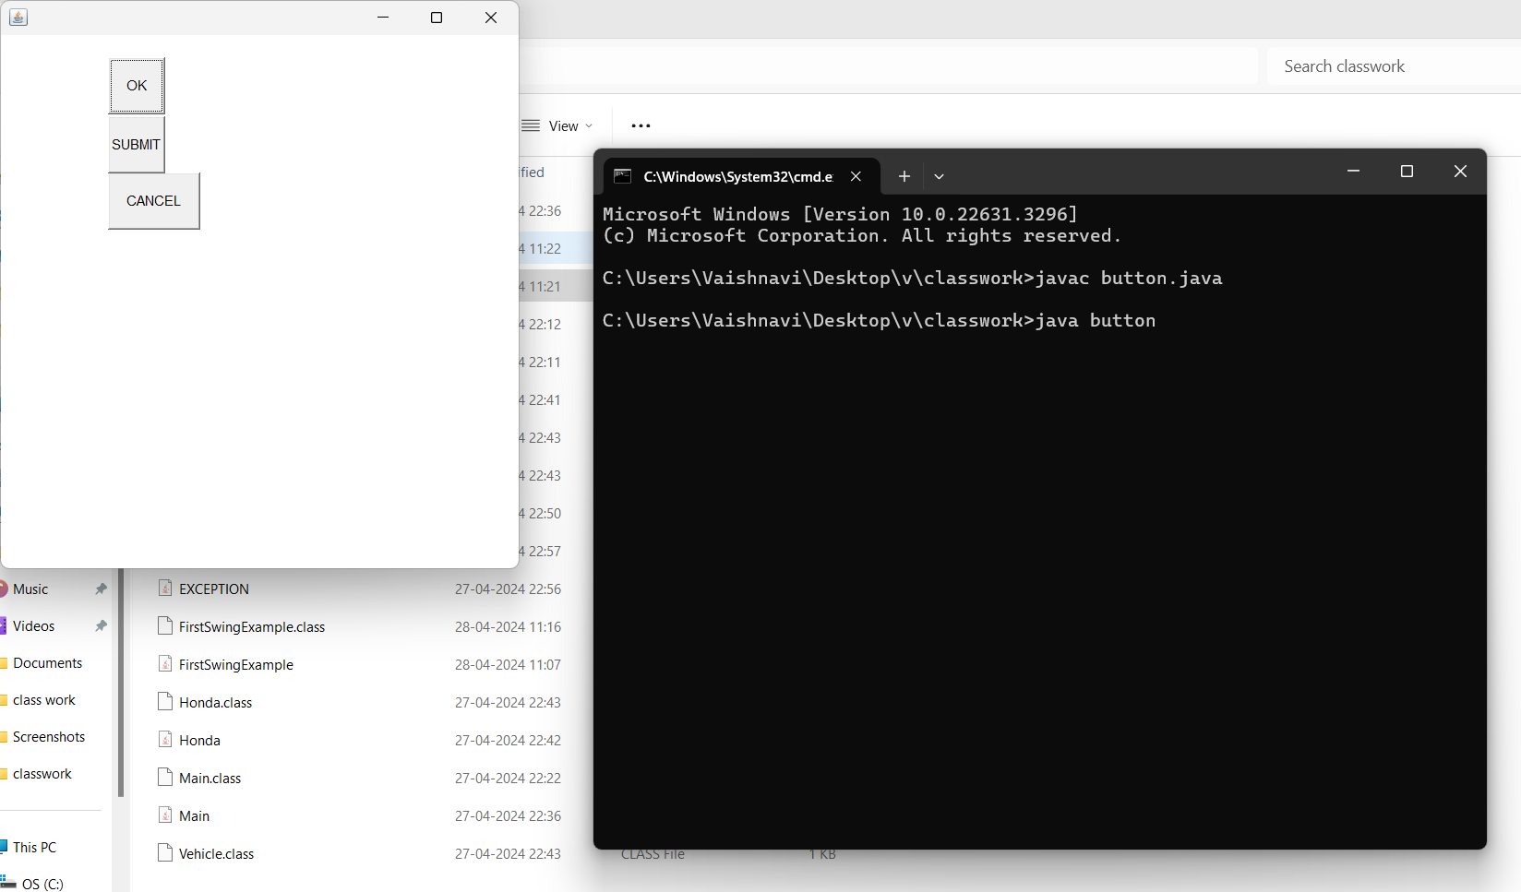

#### **Program to Add Checkbox in the Frame.**

#### **Input-**

#### import java.awt.*;

#### class Lan

#### {

#### 

#### Lan()

#### {

#### Frame f = new Frame();

#### Label l1 = new Label("Select known Languages");

#### l1.setBounds(100, 50, 120, 80);

#### f.add(l1);

#### Checkbox c2 = new Checkbox("Hindi");

#### c2.setBounds(100, 150, 50, 50);

#### f.add(c2);

#### Checkbox c3 = new Checkbox("English");

#### c3.setBounds(100, 200, 80, 50);

#### f.add(c3);

#### Checkbox c4 = new Checkbox("marathi");

#### c4.setBounds(100, 250, 80, 50);

#### f.add(c4);

#### f.setSize(500, 500);

#### f.setLayout(null);

#### f.setVisible(true);

#### }

#### public static void main(String ar[])

#### {

#### new Lan();

#### }

#### }

#### Output-

#### 