**Name-Soumya Vinod Mudalgi**

**Roll no-24**

**Div-B**

**Experiment no-2**

**Experiment name-Implement java programs based on if else statements and switch case.**

**Switch Statements in Java**

The **switch statement in Java** is a multi-way branch statement. In simple words, the Java switch statement executes one statement from multiple conditions.

## **Syntax**

switch(expression)  
{  
 case value1 :  
 // Statements  
 break; // break is optional  
   
 case value2 :  
 // Statements  
 break; // break is optional  
 ....  
 ....  
 ....  
 default :   
 // default Statement  
}

## **If-Else in Java**

If- else together represents the set of Conditional statements in Java that are executed according to the condition which is true.

## **Syntax of if-else Statement**

**if** (condition)

{

// Executes this block if

// condition is true

}

**else**

{

// Executes this block if

// condition is false

}

**1. A company decided to give bonus of 10% (of salary) to employee if his/her year of service is more than 5 years. Implement a Java program to ask user for their salary and year of service and print the net bonus amount and the total salary adding bonus.**

Input-

import java.util.Scanner;

public class Stud6

{

public static void main(String[] args)

{

Scanner scanner = new Scanner(System.in);

System.out.print("Enter your salary: ");

double salary = scanner.nextDouble();

System.out.print("Enter your years of service: ");

int yearsOfService = scanner.nextInt();

double bonusPercentage = 0.10;

double bonus = 0;

if (yearsOfService > 5)

{

bonus = salary * bonusPercentage;

}

double totalSalary = salary + bonus;

System.out.println("Net Bonus Amount: " + bonus);

System.out.println("Total Salary (including bonus): " + totalSalary);

}

}

Output-

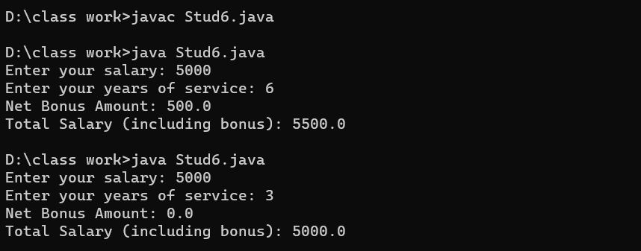

**2. A school has following rules for grading system: Below 25 – F, 25 to 45 – E, 45 to 50 – D, 50 to 60 – C, 60 to 80 – B, Above 80 - A Implement a Java program to ask user to enter marks and print the corresponding grade.**

Input-

import java.util.Scanner;

class Stud7

{

public static void main(String args[])

{

int marks;

System.out.println("Enter marks obtained by student");

Scanner aa=new Scanner(System.in);

marks=aa.nextInt();

if(marks>=80)

{

System.out.println("A");

}

else if(marks>=60&&marks<80)

{

System.out.println("B");

}

else if(marks>=50&&marks<60)

{

System.out.println("C");

}

else if(marks>=45&&marks<50)

{

System.out.println("D");

}

else if(marks>=25&&marks<45)

{

System.out.println("E");

}

else

{

System.out.println("F")

}

}

}

Output-

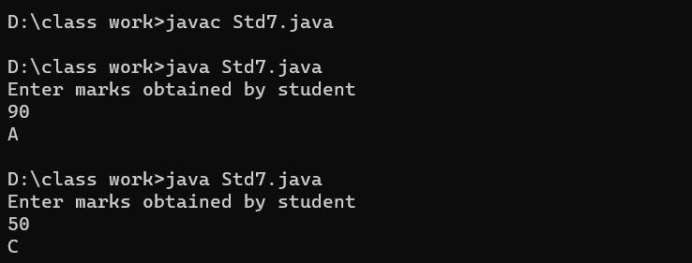

3. **Program to check Vowel or Consonant:**

**Input-**

public class Example {

public static void main(String[] args) {

char ch='O';

switch(ch)

{

case 'a':

System.out.println("Vowel");

break;

case 'e':

System.out.println("Vowel");

break;

case 'i':

System.out.println("Vowel");

break;

case 'o':

System.out.println("Vowel");

break;

case 'u':

System.out.println("Vowel");

break;

case 'A':

System.out.println("Vowel");

break;

case 'E':

System.out.println("Vowel");

break;

case 'I':

System.out.println("Vowel");

break;

case 'O':

System.out.println("Vowel");

break;

case 'U':

System.out.println("Vowel");

break;

default:

System.out.println("Consonant");

}

}

}

Output-

