**Name-Soumya Vinod Mudalgi**

**Roll no-24**

**Div-B**

**Experiment no-03**

**Experiment name-Implement java programs based on while ,do while and for loop.**

Three types of Conditional statements this second  type is loop statement .

* [**while loop:**](https://www.geeksforgeeks.org/java-while-loop-with-examples/) A while loop is a control flow statement that allows code to be executed repeatedly based on a given Boolean condition. The while loop can be thought of as a repeating if statement.

**Syntax :**

while (boolean condition)

{

loop statements...

}

* [**for loop:**](https://www.geeksforgeeks.org/java-for-loop-with-examples/) for loop provides a concise way of writing the loop structure. Unlike a while loop, a for statement consumes the initialization, condition and increment/decrement in one line thereby providing a shorter, easy to debug structure of looping.

**Syntax:**

for (initialization condition; testing condition;increment/decrement)

{

statement(s)

}

* [**do while:**](https://www.geeksforgeeks.org/java-do-while-loop-with-examples/) do while loop is similar to while loop with only difference that it checks for condition after executing the statements, and therefore is an example of **Exit Control Loop.**

**Syntax:**

do

{

statements..

}

while (condition);

**1. Implement a Java program to print multiplication table of user entered number.**

Input-

import java.util.Scanner;

class Std10

{

public static void main(String args[])

{

int num;

System.out.println("Enter num to print the table");

Scanner aa=new Scanner(System.in);

num=aa.nextInt();

for(int i=1;i<=10;i++)

{

int table=num*i;

System.out.println(+table);

}

}

}

Output-

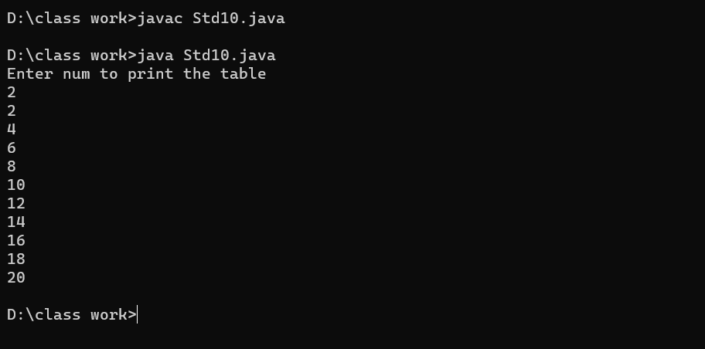

2. Implement a Java program to accept an integer number from user and check whether it is an Armstrong number or not. (Armstrong number: e. g. 153= 13+53+33 )

import java.util.Scanner;

public class Std11

{

public static void main(String[] args)

{

Scanner aa = new Scanner(System.in);

System.out.print("Enter an integer number: ");

int number = aa.nextInt();

int originalNumber = number;

int sum = 0;

while (number > 0)

{

int digit = number % 10;

sum += (digit * digit * digit);

number /= 10;

}

if (sum == originalNumber)

{

System.out.println(originalNumber + " is an Armstrong number.");

}

else

{

System.out.println(originalNumber + " is not an Armstrong number.");

}

}

}

Output-

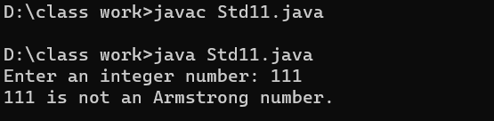

3.Program to print numbers less that 5.

Input-

public class Main {

public static void main(String[] args) {

int count = 0;

do {

System.out.println(count);

Count++;

}

while (count < 5);

}

}

Output-

