**Name: Soumya Mudalgi**

**Roll No:24**

**Experiment No: 7**

**Title: Implement java programs based on static methods, non-static methods and method overloading.**

**Code:**

**Non Static:**

class Rectangle

{

int length,width;

void getdata(int x,int y)

{

length=x; width=y;

}

int calarea()

{

int area = length*width; return area;

}

}

class Area

{

public static void main(String args [])

{

int a,b;

Rectangle rect1 = new Rectangle(); Rectangle rect2 = new Rectangle(); rect1.length = 10;

rect1.width = 2;

a = rect1.length*rect1.width; System.out.println("Area of Reactangle A is :"+a); rect2.getdata(2,3);

b = rect2.calarea();

System.out.println("Area of Reactangle B is :"+b);

}

}

**Output:**



**Static:**

class Operation

{

public static int add(int a, int b)

{

return a+b;

}

public static int sub(int a, int b)

{

return a-b;

}

public static int mul(int a, int b)

{

return a*b;

}

public static double div(int a, int b) { return a/b;

}

}

public class statmethod

{

public static void main(String [] args)

{

int n1=10; int n2=2;

int sum = Operation.add(n1,n2); int subs = Operation.sub(n1,n2); int prod = Operation.mul(n1,n2); double quo = Operation.div(n1,n2);

System.out.print(" "+sum+" "+subs+" "+prod+" "+quo);

}

}

**Output:**

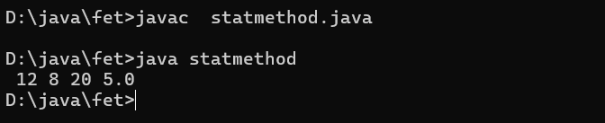

**Method overloading:**

class overloading

{

int square(int x)

{

return x*x;

}

double square(double y)

{

return y*y;

}

}

class methodover

{

public static void main(String [] args)

{

overloading o1 = new overloading(); int a = o1.square(2);

double b = o1.square(4.3); System.out.println(a); System.out.print(b);

}

}

**Output:**

