**JAVA INTERVIEW QUESTIONS (DAY-1)**

**1.Simple Java Program.**

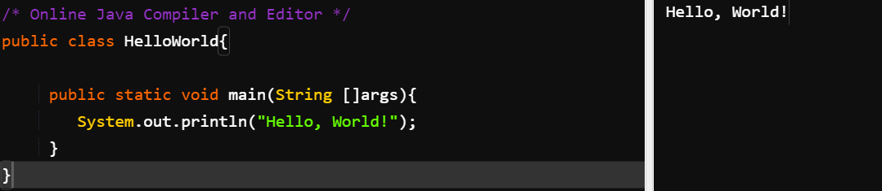

**2.Addition of Two Integers.**

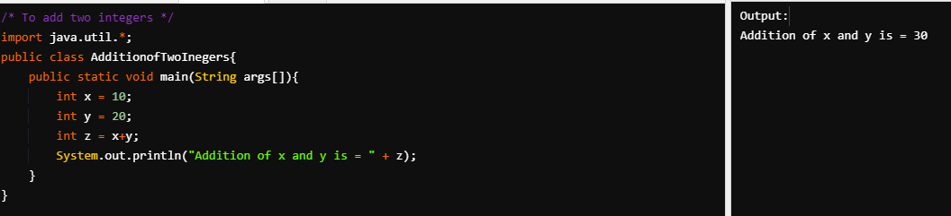

**3. Printing Integers from 1-10 using for loop.**

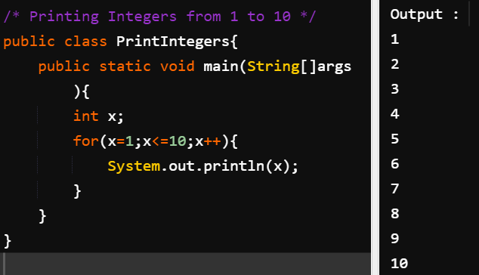

**4. How to get Using input using Scanner Program in java**

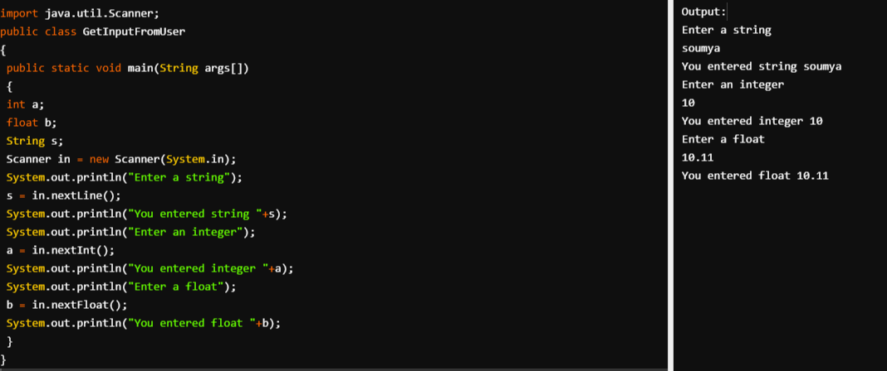

**5. How to convert Fahrenheit to Celsius Program in java**

