**JAVA PROGRAMS – DAY 2**

1. **How to swap 2 no using 3rd variable Program in java**

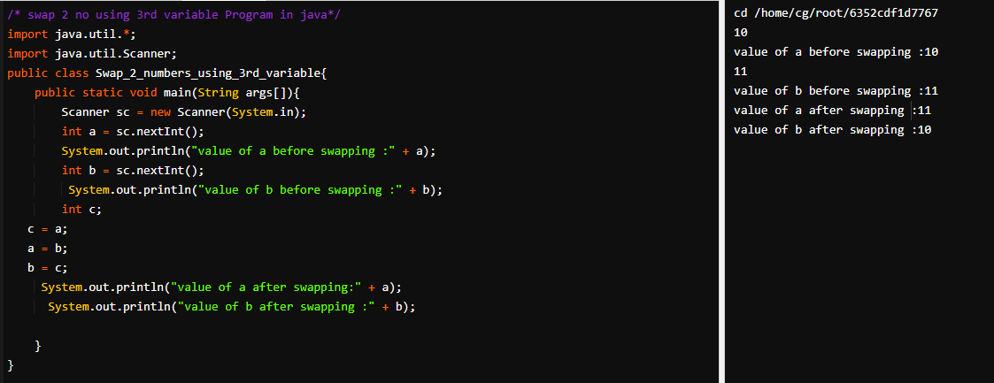

1. **How to swap 2 no without using 3rd variable Program in java**

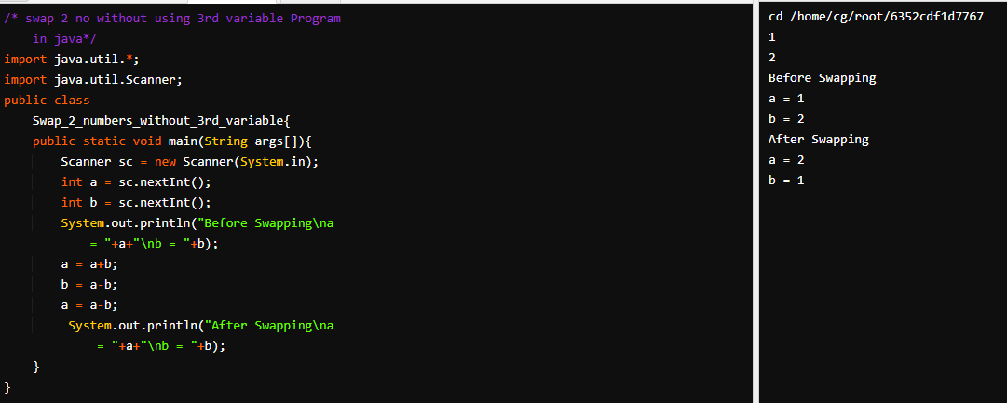

1. **Find Largest no in java Program**

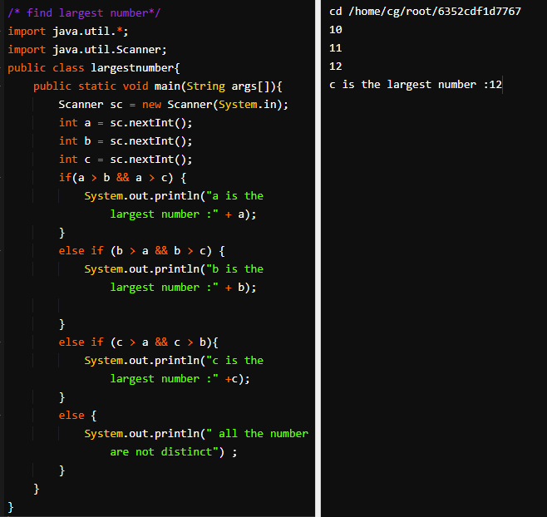

1. **IF ELSE clause in Java.**

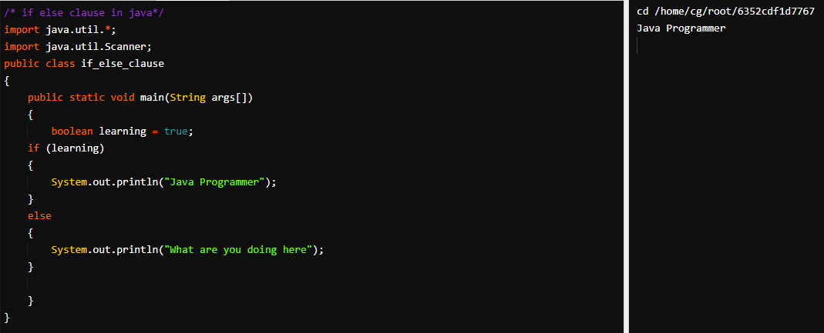

1. **If Else clause in java- Program 2**

