**DAY-3**

1. **How to check Odd and Even Number in Java.**

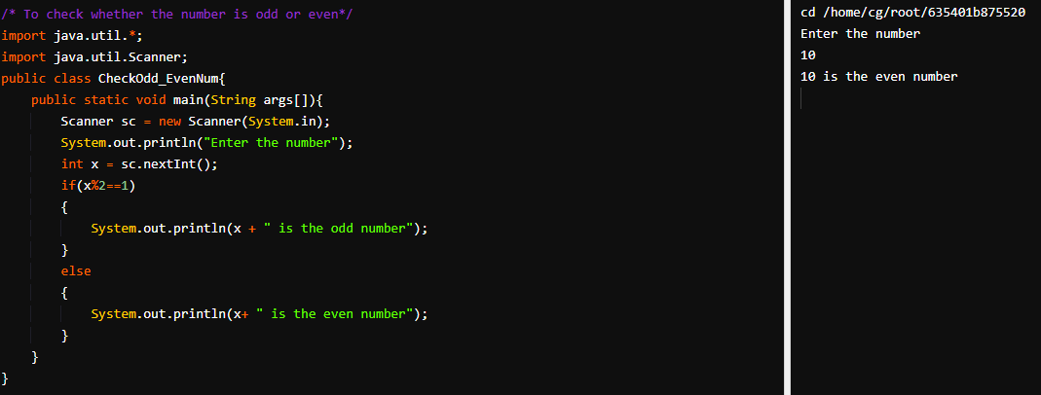

1. 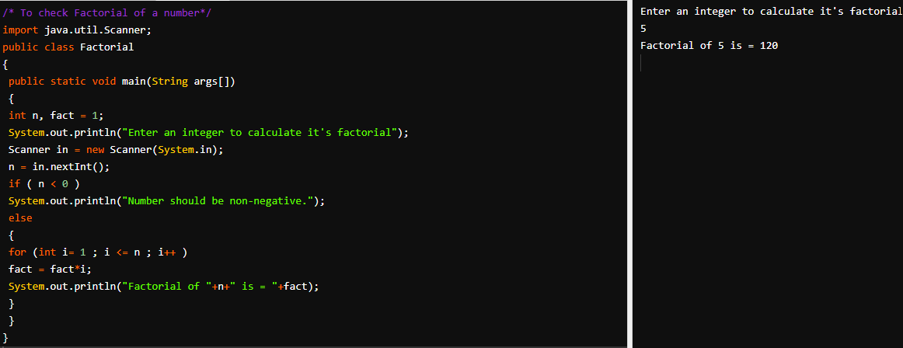**Find factorial for given number in Java.**
2. 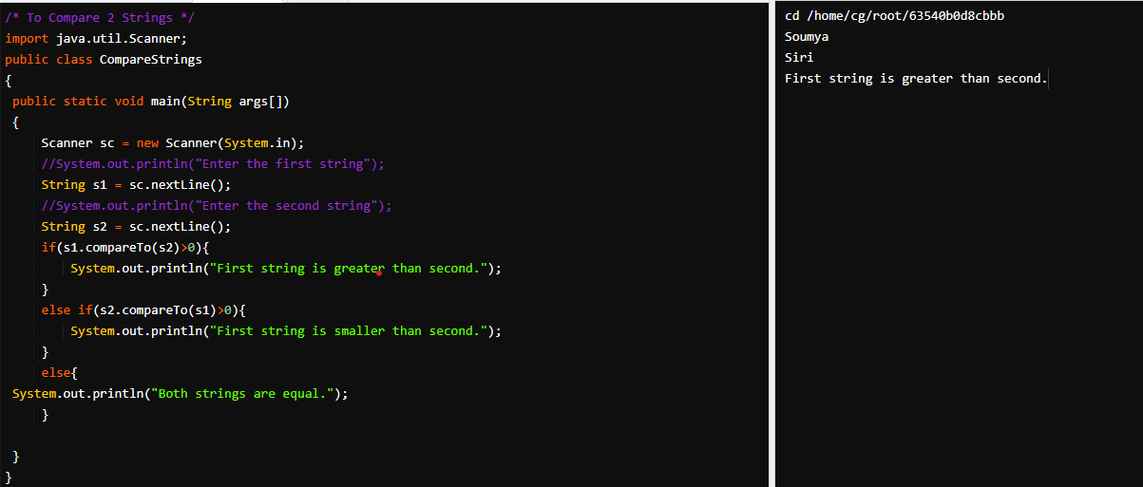**How to compare 2 strings in Java.**

**About compareTo**

* The compareTo() method compares two strings lexicographically.
* The comparison is based on the Unicode value of each character in the strings.
* The method returns 0 if the string is equal to the other string. A value less than 0 is returned if the string is less than the other string (less characters) and a value greater than 0 if the string is greater than the other string (more characters).
* **Tip:** Use compareToIgnoreCase() to compare two strings lexicographyically, ignoring lower case and upper case differences.
* **Tip:** Use the equals() method to compare two strings without consideration of Unicode values.

1. **Simple For Loop Program in Java.**

