**EXPERIMENT-5**

**AIM:** Write a MapReduce to analyse weather data set and print whether the day is sunny or cool day

* 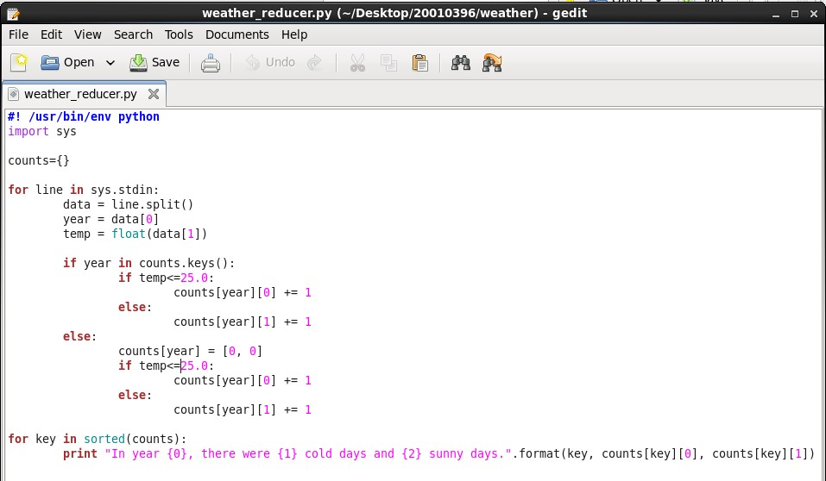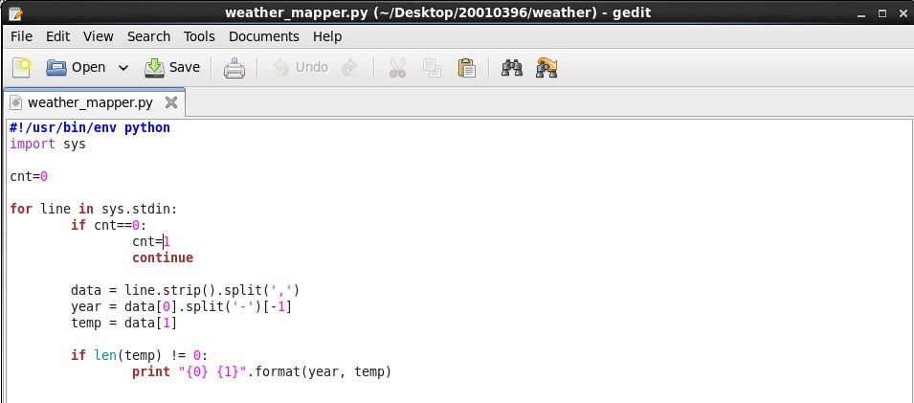**Creating Program files**

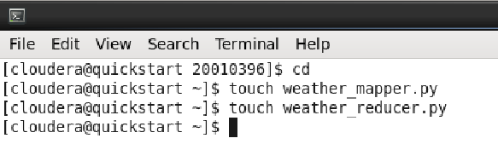

* **Granting execution permission**
* **Copying file from local to HDFS**



* 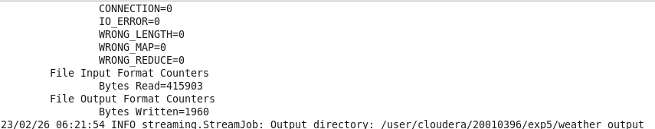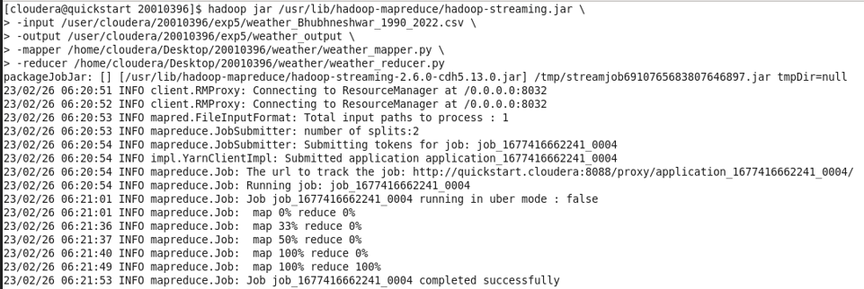**Program execution using Hadoop-streaming.jar**
* **Displaying the output in the terminal**

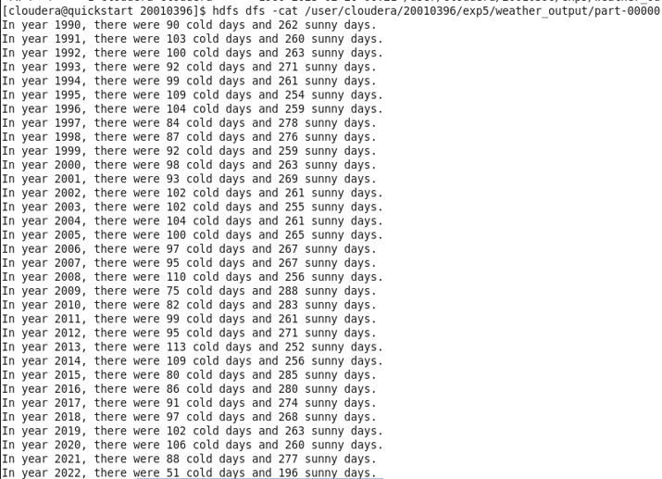

Submitted By:

Name: Sohan Choudhury

Regd. No.: 20010396

Branch: CSE (AI & ML)

Group: 4 (H)